Snowshoeing and a Turkey Dinner
Saturday was a perfect winter day that allowed Scott and me to go on a snowshoeing adventure for the afternoon. After doing some research on which direction to go that would have the best snow in addition to some nice views, we settled on driving north to Ashton, Idaho. There is a trail that used to be a railroad thruway and then about 12 years ago it was renovated to be a hiking trail instead. It's called the Ashton-Tetonia Trail.

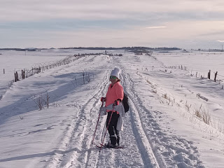

The weather LOOKS cold, but it really wasn't. The temperature was about 31 degrees, but during our hike the sun came out in full force, and we began shedding layers as we went along.

After Google took us to the wrong starting point, we found a better option nearby on 4700 East, close to one of the entrances to Ashton-Tetonia Trail State Park.

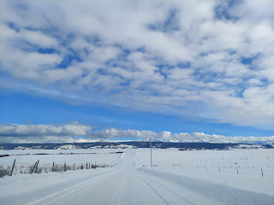

We parked on the road behind a string of cars that had come to enjoy the trail as well. There was also a Search & Rescue Van and ambulance in the lineup, with their snowmobile unloaded and ready in case a need arose, and the handful of personnel were standing around talking and drinking their coffee together.

From where we parked, there is a restroom a few paces away (but it was locked), and right across from the bathroom is an open gate to hop on the trail.

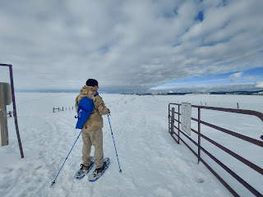

As we shuffled along in our snowshoes, a trio of large dogs came barking and running up to greet us ahead of their owners. They were friendly, thank goodness, and just wanted to see who we were.

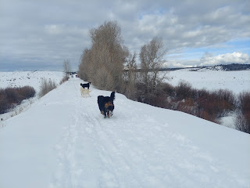

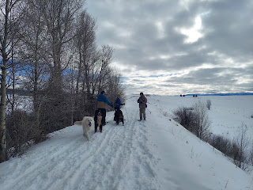

I bought snowshoes for Scott and me last Christmas, but we have not used them yet. There was just too much going on last January and February leading up to when Scott left for Italy in early March. We tried them on in the snow in front of our house before we left home, just to make sure they would work. All was well.

On the trail, however, I kept having issues with my right snowshoe. The heel strap kept loosening and my foot would be flopping around to the point of the snowshoe almost flinging off. After a few tries, we found a way to secure the strap better and then I didn't have any more problems.

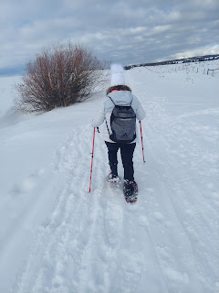

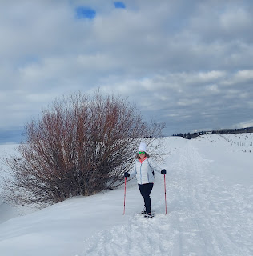

We cruised along and enjoyed the beautiful wintry wonderland on our right and our left.

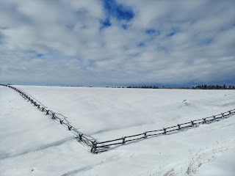

Video that Scott took of me coming towards him: (10 seconds)
https://photos.app.goo.gl/DW74KMMyE7gGyqs69

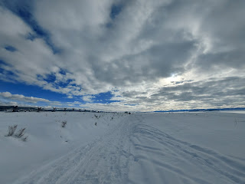

As we got closer to the bridge, we smelled some fresh skunk perfume . . . and as we encountered an older couple on XC skiis, they told us that another couple had just struggled with a situation of trying to continue along but a couple of skunks were in the middle of the trail and they didn't dare try to pass. This happened about 30 minutes before we came through . . . yikes.

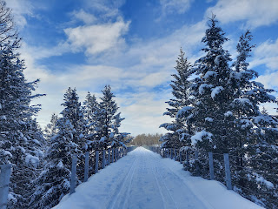

This is the Bridge at B-word Creek. Yes, that's correct. It was named by the French some time ago, and their word meant DEER. (biche) They noticed that there were DEER in the creek. But nowadays, it has a different and less pleasant meaning . . .

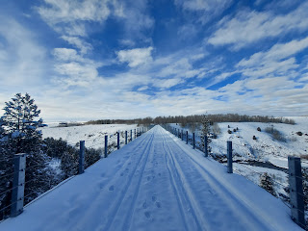

The railroad trestle was discontinued in 1984 and became open to the public, along with the rest of the trail, in 2010. The length of the bridge is 640 feet and it's situated 130 feet above the creek below.

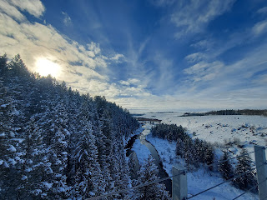

A couple of snowmobilers passed us as we were admiring the views from the bridge. They were going nice and slow, which was very polite.

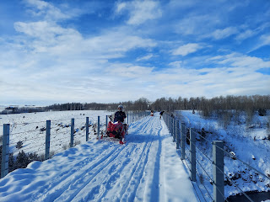

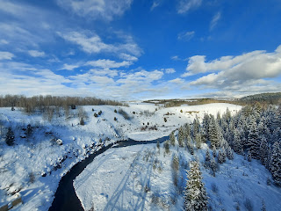

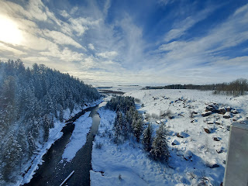

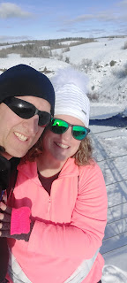

After spending a few minutes on the bridge, we turned around to head back. We passed a couple of bushes that were very pungent with the smell of fresh skunk . . . so we decided to be as loud as possible to make sure we didn't surprise any of them, ha ha. Thankfully we never saw any black cats with a white stripe down their back . . .

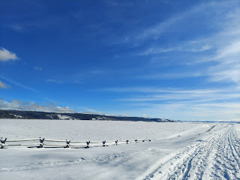

You may notice the blue sky above in place of all the clouds and fog from earlier in our hike. This meant that the temperature felt significantly warmer, too. Or maybe it was just all of the exertion that went into snowshoeing that made us so sweaty . . . either way, we had to shed another layer on our way back to the car.



The Grand Tetons were also visible for the first time off in the distance. They were quite majestic as they towered over the land, covered in snow.

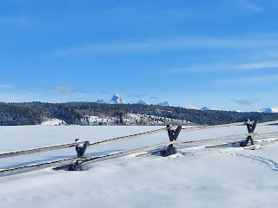

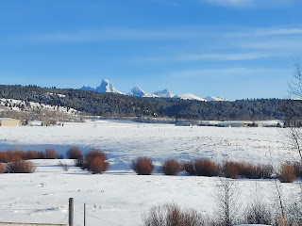

It seemed like we were much faster getting back to the car than when we headed toward the bridge. Isn't that always the case though? You typically take time for photos on your way to the goal, but you don't need to take as many photos on the way back. And that whole thing about "smelling the barn . . ."

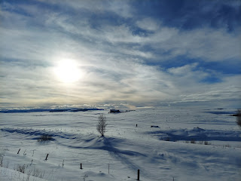

After about 2 hours out on the trail, we made it back to our car. We were the last, lone car still parked on the road. Even the Search & Rescue guys left. They either had a great deal of confidence in our abilities, or they just plain didn't care if we made it back or not. LOL

Grand Tetons behind me (below)

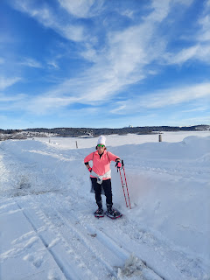

The sunset was spectacular on the way home to Idaho Falls. It was a peaceful drive.

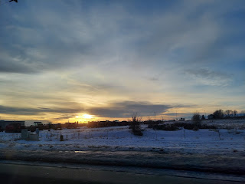

As for the rest of the week . . .

Scott thoroughly enjoyed making his rounds inside and outside to see what might need fixing.

He loaded up 8 bags (40 lbs each) of salt pellets at Sam's Club to last me through the rest of the year for our water softener. He hefted them into two carts, then into the trunk of the car, then all of them needed to be carried downstairs and placed into the utility room. What a strong and capable guy! I hate those heavy bags, so I was very grateful that he took care of this for me.

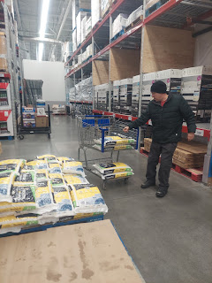

He took down the bird's nest that I never got to before I left in the fall . . . it completely engulfed our back porch light fixture . . . but now it's all cleaned up!

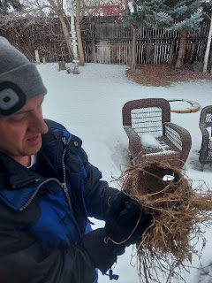

On one of the several times we drove up to Rigby to visit his parents, we just happened to arrive as the garbage truck was emptying all the dumpsters on their street. He thoughtfully hauled the dumpster up the sloped driveway so his 90 year old father wouldn't feel the need to ice skate out to retrieve it and then ice skate uphill to set it up against the garage door.

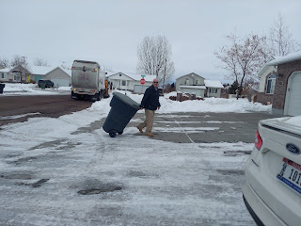

He even took apart the portable A/C unit that wasn't working very well in our bedroom last summer. He cleaned it up and tinkered with it until it seems to be ready for the upcoming heat that's sure to hit in July and August. I am so grateful for his tinkering skills . . .

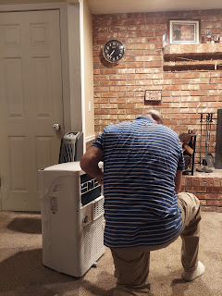

Tuesday evening
, we were able to be part of a wonderful and interesting presentation by a friend of Phil and Coy (Scott's parents). His name is Brent Peterson and he has the brain of an engineer along with a zeal for recreating scriptural artifacts from the Bible and the Book of Mormon.

The audience was small (about 7 of us), which made the presentation intimate and more meaningful, especially when you're sitting in the front row . . .

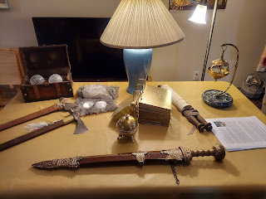

DIY leather scroll with scriptures written on it. Leather would have lasted much longer than paper or papyrus.

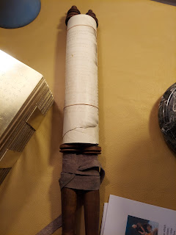

DIY Liahona (a compass that would point the way to go if participants were obedient to God's commandments). Brent pieced this together using several different pieces and parts, melding them together along the way.

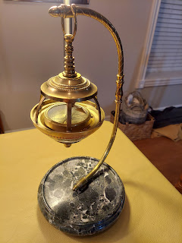

DIY Brass Plates (Book of Mormon): Another Testament of Jesus Christ from the inhabitants that lived on the North American continent from roughly 600 BC to 400 AD (the Nephite and Lamanite peoples), and also a history of the Jaredites that came to North America at the time of the Tower of Babel in Old Testament times.

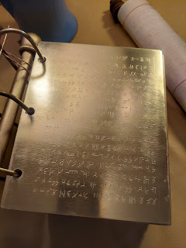

Another version of the Liahona that he built. This one opens up!

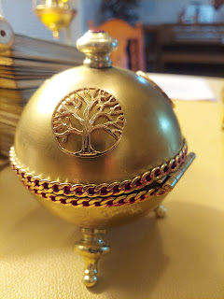

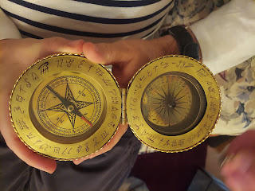

Video of the spindles moving and reacting as it's being held: (8 seconds)
https://photos.app.goo.gl/cmBwSP3fyUwVykpA6

Brent took a hunk of celenite and broke a few pieces off. He then sanded and shaped them into 16 clear stones to represent the stones that the brother of Jared used to light the barges to sail from the Middle East to North America shortly after the Tower of Babel time frame.

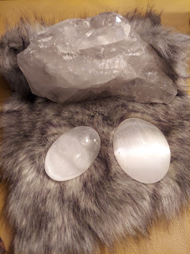

Glass balls that light up - he said these could also represent the stones that the brother of Jared used to give light to their barges as they sailed across the ocean. The brother of Jared asked the Lord to touch them with his finger to provide the light that they needed. He had a LOT of faith to ask for Jesus to do this!

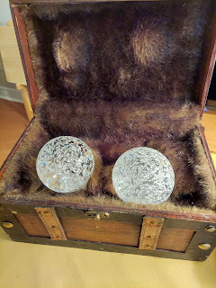

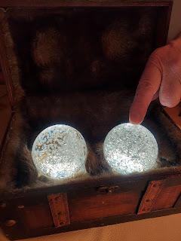

DIY weapons that the Nephites and Lamanites would have used on the American Continent between 600 BC - 400 AD. The Nephites and Lamanites are the ancestors of the Native Americans.

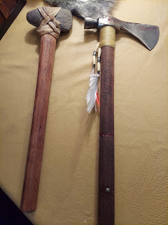

DIY sword of Laban (Book of Mormon). It's actually really heavy, as a king's sword should be. *Brent did not make this himself, he told us he bought it at a convention. But he did inscribe the words on the sword himself: "This sword will never be sheathed again until the kingdoms of this world will become The Kingdom of our God and His Christ."

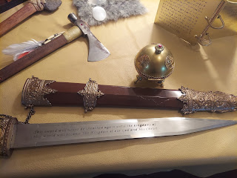

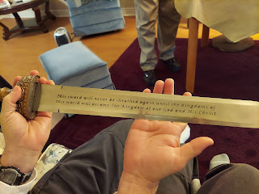

Brent showing the sword to Phil

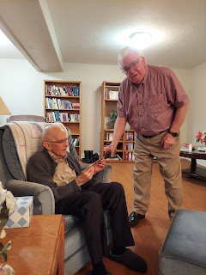

DIY Brass Serpent during Moses' time (Old Testament) as he led the Children of Israel through the wilderness for 40 years. All they had to do was look upon the serpent on the cross and live. We had an interesting discussion about why Jesus Christ would be represented by a serpent, since we usually associate a serpent with the Devil.

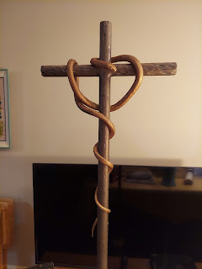

Brent Peterson is a very talented man who loves to build things and figure out lots of new ways to build them. He is smart and he is a deep thinker. I like deep thinkers. All in all, I think the presentation was very thoughtful and intriguing. He has obviously read a lot more than I have, so he has a lot more information in his noggin to share. I have some catching up to do!

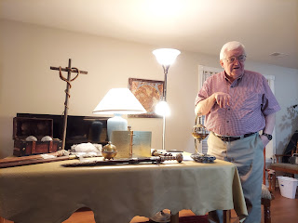

After some cookies and wassail, the small crowd dispersed, including a few who lived right across the street. The street was basically just a giant ice skating rink, so the older folks linked up together to cross the treacherous divide, with Scott looking on to make sure they got safely home.

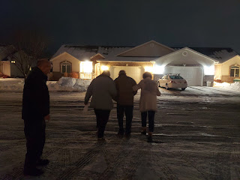

On Thursday
, Scott and I attended the temple in Idaho Falls. It was so nice to be in the temple together, especially since the Rome Temple is 5 hours away in Italy . . . here it's only about 10 minutes away. I didn't get a picture of us in front of the temple this time - - I completely forgot. That would have been nice to have.

After the temple session, we drove up to Rigby to have lunch with Scott's parents again. Coy made a lovely soup called "White Bean Chicken Chili w/ Cream Cheese Soup". It was DELICIOUS!!

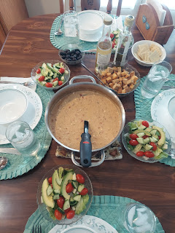

Here is her recipe:

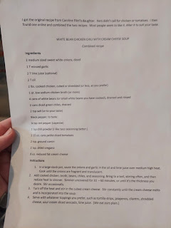

We have thoroughly enjoyed spending so much time with them this week. And some good homecooked food never hurt anyone either . . . especially after all the junk food we ate last week while traveling!

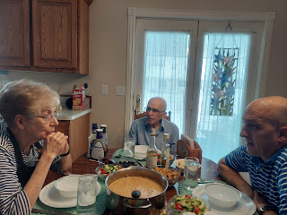

The food was so good, it even put Dad into a small coma after lunch . . . bless his heart.

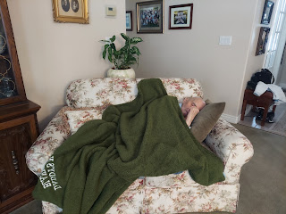

Later in the afternoon when we were back at our own house, we got an emergency notification on our phones that we were under a Boil Advisory in Idaho Falls until further notice.

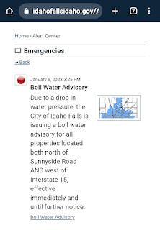
Apparently, there was a mechanical issue that caused a drop in water pressure at two of the 20 city wells. The concern was that if the pressure was low (less than 20 psi), it could allow contaminants to creep in (backflow).

Scott immediately ran out and got us another couple cases of water, even though we already had 1.5 cases in the garage. It was nice to have more, though, . . . JUST IN CASE.

Thankfully, the boil order was lifted the following afternoon, with the lab results coming back negative (no contaminants in the water). It was all just as a precaution, which I appreciate.

Friday
was spent preparing to have a Turkey Feast with our friends, Rich and Andrea Garner. We baked a turkey so that Scott could have some turkey sandwiches afterwards. He really enjoys those . . .

We cut up some lemons, onions, garlic, and fresh rosemary to add to the turkey. It turned out beautifully!

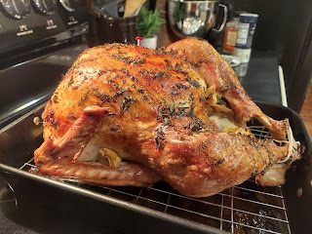

The Garners brought green salad, rolls, and Rich's special yams that had pineapple tidbits, mini marshmallows, and spices added in. I made homemade stuffing, roasted Brussels sprouts, and the turkey.

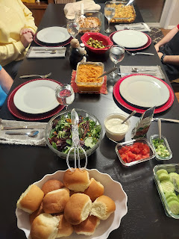

It was nice of my neighbor, Kim Parkinson, to purchase a turkey for us ahead of our arrival and then put it in my freezer. It would have been much harder for me to find a turkey after the holidays were all done.

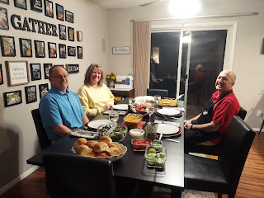

We had a great visit with our friends, and got all caught up since we had last seen them in Italy. :)

My friend Jasmine sent us a couple of beautiful homemade gifts for Christmas. She is doing a lot of wood burning lately and is trying out some new techniques. She is hoping to begin making a profit in the near future as she slowly builds up her inventory. I am so glad she found a new hobby to enjoy!

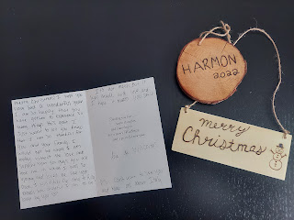

Jasmine has been such a special friend to me all these years. I first met her when she was 6 years old. She is now 21 years old and thriving in her marriage while being a step-mom to their cute 3 year old little boy. She has been through so much in her life and I'm just so happy that she is doing so well now.

There was some excitement in Northern CA this past week as a bomb cyclone passed through, dumping several inches of rain and doing quite a bit of damage in the process! My parents were careful to make sure they had some emergency preparedness items on hand (alternate source of light for potential power outages, generator and fuel, water, medicines, food, etc.). Thankfully there wasn't any significant damage that happened to their homes or properties, other than LOTS of water everywhere from the rain.

My brother, Ryan, a Police Sergeant in Rohnert Park, worked a long shift during all the chaos of the massive storm. He mentioned downed trees, severe flooding, 101 mph wind gusts, and even the tragic death of a 2 year old who died when a tree fell on their home.

Here are some of the texts in our family conversation regarding the storm:

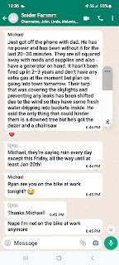

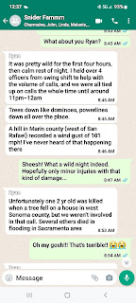

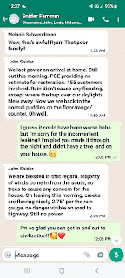

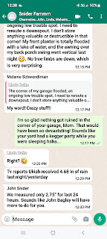

My mom rigged an improved downspout that fared exceptionally well during the next round of rain. Way to go Mom! She said it only cost her $2.21 and a little bit of labor. No more flooding in her garage now. :)

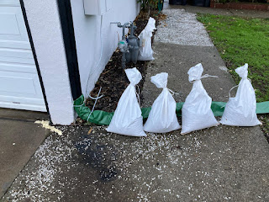

Sunday, during church I shared my testimony of how Jesus Christ is my anchor no matter where I am. I've been trying to feel like I have roots somewhere lately, when everything is so temporary. I'm only here for 3 months, then I'm overseas for 3 months, then back for 3 months, etc. Nothing feels permanent. It's hard to serve in the church when I'm not in one place for very long, but I'm still willing to dig in and help wherever help is needed. In Italy, I've helped with the little ones in the nursery, taught in a primary class for several weeks, and helped teach the young women how to do family history, etc. And when I'm in Idaho Falls, I serve on the family history committee, which I absolutely love.

But I was still feeling a little bit lost during the Christmas season. I was sick for about a month and didn't get to celebrate the season in the ways that I had hoped for. It was starting to feel like I was disconnected from Him whose birth we celebrate in December. As I came out of being sick, my first desire was to grow closer to my Savior. I wanted to get out and see as many Nativities as I could, and I tried to listen to uplifting Christmas music to help my heart connect to Christ. I prayed every day that I could feel close to Him. And it began to work!

I slowly started to recognize that even though I am "transient" and my circumstances feel temporary, Jesus Christ is still the Anchor of my soul. He is constant, even when nothing else seems constant. He is always there and loves me wherever I happen to be. His Gospel is permanent and eternal, even if my life feels otherwise. I am grateful for something to hold onto and I am letting that concept sink deeply into my heart right now. Especially as Scott just left early this morning . . .

After church we drove up to Rigby again to visit Phil and Coy. I convinced my mother-in-law to let me make the main dish this time, since she had made us several meals during the past week. I chose to try a new soup recipe:
https://www.modernhoney.com/lemon-chicken-orzo-soup/

This Lemon Chicken Orzo Soup is INCREDIBLE!!! It's pretty easy to throw together and the flavors are out of this world. It is my new favorite soup EVER!!

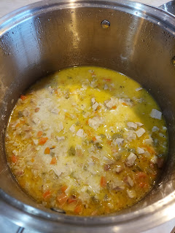

I made a double batch so I could have some leftovers this week. Yay for me!

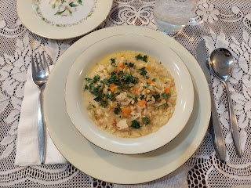

We had some lovely dinner conversation that continued into the living room afterwards. Coy brought out some of her cookies that she ALWAYS has on hand . . . I sent this picture to my kids because I knew they'd be drooling clear across the country, ha ha. Amber wrote back: "Mom, that's my inheritance."

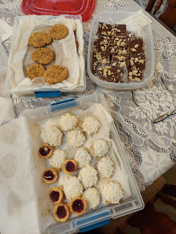

Coy makes batches of cookies and bars and then freezes them until an occasion requires pulling them out to share with company. I need to do that more often . . .

We all took turns reading something to the group, but it was all very informal. More like, Hey, I wanted to share something that I read recently . . . Below, Dad is reading something to us while Mom warms herself by the fire. How cozy. :)

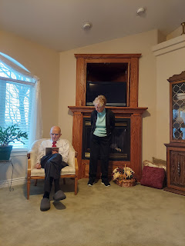

Eventually it was time to say our goodbyes, give hugs, and take photos.
Below: Scott is in the middle with his parents, Phil and Coy

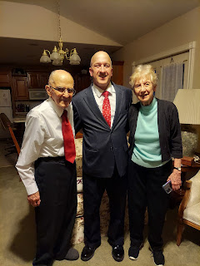

After Coy took this photo, I commented that it looks like we're Siamese twins or something. Joined at the hip? ha ha

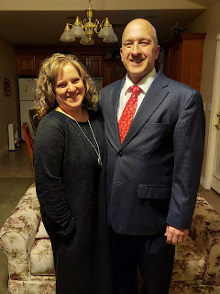

Our last selfie for a while. XOXO

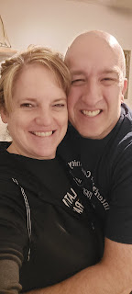

Scott got all packed up and organized Sunday night. We set our alarms and went to bed . . .

Of course we both woke up before our alarms went off though. He woke up at 4:00 instead of 4:30 and I woke up at 4:52 instead of 5:00. Weird how our brains are on high alert when there's something big coming up!

I drove him to the airport this morning (Monday) at 5:15 a.m. and hugged him several times before letting him go.

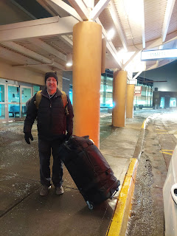

It's always a weird time when he leaves. I'm a mixture of "I don't want you to go . . ." versus "Could you just hurry up and go so that we can start the clock counting down to be together again??" I want him to go, but I don't want him to go . . .

Thankfully, this next 90 day cycle will be a little shorter than usual. He was with me at the beginning of the cycle for 2 whole weeks, and then I'll be back over in Italy with him by St. Patrick's Day. I think the time will go pretty fast between now and then . . .

The only photos of grandchildren that I have this week are from Jack Jack.

He's getting pretty good at taking selfies. XOXO

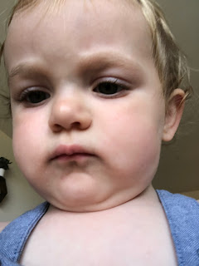

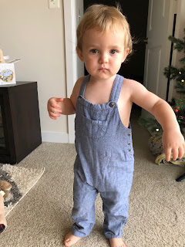

Hannah was thoughtful to share this precious picture of the two boys working in the kitchen together.

