Southern Gals
Having granddaughters around gives me an opportunity to get out and have a little fun with some energetic buddies. They are always ready for an adventure! This past week, we had several fun adventures together. :)
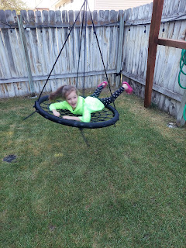

After 3 days in the car, Amber, Abby, and Gwen arrived last Sunday around dinner time. This picture just captures it all . . . I heard screams of "Mimi!" "Mimi!" before I actually saw their cute faces, and soon after, little bodies were running toward me at full speed.

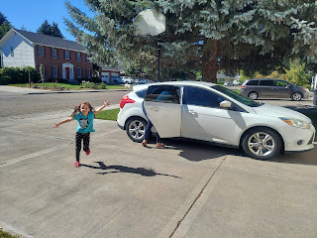

Home away from home.

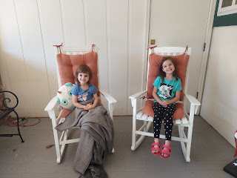

After dinner-ish (the girls were too excited to eat very much), Abby and Gwen discovered a tote full of dress up clothes in their bedroom closet downstairs. They immediately became Queen Marigold (Abby) and Princess Rainbow (Gwen), while Amber and I somehow managed to turn into their ladies in waiting. Our jobs included carrying dress trains, adjusting any wardrobe malfunctions, and bringing snacks to the Royals before bed.

Video of Lady in Waiting #2 bringing food down to their majesty's quarters: (8 seconds)
https://photos.app.goo.gl/f1Czq6D4SpKLLV3h9

T'was a fancy bedtime feast of PBJ and goldfish - - picnic style.

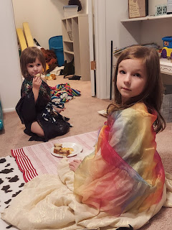

I asked Gwen to smile. This is what I got. LOL

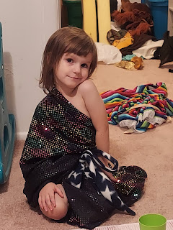

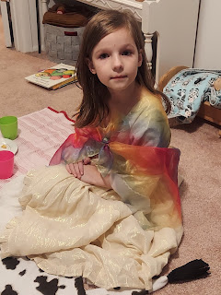

They slept in the same bed for an entire week! Miracle of all miracles. What you don't see - but what kept the peace - was the body pillow down the length of the middle of the bed.

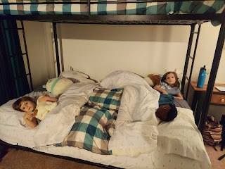

Monday:
We eased into a nice lazy Monday and didn't try to do a whole lot. They all appreciated some time to just hang out, especially in the back yard during the cooler morning hours. We get a lot of shade in the mornings here, which is quite different from the girls having to hide from the outdoor heat down in Louisiana during summer months.

Amber and Abby took advantage of the beautiful morning lighting to do a photo shoot in the back yard.

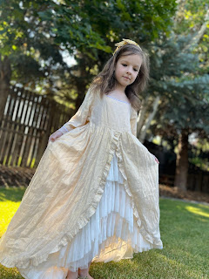

Gwen announced that she needed to practice flying, since she would be having a flying contest at sunset that evening. "Gotta get to work!" she said.

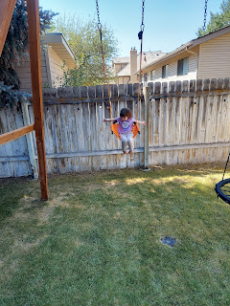

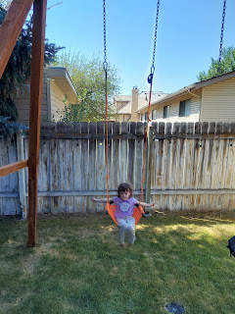

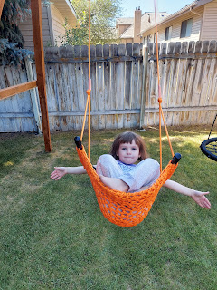

Abby and I picked some raspberries out of my garden together.

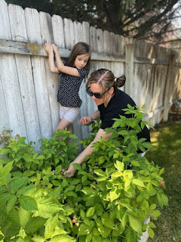

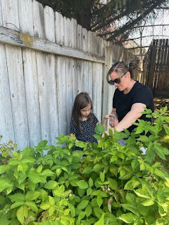

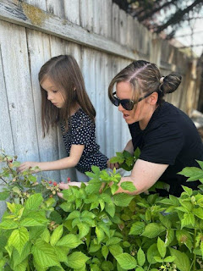

We even shared some with Gwen, to fuel up her tank as she practiced her flying techniques. She snarfed them as fast as we could pick more. Each time she swung forward, my hand was poised and ready for her to snatch a berry or two at a time . . .

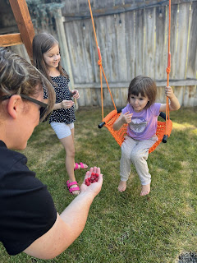

I had a massage later in the afternoon, while Amber took the girls over to visit a friend of hers and to let the girls play with the friend's children.

Tuesday:
We had more "flying lessons" to practice and perfect in the morning. Gwen was taking this all very seriously!

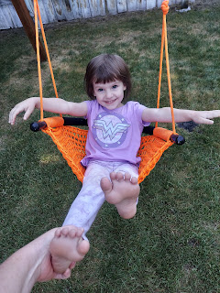

Slow-mo video of Gwen: (1 min, 13 seconds)
https://photos.app.goo.gl/KS5Cz94UfLA11QUf9

*This is the slowest you might ever see Gwen in motion.

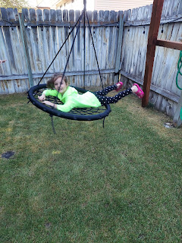

I did a slow-mo video of Abby, too, but for some reason it ended up being a LOT longer. Please do not feel obligated to watch the entire thing. (2 minutes)
https://photos.app.goo.gl/HREPJmUphcAdU6RL9

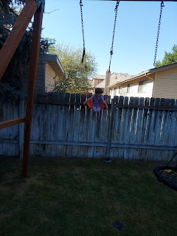

We also got to talk to Avery in Italy! It was the most darling phone call ever. Gwen had been saying that she wanted to teach Avery the ABC's. Avery was completely dialed in and listened the entire time!

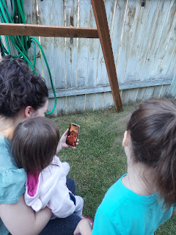

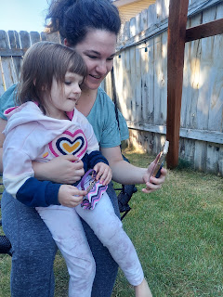

Short clip of how happy Avery was to see her little cousins: (12 seconds)
https://photos.app.goo.gl/ZNYgbjrLndBnjSKN6

Video of Gwen's ABC's - teaching Avery that "B" is for baby and "C" is for caterpillar. (15 seconds)
https://photos.app.goo.gl/vrq6cL8mdByN3RJJ9

Video of Gwen's ABC's - she's explaining how to pronounce "R" and that it's for rainbow, followed by some snake sounds for the letter "S". (17 seconds)
https://photos.app.goo.gl/UKMmwzpJAEJfDkQ26

We did a little shopping at some point in the day, since Amber wanted to find a new dress or a skirt. There are some really cute women's clothing in Seagull Book, believe it or not, so that's where we ended up. While Amber browsed the dresses, I took the girls on an explore in the back of the store so we could pick out a couple of coloring books or a toy. We had a lot of fun! We even sat down on the floor in one aisle so we could read a children's book about how to connect with our ancestors (through questions and comparing our life now to theirs back then).

We also enjoyed a slow walk through a gallery of paintings of Jesus, talking about what each one was all about.

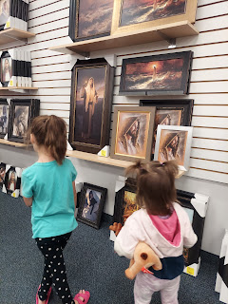

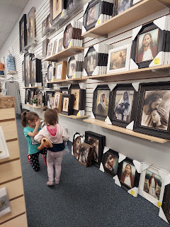

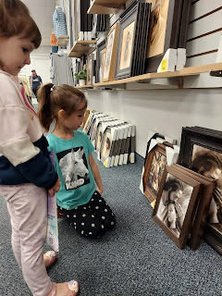

Later that afternoon, Jacob called to share Jack with all of us. He had a giant crayon that he was learning to color on the paper with (as opposed to shoving it in his mouth to eat).

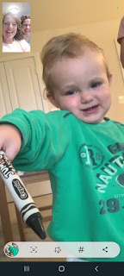

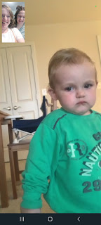

That night, Amber had one of her best friends over, Julie Mills, to chat and eat snacks together. Amber made a beautiful charcuterie board array, with cuts of meats, cheese, fruit, crackers, homemade tomato jam, and fruit gushers.

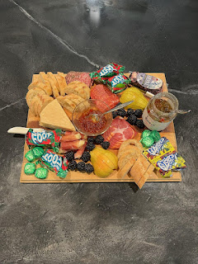

After they visited for about an hour, they went off to a movie with Julie's sisters and family, while I stayed home to be with the girls and get them all tucked into bed.

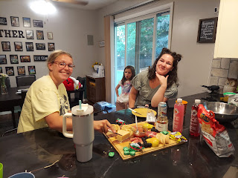

Wednesday:
We drove up to Rigby to visit with Grandma and Grandpa Harmon for the morning. We had such a lovely visit!!

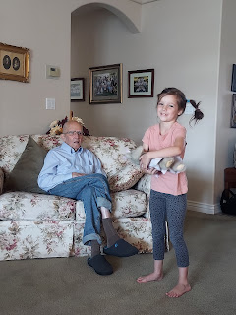

Grandma Harmon provided some late morning snacks for the girls to enjoy at the table.

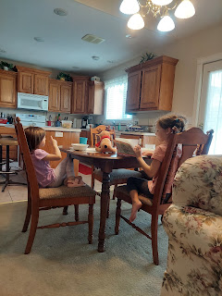

Amber spent some time sharing the latest developments in our family history book project with Grandma. Grandma had some family history stories of her own to share, too!

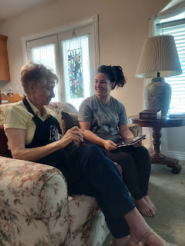

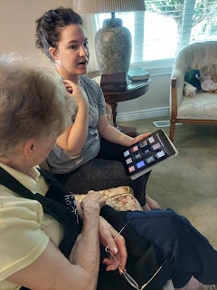

Meanwhile, the girls had fun arranging ALL of Grandma and Grandpa's stuffed animals that have been lovingly preserved for just such an occasion.

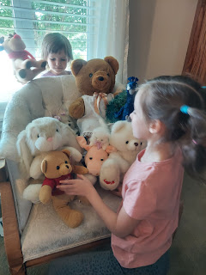

Gwen wanted to use my camera to take some pictures . . .

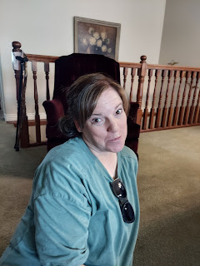

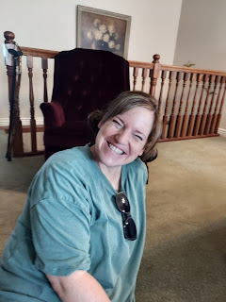



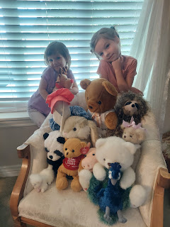

Amber had some silly videos to share . . .

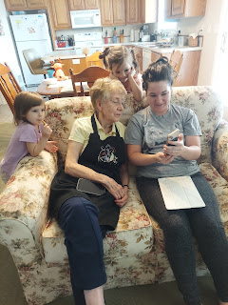

And Abby was such a gracious and friendly great-granddaughter. She took time to talk with each of her great-grandparents, and had some really impressive grown-up conversations. It was really special to see her bonding with Phil and Coy.

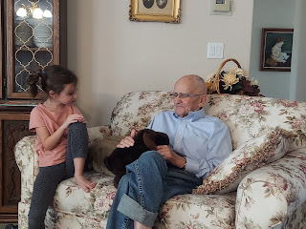

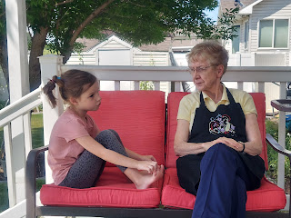

Abby was in love with all of Coy's beautiful flowers, so Grandma took her on a walk around the yard, getting her a variety of flower cuttings to take home.

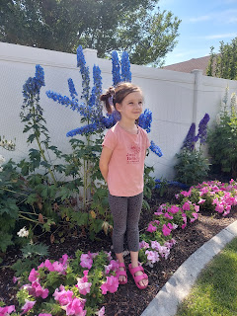

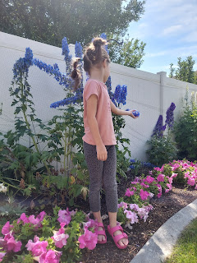

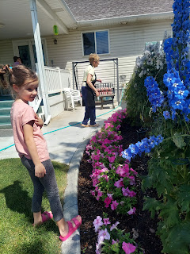

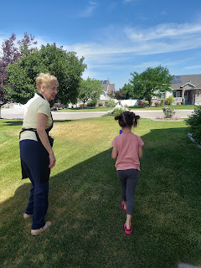

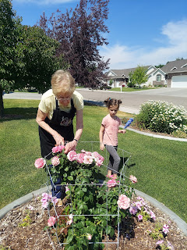

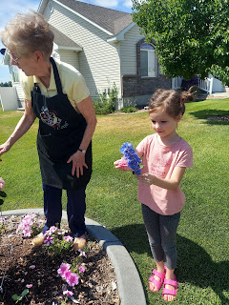

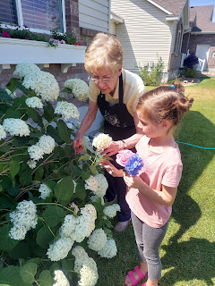

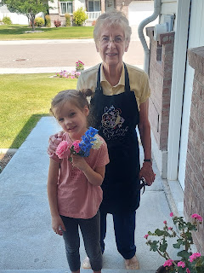

The last one needed to go in her hair, she decided. :)

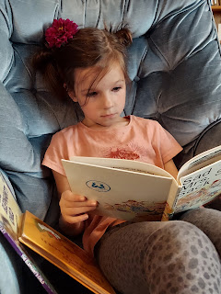

Then it was off to see my niece, Natalie, at the Rigby Wendy's, where she serves as the manager. It was a busy lunch hour, but Natalie was able to take her own lunch break and come sit with us for a bit while we all ate together. We enjoyed visiting with her and learning about all the things she's been up to in recent months. She seems to be very happy and doing really well!

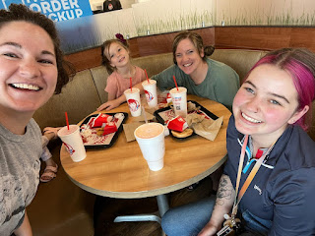

Next we went down the street to Rigby Lake for the afternoon. I was excited to take my Origami Paddler out in the water for the first time! Origami Paddler is the name of my paddleboard/kayak combo that folds up into thirds so it will fit nicely in my trunk. I had wanted a paddleboard for a long time, and thankfully Weston spotted this one on Kickstarter.com and shared it with me back in late 2019. Kickstarter is a platform for aspiring innovators to bring their ideas to life. Wherever they are in the process of creating something, they can put their idea on Kickstarter for people (like me) to contribute financially to the process, which helps their dream to come alive. In the case of the Origami Paddler, the designer, Tim Neimeier, had already been creating kayaks and paddleboards for decades. This time, though, he had one motto: To put more butts in boats. He wanted to create a way for people to transport their paddleboard/kayak and to get out on the water, even if they didn't have a truck or a roof rack or a huge trunk. The price tag was only $350 so I was definitely IN!!

Unfortunately, this was right before Covid hit during 2020, so it took a lot longer than the company ever anticipated to get all the Paddlers made and off the production line and into people's homes. By the time mine arrived last fall, it was too late in the season for me to get any enjoyment out of it. And then I went to Italy this spring, so this was finally the right time for its maiden voyage.

It was SO. MUCH. FUN!!! My favorite thing about that afternoon was having Gwen at one end of my board and Abby at the other end. We'd paddle out to the buoys and then Abby wanted to jump off and swim over to one.

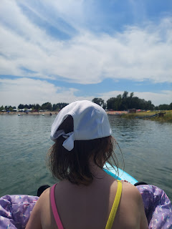

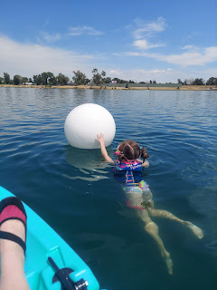

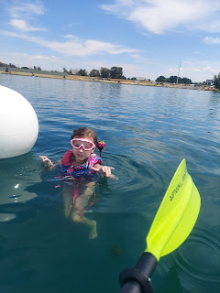

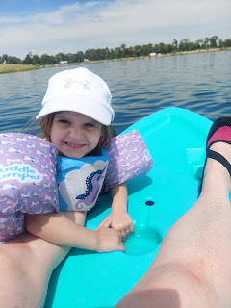

Amber and I took turns using it for most of the afternoon.

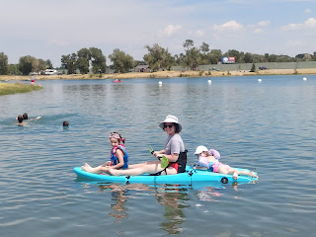

Above and below: Amber with the girls out in the quietest section of the lake. There is an island in the center of the circular (and man-made) lake, so I walked out on the island to take a few pictures and videos of them.

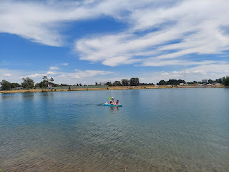

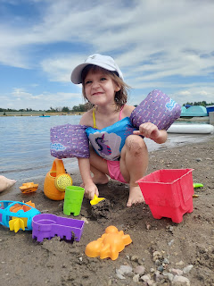

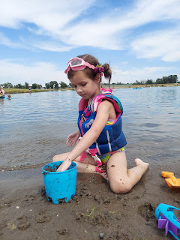

Rigby Lake is somewhat small, but it's big enough to have some quiet space to just be still and enjoy the moment.

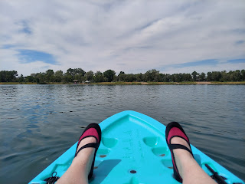

Gwen kept wanting to be the motor for the back end. (13 seconds)
https://photos.app.goo.gl/C2JFYDZCSBYggGDz5

The girls also took turns learning how to use the paddles. In this video, Gwen was paddling up front and Abby was the "motor" on the back end. (12 seconds)
https://photos.app.goo.gl/zLXQkhkJygruMkob8

Me with Gwen and Abby

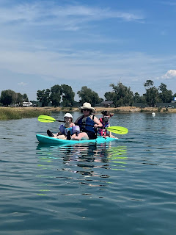

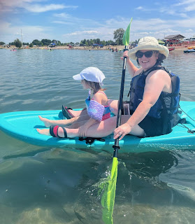

We stayed for about 4 hours before finally heading home. Before leaving, though, we bought 2 giant snow cones to share amongst the four of us.

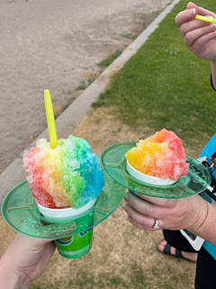

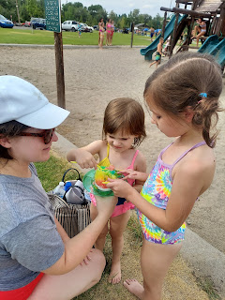

I didn't know Amber took this photo behind me until later that evening. What a sweet moment to capture!

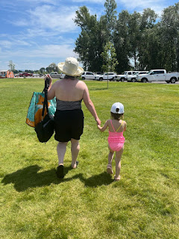

The Origami Paddler weighs roughly 40 lbs. It comes with a carrying strap, but it still took a toll on my shoulder as I grappled with getting it to and from the trunk over to the beach and back. The company also sells a wheely cart - but I didn't buy it initially because I thought I could handle carrying it by myself . . . I am rethinking that now.

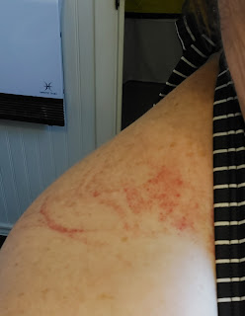

This was Scott's sunrise in Italy as I was ending my day in Idaho.



Thursday:
We went to the local Tautphaus Park Zoo (pronounced Toffus) with one of Amber's friends from high school, Sarah Barnish Carpenter, along with Sarah's 3 young children (including one year old twins!). Sarah's sister came along to help her with the little ones.

The girls got to try on a turtle shell and learn about the life of a tortoise.

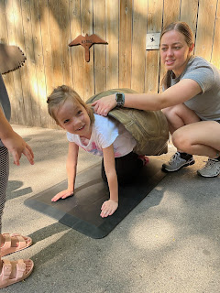

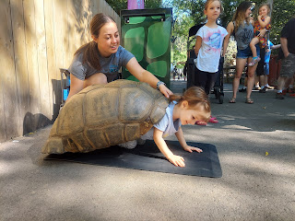

My favorite spot in the zoo (and Scott's) is the otter exhibit. The otters are always so fun and playful!

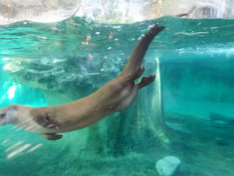

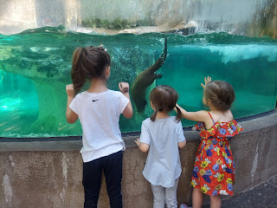

Video #1 of the otters: (29 seconds)
https://photos.app.goo.gl/w7fWdfWYZvGatA1D6

Video #2 of the otters: (11 seconds)
https://photos.app.goo.gl/UomKsttrXMWGm2fr5

Gwen communicating with her monkey friend.

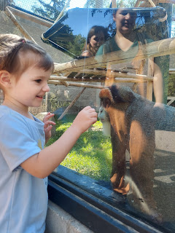

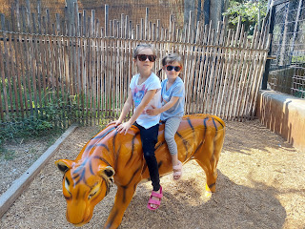

If you're brave (and thirsty enough) you can put your head in the lion's mouth to get a drink.

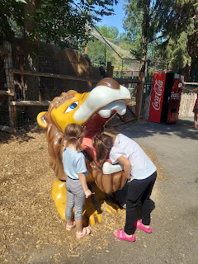

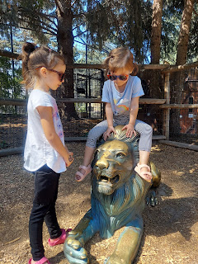

They had several volunteers in the zoo on the day that we went - I've never seen anything like this before. The volunteers had stations set up all over the zoo to help the children interact more with what they were seeing. Abby and Gwen could touch animal skulls, animal claws or feathers, and even pet a lion's pelt.

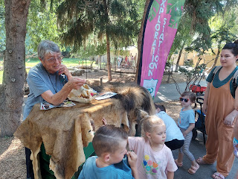

The volunteer at this station was telling the story of 3 generations of lions that have lived (and continue to live) in the exhibit behind us. The grandfather died of old age and this is his pelt. She had photos of the Grandpa's son, whose mother got sick and couldn't care for him. The baby lion ended up being bottle-fed and was partnered up with a large white dog at the zoo for comfort and education on animal etiquette and behaviors. What a wonderful thing to share with the public!

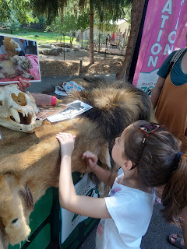

We called Scott a couple of times while we wandered around the zoo so that he could "join" in with us.

We wisely packed a lunch to eat once we finished up at the zoo, and found a nearby table to sit on in the shade.

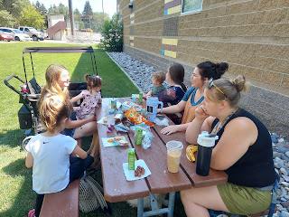

Below - from the left: Sarah's sister Amy (holding one of the twins Ben), then Amber and her friend Lyndsey Rasmussen. On the other side: Abby, and Sarah, holding her other twin, Josie. Sarah also has a 3 year old named Bella, but she was too busy running around and playing with Gwen and Abby. :)

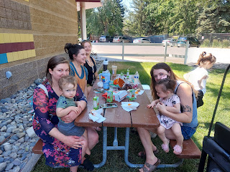

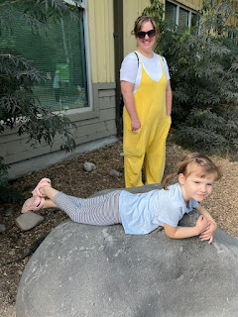

It was nice to come home and unwind by watching a movie. Ha ha, the girls always complain about how cold it is in my house when they come to visit me in the summer time. I don't have any actual A/C, so the only thing I can do is to open up my windows at night and place box-fans in each one to draw in the cooler night air. Then I close everything up by 8:30 a.m.

Gwen liked to rummage through my winter gear to find a hat, scarf, and mittens in order to keep herself warm, LOL.

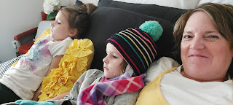

Friday:
We slowed down the pace again and chose to have a nice relaxing morning. I helped Abby practice making mac & cheese by herself. I showed her how to fill up the pot halfway and put it on the stove to boil. I taught her to read the instructions all the way through once before ever starting on Step 1. She was a little intimidated in handling the hot water at the end, and rightfully so. I drained the noodles but showed her how to use oven mitts and how to dump it all out into a colander. She put in the butter, milk and cheese sauce and did all of the stirring herself.

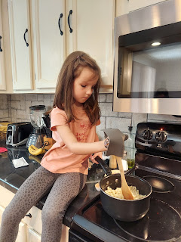

My favorite and most proud moment came when I had her carry the finished pot of macaroni & cheese over to the counter by herself and set it down on a hot pad. It was heavy and still hot, but she did it! And the look on her face when she realized that she did it was just priceless. She radiated sheer joy!!

I set up the latest swimming pool purchase for the girls to splash around in for the afternoon. Instead of buying the usual blow-up style of pool, this time I ordered a portable doggy pool from Amazon. It folds up small for storage - accordion style, and it's strong and durable too! It also has a drain plug on one side, which is helpful.

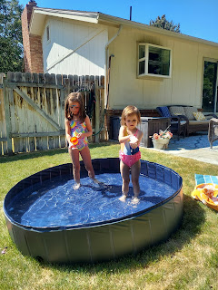

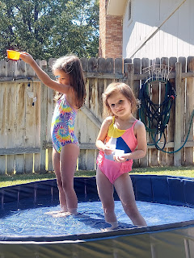

At the end of the afternoon we went to the roller skating rink for an hour. While I would have liked to skate much longer, I don't think their air conditioning was working AT ALL. It was pretty stuffy and warm in the rink. Blech. We stayed for an hour and that was
plenty
!

Gwen did awesome using her "helper" as she learned how to keep her feet going straight and not get tangled up.

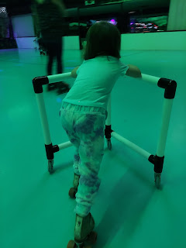

Video of Gwen taking one of her first laps around the rink, when Abby comes zipping by on the side. LOL
(13 seconds)
https://photos.app.goo.gl/4gdgAyXJaJtgatUF6

Video of Abby cruising around the rink like a pro: (19 seconds)
https://photos.app.goo.gl/c4ivv8f5MYBCYg9u7

Video of Abby getting all fancy, spinning her "helper" around: (21 seconds)
https://photos.app.goo.gl/y1ZsHruaVHkXvFr16

Video of Gwen near the end of the hour, doing great with a "walking" technique: (9 seconds)
https://photos.app.goo.gl/9nrKsUGo2b8Qpz8d7

Amber and Abby taking a lap. We swapped often - who was with Gwen and who was trailing along behind Abby.

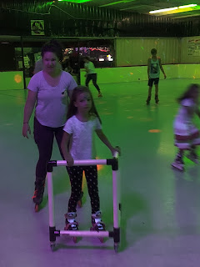

We had a very sweaty and very fun time!

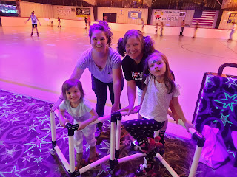

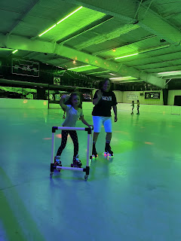

When we went to Arctic Circle for a quick dinner afterward, these guys were in line in front of us. Only actually it turned out that the young man dressed up as a cowboy (on the left) had some disabilities. It was obvious right away that he had the capacity of maybe a 4 year old, but the man with him was so patient and kind, saying, "Okay Cowboy, let's go find us a table." It was only briefly unnerving that he had several "guns" attached to his gunbelt . . .

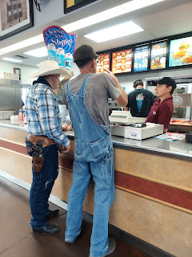

Amber headed up to the Whitworth's in Rigby for a family birthday party (Weston's oldest brother Tyler) and I headed back to the house to cool off in my faux A/C house and wait for their return. :)

Meanwhile, Scott went on another hike up in the mountains of Italy. He got up super early again to get up to the top before it got too hot. After about 50 hairpin turns, he made it up to the parking lot and trailhead for the 52 Tunnels hike.

Wikipedia has a good explanation for what it's all about. The tunnels were built during WWI.

https://en.wikipedia.org/wiki/Strada_delle_52_Gallerie



Scott shared a few photos with me. He said the view above was within about 50 feet of where he parked the car to begin the trail.

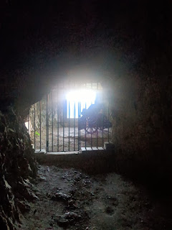

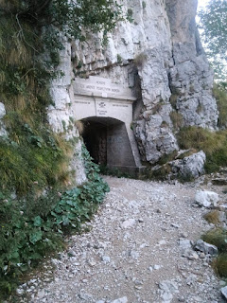



He went through about 12 tunnels before turning around to head back. Some of them were quite long. But he hadn't brought a good headlamp or flashlight with him and was relying solely on the flashlight from his cellphone . . . We'll go up there together again this fall, he promised.

Saturday:
Jacob turned 26 years old!! He celebrated by going out to lunch with his family and some friends to get Ethiopian food. He collaborated with Amber and Weston ahead of time to know what to order.

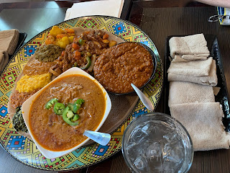

Not sure which is which, but here's what they ordered: Bozeno shiro, Misir wot, Awaze tibs, with a veggie combo. It looks amazing!! He said that the Bozeno shiro + injera was incredible. Injera is like a giant brown crepe, very light and spongy. It's good for mopping things up or filling up with stuff.

Screenshots of the birthday boy during a video call - -

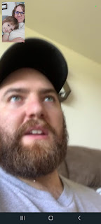

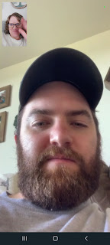

We also got to see Jack during the same video call. :) His hair looks SO blonde!!

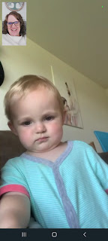

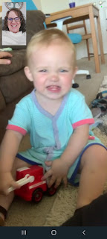

Gwen, in her usual creative fashion, "needed" a sledding hill because this was the day of her sledding competition. She donned her favorite winterwear, and set out to practice.

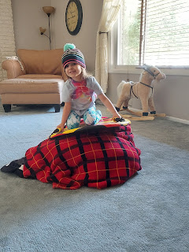

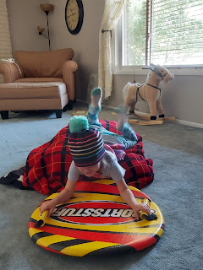

Weston finally made it up to Idaho, after a missed flight and an overnight stay in the Dallas Airport. His flight from Shreveport to Dallas was delayed due to weather issues, and by the time he arrived in Dallas, his next flight was already out on the runway . . . leaving without him.

He made it to Idaho Falls by 1:00 p.m. on Saturday, exhausted beyond exhausted. He took an afternoon nap, which bled over into the dinner hour. We worked hard to get him vertical enough to participate in our campfire dinner, and soon he was somewhat alert and able to build the fire. We roasted hot dogs (I skipped the bun) with homemade potato salad on the side.

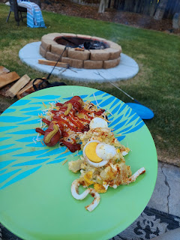

Amber and Weston practiced making a few calzones over the fire, in preparation for their Whitworth family campout starting today (Sunday). They were assigned the first meal (dinner) for Sunday, with the anticipation of 23 family members being in attendance. After the first calzone burned (even with double foil), they began to flip the packet more often and were able to find success in the 2nd and 3rd calzones.

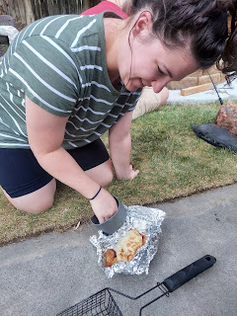

Much resting took place after the bellies were satisfied.

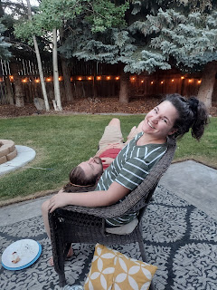

I offered to read to the girls, so they happily brought a big stack of books outside for me to begin reading. It was a nice ambiance with the trees, the campfire, and the outdoor lights along the fence.

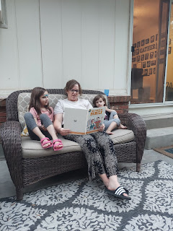

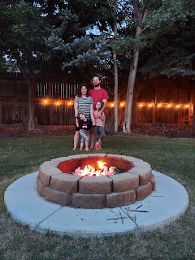

I also made a rhubarb-raspberry pie for the first time. It wasn't all that different from a strawberry-rhubarb pie, and it was quite tasty! I had an abundance of rhubarb to use up, and Weston's mom gave us a ton of raspberries from her abundant garden crop. It seemed like a natural pairing, so I did it.

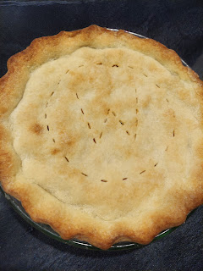

Sunday:
Nobody wanted to get out of bed and get ready for church because we were so tired . . . but we did it anyway. :) The speakers were wonderful and we appreciated being able to take the Sacrament. After the meeting was done, we came home and worked as a team to get Amber and her family packed up and ready to leave.

Gwen ran around the house chasing after Abby with a toy sword . . .

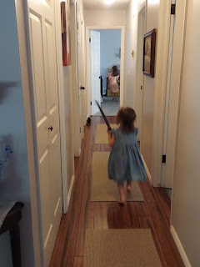

And then it was time for a lunch break.

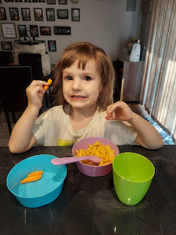

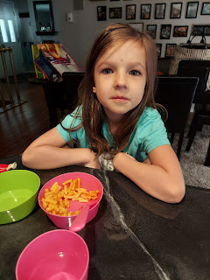

During lunch, we called Scott ("Poppa"). He and Gwen made silly faces at each other.

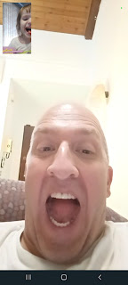

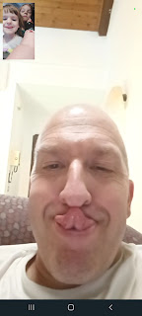

All too soon, the Whitworths were in the car and ready to leave.

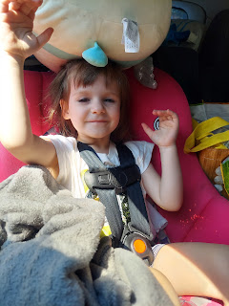

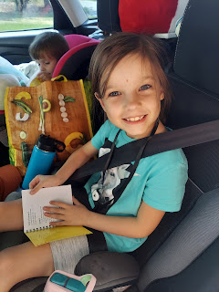

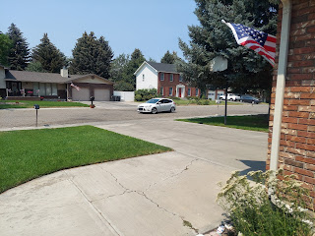

It was a wonderful week, with so many fun moments and memories to share forever. I will miss them!!

Well, I've definitely shared several photos and videos of Abby and Gwen, as well as the video call we had with Avery.

But I have a whole slew of photos of Jack to share.

Jacob called me this evening to visit some more, which I always love. At one point, Jack went over to sit on a book. Jacob told me how Jack seems to have an obsession with just this one book . . . he'll sit on it, he'll bend it crazily, and he's been mangling the book a little bit at a time. (If any of you readers are the person who sent this book to Jack, please accept their deepest apologies.) I remember when Amber was his age (and even younger) . . . she would EAT her books! There were bite marks, chunks missing, etc. It's definitely a phase that they go through, because Amber reveres books now and would never purposely ruin one.

So please don't be too offended by this series of screenshots you're about to see . . .

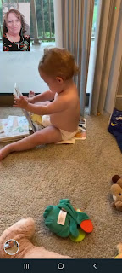

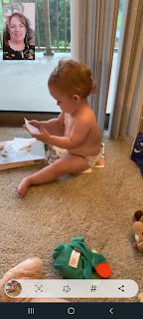

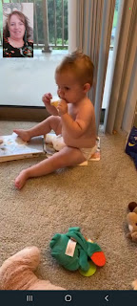

They really are wonderful parents, and they read to him all day long. He loves his books and will eventually come to respect his books . . .

And just like that, after he tasted a piece of the book, he hopped up and came over to give me some cheeser grins again.

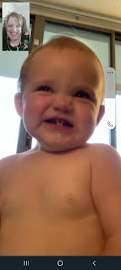

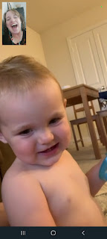

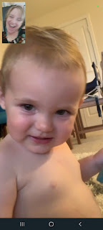

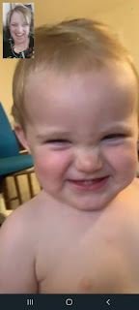

He likes to give a shout and then wait for your reaction.

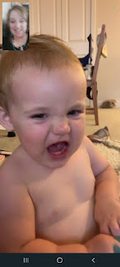

And I think this is becoming our Mimi-Jack connection: he puts the back of his hand to his mouth and while bouncing his wrist on and off his mouth, he'll make a long sound. It ends up being quite silly. It seems this has become our new thing. Our vibe. It's like he's saying, "Hey, Mimi, I remember when we did this back and forth on our last phone call. Let's do it again!" We have our own secret language. :)

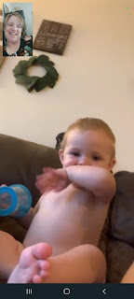

He sure cracks me up!!

Jacob made some pesto pasta for dinner a few days ago. It looks like it was delicious!

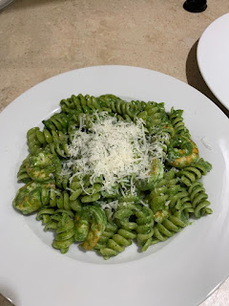

Jack seemed to think so.

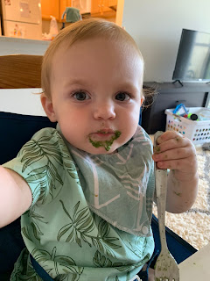

Here he is listening to the lesson in church today. What a good boy.

