There's No Place Like Home
I'm home! And I'm loving it so much. "Life takes you unexpected places. Love brings you home."
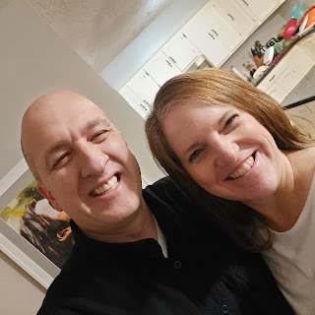

I have much to be grateful for, much to reflect on, much to catch up on, and much to look forward to. I still can't believe I was able to do as much as I did in my month of travels. One thing this past month did for me was to help bring clarity to my life. I feel like I am much more focused now, and dialed in on the things that matter most. Like family, friends, and how I spend my time each day. I am grateful to have a fresh perspective, fresh motivation, and fresh enthusiasm for those things that matter most.
Monday:
After I finished my blog for the previous week, I was able to squeeze in a brisk walk down to the water's edge in Lisbon, Portugal. It was a 40 minute walk each way, and the weather was nice and warm. Thankfully there was shade on the side of the street where I was, otherwise I would have melted onto the sidewalk and wouldn't have ever made it home!
Lisbon has all kinds of cool artwork and interesting things to see. I only saw a fraction of what Lisbon has to offer, but I enjoyed the little bit that I saw in 2 hours while on foot. :)
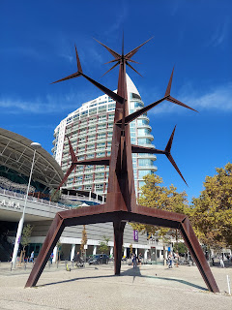

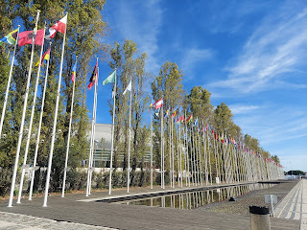

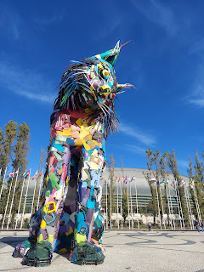

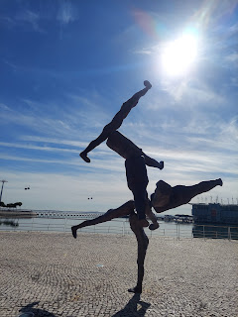

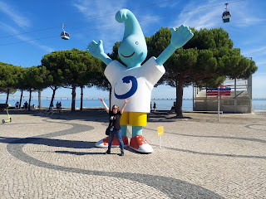

Technically this is the Tagus River that flows into the Atlantic Ocean. It looked so wide when I was there, that I actually thought it WAS the ocean! If you look on a map (for Lisbon), look for the Hotel Star Inn by the Lisbon Airport. That's where I stayed the night. Then follow the Avenue Berlim (yes, that's how you spell it) all the way east to the water, and also to what is called Parque das Nacoes. That's the walk that I took. You can see how wide the water is on the map, and you'll understand why I thought it was the ocean!

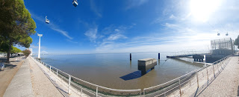

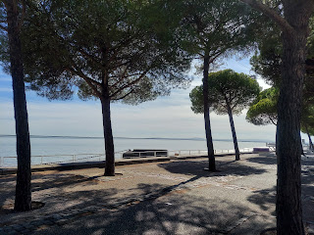

I found a little restaurant near the water where I could grab a quick lunch before scurrying back to my hotel and over to the airport. I chose the fried cuttlefish and a side salad. It was "okay". I've decided that cuttlefish isn't really my thing. It was interesting to try twice, but I don't think I'll need it in my future, ha ha. It's a little too rubbery to chew. I found out later that it's related to squid.

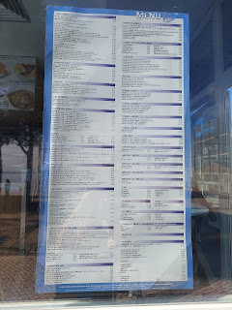

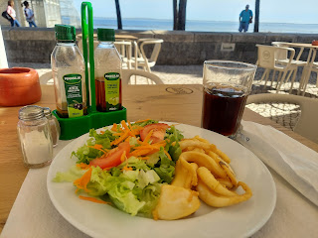

On my way back to the hotel, I passed this giant pile of mosaic bricks. It made me appreciate all the hard work that goes into maintaining the beautiful sidewalks here. It must be so time consuming to place each individual piece . . .

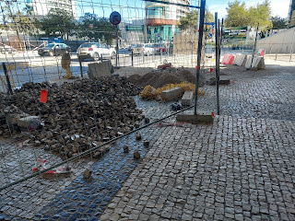

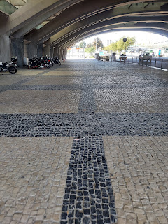

They have a lot of bike paths here, which tells a lot about a city and what its priorities are.

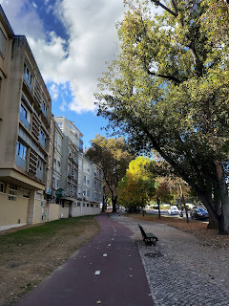

Okay, let's talk about foreign airports for a minute, and how unorganized they are compared to airports in the U.S.

In Europe, you walk into an airport and you have no idea where to check in and drop off your luggage. It's huge, there's a ton of people, and nothing to tell you where to go. So far, I have found that the best thing to do is to arrive as early as you can (like 2.5 or 3 hours ahead of your flight), and then just pick a direction and start walking until you get deep enough into the airport that you find some information screens. You can then look for your flight on the screen, which will then tell you what station number(s) you can go to check in your luggage and get your boarding pass. There are typically about 150 stations to check you in, but you need the correct number that pertains to your airline, and it can only be found on this information screen. You just have to wander for a while until you hit the jackpot to find said screen.

Once you check in and hand off your luggage, then you will go through security. In this case, though, they don't check your photo ID or boarding pass. They only want to screen your carry on items and send you on from there.

As you exit the security area, you will pass through a giant "duty-free" shopping store where you can buy anything from perfume to alcohol to jewelry to chocolate and various snacks. They funnel you over to the registers to pay for anything you may have purchased. THEN you are free to exit and try to find your gate.

Another problem with a lot of airports in Europe is that they often don't let you know where your gate is until one hour before your flight leaves. It wouldn't be such a big deal if they didn't still have several hoops for you to jump through . . .

Like this photo below. As I headed to my gate, I had to pass through another security check. This time it was a line of passengers that was so long it scared me! I was worried it might take forever and that I would miss my flight! This time I had to show my passport, my boarding pass, and my negative Covid-19 test.

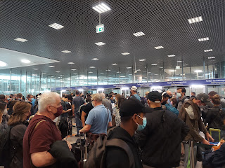

When I sent this worrisome photo to my family, Amber quickly responded with this video of Gwen and the question: "Is the line moving along as fast as Gwen?"

Video of Gwen riding her tricycle down the road: (11 seconds)
https://photos.app.goo.gl/XTLXdPFx68f6ny5g7

I thought I was free and clear at this point, but I was wrong. I hustled to my gate at a very brisk pace, and just when I could finally see it, I was stopped by an airport personnel lady. She indicated that I needed to fill out some (unnecessary) paper form before I could proceed. It was a form where I had to check a box stating that I had either taken a Covid test and it was negative and I had proof of this, or that I had recently recovered from the virus and had a doctor's note attesting to this, or a couple other options. Then I had to sign it, date it, and get into another line. Completely unnecessary if you ask me. We already had to fill out an online form, plus we had to show our negative test when we checked in.

In the next line, a security guy wanted to check my passport (again), my boarding pass (again), and look at my form. Then he let me proceed to the gate.

At the gate, there was yet another line. As I stood there waiting to move forward, I noticed on the information screen that our flight status was showing "Final Boarding". And then I heard an announcement saying that our flight was about to close and this was the LAST CALL!! Finally it was my turn to scan my boarding pass and show my passport one more time. I thought this meant that I would go down the walkway and around the corner to actually board the plane. Nope. Not even close.

We walked down several hallways, then down an escalator, then we boarded a BUS!!! The bus sat there for several more minutes. It felt like an eternity. I assumed that this was the last bus across the tarmac to our plane and therefore we would have to wait until the gate actually closed and we got the last few stragglers on board. Finally, the bus pulled away from the gate, filled to the brim with the last lucky passengers for our flight. It drove across the entire airport, or so it seemed, because we drove for a good 6-7 minutes before arriving at our plane.

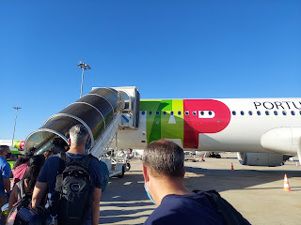

Everything took soooo loooong to get on board and into our seats. By the time we actually left Lisbon, we were 30 minutes past when it was supposed to leave. Maybe we could have left on time if they didn't have so many checkpoints and lines on our way to the actual airplane!!

In the United States, you arrive at the airport, which is clearly marked with each airline at the curb outside, and it's easy to see each airline when you enter the terminal.

You check in your bags, go through security (ONCE), and then you find your gate. Done. End of story. I wish that the rest of the world could be more streamlined, as well as more simplified in their process. Maybe there would be a whole lot less stress, and the planes could also be more punctual in their departures.

Goodbye Beautiful Lisbon.

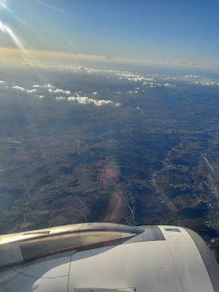

Because we left around dinner time, we basically chased the sunset for several hours. It was a beautiful sight to enjoy.

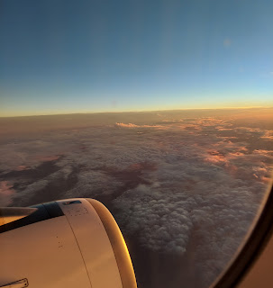

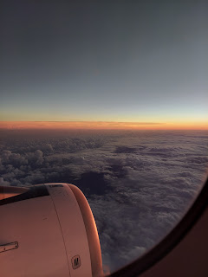

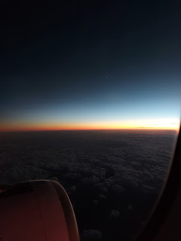

They fed us a light meal for dinner. I thought it would be interesting to show you a typical airplane meal. I had a chicken breast, mushrooms, and broccoli for the main entrée; a tiny side salad with a tiny bottle of olive oil for dressing; a slice of wheat bread folded in half; and a few pieces of diced apples. I didn't eat all of it. It was just "okay". I was glad, however, that I had grabbed a little bite to eat in the food court before I got to my gate.

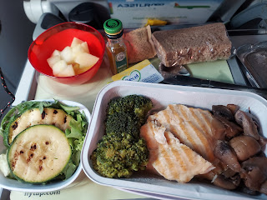

After several hours in the air, the pilot announced that there was a huge rainstorm in Washington DC and that because he had been instructed to "stall" by circling the airport for a while, we would therefore be delayed in our arrival by about 30 minutes. He had already made up for our late departure, but now we would be delayed again.

I was so glad when we landed! It was quite turbulent as we were descending. I don't know that I've ever felt the wind pushing us around as much as it did with that landing! I felt a bit sick to my stomach by the time we arrived, and I had a headache as well. Plus it felt like it was 2:00 a.m. with the time difference.

Even though we had to board a bus and be transported to the customs area, it didn't take very long, thank goodness. I was just so happy to see the American flag!!

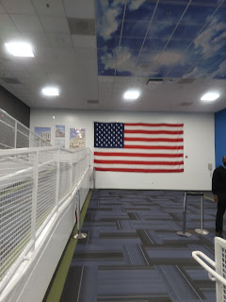

Meanwhile, Jacob was driving through the same crazy rainstorm to pick me up. I flew into Dulles International Airport, which was about a 45 minute drive from his house. He said that the rain was so tremendous at times that everyone had to slow down to 25 mph on the freeway with their hazard lights on. But he arrived safely, I threw my luggage in the trunk, and then we carefully made our way back to his place for the night.

I was extremely grateful that it was at the end of the day so I could just crawl into bed. I slept very well, except that I woke up at 5:00 a.m. and couldn't go back to sleep. (Fast forward to Saturday - I'm still struggling with being able to sleep through the entire night. This morning, I woke up at 4:45 a.m. and couldn't go back to sleep.)

Tuesday:
The happiest moment of all - seeing Jack again!! I brought him a couple of baby books from Germany, including this darling one with a little lamb finger puppet. He loved it!

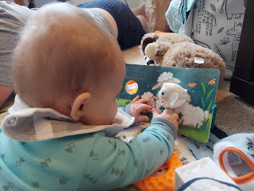

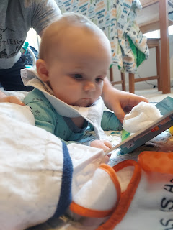

He's really good at doing the "Superman" pose, while kick-kick-kicking his legs. :)

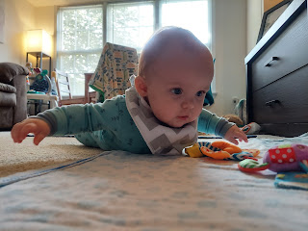

And then rest for a minute.

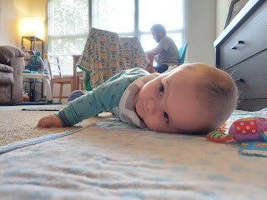

I was more than happy to entertain Jack while Jacob was "at work" for the morning. Jacob does such a great job at taking care of Jack at the same time as working from home every day. He even periodically includes Jack in what he calls, "Bring your child to work day", by holding Jack on his knee and bouncing him gently while he continues to type on his laptop. Jack is so chill that he is completely content to just hang out with Dad. Hannah works until about 12:30 at the school every day, but when she's home, Jacob can dig into deeper work projects where he can really focus and concentrate uninterrupted.

Hannah and I had fun in this next video, where we propped a toy ring on Jack's face. We thought he would try to grab it at some point, but he seemed completely content to just leave it there!!

Click to watch: (51 seconds)
https://photos.app.goo.gl/fqnRzPcw55YFFxFv5

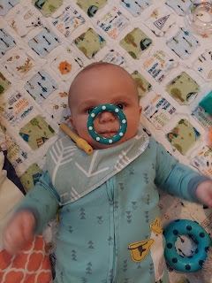

He also loves his soft cuddly blankets. When he's sleepy, Jacob will sometimes arrange Jack in the corner of the couch all nestled in, and he will just fall asleep on his own, ha ha. What a cutie!

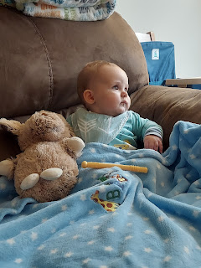

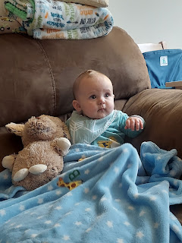

Dinner time: oatmeal. He's really good at eating his food.

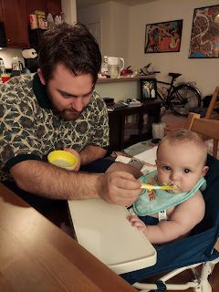

Is this all I get? Oatmeal? I see what you guys are eating. I know what's going on here.

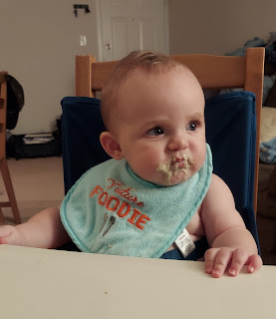

This is what he really wants. Spaghetti.

Best video of Jack ever: (24 seconds)
https://photos.app.goo.gl/M7JDZxzZyqFFmEgm6

Video of Jack eating his oatmeal: (28 seconds)
https://photos.app.goo.gl/vnK75oaDc2m9UuxH6

Video of Hannah and Jack - he's got such a cute giggle!! (34 seconds)
https://photos.app.goo.gl/5fY3fAaMxRUozxaUA

The day was calm, relaxing, and peaceful. It was also wonderful to be with my kids and know that they were happy to take care of me and feed me and entertain me.

Wednesday:
After Hannah headed off to work, Jacob and I took Jack for a bike ride. There's a trail nearby called Four Mile Run. It was a beautiful fall morning, crisp and calm.

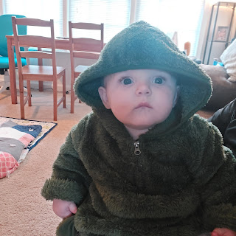

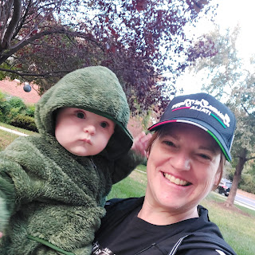

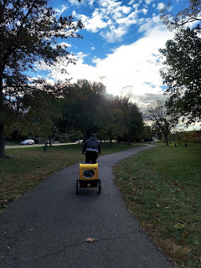

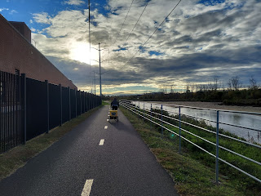

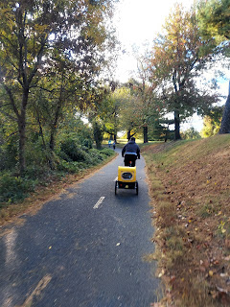

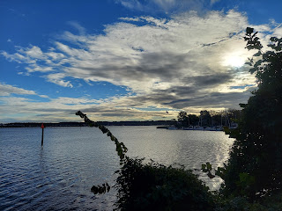

Later, around 2:30, I headed to the nearby Reagan National Airport. We called for a Lyft ride this time, because Hannah had a long day of training at work and she needed the car. It worked out well and the driver arrived right on time to pick me up. It was pretty funny when the Lyft driver thought I was Jack's mom! He saw me kissing Jack's cheek and saying goodbye, and said, "It's always so hard to leave your baby behind, isn't it?" He was shocked to find out that I was the grandmother!! :)

My experience at the airport this time was perfection. No issues whatsoever, just quick and very straightforward. I was so incredibly grateful.

I flew 4 hours to Denver, had a very quick 30 minute window to hustle to another gate and hop on the next plane, and then 90 minutes later I was landing in Idaho Falls. :)

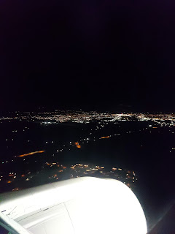

As my luggage arrived on the carousel, I quickly located my new winter coat and put it on. Idaho is quite a bit colder than where I've been for the past month!!

It was so wonderful to be reunited with my sweetheart! He has patiently waited for me to finish playing all over the world and come home to him. It was interesting, though, having our roles reversed this time. Usually he's the one leaving me . . . and he's always gone a lot longer with his military assignments.

He put together a dinner plate for me and then, as soon as I was done eating, we got ready for bed. Even though I fell asleep quickly, I still woke up at 5:00 a.m.

Thursday:
I got up way too early, but decided to just dig in and get cracking on the day. After all, I had a lot to do! I finished unpacking, I started some loads of laundry, I made a menu plan and went to the grocery store, I had a haircut appointment mid-morning, and I baked some cupcakes.

I am pleased to announce that my interest in cooking has resurfaced and I am happily in the mood to put some tasty meals on the table for the two of us! I made some Japanese Katsu pork for dinner, with caramelized onions, sauteed broccoli slaw, and scrambled eggs, along with a nice tangy sauce. It was absolutely fantastic!

Here's the recipe I used: (I swapped out the rice for the broccoli slaw instead - lower carb count that way)
https://thewoksoflife.com/katsudon/#recipe

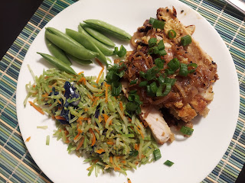

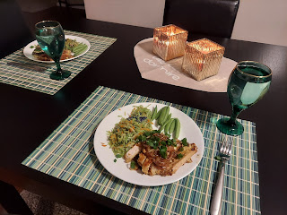

Friday:
I took care of several loose ends, ran some errands, made some phone calls, and enjoyed seeing the beautiful fall colors still hanging on for a little bit longer in my yard.

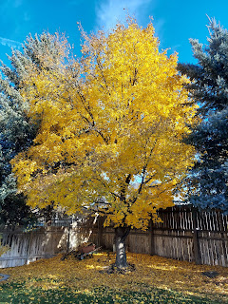

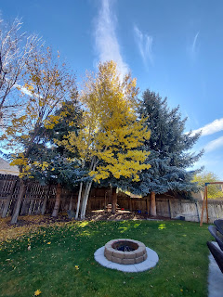

I decorated the Halloween cupcakes to deliver to all of the girls in my young women's class. The little sign I included with each plate simply said, "It's so good to see you!!" And then I put several candy eyeballs on for decoration.

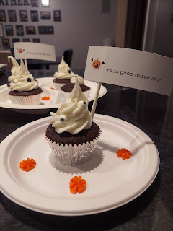

The girls were so happy to see me as I delivered them to each house. They made me feel so loved. To have them spring toward me and wrap their arms around me and to hear them say, "I'm so glad you're back!" just really feels good. :)

Scott and I ate leftovers for dinner and then we watched a Jason Bourne movie. Always a good time.

Saturday:
After waking up at 4:45 a.m. and not being able to go back to sleep after hours of trying, I got up and got ready for the day around 7:00 a.m. Scott and I went over to help clean the church at 8:00. Our assigned task this time was vacuuming. I helped vacuum the chapel, while Scott worked on all the hallways. Several other families showed up to help as well - cleaning windows, bathrooms, sanitizing surfaces, emptying garbages, etc. The church was sparkly clean in about one hour. Many hands make light work. :)

Once we got back to the house, I was fading pretty hard. I climbed back into bed and closed my eyes for about 2 hours. It felt really nice.

I delivered the last couple of cupcake plates to those who weren't home the night before, and then Scott and I drove up to Rigby to have lunch and visit with his parents. :)

We went to the nearby Wendy's for lunch. It was so nice to see them again after so long!!

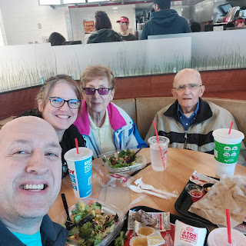

We went back to their house and visited for a while longer, making plans for a Thanksgiving meal together - which is just around the corner!! I also took home a large box of apples from their tree, from which I am excited to make some applesauce (and whatever else I choose to do with them) this coming week.

As we came back into Idaho Falls, we stopped at the car wash. I didn't know it was haunted!!

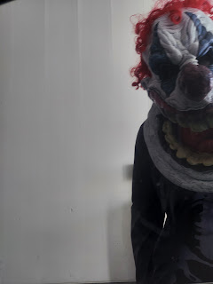

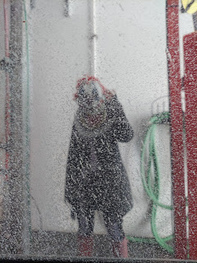

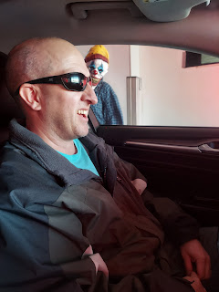

Since the afternoon was sunny and (somewhat) warm, we headed outside to tackle the front yard. While Scott worked on gathering all the leaves on the ground, I gave this flower bed a significant makeover.

Before:

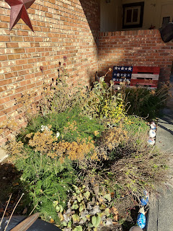

After:

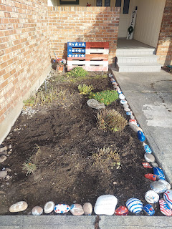

I dug up 2 giant-and-out-of-control yarrow plants. They had spread to the point that they were taking over my entire garden space! I prefer a neat and tidy garden presentation, not an unruly one. I'll have all winter long to ponder what I can plant in the spring. This is where I have my perennial patriotic garden, where each plant is either red, white, or "blue".

Jacob and Hannah's new ward in Arlington, VA held a Trunk or Treat, as well as a Halloween dessert baking competition. They said it was really fun! They brought pumpkin bread as their contribution - which sounds so delicious right about now!!

And since Jack has a nickname of Jack-Jack, it lent itself perfectly to their family dressing up as the Incredibles for Halloween. So fun!!

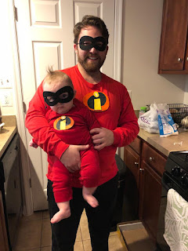

They didn't get a photo of Jack and Hannah together, but they shared a little video of the two of them.

Click here to watch: (14 seconds)
https://photos.app.goo.gl/DBuBmrkBEsSVKbDGA

Our neighbor Kim, across the street, always does such a great job decorating for all the major holidays. Halloween is no exception. While I am not into Halloween all that much, I do enjoy seeing where she stages the witch mannequin each year. They are such fun neighbors to have, and good friends as well.

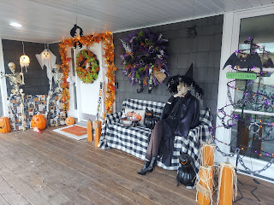

And lastly, here are my darling granddaughters down in Louisiana, dedicated Harry Potter fans. :)

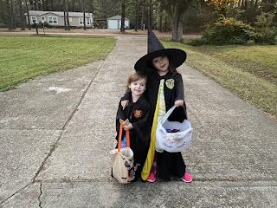

Amber dressed up as Lumber Jill.

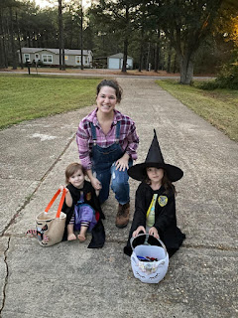

And Weston channeled his dark side, ha ha. I know he's a Star Wars super fan, but I'm not exactly sure what he is here . . .

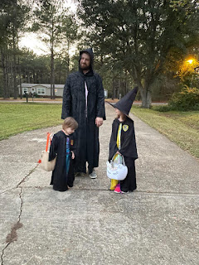

And then there's my 100 year old grandma - the cutest witch you've ever seen!! :) XOXOXO

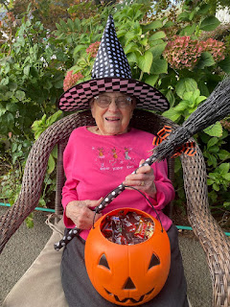

Happy Halloween!

