Thunderstorms, Sunsets, and Settling In
It feels SO GOOD to settle into some sense of normalcy, to putter around the house doing laundry, organizing stuff, planning the next week's menu, etc. I'm still dealing with a little bit of guilt on the days that I'm NOT running around like a chicken with its head cut off. I have been in GO!GO!GO! mode for three years, and it's hard to undo those habits and just slow it down and be okay with doing less.

This post will hopefully demonstrate some of the new habits that I'm striving for, along with plenty of photos of the beautiful scenery that we encounter here every day.

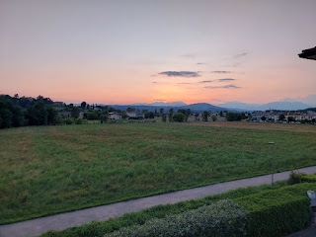

Our appointment was perfectly successful when we went to the Soggiorno Office on Caserma Ederle (the main base in Vicenza). I say "perfectly successful" because the lady was very impressed that we didn't forget anything and that the forms were all filled out correctly. This was the follow-up to our appointment at the Italian Consulate in San Francisco last month. It's still going to take a little bit of time to get through the process, something that we're learning as we go along. At this appointment, we had to produce forms and documents such as our marriage certificate, the rental agreement for this house, proof of Scott's new job, visa photos that we took for free in the little photo booth that sits in the hallway, etc.

This is the door to the Soggiorno Office . . .

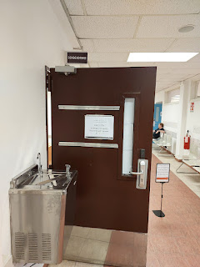

Once these things have all been reviewed, then we can schedule the next appointment to get fingerprinted downtown. Once that's done and they see that we are not criminals or terrorists, then I *think* our paperwork will be in the final stage to get our soggiorno papers. I've heard horror stories of times when my friends from Vicenza traveled to another country in Europe for whatever reason (vacation, son's soccer game, etc) and they accidentally left their soggiorno paperwork behind. You can get in real trouble if you don't bring your soggiorno document PLUS your passport everywhere you go.

Noted. I will be oh so diligent about bringing my soggiorno
and
my passport when I travel.

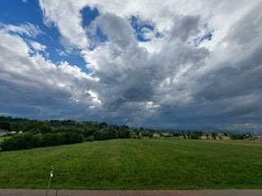

Every day, one of my favorite things to do is just look out the window. Any window.

Through the kitchen windows, I see the field behind us, the mountains in the distance, and the sunsets.

Through the dining room doors, I can see my neighbors working in their gardens, rototilling, planting, etc.

Through the bedroom windows, I can see the lovely home across a small divide, where an older lady putters around with her leaf blower, or carries a watering can on regular rounds for her pretty flowers.

I made these tostadas for dinner on Cinco de Mayo. Huge success. The recipe can be found here:
https://www.eatingwell.com/sweet-potato-black-bean-tostadas-8769923



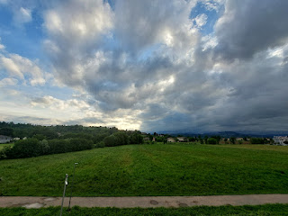

One evening after dinner, we went for our habitual walk. We have many options to choose from - but this time we chose to walk in the fields between our street and Del Din (the base where Scott works). We tried a new loop, the one that takes us to the east side of the fields and close to the base. Wherever we go, no matter which direction, we always end up walking for about 45 minutes by the time we return home.

The clouds turned into an interesting spectacle as our walk progressed . . . soon they began to look like wispy pink cotton candy that was stretched into clumps across the sky . . . Also, we were suprised to see the lights of Monte Berico and the Basilica that sit atop one of the tallest hills in Vicenza. You can see it lit up on the far left in the photo below.

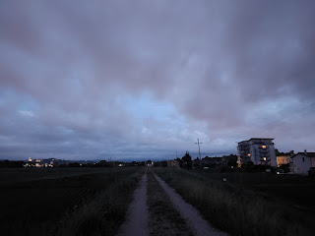

I mentioned last week that we've been slowly winning the battle against the ants. So far, that's still the case. We had to jump into action for a few days, spraying both inside and out, getting ant hotels that feed them a yummy bait that they take back to share with the queen and everyone else, as well as doing regular perimeter checks throughout the day.

This is what we saw on one of the first days of the war: (29 seconds)
https://photos.app.goo.gl/e9FkC7YnsjHSrfvj7

The ants had formed a unified highway trail that marched up the side of our 3-story building and up to the tippy top! Something we did regularly was to spray where we could actually reach (down near the bottom) to break up that well-worn trail. This, combined with all the other tactics, has been working remarkably well.

With rain almost every day for several days in a row, it's no wonder they collectively decided to find higher ground. We do live on the edge of several farm fields, so we're on the precipice of nature and civilization. I'm learning to be patient with the discrepancy and to find new ways to protect the sanctity of our home on the third floor.

On one particular evening, we took our evening walk through the fields again. For the first while, my main focus was just on how beautiful the photography opportunities were with those moody clouds . . .

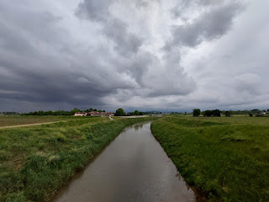

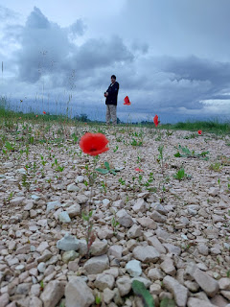

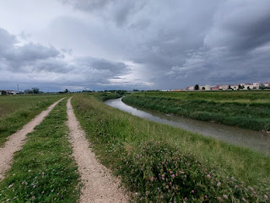

Del Din, sitting across the river, looked as if the sky had formed a giant spotlight to illuminate it . . .

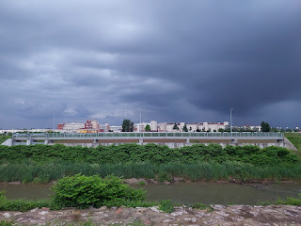

Soon, however, we began to notice the dark clouds off in the distance. We could not tell which way they were slowly headed, but we noted them nonetheless . . .

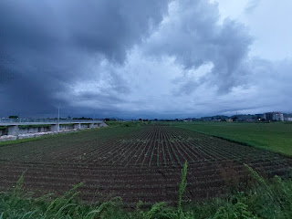

I enjoyed stopping here and there to take some photos as we rounded the bend in the middle of the fields, and then we began the final stretch back to our house . . .

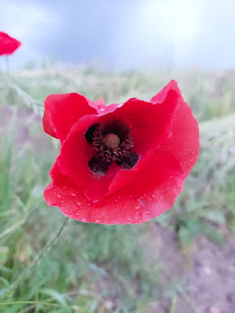

Less than 2 minutes later, the rain hit.

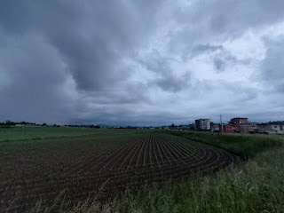

We quick-stepped the half-mile back home, but we were absolutely drenched by the time we arrived, ha ha. We did not bring any umbrellas with us, but we were at least smart enough to wear a rain jacket over our hoodies. Scott had his tan army boots on which kept his feet dry, but I had very breathable Hokas on. This meant that with every step, I not only felt the squishing, but I could also hear the "squish, squish, squish" of my sopping wet socks inside my tennis shoes. How fun, lol.

I took a quick selfie as we waited for the gate to open up to our long driveway . . .

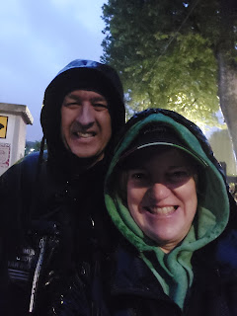

I left my rain jacket downstairs to drip dry and then I carefully squooshed my way up all the flights of stairs to the top. My shoes were literally so saturated that two days later, they were still damp! We finally had a little bit of sunshine to where I could lay them in a sunny spot to finish drying. Wow, what an adventure that whole thing was!

The next day, the clouds began forming another beautiful sunset. I took a series of photos to show the progression as I prepared dinner . . .

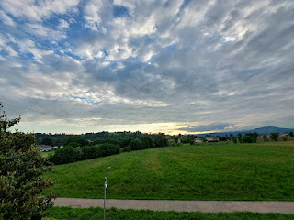

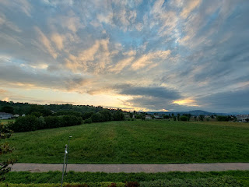

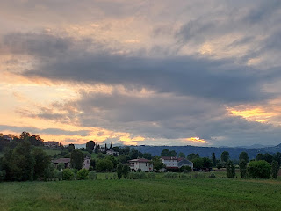

As we go on our nightly walks, we pass by the garden of our closest neighbor and also their peony bush that sits near the gate. It's been fun to see the slow process of the flower buds opening up.

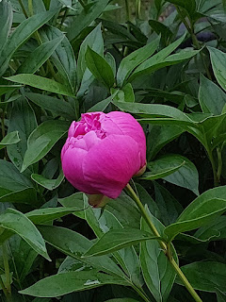

I've said this before, but one of my favorite things about living in Italy is getting to hang my laundry out to dry. It's so grounding. It's similar to cooking in a new place, or digging your hands into the earth by working in a garden. It connects you to where you are, but also connects you to everyone who's ever been there through the centuries of time. We all need to eat, clean, work, and be outside. These are things that are so good for the soul.

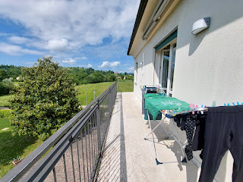

I accompanied Scott to Ederle one afternoon so we could wash the car on base. It was looking pretty sad. But not anymore! This is one of those classic Italian car washes where you park the car and it doesn't move, but the cleaning contraption moves back and forth along the tracks instead.

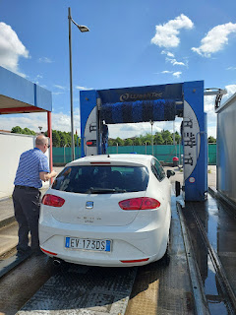

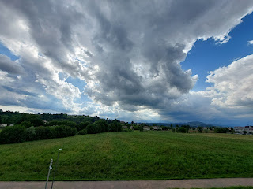

We took a different walking route one evening, choosing a paved trail that leads through the fields behind our house and where I take photos of the sunset every night. There is a little lane that splits off from the main trail and we decided to go check it out.

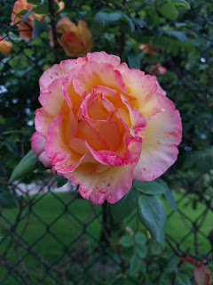

We passed by a villa . . .

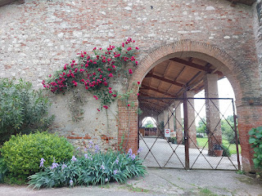

A trickling creek . . .

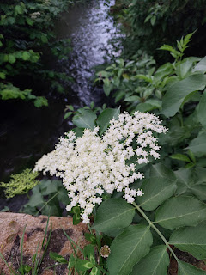

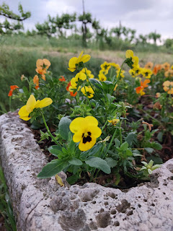

And the cutest birdhouse all decked out in Italian pride . . .

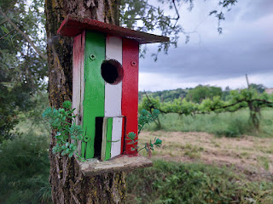

We always pass by this church on our way home. Sometimes the bells are ringing, other times not.

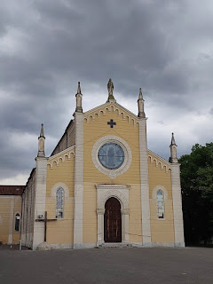

I hope to one day be able to grow some roses with even a little bit of success back in Idaho. The winters are just so cold, which takes a toll on the life span of many plants in such a harsh climate. For now, I will just soak it all in while I'm here. Roses are literally everywhere.

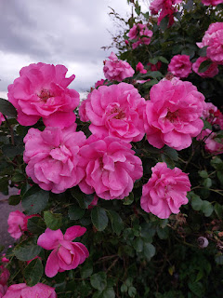

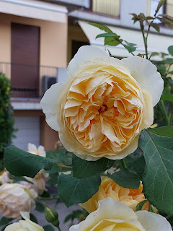

Last Saturday, we drove up to Aviano to see Avery and Kylie. We hadn't seen them in several months!

We passed through a really cute town called Roveredo en Piano on the way. You can see a little glimpse of it here: (15 seconds)
https://photos.app.goo.gl/Vt4oHTo1RLh2BFzA8

Their church was tall, stately, and pretty, especially with the mosaic of Christ on the front facade . . .

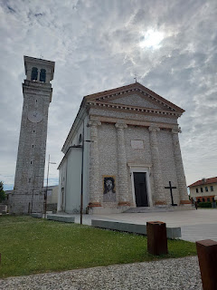

This is the one rose left at Avery's house, ha ha. According to her mother, a very reliable source, Avery keeps picking every bloom that opens up. You really can't blame her, though. I've never seen such a striking color combination of bright yellow, orange, and fire red.

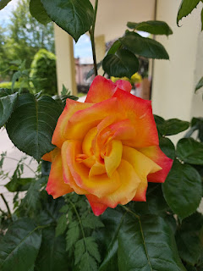

The *most precious video ever* of Avery's face when she opened the door: (3 seconds)
https://photos.app.goo.gl/EFJAicUxWvbU3Fmv7

All of their furniture had recently been picked up to begin making its way up to Germany, so we sat and visited on the floor of their living room. They had a few things left to make life somewhat comfortable during the transition, but most of the house was empty.

Kylie and Miles recently bought a new car, a BMW (because they're cheaper over here when we live so close to their source!). They practiced making sure that their suitcases, TV, and misc. items that were intentionally left behind could all fit into the car, because they wanted to make sure before the moving company drove off with everything else! Now, they're just waiting out the next few days until they can begin their drive up to Ramstein, Germany to start Miles' new post up there.

*Note: Since last weekend's visit, Avery, Kylie and Miles, are all settled into a hotel on the base in Aviano. I was supposed to go up and help Kylie get the house clean last Tuesday, but then she found out that her landlord planned to hire someone to just do it instead. This was a big relief for Kylie because she was already exhausted from doing everything else up to that point.

We are heading up to see them again tomorrow (Saturday), since they leave early next Friday (May 23) to drive up to Germany. Thankfully, we're already making some plans to see them in September, once they get more situated.

We took Avery on a little walk down the street, past the church, and over to the Italian Cemetery.

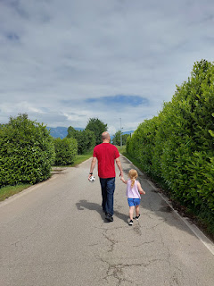

Video of Avery wanting to "run fast": (5 seconds)
https://photos.app.goo.gl/GpTqnj5HMkTTZTAX8

Video of Avery running along, promising to beat her mom: (4 seconds)
https://photos.app.goo.gl/4LdeTMfN9NYNsfUz9

Video of Avery and Scott playing some soccer in the parking lot of the cemetery: (6 seconds)
https://photos.app.goo.gl/WgtAqDaTLWuQT4Yz6

I feel the need to add that I do interact with Avery A TON!! But nobody is taking photos or videos of me, and that's okay. I'M the photographer . . . so that often means that I am mostly just capturing other people's moments.

The cemetery borders a large field with hundreds of tiny baby corn plants starting to grow . . .

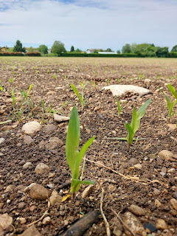

Avery was super happy and content to just hang out on top of a large family vault at the cemetery, ha ha. And she is quite a poser, too! I wanted her to say cheese, and this is what I got . . .

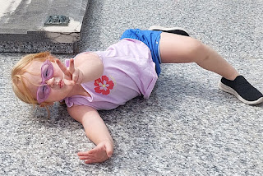

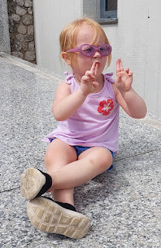



She absolutely loved this vault! She didn't ever want to get off, ha ha.

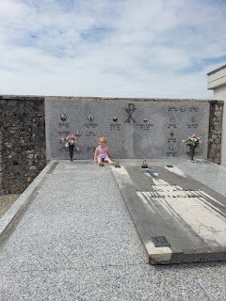

Kylie had to capture and tickle Avery in order to convince her to start walking home with us. XOXO

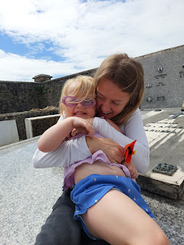

The corn field on the other side of the road was a few weeks ahead of the younger plants . . .

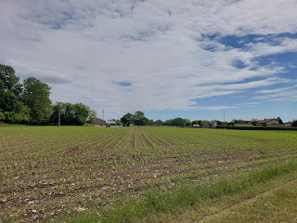

Video of Mr. Italian Farmer spraying his crop of corn: (3 seconds)
https://photos.app.goo.gl/CouQrNeUhKECihGe8

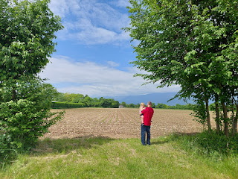

I finally asked for some pictures of me with Avery before we left . . .

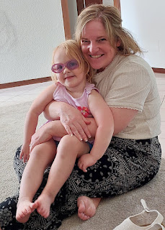

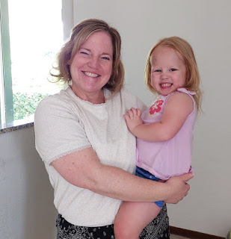

Avery was hungry for lunch, so Kylie sent her into the bathroom to wash her hands. I was curious if she might need some help, so I followed her. I found a hilarious surprise - - they had turned the bidet into a little toddler-sized sink for Avery!!!! HA HA HA HA HA Who knew??!! (A young mom knew)

Watch her here: (23 seconds) (*I'm certain they do NOT use their bidet as an actual bidet!!)
https://photos.app.goo.gl/BgizWdZiK8WP3NTR8

On the drive home, I was poised and ready for several minutes in order to get this video for Scott. We had passed underneath a unique overhead structure as we drove up to Aviano that morning, and he was super curious about how it was put together. I made note of a nearby exit to watch for on the drive home later, and here it is:

(11 seconds)
https://photos.app.goo.gl/2W8hwVGRoK2wbzLB6

We made our weekly pilgrimage over to the Iper Tosano grocery story after driving back from Aviano. Something I noticed in their pasta aisle is that some of their colorful shapes and sizes are made from natural ingredients - not from any food dyes.

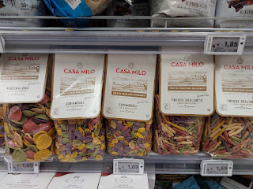

I used my Google Translate app to translate the ingredients . . . (click photo to enlarge)

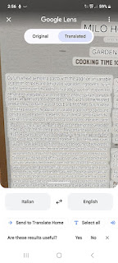

They use carrot, red beet, turmeric, spinach and tomato to give the pasta those pretty colors!!

I also wanted to share just a small portion of all the specialty cheeses they have in this store. This is a video of the locally made, or regionally made, cheeses - and does not include the separate refrigerated aisle of regular cheeses (sliced, shredded, bricks, etc.) Also, it should be noted that the prices you'll see in the video are per KILOGRAM. The actual price of each package is much, much lower.
(12 seconds)
https://photos.app.goo.gl/uRZ4KBy2AoRZ8Tdy6

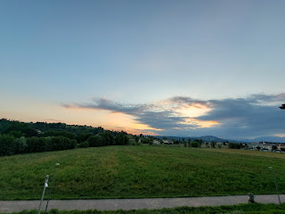

A lovely Mother's Day evening walk through the fields by Del Din . . .

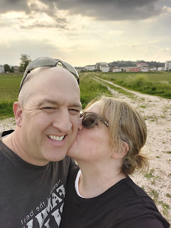

The way those rays of sunlight filter down through the clouds . . . XOXO

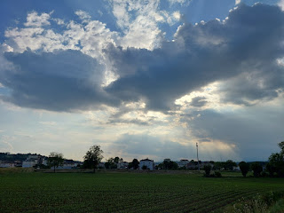

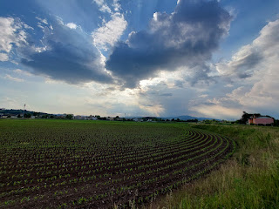

Another distinctive color of rose . . . I absolutely loved this one!!

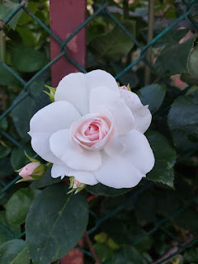

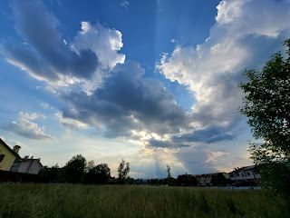

The gate to our long driveway and home sweet home . . .

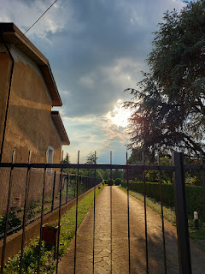

The side yard leading up to the house . . .

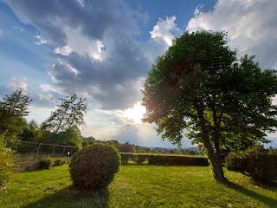

And another gorgeous night sky . . .

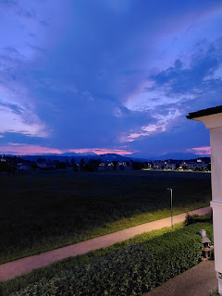

The new missionary couple serving here in Vicenza are the Sims. Elder and Sister Sim. Lynn and Terry Sim, to be exact. Sister Sim has been organizing a quilt to be made for the USO and the local military community, handing out white muslin squares each Sunday to anyone who is willing to participate. She was thrilled when I offered to work on a quilt square - and I was eager to dig into a little sewing project. I knew almost immediately what I wanted to do for my square. She had suggested that people could use fabric pens, buttons, cloth, etc.

I wanted to make a heart with the colors of the Italian flag.

I had to do a little research because I haven't done anything like this before, even though I knew exactly what I wanted as the end product. What I ended up having to combine was the technique of "raw edge quilting" mixed with "scrappy piece quilting". Raw edge quilting ends up with a sort of rag quilt look once it gets washed. The edges of the seams will curl and create a cute, shabby-chic effect. Scrappy piece quilting basically means you are piecing together scraps and making it all fit together. There is some trimming involved, of course, to make sure it will work out okay.

I watched a few YouTube videos until I was somewhat confident to begin my project.

I had a piece of thin fusing material on hand, so I used that as my foundation. I cut out and stitched on some coordinating pieces of green fabric that overlapped at the seams, and I laid them out in a mosaic sort of pattern, sewing one piece on at a time before adding the next one.

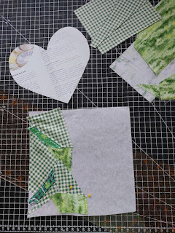

I wish I had more than one variety of white fabric, but alas, I only had the one, so I just cut it into various shapes to continue the mosaic design. Eventually, I added some red fabrics to finish it up.

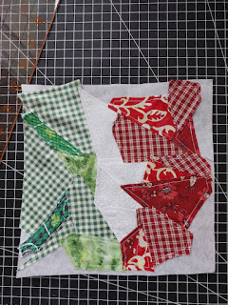

I pinned a paper heart onto the mosaic of green, white, and red . . . and I cut out a heart shape.

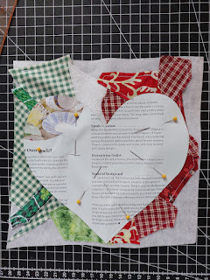

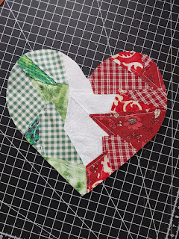

The last step was to sew it onto the white muslin square that Sister Sim had given to me. I don't have a picture of this, but I also sewed a cute little green button at the top of the heart, where the white and the red fabric come together. It adds a nice little pop of texture and some finality to the end result.

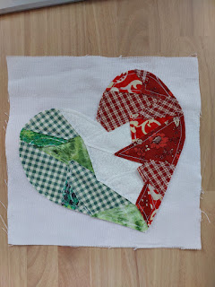

In total, it took me a chunk of one afternoon to complete the entire project. I love how it turned out! I want to make a second one for myself, one that I can put into a frame and hang on the wall. Maybe I'll make another heart with colors of the US flag, too. And I'll hang them side by side. Yeah, I think I'll do that. :)

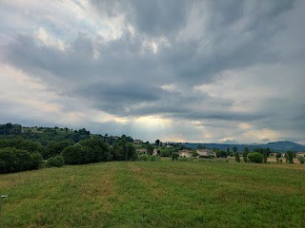

I found a different way to make a dinner from those fabulous already-shelled mussels from Iper Tosano's. This time, instead of a lemony-garlic broth, I made a tomato-based broth with garlic and onion that had simmered for about 30 minutes before stirring in the mussels. It was delicious!!

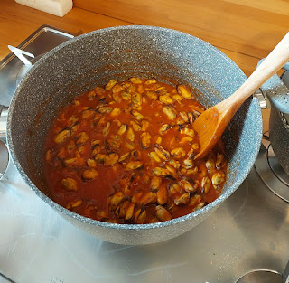

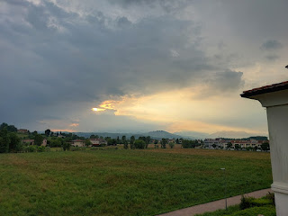

I hope you are getting a feel of just how many times I am looking out my windows to admire the beautiful sky, and then stepping out onto the balcony to take another photo as the day progresses. I can't help it. I can't NOT do it. It's just too pretty to ignore . . .

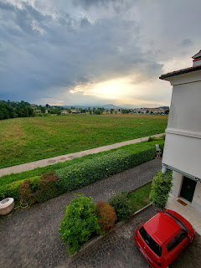

We added onto our evening walks by trying a new road that extends past the church where we hear the bells ringing nearby. We didn't make it very far, because I was pretty sore from all the new exercises I've been doing lately. But the vineyards and roses were quite lovely along the way.

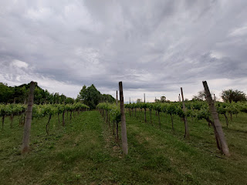

These calla lilies were bigger than my entire hand!!

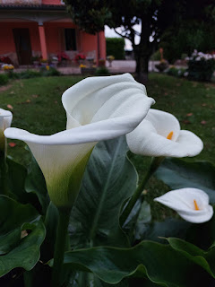

Also, I wanted to share this recipe that I put together for a natural bug spray to use along our windows and doorframes. I love ChatGPT. I found some witch hazel at the Commissary and then I already had all the essential oils on hand.

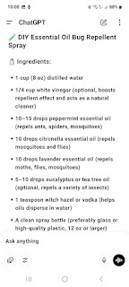

Scott took me over to the gym at Del Din for the first time a few days ago. We parked the car in one of the parking garages and then we had to walk maybe 1/4 of a mile across the "campus" to get to the huge gym. They even have an indoor pool!! It's only open M-F from 0600 to 1400 hours, but it looked really nice, with swimming lanes set up and diving boards, too.

I used the rowing machine and then the stair climber. That was a great combo and I can't wait to get back and do it again.

When we got back to the parking garage, we saw an adorable little Fiat. It was just my size!!! XOXO

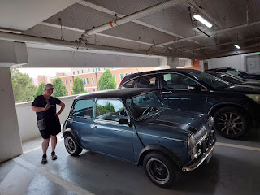

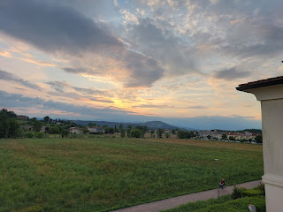

I've also started back up on Maisie's Quiet Book this past week. My sister, Melanie, helped me get this page started when she visited me recently in Idaho Falls, and now I'm adding more details to it. When it's done, it will be a counting page, but also a fun activity where you can pretend to bake some cookies. Each cookie will have corresponding chocolate chips on top, with the numbers 1-9 underneath. The cookies will velcro to the baking pan. The baking pan won't move (or fit into the oven), but the oven door will open and close and she can place one or two cookies inside. The cupboard doors will also open and close, but I'm still deciding on what little items to put on the shelves inside . . .

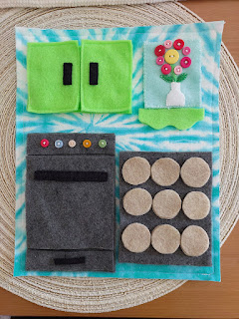

Scott calls me every day when he gets off work. Even though he's less than 5 minutes away, he always calls. Sometimes he wants to know if he should stop at the store to get anything for dinner, but mostly he just wants to chat. During the day, he's not allowed to have his phone in the same room as where he works, so we don't usually chat until he gets home. Or when he calls me on his looooong commute home, ha ha.



With one of the storms that ripped through recently, we had some surprises happen. The first surprise was that a living room window slammed shut and knocked over a brand new picture frame of my Grandpa John Snider and his whole family. It broke the frame, but not the glass. Go figure.

The next surprise was that the storm slammed one of the kitchen windows shut while we were watching a show that same evening. It wouldn't have been such a big deal, except that a bottle of vegetable oil was holding the window open at the time. When the wind slammed the window shut, the bottle of oil crashed onto the floor and started spilling oil everywhere. Thankfully, the bottle was made of plastic, but it took some effort to clean up all the oil.

I put the oily towels into the hamper to wait for laundry day. That was a big mistake.

As more clothes landed in the hamper, they soaked up some of the oil from the towels. Yuck.

When I did the load of laundry a few days later and hung them out to dry on the balcony, several items clearly had oil stains on them even after being washed. Hmmm . . . how to fix THAT?

ChatGPT came to the rescue once again, with a remedy for getting the oil stains out. It involved using Dawn dish soap, a scrubber or brush, and some baking soda. We had to go to the Commissary for the Dawn dish soap, since it's not sold in Italian stores. And then it was a series of multiple attempts to get it all resolved.

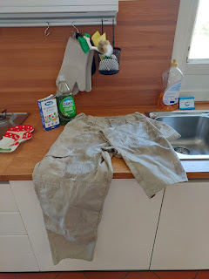

The process went something like this:
~Scrub some dish soap into the spot
~Let it sit for at least 30 minutes
~Wash it in as hot of water as it can handle (In our case, I just threw it into the washer)
~Hang it to dry
~Then check to see if any oil stains are still visible
~If not, then YAY!
~If so, then back to the beginning and start all over again

Scott's khaki tactical pants were the most resistant out of all the items that needed attention. I washed a duvet cover using this method, along with some other clothing, and they turned out great the first time. But his pants were quite stubborn. When the dish soap didn't remove the oil, I had to scrub in some baking soda, too. And each round involved lots of waiting and patience, since our washer takes about 1.5 hours to do one simple load of laundry.

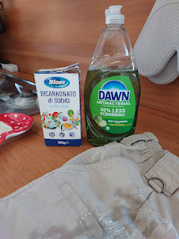

I learned that I didn't need to add quite as much laundry soap to those loads because there was so much dish soap already soaked into the fabric, ha ha.

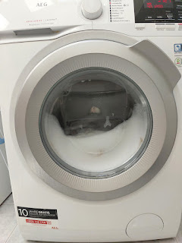

After about 3 days of actively working to get the oil out of our bedding, clothing, etc. I can happily report that it's all taken care of - finally.

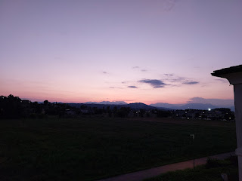

We made it back out to the place where we left off a few nights earlier, when I couldn't finish the walk because I was so sore. I was very intrigued by these dual-tone roses . . . they are both light pink and bright pink all at the same time!

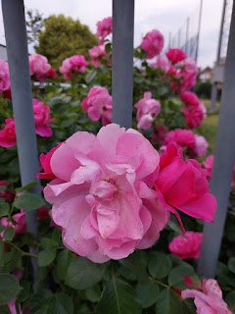

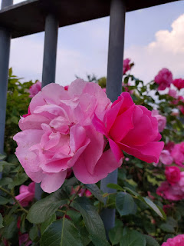

We walked far enough out on this road that we started coming into another tiny little community with its own church!! There was even a thoughtful memorial set up near a bus stop - devoted to all the ladies who used to wash the laundry many years ago.

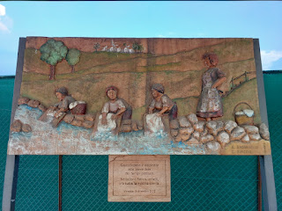

The plaque underneath reads: (with Google Translate)
"This work is dedicated to the washerwomen of times gone by. In their toil, in fact, lies our entire history." Vicenza, 3 December 2022

There is an old washing station in front of the mural and plaque . . .

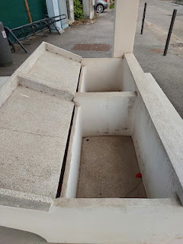

As we were admiring the washing station area, we noticed it was starting to sprinkle. So, unfortunately, we had to cut our walk short once again. We trekked home as fast as we could so we didn't get caught in a torrential downpour like last time, ha ha. But I did stop a couple times to snap a photo or two. I couldn't help it!

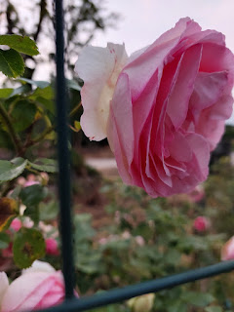

This new color of rose caught my attention . . .

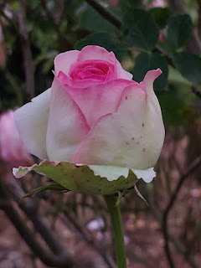

The buds are mostly white with pink edges, but the fully opened blooms are mostly pink with white edges!!

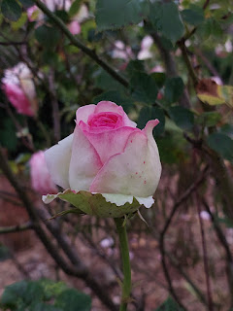

This was the sky behind us as we hurried home . . .

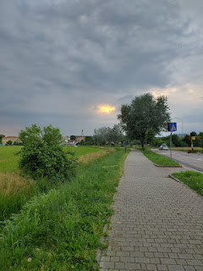

Behind someone's gate sits a gorgeous rose bush with several crisp white blooms . . .

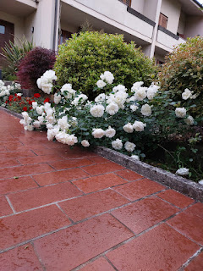

We made it home in dry clothes, thankfully. It only sprinkled a little bit on our way home, but then it stopped altogether. (More on that in just a moment . . .)

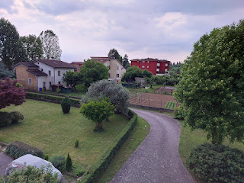

I've been paying attention to our neighbor's garden process the past few days. They put several rows of very tall poles into the ground and I wondered if they might be planting pole beans or something. But then we walked past last night and I noticed that they planted a tomato plant at the base of each pole! I'll share some updates as the growing season progresses. I'm also hoping to plant a few things myself . . .

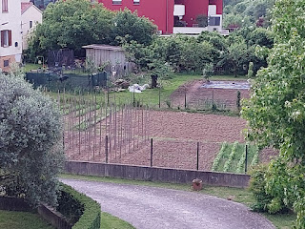

This same neighbor was also out rototilling a portion of his garden yesterday morning. I took a sneaky video of him: (16 seconds)
https://photos.app.goo.gl/kVp13vf6M1mh2KWX7

It's just nice to see that people plant gardens and do stuff in other parts of the world. :)

As for last night, HOLY CANNOLI - I think that was the biggest storm I've ever seen in Italy!!

While we were watching a show and relaxing after our walk, the rain began to fall. The rain turned into torrential rain, which soon turned into hail. The lightning and thunder made us jump several times, as the thunderstorm persisted well past when we tucked ourselves into bed a couple hours later. I thought about putting on my sleep mask so I wouldn't be bothered by the lightning flashes behind my closed eyelids, but thankfully I was sleepy enough that I didn't need it at all. I slept hard through the night and when I woke up this morning, a nice cool temperature trickled in through our open windows, and the birds were all chirping and chattering and singing.

I love Italy.

