Tour of Vicenza & Some Asiago Cheese
This was a much quieter week, something that was much appreciated. We stayed in the Vicenza area and I became more of a homebody again, which was nice. On the weekend, Scott and I drove up into the mountains for a day trip to Asiago. It was truly amazing and I learned that Asiago is now my new favorite place in Italy. :)

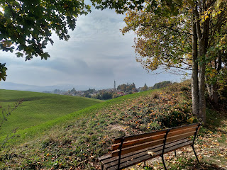

Last Tuesday evening, the Relief Society presidency in our ward organized a walking tour of downtown Vicenza. They did the same tour last October with great success, and since there were several new families in our ward that moved in over the summer, they figured it was a good idea to do it again. Our tour guide, Monica, is from Vicenza and speaks very good English.

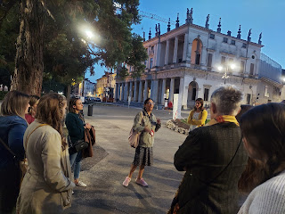

We met at the Teatro Olimpico near the center of Vicenza. There were about 20 ladies altogether that came to participate. The evening weather was also perfect for our tour.

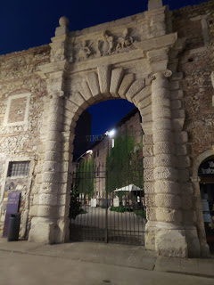

The biggest draw of tourists to Vicenza is to see the works of Andrea Palladio, who built so many structures here in his typical "Palladio" style. Architects, designers, and artisans from all over the world come here to see his work from the 1500s. I learned that these Palladian Villas of Vicenza are on the list as a UNESCO World Heritage Site. WOW!! Other sites on that UNESCO list include the Roman Colosseum in Rome, the Cinque Terre, etc. So that is a BIG DEAL! Thomas Jefferson's estate in Virginia, "Monticello" is a Palladian edifice. He really admired the style of Palladio and wanted his home to reflect that. The White House in Washington DC is also built in the style of Palladio.

I've shared a couple of websites below for more information about Andrea Palladio and the history of his great works here in Vicenza, including an article that RICK STEVES wrote about Vicenza and Palladio.

This next villa had a unique feature that made me smile. This is the entrance gate where someone would ring or knock upon arrival. If the servants didn't want to (or couldn't get there quickly enough) hurry down to see who it was, there was a secret spying hole through which they could see who was standing below . . .

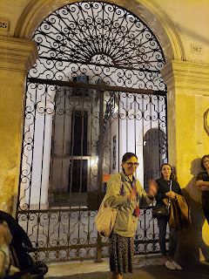

Through the mouth of this ancient man's face on the ceiling, one could look down from above to make sure all was well before they came down to open the entry gate. The ladies in the tour group were joking that maybe someone could have poured something down the hole if they didn't like who was standing there . . .

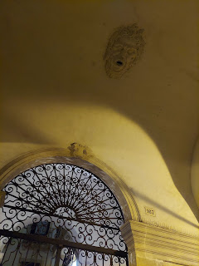

Monica took us to a few different nearby streets to talk about a few of the more prominent structures that Palladio had a hand in building. Below: she was shining a light to point out some features on the exterior of a building, helping us note the difference between the original plaster and bricks of different eras.

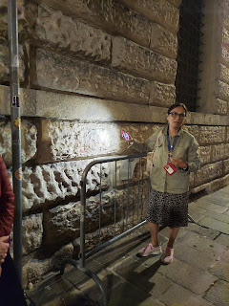

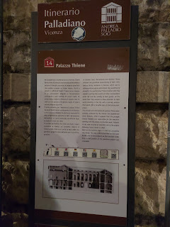

I enjoyed helping Joy Simons by pushing her baby stroller. Little Rosie (18 months) was practicing her escape-artist techniques by slipping out of her stroller and running away on the cobblestone streets every chance she could get, ha ha. Joy was a very patient and cheerful mother, while I just followed along with the stroller. :)

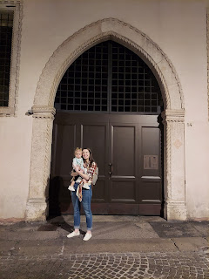

It was especially beautiful to see all the buildings lit up at night. It added a nice ambiance to the tour.

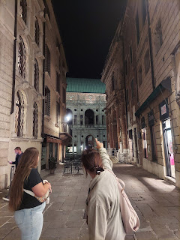

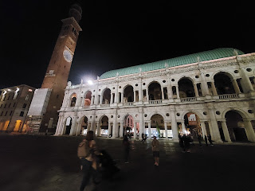

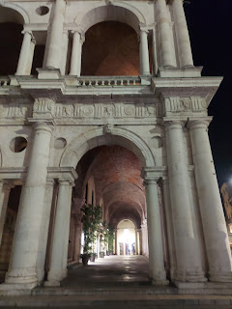

A statue of Palladio stands majestically in one of the piazzas, surrounded by several quaint little shops and restaurants.

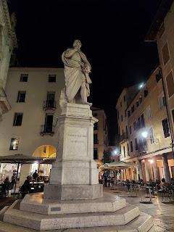

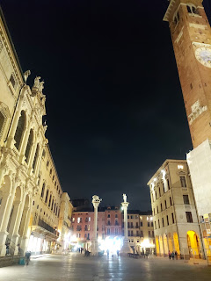

Here are those 2 websites if you want to know more about downtown Vicenza and the history of Palladio here:

https://www.timetravelturtle.com/andrea-palladio-vicenza-italy/

https://www.ricksteves.com/watch-read-listen/read/articles/vicenza-palladian-paradise

When the tour was over, several of us walked a couple blocks over to a gelato cafe to get a sweet treat. It was different than the other gelaterias that I've been to because in this one you couldn't see the gelato through the big glass window as you step inside. They were all covered up with individual aluminum lids so you couldn't see the colors or the flavors . . . The flavors were all listed on the wall above, but it didn't do me much good because I didn't know what 95% of them meant, ha ha.

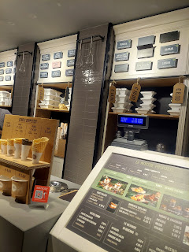

One of the flavors listed was Limone (lemon) and that has consistently been one of my favorites, so I knew I wanted that. But typically you can choose 2-3 flavors in your cone or cup, so I was at a loss . . . The lady at the register was super friendly, but spoke zero English. I am also super friendly, but I speak very limited Italian. So there we were.

I could ask for one cup (coppetta), size medium (media), and that one of my 2 (due) scoops needed to be Limone. As for the other flavor, I just shrugged and indicated that I didn't know what to do. She said, in Italian, something along the lines of, "Do you want something fruity or cream based?" (I could pick out a couple words here and there) I answered that I'd like something cream based (latte). She made a couple of suggestions in Italian . . . but when I gave her a blank stare with a crooked smile in return, she offered me a sample of something she was trying to recommend. It was amazing! I indicated with "sign language" and gesturing that I wanted THAT one! (whatever IT was) It was a vanilla gelato with chunks of stuff in it, maybe some caramel and chocolate chunks of some sort. But it sure was yummy!

I exited the cafe with my 2 scoops of gelato for $3.50. A happy ending to a happy evening.

On Wednesday, I laid low for the day, due to exhaustion. I didn't do anything exhausting to speak of on Monday and Tuesday, but Wednesday I woke up with a big headache and lots of pressure in my head. I literally stayed in bed the entire day in my pajamas, only getting up to eat or use the bathroom. I was so tired, and considerably dizzy, too. It felt really nice to do nothing for a day.

On Thursday, I woke up with only a slight headache, but I felt much better after a shower. I had an appointment for a haircut and color with Antonella, and I didn't want to miss that!

It only took 3.5 hours from start to finish . . . LOL

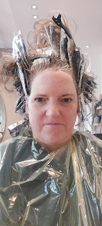

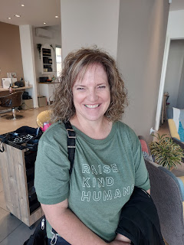

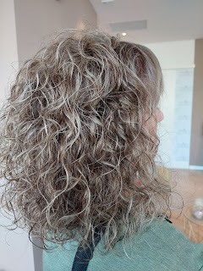

Antonella took all of these photos, ha ha. She runs the salon and is quite a ball of energy!! She has her many minions doing several tasks all day - shampoos, cuts, colors, styling, etc. Meanwhile, she is greeting everyone, scheduling appointments, answering questions, and doing several haircuts of her own, even styling clients' hair as well. She is everywhere all at once, ha ha. She is super friendly and when she smiles, she lights up the room.

Antonella took a bunch of pictures so we could share the experience with Tessa, my hairstylist back in Idaho Falls. Tessa was so happy to be a part of everything! :)

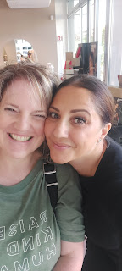

I'm going to try to post an audio clip that she left on my Whatsapp messaging so you can hear just how darling she is with her Italian accent. (hopefully this link works . . . ) (51 seconds)

https://drive.google.com/file/d/1-9oDSd4oJwGHpk0FFimkeLWwzCY7h6dr/view?usp=sharing

That, of course, was the main event on Wednesday. The rest of the afternoon and evening were spent getting a few groceries, preparing a meal, and relaxing with Scott in the evening.

On Friday, I worked on Avery's Quiet Book for a good portion of the day. I opened up my new sewing machine and put it to work for the first time. Everything works great! I'm having a good time working on the last couple of activity pages for her . . . and I'm hopeful that it will all be done in time for her birthday in one month.

I also worked on my primary lesson for the 5-6 year old class at church, and did some family history research, too. Our Bishop's wife, Katie, asked me earlier in the week if I could teach her primary class for the next 6 weeks. She had a family emergency back in the United States and needed to leave right away and won't be back for about 6 weeks. Their oldest son is really struggling at college and needs some family support for a while. I told her I was happy to help her out with her class and she was so grateful.

That evening, Scott took me out to dinner. During the summer months that I was home in Idaho, he loaned our Peugot station wagon to one of his buddies at work. Their car had been in an accident and was not driveable, and would not be driveable for some time. It worked out nicely that we had this extra car to share with their family, since I was gone. Just before I came back over to Italy, his friend brought the car back to us along with several gift cards as a token of their appreciation. One of those gift cards was for a nearby restaurant - a favorite of theirs - so that's where we chose to go for dinner.

As we were about to enter the restaurant, we happened to run into this friend's wife, Andrea. They live closeby and always order pizza from this same family restaurant every Friday night. It was nice to meet her in person for the first time. She is super cute and super friendly. I think we are going to be good friends. Her husband is gone on a deployment right now, so we chatted for a bit before Scott and I went inside to sit down.

We were greeted several times by all the employees as we were led through the restaurant to our table. It was so nice to hear "Buona sera" over and over. We felt really special and welcomed.

We ordered mussels for an appetizer, and they brought out some adorable bibs for us to wear. They even offered to help us put them on, ha ha. The mussels were sitting in a large bowl with a tomato-based broth in the bottom. We found that if we dipped the mussel meat into the broth it made them taste oh-so-amazing!!

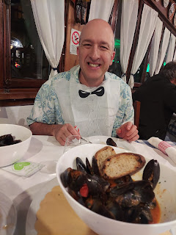

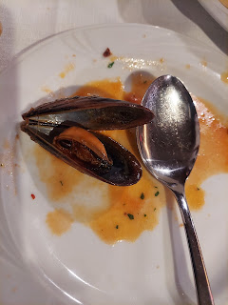

I ordered grilled tuna with a balsamic glaze. It came with some fries and buttered spinach on the side.

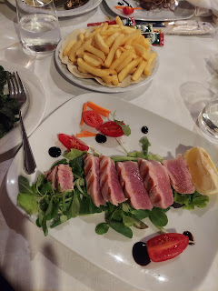

Scott ordered the steak with fried onions on top, with an artsy smear of balsamic glaze on the side.

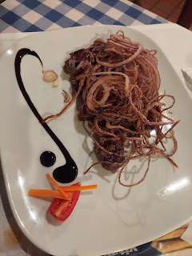

The food was very delicious and we were happy with what we chose.

Saturday was the best day of the week for sure! We slept in a little bit, which was nice, and then we headed up into the mountains north of us to visit a darling little town called Asiago. The population is roughly 6,500. It is just the cutest, most charming little place!!

It only takes just over an hour to get to Asiago from our house, but boy is it an exciting drive! There are multiple switchbacks and the views are breathtaking. I couldn't get a good picture of the expansive views of the valleys below because of the guard rail that was blocking my view . . . but I suppose having a guard rail is more important than me needing a picture.

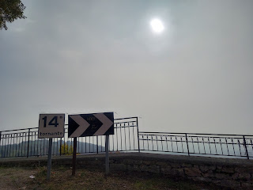

Here are some photos of our drive through the beautiful fall foliage that is up in the mountains right now.

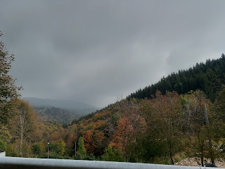

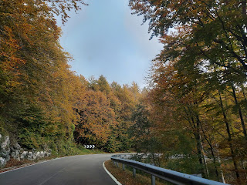

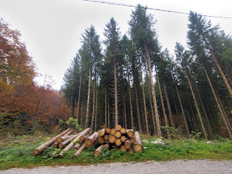

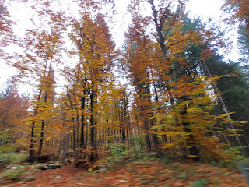

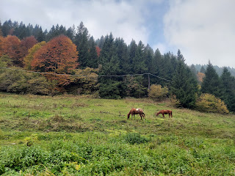

As I crept closer to the third horse, he got skittish and started trotting away. He was so handsome though!

Video of the horse and the surrounding hillsides: (18 seconds)
https://photos.app.goo.gl/4iaA9g7FihHEtJ7cA

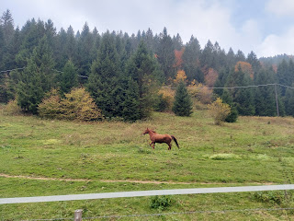

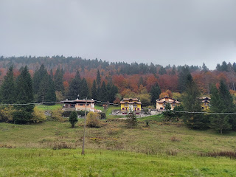

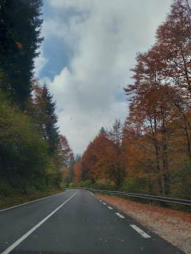

Coming into Asiago, it was every bit the charming town that I had anticipated. Something that I didn't anticipate was how much of an Austrian influence the houses would have. After I learned last week that Italy didn't become Italy until 1861, other bits of history are starting to make more sense now. The Austro-Hungarian empire had a big influence in this region through many centuries, which is evident in the architecture of Asiago, high up in the mountains.

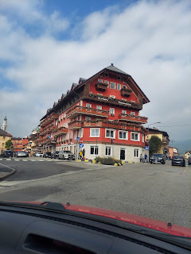

I noticed the interesting balcony on this next house as we were parking our car. Very cool.

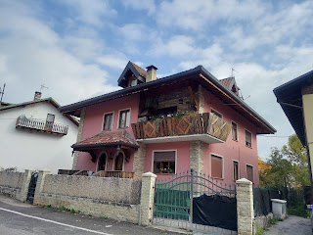

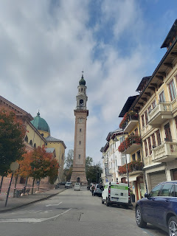

We walked around the corner and found a pizzeria for lunch before we began our hike. I finally found some Italian pizza that I ACTUALLY LIKED!! Most of the pizza here is so plain and unenjoyable. It usually needs some good seasonings in the sauce, like oregano, Italian seasoning, or just some good old fashioned salt. But this pizza was full of flavor and very unique as well because it had a fried egg on top!!
The long white pieces are asparagus. There are also mushrooms, ham and cheese. (*Our friends later explained to us that the Italians do some sort of storing process with the asparagus that prevents it from turning green. I'll have to look into that . . .)

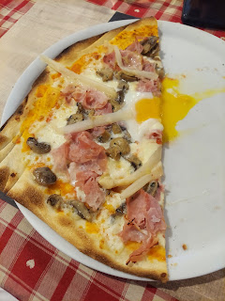

Across the street from the pizzeria is this giant park, "Parco Millepini Asiago". I can't wait to bring our grandchildren here in the spring!

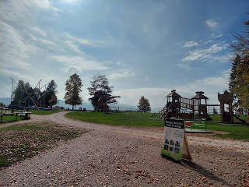

In addition to the usual play structures, there is a bungee area with trampolines underneath each person's harness . . .

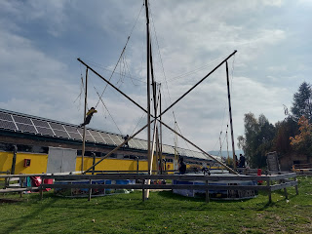

There is also a zipline and plenty of room to roam.

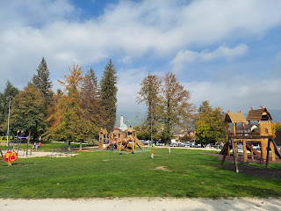

This also happened to be the starting point for our hike: Strada del Vecchio Trenino. Road of the Old Little Train.

The railway began in 1910 as a way to transport people and goods to and from the high plateau. It connected 4 communities together, but could only travel up to 10 km per hour . . . Due to war and the introduction of more modern methods of transport, it was discontinued in 1958. Later the tracks were converted into a hiking/biking path which is enjoyed by many people throughout the year.

In the center of the Park, we passed this monument as we began on the trail.

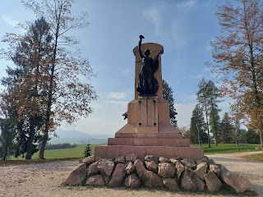

The countryside was just exquisite . . .

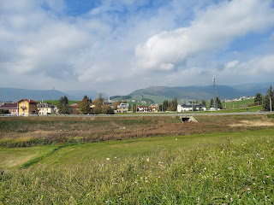

We began where the little red marker is pointing on the yellow trail.

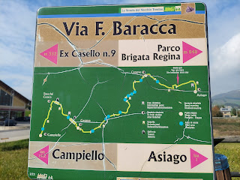

Alpine horses frolicking in the meadow . . .

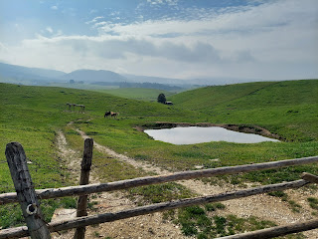

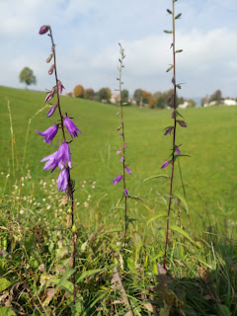

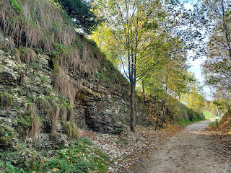

First town on the way: Canove. We walked past an old train station that is now connected to a small park.

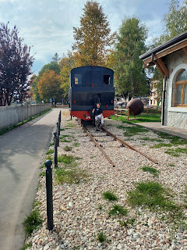

Outside the old station there are some WWII artifacts, such as these salvaged ammunition pieces.

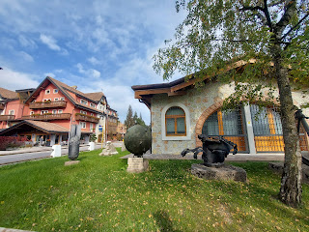

Beautiful fall colors everywhere!

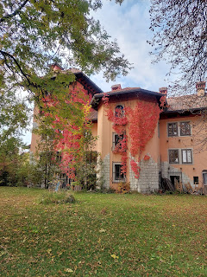

A cute touristy train came tooting along the path at one point, full of passengers: (19 seconds)
https://photos.app.goo.gl/9nFmoVhPAeFsewS66

In Canove, we walked past a fun little fall festival going on.

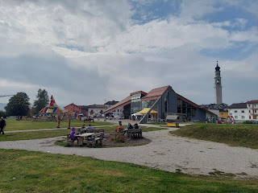

There was a petting zoo . . .

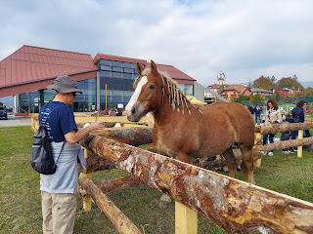

And the largest chicken jumping house I've ever seen . . . actually, it's the first and only CHICKEN jumping house that I've ever seen . . .

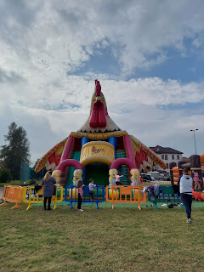

Another beautiful WWI Memorial. We saw this memorial down the street from the path we were on, but we made the short detour to see it up close.

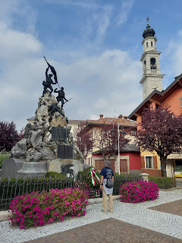

On our way back to the path . . . such bright colors!

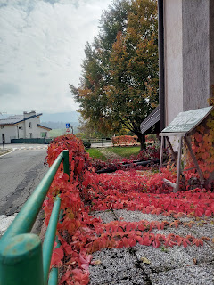

Since the Trail is not a circular route, we decided to just walk until we felt like we had had enough, and then we'd turn around and head back. We walked for about 90 minutes to see what we could see . . .

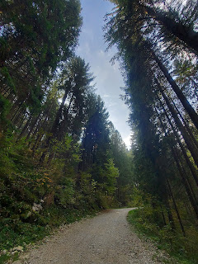

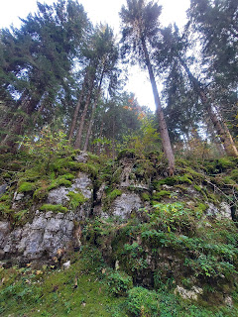

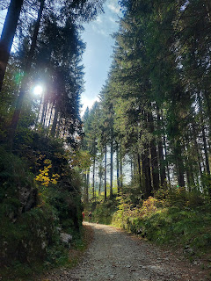

We made it about halfway before tiring. I was hoping to make it to the 2 railway tunnels, but they were at the other end of the trail. It's about 12 km one way if you go from one end to the other.

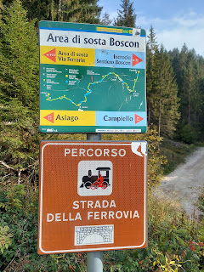

Instead, we sat on a bench for a while, just soaking in the 58 degrees of sunshine, the peace and quiet of the forest, and the occasional tourist train going by.

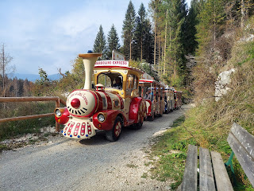

Scott found a different way for us to get back to our car, using Google Maps as our guide. It took us through the countryside instead of through the forest and the little towns.

Of course, that also meant we would be walking where all the cows have also walked recently . . .

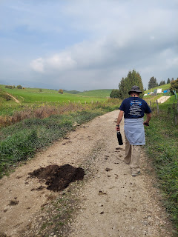

Up on this far ridge, there was a white horse and maybe 3-4 cows. See if you can spot them . . .

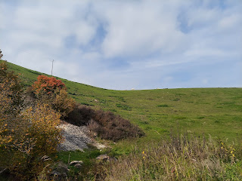

I've noticed in Italy, that when there is a special occasion, the family home is lined with ribbon bows, such as this one below. Our friends in Vicenza just recently had a baby, and when we went to see them Friday night, their house had several blue ribbon bows along their gate and around their property. I was like, Ohhh! I get it now . . . they had a baby BOY so that's why there are blue bows on display! It all makes sense now. So when I saw this house near Asiago, I figured they must have had a little boy recently as well.

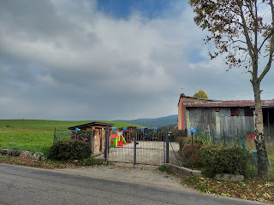

Some alpine moo-cows. :)

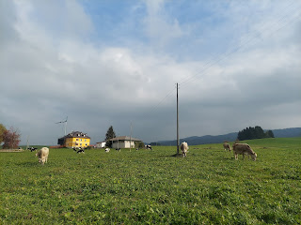

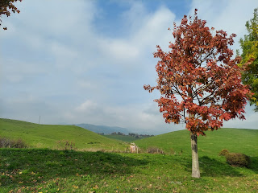

There are signs in Italy that indicate if you are IN the city limits or not. If you leave the city limits of Asiago, as shown below, the sign will have a red slash through the name of the town to indicate you are now leaving that municipality.

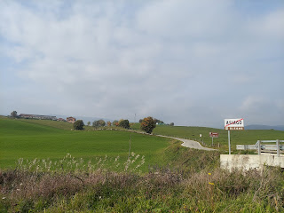

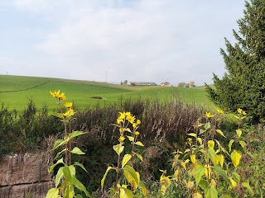

As we got closer to Asiago, we noticed a HUGE monument off in the distance. (click on the photo to zoom in) I remembered reading about a WWI Memorial in town and wondered if this was the same one.

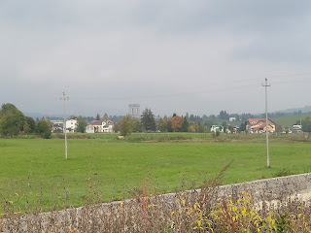

After we made it back to our car, we drove less than 5 minutes and parked below the monument.

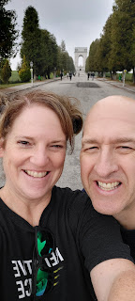

It is a LOOONG path on a steady incline up to the monument, but there is symbolism in that . . . When Scott was mumbling under his breath, I suggested that maybe this was intentional. We have to suffer at least a little bit, considering all that these soldiers did over a hundred years ago.

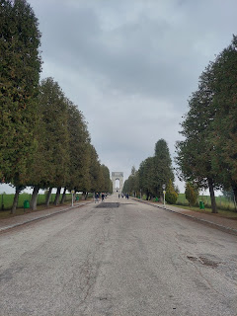

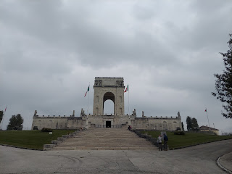

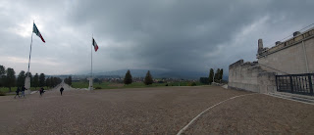

Short video of Asiago as seen from the height of the monument: (25 seconds)
https://photos.app.goo.gl/GwdxHjrrL39oVXv17

We went inside and had to pause to take it all in. This was truly one of the most beautiful and magnificent military memorials we have ever seen!! It was divided into several large corridors, with really long rows of name after name on individual plaques.

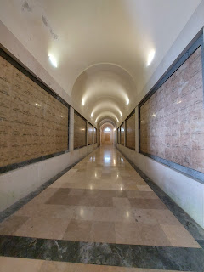

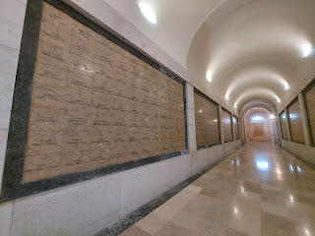

Scott noted that on the map when we first walked in, there didn't appear to be anything behind the names, just some large "empty" blocks behind the names. He wondered if there was anything inside . . . (more on that in a minute)

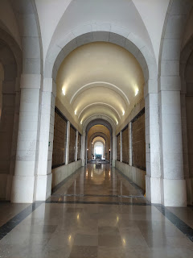

Beauty everywhere, in spite of the reason why the Memorial was built in the first place.

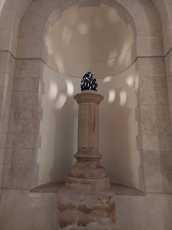

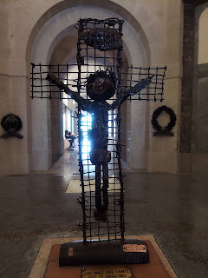

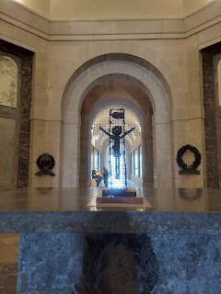

There were rooms located on the right and the left as we first walked in. The room on the right was dedicated to the history and artifacts from 1915-1916. The room on the left was more of the same, but focused on the years 1917-1918.

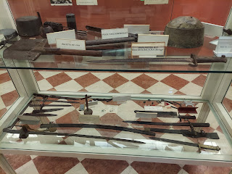

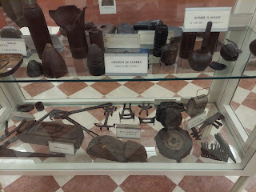

I wish that I could have read the Italian words on everything, but instead I just focused on the faces. Those tell a story of their own. A somber story, but one of beauty and sacrifice.

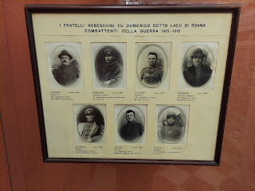

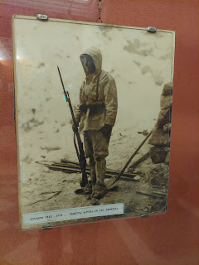

At the opposite end is an open door that draws your eyes to the surrounding pastural farmlands. They quietly offer a subtle peace, a feeling of healing, and a hope in the future.

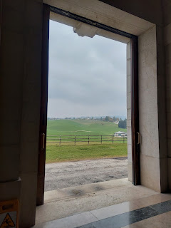

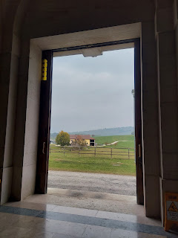

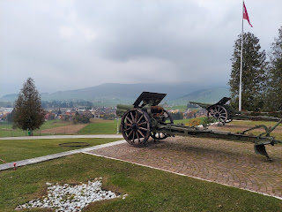

As we left the Memorial and started walking back down the hill to our car, we noticed this sign off to the side. There was another gravel hiking trail that began there and I was curious where it led to.

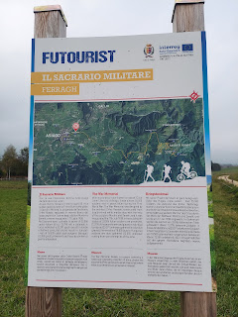

That's when we got an answer to Scott's earlier question of what else might be taking up so much space within the walls of the Memorial. Thank goodness for an explanation that was in ENGLISH!!

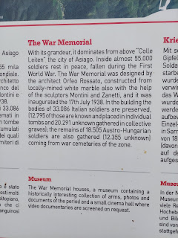

Wow. That made our experience even more special to learn those important details!!

Our last stop in Asiago was to visit the Cheese Factory. We had walked right past it earlier as we made our way back to our car after that long hike, but didn't realize what it was at the time.

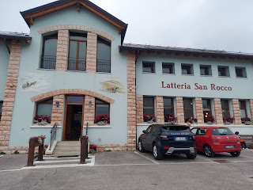

As soon as you step inside, you are invited to take a little paper ticket with a number on it. Then you wait for your number to be called. We grabbed one and noted that our number was "58". As we stepped into the lobby where all the clientele were being helped with their purchases, I saw that number "57" was currently being served. Yikes!! That meant that we were next and we were still just trying to get our bearings . . .

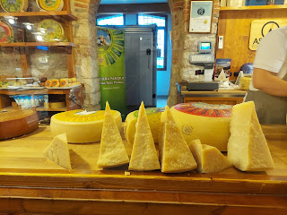

Thankfully we had a couple minutes to get our act together before our number was called. We had no idea what flavors any of the cheeses had to offer - how strong or mild they might be. But we figured you can't go wrong with choosing a basic Asiago cheese. Still, there were multiple types of Asiago cheeses . . . goodness gracious.

It was our turn now, so we pointed to the poster on the wall and indicated that we wanted some of the Asiago Alpine Grun cheese, even though we had no idea what it was, ha ha. The girl helping us spoke zero English, so she just indicated with her sharp knife on the giant cheese wedge to see if that was a good amount for us. Looked good to me!

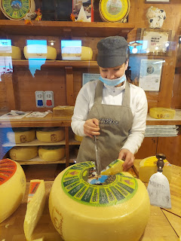

She wrapped it up for us and rang us up at the register. I asked her to add in a little container of something called "Crema di Asiago" that was behind the glass case next to the cashier. Again, I had no idea what it was, but hey, I was feeling adventurous! The wedge of cheese cost us $6.50 and the "crema" was another $2.70.

The next day, when I gave them each a try, I definitely enjoyed the Asiago cheese. It's very mild and would go very nicely with grapes, if they were still in season. I'll have to pair them with apple slices instead.

The "Crema di Asiago" was interesting . . . I didn't like it as much. It's supposed to be like a cream cheese, but it was pretty soft, almost like spreading a thick Cool Whip onto your cracker. It didn't have a lot of flavor either, but when I dipped some garlic/butter croutons into it, wow, now that was tasty! That's when I realized that maybe I'm supposed to flavor the cream cheese with herbs and spices to my own liking and they just provided me with a base of sorts. I'll have to do some experimenting in the next few days. :)

In the brochure (in English!) that I picked up before leaving, I learned that Asiago, Italy is literally where Asiago cheese came from originally!! They have also won numerous international awards for their alpine cheeses, some of the finest in the world!! Wow. I'm so impressed.

And then we drove home to Vicenza.

Coming back down the mountain, and seeing again just how high up we were, was nuts!! If there was somewhere safe to pull over and get a photo, I would have done it. I saw one place that could be a possibility for next time though.

Not my best shot, but here is a glimpse of a vineyard as we sped around a curve coming down into the valley.

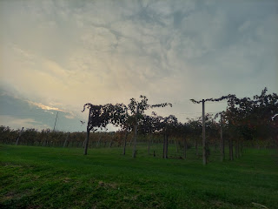

On Sunday, I began teaching the 5-6 year olds in Primary for the next 6 weeks. The 25 minutes of class time went really well, and the 4 children that came are super cute. One of the boys, Noah, might be a little tricky in the coming weeks. He had some interesting (and disturbing) things to say and I think he might be heavily influenced by video games at home, making it more difficult for him to separate fantasy from reality.

After church, Scott and I worked together in the kitchen to prepare a meal to drop off for the Bishop (since his wife is gone for a while) and we also made a separate dessert to take to dinner at the Parkers later that evening.

We made "Cheesy Beef and Rice", a favorite of Scott's for several years. You brown some ground beef, sautee some rice/shredded carrots/fresh garlic, and then add beef broth and seasonings and simmer for a few minutes. Put it all together, and then bake it in the oven (covered) for about 45 minutes. Take off the foil and add some shredded cheese on top and bake until the cheese is all melty. It's SO GOOD. We made a double batch so that the Bishop could have a nice meal this week with his 2 older kids that are still here in Italy. (His wife took the 2 youngest children with her back to the U.S. since she was home-schooliing them.)

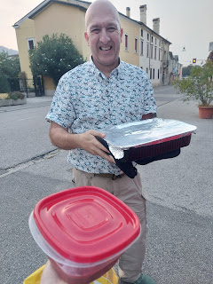

We also brought them some fresh salsa that we made on Friday night, along with a bag of tortilla chips.

Then we drove up one of the many hills surrounding Vicenza to have dinner with the Parkers. They had also invited the sister missionaries to join us. We sat outside on their comfortable porch as the sun set and dusk settled in. It was lovely.

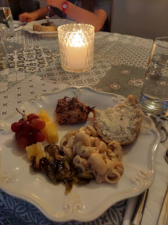

Kevin grilled some chicken, while Marnie made some fresh homemade bread, pasta with cannelini beans (popular here in Italy) and melted Parmesan, roasted Brussels sprouts, and fresh fruit. It was super yummy!

For dessert, I made my layered pudding dessert again, since it was such a hit when the Garners were here.

Recipe can be found here:
https://photos.app.goo.gl/ybGtLLrQG52FJ5oJ8

We laughed and told lots of stories together. Before we left, the sister missionaries shared a nice message about being converted to the Gospel of Jesus Christ - what it means to be converted, how to stay converted, and how to help others in their conversion process.

As part of my own conversion, I am trying to listen closely to the Holy Ghost when He speaks to me. To be converted, in my mind, means to make whatever lifestyle changes are needed in order to follow the Savior Jesus Christ. It's more important to follow Him than to worry about what anyone else thinks of me. I'm okay to stand out, to be different, and to stand on my own if it means that I am following Jesus Christ. Ultimately, I want to "impress" my Father in Heaven and His Son, Jesus Christ by doing what is right as much as possible.

I feel like I have been converted many times in my life. Typically I have been moved to do something life-changing, such as finding a new group of friends to surround myself with, or start going back to church (after I stopped going for a few months), or make reading my scriptures a daily habit. Other times, while still life-changing, the act itself was a seemingly small thing.

For example, when I was in Virginia back in February of 2020 on my big family history tour up the East Coast. I was staying with an AirBnB host who also happened to be a Baptist minister. He corralled me into a lengthy and intimidating "discussion" (more like an interrogation) of what my religious beliefs were, and made me feel like I was in trouble the entire time. I was very upset afterwards, wondering yet again why people even do this! I would never make someone feel like their religious beliefs are wrong!! Instead, I'm always interested in finding out what they believe and I try to gain some understanding. I am naturally curious and I like to learn about other cultures, religions, and belief systems.

The life-changing moment came the following day when I encountered someone else . . . I went into the "Oldest (brick) Church in the U.S." in Smithfield, Virginia (St. Luke's Church). A lady greeted me as I inquired when the next tour was due to begin. She asked where I was from, and when I told her I was from Idaho, she was surprised as to why I would be all the way across the country in tiny little Smithfield, VA. I shared that I was doing family history and visiting some of the places where my ancestors used to live.

That's when she launched into a mini tirade about "those Mormons" and why are they so obsessed with family history, etc. As she went on and on, I heard the Holy Ghost whisper to me to open my mouth. I didn't really want to say
anything
after the grilling I had received the night before from my AirBnB host. But after some patient and loving promptings, I finally did open my mouth to share what I believe. I told the lady that I am a Mormon, even though that's just a nickname and that the real name of our church is The Church of Jesus Christ of Latter-day Saints. I told her that we believe in the power of families, that we are all part of God's eternal family, and that we believe in finding out who our family members are and the strength that comes from being gathered and connected, identified and known.

She was instantly contrite and apologetic, which surprised me. I told her it was no problem. But that was a life-changing moment for me.
A conversion
. I learned that things aren't always perfect when people have different beliefs, and that there will be times where my beliefs will be put under the microscope. I ought not to shut down completely and put my head in the sand, but instead I need to trust in God, in Jesus Christ, and in the Holy Ghost to help me, to inspire me, and to teach me what to do in those moments.

