**Home Page**

Improve the layout of these pages. It looks messy and scattered. Improve the alignment of text and pictures. Add background matching color instead of simple white.

Change logo and name and make logo picture large   
New name : Auptimally

Logo picture : change to picture 1

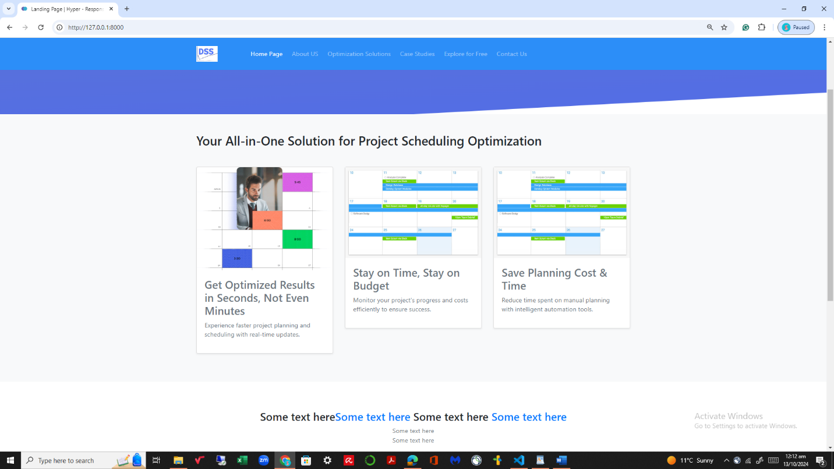

Change this picture to picture 2

Replace this with following text :

Do you know large scale scheduling and resource assignment problems are NP hard means computationally difficult to solve but it can be solved quickly by our latest optimization methods

Only first letter should be in higher case

Replace 3rd point with this text:

Generate scheduling and resources utilization optimal plan via dashboard in seconds

Add text in 5th point:

User friendly software ,simple excel file input and get results output in excel file

Add new 6 point:

Customize your model and constraint based on your own requirements

Replace all these symbols with picture 3

**About Us page**

Improve the layout of these pages. It looks messy and scattered. Improve the alignment of text and pictures. Add background matching color instead of simple white.

**Who We Are?**

**Auptimally** is composed of seasoned researchers and industry experts dedicated to delivering advanced project scheduling and resource optimization solutions. Our team combines practical experience with cutting-edge research to tackle complex, NP-hard problems in industries such as construction, workforce management, equipment allocation, and project planning. We develop adaptable, user-friendly software designed to streamline operations, optimize resource use, and ensure projects are completed on time and within budget. Our mission is to provide organizations with the tools needed to enhance efficiency and meet their project goals effectively.

Add picture 4

**What We Do?**

At **Auptimally**, we develop powerful SaaS software to optimize project scheduling and resource management. Efficiently managing resources—people, fuel, materials—within business constraints requires testing multiple scenarios. Our software bridges the gap between efficiency and adaptability, delivering robust, explainable, and responsive plans. With our simple, fast method, our customers can generate and manage optimal resource plans effortlessly.

Add picture 5

**How We Do It?**

We have developed our solutions using a series of sophisticated and advanced technologies and methods such as Optimization, Genetic Algorithms (GA) and other Heuristics to deliver the best possible optimal solutions for your Projects Planning.

Add picture 6

**Optimization Solutions page**

Improve the layout of these pages. It looks messy and scattered. Improve the alignment of text and pictures. Add background matching color instead of simple white.

1. Input your data
2. Run the optimization model
3. Get results in dashboard fast
4. Download the optimized schedule and resources calendar

Use pictures from your update software based on the step

**Case Studies**

Add background matching color instead of simple white.

Link is missing of these case studies

1. Link *Hybrid Approach To Minimize Construction Project Delays* case study with this

https://www.etsmtl.ca/en/news/hybrid-approach-to-minimize-construction-project-delays

1. Link *Optimization Model Based on Business Process Re-engineering*  case study with this

https://iglc.net/Papers/Details/2137

1. Link Impacts of *Multi-skills on Project Productivity and Completion Time*  with this

<https://doi.org/10.22260/ISARC2024/0042>

**Explore for Free**

Add background matching color instead of simple white.

Free trial : $0 for one week

The Universal Plan is $49/month

For Customize Plan : Contact us (no need to mention price)

Remove the space between lines , make it professional

**Contact Us page**

Improve the layout of these pages. It looks messy and scattered. Improve the alignment of text and pictures. Add background matching color instead of simple white.

Muhammad Atiq Ur Rehman, the founder of Auptimally, holds a PhD from École de technologie supérieure in Montreal. With around 8 years of professional experience in the supply chain industry, he specializes in developing mathematical optimization applications for supply chain management and scheduling. His expertise in applying optimization techniques to real-world problems has been integral in creating Auptimally's cutting-edge SaaS software. In addition to his professional achievements, Atiq values spending time with his family, maintaining a balance between his career and personal life.

Use picture 7 for founder

Auptimally is situated in Montreal, a vibrant hub of innovation in North America. Known for its thriving tech ecosystem and strong support for startups, Montreal provides unparalleled access to world-class talent, research institutions, and industry networks. The city's strategic location offers a gateway to both the U.S. and European markets, making it an ideal place for companies looking to expand globally. This dynamic environment enables Auptimally to stay at the forefront of technological advancements, ensuring cutting-edge solutions for our clients.

Use picture 8

**Get in Touch:**  
Have questions or need a custom solution? Reach out to us anytime, and we’ll be happy to assist you.

**Email Address:** customerfirst@auptimally.ca

**Contact:** +1 514-699-9050

**Office Address:** 355 Peel St, Montreal, Quebec H3C 2G9, Canada

**Office Time:** 9:00AM To 6:00PM

For your idea

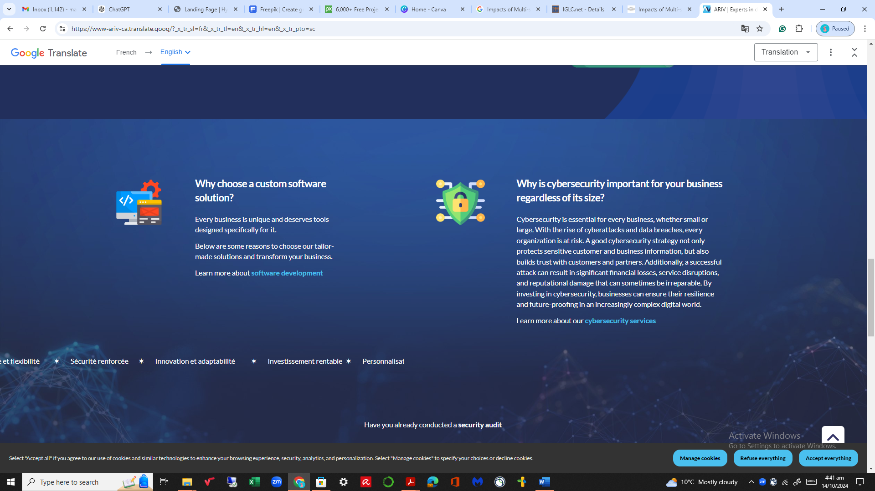

Look at the alignment of this website

Choose this background color theme and text alignment like of this website

<https://www.ariv.ca/>

**For Software**

**For sign up subscription and software , do all the changes that we discussed in our last meeting.**