**Investigating the persistence of Fe-P in lake sediment under sulfidic conditions**

Harm van Kuppevelt12*, Michael Hupfer­12, Ugo Marzocchi3

* harm.van.kuppevelt@igb-berlin.de

1 Leibniz Institute of Freshwater Ecology and Inland Fisheries, Müggelseedamm 301, 12587 Berlin, Germany

2 Brandenburg University of Technology Cottbus-Senftenberg, Platz der Deutschen Einheit 1, 03046 Cottbus, Germany

3 Center for Water Technology (WATEC), Department of Biology, Aarhus University, Ole Worms Allé 3, Building 1171, 8000 Aarhus C, Denmark

# Abstract

# Introduction

Eutrophication remains a critical environmental challenge for freshwater ecosystems globally, primarily driven by excess nutrient inputs that lead to algal blooms, hypoxia, and overall degradation of water quality (Ansari and Gill, 2014; Correll, 1998). Effective management of these nutrient levels is pivotal for the restoration and preservation of aquatic environments. Phosphorus (P) is often a limiting nutrient in these systems, and its management is crucial in curbing eutrophic conditions. While traditional approaches have focused on mitigating external sources of P such as agricultural runoff and urban wastewater, the complexity and persistence of internal P sources within lake sediments also require attention (Tammeorg et al., 2024).

The internal cycling of phosphorus is influenced significantly by the interactions between iron (Fe) and sulfur (S) within the sediment. In oxygenated conditions, phosphorus can bind with iron hydroxides to form stable complexes, which act as sinks for phosphorus in the sediment (Gunnars et al., 2002). However, under reducing conditions, these iron-bound phosphates can become unstable and release phosphorus back into the water column (Hupfer and Lewandowski, 2008). This dynamic is further complicated by the presence of vivianite (Fe(II)3(PO4)2·8H2O), a mineral that can sequester phosphorus effectively under certain conditions (Rothe et al., 2016).

Vivianite is particularly interesting due to its ability to store phosphorus in anoxic sediments, potentially serving as a long-term P sink in eutrophic systems. However, the formation and stability of vivianite are influenced by a variety of factors including the availability of Fe(II), the presence of sulfides, and microbial activity (Dijkstra et al., 2018; Rothe et al., 2016). Notably, the interaction between vivianite and sulfides poses a significant challenge to its stability. In sulfidic conditions, the reaction of sulfide with iron from vivianite can lead to the release of phosphorus, thus reducing the effectiveness of vivianite as a phosphorus sink and potentially exacerbating eutrophic conditions (Wilfert et al., 2020).

Sediment samples providing a high contrast for experimental treatments involving iron. Experiments with iron amendment by Heinrich et al. (2020) demonstrated a transformation to vivianite within months timeframe under anoxic conditions

Our study addresses a critical gap in understanding the limiting effect of vivianite sulfidation on the effectiveness of iron amendments in freshwater sediments. By investigating the fate of vivianite under controlled, high sulfidic conditions, we aim to elucidate the mechanisms by which sulfide interactions may mobilize phosphorus from iron-bound reserves in sediments. This knowledge is crucial for developing strategies to manage internal phosphorus loads in lakes, particularly in the context of iron-based remediation strategies which may inadvertently promote sulfide production and phosphorus release if not properly managed. This investigation employs a combination of field sampling and controlled mesocosm experiments to simulate and observe the interactions between iron, sulfur, and phosphorus in sediments under varying redox conditions, providing insights into the complex biogeochemical processes that regulate nutrient cycling in aquatic systems.

# Material and Methods

## Sediment Collection

Sediment samples were collected in May 2023 from lake Langer see (N52.24333 °, E13.78805 °), a shallow eutrophic freshwater lake in Eastern Germany characterized by its low iron content and high primary productivity, chosen after Heinrich et al. (2020) A piston corer with diameter of 6cm was used to collect sediment cores at a water depth of 3.4 m. Surface sediments from the top 3 cm were pooled, gathering a total of 2L of sediment. The sediment was processed in the laboratory the same day.

## Iron amendment

Iron amendment and subsequent anoxic incubation stimulating vivianite formation was done following the method described by Heinrich et al. (2020). Amorphous iron hydroxide (FerroSorp® Plus) was powdered using an agate mortar and pestle, and 10.1 g was suspended in a solution of 9.73 g NaH2PO4•2H2O in ultrapure water. The suspension was mixed for 2 days, then centrifuged and washed 9 times with ultrapure water to remove all P from the water. The phosphate-loaded iron hydroxide (Fe-P) was suspended in 125mL ultrapure water, and directly used for sediment treatment. 1 L of mixed sediment was enriched with 70 mL of Fe-P suspension. The sediment was incubated within a closed 1L bottle filled completely with sediment. A control setup included another sediment bottle without Fe-P treatment. The containers were placed air tight jars with oxygen absorption satchels, and stored in a nitrogen filled glovebox (O2 <1%) to ensure anoxic conditions during incubation. Periodically, the bottles were mixed, subsamples were taken under N2 atmosphere and analyzed by sequential extraction to monitor Fe-P transformation. After 42 days of anoxic incubation, final subsamples were taken and the sediment processed for the subsequent incubation procedure.

## Incubation Procedure

All water mentioned in this section was artificial lake water, unless otherwise specified. The composition of the water was loosely based on the chemical composition of lake Langer see surface water, and made from a 1000× dilution of a stock solution (MgCl2•6H2O: 81.386 g; CaCl3•2H2O: 125.030 g; KHCO3: 20.150 g; NaHCO3: 120.111 g) (Smith et al., 2002)

The treated and untreated sediments were distributed over 10 tubes (6cm diameter, 10cm height) as follows (Fig. 2A): first, untreated sediment was filled up to a height of 4cm above a movable rubber stopper, then 2 cm of treated sediment was carefully spooned on top of the first layer, and the rest of the tube was slowly filled with water. The tubes were placed in two identical 20L aquaria, 5 replicates in each aquarium, which were subsequently filled with 15L water. Overlying water in one aquarium was enriched with sulfate (added 150 mL 0.1M NaSO4 in Millipore water; target concentration 1mM sulfate), simulating high sulfidic conditions, while the other aquarium served as control without added sulfate. The water was kept aerated and flowing by a gentle stream of air produced by aquarium pumps, ensuring a homogeneous water body without disturbing the sediment surface.

The next day, when the sediment had settled in the tubes, the bottom the sediment was carefully pushed up to 0.5cm below the upper rim, for better water flow above the sediment and easier access for in-situ porewater analysis directly after. Finally, diffusive gradient in thinfilm (DGT; LSPX-NP, DGT® research) for capturing Fe and P were inserted in 4 of the replicate tubes in each aquarium, leaving the fifth sediment tube undisturbed.

The tubes were left incubating over a period of 98 days within a climate chamber of ? °C, under mostly dark conditions to prevent primary production in the water body. After respectively 20 and 62 days, progress was monitored by porewater analysis, and the subsequent sacrifice of one sediment tube with DGT per treatment. At the end of the experiment, the porewater was again analyzed, and the final 2×3 tubes were processed.

## Microsensor and DGT Profiling

Porewater conditions were monitored using microsensors capable of measuring oxygen (O2), hydrogen sulfide (H2S), and pH levels at micro resolution (UNISENSE; O2, SULF, pH). The sensor tips were positioned on the sediment-water interface with help of a stereoscope, and moved to a different position on the sediment after each profile. Profiles were taken by measuring the concentration at increasing depth from 1cm above to max 4 cm below the sediment with intervals of 250µm, measuring each interval for 2s after 2s equilibrium waiting time.

DGT probes were employed to capture porewater release of P and Fe, by accumulation of both species in a mixed chelex/titanium oxide binding layer. The probes where handled and processed following the guidelines of the manufacturer (DGT® research). All probes were placed upright in the sediment at the beginning of the experiment (Fig. 2B), and retrieved at different timepoints. After retrieving the DGTs from the sediment, they were rinsed and sliced in 0.5cm intervals before processing the gel by soaking in 1M HNO3 and 1M NaOH, respectively. The NaOH extracts were measured for P, while the final timestep was also measured for Fe content by analyzing the HNO3 extract.

## Sediment Processing

Sediment at different timesteps was processed for detailed solid phase analysis. The sediment from the tubes was sliced in 0.6cm intervals and collected in 50mL falcon tubes and homogenized. Sediment slices as well as the starting treated and untreated sediments were preserved by freezing at -20 °C for less than a month before further processing. The sediment was thawed before subsampling for analysis by sequential extraction, and immediately refrozen. The final sediment samples were preserved by freeze-drying for subsequent analysis by X-ray Diffraction (XRD) and scanning electron microscopy (SEM). Total P, Fe and other relevant metals such as magnesium (Mg), manganese (Mn) and calcium (Ca) were determined by digesting a subsample (50-100mg) in a 1:3 vol/vol mixture of concentrated HCl and HNO3, and analyzing the digestate.

## Analytical Methods

### P Sequential extraction

### Scanning Electron Microscopy

### X-ray diffraction

### Spectroscopic methods

Soluble reactive phosphorus (SRP) was quantified photometrically at 880nm using the molybdenum blue method, the extracts of the sequential extraction were measured in 1cm cuvettes on a ? spectrophotometer, while the DGT extracts were measured for P using ? well microplate photometry. Total phosphorus in the extracts were measured the same way after digesting 4mL of extract with 1mL 5 wt% K2S6O8.

Metals including Fe, Mg, Mn and Ca, as well as total P were measured using Inductively Coupled Plasma-Optical Emission Spectroscopy (ICP-OES), In the case of Fe determination in sequential extracts, atomic absorption spectroscopy (AAS) was used.

## Data Analysis

All data was processed in R.

Total sulfide (TS) concentrations in the porewater were calculated from the H2S and pH concentration profiles following:

$$[TS]=(\frac{{10}^{-pK_{a\left(H_{2}S\right)}}}{{10}^{-pH}}+1)×[H_{2}S]$$

Where [TS] and [H2S] are the concentrations of total sulfide and measured hydrogen sulfide respectively, pH the measured pH at the same depth, and pKa(H2S) the pKa of the acid base pare H2S and HS-.

# Results

A Fe/P molar ratio of 1.8 was determined in the Fe-P was estimated as 1.8, measured by ICP-OES

# Discussion

# Conclusion

# Acknowledgements

# References

Heinrich, L., Rothe, M., Braun, B., Hupfer, M., 2020. Transformation of redox-sensitive to redox-stable iron-bound phosphorus in anoxic lake sediments under laboratory conditions. Water Res. 189, 116609.

Smith, E.J., Davison, W., Hamilton-Taylor, J., 2002. Methods for preparing synthetic freshwaters. Water Res. 36, 1286–1296. https://doi.org/10.1016/S0043-1354(01)00341-4

# Figures

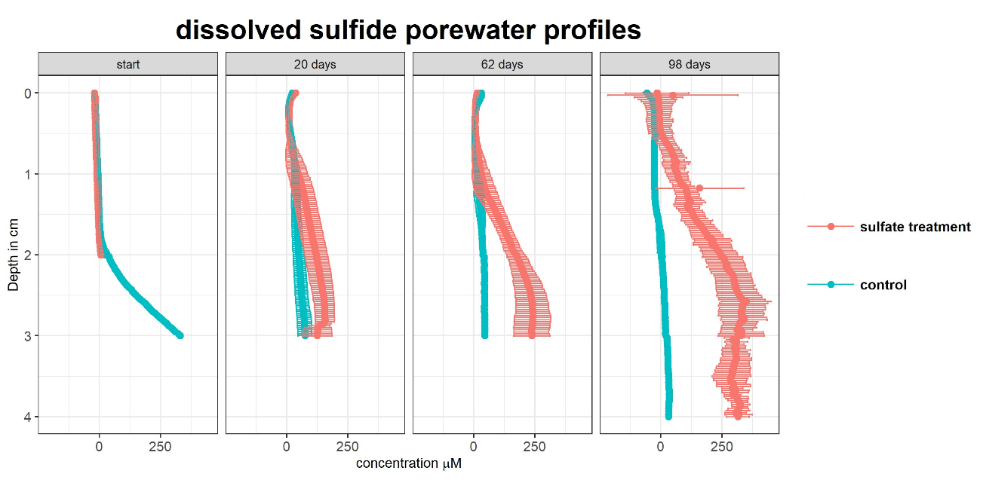

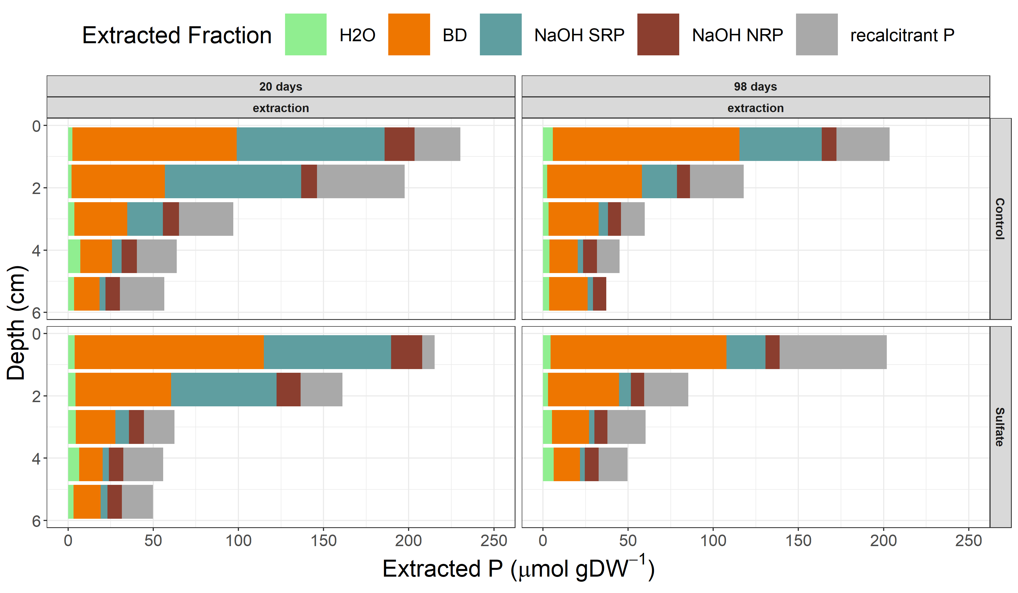

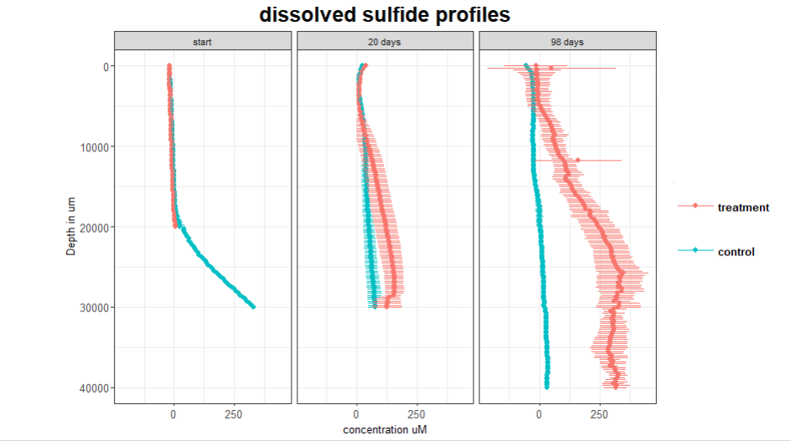

# Tables