Ames Housing Dataset
Regression problems
Outlier removal develops better regressive models
# Last amended: 14th Sep, 2026
# My folder: C:\Users\ashok\OneDrive\Documents\anomaly_detection\numericOutliers
# Virtual Machine: ubuntu_database
#GitHub site:
#KNIME Files:
a) outlierRemoval_ImprovingXgboost-I
b) outlierRemoval_ImprovingXgboost-II
c) outlierRemoval_ImprovingXgboost-III
Ref: This link Here
Contents
Approach 3
About the dataset 3
Start from here: 3
Chapter-I 4
1. Column name replacer 4
2. Resort column names for easy search: 4
3. Rule Engine 5
4. Column Filter 6
5. Metanode creation 6
Chapter-II 8
Chapter-III 9
Chapter-V 13
Chapter-VI 15
Chapter VII 16
Chapter VIII 18
Salary Dataset 19
More Datasets 19

T
his example shows how data pre-processing and outlier removal can increase predictive performance in a regressive model. We predict SalePrice in the AmesHousing dataset, in a step-by-step manner.
Out final model is as follows:
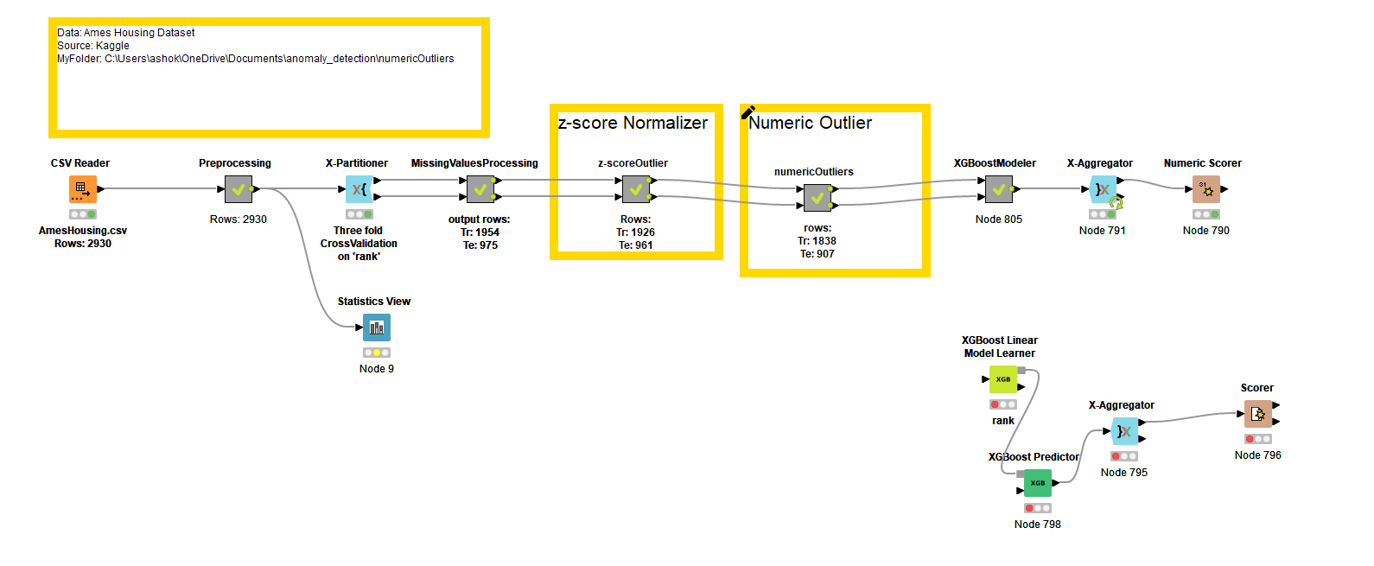
Result with 10-fold cross-validation:
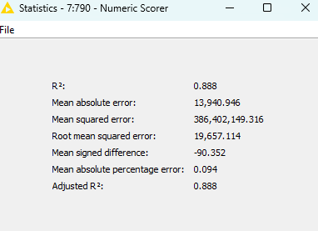

Approach
In a number of datasets for regression the target feature may have skewed distribution. Along with this, an important feature within the dataset may also have skewed distribution. In such cases, the approach of outlier removal as illustrated in this example may benefit predictive modelling.

About the dataset
The Ames Housing Dataset is a well-known dataset in the field of machine learning and data analysis. It contains various features and attributes of residential homes in Ames, Iowa, USA. The dataset is often used for regression tasks, particularly for predicting housing prices.
Here are some key details about the Ames Housing Dataset:
- Number of Instances: The dataset consists of 2,930 instances or observations.
- Number of Features: There are 79 different features or variables that describe various aspects of the residential properties.
- Target Variable: The target variable in the dataset is the "SalePrice," representing the sale price of the houses.
- Data Types: The features include both numerical and categorical variables, covering a wide range of aspects such as lot size, number of rooms, location, construction, and more.
The Ames Housing Dataset is widely used in the machine learning community for tasks such as regression modeling, feature engineering, and predictive analytics related to housing prices. It serves as a valuable resource for developing and testing machine learning algorithms and techniques in the real estate domain.

Start from here:
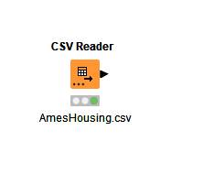

Chapter-I
Data Preprocessing
Go on adding these few pre-processing nodes. The nodes used are:
i) Column Name Replacer, ii) Column Resorter, iii) Rule Engine and iv) Column Filter.

Column name replacer
Remove spaces from all column names.
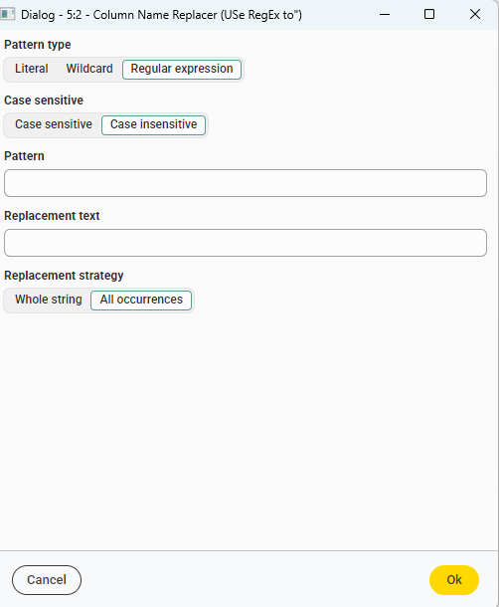
Figure 1: Select Regular Expression, Case Insensitive and All occurrences as here. Write a space in Pattern and nothing in Replacement Text. Clikc OK.

Resort column names for easy search:
We have a large number of columns. To quickly search them in various nodes, better they are listed in a sorted manner.
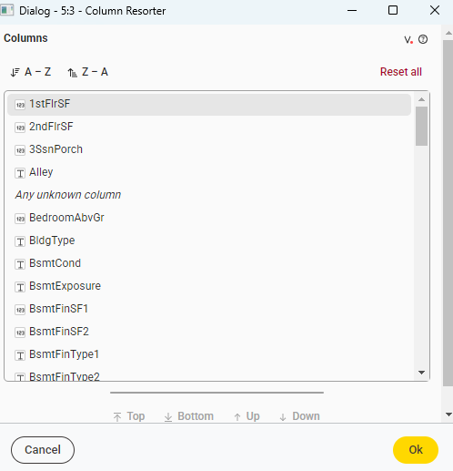
Figure 2: Click A-Z and click OK to order column names.

Rule Engine
Add a Rule Engine with to replace column ‘OverallCond with binary values and transform it into categorical feature. Call new node as ‘rank’. We will also test it as our another Target node for classification.
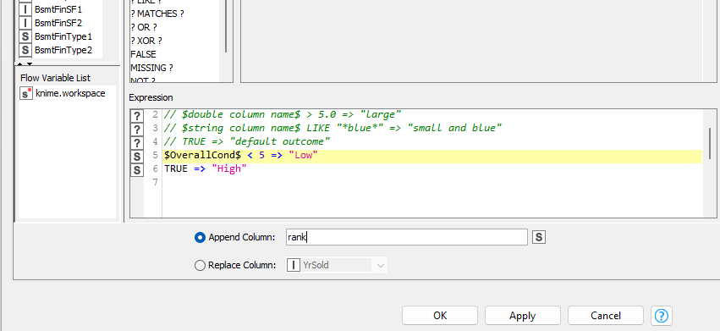
Figure 3: Name the new column as 'rank'. It is appended to existing columns
We name it as ‘rank’ column as our target for classification.
$OverallCond$ < 5 => "Low"
TRUE => "High"

Column Filter
Finally, we add a column filter node to filter out ‘OverallCond’, Id and ‘MSSubclass’ columns. ‘MSSubclass’ has high correlation with ‘rank’.

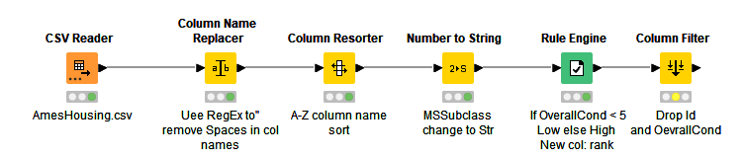

Metanode creation
We transform or bundle all but one starting node into Preprocessing metanode. Just select your nodes, right-click and click Create Metanode. Give it a name and you are done. If the output port is missing, proceed as below.
To add an outport port to Preprocessing node, right-click on it. In the context menu click: Metanode—>ReconfigureAdd an output port for Table, as below:

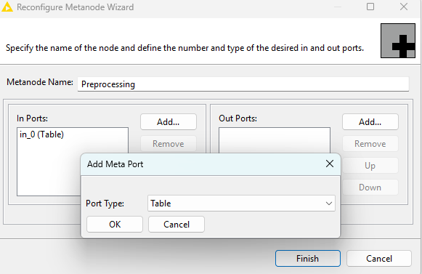
Figure 4: Click on Add button to add a Table port.
Then open Preprocessing Metanode and join the output port of the last node to input in the right wall. So, we do:

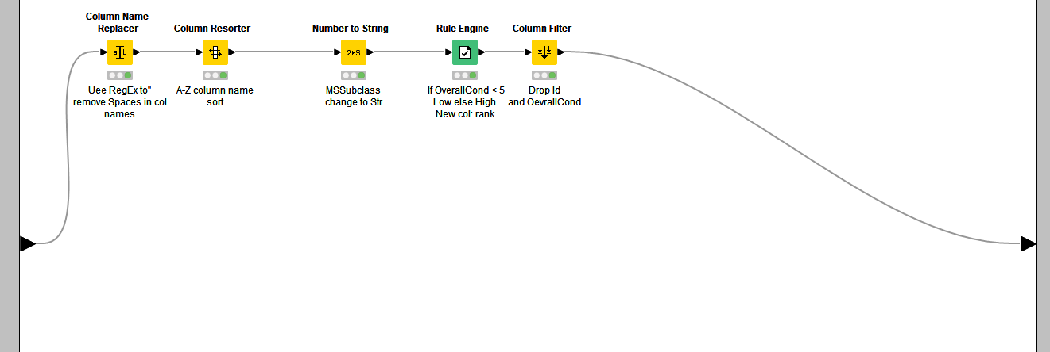
Figure 5: Right click to open Preprocessing mode and connect the last node’s output port to the port on the right-wall as below.

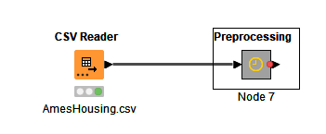
Figure 6: Preprocessing node now has an output port.
.

Chapter-II
Cross-validation node
We will be using three-fold cross-validation to evaluate our models. So, we add a Cross-validator (Cross-Partitioner: X-Partitioner) as below.
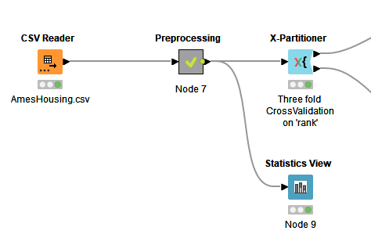
Figure 7: Try with three-fold, five-fold and 10-fold cross-validation.
Perform:
Random sampling: If target is SalePrice
Stratified sampling: if target is rank

Chapter-III
Missing values handling
# File: outlierRemoval_ImprovingXgboost-I
Add Statistics View node:
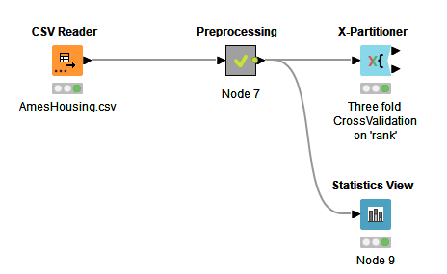
Configure ‘Statistics View’ node first for columns of data type Number:
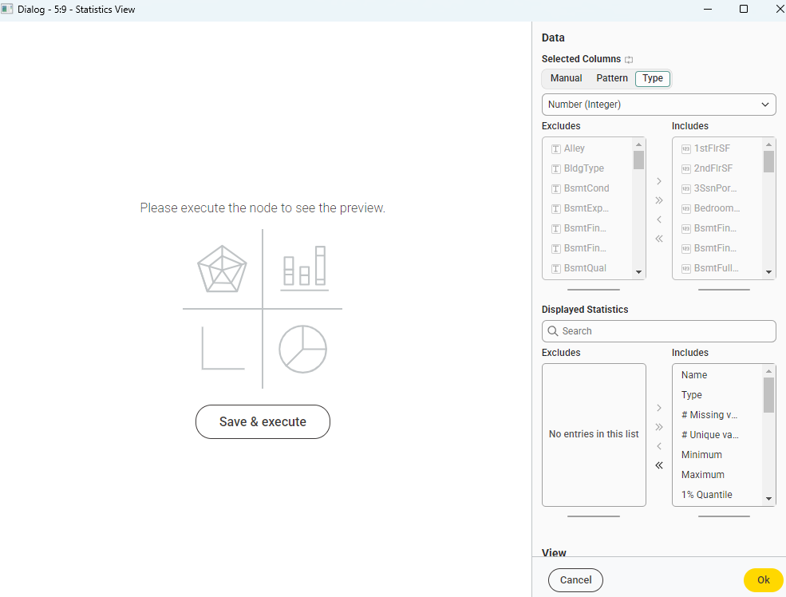
Figure 8: Configure first for columns with Type->Number and we select all statistics. Click OK.
In the Statistics View, sort ‘Missing values’ column in Descending order. To decide how to fill up missing values, observe 50% quartile (median) and mean in each case. Here is the brief:
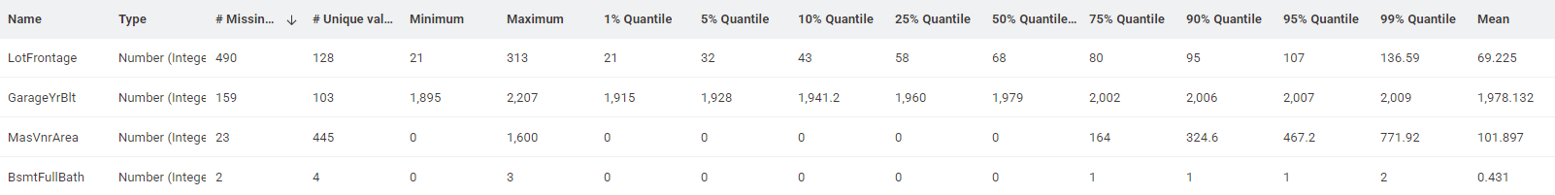
Figure 9: Top four columns with missing values.
There is not much difference between Mean and Median for the first three cases where number of missing values is high.
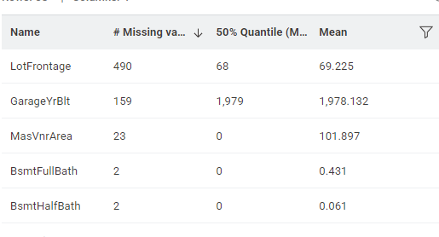
Figure 10: For the first three columns values of Mean and Median are about the same.
For the rest Number columns, we can select Median as the missing value filler. And, for the columns with String data type, the status of missing values is as below:
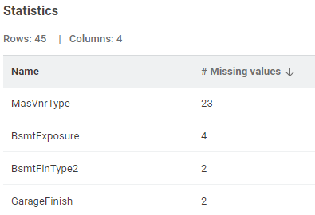
Figure 11: Columns with string data type—Missing values
In these cases we select Mode as the filler.
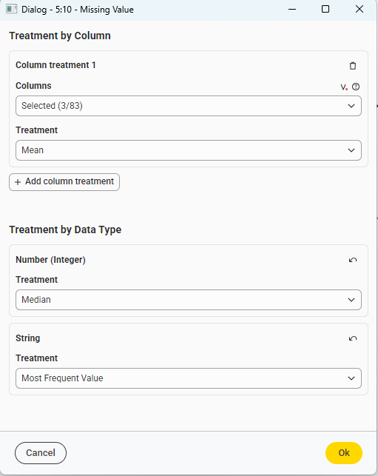
Figure 12: For three columns, we select Mean as the filler. For the remaining number type, we select Median as the filler and for all String types we select Mode as the filler.
In Knime diagram, we add Missing Value node to analyse each feature on training side of data. And then, apply the same missing-value-fill-policy on the test side.
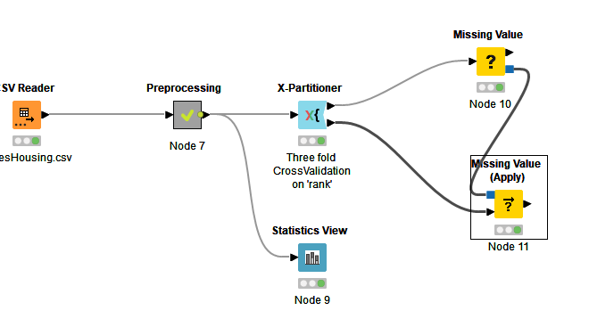
Figure 13: We will shortly put both the Missing value nodes in a Metanode.

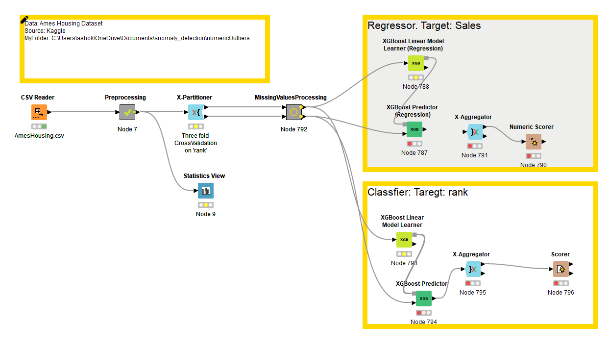
Figure 14: Complete Configuration for two kinds of cases: Regression and Classification
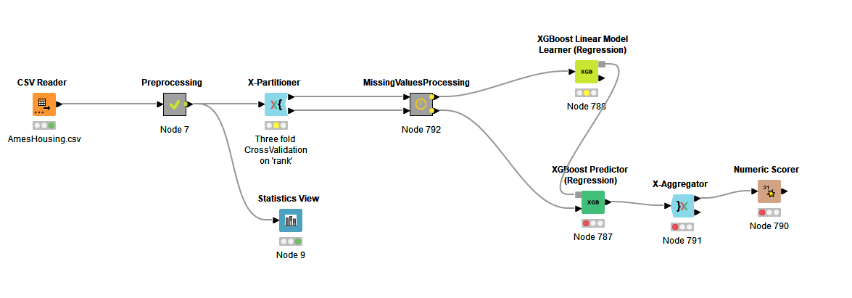
Result is as below for 10-fold cross-validation:
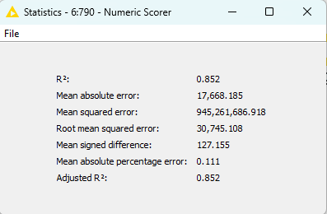

Chapter-V
Remove outliers
We now remove outliers first from LotArea and then from Salesprice. We use Z-score to remove outliers from LotArea. The basic configuration is as follows:
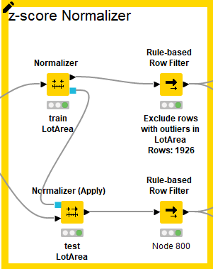
Normalizer is configured, as:
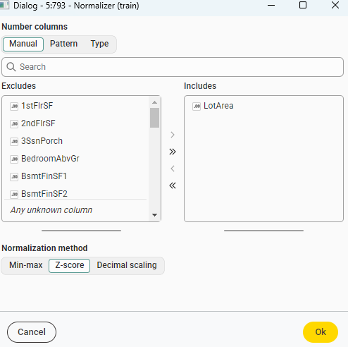
Figure 15: Select z-score
And here is the window of Rule-based row filter.
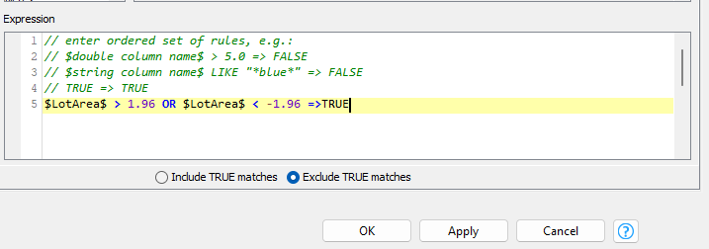
Figure 16: Exclude all rows that match the condition

Chapter-VI
Modelling
# File: outlierRemoval_ImprovingXgboost-II
Perform modelling again after creating another metanode as below:
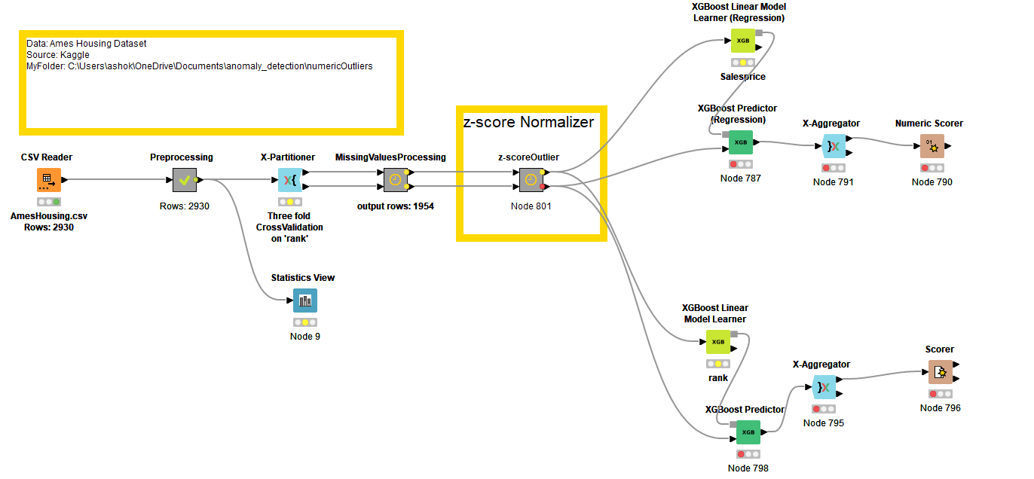
Figure 17: We get better results for Saleprice prediction
Result for 10-fold cross validation is as below:
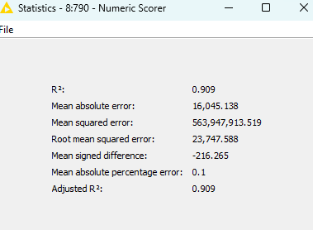

Chapter VII
Numeric Outlier
We further add numeric outlier (based on IQR metrics) as below:
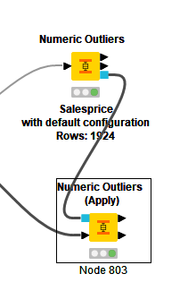
Figure 18: Salesprice with numeric outlier (IQR )

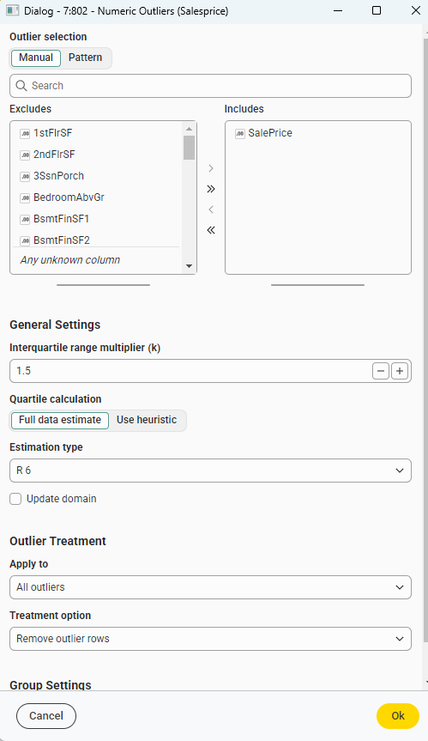
Figure 19: For Treatment option, Remove outlier rows

Chapter VIII
Modelling
# File: outlierRemoval_ImprovingXgboost-III

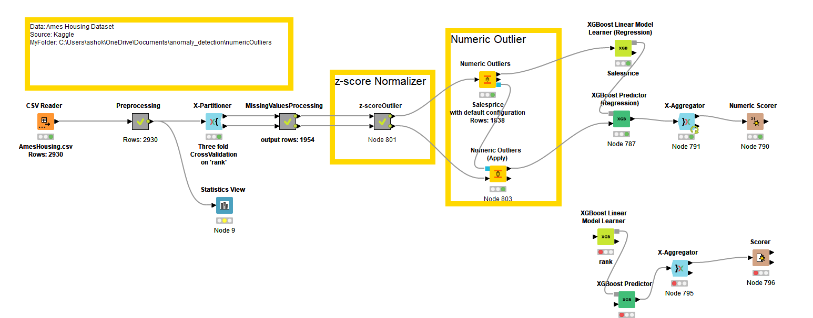

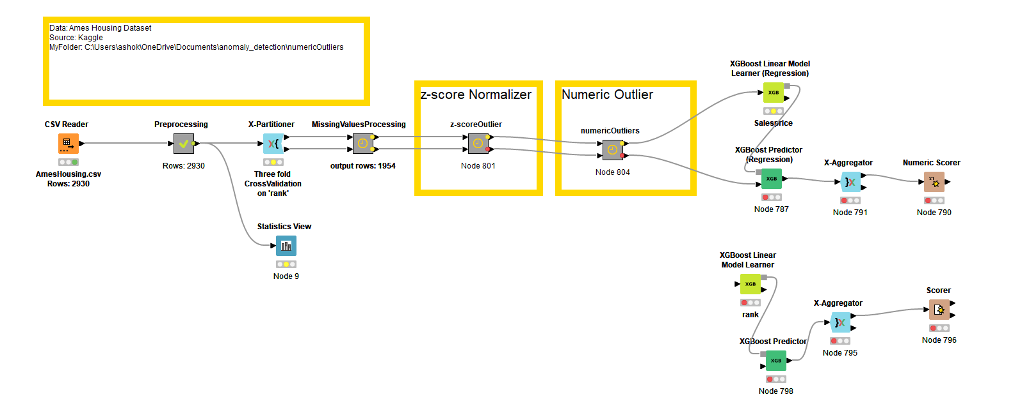
Results progressively get better Chapter by Chapter, especially for SalesPrice target. Results for 10-fold cross-validation are as below:

Salary Dataset
It’s a small dataset. We have to predict salary. There are only two rows with missing data. We remove them. Z-score outlier filtering is done on Age and IQR filtering is done on Salary. Possibly IQR filtering is not removing any rows. You can also try with z-score filtering on Salary to see how much performance improves. We use Random Sampling with 5-fold cross validation. The workflow is simple and is as below. Job Title has multiple levels. We need a Domain Calculator to understand it.

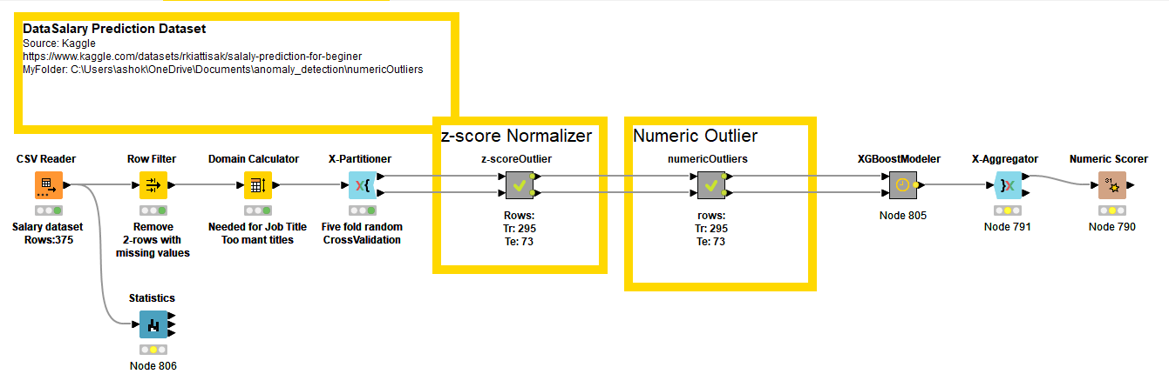
Outlier removal does make marginal improvements, dataset being small.

More Datasets
In Kaggle, search for datasets on Regression problems. OR on Internet make the same search. The above modelling approach will apply to most problems on regression.
#########

