Web-scrapping and Summarization workflow
# Last amended: 4th March, 2025
# My folder: OneDrive/Documents/flowise/n8n

Does not require any API. Summarization tool takes some time.

Overall workflow:

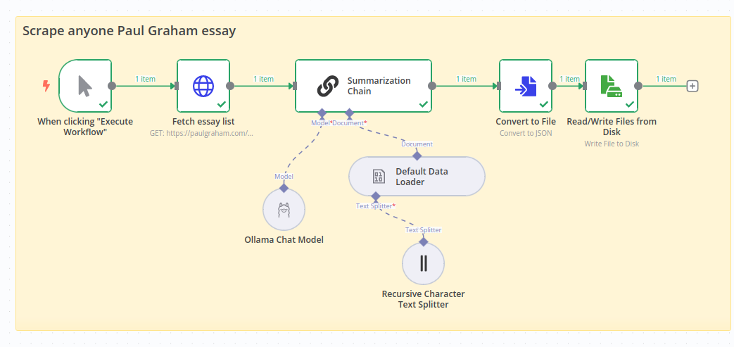
About Web-scrapping:
Improving the accuracy of web scraping data involves refining your scraping technique and understanding the website structure you're targeting. Here are a few tips to enhance accuracy:
- Inspect the Website Structure: Before you can scrap the HTML structure of the website to understand how the data is organized. This will help you identify the elements (h1, h2 etc) you need to target accurately.
- Use Targeted Selectors: Utilize precise CSS selectors or XPath expressions to target specific elements containing the desired data. Avoid broad selectors that may capture irrelevant information.
- Handle Dynamic Content: Some websites load content dynamically using JavaScript. Ensure your scraper can handle dynamic content by using tools like Puppeteer or Selenium or by analysing network requests to replicate AJAX requests.
- Implement Error Handling: Build error-handling mechanisms into your scraper to gracefully handle unexpected situations, such as missing data or changes in website layout.
- Regularly Update Scraping Logic: Websites frequently undergo updates that may affect scraping accuracy. Review and update your scraping logic regularly to adapt to any changes.
- Test and Iterate: Test your scraper with different scenarios and iterate on your scraping logic based on the results. This iterative process can help refine the accuracy of your scraping.
By applying these strategies and experimenting with different approaches, you can improve the accuracy of your web scraping data extraction. It might also be a good idea to scrape the website separately and upload the resulting document (after inspecting and optimizing it)

Fetch Essay list node:

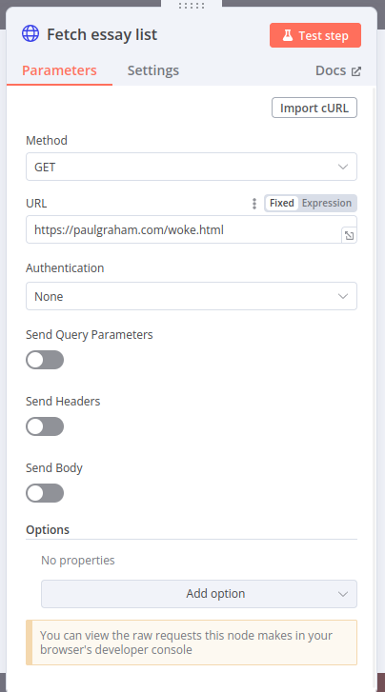
Figure 1: Site: https://paulgraham.com/woke.html
Summarization chain:

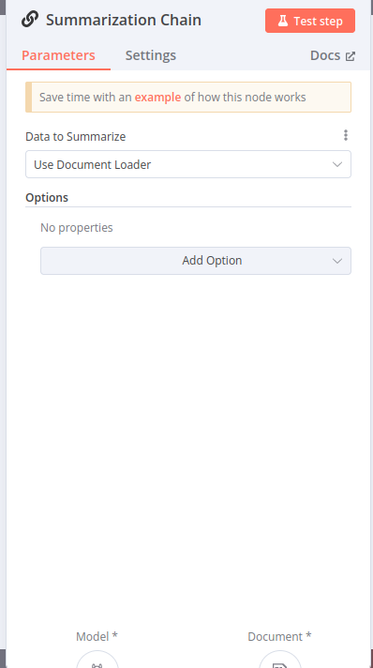

Data Loader:

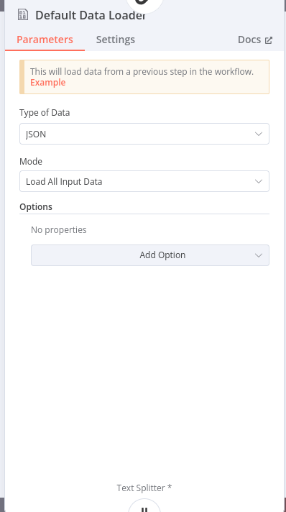

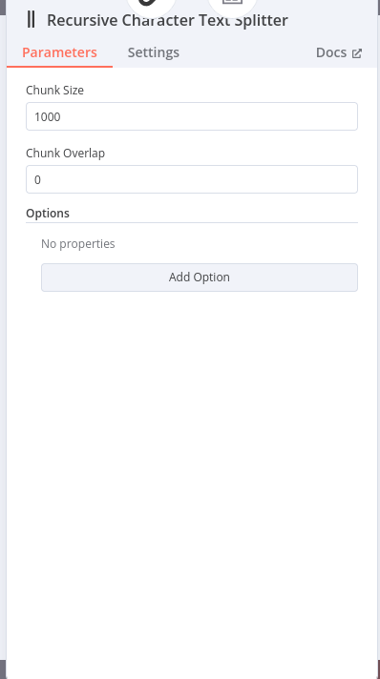
Recursive test splitter

Convert to file
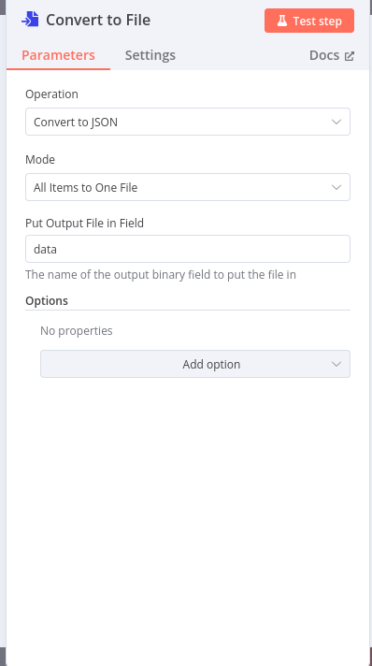

Read/Write file:

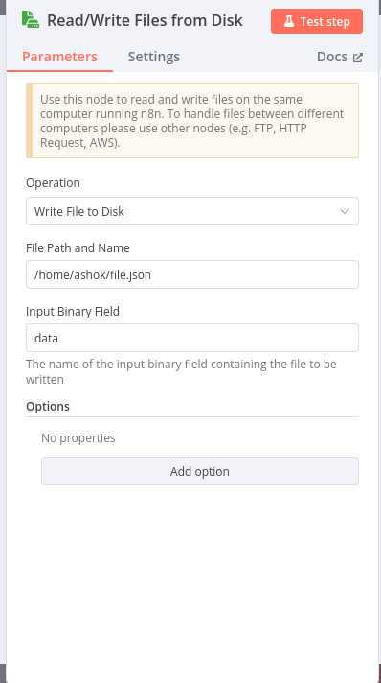

Final summarization output





