Web-scrapping and Summmarization workflow
# Last amended: 4th March, 2025
# My folder: OneDrive/Documents/flowise/n8n

Does not require any API. Summarization tool takes some time.

Overall workflow:

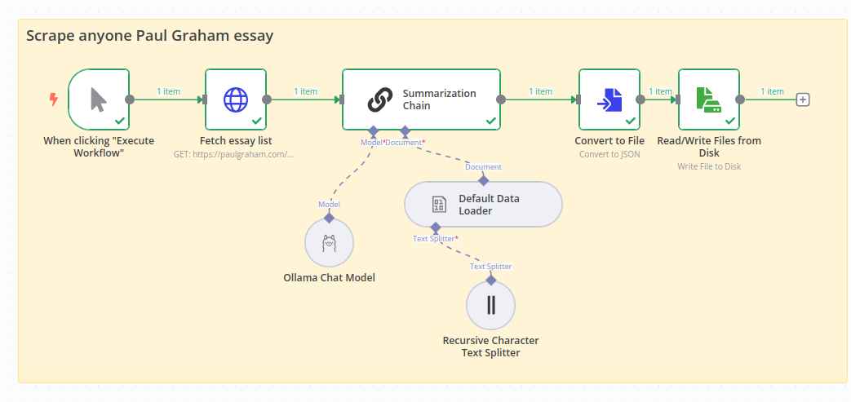

Fetch Essay list node:

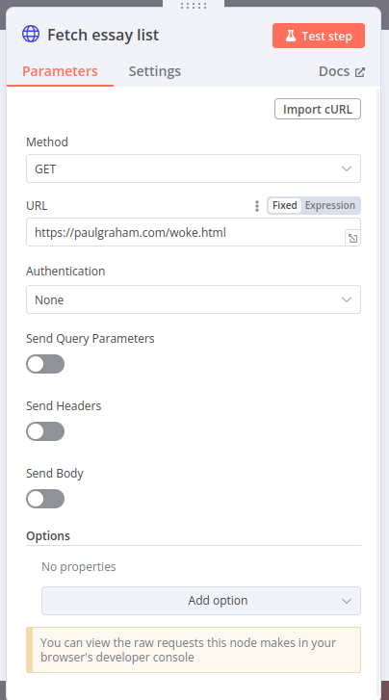Figure 1: Site: https://paulgraham.com/woke.html

Summarization chain:

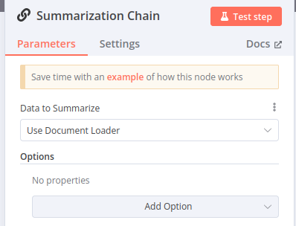

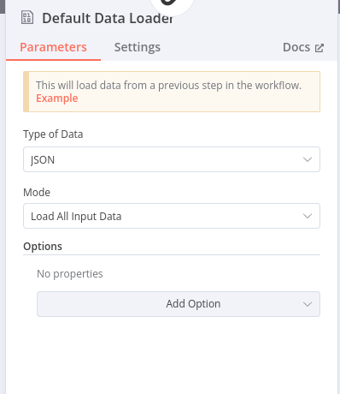
Data Loader:

Recursive test splitter

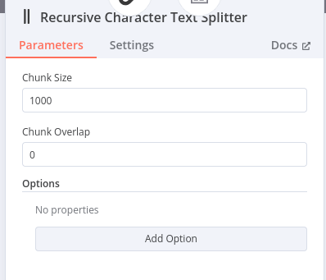

Convert to file
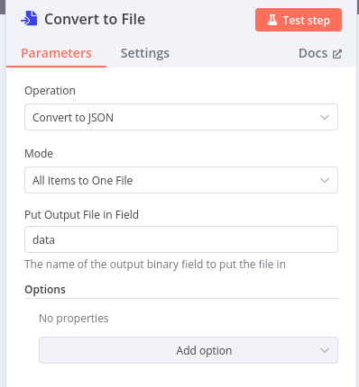

Read/Write file:

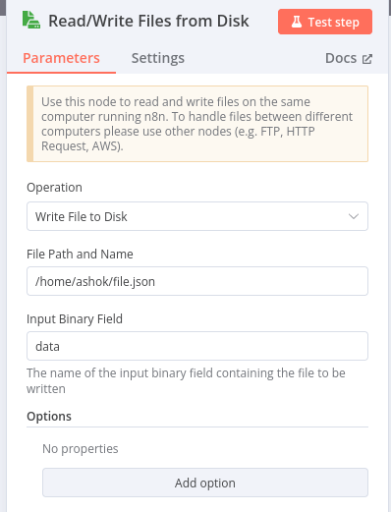

Final summarization output





