Types of LLMs & Agents
# Last amended: 12th July, 2026
# My folder: C:\Users\ashok\OneDrive\Documents\llm
# GitHub: https://github.com/harnalashok/LLMs/tree/main/install_ai_tools/misc
# One reference is here and another one ‘A comprehensive review of LLMs’ is here.

Table of Contents
Types of LLMs & Agents 1
Summary of LLM models 2
1. Foundation or Base models 2
2. Chat models 2
3. Instruction Tuned models 3
4. Mixture of experts model 4
What is MOE model: 4
5. Reasoning models 5
6. Embedding models 6
Made up examples 7
7. Multimodal models 9
8. Deep Research Agent 9
What are Deep Research Agents: 9
Example of a Deep Research Agent: 11
Use cases of multi-agent systems 11
9. Agent Orchestration 12
Sequential Agents 12
Hierarchical agents 13
Agent Networks 14
10. What is a Transformer model: 16
Example: 16
11. Decoder only models 17

Summary of LLM models
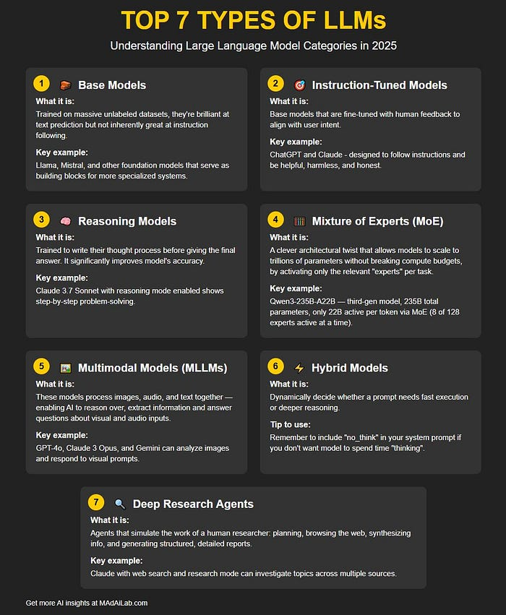
Exercise for students: Get list of example models from ollama library and HuggingFace

Foundation or Base models
All generative LLMs are designed to take in some text and then predict what text is most likely to come after it.
"Base" models are trained on a wide variety of different texts, so they make minimal assumptions about the structure of the text they're completing.

Chat models
Chat models are created from base models by training them on transcripts of dialogue, so they assume that whatever text they are given is a fragment of dialogue. You can chat with them by filling in one side of a conversation and letting the model fill in the other. (See this link for dataset on HuggingFace. It is in .parquet format.)
Here are examples of chats from training dataset:
[
{
"role": "user",
"content": "Why is the sky blue during the day but red at sunset?"
},
{
"role": "assistant",
"content": "It is because of a phenomenon called Rayleigh scattering. Sunlight reaches Earth's atmosphere and is scattered in all directions by gases and particles in the air. Blue light is scattered more than the other colors because it travels as shorter, smaller waves. At sunset, the sun is lower on the horizon, so the light has to pass through more atmosphere. This scatters out the blue light and allows longer wavelengths, like red and yellow, to pass straight through to your eyes."
},
{
"role": "user",
"content": "Can you summarize that explanation into just one short sentence for a 5-year-old?"
},
{
"role": "assistant",
"content": "The air scatters away the blue light during the day, but at sunset, the light has to travel so far that only the red light makes it to your eyes."
}
]
[
{
"role": "user",
"content": "Hi, I was charged twice for my subscription this month. Can I get a refund?"
},
{
"role": "assistant",
"content": "Hello! I am very sorry to hear that you were billed twice. I can certainly help look into this and process a refund for the duplicate charge. To get started, could you please provide the email address associated with your account and the transaction IDs from your receipt?"
},
{
"role": "user",
"content": "My email is test@email.com. The two transaction numbers are TXN-9981 and TXN-9982."
},
{
"role": "assistant",
"content": "Thank you for providing those details. I have located your account and verified the duplicate billing for TXN-9982. I have just initiated a refund of $14.99 back to your original payment method. It should reflect in your bank account within 3 to 5 business days. Is there anything else I can assist you with today?"
}
]

Instruction Tuned models
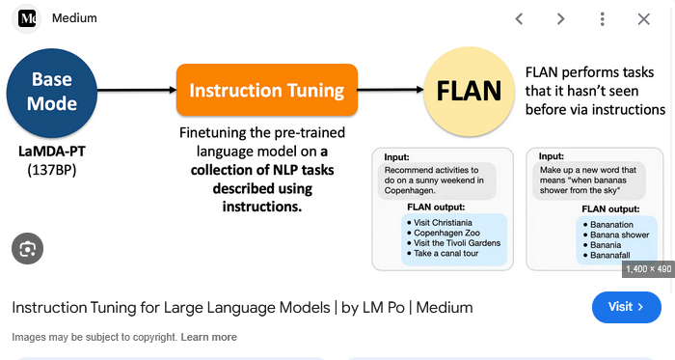
A typical dataset for instruction fine-tuning consists a) Instruction, b) Input Query and c) Output Response.
Instruction: “Translate the following English sentence to French.”
Input: “The weather is nice today.”
Output: “Le temps est agréable aujourd’hui.”
One highly popular dataset for instruction fine tuning is here on HuggingFace. And here is a list of top 10% instruction tuning datasets on HuggingFace. Here is how to test an instruct model:
- ollama run granite4:350m
- Ollama run llama3.2
Give these instructions:
- "Write an email in exactly 150 words." (Check with word count).
- Formatting constraints: "Start every paragraph with an exclamation mark" or "Output the final answer in JSON."
- Forbidden elements: "Write about coffee without using the letter 'e'."
Models often degrade when asked to perform multiple tasks simultaneously. Test composition by stacking rules to see where the model breaks:
- Level 1: Summarize this article.
- Level 2: Summarize this article in 3 sentences, without using the letter 't'.
- Level 3: Summarize this article in exactly 50 words, use bullet points, and cite at least two sources.

Mixture of experts model
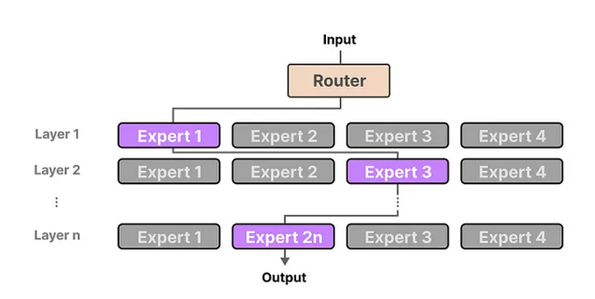

What is MOE model:
An LLM is made of a pile of “layers”, each layer having both “attention heads” (which are responsible for understanding the relationship between words in the “context window”) and a “feed forward” block (a fully connected “multi-layer perceptron”, the most basic neural network), the later part is responsible for the LLM ability to store “knowledge” and represents the majority of the parameters.
MoE just comes from the realization that you don't need to activate the whole Feed forward block for every layer at all time, that you can split every feed forward blocks in multiple chunks (called the “experts”) and that you can have a small “router” in front of it to select one or several experts to be activated for each tokens instead of activating all of them. Thus, very simply, each expert is in fact, each Feed Forward layer.
The massively reduces the computation and memory bandwidth required to power the network while keeping its knowledge storage big.
Oh ,also what kind of knowledge is stored by each “expert” is unknown and there's no reason to believe that they are actually specialized for one particular task in a way that a human expert is.
And here is a workflow for MOE as compared to foundation models.
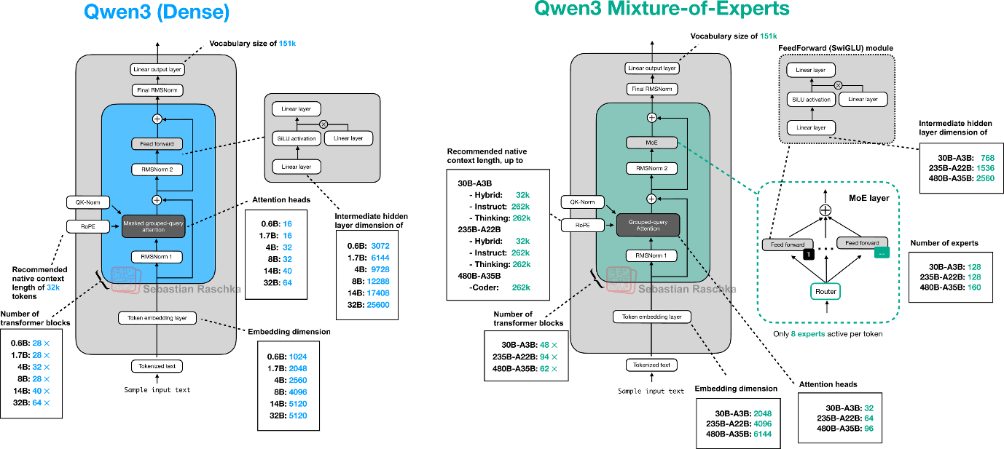

Reasoning models
Reasoning models are trained by transitioning from predicting words to learning a step-by-step thinking methodology. While standard Large Language Models (LLMs) rely on massive data imitation, reasoning models are built using large-scale Reinforcement Learning (RL) on verifiable problems.
The process begins with a foundation or instruction-tuned model. AI developers use Supervised Fine-Tuning (SFT) by feeding the model a highly curated dataset filled with complex coding, math, and logic problems. Crucially, these examples don't just contain the correct final answer—they explicitly outline detailed, step-by-step thinking traces. This teaches the model the basic syntax of "thinking" before answering.
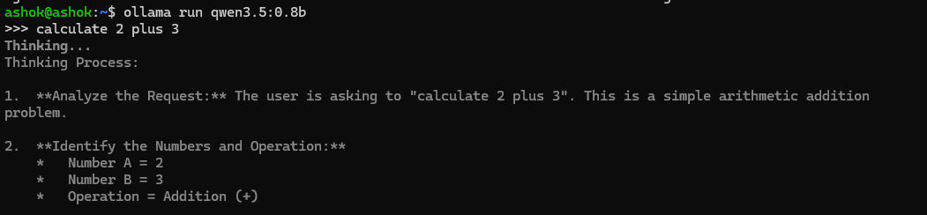
Figure 1: Thinking model output
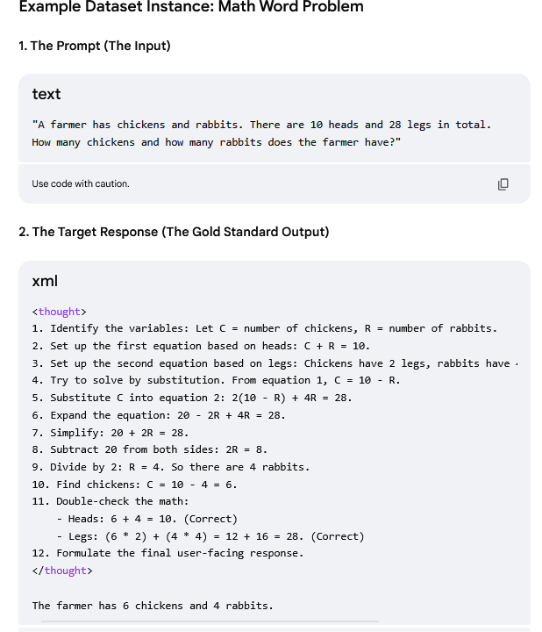

Embedding models
At their core, embedding models are designed to transform unstructured data into a high-dimensional, vector space. During transformation, each vector, or embedding, extracts or encapsulates the essential features of the input, preserving two things:
  - semantic relationships (as for example, between, bear and fish; bears and fish are semantically related, primarily through the thematic relationship of predator and prey in natural ecosystems. While they are not synonyms or hyponyms) and,
  - structural information (as for example ‘bear ate the fish’ AND NOT ‘fish ate the bear’ though they contain exactly the same four words).
These embeddings enable various downstream tasks, including semantic search, recommendation systems, clustering, classification, and more.
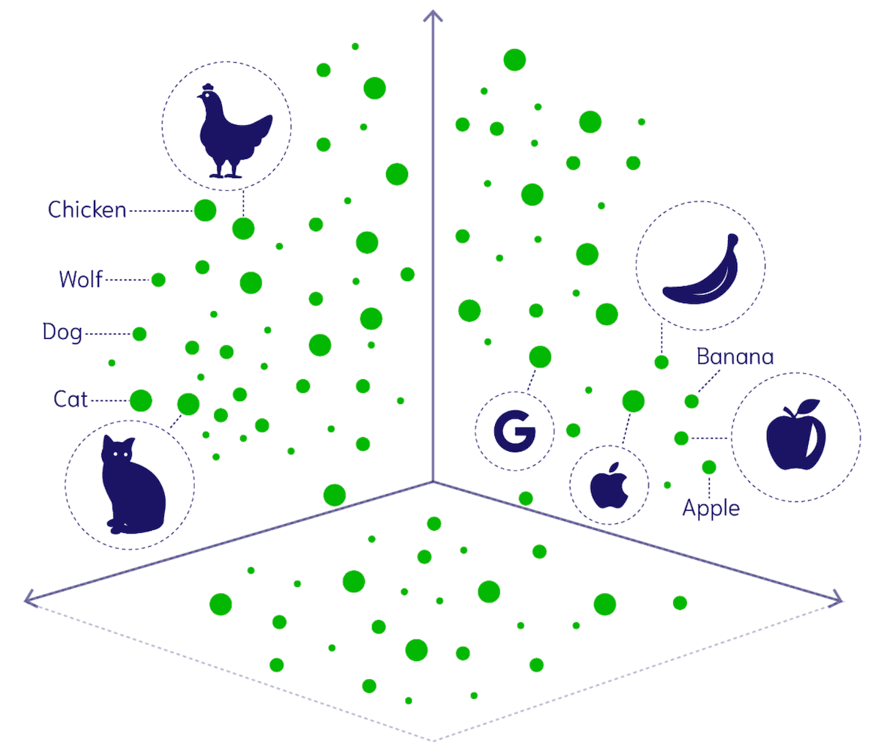
Figure 2: Similar objects fall in the same vector or coordinate space near to one another.
Embedding models are trained to ensure that similar inputs have embeddings that are close in the vector space, while dissimilar ones are placed far apart. This geometric arrangement in the embedding space allows for efficient similarity computations using distance metrics like cosine similarity or Euclidean distances.
Think of embeddings as GPS coordinates for abstract concepts. On a normal map, nearby coordinates mean two places are physically close. In an embedding space, nearby coordinates mean two concepts are ideally close.

Made up examples

Example1:
When data passes through an embedding model, it is converted into an array of numbers or vector containing hundreds or thousands of decimal numbers (dimensions). Each decimal number in the vector (also called dimension) tracks an abstract feature or relationship learned by the AI during training. Here is a made-up example of vectors for three words:
[Roy, Mas,Age]
Vector for King: [0.99,0.95,0.7]
Vector for Queen: [0.99,0.05,0.7]
Vector for Apple: [0.00,0.15,0.7] (0.15 being preferred by males;
0.7 for being Ripe apple as against green apple)
The numbers in each of the above three vectors may track Royalty, Masculinity and Age respectively. Thus:
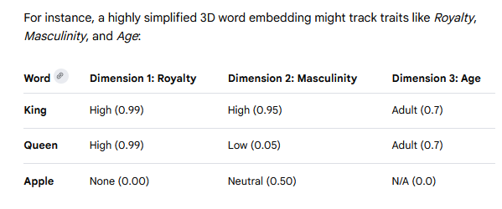
Figure 3: Each number in the array of numbers (vector) indicates
some value assigned to some feature of the word.

Example2:
Here is another made up example on vector dimensions of Violence, Entertainment value and Nationalistic sentiment:
 | Violence | Entertainment value | Nationalistic sentiment
Dhurandhar | 0.9 | 0.7 | 0.9
3 Idiots | 0.0 | 1.0 | 0.5
Dangal | 0.1 | 0.8 | 0.95
Embedding model vectors may contain hundreds or thousands of decimal numbers (dimensions). The larger the vector space, more the semantic clarity and the structural relationships between words but would require more computational resources to process data. Smaller the vector space, less the computational power required but then less also would be semantic similarity.
Does bank in ‘river bank’ and bank in ‘finance bank’ have different vectors through embedding model?
Yes, the word "bank" will have different vectors in these context sentences if you use a modern context-aware embedding model. (Remember vectors store both semantic as also structural relationships).
Older embedding models like Word2Vec or GloVe give "bank" the exact same vector regardless of context. Modern Transformer-based models like BERT, GPT, or text-embedding-3 generate completely different vectors based on surrounding words
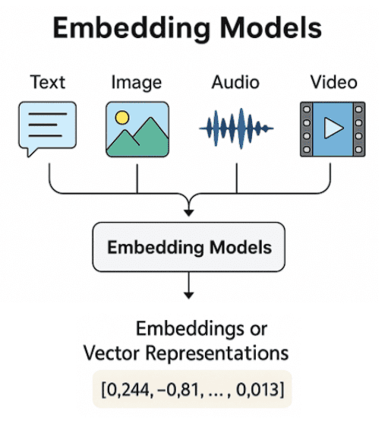
Figure 4: Vectors for 'apple', ‘apple sound’ and ‘apple in picture’ will be the same.

Multimodal models
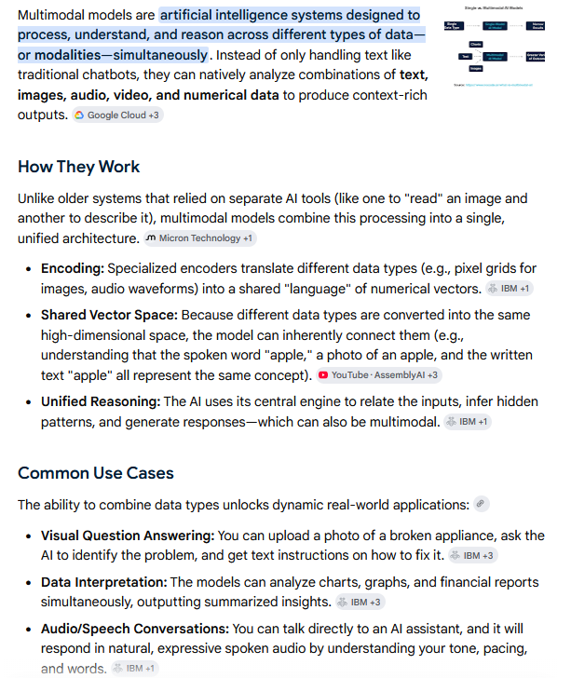
MLLMs expand upon the foundations laid by traditional LLMs. While they often leverage a powerful pre-trained LLM as their backbone for language understanding and reasoning, they incorporate additional components to handle non-textual data. The core architectural difference lies in the need for specialized encoders for each modality. For instance, an MLLM might use a Vision Transformer (ViT) or a Convolutional Neural Network (CNN) to process images, an audio encoder for sound, and the standard LLM tokenizer/embedding layer for text. These encoders transform the input from each modality into vector representation. A crucial step in MLLM architecture is embedding alignment and fusion. The embeddings generated by the different modality encoders need to be projected into a shared space where the model can understand the relationships between them. A dedicated fusion module or specific training techniques (like contrastive learning) are employed to integrate these diverse representations into a unified multimodal vector space. This allows the model, for example, to connect the word “dog” in a text caption to the visual features of a dog in an accompanying image.

Deep Research Agent

What are Deep Research Agents:
Given a goal, an autonomous agent is one which can plan (say steps for execution), reason out (say how a step be executed), use correct tools among the set of tools and communicate its decisions. Ii is powered by an LLM model.
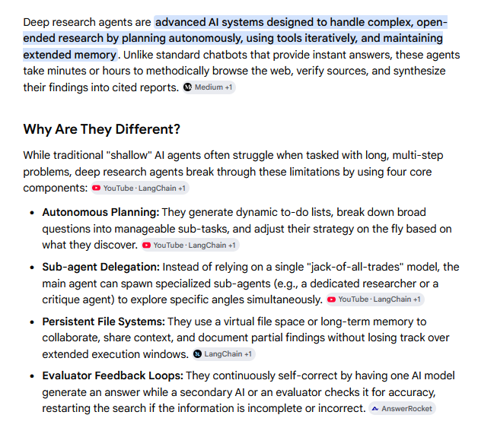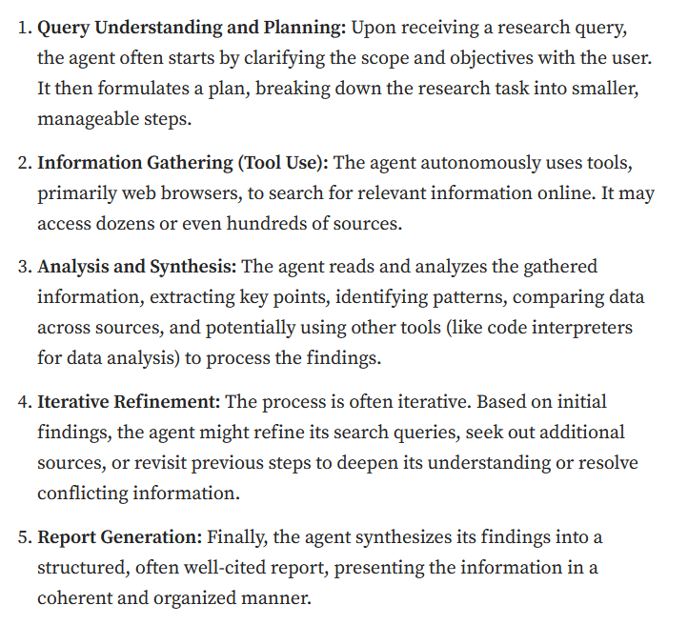
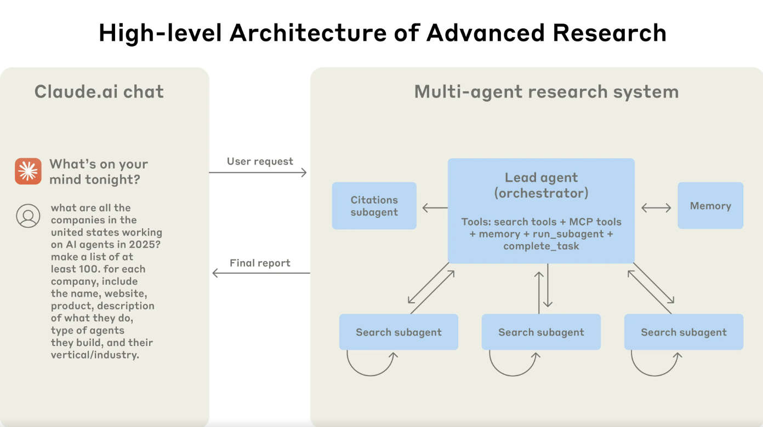

Example of a Deep Research Agent:
Prompt: How would I go about designing a Deep research Agent system that answers questions on diabetes. The system would consult reputed publications, especially the recent papers, published books, and other reputed resources on the subject on the Internet.
Here's how to design a Deep Research Agent system for Diabetes using CrewAI:
Recommended Architecture
Use a Hierarchical Process with a manager agent coordinating specialized sub-agents:
Agents
- Manager Agent— orchestrates the crew, delegates tasks, validates outputs
- Literature Search Agent— finds recent academic papers (arXiv, PubMed-style searches)
- Web Research Agent— searches reputed web sources (journals, health organizations)
- Synthesis Agent— compiles and summarizes findings with citations
Key Tools to Use
Tool | Use
ArxivPaperTool | Find recent academic papers without an API key.
TavilyResearchTool | Conduct multi-step web research and produce cited reports.
SerperDevTool | Search Google for reputable publications.
ScrapeWebsiteTool | Extract content from selected journal or book pages.
PDFSearchTool | Search downloaded PDFs using RAG.

Use cases of multi-agent systems
Multi-agent systems (MAS) can solve many complex, real-world tasks. In general, MAS will find applications wherever there are multiple sensors working towards same shared objective—car sensors interacting with traffic light(s), car sensors interacting with toll-payment system, Security systems having multiple sensors. Some examples of applicable domains include:

Transportation

(Refer: this blog)
MAS can be used to manage transportation systems. The qualities of MAS that allow for the coordination of complex transportation systems are communication, collaboration, planning and real-time information access. Examples of distributed systems that might benefit from MAS are railroad systems, truck assignments and marine vessels visiting the same ports. Traffic Flow Agents monitor and analyse the ebb and flow of vehicles across city streets using Machine Learning. Using real-time data and predictive algorithms, these agents can:
- Detect congestion hotspots before they become gridlock nightmares
- Suggest alternative routes to drivers, helping to balance traffic loads
- Adjust traffic signal timings on the fly to optimize vehicle throughput

Healthcare and public health
Reference this blog
Multi-agent systems can be used for various specific tasks in the healthcare field. These agent-based systems can aid in disease prediction and prevention through genetic analysis. Wearable and loT-connected agents monitor patient vitals in real-time. If anomalies (e.g., heart rate spikes or drops in oxygen) are detected, the system automatically alerts medical staff or triggers rapid response protocols. As patients undergo various tests, the MAS collect all structured, unstructured and image data and makes its analysis and recommendations on the proposed diagnostic method to be adopted. We may have Diagnostic Agent, Risk-stratification agent (may assess severity and predict potential outcomes. Morbidity and mortality risks are calculated using an established scoring system),

Supply chain management
Numerous factors affect a supply chain. These factors range from the creation of goods to the consumer purchase. MAS can use their vast informational resources, versatility and scalability to connect the components of supply chain management. To best navigate this intelligent automation, virtual agents should negotiate with one another. This negotiation is important for agents collaborating with other agents that have conflicting goals.¹⁶

Defence systems
Multi-agent systems can aid in strengthening defense systems. Potential threats can include both physical national security issues and cyberattacks. Multi-agent systems can use their tools to simulate potential attacks. One example is a maritime attack simulation. This scenario would involve agents working in teams to capture the interactions between encroaching terrorist boats and defense vessels.¹⁷ Also, by working in cooperative teams, agents can monitor different areas of the network to detect incoming threats such as distributed denial of service (DDoS) flooding attacks.

Agent Orchestration
Reference this article on Medium and this IBM blog
Hierarchical multi-agent systems and agent networks (mesh or decentralized architectures) represent two distinct ways to organize artificial intelligence. A hierarchical multi-agent system acts like a corporate org chart with a clear chain of command (managers delegating to workers). An agent network functions like a decentralized web where peer agents collaborate and share information directly.

Sequential Agents
In CrewAI, sequential agents execute tasks linearly in a predefined order where the output of one task automatically serves as context for the next. This is the default execution strategy (Process.sequential) and is ideal for structured pipelines like a "Research-then-Write" workflow.
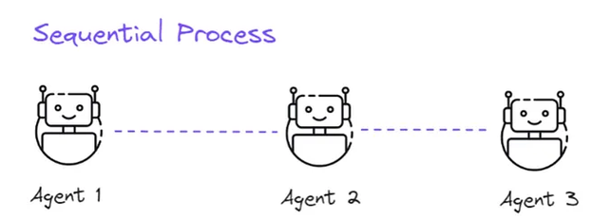
You can customize how data moves through your sequential pipeline using specialized Task parameters:
- context: If a downstream task needs data from multiple previous tasks (not just the immediate predecessor), you can explicitly pass them as an array: context=[task_one, task_two].
- async_execution=True: If two tasks early in the pipeline do not rely on each other, you can run them in parallel. The sequential crew will wait for both to finish before passing their combined context to the next step.
- output_json / output_pydantic: Forces an agent to structure its handoff data into a rigid schema, preventing downstream parsing errors.

Hierarchical agents
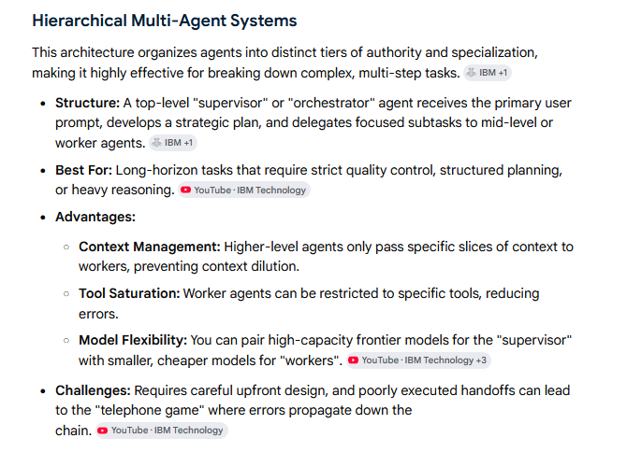
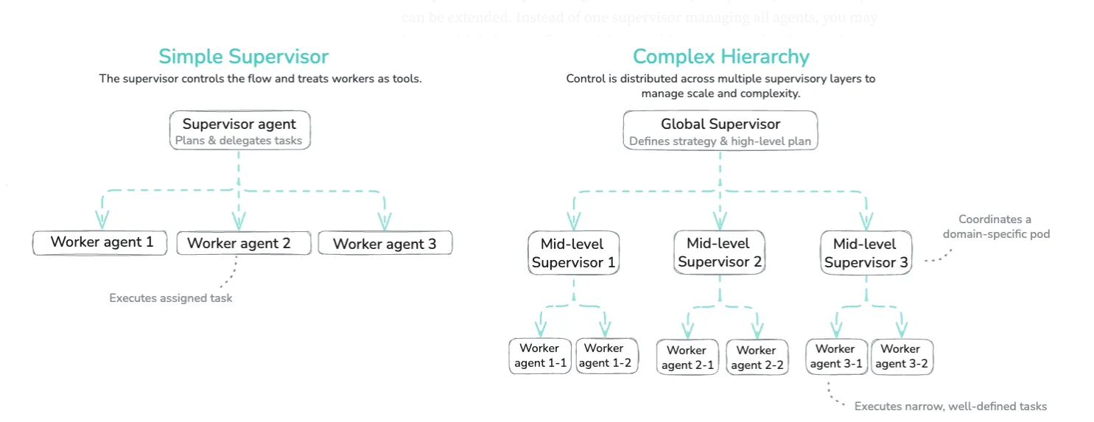
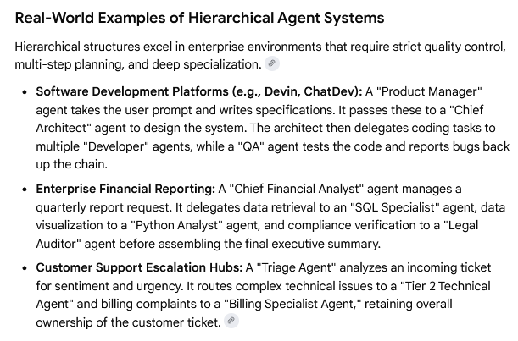

Agent Networks
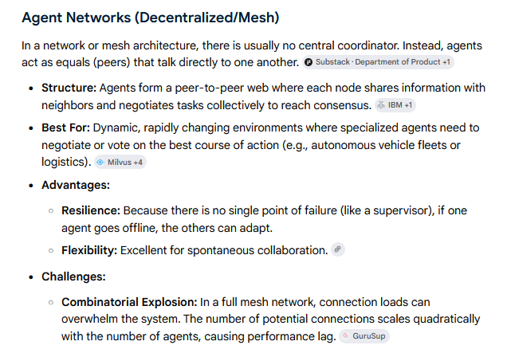
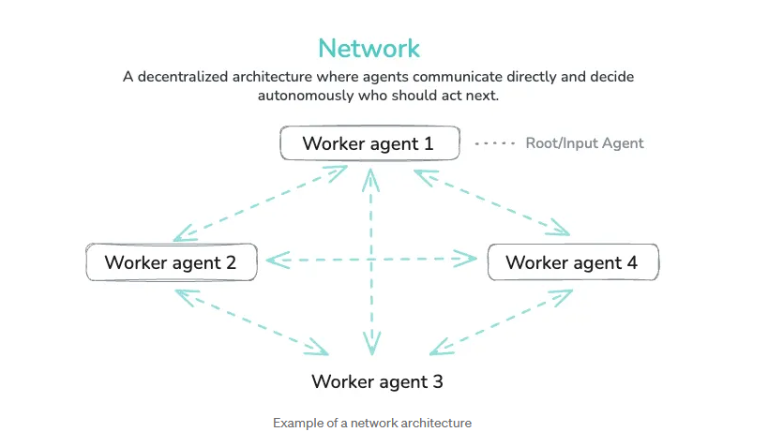
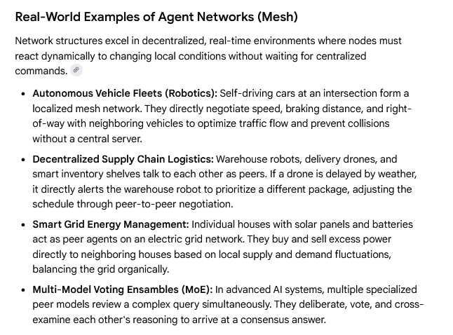
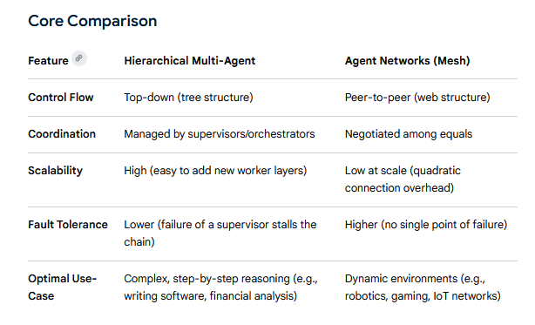
Custom Workflow
In a custom workflow architecture, you explicitly design the execution flow between agents. You decide how agents are connected and how tasks move through the system, using sequential steps, conditional branches, loops, or parallel execution. This approach does not rely on open-ended agent interactions or a central supervisor; instead, the behavior of the system is defined by the workflow itself, giving you full control over how it operates.
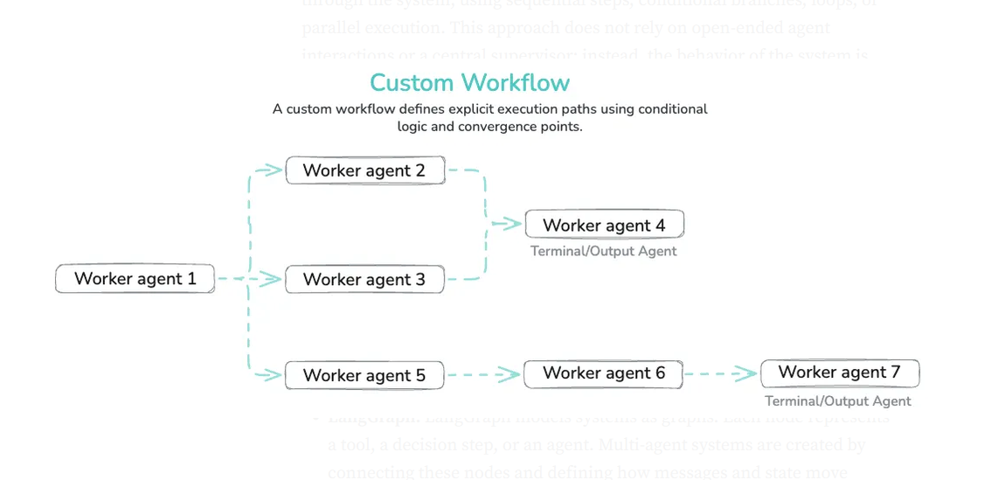

What is a Transformer model:
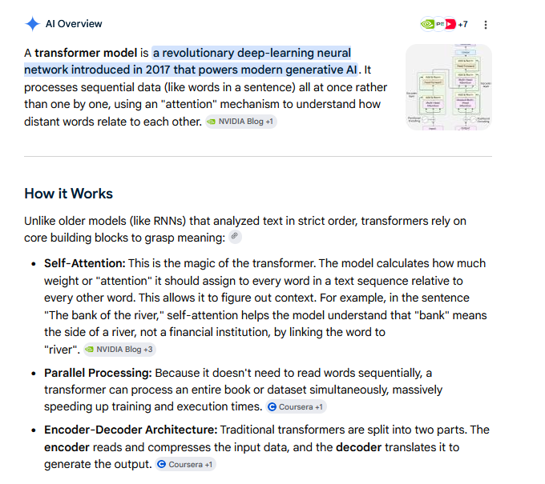

Example:
Look at how the meaning of the exact same word changes completely across two different sentences:
Sentence A: "The hunter sat on the muddy bank watching the ducks."
Sentence B: "The businessman walked into the brick bank to deposit cash."
Without self-attention, a computer might look up "bank" in its digital dictionary and guess the wrong meaning. With self-attention, the word "bank" looks at its neighbours to define itself.
The model calculates an attention score between "bank" and every other word in Sentence A:
"bank" + "hunter" High connection (hunters sit outdoors).
"bank" + "muddy" Very high connection (nature/earth concept).
"bank" + "ducks" Very high connection (animals found near water).
The model has earlier read billions of sentences during training phase. And from that experience the model has adjusted its internal settings (called weight matrices). If the model is still under training, it will marginally further adjust its weight matrices. Once the model is finished training, its past-experience is completely frozen. When you hand it the new sentence—"The businessman walked into the brick bank..."—the model applies its frozen blueprints to the active words to understand what exactly ‘bank’ means.
Another example:
The animal didn't cross the street because it was too tired.- ‘it’ is related to animal
The animal didn't cross the street because it was too wide.--> ‘it’ is related to street

Decoder only models
In Artificial Intelligence, a decoder is called autoregressive model because it loops back (automatically) to consume its own past outputs (i.e. it regresses) as inputs to predict the next piece of data. Most modern LLMs are decoder-only models. Meta's Llama 3.2, for example, or OpenAI’s GPT line of models—from the lightweight 1B and 3B versions to the massive 90B version—relies on a decoder-only pre-trained transformer architecture. The vast majority of household AI names operate on a decoder-only architecture. Imagine you ask an AI decoder (like a standard Large Language Model) to complete the phrase: "The cat sat on the...". The decoder runs a loop where its previous output becomes its next input:



