Twilio in n8n
# Last amended: 1st March, 2025
# Ref: https://n8n.io/workflows/401-send-an-smswhatsapp-message-with-twilio/
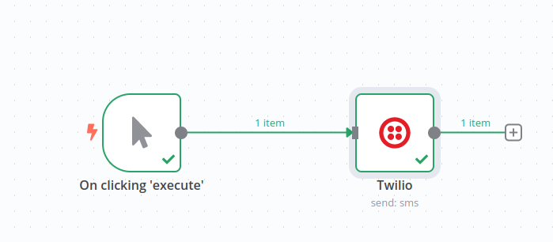
# My folder: Onedrive->flowise->n8n->2.twilio

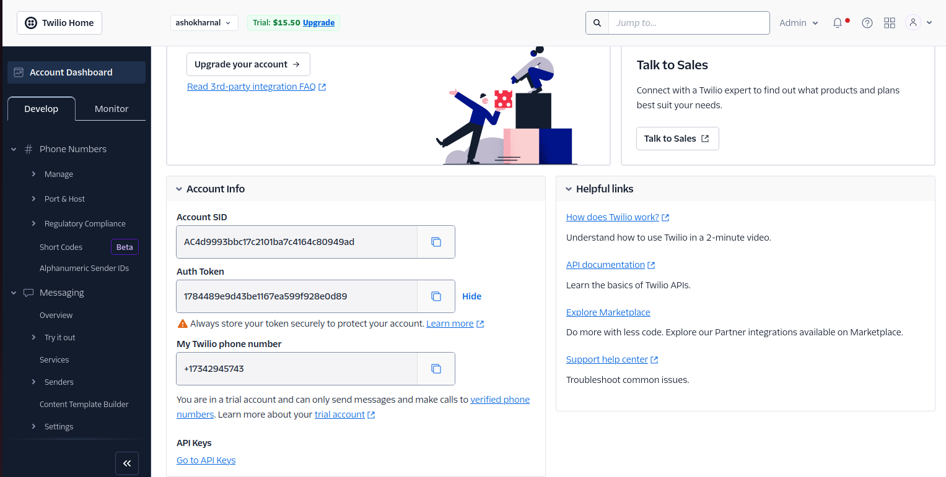
Account SID number:
AC4d9993bbc17c2101ba7c4164c80949ad
Auth Token
1784489e9d43be1167ea599f928e0d89
My Twilio phone number
+17342945743
My Phone Number:
+918750893093

Refer here to configure Twilio.

Using Auth Token
To configure this credential, you'll need a Twilio account and:
- Your Twilio Account SID
- Your Twilio Auth Token
To set up the credential:
- In n8n, select Auth Token as the Auth Type.
- In Twilio, go to Console Dashboard > Account Info.
- Copy your Account SID and enter this in your n8n credential. This acts as a username.
- Cop your Auth Token and enter this in your n8n credential. This acts as a password.
Refer to Auth Tokens and How to Change Them for more information.

Configuration of Twilio node.
Only SMS works not WhatsApp.

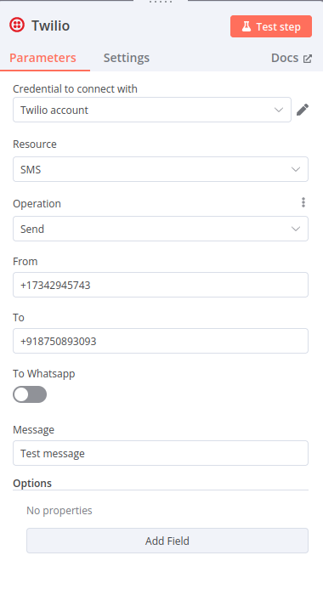

Test working
See the right hand side.





