Agents

A. Using Classic chatflows from scratch

Tools Agent:
In Flowise, a "tool agent" is a type of AI agent that is specifically designed to , essentially acting as a mediator between the user's request and the available tools within the system, allowing for more complex actions and interactions beyond just generating text.
Key points about tool agents in Flowise:
- Function calling:
They utilize "function calling" capability to interact with different tools, specifying the necessary parameters and arguments for each tool based on the situation.
- Decision making:
The tool agent analyzes the user query and decides which tool is best suited to fulfill the request from a set of available tools.
- Integration with LLMs:
While the tool agent manages tool selection and execution, it often leverages a large language model (LLM) to understand the user's intent and provide context for choosing the appropriate tool.
Example scenario:
- User input: "What is the weather like in New York City today?"
- Tool agent action: Recognizes the request is about weather and selects the "Weather API" tool, providing the necessary location data (New York City) as input to retrieve the weather forecast.

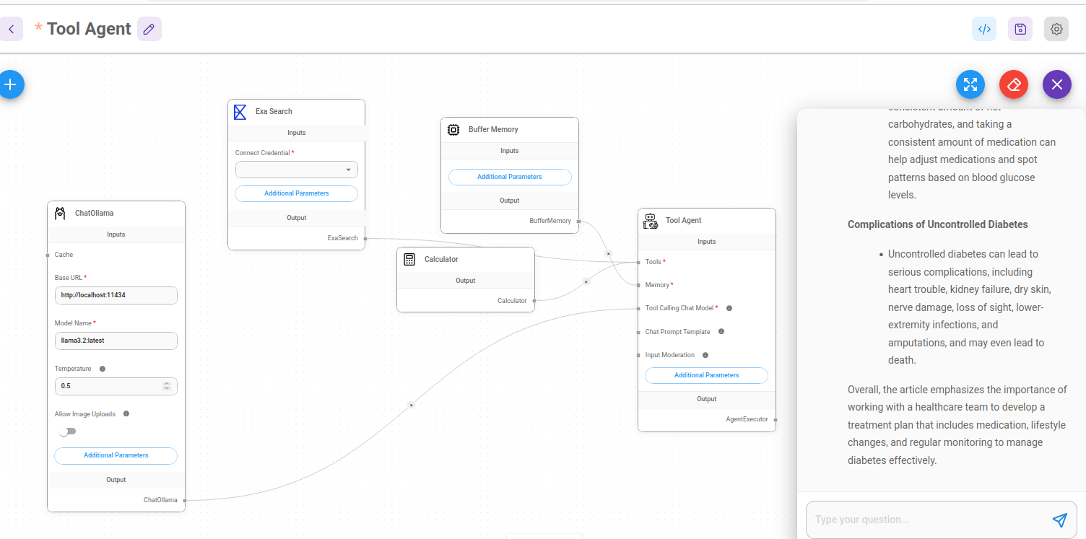

Json file name: tooll_agent: Tool Agent Chatflow.json
My ExaAi API: ec0029cc-e2c1-4664-b5a8-13c0f525fbf2
email: ccma@fsm.ac.in; password of gtm*8 (usual).
https://dashboard.exa.ai/api-keys

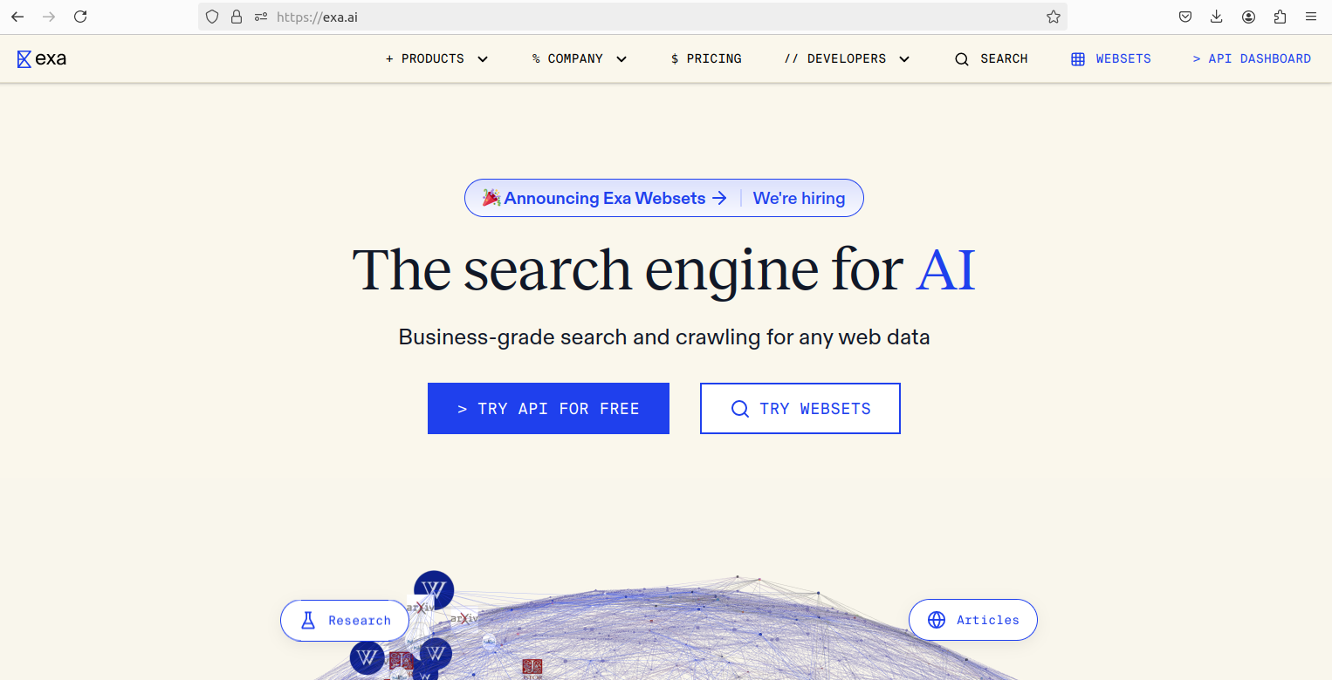Figure 1: Exa AI web site. API is for free with some limitations.

Build ANY AI Agent with Flowise and n8n, Here's How

https://www.youtube.com/watch?v=-zlbm58WRAA&t=32s

