Twilio in n8n
# Last amended: 29th August, 2025
# Ref: https://n8n.io/workflows/401-send-an-smswhatsapp-message-with-twilio/
# My folder: Onedrive->flowise->n8n->2.twilio

Send SMS

1. Open twilio home page:
https://www.twilio.com/en-us
2. Click on 'Start for free' button at the top-right
3. At the bottom of this page, click on Sign up with Google
4. After sigining in, you have to enter your mobile number so as to verify the destination SMS address. Click the button Send code via SMS
5. You will receive a verification code on your mobile by SMS. Enter the code and click Verify button.
6. You will get a recovery code. Copy and Save it somewhere (maybe your email): XYTMNTY5PGJLS7FA52S5MY3YHP
7. Click Continue button
8. Fill up some survey information.
Which channel are you interested in? ==> Select SMS
9. You are taken to following screen. This screen has two parts: Top and Bottom.

In the top part, you are invited to get a free telephone number from where you will get an SMS. Note down this number.

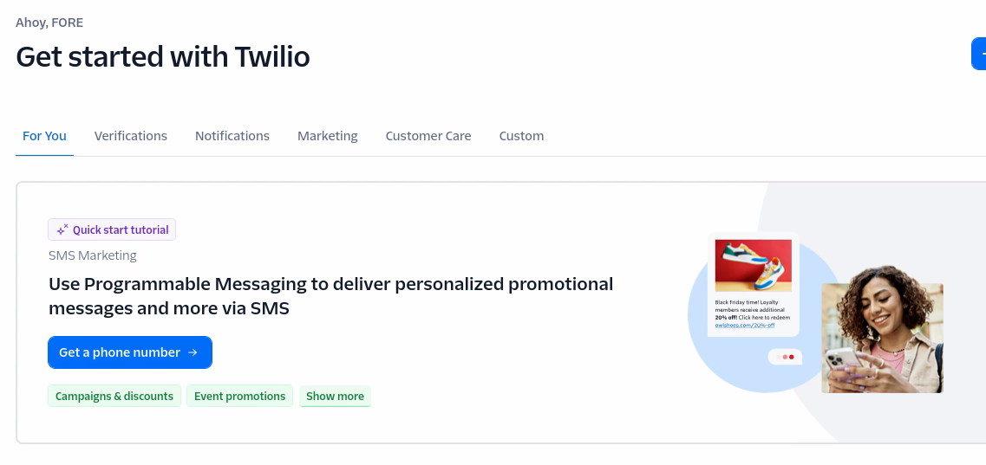Figure 1: Click Get Phone Number

In the bottom part of the page you get Account informtion and Auth token. Save thsi information also.

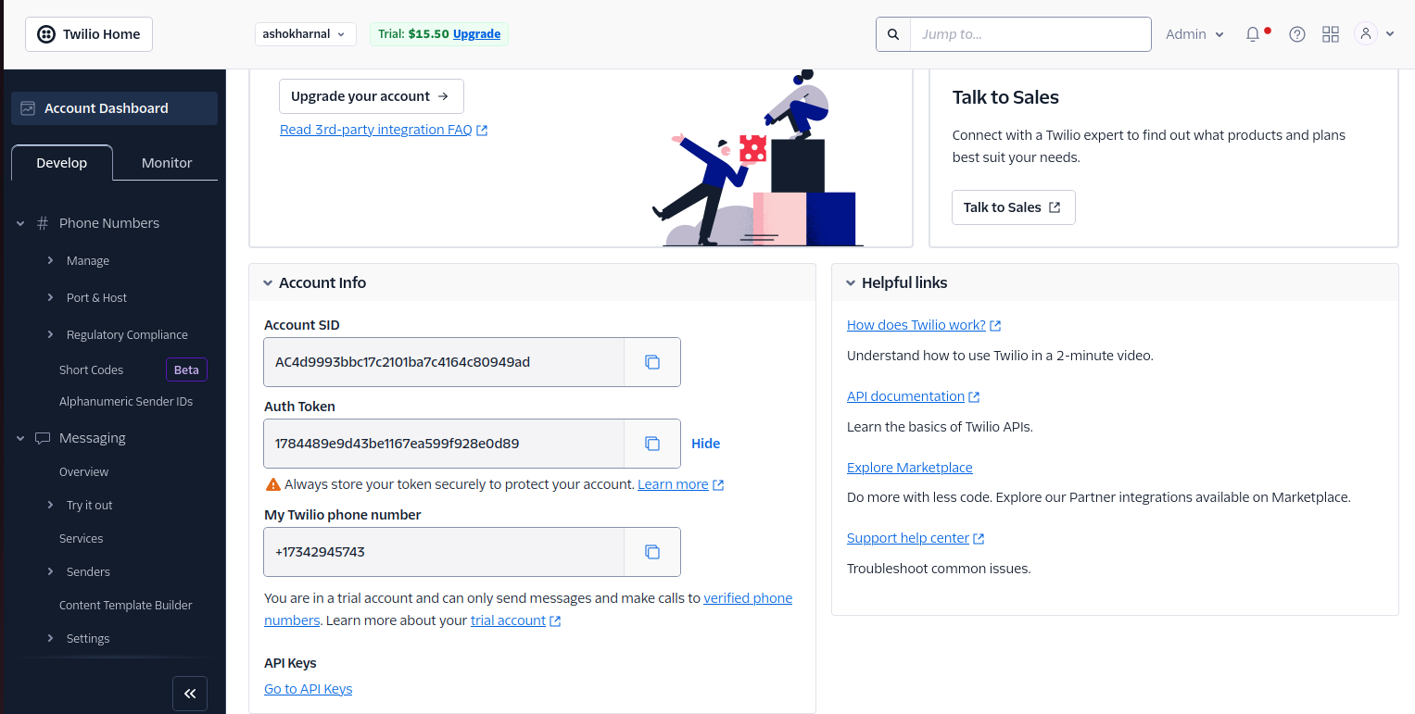Figure 2: Copy each and every information from this page into your email

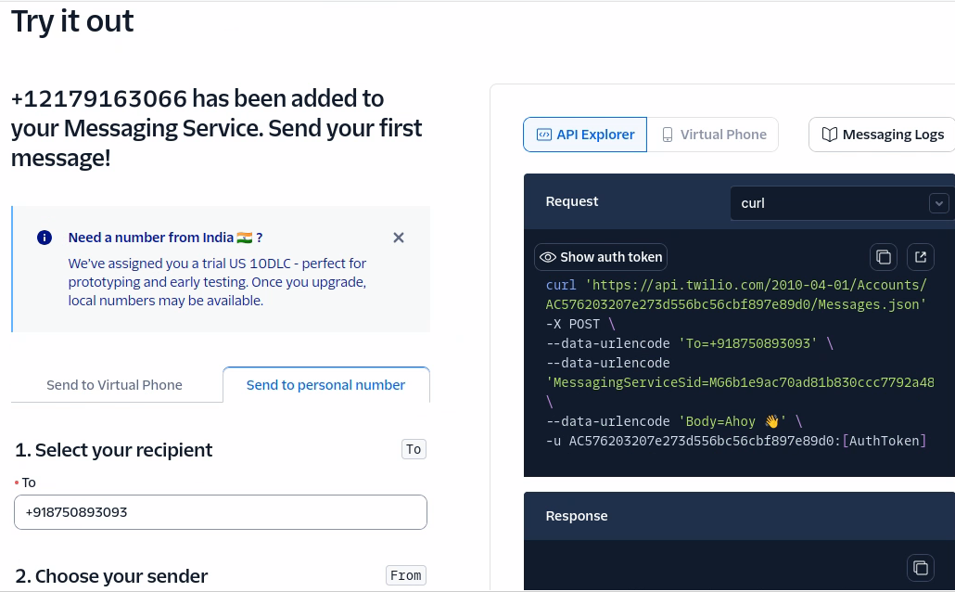
Figure 3: You can get an SMS from the telepone number allocated to ypu.

Account SID number:
AC4d9993bbc17c2101ba7c4164c80949ad
Auth Token
1784489e9d43be1167ea599f928e0d89
My Twilio phone number
+17342945743
My Phone Number:
+918750893093

Should you login again, you will also be lead to your accounts page where you can get full information.

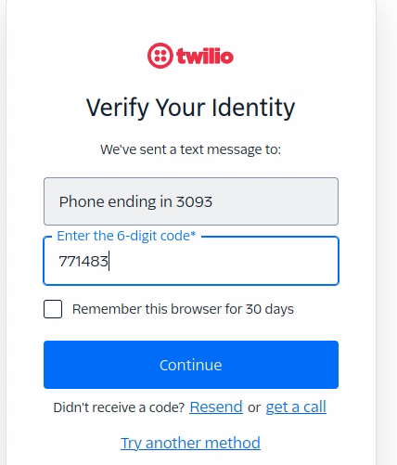

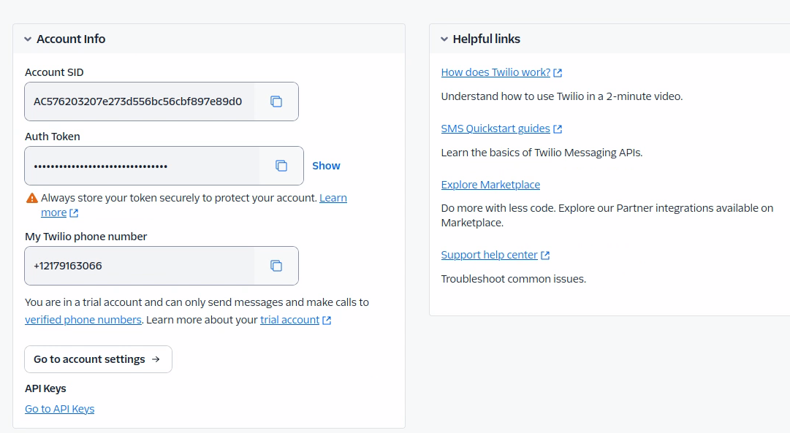

Configuring n8n to use Twilio

Refer here to configure Twilio in n8n

Using Auth Token
To configure this credential, you'll need a Twilio account and:
- Your Twilio Account SID
- Your Twilio Auth Token

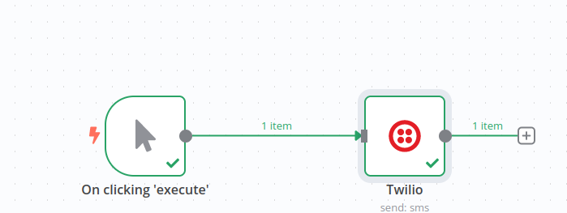
To set up the credential:
- In n8n, select Auth Token as the Auth Type.
- In Twilio, go to Console Dashboard > Account Info.
- Copy your Account SID and enter this in your n8n credential. This acts as a username.
- Cop your Auth Token and enter this in your n8n credential. This acts as a password.
Refer to Auth Tokens and How to Change Them for more information.

Configuration of Twilio node.
Only SMS works not WhatsApp.

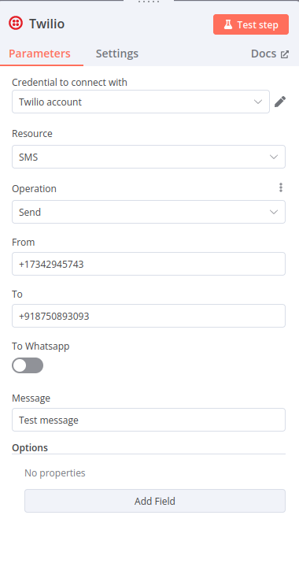

Test working
See the right hand side.

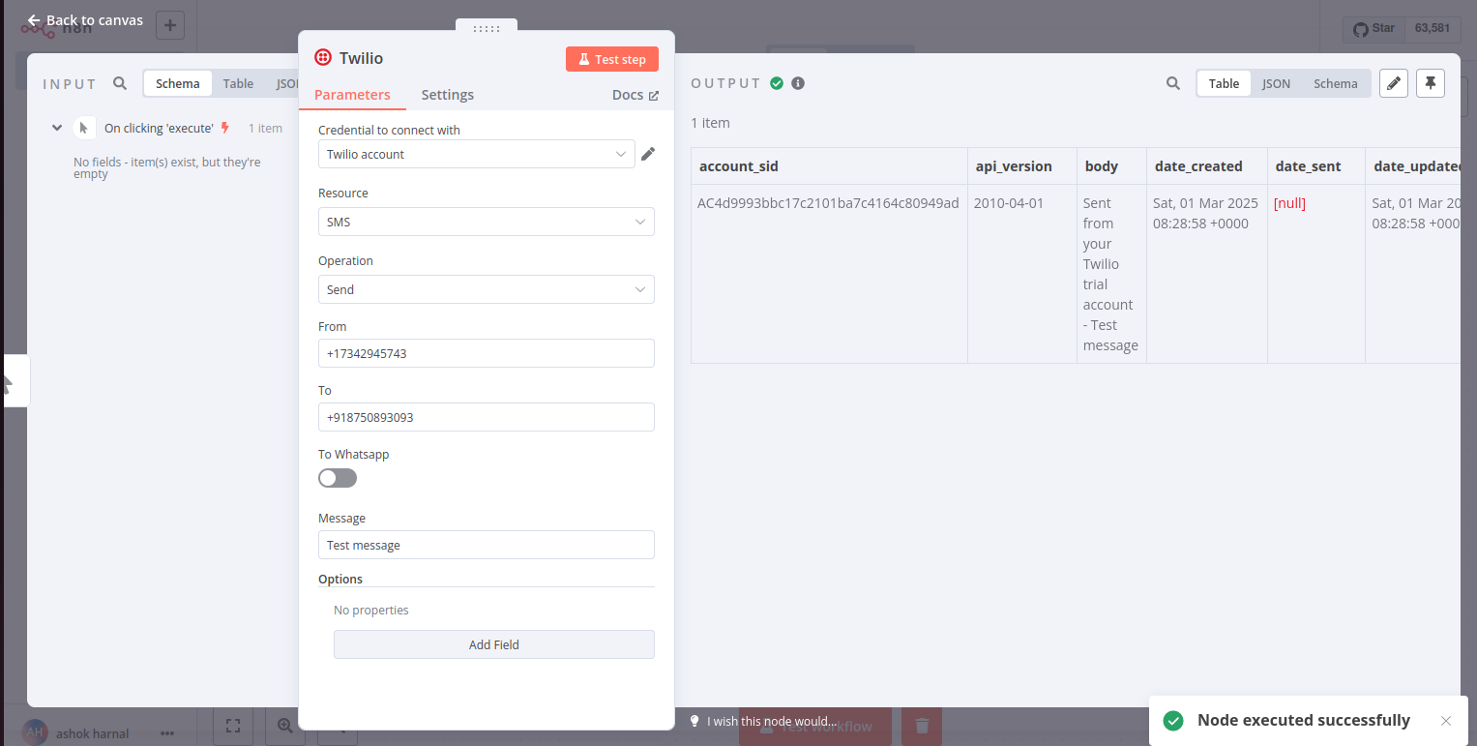

Receiving Results from AI Agent through Twilio:

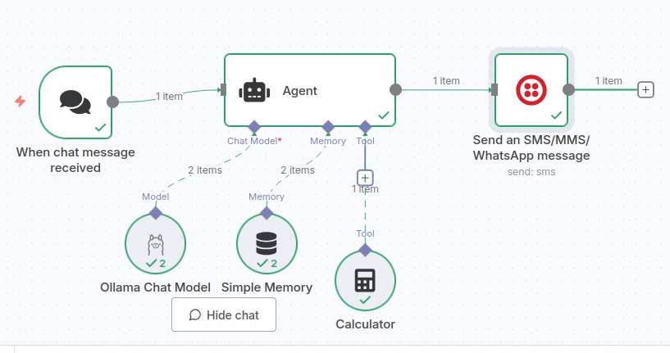Figure 4: Issue prompt: Calculate 32 + 40. See below configuration of Twilio

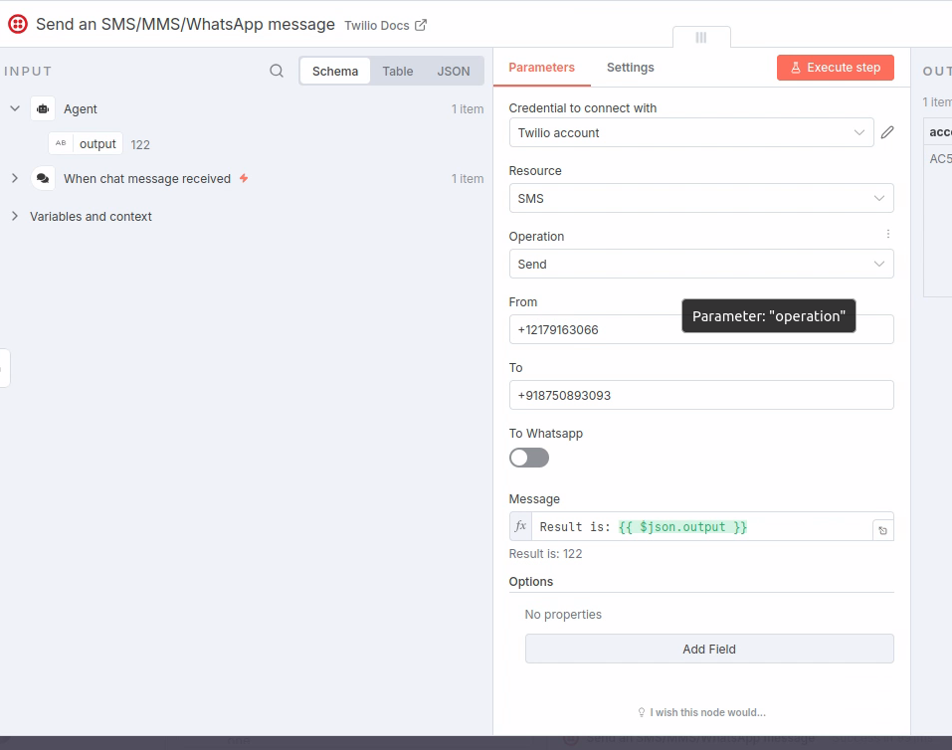Figure 5: Output dragged to Message text box

#################

