**Originator:-Harneet Kaur**

**ID:-100365644**

**Reviewers:-Jasdeep Kaur(100359509)**

**Baljinder Kaur(100362124)**

**Jasjeet Kaur(100363149)**

**Use Case Diagram**

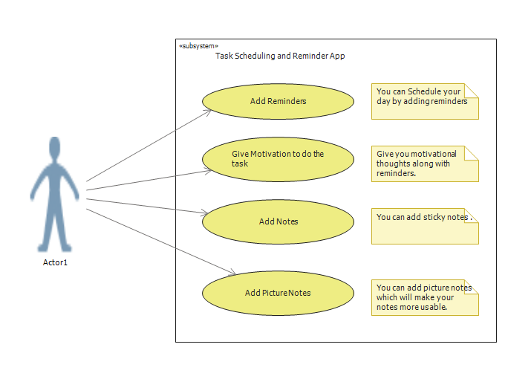

**Use Case Descriptions**

|  |
| --- |
| Use Case Title: Add Notes |
| Primary Actor: User |
| Level: Kite (summary) |
| Stakeholders: User |
| Precondition: User must download the application |
| Minimal Guarantee: Alarm on time |
| Success Guarantees: Able to add sticky notes along with reminder |
| Trigger: User access the application |
| Main Success Scenario:   1. User opens the **Add Notes** tab. 2. User will able to type the detailed notes. 3. User will able to add their notes successfully. 4. User can access those notes anytime in the future. |
| Extensions:  1a. User do not able to open **Add Notes** tab.  1a1. User quits the app.  2b. If user do not able to type the notes.  2b1. User quits the app.  2b2. User can add just reminder.  3c. If user do not able to save the notes successfully.  3c1. Quit the app.  3c2. User can add another picture notes.  3c3. User can add just reminder.  4d. If user do not able to able to access the notes in future.  4d1. Quit the app. |