HowTo_Patch_WebSphere

WebSphere Patching FP 21

Example server – uk1od04tsb

GUI

1. Login to server, using putty . Make sure x11 forwarding is enabled.
2. Check x11 is working by running simple command
> xclock
a display would pop up of a clock
3. check if you have a .Xauthority file in home directory.
Copy it in tmp. And give it permission
cp .Xauthority /tmp
chmod 777 /tmp/.Xauthority
4 switch to was user
export XAUTHORITY=/tmp/.Xauthority
5. if you get error – Cant open display . Set DISPLAY variable and try again.
export DISPLAY=localhost:10.0

TBC → TO BE CONTINUED

----------------------

Command line

List packages already installed :
./imcl listInstalledPackages

was@uk1od04tsb:/opt/IBMIM/eclipse/tools> ./imcl listInstalledPackages
com.ibm.cic.agent_1.6.2000.20130301_2248
com.ibm.websphere.BASE.v85_8.5.5021.20220202_1245
com.ibm.websphere.IBMJAVA.v70_7.0.4001.20130510_2103
com.ibm.websphere.IHS.v85_8.5.5021.20220202_1245
com.ibm.websphere.PLG.v85_8.5.5021.20220202_1245

List packages on downloaded packages / repositories

s@uk1od04tsb:/opt/IBMIM/eclipse/tools> ./imcl listAvailablePackages -repositories /var/opt/BESClient/websphere.delete/fp021sup/
com.ibm.websphere.APPCLIENT.v85_8.5.5021.20220202_1245
com.ibm.websphere.APPCLIENTILAN.v85_8.5.5021.20220202_1245
com.ibm.websphere.IHS.v85_8.5.5021.20220202_1245
com.ibm.websphere.IHSILAN.v85_8.5.5021.20220202_1245
com.ibm.websphere.PLG.v85_8.5.5021.20220202_1245
com.ibm.websphere.PLGILAN.v85_8.5.5021.20220202_1245
com.ibm.websphere.PLUGCLIENT.v85_8.5.5021.20220202_1245
com.ibm.websphere.PLUGCLIENTILAN.v85_8.5.5021.20220202_1245
was@uk1od04tsb:/opt/IBMIM/eclipse/tools>

was@uk1od04tsb:/opt/IBMIM/eclipse/tools> ./imcl listAvailablePackages -repositories /var/opt/BESClient/websphere.delete/fp021
com.ibm.websphere.BASE.v85_8.5.5021.20220202_1245
com.ibm.websphere.BASETRIAL.v85_8.5.5021.20220202_1245
com.ibm.websphere.DEVELOPERS.v85_8.5.5021.20220202_1245
com.ibm.websphere.DEVELOPERSILAN.v85_8.5.5021.20220202_1245
com.ibm.websphere.EXPRESS.v85_8.5.5021.20220202_1245
com.ibm.websphere.EXPRESSTRIAL.v85_8.5.5021.20220202_1245
com.ibm.websphere.ND.v85_8.5.5021.20220202_1245
com.ibm.websphere.NDDMZ.v85_8.5.5021.20220202_1245
com.ibm.websphere.NDDMZTRIAL.v85_8.5.5021.20220202_1245
com.ibm.websphere.NDTRIAL.v85_8.5.5021.20220202_1245

was@uk1od04tsb:/opt/IBMIM/eclipse/tools> /opt/WebSphere/AppServer/bin/versionInfo.sh | grep -i packag
Package com.ibm.websphere.IBMJAVA.v70_7.0.4001.20130510_2103
Package com.ibm.websphere.BASE.v85_8.5.5010.20160721_0

./imcl install offering_ID_offering_version,optional_feature_ID -repositories source_repository -installationDirectory product_installation_location -secureStorageFile storage_file -masterPasswordFile master_password_file -acceptLicense -sP

UPGRADE WAS

./imcl install com.ibm.websphere.BASE.v85_8.5.5021.20220202_1245 -repositories /var/opt/BESClient/websphere.delete/fp021 -installationDirectory /opt/WebSphere/AppServer -acceptLicense -sP

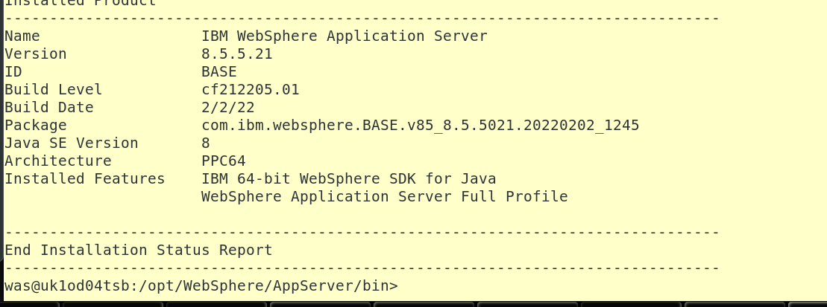

UPGRADE PLUGIN

./imcl install com.ibm.websphere.PLG.v85_8.5.5021.20220202_1245 -repositories /var/opt/BESClient/websphere.delete/fp021sup -installationDirectory /opt/WASPLG -acceptLicense -sP

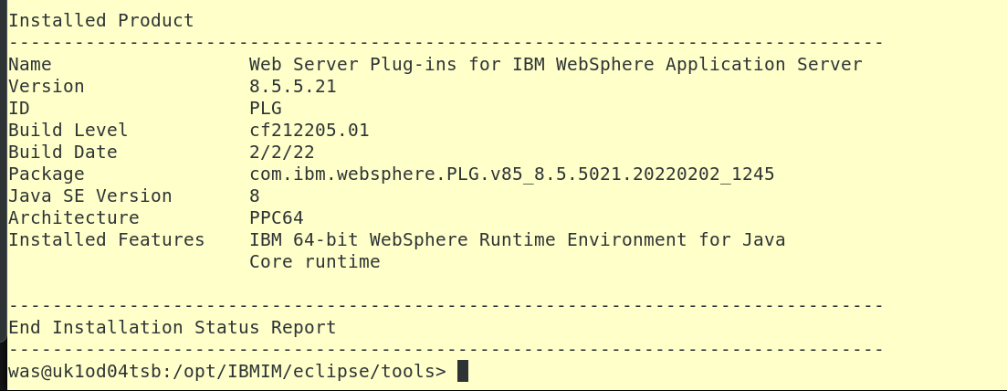

UPGRADE IHS

./imcl install com.ibm.websphere.IHS.v85_8.5.5021.20220202_1245 -repositories /var/opt/BESClient/websphere.delete/fp021sup -installationDirectory /opt/IBMIHS -acceptLicense -sP
