**Subject: Pedestrian Evacuation in the Event of a Tsunami in Hanoi**

**Overview**

The "Evacuation" model is an agent-based simulation designed to address the critical issue of pedestrian evacuation in the event of a tsunami or similar natural disaster. The focus is on Hanoi, a city that is increasingly vulnerable to such catastrophic events, particularly due to its location near the Red River and the potential threat of dike breaches. This model simulates the behavior of residents in response to an imminent flood risk, emphasizing the importance of information dissemination and the subsequent actions of the populace.

**Context**

The simulation operates under the scenario of a sudden natural disaster, specifically targeting urban areas where the population density is high and the risk of casualties due to flooding is significant. The model does not simulate the flooding itself but focuses on human behavior in reaction to the flood threat. It aims to provide insights into how a population might effectively be evacuated from danger zones, particularly in urban settings like Hanoi.

**Scenario**

* At the start of the simulation, all residents are located in their homes.
* Only 10% of the population is initially aware of the flood threat. This subset of the population is determined randomly.
* The informed individuals will begin evacuating towards a designated shelter, which is the largest building in the area.
* Residents observing others evacuating within a 10-meter radius have a 10% chance of starting their evacuation.
* The model's endpoint is reached once all informed individuals have evacuated.

**Significance**

This model serves as a tool for urban planners, emergency response teams, and policymakers to understand and improve evacuation strategies in densely populated areas. It aims to reduce the time required for complete evacuation and to identify key factors that influence the effectiveness of such emergency procedures. The findings could inform real-world strategies to increase the efficiency of disaster response and potentially save lives.

**Hypothesis**

**Primary Hypothesis**

* **Effective Information Dissemination is Crucial for Timely Evacuation**: Given that only a fraction of the population (10%) is initially aware of the impending disaster, the model hypothesizes that the speed and extent of information dissemination among the populace play a critical role in the overall evacuation efficiency. The quicker and more widespread the dissemination, the faster the evacuation.

**Secondary Hypotheses**

* **Observational Learning Influences Evacuation Decisions**: The model posits that individuals observing their peers evacuating will likely follow suit. This mimetic behavior is hypothesized to significantly contribute to the evacuation process, especially among those initially uninformed about the disaster.
* **Proximity to Shelters Affects Evacuation Efficiency**: The model suggests that the spatial distribution of residents in relation to the shelter (largest building) will impact evacuation times. Residents closer to the shelter are likely to evacuate faster, thereby influencing the overall evacuation efficiency.

**Potential Findings**

* The simulation might reveal that certain urban layouts or population distributions lead to more efficient evacuations.
* It could also highlight the critical threshold of informed individuals needed to trigger a large-scale evacuation through observational learning.
* The model may demonstrate the importance of strategically located shelters and their capacities in managing mass evacuations effectively.

**Implications**

* Findings could influence urban planning, especially in disaster-prone areas, by emphasizing the layout of residential areas and the strategic placement of shelters.
* The results may underscore the need for efficient communication channels and systems during disasters to inform as many residents as possible in the shortest time.
* Insights from the model could be used to train residents and emergency personnel, preparing them for efficient response in real-life scenarios.

**BASE MODEL**

**Subject**

The "Evacuation" model simulates the emergency evacuation of a coastal population in a tsunami context. It focuses on pedestrian dynamics, highlighting the residents' behavior in response to a flooding threat. The model aims to understand and optimize evacuation strategies to improve disaster preparedness and response.

**Hypothesis**

The core hypothesis driving this model is that efficient information dissemination and strategic evacuation can significantly enhance the safety and speed of evacuation in disaster scenarios. The model postulates that:

1. Informed individuals will immediately start evacuating towards the shelters.
2. Uninformed individuals have a chance to become informed upon observing others evacuating, thereby spreading awareness organically.
3. The evacuation process's efficiency is heavily dependent on the urban layout and the residents' distribution.

**Species:**

* **building:**Represents a building, with attributes height and **isShelter** (the building is the shelter).
* **road**: Represents a road segment, with attributes **speed_rate** (reflecting congestion)and **nb_inhabitants** (number of nearby inhabitants).
* **inhabitant:**Represents an inhabitant, with attributes**:**
  + **isInformed:**Whether they are aware of the evacuation.
  + **isEvacuating:**Whether they are actively evacuating.
  + **isEvacuated:**Whether they have reached a shelter.
  + **home:**Their starting location.
  + **target**: Their current evacuation destination.
  + **location:**Their current position.

**Reflexes:**

* **update_speed** (global): Updates road speed rates based on congestion.
* **simulation_running_condition** (global): Pauses the simulation if all inhabitants are informed or evacuated.
* **inform_evacuating** (inhabitant): Inhabitants can become informed by proximity to other evacuating or informed inhabitants.
* **just_moving** (inhabitant): Uninformed, non-evacuating inhabitants move randomly.
* **evacuated** (inhabitant): Resets an inhabitant's state after reaching a shelter.
* **isInformed**(inhabitant): Starts evacuation when an informed inhabitant has no target.
* move (inhabitant): Moves inhabitants towards their target on the road network.

**Model Workflow**:

1. **Initialization**:
   * Load building and road data.
   * Assign inhabitants to homes and determine initial awareness (10% are informed).
2. **Evacuation Process**:
   * Informed inhabitants head towards shelters.
   * Uninformed inhabitants may become informed upon close contact with evacuating individuals.
   * Movement is constrained by the road network and proximity to shelters.
3. **Termination Condition**:
   * The model pauses when all informed inhabitants have evacuated or no one is left uninformed about the evacuation.

**Extension 1**

**Requirement:**

Not all residents know where to evacuate and only 10% will go directly to the shelter. The rest will move to random buildings trying to search for the shelter - if the resident is less than 20 m from the shelter, he/she goes straight to it.

**Overall Purpose:**

* Simulates an evacuation scenario with extensions to model information spread and shelter-finding behavior.
* Explores evacuation dynamics and how individuals make decisions during evacuations.

Key Components:

**1. Global Variables and Initialization:**

* Same as in the original code.

**2. Species:**

* Same as in the original code.

**3. Reflexes:**

* **update_speed and simulation_running_condition:** Same as in the original code.
* **inform_evacuating (inhabitant):** Modified to allow a 10% chance for informed inhabitants to immediately know the shelter location.
* **check_shelter (inhabitant):** New reflex for informed inhabitants to search for nearby shelters.
* **just_moving (inhabitant):** Modified to prevent checking already-checked buildings.
* **evacuated and move:** Same as in the original code.
* **evacuating (inhabitant):** New reflex to set **isEvacuated** when an evacuating inhabitant reaches their target.

**4. Experiment:**

* Same as in the original code.

**Key Changes in Extension 1:**

* **Immediate Shelter Information:** 10% chance for informed inhabitants to directly know the shelter location.
* **Shelter-Finding Behavior:** Informed inhabitants actively search for nearby shelters within a 20-unit radius.
* **Preventing Rechecking Buildings:** Inhabitants maintain a list of checked buildings to avoid redundant exploration.

**Extension 2**

**Requirement**

We consider different types of mobility: car, motorcycle, walking. A person is 20% likely to have a car, 70% likely to have a motorcycle. A car can go faster on an open road, but will be more affected by traffic jams. Motorcycles will travel slightly slower than cars (0.85 factor), but will be half as affected by traffic jams. Pedestrians will be 10 times slower than cars, but will be 5 times less affected by traffic jams.

**Overall Purpose:**

* Simulates an evacuation scenario with further extensions to model diverse mobility types and their impact on traffic.
* Explores evacuation dynamics under varying transportation modes and congestion levels.

**Key Components:**

**1. Global Variables and Initialization:**

* Same as in Extension 1.

**2. Species:**

* Same as in Extension 1, except for the addition of mobilityType to the inhabitant species.

**3. Reflexes:**

* **update_speed, simulation_running_condition, inform_evacuating, check_shelter, just_moving, evacuated, and evacuating:** Same as in Extension 1.
* **update_current_road (inhabitant):** New reflex to determine the road segment an inhabitant is currently on.
* **move (inhabitant):** Modified to incorporate mobility types and traffic density:
  + Inhabitants have a **mobilityType** (CAR, MOTORCYCLE, or WALKING) that affects their base speed and traffic impact.
  + Traffic density is calculated based on the number of inhabitants on the current road segment.
  + Movement speed is adjusted based on both base speed and traffic density.

**4. Experiment:**

* Same as in Extension 1.

**Key Changes in Extension 2:**

* **Mobility Types:** Inhabitants now have distinct mobility types with varying speed factors and traffic impacts.
* **Traffic Density Calculation:** Traffic density is calculated for each road segment, considering the number of inhabitants present.
* **Traffic-Adjusted Movement:** Inhabitant movement speed is dynamically adjusted based on their mobility type and the traffic density on their current road segment.

**Extension 3**

*On this extension, I have not finished the experiment to have an exploration to research, analyze, and compare 3 different strategies but please the simulations have been running*

**Requirement**

the 10% of the population who are aware of the situation at the start of the simulation are no longer chosen randomly, but according to different strategies: those furthest from the shelter, and those closest to the shelter. Compare the 3 strategies (random, furthest, closest) in terms of number of evacuees and evacuation time. Create a batch exploration to examine which strategy is the most efficient (time for the total evacuation/time spent on the roads), depending on the number of initial people and the alert time before the river flooding.

**Overview:**

* **Purpose:** Simulates an evacuation scenario with diverse features, including different alert strategies, various transportation modes, and traffic congestion.
* **Key Features:**
  + Dynamic traffic handling based on road density
  + Multiple alert strategies (random, furthest, closest)
  + Different transportation modes (car, motorcycle, walking) with varying speed and traffic impact
  + Parameter configuration for population size, alert time, and shelter number
  + Batch-mode simulations for exploring different scenarios

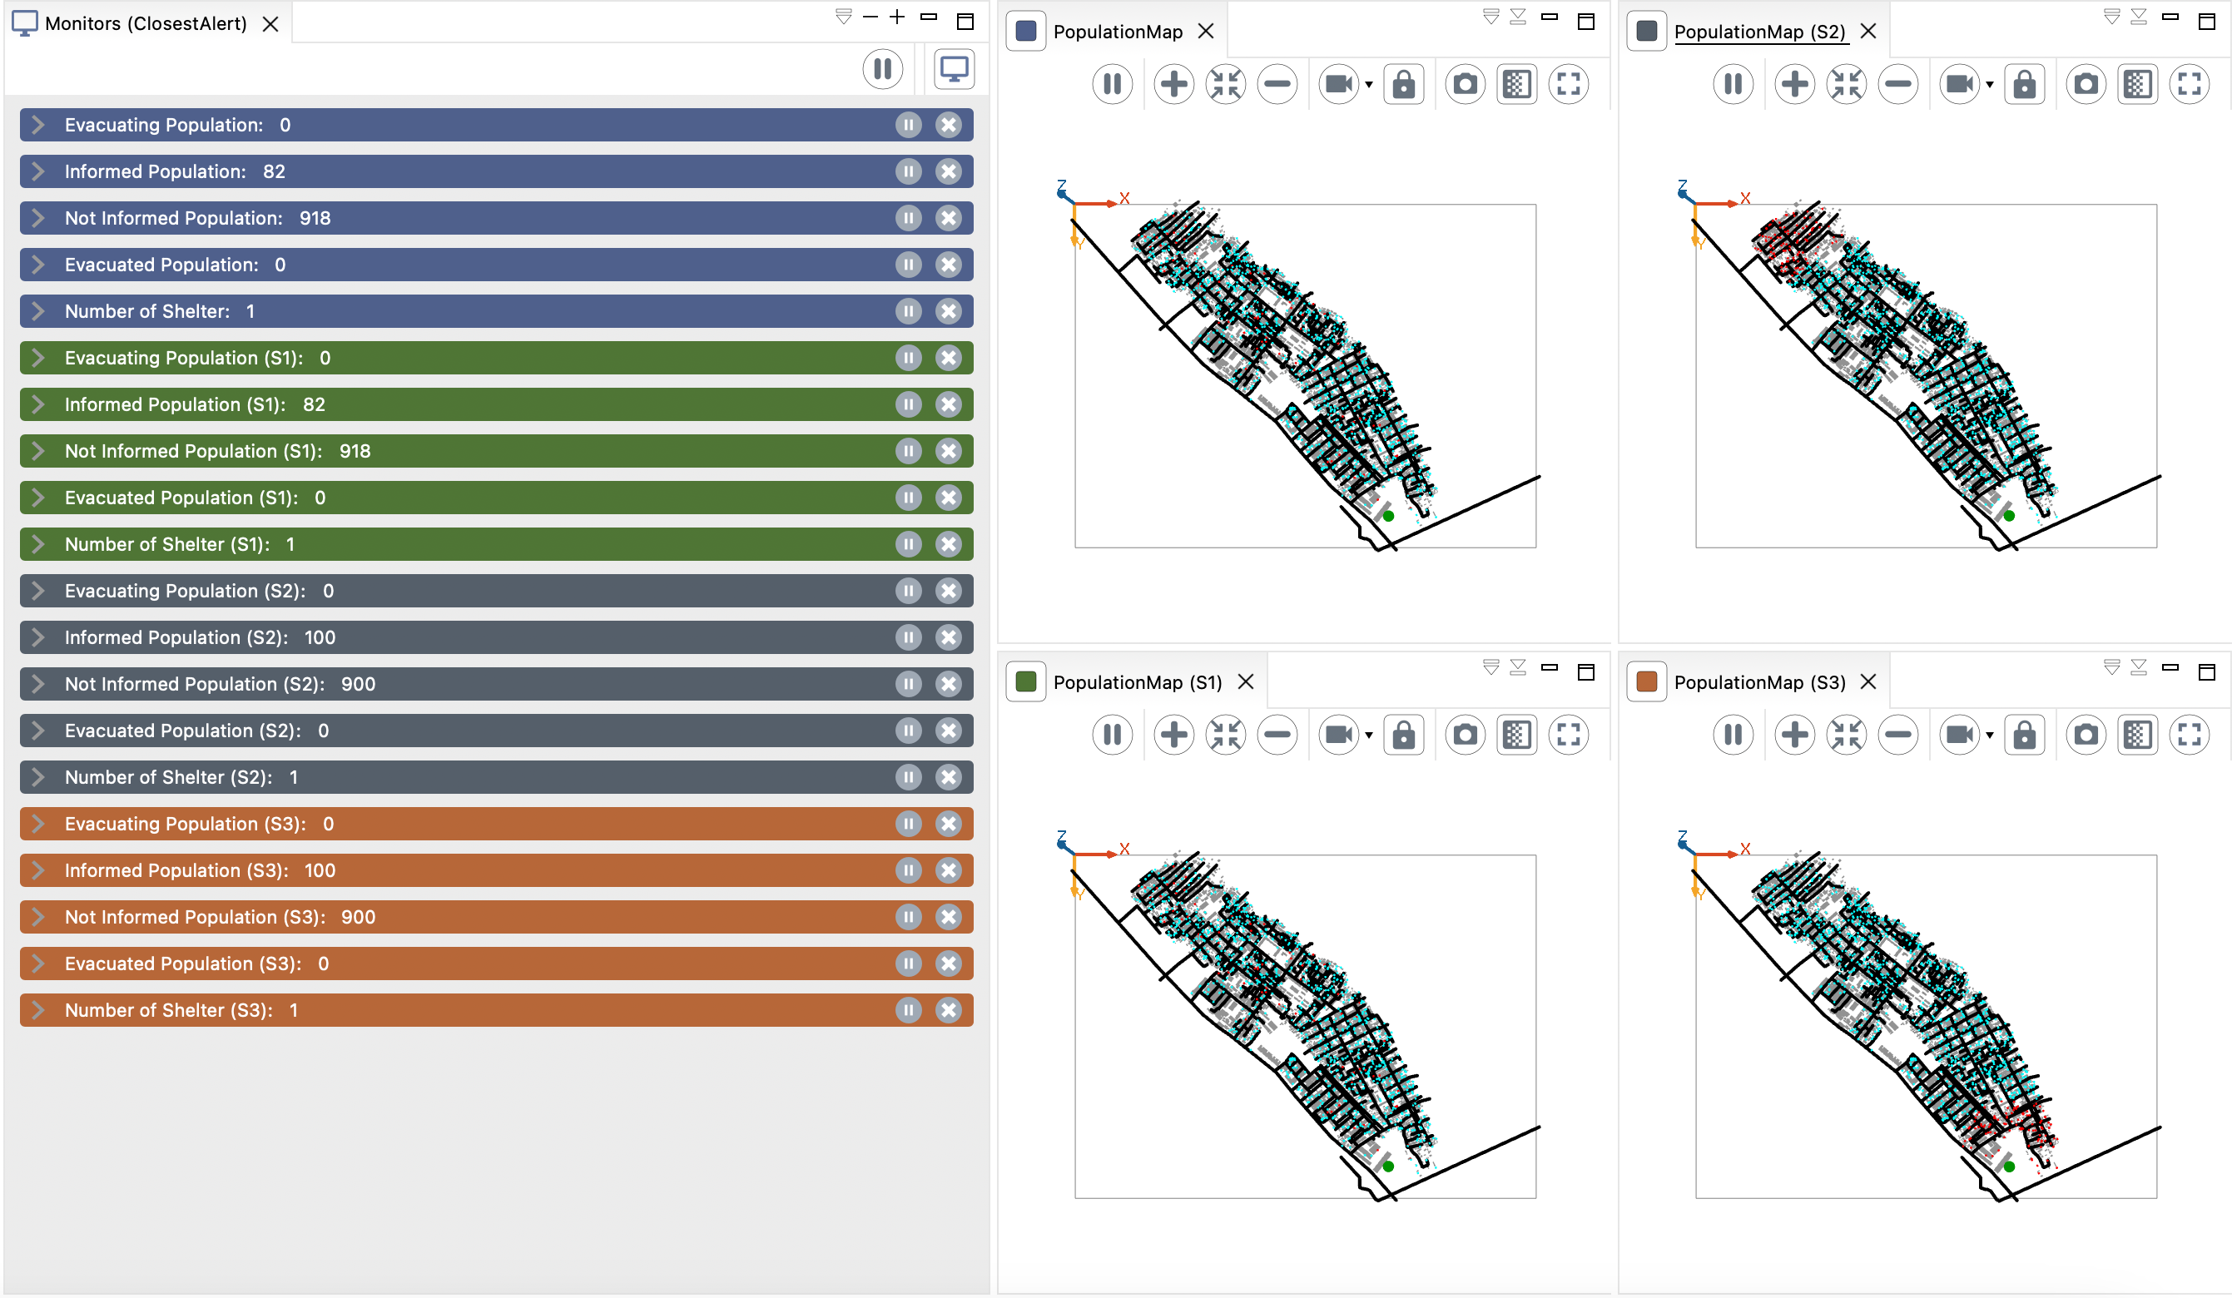

**Code Structure:**

1. **Global Variables and Initialization:**
   * Set up parameters, load road and building data, create species, initialize variables, and assign shelters.
2. **Species:**

Same as the base model

1. **Inhabitant Reflexes:**

* **inform_evacuating**: Informs nearby inhabitants with a 10% chance if an inhabitant is not informed and not evacuating.
* **check_shelter**: If an informed inhabitant is near a shelter, it starts evacuating towards it.
* **just_moving:** If an inhabitant has no target and is not informed or evacuating, it randomly moves to a building.
* **evacuated:** Removes the inhabitant from the simulation once it reaches the shelter.
* **evacuating:** Updates the inhabitant's status to evacuated once it reaches the shelter.
* **update_current_road**: Updates the current road of the inhabitant based on its location.
* **move**: Moves the inhabitant towards its target considering its mobility type and traffic density.

1. **Road Reflexes:**

* **update_speed_rate:** Updates the road's speed rate based on the number of inhabitants on it.

1. **Global Reflexes:**

* **update_speed**: Updates the speed of all inhabitants based on the road they are on.
* **simulation_running_condition**: Pauses the simulation when all inhabitants are informed or evacuated.

**Comparison with the Previous Model:**

The main differences in reflexes between the current and previous models are:

* **Inhabitant Mobility:** The current model incorporates different mobility types (car, motorcycle, walking) with varying speed and traffic impact.
* **Traffic Handling:** The current model considers traffic density on roads, which dynamically affects the movement speed of inhabitants.
* **Alert Strategies:** The current model supports three alert strategies (random, furthest, closest) for informing inhabitants.

**Additional Features:**

The current model includes additional features not present in the previous model, such as:

* **Batch-mode simulations:** Allows running multiple simulations with varying parameters.
* **Parameter configuration:** Provides options for adjusting population size, alert time, and shelter number.
* **Visualization and result saving:** Facilitates model analysis and comparison.

**Key Points:**

* Inhabitants move towards designated shelters based on their information status and evacuation progress.
* Traffic density on roads affects movement speed.
* Different alert strategies can be explored.
* Simulations can be run in batch mode with varied parameters.
* The code incorporates features for visualization and result saving.