Home Work 4

**Harnish Shah**

**001348174**

Summary

Data Used:

[Adults](https://archive.ics.uci.edu/ml/datasets/Adult): (<https://archive.ics.uci.edu/ml/machine-learning-databases/adult/adult.data>)

# Histogram

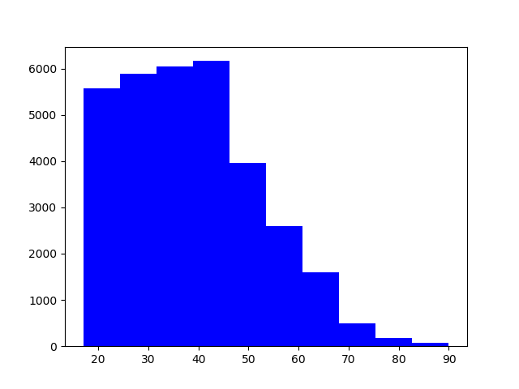

# Scatter plot

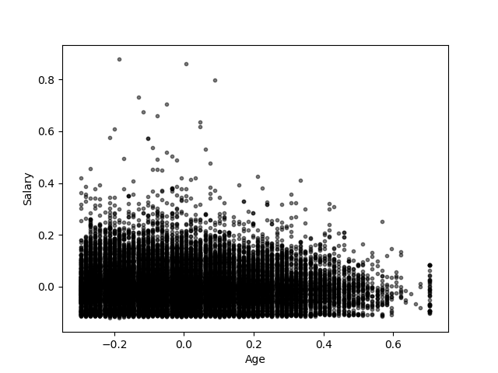

# Box plot

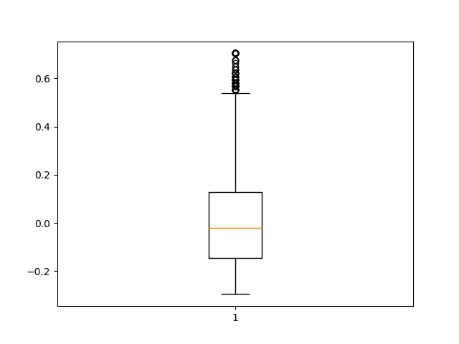

# Density map

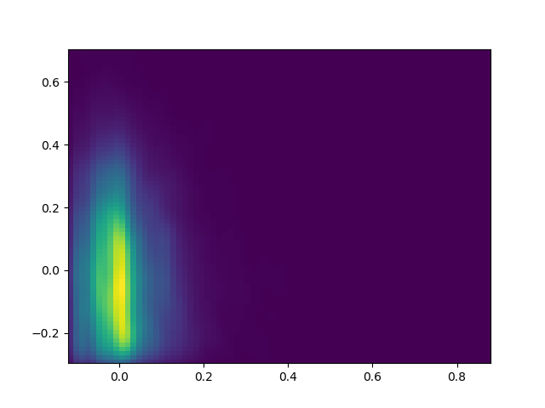

# Parallel coordinate plot

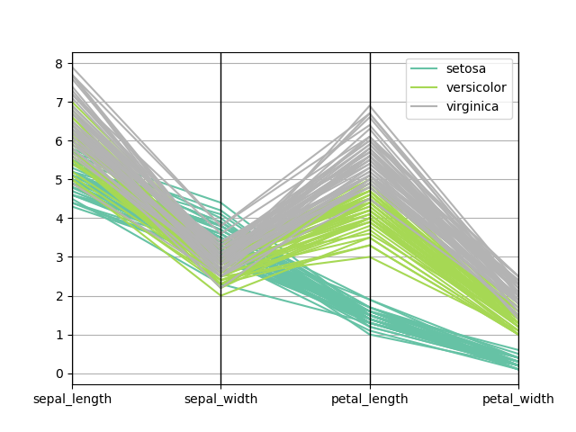

# Correlation matrix plot

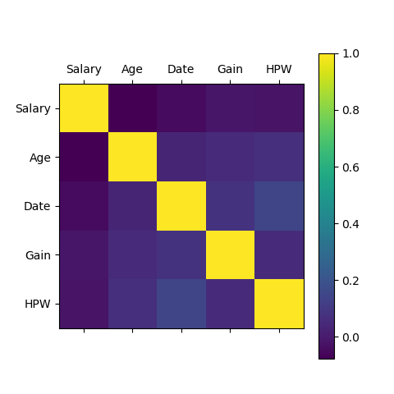

# Word cloud

