SysOps Assignment

SonarQube

SonarQube is an open-source platform for continuous inspection of code quality. It helps developers, teams, and organizations manage and improve the quality of their codebase by identifying code issues, security vulnerabilities, and code smells. SonarQube provides a centralized dashboard to view detailed analysis results, enabling teams to make data-driven decisions for code improvement.
Key Features of SonarQube:
1. Code Quality Analysis: SonarQube performs static code analysis to assess the quality of the codebase. It identifies issues related to code duplication, complexity, coding standards, and potential bugs.
2. Security Vulnerability Detection: The platform detects security vulnerabilities and potential risks in the code, helping teams address security-related concerns.
3. Code Smells Detection:SonarQube identifies code smells, which are indicators of poor code design or implementation. It suggests improvements to enhance code readability and maintainability.
4. Coverage Analysis: SonarQube measures code coverage, providing insights into the percentage of code that is covered by automated tests.
5.Integration with CI/CD: SonarQube can be easily integrated into the Continuous Integration (CI) and Continuous Deployment (CD) pipelines, automatically analyzing code on every build.
6. Customizable Quality Profiles:Users can define custom quality profiles to tailor the code analysis to their specific project requirements.
7. Issue Management: SonarQube provides a comprehensive list of identified issues, allowing teams to prioritize and manage the remediation process effectively.
8.Historical Data and Trends: The platform tracks code quality over time, providing historical data and trends to monitor improvements or regressions.
9.Wide Language Support: SonarQube supports various programming languages, including Java, JavaScript, Python, C#, TypeScript, Kotlin, and more.
10.Plugins Ecosystem:A wide range of plugins is available to extend the functionality of SonarQube for specific needs.
Disadvantages of SonarQube:
While SonarQube is a valuable tool for code quality management, it does have some disadvantages and limitations that users should be aware of:
1.False Positives and Negatives: SonarQube's static code analysis may produce false positives (reporting issues that are not actual problems) or false negatives (failing to identify actual issues). This can lead to confusion and extra effort in reviewing and validating reported issues.

2. Complex Configuration: Setting up SonarQube and configuring it for specific projects can be challenging, especially for larger and more complex codebases. It requires a good understanding of the tool's configuration options and coding rules.

3.Performance Impact: Running code analysis on large projects can be time-consuming and resource-intensive. Integrating SonarQube into the CI/CD pipeline may increase build times, affecting development workflow.

4. Limited Dynamic Analysis: SonarQube focuses on static code analysis, which may not detect runtime-related issues or issues that occur under specific conditions.

5.Language Support: While SonarQube supports multiple programming languages, some languages might have limited rule sets or fewer plugins available, which could result in less comprehensive analysis.

6.Inaccurate Security Analysis: The security analysis provided by SonarQube might not be as exhaustive as specialized security tools, leading to potential blind spots in identifying security vulnerabilities.

7.Overhead on Developers: Developers may spend additional time fixing reported issues, which can slow down development velocity, especially in the initial stages of codebase improvement.

8.Limited Integration for Some Tools: Integrating SonarQube with certain build systems or CI/CD pipelines might require additional effort or customizations.

9.Code Dependency and Config Management: Managing code dependencies and configurations for SonarQube may become complex, particularly in a microservices architecture.

Despite these disadvantages, many development teams find SonarQube to be a valuable asset in managing code quality, catching potential issues early in the development process, and promoting best coding practices. It's essential to understand these limitations and use SonarQube in conjunction with other tools and practices to achieve comprehensive code quality management.
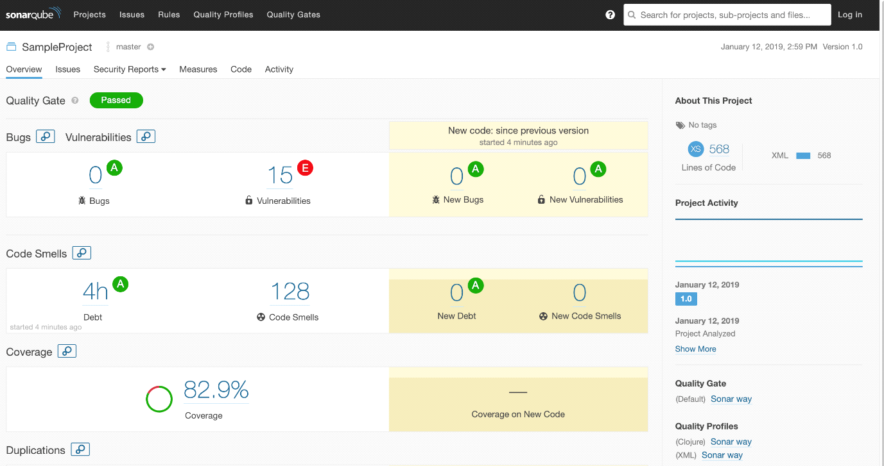
Here's an overview of the administrative capabilities in SonarQube:
- Access Control and Users Management: The management console allows administrators to define and manage user accounts with different levels of access rights. It provides options to set up user authentication methods, such as local accounts, LDAP, or SAML, and manage user groups.
- Quality Profiles and Rules Configuration: Administrators can define and manage quality profiles, which are sets of rules for code analysis specific to different programming languages. The management console allows the customization of these rules and their activation or deactivation for specific projects.
- Quality Gates Management: Quality gates define criteria that projects must meet to be considered of high quality. Administrators can configure and manage quality gates, setting thresholds for code quality metrics and rules compliance.
- Project and Branch Management: The management console allows users to create and manage projects in SonarQube. It also provides features to handle code analysis on different branches and manage project settings.
- Plugin and Extension Management: Administrators can install, update, or remove plugins to extend SonarQube's functionalities. The management console offers options to browse available plugins and configure installed ones.
- System Settings and Configuration: The administrative interface allows users to configure various system settings, such as email notifications, webhooks, and database settings.
- Viewing Reports and Metrics: Administrators have access to various dashboards and reports that provide insights into code quality metrics, issues, and trends across projects.
- Maintenance and Upgrades: The management console allows administrators to perform routine maintenance tasks, such as database backups, logs management, and system upgrades.
- Integration and Security Management: The administrative interface includes options to configure integration with external systems, such as CI/CD tools, version control systems, and issue trackers. It also provides options to manage SSL certificates and security-related configurations.
The specific features and capabilities available in the management console may vary depending on the version of SonarQube you are using and the installed plugins. As SonarQube continues to evolve, new features and improvements may be added to enhance the administrative capabilities and user experience.

Components of SonarQube:
1. SonarQube Server: The core component that performs code analysis, stores analysis results, and provides the web interface for reporting and analysis.

2. SonarScanner: The command-line tool used to analyze projects and send analysis data to the SonarQube server.

3. Quality Profiles: Configurations that define coding rules, metrics, and checks used during code analysis.

4. Quality Gates: A set of predefined conditions that must be met for a project to be considered of high quality.

How to Get Started:
- Download the SonarQube server and SonarScanner from the official website.
- Install and configure the SonarQube server on your server or cloud instance.
- Integrate SonarScanner into your build process or CI/CD pipeline to perform code analysis.
- Access the SonarQube web interface to view analysis results and manage code quality.
SonarQube provides a powerful and user-friendly platform for improving code quality, enhancing security, and maintaining clean codebases in software development projects.

JFrog
JFrog is a company that provides a suite of products to help with various aspects of software development and DevOps processes. Their products are focused on managing and distributing software artifacts, enabling developers to build, package, and deploy applications efficiently. One of their popular products is JFrog Artifactory, a universal artifact repository manager.
JFrog offers a comprehensive DevOps platform that includes various products and components to help with different aspects of the software development and delivery process. Here are the key components of JFrog's DevOps platform:

1. JFrog Artifactory:
Artifactory is a universal artifact repository manager that serves as a centralized hub for storing, managing, and distributing binary artifacts, dependencies, and build artifacts. It supports various package formats like Maven, Gradle, npm, Docker, PyPI, and more.

2. JFrog Xray:
Xray is a DevSecOps tool that integrates with Artifactory to provide continuous security and compliance scanning for software components. It identifies security vulnerabilities, license violations, and other issues within the artifacts stored in Artifactory.

3. JFrog Distribution:
JFrog Distribution enables secure and efficient distribution of software releases and updates to different target environments. It allows teams to deliver software artifacts to remote locations and manage the release process.

4. JFrog Pipelines:
Pipelines is a CI/CD automation platform that helps teams define, manage, and execute continuous integration and continuous delivery workflows. It allows seamless integration with various tools and processes in the CI/CD pipeline.

5. JFrog Insight:
Insight provides comprehensive insights and analytics to monitor the performance and efficiency of DevOps processes. It helps teams gain actionable insights to optimize their development and delivery pipelines.

6. JFrog Mission Control:
Mission Control is a centralized management tool that allows users to monitor and manage multiple JFrog Artifactory instances and clusters. It provides a single view of all Artifactory instances, helping organizations streamline operations.

7. JFrog Container Registry:
The JFrog Container Registry allows teams to store, manage, and secure Docker container images and Helm charts. It integrates with Kubernetes and other container orchestration platforms for seamless container management.

8. JFrog ChartCenter:
ChartCenter is a free public repository for Helm charts, a popular package manager for Kubernetes. It provides a central place to discover, share, and collaborate on Helm charts.

9.JFrog GoCenter:
GoCenter is a central repository for Go modules, providing reliable and immutable Go dependencies for Go developers.

These components work together to create an end-to-end DevOps solution that enhances the efficiency, security, and scalability of software development and delivery processes. JFrog's DevOps platform is widely used by organizations to accelerate software development, improve code quality, and deliver high-quality software products to customers.

JFrog Artifactory:
JFrog Artifactory is a robust and universal artifact repository manager. It serves as a central repository for storing and managing binary artifacts, dependencies, and build artifacts generated during the software development process. Artifactory supports various package formats, including Maven, Gradle, npm, Docker, RubyGems, PyPI, and more. It is designed to be scalable, secure, and highly available, making it suitable for small development teams and large enterprise-scale organizations.
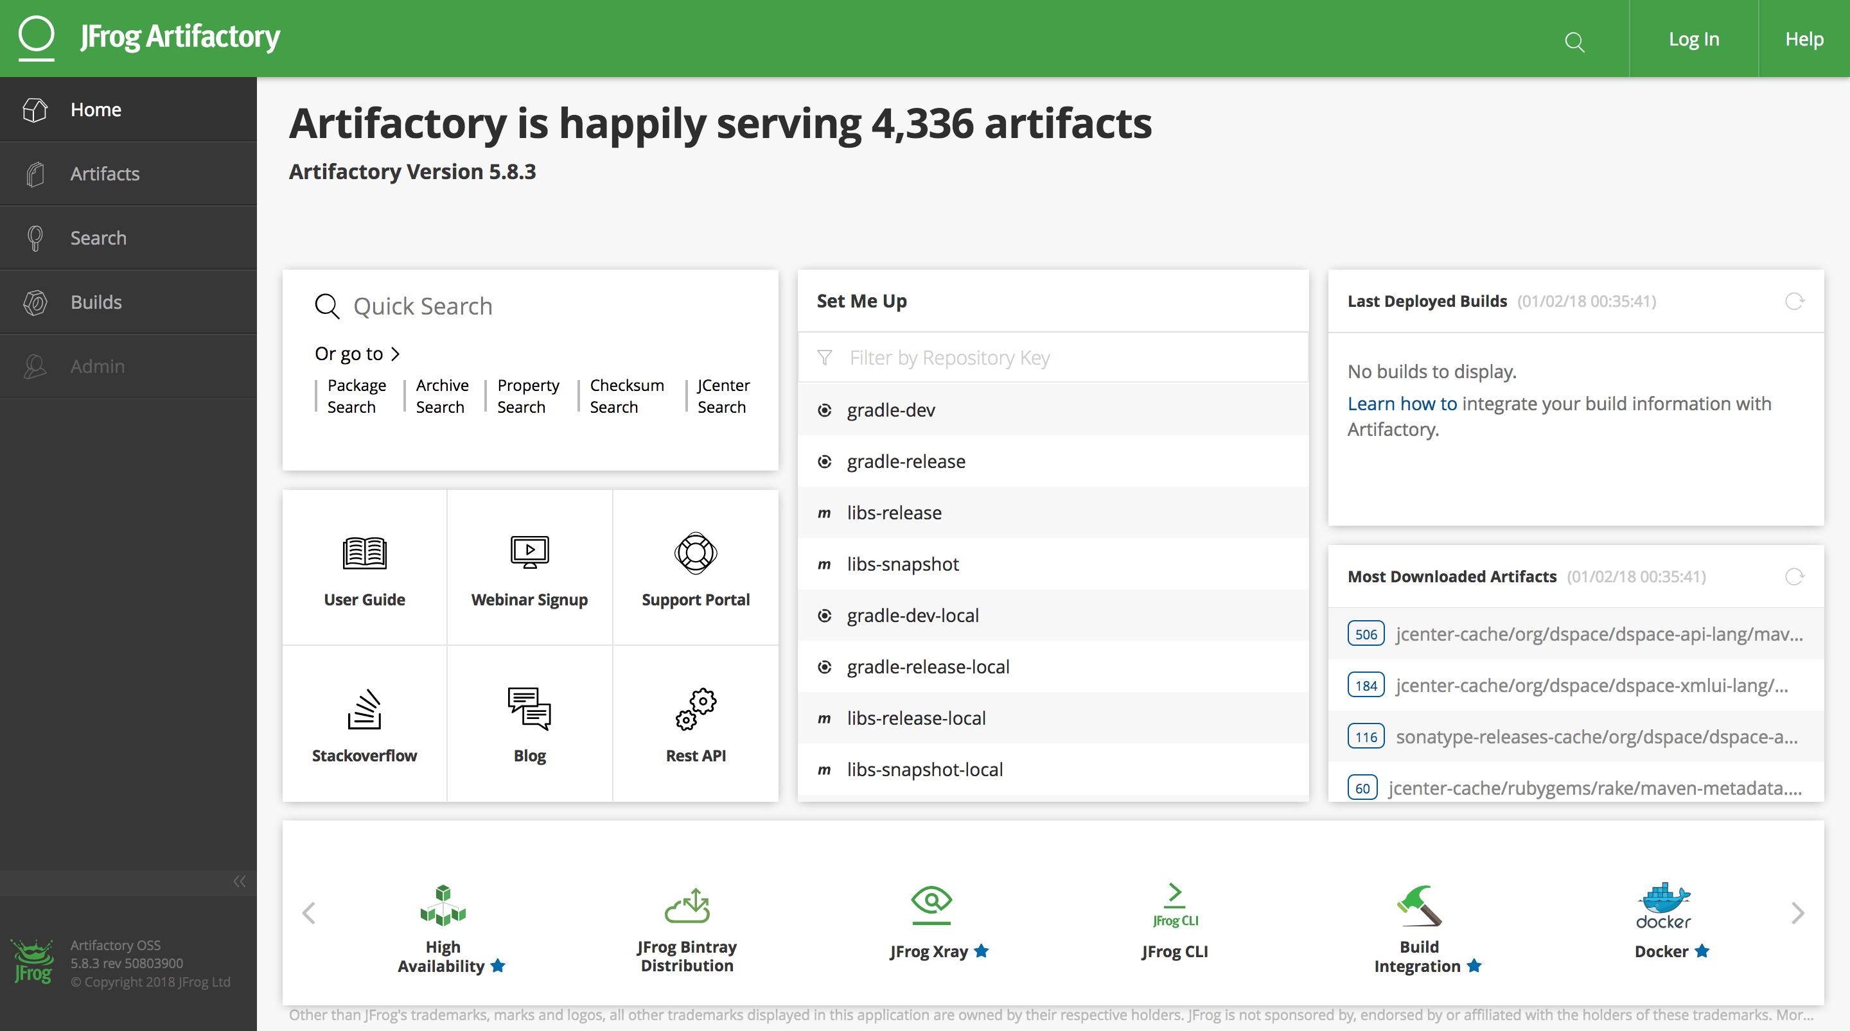

Key Features of JFrog Artifactory:

1. Universal Repository: Artifactory serves as a single, central repository to store and manage all types of binary artifacts, regardless of the package format or technology used.

2.Dependency Management: Artifactory enables dependency management, caching, and resolution for various package managers, reducing build times and network dependencies.

3.Build Integration: It seamlessly integrates with popular build tools like Maven, Gradle, and npm, facilitating artifact resolution and deployment during the build process.

4. Security and Access Control: Artifactory provides fine-grained access control and permissions to secure artifacts, ensuring only authorized users have access to specific repositories or artifacts.

5. Versioning and Metadata: Artifactory tracks version history and metadata for artifacts, allowing developers to manage different versions of software components effectively.

6.Replication and Distribution: Artifactory supports remote repository replication, enabling teams to distribute artifacts across different geographical locations or environments.

7.Build Promotion and Pipelines: It allows for defining build promotion and distribution pipelines to automate the promotion of artifacts from one repository to another.

8. Integration with CI/CD Tools: Artifactory seamlessly integrates with popular Continuous Integration (CI) and Continuous Deployment (CD) tools like Jenkins, Bamboo, and TeamCity.

9. RESTful API: It provides a RESTful API for automation and integration with other tools and processes.

JFrog Xray:
Apart from Artifactory, JFrog offers another product called JFrog Xray. Xray is a DevSecOps tool that integrates with Artifactory to provide continuous security and compliance scanning for software components. It identifies and alerts on security vulnerabilities, license violations, and other issues in the artifacts stored in Artifactory, enabling teams to identify and remediate potential risks in their software supply chain. JFrog Xray is a DevSecOps tool provided by JFrog that complements JFrog Artifactory, the artifact repository manager. While Artifactory focuses on managing and storing binary artifacts, Xray specializes in providing continuous security and compliance scanning for these artifacts. It helps teams identify and address potential security vulnerabilities, license violations, and other issues within their software components, ensuring a more secure and compliant software supply chain.
Key Features of JFrog Xray:

1. Continuous Security Scanning: Xray continuously scans artifacts stored in JFrog Artifactory for security vulnerabilities and threats. It leverages a comprehensive vulnerability database to identify known security issues within third-party dependencies and other components.

2.License Compliance: Xray helps organizations manage software license compliance by scanning and identifying any non-compliant dependencies and ensuring that only approved licenses are used.

3. Impact Analysis: Xray provides an impact analysis feature that identifies where specific components are used across the organization's projects. This helps in understanding the potential risk and impact of a security vulnerability or a license violation.

4.Component Analysis: Xray offers detailed information about each component, including metadata, security vulnerabilities, and license information. This allows developers to make informed decisions about using specific components in their projects.

5. Integration with CI/CD Pipelines: Xray seamlessly integrates with CI/CD tools, such as Jenkins and Bamboo, allowing automated scanning of artifacts at different stages of the development pipeline.

6. Policy Violation Alerts: When Xray identifies security vulnerabilities or license violations, it can trigger alerts to notify relevant stakeholders. These alerts can be integrated into communication channels like Slack or email.

7. Integration with IDEs: Xray integrates with popular Integrated Development Environments (IDEs) like IntelliJ IDEA, Eclipse, and Visual Studio Code, providing real-time security and compliance feedback to developers as they code.

8. Remediation Recommendations: Xray offers remediation recommendations to address security vulnerabilities and license issues. It suggests updated versions of components that do not have the identified problems.

9.Audit and Compliance Reports: Xray provides detailed audit logs and compliance reports, which can be useful for internal audits or regulatory compliance requirements.

Advantages of JFrog Xray:

- Enhanced Security: Xray helps organizations proactively identify and mitigate security vulnerabilities, reducing the risk of potential breaches and security incidents.

- License Compliance: It ensures that software components used in projects comply with the organization's licensing policies, preventing potential legal issues.

- Supply Chain Visibility: Xray provides visibility into the software supply chain, allowing organizations to make informed decisions about component usage and potential risks.

- Seamless Integration: Xray seamlessly integrates with JFrog Artifactory and popular CI/CD tools, making it easy to incorporate security and compliance scanning into existing development processes.

- Continuous Monitoring: Xray provides continuous monitoring of artifacts, allowing teams to respond quickly to emerging security threats and compliance issues.

Overall, JFrog Xray is a powerful DevSecOps tool that complements JFrog Artifactory, enabling organizations to ensure the security and compliance of their software supply chain from development to deployment.

Conclusion:
JFrog's suite of products, including Artifactory and Xray, provides developers and DevOps teams with powerful tools to manage and secure their software artifacts, streamline their development processes, and ensure software quality and compliance throughout the software development lifecycle.

GitHub
GitHub is a web-based platform that provides hosting services for version control repositories using Git, a distributed version control system. It is one of the most popular and widely used platforms for software development, collaboration, and code sharing. GitHub allows developers to work together on projects, manage code changes, and track the history of modifications efficiently. Here are the key aspects of GitHub:

1. Version Control:
GitHub is built on Git, a powerful distributed version control system. Git allows developers to track changes in their codebase over time, making it easier to collaborate, revert changes, and manage multiple branches.

2. Repositories:
In GitHub, a repository (often called "repo") is a collection of files and folders that make up a project. Repositories can be public or private, depending on whether the code is open-source or proprietary.

3. Collaboration and Forking:
GitHub encourages collaboration by allowing developers to "fork" a repository. Forking creates a personal copy of the original repository in the user's GitHub account, enabling them to make changes independently. After making improvements, developers can propose their changes back to the original repository through a "pull request."

4. Pull Requests:
Pull requests (PRs) are a fundamental part of the collaboration process in GitHub. When a developer wants to contribute changes to a repository, they create a pull request. The pull request allows others to review the changes, provide feedback, and merge the changes into the original repository if approved.

5. Branching and Merging:
GitHub allows developers to create branches of a repository to work on specific features or fixes without affecting the main codebase. Branches can be merged back into the main branch (usually "master" or "main") once the changes are ready to be integrated.

6. Issue Tracking:
GitHub provides a built-in issue tracking system to manage bugs, feature requests, and tasks related to a project. Developers can create issues, assign them to team members, and track their progress.

7. Continuous Integration (CI) and Continuous Deployment (CD) Integration: GitHub integrates with various CI/CD tools, enabling automatic testing and deployment of code changes. This integration helps maintain a smooth development workflow and ensures the quality of the codebase.

8. GitHub Actions:
GitHub Actions is a built-in feature that allows developers to automate workflows, including building, testing, and deploying applications directly from GitHub.

9. Code Review and Discussions:
GitHub provides features for code review, including inline comments, discussions, and the ability to suggest changes. Code reviews help maintain code quality and foster a collaborative development environment.

10. Community and Social Features:
GitHub is not just a version control platform; it is also a social network for developers. Users can follow repositories, star projects they find interesting, and participate in discussions.

GitHub has become a central platform for open-source software development, allowing developers to share their work, contribute to others' projects, and build a vibrant community of developers worldwide.

Advantages of GitHub:

1. Version Control: GitHub provides a powerful version control system using Git, allowing developers to track changes, collaborate, and manage code efficiently.

2. Collaboration and Forking: GitHub encourages collaboration by allowing users to fork repositories and contribute changes through pull requests. This fosters an open-source community and facilitates teamwork.

3.Code Review and Discussions: GitHub's code review features enable developers to provide feedback, suggest changes, and discuss code improvements, leading to higher code quality.

4. Issue Tracking:The built-in issue tracking system helps teams manage bugs, feature requests, and tasks, streamlining project management.

5. CI/CD Integration: GitHub seamlessly integrates with popular CI/CD tools, automating testing and deployment processes, which improves code reliability and delivery speed.

6. Community and Social Networking: GitHub serves as a social network for developers, allowing them to follow projects, discover interesting repositories, and engage in discussions.

7. Visibility and Exposure: Public repositories on GitHub offer a platform for developers to showcase their work, gain exposure, and attract contributions from the community.

8.Project Hosting: GitHub provides a reliable and scalable hosting infrastructure for projects, removing the need for developers to manage their own version control servers.

Disadvantages of GitHub:

1. Limited Privacy for Free Accounts: Free GitHub accounts are limited to public repositories, which might not be suitable for projects that require private code hosting.

2.Dependency on External Service: GitHub is a cloud-based service, so developers are reliant on its availability and performance. If GitHub experiences downtime, it can impact development workflows.

3. Learning Curve: Git and GitHub have a learning curve for beginners, especially those new to version control systems.

4. Repository Size Limit: Free GitHub accounts have restrictions on repository size, which may be a limitation for large projects with extensive histories.

5. Security Risks: Hosting code on a public repository exposes it to potential security risks, as attackers can analyze the code for vulnerabilities.

6. Migration Challenges: Transferring repositories to another version control system or self-hosted solution can be cumbersome if you decide to move away from GitHub.

7. No Official Offline Mode: GitHub relies on internet connectivity, and there is no official offline mode for working without an internet connection.

It's important to note that many of the disadvantages can be mitigated or are not significant concerns for most developers, and GitHub remains an immensely popular and valuable platform for software development and collaboration.

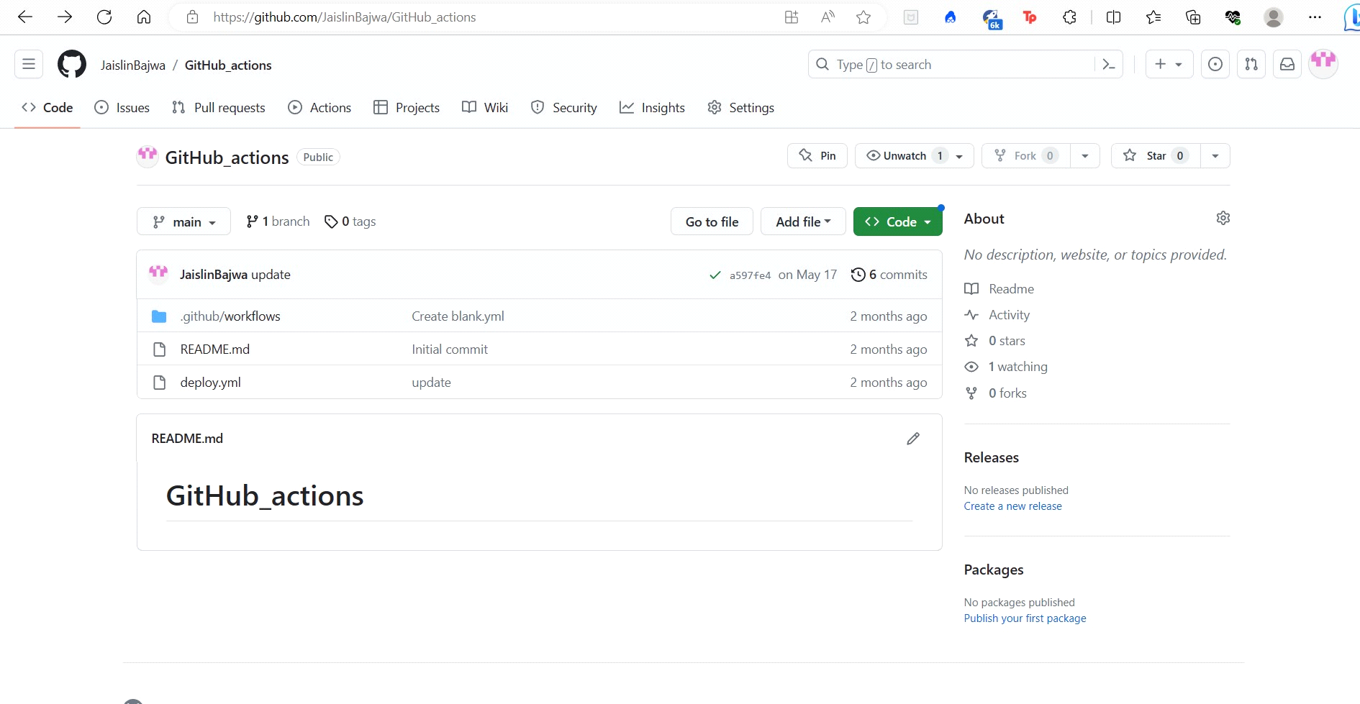

GitHub is a web-based platform that provides a range of features and components to support collaborative software development and version control using Git. Here are the key components of GitHub:

1. Repositories:
Repositories are at the core of GitHub. Each repository (repo) is a collection of files and folders that make up a project. Repositories can be public, visible to everyone, or private, accessible only to authorized users.

2.Version Control with Git:
GitHub is built on Git, a distributed version control system. Git allows developers to track changes to their code over time, collaborate with others, and manage different branches of their projects.

3. Branches:
Developers can create branches within a repository to work on new features or bug fixes without affecting the main codebase. Branches allow for parallel development and isolation of changes.

4. Pull Requests (PRs):
Pull requests are a fundamental feature for collaboration in GitHub. When a developer wants to contribute code changes to a repository, they create a pull request. The pull request allows others to review, discuss, and merge the changes into the main branch.

5. Issues and Project Management:
GitHub provides an issue tracking system for managing bugs, feature requests, and other tasks related to a project. Issues can be assigned to specific team members and organized using project boards.

6. Code Review and Discussions:
GitHub facilitates code review by allowing team members to leave comments, suggest changes, and discuss code within pull requests. This promotes collaboration and ensures code quality.

7. Wiki and Documentation:
Repositories can have associated wikis to provide documentation and other project-related information.

8. GitHub Actions:
GitHub Actions is an integrated CI/CD (Continuous Integration and Continuous Deployment) system that allows developers to automate workflows and build, test, and deploy their projects directly from GitHub.

9. GitHub Pages:
GitHub Pages enables users to host static websites directly from their repositories, making it easy to showcase documentation, project information, or personal websites.

10. Code Search and Code Intelligence:
GitHub offers powerful code search capabilities, allowing users to find code snippets, functions, and specific files within repositories. Additionally, it provides code intelligence features like syntax highlighting and code suggestions.

11. Community and Social Features:
GitHub fosters a strong developer community, allowing users to follow repositories, star projects they find interesting, and participate in discussions through comments and issues.

These components collectively make GitHub a powerful and user-friendly platform for collaboration, version control, and project management in software development. GitHub has become a leading platform for open-source projects and is widely used by individuals, teams, and organizations to build and share software.
In conclusion, GitHub is a widely adopted and powerful web-based platform that revolutionized the way developers collaborate, manage version control, and build software. With its foundation on Git, GitHub enables distributed version control, making it easy for developers to track changes, work collaboratively on projects, and manage code branches effectively.

The key components of GitHub, such as repositories, branches, pull requests, and issue tracking, provide a seamless and efficient workflow for teams to work together, review code changes, and manage project tasks. GitHub's integration with CI/CD tools through GitHub Actions further streamlines the development process, automating build, test, and deployment pipelines.

The platform's emphasis on community and social features creates a vibrant ecosystem, encouraging developers to share their work, contribute to others' projects, and engage in discussions. This fosters an open-source culture of collaboration and knowledge sharing.

Overall, GitHub has played a significant role in advancing the software development industry by providing a robust and user-friendly platform for version control, code collaboration, and project management. Its widespread adoption and continuous evolution have made it an indispensable tool for developers, teams, and organizations worldwide. Whether it's for open-source contributions, personal projects, or enterprise-level software development, GitHub remains a go-to platform for developers to build, share, and collaborate on software.

SWAGGER HUB
Definition: SwaggerHub is a web-based platform that allows developers to create, document, and manage APIs (Application Programming Interfaces) in an easy and organized way. It provides tools and features that enable developers to design, test, and share their APIs with others. SwaggerHub helps streamline the API development process, making it more efficient
and collaborative for teams working on building software applications or services that need to communicate with each other. After creating an API, we can sync that API with GitHub(or any CI/CD tool).
Here are some of the features of SwaggerHub:
• API Design Editor: SwaggerHub provides a user-friendly editor to visually create and
design APIs, making it easier to define endpoints and data structures.
• API Documentation: It automatically generates interactive documentation for your APIs, helping developers understand how to use them effectively.
• Collaboration: SwaggerHub allows multiple team members to work together on API design and documentation in a coordinated manner.
• Mock Servers: You can create mock servers to simulate API behavior, enabling early testing and development even before the actual API is implemented.
• API Testing: SwaggerHub allows you to define and execute tests for your APIs to ensure they function as intended.
• API Monitoring: It provides real-time monitoring of API performance and usage, helping you identify and address potential issues.
• API Publishing: Once an API is ready, you can easily publish and share it with others, making it accessible to developers and partners.
• Integration with Git: SwaggerHub can be integrated with Git, making it convenient to manage API definitions using version control.
• Security and Access Control: It offers access control features to protect sensitive API information and ensure only authorized users can make changes.
• API Lifecycle Management: SwaggerHub supports the entire API lifecycle, from design to deployment and maintenance, making it a comprehensive tool for API management.
➢ Let’s start by creating an API now by just clicking on “Create New” Button.
➢ After that, a template will open to configure the API. We can create the API under a user as well as inside any organization. There you just need to select a project name.
i) Specification: Specification is just the version of API that we want to create.
ii) Template: There will be some preexisting templates and we can select any one of the templates like Simple API, IOT etc.
iii) Name: Give any name to newly created API. Remember, the name will be in alphanumeric pattern. You can’t put a space between if you put that, an error will be displayed.
iv) Visibility: We can set the visibility to private or public according to the requirements.
For example, if you have created an API inside an organization and you have set it to private, so all the members of that particular organization will be able to see that API. But if you have provided the visibility as public, so API will be visible to everyone, irrespective of the organization.
v) At last, just click on Create API.
➢ Now the URL present in servers' part, you can just copy that and send it to someone so they will be able to redirect over here.
➢ The main thing over here is versions, what if you want to change the versions. For example, you have done some changes in your current API so after doing that, you can simply add a new version by clicking on “Add New Version” Button. One more thing to note here is if you have created 2-3 versions, so the newly created version will be the one who will be active.
➢ You can make your API private or public here as well, by just clicking on “Lock Icon”.
➢ If you want to delete any version, just click on “Delete Icon”.
➢ Under the name of created API, there will be any options like we can fork an API, we can change the owner, one can delete the API and rename the API as well.

