**Odometer Reader**

**Objective**

The purpose of this task is to assess your ability to develop a solution for extracting the odometer reading from images of car dashboards. You are permitted to utilize any publicly available dataset from online sources. The task is divided into three phases, each aimed at solving a specific challenge in the process of isolating and classifying the digits that represent the odometer value. It is expected that deep learning-based solutions will be employed for Phases 1 and 2.

**Phase 1: Detection of the Odometer Area**

In this phase you are required to localize the odometer area within the dashboard image. The odometer may be displayed in different regions of the dashboard and may have varying formats. The output of this phase should be a bounding box that isolates the odometer area. Kindly refer to Figure 1 for examples related to Phase 1.

**The metrics to be employed:** Precision, Recall and mAP@0.5 (Mean Average Precision)

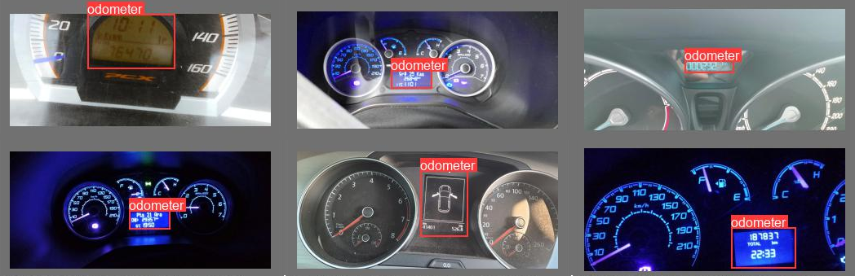

**Figure 1.** Odometer Detection Examples

**Phase 2: Detection and Classification of Digits in the Odometer Area**

The next step is to detect and classify the digits in the odometer area. The task involves extracting each digit and assigning a numerical value to it. Depending on the dataset utilized, the digits within the odometer may be presented in either digital or analog format. Consequently, your approach must be sufficiently robust to accommodate both scenarios. The output of this phase should be the classified digits in the odometer area. Kindly refer to Figure 2 for illustrative examples related to Phase 2.

**The metrics to be employed:** Precision, Recall, mAP@0.5 (Mean Average Precision)

**Tip:** It is highly recommended that you assign a specific value to non-digit elements and classify them accordingly, as this will simplify the subsequent phase.

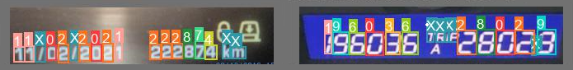

**Figure 2.** Digit Detection and Classification Examples

**Phase 3: Filtering Results**

The final phase involves distinguishing the true odometer reading from other numerical values that may be present in the identified region, such as the date or time. You will need to develop a filtering method that accurately isolates the odometer digits based on contextual or visual cues and outputs the final odometer reading. For the sake of convenience, you may assume that the true odometer reading corresponds to the total kilometer value when both the total kilometer and trip distance are present.

**The metric to be employed:** Performance of Phase 3 will be evaluated as the overall end-to-end accuracy. Therefore, achieving a Top-2 accuracy whereby one of the two values returned is the correct odometer reading is deemed sufficient.

**Tip:** You are encouraged to utilize patterns containing both digit and non-digit elements to estimate whether the value represents an odometer reading.

**Deliverables**

* A report explaining your approach, methodology, and any assumptions made during the task.
* A well-documented Python codebase used to implement the solution.