MERCHANT

User Manual
  - For store owners and employees
Phone and tablet edition
Set up your store. Manage products and staff.
Sell, receive stock and review your records.
Based on current-system-features.md
Source reviewed: 25 October 2026
Document version: 1.0
An editable operating guide covering all 22 source sections.

Contents
1. Getting started 4
1.1 About this manual 4
1.2 Sign in and read the legal pages 4
1.3 Find your way around 4
1.4 A first-sale checklist 5
2. Create and manage stores 6
2.1 Create a store 6
2.2 Choose or change a store level 7
2.3 Delete a store 7
3. Add products and selling prices 9
3.1 Create or edit an item 9
3.2 Scan a product and read its label 10
3.3 Set an item price 11
3.4 Import items from CSV 12
4. Sell, take payments and close a shift 14
4.1 Open a session 14
4.2 Add items at the Register 14
4.3 Review the Cart and complete payment 16
4.4 Scan to sell 17
4.5 Review orders and receipts 18
4.6 Process a return 18
4.7 Cancel a sale 19
4.8 Close a session and inspect shift records 19
5. Receive, count and review stock 21
5.1 Record a stock movement 21
5.2 Enter opening stock or a physical count 21
5.3 Check stock on hand 21
5.4 Trace stock movements 21
6. Read business reports 22
6.1 Use the Dashboard 22
6.2 Read the General Ledger 23
7. Invite staff and manage access 24
7.1 Create and share access codes 24
7.2 Request access to somebody else's store 24
7.3 Approve, decline or revoke access 25
7.4 Assign a role and individual permissions 25
7.5 Create, edit or delete a role 25
7.6 Permission reference 26
7.7 Read notifications 27
8. Customize your menu and practise 29
8.1 Show or hide your screens 29
8.2 Learn safely in Store Guide 30
9. Configure store details, dates and money 32
9.1 Change store details and default accounts 32
9.2 Maintain fiscal years 33
9.3 Control receipt totals with Global Defaults 33
9.4 Set time zone and number rules 33
9.5 Format the default currency 33
10. Configure accounting, payments and taxes 35
10.1 Maintain the Chart of Accounts 35
10.2 Control accounting behavior and frozen periods 35
10.3 Add payment methods 35
10.4 Create and check a sales tax template 36
10.5 Define item-specific tax rates 37
10.6 Create tax categories 37
10.7 Choose tax templates using rules 37
11. Configure stock, selling and registers 38
11.1 Set up warehouses 38
11.2 Define units of measure 38
11.3 Convert between units 38
11.4 Create price lists 38
11.5 Create brands and their defaults 39
11.6 Organize item groups 39
11.7 Set stock defaults and valuation 39
11.8 Configure selling prices 39
11.9 Create automatic pricing rules 40
11.10 Configure a POS Profile 40
12. Set document numbers and receipt appearance 41
12.1 Configure document naming 41
12.2 Edit a receipt format 41
12.3 Create a letter head 42
12.4 Choose receipt content 42
13. Manage your account 43
13.1 Open Account and change appearance 43
13.2 Sign out or find account deletion 43
14. Troubleshooting and reference 44
14.1 Common problems 44
14.2 What works offline 45
14.3 Glossary 45
14.4 Source and coverage 46

1. Getting started

1.1 About this manual
Merchant helps you manage a store, its products, sales, stock and accounting records. This manual is for store owners and employees using the phone or tablet interface. A store represents one business without branches.
Instructions use the exact labels shown in the app. A path such as Stock > Items & Pricing > Items means open Stock, find the Items & Pricing section, and tap Items. A section heading is not necessarily a separate button. Numbered steps describe actions; the result paragraph explains what to expect.
Your available screens depend on your permissions, the store level and your personal Features choices. If a page is missing, follow section 14.1 before assuming that the feature is unavailable. Settings and transactions described here apply to the store you have opened.
This manual is based on the supplied current-system-features.md, reviewed on 25 October 2026. It describes that documented version. It does not specify installation requirements or procedures absent from the source.

1.2 Sign in and read the legal pages
Where: The sign-in screen, headed Merchant and Welcome.
1. Tap Terms of Service or Privacy Policy to read the document before signing in.
2. Tap Back to return to the sign-in screen.
3. Tap Continue with Google or Continue with Facebook and follow the selected provider's prompts.
Result: Once signed in, use Home to create a store or request access to an existing one. Both legal pages can also be opened later from Account. They show their last-updated dates. The source documents publisher-name and contact-email placeholders; this manual does not supply replacement details.

1.3 Find your way around
The main Home tab lists your stores. It is different from the Home destination inside an opened store.
Location | Phone | Tablet
Main navigation | Bottom tabs: Home, Access Codes, Account | Access Codes and Account icons in the Home header
Stores | Cards in rows; list headed Active Stores | Cards in a grid; list headed Your Stores
Store navigation | Tap Menu in the header | Side rail stays visible in portrait and landscape
Register | Items page, then a Cart bar opens the Cart page | Items and Cart appear side by side
Forms and lists | A selection often opens another page or a bottom sheet | Some forms open alongside a list or in a dialog

1. On the main Home tab, tap a store card to open it.
2. On a phone, tap Menu. On a tablet, use the visible side rail.
3. Tap the destination you need: Home, Dashboard, Sell, Stock, Accounts, Employees, Setup or Features, where available.
4. Tap Your stores in the header to return to your stores list.
Result: You work inside the selected store. The store name in the header identifies it. The store's Home page is intentionally empty for people with work permissions. A person with no role sees You're in. The owner hasn't given you a role yet.
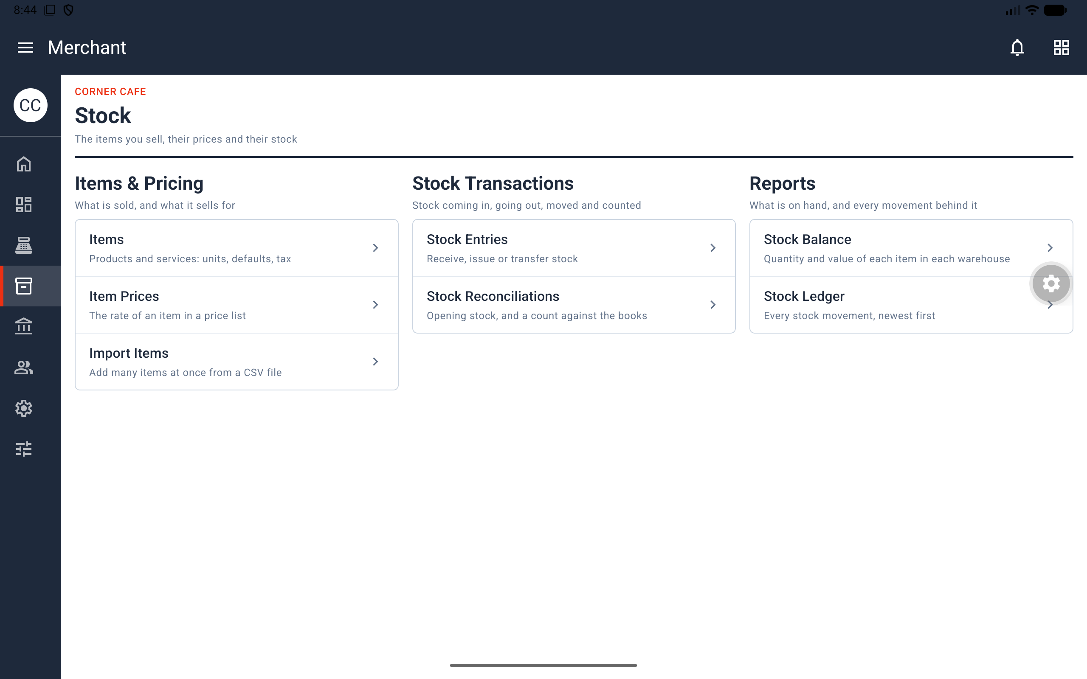
Figure 1. Tablet Stock screen with the side rail and grouped work areas visible.
Access note: Home and Features cannot be hidden. Employees belongs to the owner alone. A menu item may be hidden by the store level or personal choices even when you have permission to use it.

1.4 A first-sale checklist
For a new owner, this sequence provides a short route into everyday work. The detailed procedures follow in later chapters.
1. Create a store and choose its level (chapter 2).
2. Add an item and its selling price (chapter 3).
3. Check stock availability and the store's stock settings. Level 1 permits negative stock; other configurations may block a sale without enough stock.
4. Open a session under Sell (section 4.1). Levels 1–4 create Main Register if the store has no register.
5. Add the item to the Register, review the Cart and payment, and tap Complete Order (sections 4.2–4.3).
6. Review the sale in Orders and close the session after counting the money (sections 4.5 and 4.8).
Before operational use: Check the store time zone before the first sale. If you want to learn without saving transactions, use Store Guide and its practice store (section 8.2).

2. Create and manage stores

2.1 Create a store
Where: Main Home tab > Create New Store.
1. Tap Create New Store. Step 1, Your store, opens with the title Name your store.
2. Enter STORE NAME.
3. Select COUNTRY and check DEFAULT CURRENCY, the currency used for the books. All three fields are required.
4. Tap Next.
5. In step 2, Its level, choose how much you want to manage. Level 1 · Just Sell is selected initially.
6. Tap Create Store.
Result: The store appears on Home. Tap its card to enter. It starts with a fiscal year, settings, accounts, payment modes, tax records, warehouses, units, a price list, item groups, naming series, a receipt format and the three built-in roles. Levels 1–4 also create Main Register when no register exists.
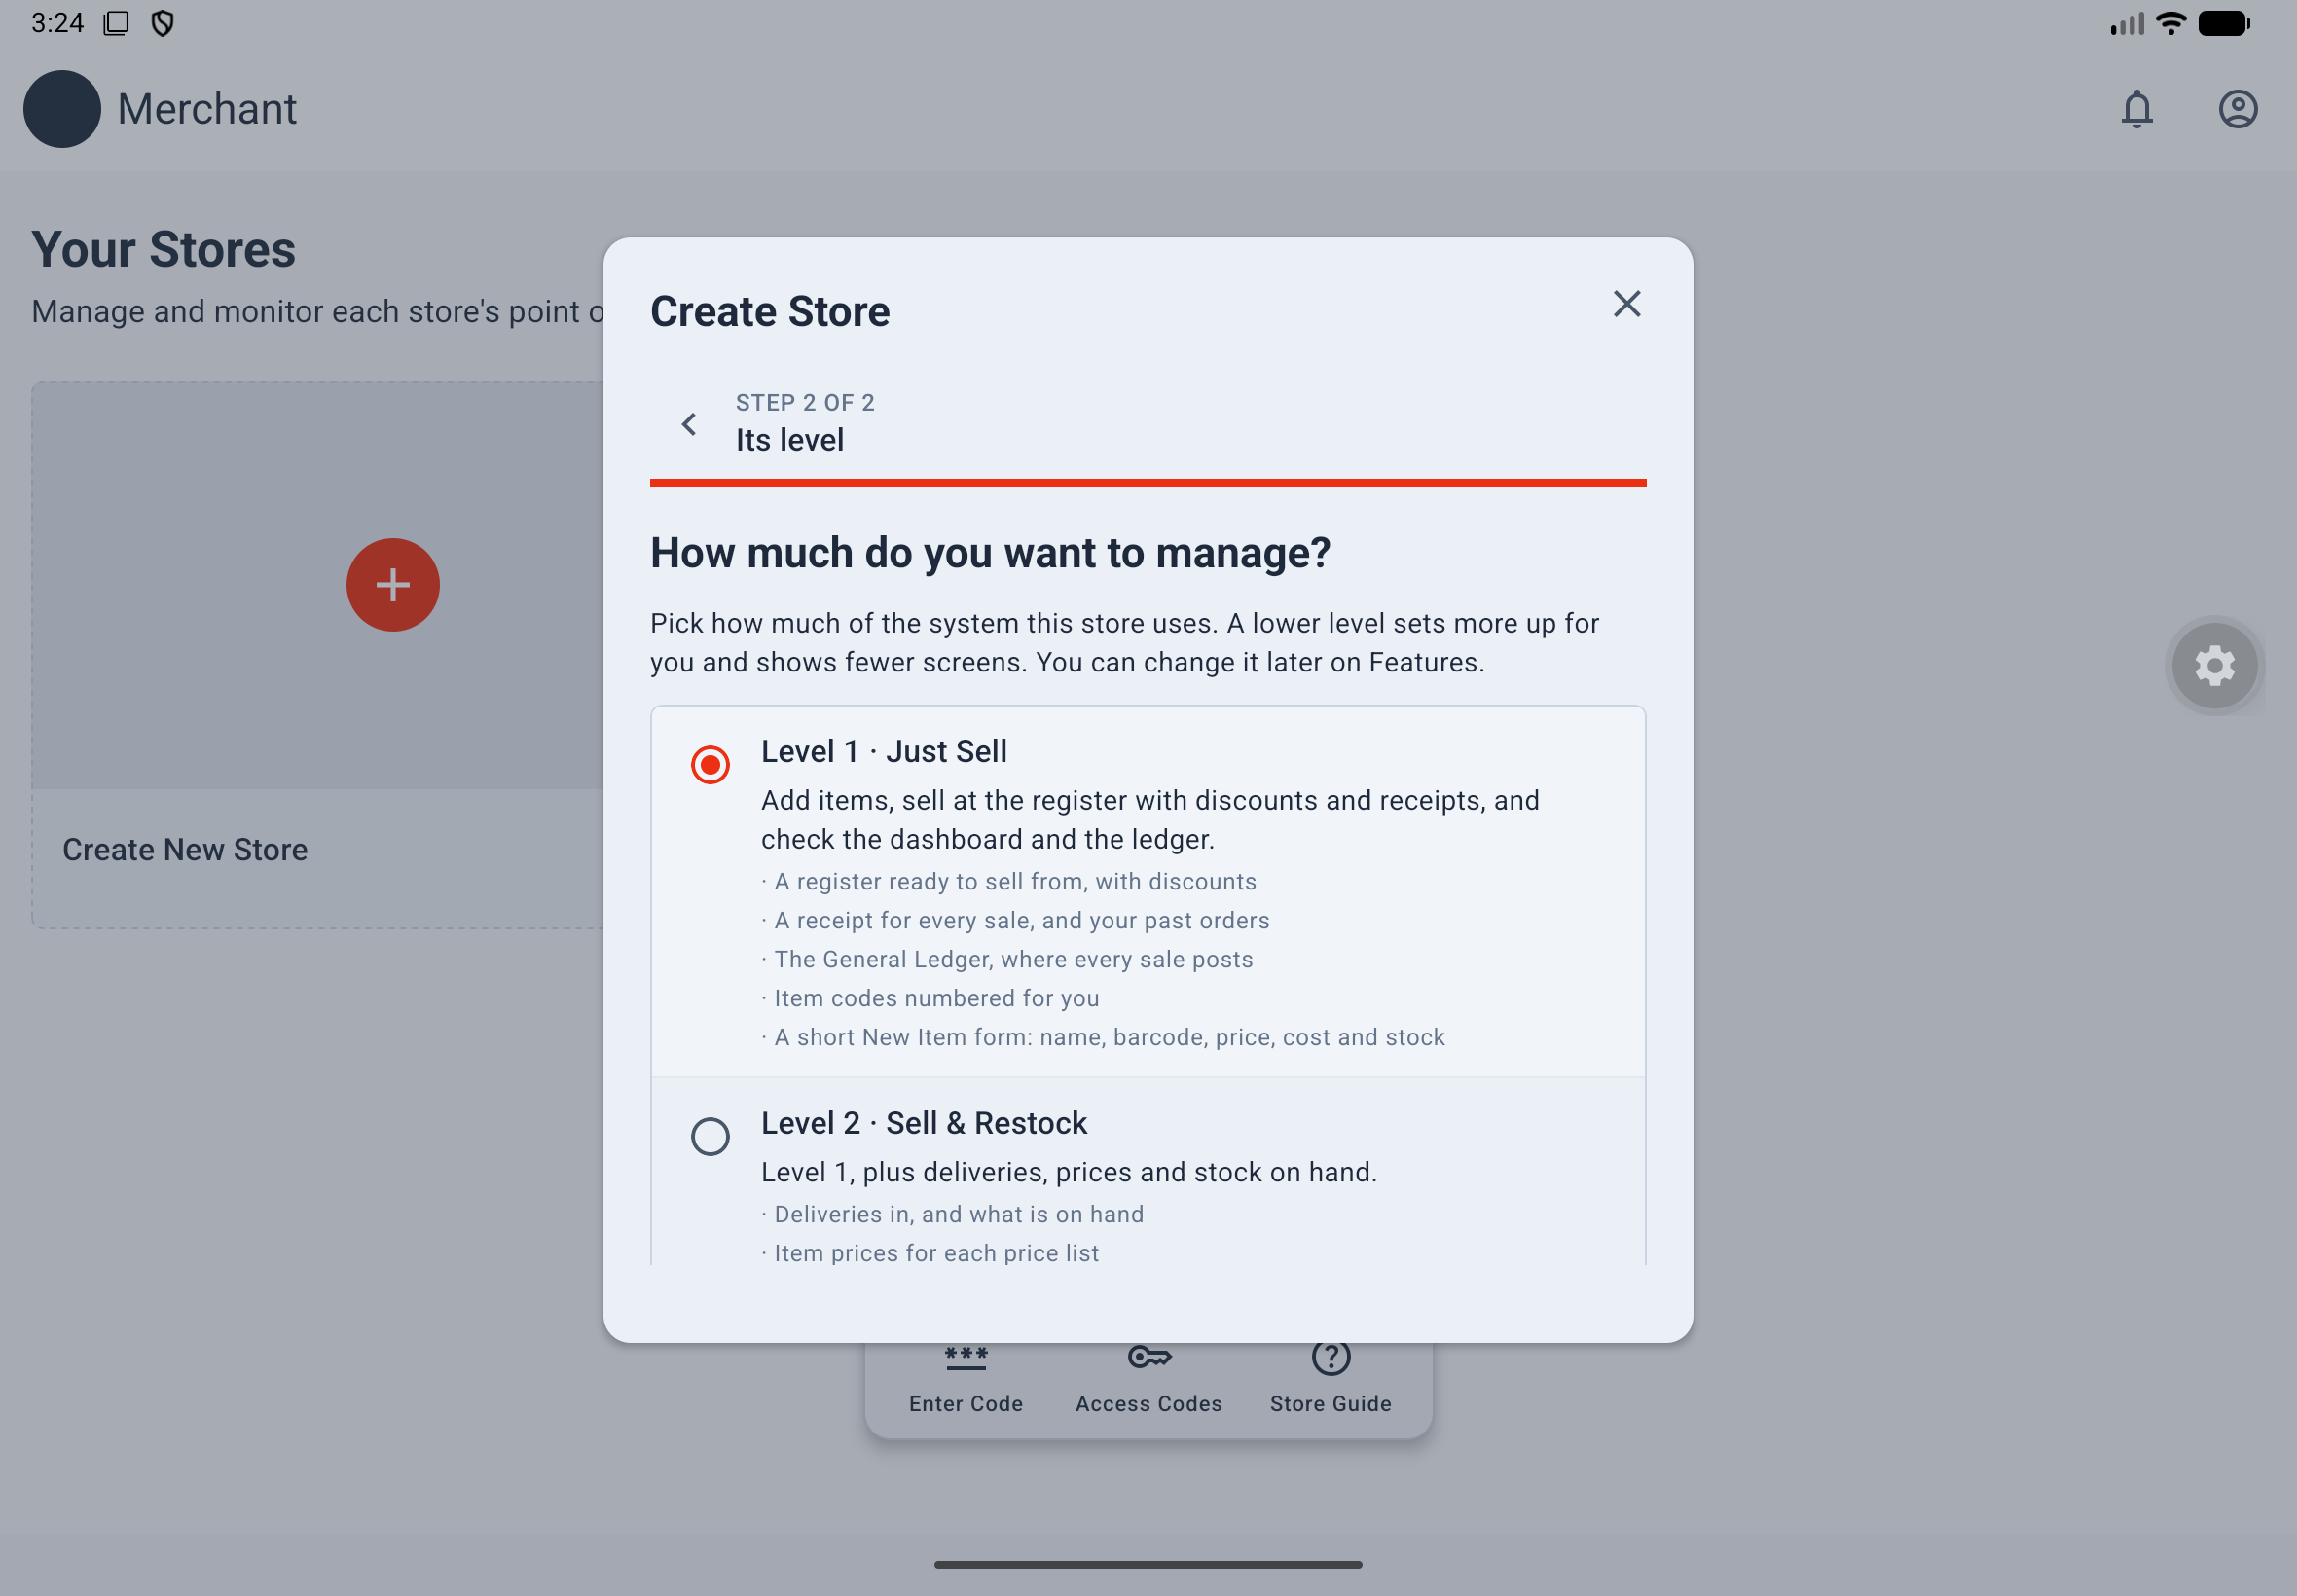
Figure 2. Level 1 selected in the second step of store creation.
Going back: The small step back arrow or Android Back returns from step 2 to step 1 and keeps the entered fields. The back arrow in the dark bar leaves the creation page. You can edit store details later in Setup > Store & Calendar > Store.

2.2 Choose or change a store level
Who: Only the owner chooses or changes a store's level. Levels simplify menus and item forms; permissions still determine what a person can do.
Level | Purpose | Menu additions compared with the previous level
1 · Just Sell | Add items, sell, give permitted discounts, review orders and the Dashboard | Dashboard; Sell with sessions, Register and Orders; Stock with Items
2 · Sell & Restock | Manage deliveries, selling prices and stock on hand | Item Prices, Stock Entries, Stock Balance
3 · Staff & Stock Control | Manage staff, counts, imports, shift records and basic settings | Employees; POS Opening/Closing Entries; Import Items; Stock Reconciliations; Stock Ledger; basic Setup pages
4 · Full Store | Use books, taxes, pricing rules and operational settings | Accounts/General Ledger; Currency; both tax template pages; Warehouses; Stock Settings; Selling Settings; Pricing Rules
5 · Everything, by Hand | Show every screen and field | Fiscal Years; Global Defaults; System Settings; Chart of Accounts; Accounts Settings; Tax Categories; Tax Rules; UOM Conversion Factors; Document Naming Settings

Level 3's basic Setup pages are Store, Modes of Payment, UOMs, Price Lists, Brands, Item Groups, POS Profiles, Print Formats, Letter Heads and Print Settings. Home and Features remain available at every level. Stores created before levels were introduced are Level 5.
1. Inside the store, open Features.
2. Under STORE LEVEL, tap Change Level.
3. Select a level on Store Level.
4. Tap Save, or Cancel to keep the current level.
Result: The store uses the selected level. Everyone's personal menu choices reset to that level's menu; each person can customize their menu again. A level change only adds its setup; it never deletes records. Do not assume that switching levels reverses settings previously enabled by another level. Offline, Save waits for a connection.
Automatic setup: Levels 1–4 create Main Register if there is no register, using Stores and Cash, with Cash allowed for returns. The generated register enables PRINT RECEIPT ON ORDER COMPLETE and ALLOW USER TO EDIT DISCOUNT. Applying a discount still requires Apply Discounts; a built-in Cashier does not have it. Levels 1–2 use item naming series. Level 1 enables ALLOW NEGATIVE STOCK.
Existing registers: Moving a store with its own register to Level 1 preserves that register's switches. The documented update on 22 October 2026 enabled receipt opening and discount editing on Main Register for stores already at Level 1 or 2. Always check an existing profile's actual settings instead of assuming that changing the level recreates it.

2.3 Delete a store
Who: The owner. Employee access does not allow store deletion.
Warning: Deleting a store removes everything kept in it and cannot be undone.
1. Return to the main Home tab.
2. To delete one store, tap its red delete icon, type the store name, then tap Delete.
3. To delete several, long-press an owned store card, tap the other cards, tap the red delete action, type DELETE, then tap Delete.
Use Select all during multiple selection if appropriate. Back or X ends selection. A store owned by someone else cannot be selected.

3. Add products and selling prices

3.1 Create or edit an item
Where: Stock > Items & Pricing > Items. Who: Owner or a person with Manage Items can manage items. Other permissions may be needed for pricing or opening-stock actions.
1. Tap New Item, or open an existing item to edit it.
2. Optionally tap Scan Product to read the product's barcode or label (section 3.2).
3. Enter the fields visible for your store level, using the table below.
4. Enter the selling price. For a new stock item, enter initial stock and cost where your access allows it.
5. Check the information and tap Save.
Level | New-item fields and labels
1 | Scan Product, BARCODE, ITEM NAME (REQUIRED), SELLING PRICE, STOCK ON HAND, COST PER UNIT
2 | Level 1 fields plus ITEM GROUP, unit, DESCRIPTION, MAINTAIN STOCK, DISABLED and RE-ORDER LEVEL
3 | Adds ITEM CODE, BRAND, Units of Measure and the remaining Inventory fields; uses STANDARD SELLING RATE, OPENING STOCK and VALUATION RATE
4–5 | Full item form, including Inventory, Stock Levels, Units of Measure, Defaults, Discounts and Item Tax

Result: The item appears in the Items list. A register offers it according to the profile's restrictions. Stock Balance shows its stock where applicable.
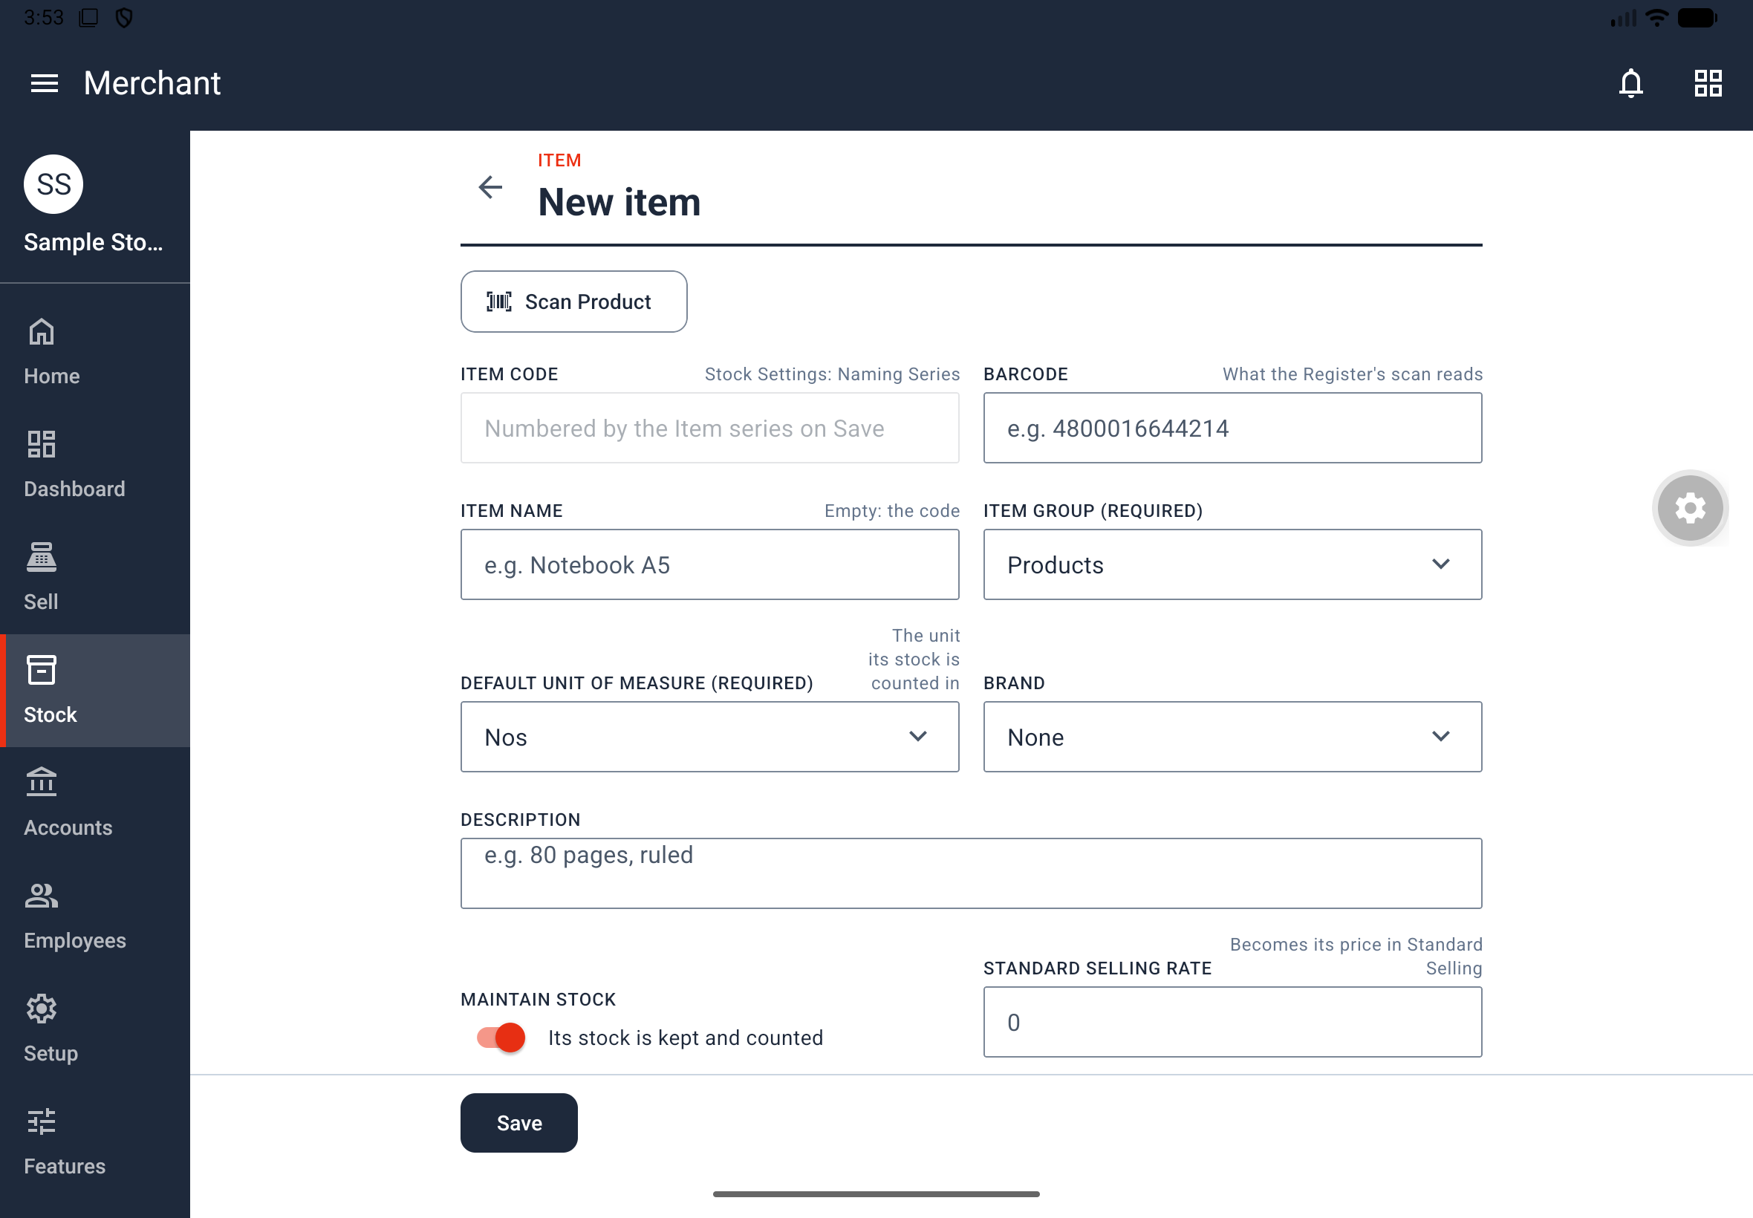
Figure 3. New Item form with the main item details and selling-price fields.
Rules: An item code cannot change after saving; a barcode can. Hidden fields still receive defaults: item group, unit and warehouse from Stock Settings, and a code from the Item series. A field that cannot be filled automatically becomes visible. When the code is hidden, ITEM NAME is required; an empty name produces Enter a name.
Barcode: Optional, no spaces, at most 64 characters and unique within the store. A duplicate produces Another item already has this barcode. Search the Items list by code, name or barcode to find a saved item. The opening-stock fields apply to new items; use stock documents for subsequent movements or counts.

3.2 Scan a product and read its label
Where: An item page > Scan Product. Who: Owner or Manage Items. The documented scanner requires an app build dated 15 October 2026 or later.
1. Tap Scan Product. Allow camera access when prompted.
2. Point the back camera at the barcode and wait until the barcode line appears.
3. To read the label, point at its name and price and tap Read Label. Alternatively, tap Choose Photo and select a label picture.
4. If you only need the barcode, tap Done instead.
5. Back on the item page, review every filled field. Complete the group, unit and other required information where needed.
6. Tap Save to save the item.
Result: A useful label picture closes the scanner and fills applicable item fields. Scanning alone does not save an item.
Field | What the scanner can fill
BARCODE | The barcode read; a new scan replaces the existing barcode
ITEM CODE | The barcode on a new item only when the code is empty and manually entered, rather than generated from a naming series
ITEM NAME | The largest print on the label, if the field is empty
BRAND | An existing store brand named on the label; it does not create brands
DESCRIPTION | Up to four other label lines, if the field is empty
STANDARD SELLING RATE | The first price marked ₱, PHP or P, only for a new item and a person allowed to set prices

The scanner preserves typed values except for the barcode. It never supplies the item group, unit, warehouse, accounts or taxes. Lines consisting only of digits and separators, such as barcode numbers, dates or times, are not interpreted as item fields.
Camera and recognition: Supported barcodes are EAN-13, EAN-8, UPC-A, UPC-E and Code 128. A code must appear consistently for three frames. Scanning and label reading run on the phone and work without internet. If the picture is unusable, the scanner stays open with No print found. Hold the label closer, in good light.
If access is refused, use Allow Camera. If permanently refused, use Open Settings and enable the app's camera permission, then return. Choose Photo works even when camera access is refused; Read Label does not.

3.3 Set an item price
Where: Stock > Items & Pricing > Item Prices. Item Prices is available through Manage Items, subject to menu visibility.
1. Tap New Item Price.
2. Choose ITEM, PRICE LIST and UOM.
3. Enter RATE. Set VALID FROM and VALID UPTO as needed.
4. Tap Save.
Result: The list shows the item, rate, price list and dates. A register uses the price according to its price-list configuration. A price belongs to one item, price list and unit.
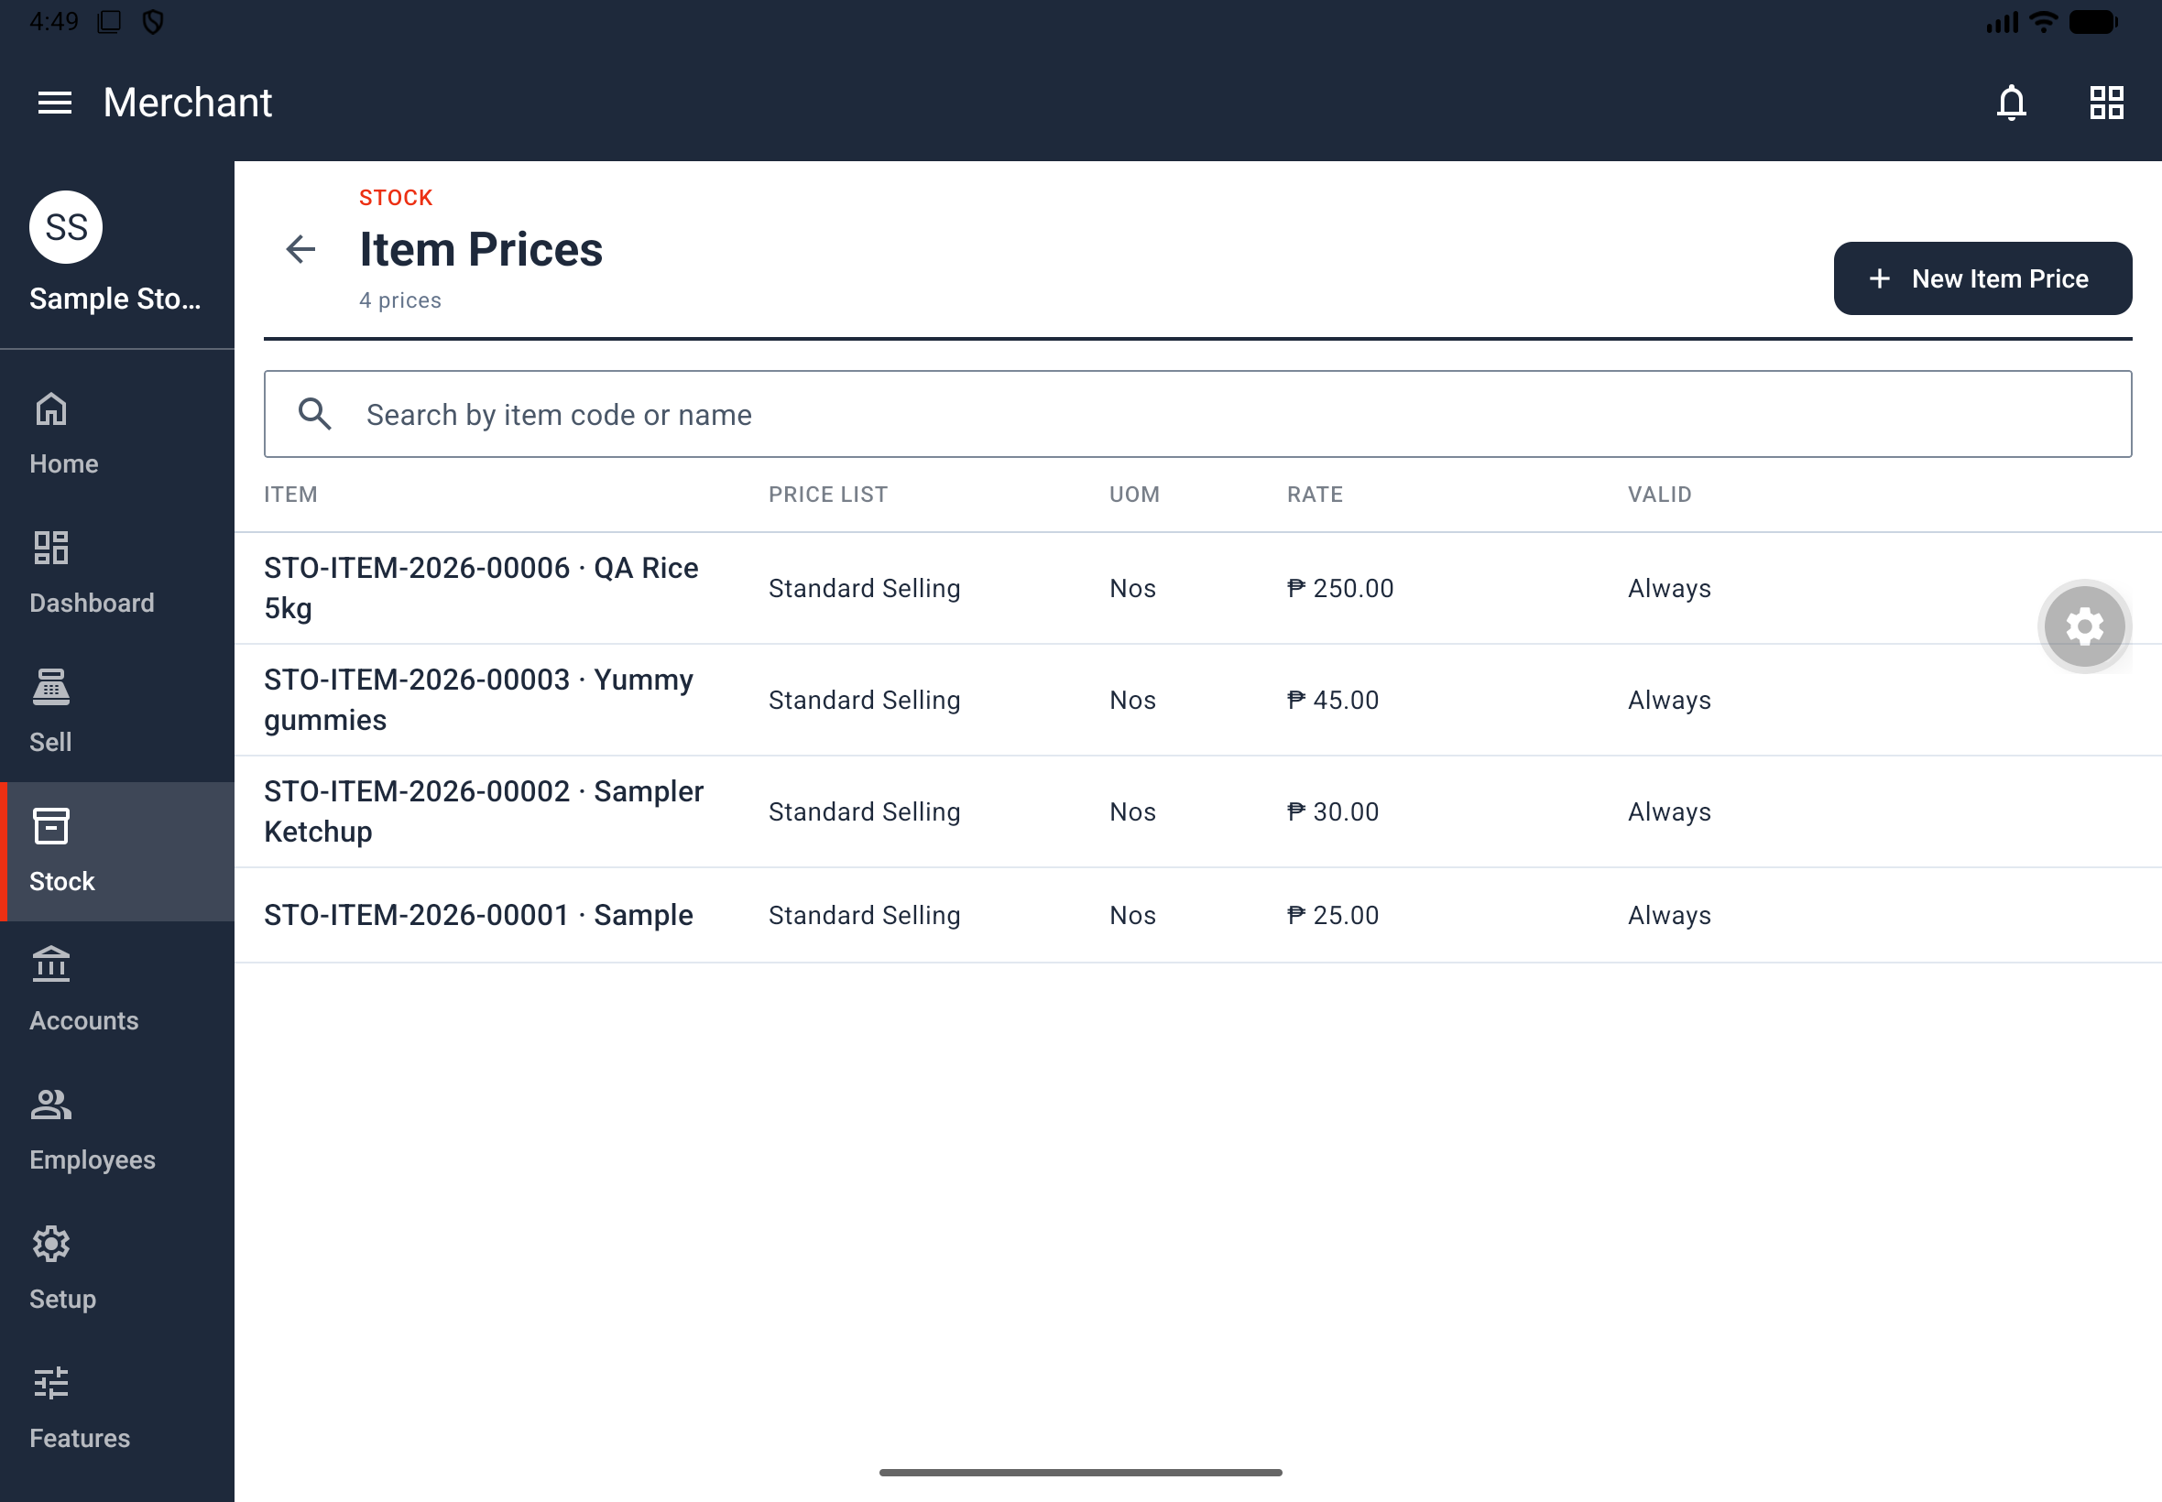
Figure 4. Saved item prices listed by item, price list, unit, rate and validity.

3.4 Import items from CSV
Where: Stock > Items & Pricing > Import Items. Who: Owner or Manage Items. Manage Items alone does not authorize importing opening stock.
1. Tap Download Template and choose a folder.
2. Open the template in a spreadsheet program and fill the required item information. Use the page's column descriptions.
3. Save the file as CSV. Keep each file to no more than 500 items.
4. Return to Import Items and tap Choose File.
5. Read and correct any reported row errors, then choose the corrected file again as needed.
6. Tap Import when every row is valid.
Result: Items appear in the Items list after import. Nothing is imported until all rows are valid. Columns include Item Code, Item Name, Item Group, Default Unit of Measure, Description, Brand, Disabled, Maintain Stock and Standard Selling Rate; use the downloaded template for the full set. There is no Barcode column. Add barcodes on individual item pages after import.
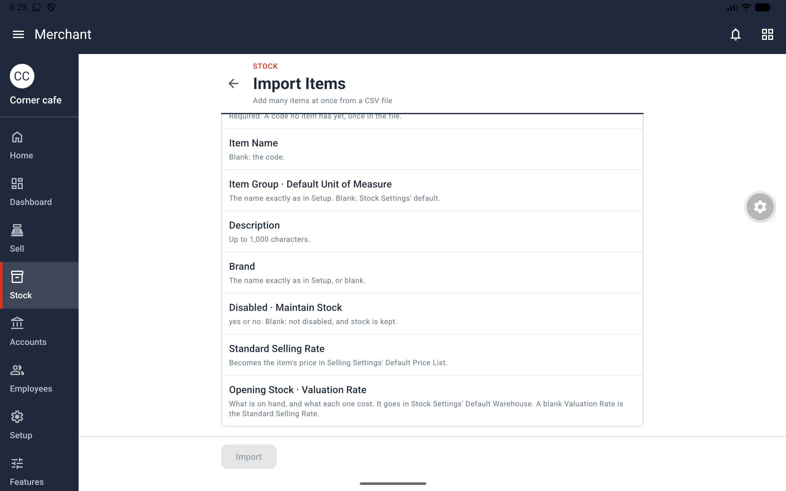
Figure 5. Import Items field guide shown before a CSV file is selected.

4. Sell, take payments and close a shift

4.1 Open a session
Where: Sell. Who: Open/Close Register opens and closes your own session; Process Sales is needed to complete sales. The profile must be available to you.
1. Tap Open Session while the session box says No session is open.
2. Choose POS PROFILE. If there is only one register, it is selected already.
3. Enter the opening amount for each payment method. For example, enter 500 for Cash when that is the actual opening cash.
4. Tap the bottom Open Session button.
Result: Sell shows the open session, register and date, with Register and Close Session buttons. A session is one cashier's shift on a POS profile. You must have an open session to ring up a sale.
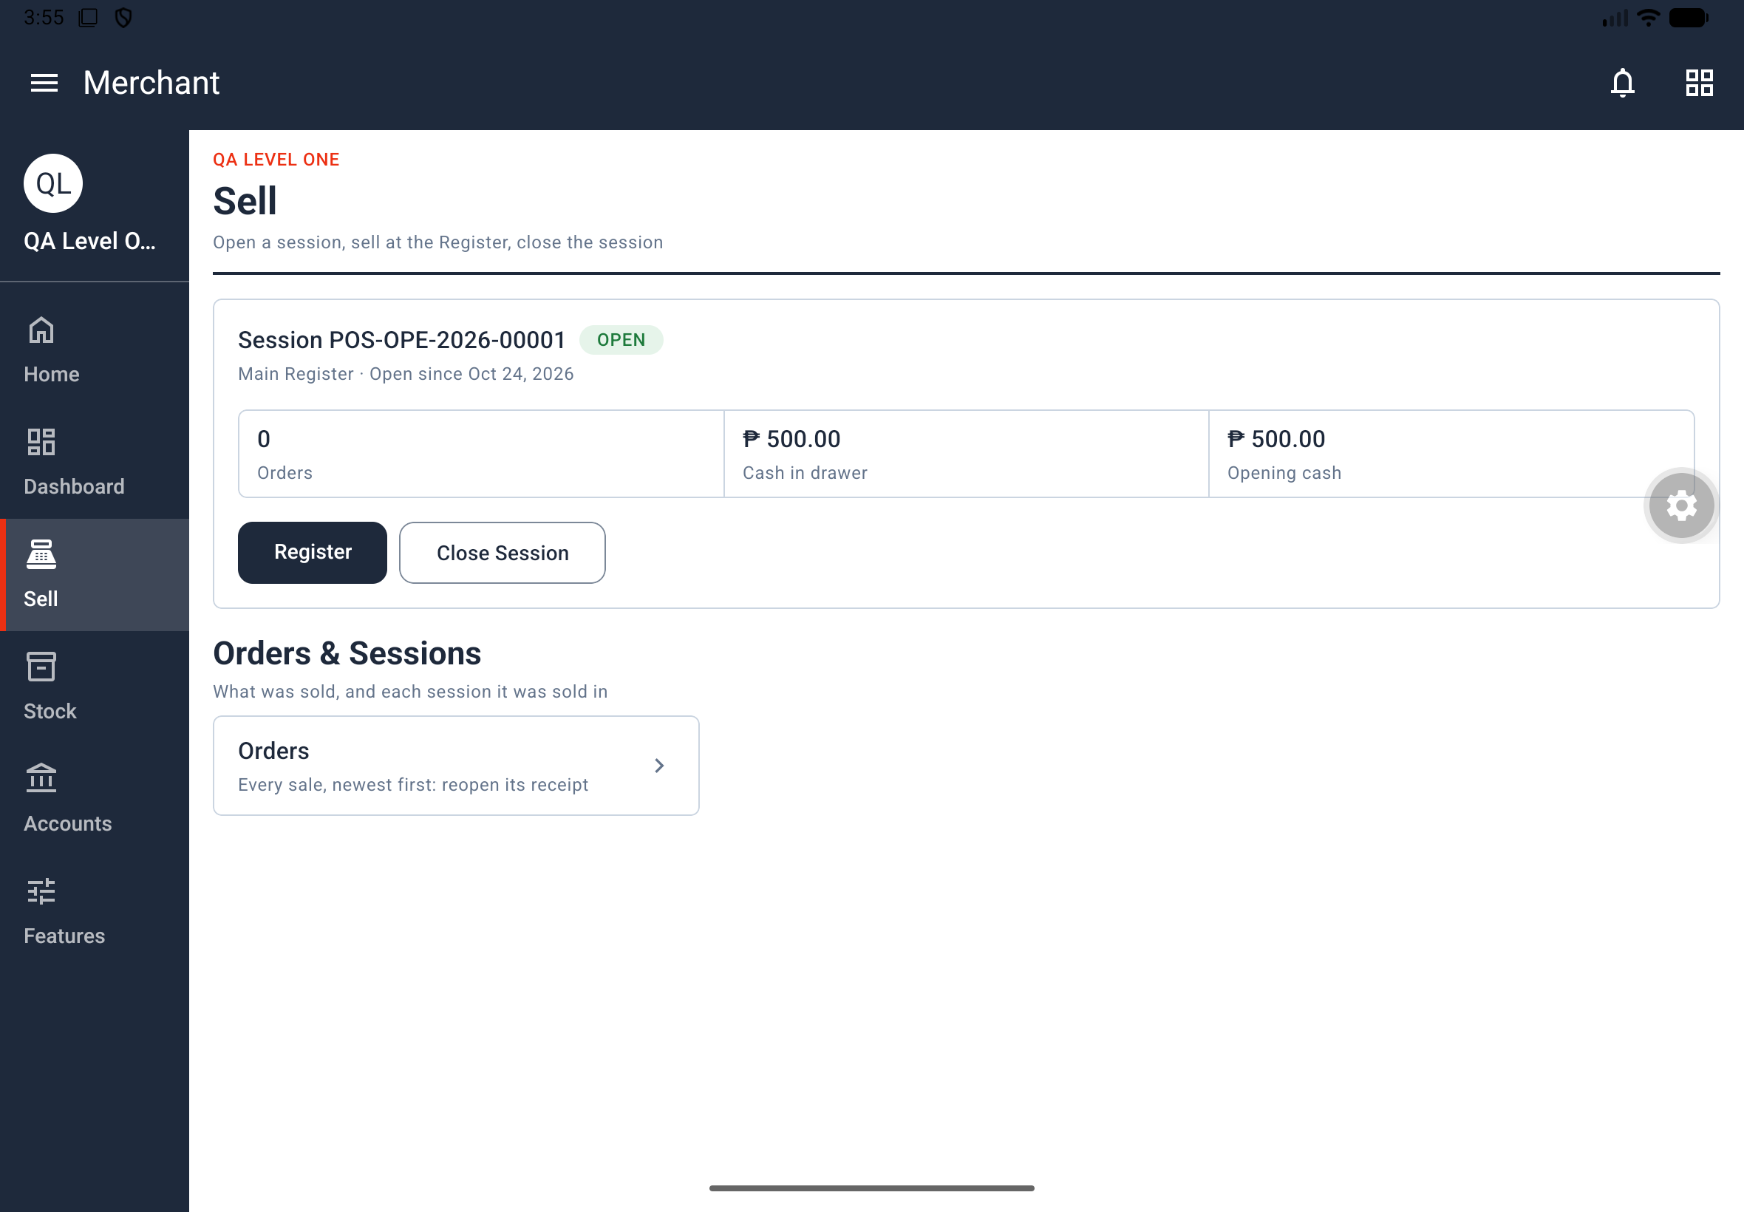
Figure 6. Open session card with Main Register and opening cash shown.
No register available: Levels 1–4 create Main Register when none exists. If setup is manual, configure a POS Profile (section 11.10). Also check whether the profile restricts its applicable users.

4.2 Add items at the Register
1. From Sell, tap Register.
2. Search by item name or code if needed. Each row shows the item's name, code, price and stock on hand.
3. Tap an item to add one unit, or use the barcode scanner described in section 4.4.
4. On a phone, tap Cart · n items · total at the bottom to open the Cart. On a tablet, review the Cart on the right of the Register.
Result: Selected items appear as cart lines. The profile determines which items the register offers. An empty tablet cart says The cart is empty. Tap an item to add it. On a phone, return to the Register to add an item.
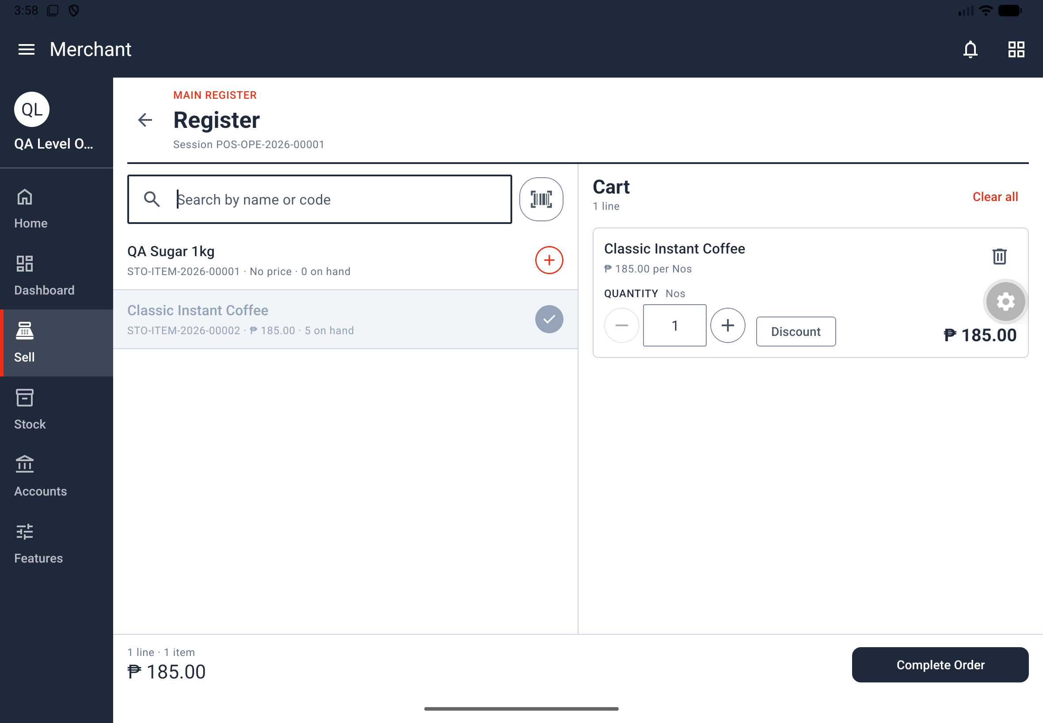
Figure 7. Tablet Register with the item list beside the current Cart.

4.3 Review the Cart and complete payment
1. Check each line's quantity, unit and rate.
2. Where permitted, apply a line or whole-sale discount as described below.
3. Review Net Total, Grand Total and Rounded Total.
4. Under Payment, check or enter amounts against the available payment methods. Cash initially contains the total.
5. Check Change, the money to give back to the customer.
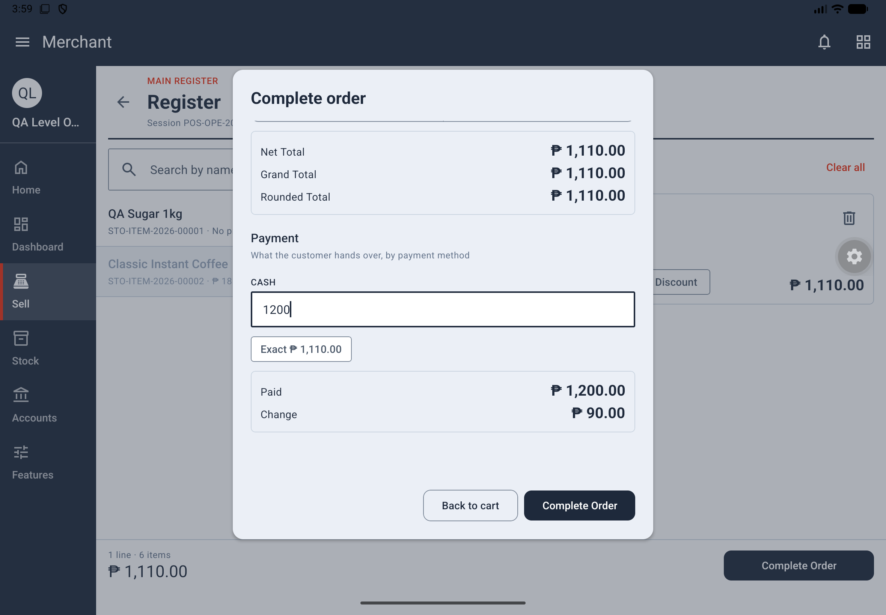
Figure 8. Payment review with cash received and change before completing the order.
6. Tap Complete Order.
Result: The sale is completed and its applicable stock and accounting records are posted. If PRINT RECEIPT ON ORDER COMPLETE is enabled, its receipt opens automatically. On a tablet, the Register remains ready for the next sale, the cart empties and payment amounts reset; Back from the receipt returns to the Register.
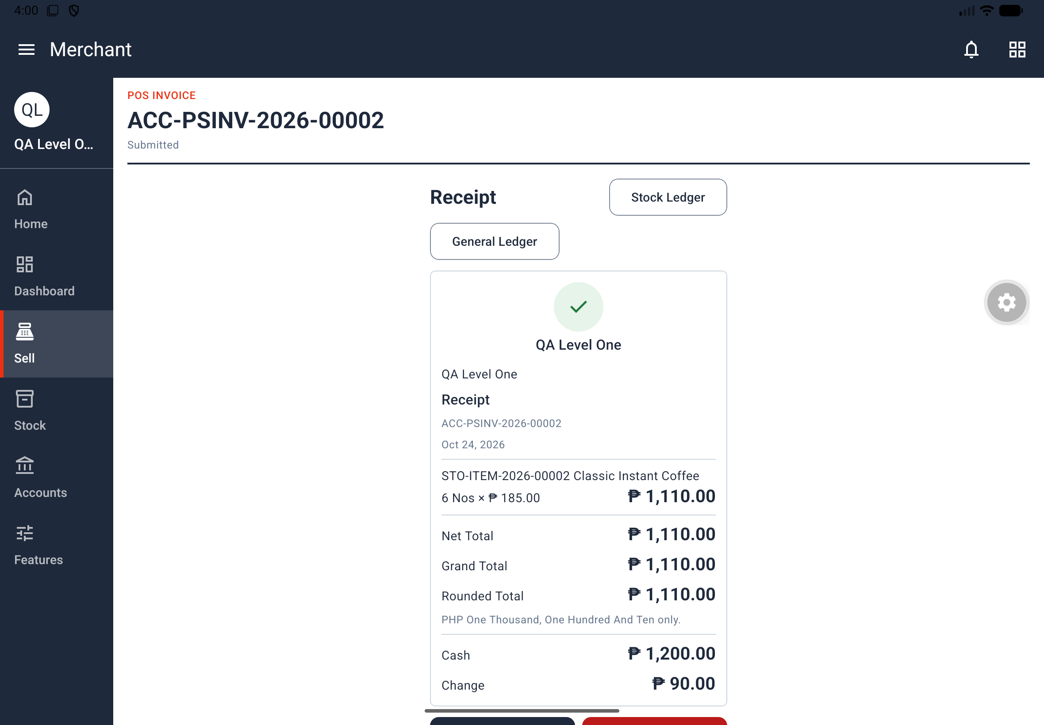
Figure 9. Completed order receipt with totals and ledger links.
Stock check: A shortage can stop the sale when negative stock is disallowed. Level 1 enables negative stock, so a sale beyond stock on hand is not refused for that reason. Treat the store's actual Stock Settings as controlling this behavior.
Discounts and prices: Apply Discounts is needed to change a price or give a discount, within the POS Profile's allowances. With discount editing enabled, line fields include DISCOUNT (%) and DISCOUNT AMOUNT, and Additional Discount applies to the whole sale. A default Cashier has no Apply Discounts permission. Automatic pricing rules can also apply; item-code rules take precedence over item-group rules, then brand rules.
Receipt note: Automatic receipt opening does not establish a hardware-printer setup procedure. The source describes receipt display and formatting; it does not document pairing or configuring a physical printer.

4.4 Scan to sell
Where: Register > barcode icon beside the search box.
1. Tap the scan button to open Scan to Sell.
2. Point the camera at a product's barcode.
3. Wait for the confirmation naming the product and cart quantity, such as Added Classic Instant Coffee · 1 in the cart.
4. Scan the next product. To add the same product again, remove it from view for two seconds, then show it again.
5. Tap Done and review the Cart.
Result: Each accepted scan adds one unit in the item's selling unit, just like tapping its row. Holding a code in view adds it only once.
The scanner searches the opened store's loaded items by barcode first, then matching item code. It works offline with those already-loaded items. Unlike Scan Product, it has no Read Label action.
If an item is not added: No item has the barcode … means no match was found. … isn't sold at this register. can mean the item is disabled, outside the profile's item groups, or out of stock when the profile hides those items.

4.5 Review orders and receipts
Where: Sell > Orders. Who: View Sales provides access to Orders; other actions depend on their own permissions.
1. Open Orders. The newest sales appear first, with number, date, amount and status.
2. Tap a sale to open its page.
3. Read the receipt: shop name, date, item lines, totals, amount in words and payment method.
4. Use Stock Ledger or General Ledger, where your permissions allow, to review related records.
Result: You can review the saved sale and reopen its receipt. A submitted sale displays SUBMITTED. Return and Cancel actions appear according to access and document eligibility.
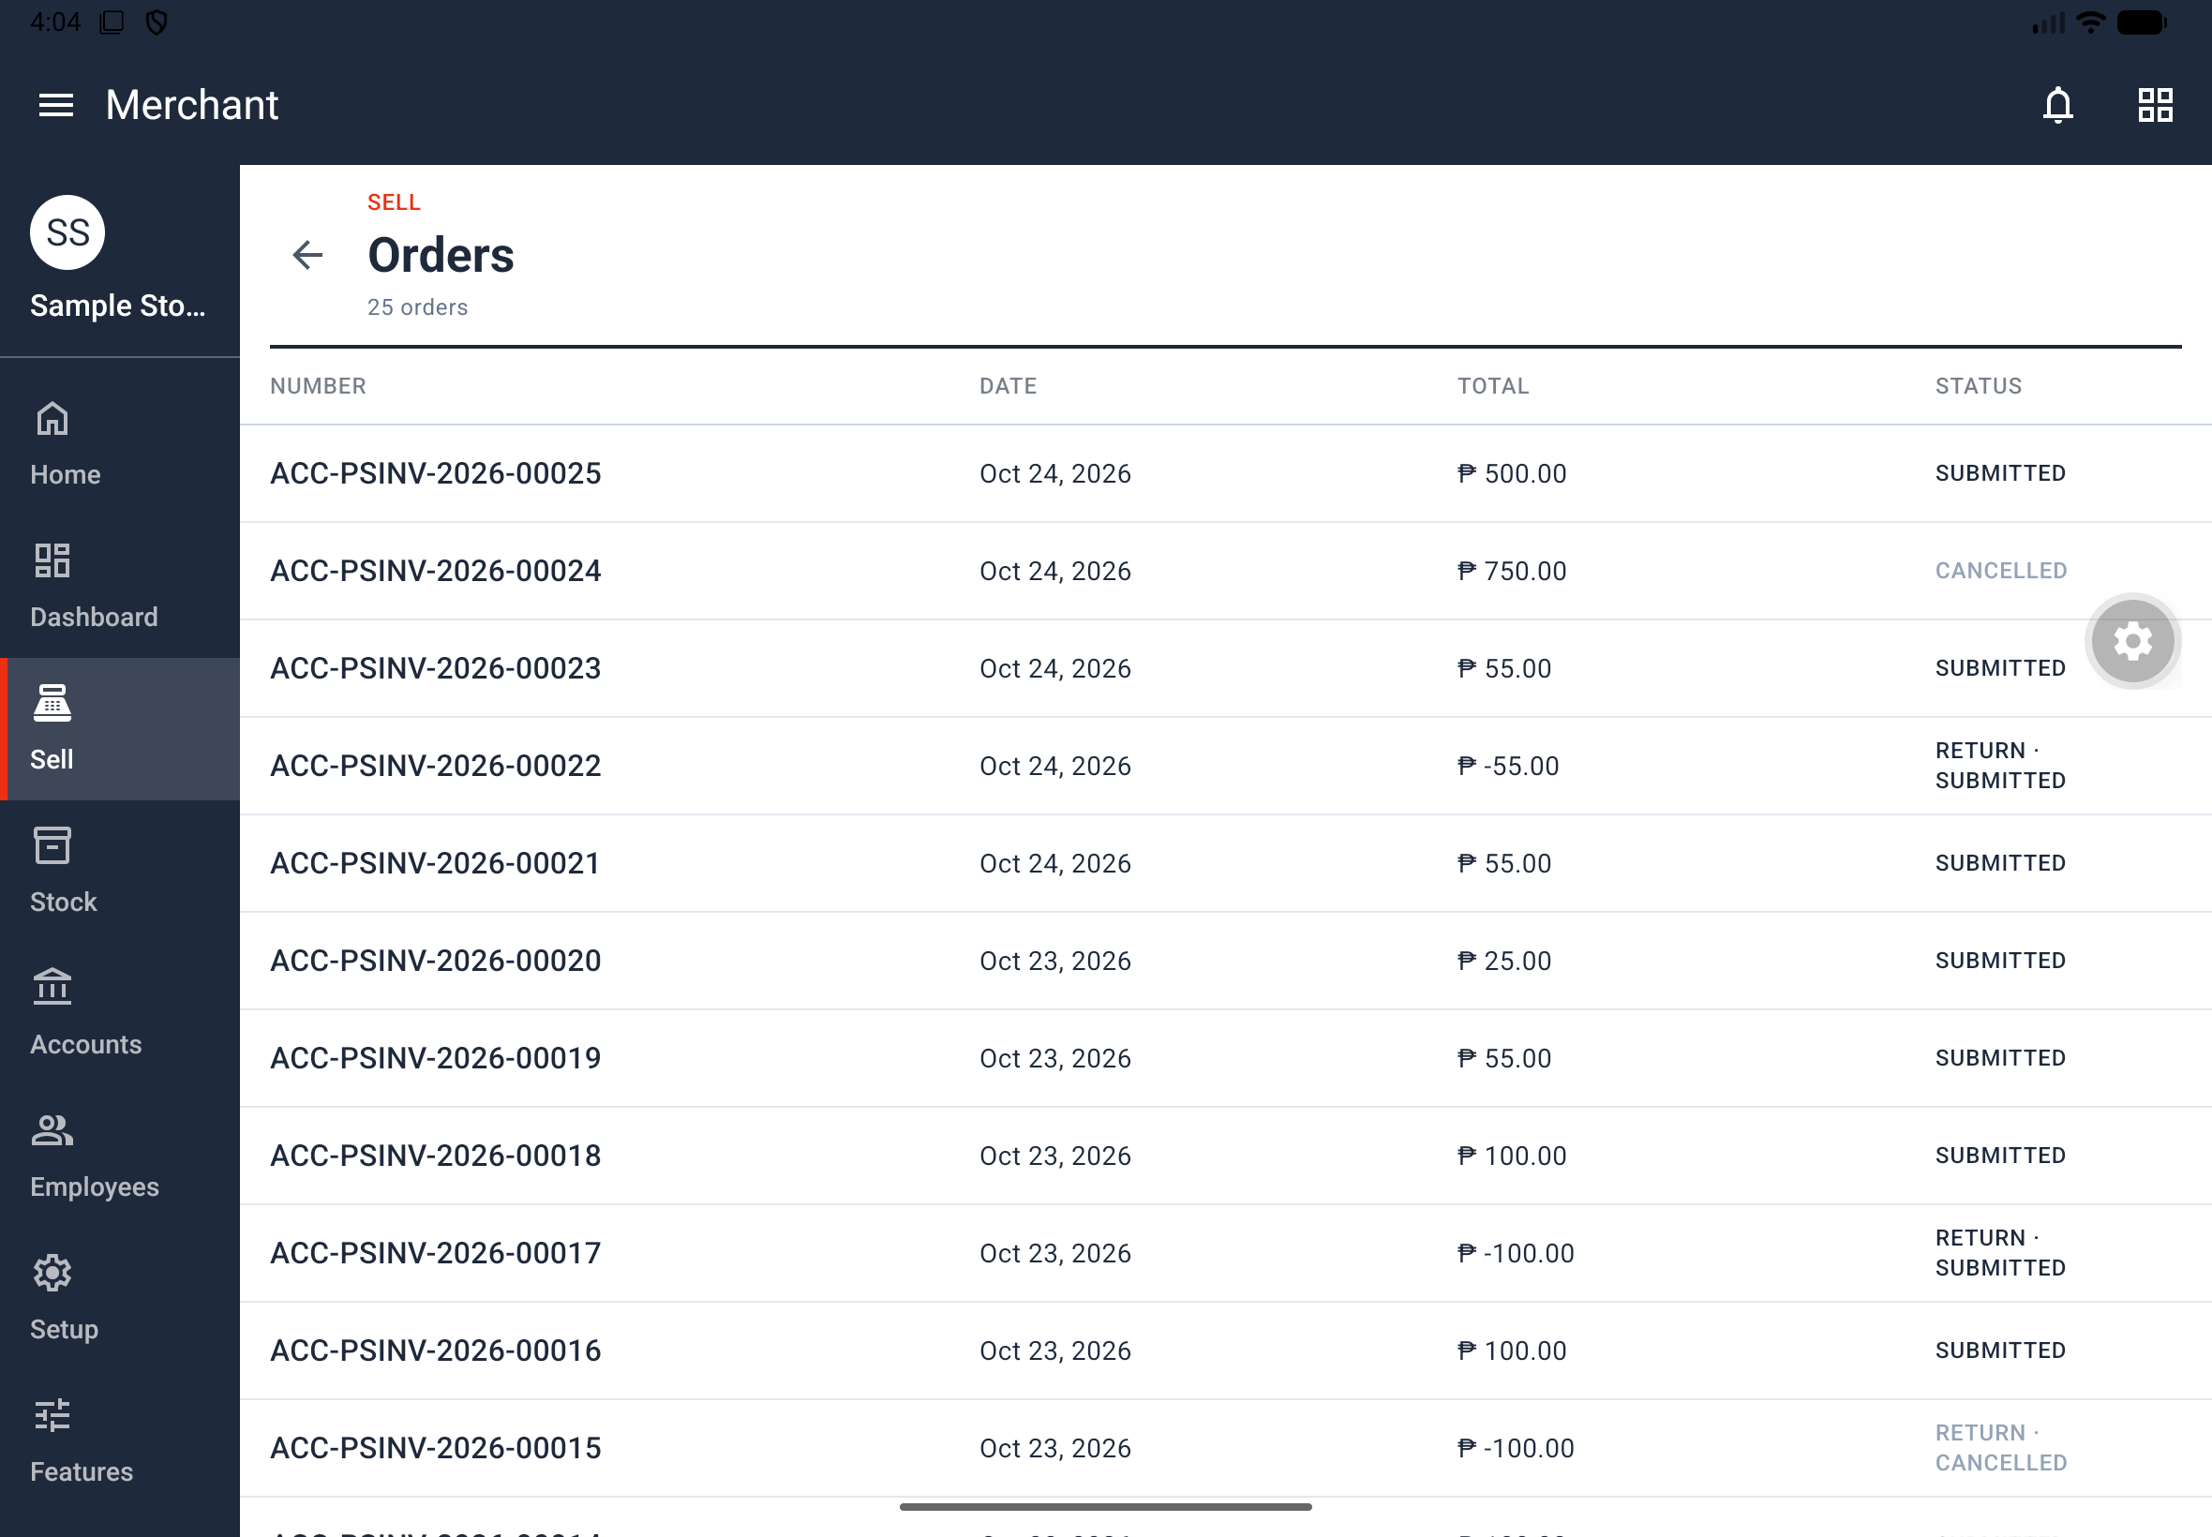
Figure 10. Orders list showing submitted, returned and cancelled records.

4.6 Process a return
Who: Process Refunds; this requires Open/Close Register. A return needs an open session of the same cashier, as specified by the source.
1. Open the original sale and tap Return.
2. Review sold and returnable quantities, and enter QUANTITY TO RETURN.
3. Check the Refund totals.
4. Review Handed Back for the permitted payment methods.
5. Tap Complete Return.
Result: The return receipt opens. Orders identifies the record as Return against the original sale. Only payment methods marked ALLOW IN RETURNS may be used for the refund.
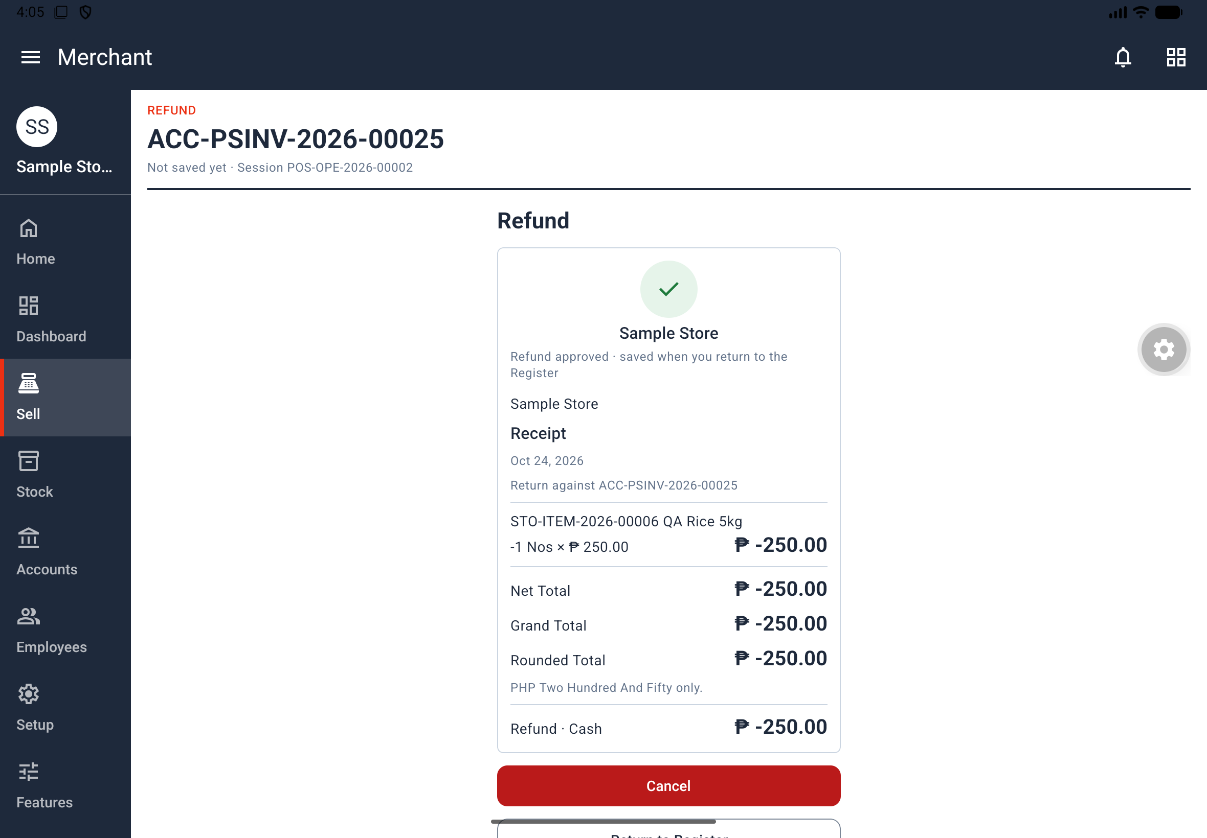
Figure 11. Refund receipt showing the returned item and cash refund.

4.7 Cancel a sale
Who: Void Transactions. A sale that already has a return cannot be voided.
1. Open the sale from Sell > Orders, where your access permits.
2. Review the sale to confirm it is the document you intend to cancel.
3. Tap Cancel and follow the app's displayed instructions.
Result: An eligible sale is cancelled. With IMMUTABLE LEDGER enabled, cancellation writes reversing entries. Cancellation and deletion behavior also depends on Accounts Settings. The source does not specify the confirmation dialog's exact wording or a separate sale-deletion procedure.

4.8 Close a session and inspect shift records
Who: Open/Close Register for your own session; Close Any Register for another person's session. View Shift Totals provides the sessions and closing lists.
1. Count the actual money or amounts for each payment method.
2. In Sell, tap Close Session.
3. Enter each method's Counted amount.
4. Tap the bottom Close Session button.
5. Open POS Closing Entries and tap the entry to review opening, expected and closing amounts, differences and totals.
Result: The session closes and its closing record is available. Expected cash equals opening cash plus the session's payments, less change given. Review any difference against the actual count.
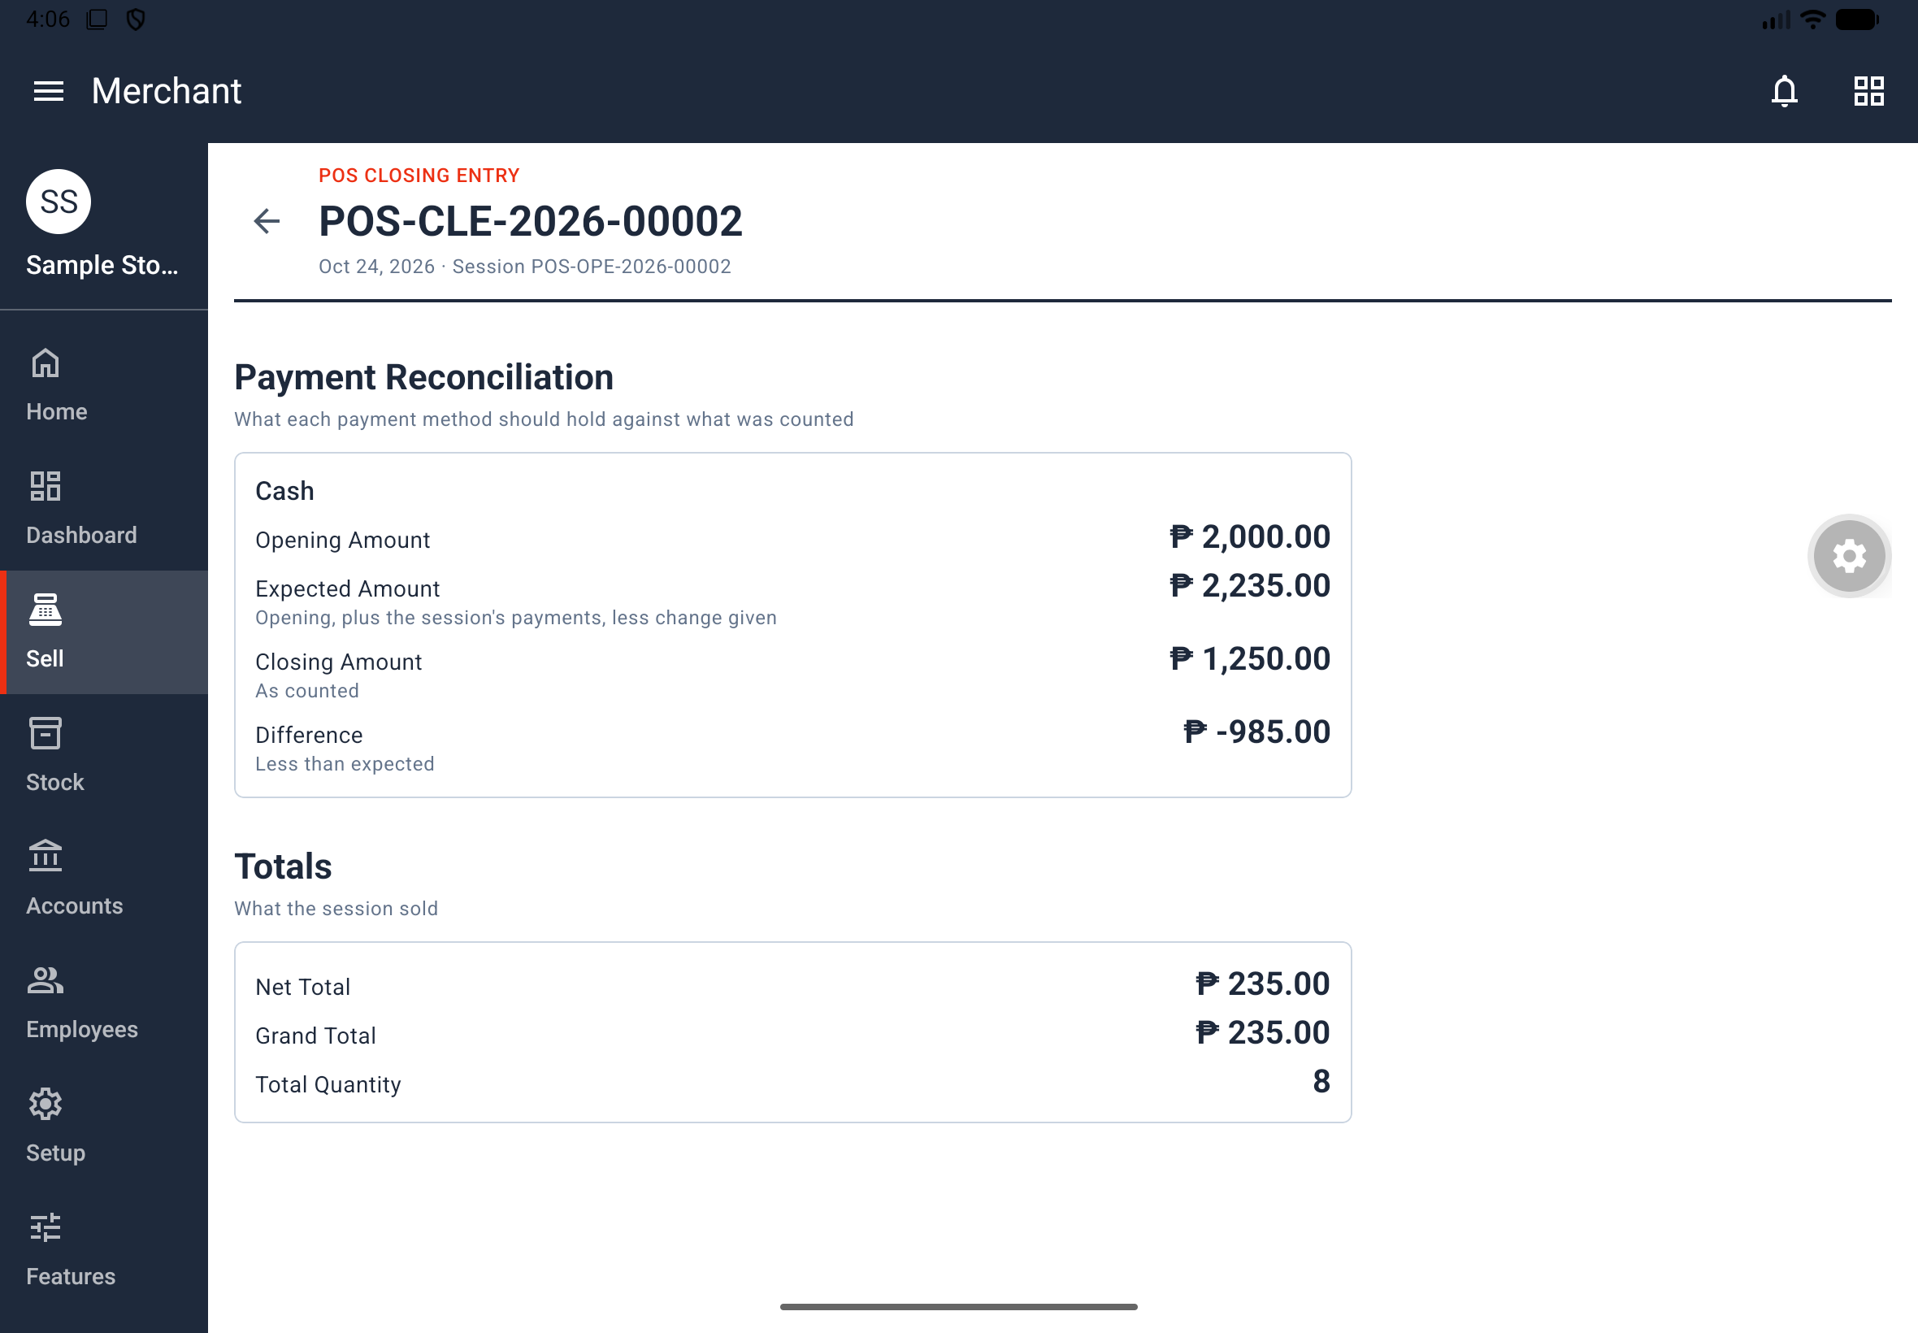
Figure 12. POS Closing Entry with expected cash, the count and the difference.
POS Opening Entries lists sessions with profile, date, opening amount and OPEN or CLOSED status. POS Closing Entries lists closed sessions with number, date and amount sold. Tap a row to inspect it. The source establishes the Close Any Register permission but does not give a separate detailed navigation sequence for closing somebody else's session.

5. Receive, count and review stock

5.1 Record a stock movement
Where: Stock > Stock Transactions > Stock Entries. Who: Receive Shipments allows stock entries and submission; Adjust Inventory is required to cancel a stock entry.
1. Tap New Stock Entry.
2. Choose PURPOSE. Material Receipt is the default. Stock entries can record stock moving in, out or between warehouses.
3. Check POSTING DATE and choose the warehouse fields required for the selected purpose. The documented receipt form uses TARGET WAREHOUSE.
4. Add item rows with ITEM, QUANTITY and BASIC RATE.
5. Tap Save, then submit the document.
Result: Submission records the movement in the Stock Ledger. Stock accounting also posts to the books when Perpetual Inventory is enabled. The posting date must be within an enabled fiscal year and comply with any frozen accounting period.
Important: A submitted document cannot be edited. Receiving permission alone does not allow cancellation. The source does not give all purpose-specific transfer fields or a detailed cancellation sequence; follow the fields and actions displayed for your chosen purpose and permissions.

5.2 Enter opening stock or a physical count
Where: Stock > Stock Transactions > Stock Reconciliations. Who: Adjust Inventory.
1. Tap New Stock Reconciliation.
2. Choose PURPOSE: Opening Stock or A count against the books.
3. Check POSTING DATE.
4. Add rows with ITEM, WAREHOUSE, QUANTITY and VALUATION RATE.
5. Tap Save, then submit.
Result: Opening Stock establishes initial quantities; a count corrects the book quantity to the entered count. Stock Balance and Stock Ledger show the result. Enter the counted quantity for reconciliation, rather than treating the form as another delivery receipt.

5.3 Check stock on hand
Where: Stock > Reports > Stock Balance. Who: View Stock Levels.
1. Open Stock Balance.
2. Review each item's warehouse, quantity, valuation and value, together with the total at the top.
3. Tap a row to inspect its movements.
Result: You can see current stock and its value. The item's Stock Levels section shows the same figures.

5.4 Trace stock movements
Where: Stock > Reports > Stock Ledger. Who: View Stock Levels.
1. Open Stock Ledger and use Filters to narrow the report as needed.
2. Review the movement's date, warehouse, document, quantity, rate, balance, valuation and value.
3. Tap a row to open its source document.
Result: You can trace the stock balance back to sales, returns and stock documents. The source does not enumerate this report's filter fields; use the options displayed in the app.

6. Read business reports

6.1 Use the Dashboard
Where: Dashboard in the store menu. Owners can view it. For employees, access comes from View Sales, View Shift Totals, Close Any Register or View Stock Levels; individual blocks require their corresponding permissions.
1. Open Dashboard.
2. Choose Today, Last 7 Days or This Month.
3. Review the available summary cards and scroll to the chart and lists.
Display | What it tells you
SALES | Net sales total with invoice count; returns reduce the total
GROSS PROFIT | The displayed gross profit figure for the selected period
OPEN REGISTERS | Open registers and expected cash
LOW STOCK | Stock requiring attention
Sales per Day | Sales chart arranged by date
Top-Selling Items | Ranking by quantity or amount, grouped by item or item group; excludes returns
Stock Alerts | Items at or below their re-order level

Result: You see a summary of the records you are permitted to read. On a tablet, the summary cards occupy one row, with report blocks arranged according to orientation and available space. A missing block can reflect permissions rather than missing data.
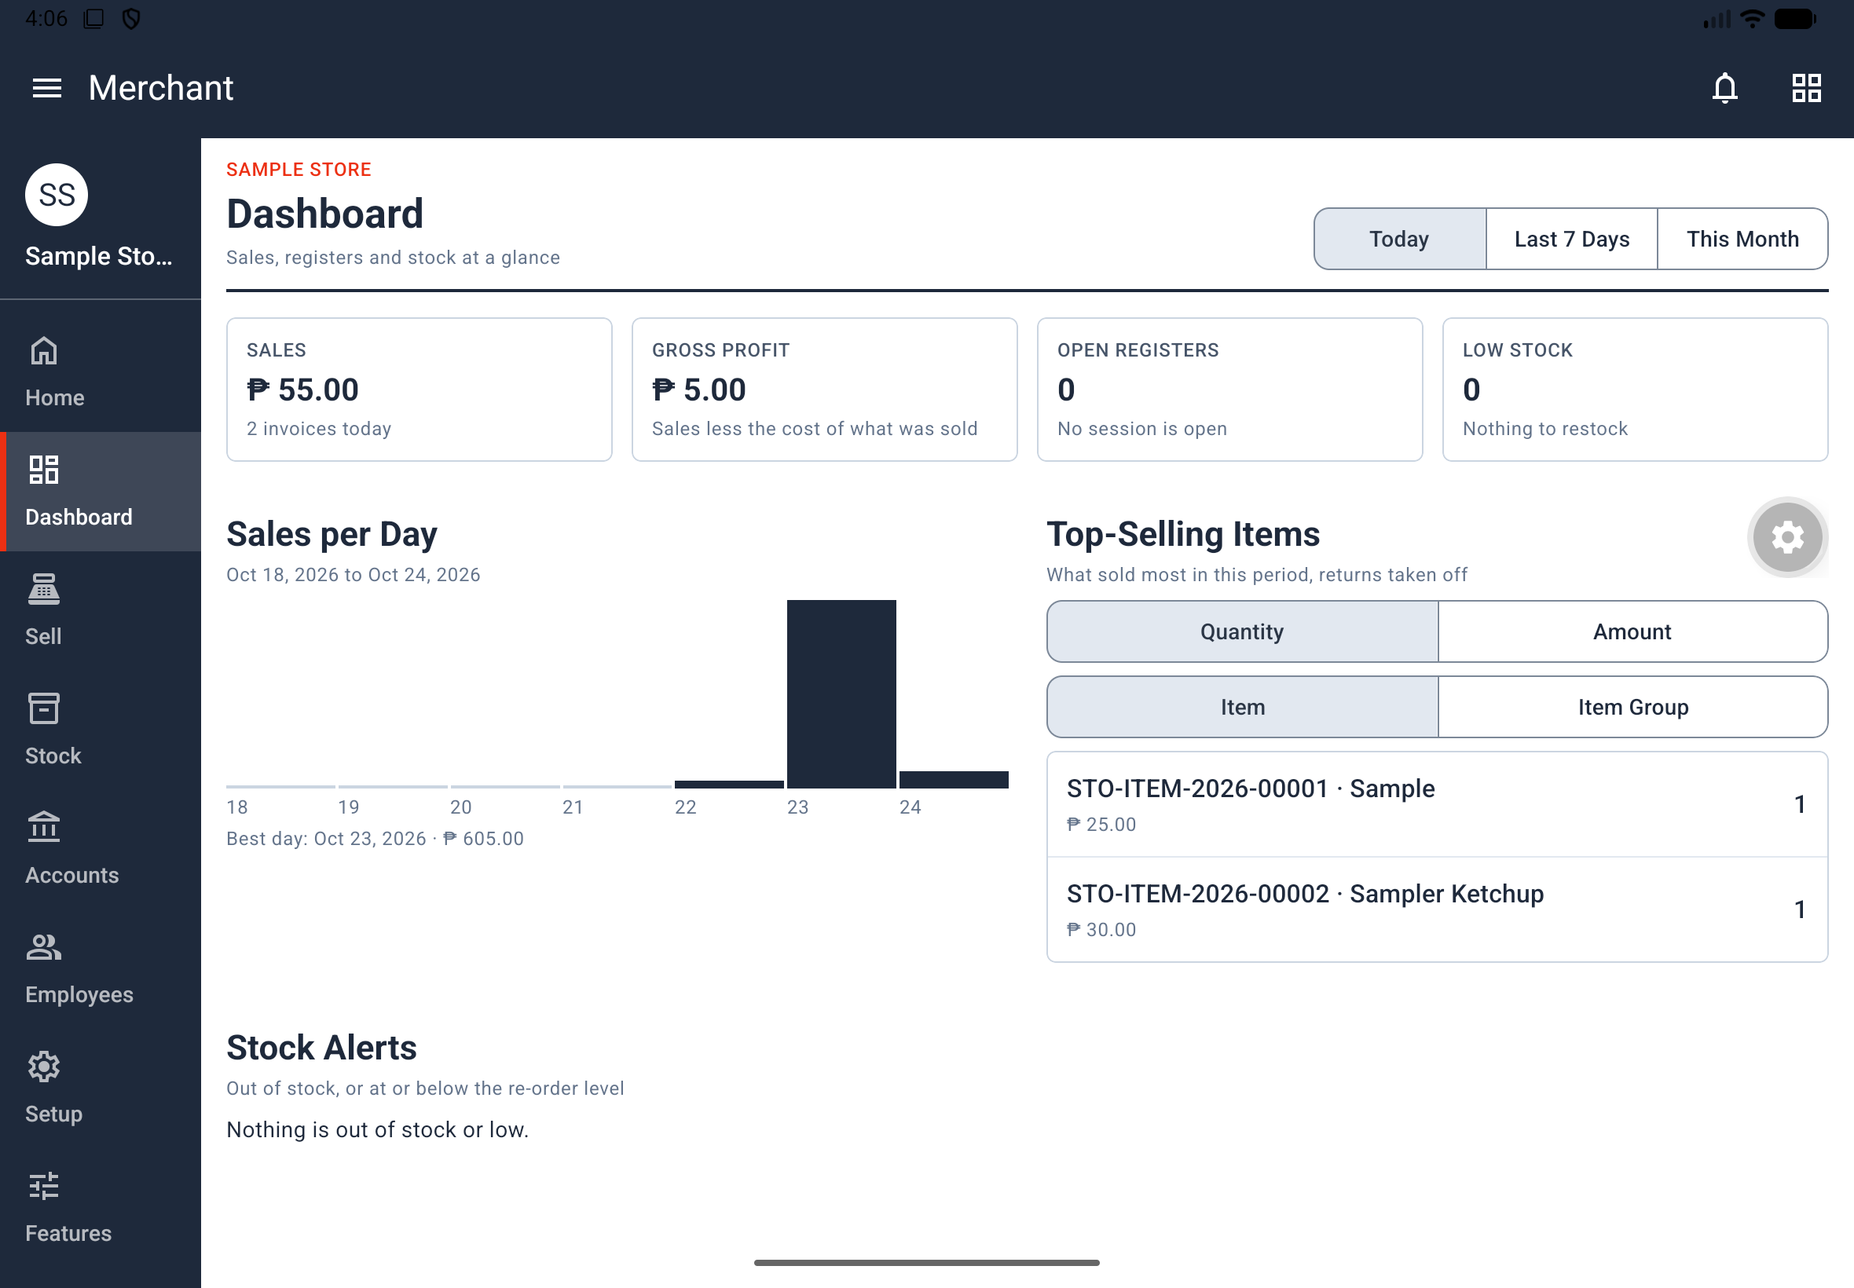
Figure 13. Tablet Dashboard with summary cards, sales chart and top-selling items.

6.2 Read the General Ledger
Where: Accounts > Reports > General Ledger. Who: View General Ledger.
1. Open General Ledger.
2. Tap Filters.
3. Set FROM DATE, TO DATE, ACCOUNT or VOUCHER NO. as needed, then tap Done. Use Clear all to remove the filters.
4. Read the account, date, voucher and debit or credit on each row.
5. Tap a row to open the source document.
Result: You can trace accounting entries to their originating documents. The source's basic sale/return example includes cash, sales, stock in hand and cost of goods sold. Actual postings depend on the transaction and settings, including Perpetual Inventory, taxes, discounts and payment accounts; do not use a fixed four-entry count as a universal check.

7. Invite staff and manage access

7.1 Create and share access codes
Where: Access Codes tab on a phone, or its key icon in the Home header on a tablet. Who: Store owner. Employees, roles and access-code administration remain owner-only even when an employee has every permission.
1. Open Codes and tap Create Code.
2. On Generate Staff Access Code, optionally enter a Label and choose the Store.
3. Set Quantity from 1 to 20.
4. Set Expires to 5 min, 30 min, 1 hour, Custom or Never.
5. Set Uses per Code to 1 person or Many people.
6. Tap Create Code.
7. Use a code's share button or Share All to send the code through a message, email or another sharing option.
Result: Staff can use the code to request access. Sharing the code does not itself approve the person or assign a role.
Code status | Meaning
Active | The code can still be used
Claimed | Pending requests reserve every remaining use
Used | All permitted uses have been approved
Expired | The expiry time has passed

Use the search box and All, Active, Claimed, Used or Expired chips to find codes. Open a code to inspect its expiry, uses and people, or to Share or Delete it.
Rules: A code has six letters and numbers, shown in a form such as A4F-7K2, and excludes 0, O, 1 and I. Custom expiry ends at midnight after the selected day in the store time zone; a past day is refused. Codes cannot be edited: delete and create a replacement. Deleting a code does not remove people already admitted through it.

7.2 Request access to somebody else's store
1. On the main Home header, tap Enter Access Code.
2. On Employee Access Code, enter the six characters supplied by the owner. Dashes, spaces and lowercase letters are accepted.
3. Tap Use Code.
4. Check the Request sent message and named store, then wait for the owner's decision.
Result: Home shows Waiting for approval until the owner decides. After approval, the store appears on Home. The owner must separately assign a role before you have work permissions.
Problems: An invalid code says it does not exist, has expired or was used, without naming the store. Ten wrong codes within 15 minutes block attempts for 15 minutes. You cannot use your own store's code; the app also identifies an existing membership or pending request. A person who owns no store sees You don't own a store in access-code administration, with an Enter Access Code button.

7.3 Approve, decline or revoke access
Who: Owner of the store.
1. In Access Codes > Requests, use Pending, Approved, Declined or All to locate a request.
2. Open it and review the person's photo, name, email, store, code and request time.
3. Tap Approve or Decline.
4. After approving, assign the person a role in Employees (section 7.4).
Result: The person is notified of the decision. Declining frees the code's use for someone else, but not for the declined person.
To remove an existing member, open Access Codes > Members, select the person and tap Revoke. Members includes people across the owner's stores, with the store, joining date and code used. Check the store before revoking. Revocation removes access; deleting the invitation code alone does not.
Timing: An approved store appears, or a revoked store disappears, within a minute while the app is open. Revocation also takes effect when the person is already inside that store.

7.4 Assign a role and individual permissions
Where: Employees, an owner-only store-menu destination. Each admitted employee starts with No role. The owner row reads YOU · OWNER · EVERY PERMISSION.
1. Open Employees. Search by name or email, or filter using All, a role chip or No role.
2. Tap the employee's row.
3. In ROLE, choose a role from the searchable list.
4. Review the permission switches grouped by work area. Turn individual permissions on or off when exceptions are needed.
5. Tap Save Changes. The button is disabled when nothing has changed.
Result: The employee receives the role's permissions with their personal exceptions applied. Their app follows the access change within a minute and receives one Access changed notification. Tablet users can view the employee detail alongside the list.
Exceptions and dependencies: A changed switch shows ROLE: ON or ROLE: OFF. Use the role's permissions removes the differences. Assigning another role keeps the person's existing exceptions. Process Sales and Process Refunds require Open/Close Register; Apply Discounts requires Process Sales. Enabling a dependent permission brings its requirement along; turning off a required permission turns off dependents.
Idle or removed staff: There is no Disable action for an employee. No role is the documented state for a retained person who is not working; the source describes no-role users as having Home only for work access, while Home and Features remain universally available menu destinations. Use Access Codes > Members > Revoke to remove the person instead. When changing a person's role, review any retained exceptions rather than assuming they have been cleared.

7.5 Create, edit or delete a role
Where: Employees > Roles. Who: Owner.
Built-in role | Starting permissions
Cashier | Process Sales; Open/Close Register
Stock Clerk | View Stock Levels; Receive Shipments
Store Manager | All twenty permissions; owner-only administration still excluded

1. Tap New Role, or open an existing role.
2. In General, enter Role Name, Description and Colour. Thirteen colours are available.
3. In Permissions, select the required permissions.
4. In Members, tick the people who should hold the role. Their current role appears beneath their name.
5. Tap Save Changes.
Result: The role appears with a coloured dot and its employee and permission counts. A role name must be unique within the store and no longer than 60 letters, as specified in the source. Each person holds one role; selecting a member moves them from their previous role.
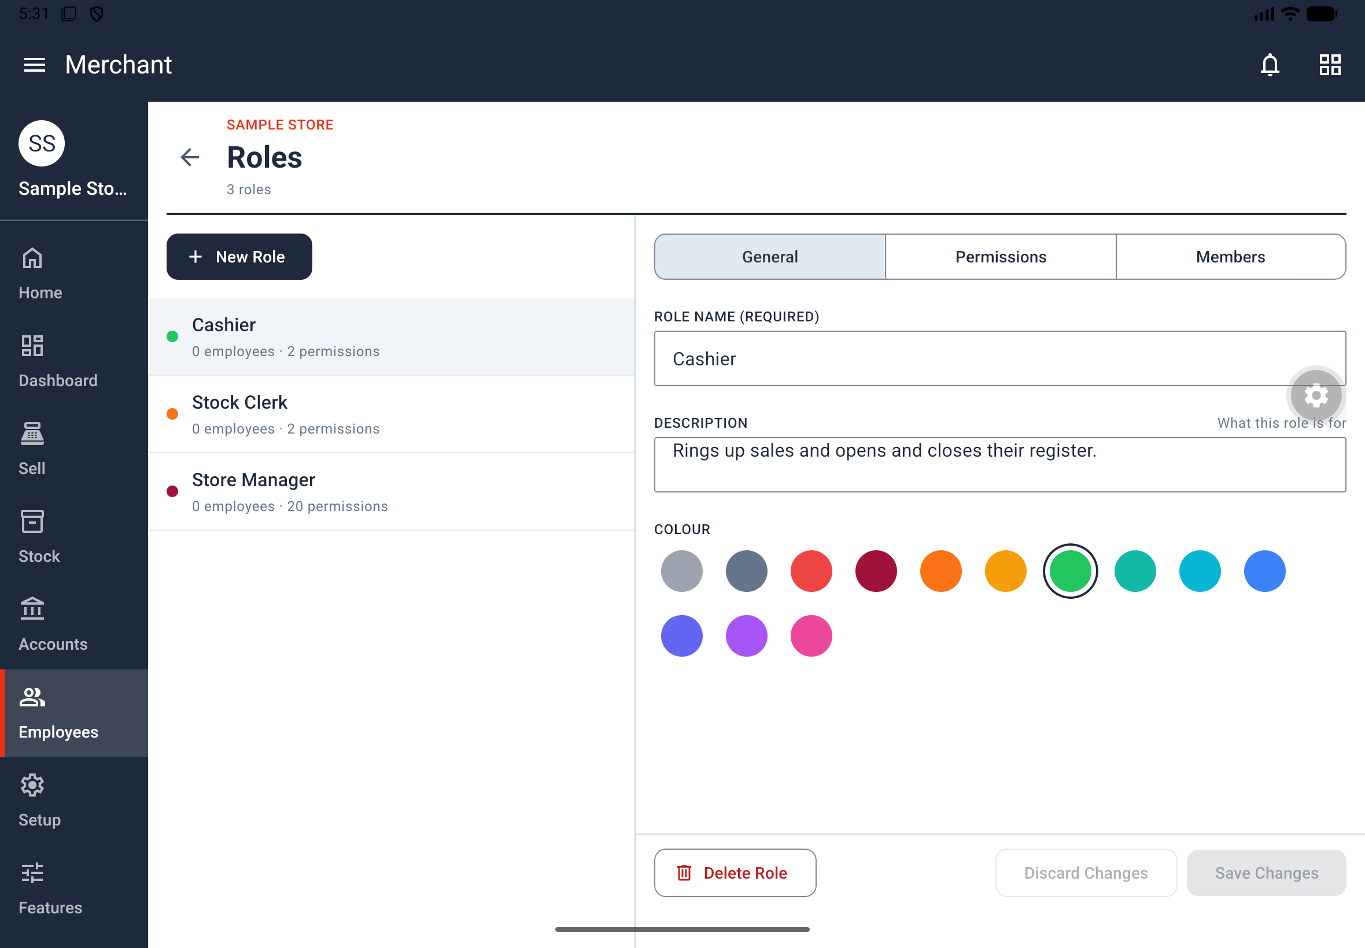
Figure 14. Built-in roles with their employee and permission counts.
Delete a role: Open the saved role and use Delete on a phone or Delete Role on a tablet. Its members stay in the store but are left with no role. If it was selected as ROLE ALLOWED PAST THE FROZEN DATE, that Accounts Settings field becomes None. On a tablet, Discard Changes and Save Changes appear beside the delete action at the bottom.

7.6 Permission reference
The following twenty permissions are the same in every store. The owner always has every permission. Permissions are enforced by the system as well as by visible controls; hiding a page does not change them.
Area | Permission | What it allows
Sales & POS | Process Sales | Use Register and complete a sale; requires Open/Close Register
Sales & POS | Apply Discounts | Change prices or give discounts where the profile permits; requires Process Sales
Sales & POS | Process Refunds | Use Return on a sale; requires Open/Close Register
Sales & POS | Void Transactions | Use Cancel on an eligible sale
Sales & POS | View Sales | Orders and sales information on Dashboard
Payment & Cash | Open/Close Register | Open and close one's own session
Payment & Cash | View Shift Totals | Session and closing lists; open registers on Dashboard
Payment & Cash | Close Any Register | Close a session left open by another person
Inventory | View Stock Levels | Items, Stock Balance, Stock Ledger and low stock on Dashboard
Inventory | Manage Items | Items, Item Prices, Import Items without opening stock, and Scan Product
Inventory | Receive Shipments | Create and submit Stock Entries, but not cancel them
Inventory | Adjust Inventory | Stock Reconciliations and cancellation of Stock Entries
Accounting | View General Ledger | Accounts > General Ledger
Setup | Store & Calendar | Its assigned store and calendar setup pages
Setup | Accounting & Payments | Its assigned accounting and payment setup pages
Setup | Taxes | Tax setup pages
Setup | Stock Setup | Stock setup pages
Setup | Selling & Pricing | Selling and pricing setup pages
Setup | POS Profiles | POS profile setup
Setup | Naming & Printing | Document naming and receipt setup

For setup pages whose precise permission grouping is not specified by the source, use the pages offered to the assigned role or ask the owner to configure them. Do not infer that a broad role title bypasses a missing permission.

7.7 Read notifications
Where: The bell on main Home or in a store header. Its red number counts unread notifications.
1. Tap the bell.
2. Review each notification's title, message and time. Unread rows have a grey background and red dot.
3. Tap a row. Access code used opens Access Codes > Requests; Request approved opens the store.
4. Use Mark all as read when appropriate. Back returns to the preceding screen.
Result: You can follow access-related updates, including approval, decline and removal. Notifications do not currently appear on the lock screen. The app checks every minute while open and when opened again. On a tablet, notifications use a readable column rather than the whole screen width.

8. Customize your menu and practise

8.1 Show or hide your screens
Where: Features, the last store-menu row, available to everyone. Changes affect only your menu for this store.
1. Open Features and select a screen.
2. Use its screen switch, a page switch or a section's Hide all / Show all control.
3. Tap an i button if you need the screen or page's PURPOSE and USE-CASE.
4. Review the n unsaved changes bar and tap Save.
Result: The page confirms Saved. Your menu now shows only what you chose. Hidden screens disappear from the side menu; hidden pages and empty sections disappear from indexes. Nothing is deleted or disabled, and permitted hidden pages can still open from another link.
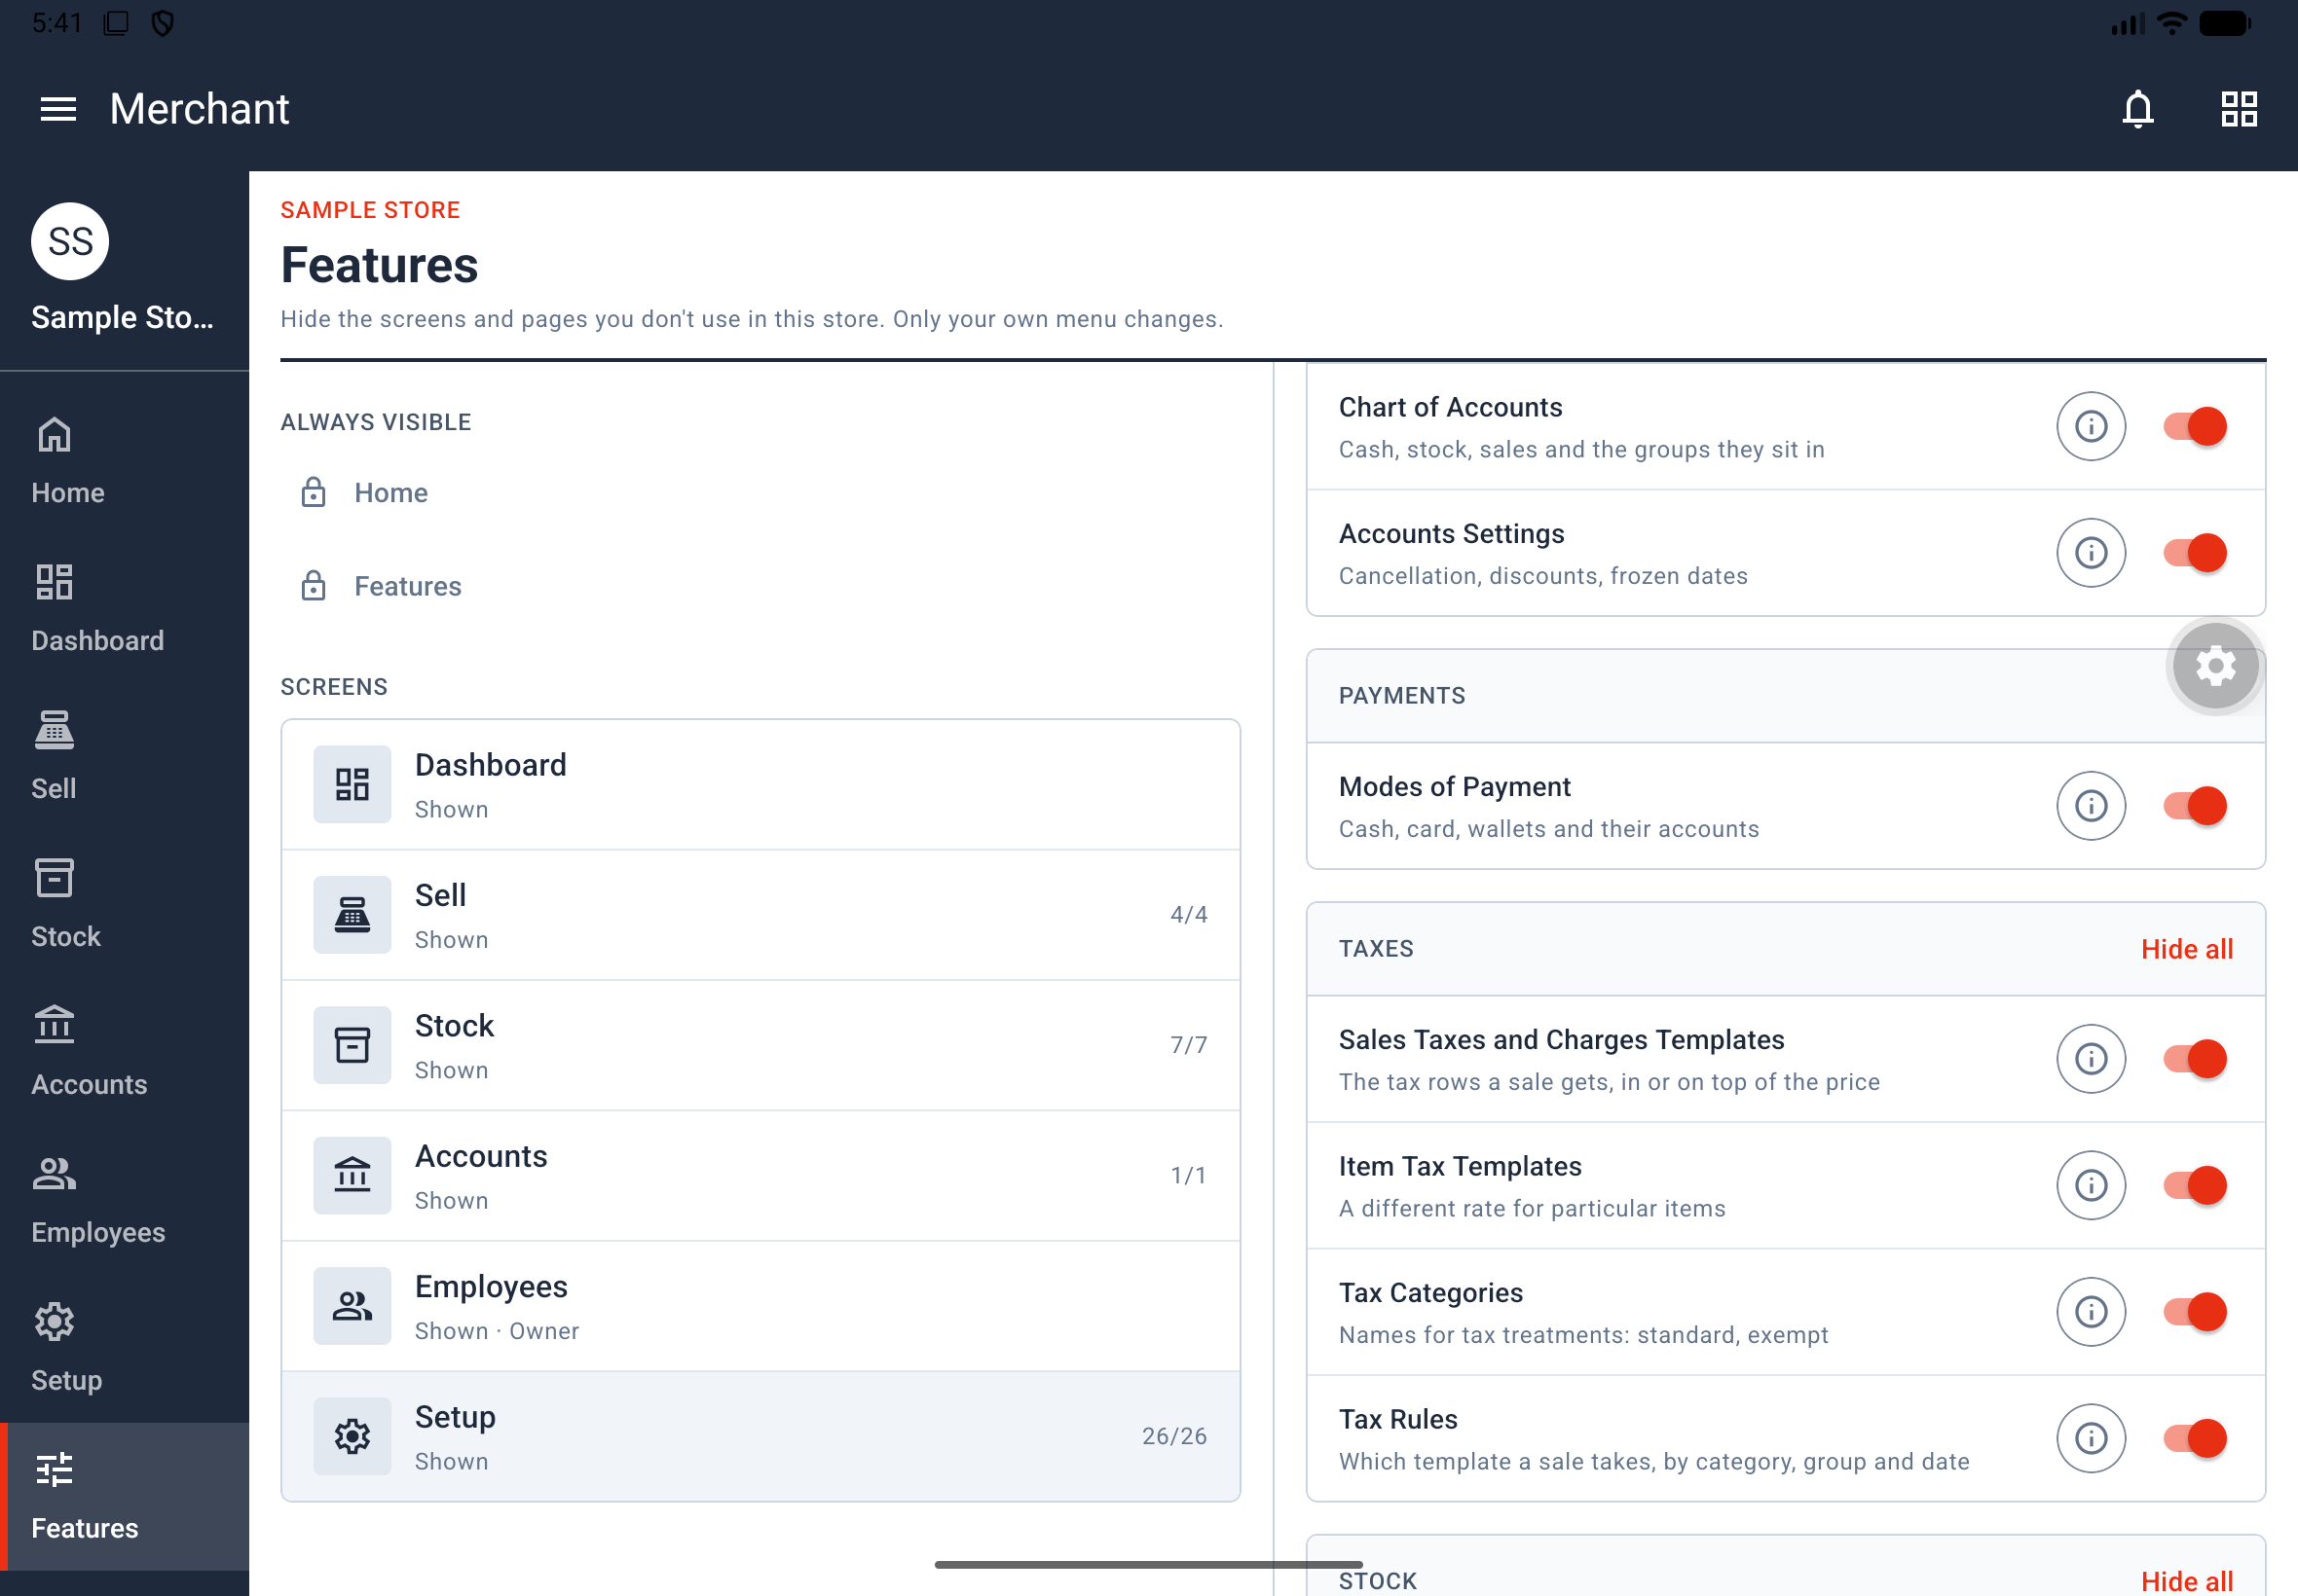
Figure 15. Features screen with store screens on the left and visibility switches on the right.
Screen | Visibility rule
Home and Features | Always visible; cannot be hidden
Dashboard and Employees | One switch controls the whole screen; Employees is still owner-only
Sell | Sessions & Register remains core when the person can open sessions; Orders and opening/closing lists can be hidden
Stock | Items remains core with Stock; other stock pages can be hidden
Accounts | No core page; hiding General Ledger hides Accounts
Setup | No core page; hiding the last setup page hides Setup

A core page counts as core only when you may open it. For someone unable to open a session, Sell pages stand independently. Turning off a screen locks its page switches. A screen with a core remembers its page choices; turning a screen without a core back on shows all its pages again.
Undo and restore: Reset drops unsaved changes. Opening another menu screen preserves them for your return; Android Back from the Features list asks Discard your changes? before leaving. Use Level n's menu restores the level's menu as an unsaved change—tap Save to keep it. The screen status can be Shown, Some pages hidden or Hidden, with a page count and an unsaved-change dot.
Across devices: Saved choices belong to your account and this store, persist after reinstall and follow you to another phone. Offline, Features uses the last copy and Save waits for a connection. A store-level change resets everyone's menu choices to the new level. On a phone, a screen opens on its own page and Back returns to the list; on a tablet, the list and selected screen appear side by side.

8.2 Learn safely in Store Guide
Where: Main Home header > Store Guide question-mark icon. Available to everyone signed in.
1. Open Store Guide to see Learn a role and Pick a role to practise.
2. Search roles by name or description and choose a role. Use X to dismiss the picker or Choose a Role to open it again.
3. In the practice store, Sample Cafe, select a task and tap Start.
4. Follow the box at the bottom and tap the highlighted control. Alternatively, choose Explore on My Own.
5. Use Start Again to restart a task, Stop Task to stop it, or the top-right X to leave the practice store.
Result: You practise with sample items, sales and sessions without altering a real store. The practice store works offline, saves nothing and resets when you leave. Android Back goes back through practice pages before leaving. A guided step advances only when its required control is used.
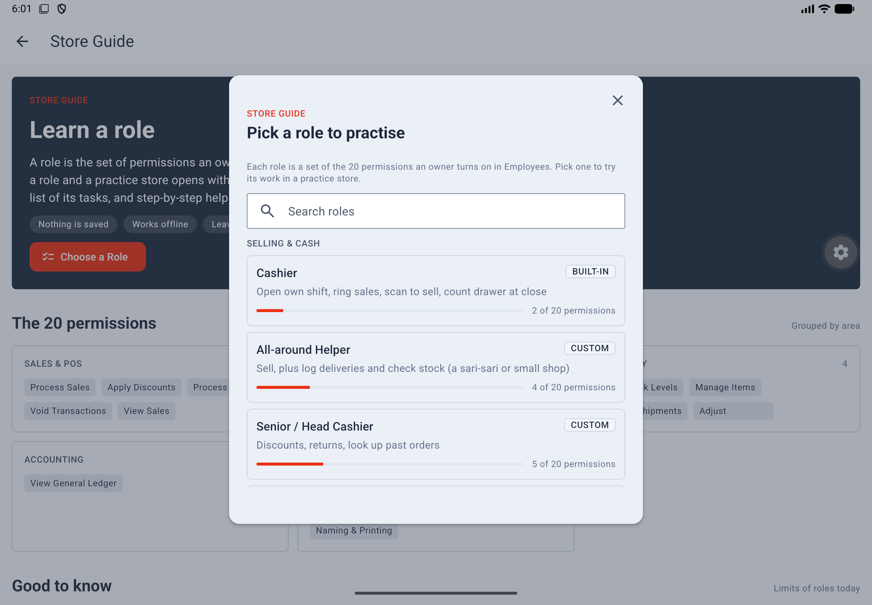
Figure 16. Store Guide role picker for choosing a role to practise.
Work area | Practice roles
Selling & Cash | Cashier; All-around Helper; Senior / Head Cashier; Returns / Customer Service Desk; Shift Supervisor; Cash Custodian / Cash Office
Stock | Receiving / Stock Clerk; Inventory Controller / Stock Auditor; Product Encoder / Merchandiser; Pricing / Promo Officer
Books & Setup | Bookkeeper / Accountant; External Auditor / Silent Partner; System / Setup Admin
Running the store | Assistant Manager; Store Manager; Owner
Not working yet | Seasonal / On-leave Staff (no role)

Each role card shows its kind, description and count out of twenty permissions. Practice examples are not all pre-created roles in a real store; new stores start with the three roles in section 7.5. Tasks cover selling, discounts, returns, voids, shifts, stock, item entry and scanning, pricing, imports, ledger reading, setup and owner administration. The practice store enforces its demonstrated restrictions: for example, a sale with a return cannot be voided, and a Stock Clerk cannot cancel a delivery.

9. Configure store details, dates and money

9.1 Change store details and default accounts
Where: Setup > Store & Calendar > Store. Who: Owner or a user with the relevant setup permission. If the menu hides this page, check Features.
1. Open Store and update STORE NAME, COUNTRY or DEFAULT CURRENCY as needed.
2. In Accounts, select the fallback ledgers used when a transaction or item does not supply its own account.
3. In Stock, review PERPETUAL INVENTORY and the stock-related default accounts.
4. Tap Save.
Group | Fields
Accounts | DEFAULT CASH ACCOUNT, DEFAULT BANK ACCOUNT, DEFAULT INCOME ACCOUNT, DEFAULT EXPENSE ACCOUNT, WRITE OFF ACCOUNT, ROUND OFF ACCOUNT, DEFAULT DISCOUNT ACCOUNT
Stock | PERPETUAL INVENTORY, DEFAULT INVENTORY ACCOUNT, STOCK ADJUSTMENT ACCOUNT, STOCK RECEIVED BUT NOT BILLED, EXPENSES INCLUDED IN VALUATION

Result: The store's identity and fallback accounts are updated. With Perpetual Inventory on, stock movements also post to the books. A warehouse with no applicable warehouse account falls back to DEFAULT INVENTORY ACCOUNT.
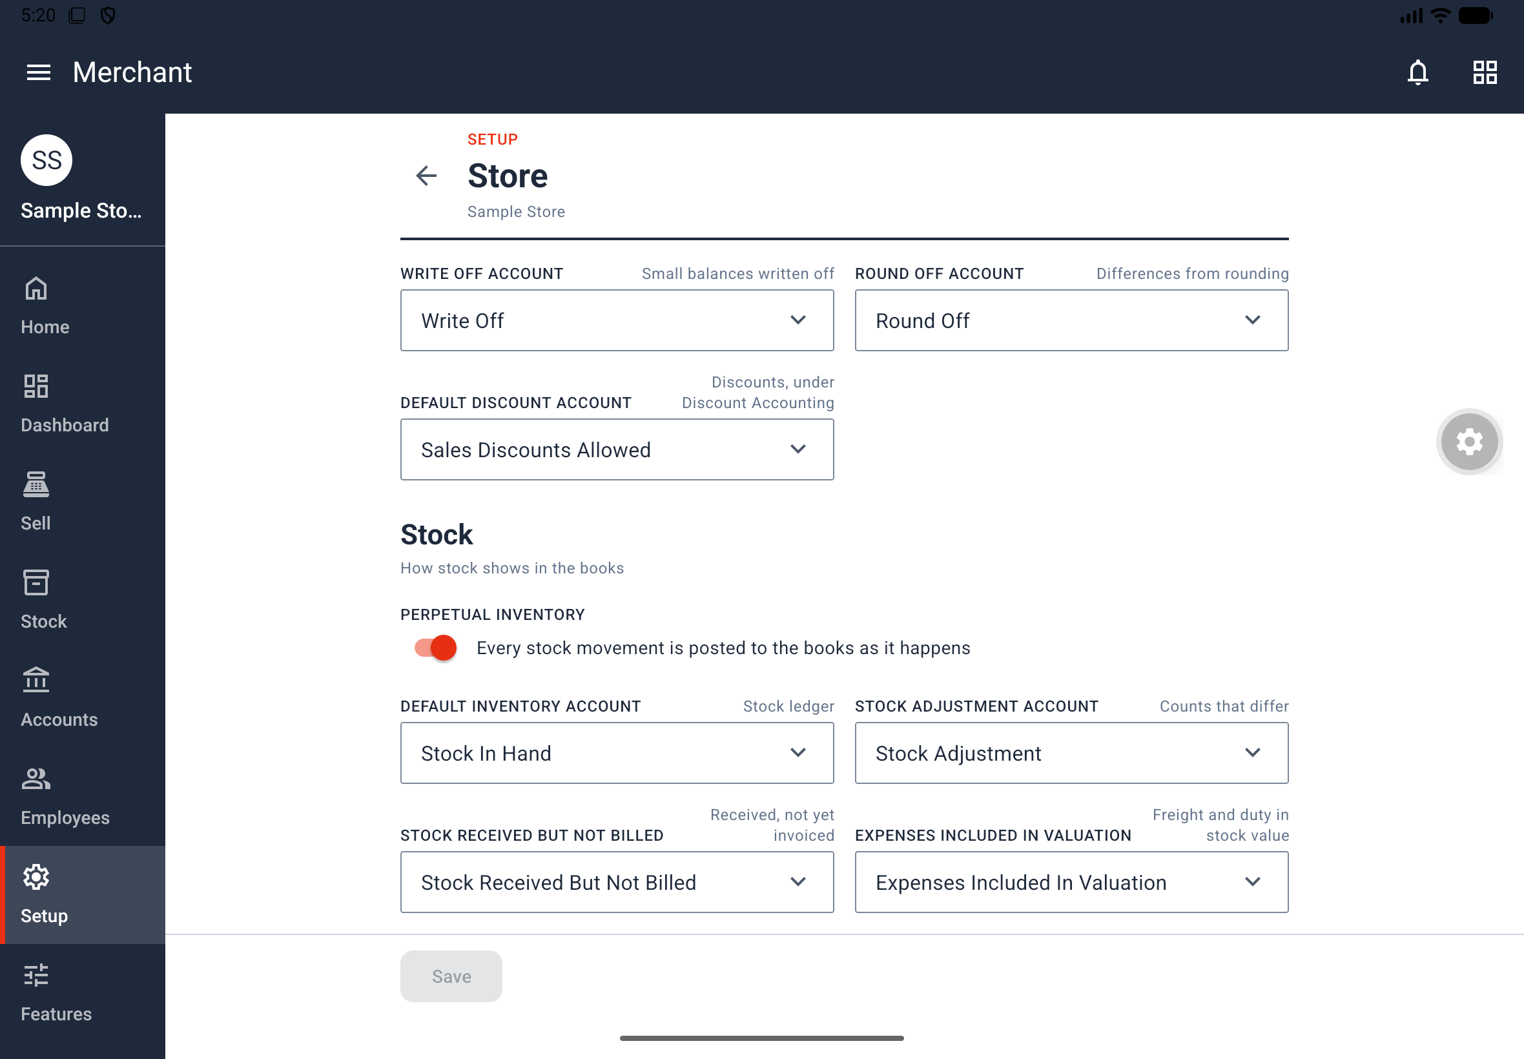
Figure 17. Store settings with fallback accounts and perpetual-inventory controls.
Validation: Default accounts must be enabled ledgers of the correct type; invalid selections prevent saving. An account used as a store default cannot be deleted. The source directs users to disable referenced accounts instead; recheck required defaults when adjusting account availability. Account and warehouse names have no store suffix, and the store has no abbreviation or cost center field.

9.2 Maintain fiscal years
Where: Setup > Store & Calendar > Fiscal Years.
1. Tap New Fiscal Year. The form starts with the next year.
2. Check the required YEAR NAME, YEAR START DATE and YEAR END DATE.
3. Enable SHORT YEAR only for a period shorter than twelve months.
4. Use DEFAULT to choose the default year, and DISABLED to control availability.
5. Tap Save, or Cancel to leave without saving. A saved record also has Delete.
Result: The list shows the year and dates, with DEFAULT, SHORT YEAR or DISABLED tags where applicable. Transaction posting dates must fall within an enabled fiscal year. The default year is the starting period for new transactions and reports.
Rules: A full year ends one day before the same date in the following year. Fiscal years cannot overlap, and only one can be the default. The .FY. naming-series part uses the fiscal year for today's date.

9.3 Control receipt totals with Global Defaults
Where: Setup > Defaults & Money > Global Defaults.
1. Review DEFAULT STORE, DEFAULT COUNTRY and DEFAULT CURRENCY. These are display values; change them on the Store page.
2. Turn DISABLE ROUNDED TOTAL or DISABLE IN WORDS on or off.
3. Tap Save.
Result: The switches control the receipt's Rounded Total line and amount in words, including relevant samples. Both switches initially start off.

9.4 Set time zone and number rules
Where: Setup > Defaults & Money > System Settings.
1. Select TIME ZONE, for example Asia/Manila. Set this before the first sale.
2. Select NUMBER FORMAT, for example 1,234,567.89.
3. Set FLOAT PRECISION for quantities and CURRENCY PRECISION for amounts.
4. Choose ROUNDING METHOD: Banker's Rounding or Commercial Rounding.
5. Tap Save. All five fields are required.
Result: The store uses these settings for today's date, number display and rounding. The time zone affects date components in naming series; precision and rounding affect currency displays and receipts.

9.5 Format the default currency
Where: Setup > Defaults & Money > Currency. The source's default-currency example is PHP.
1. Set SYMBOL, such as ₱, and choose which side of the amount it appears on.
2. Review FRACTION, such as Centavo, and FRACTION UNITS, such as 100.
3. Set SMALLEST CURRENCY FRACTION VALUE if needed, and choose NUMBER FORMAT.
4. Inspect SAMPLE RECEIPT TOTAL, which updates as you type and includes Grand Total, Rounded Total and the amount in words.
5. Tap Save.
Result: Currency formatting and amount-in-words presentation follow these values. The smallest currency fraction controls cash rounding; if it is empty, the rounded total is a whole amount. Global Defaults can hide the rounded total or amount in words.

10. Configure accounting, payments and taxes

10.1 Maintain the Chart of Accounts
Where: Setup > Accounting > Chart of Accounts. Use the applicable accounting setup permission or the owner account.
1. Open the appropriate root group: Application of Funds (Assets), Equity, Expenses, Income or Source of Funds (Liabilities).
2. Open the group that should contain the account and tap New Account.
3. Enter Account Name and, as needed, Account Number; choose Account Type and Parent Account.
4. Enable Is Group only when creating a folder rather than a posting ledger.
5. Tap Save.
Result: The account becomes available to relevant default-account fields and transactions. A parent must be a group. Use Edit Group for a group and Disabled on saved accounts as needed. Accounts used by defaults, payment modes or taxes cannot be deleted; the source directs disabling them instead.
On a tablet, each tree level uses ACCOUNT and DETAILS columns, folder icons and a path above the table. Store, payment, tax, warehouse, brand and item-group forms select accounts from this chart.

10.2 Control accounting behavior and frozen periods
Where: Setup > Accounting > Accounts Settings.
1. Review the switches in the table below.
2. If closing an accounting period, set ACCOUNTS FROZEN TILL.
3. Select ROLE ALLOWED PAST THE FROZEN DATE, or None.
4. Tap Save.
Setting | Documented starting value / purpose
IMMUTABLE LEDGER | On; cancellation creates reversing entries
UNLINK PAYMENT ON CANCELLATION | On; part of cancellation behavior
DELETE LEDGER ENTRIES WITH THE DOCUMENT | Off; part of document-deletion behavior
DISCOUNT ACCOUNTING | Off; when enabled, discounts post to their own accounts
TAXES FROM ITEM TAX TEMPLATES | On; controls use of item tax templates

Result: Posting on or before the frozen date is blocked except for the selected role. Deleting that role resets the exemption field to None. These settings affect accounting behavior, not just the visibility of ledger pages.

10.3 Add payment methods
Where: Setup > Payments > Modes of Payment.
1. Tap New Mode of Payment.
2. Enter Name and select Type: Cash, Bank, General or Phone.
3. Select Default Account and set Enabled.
4. Tap Save.
Result: The mode can be selected in POS Profiles and shown on sale payment lines. A Cash mode needs a Cash ledger; a Bank mode needs a Bank ledger.
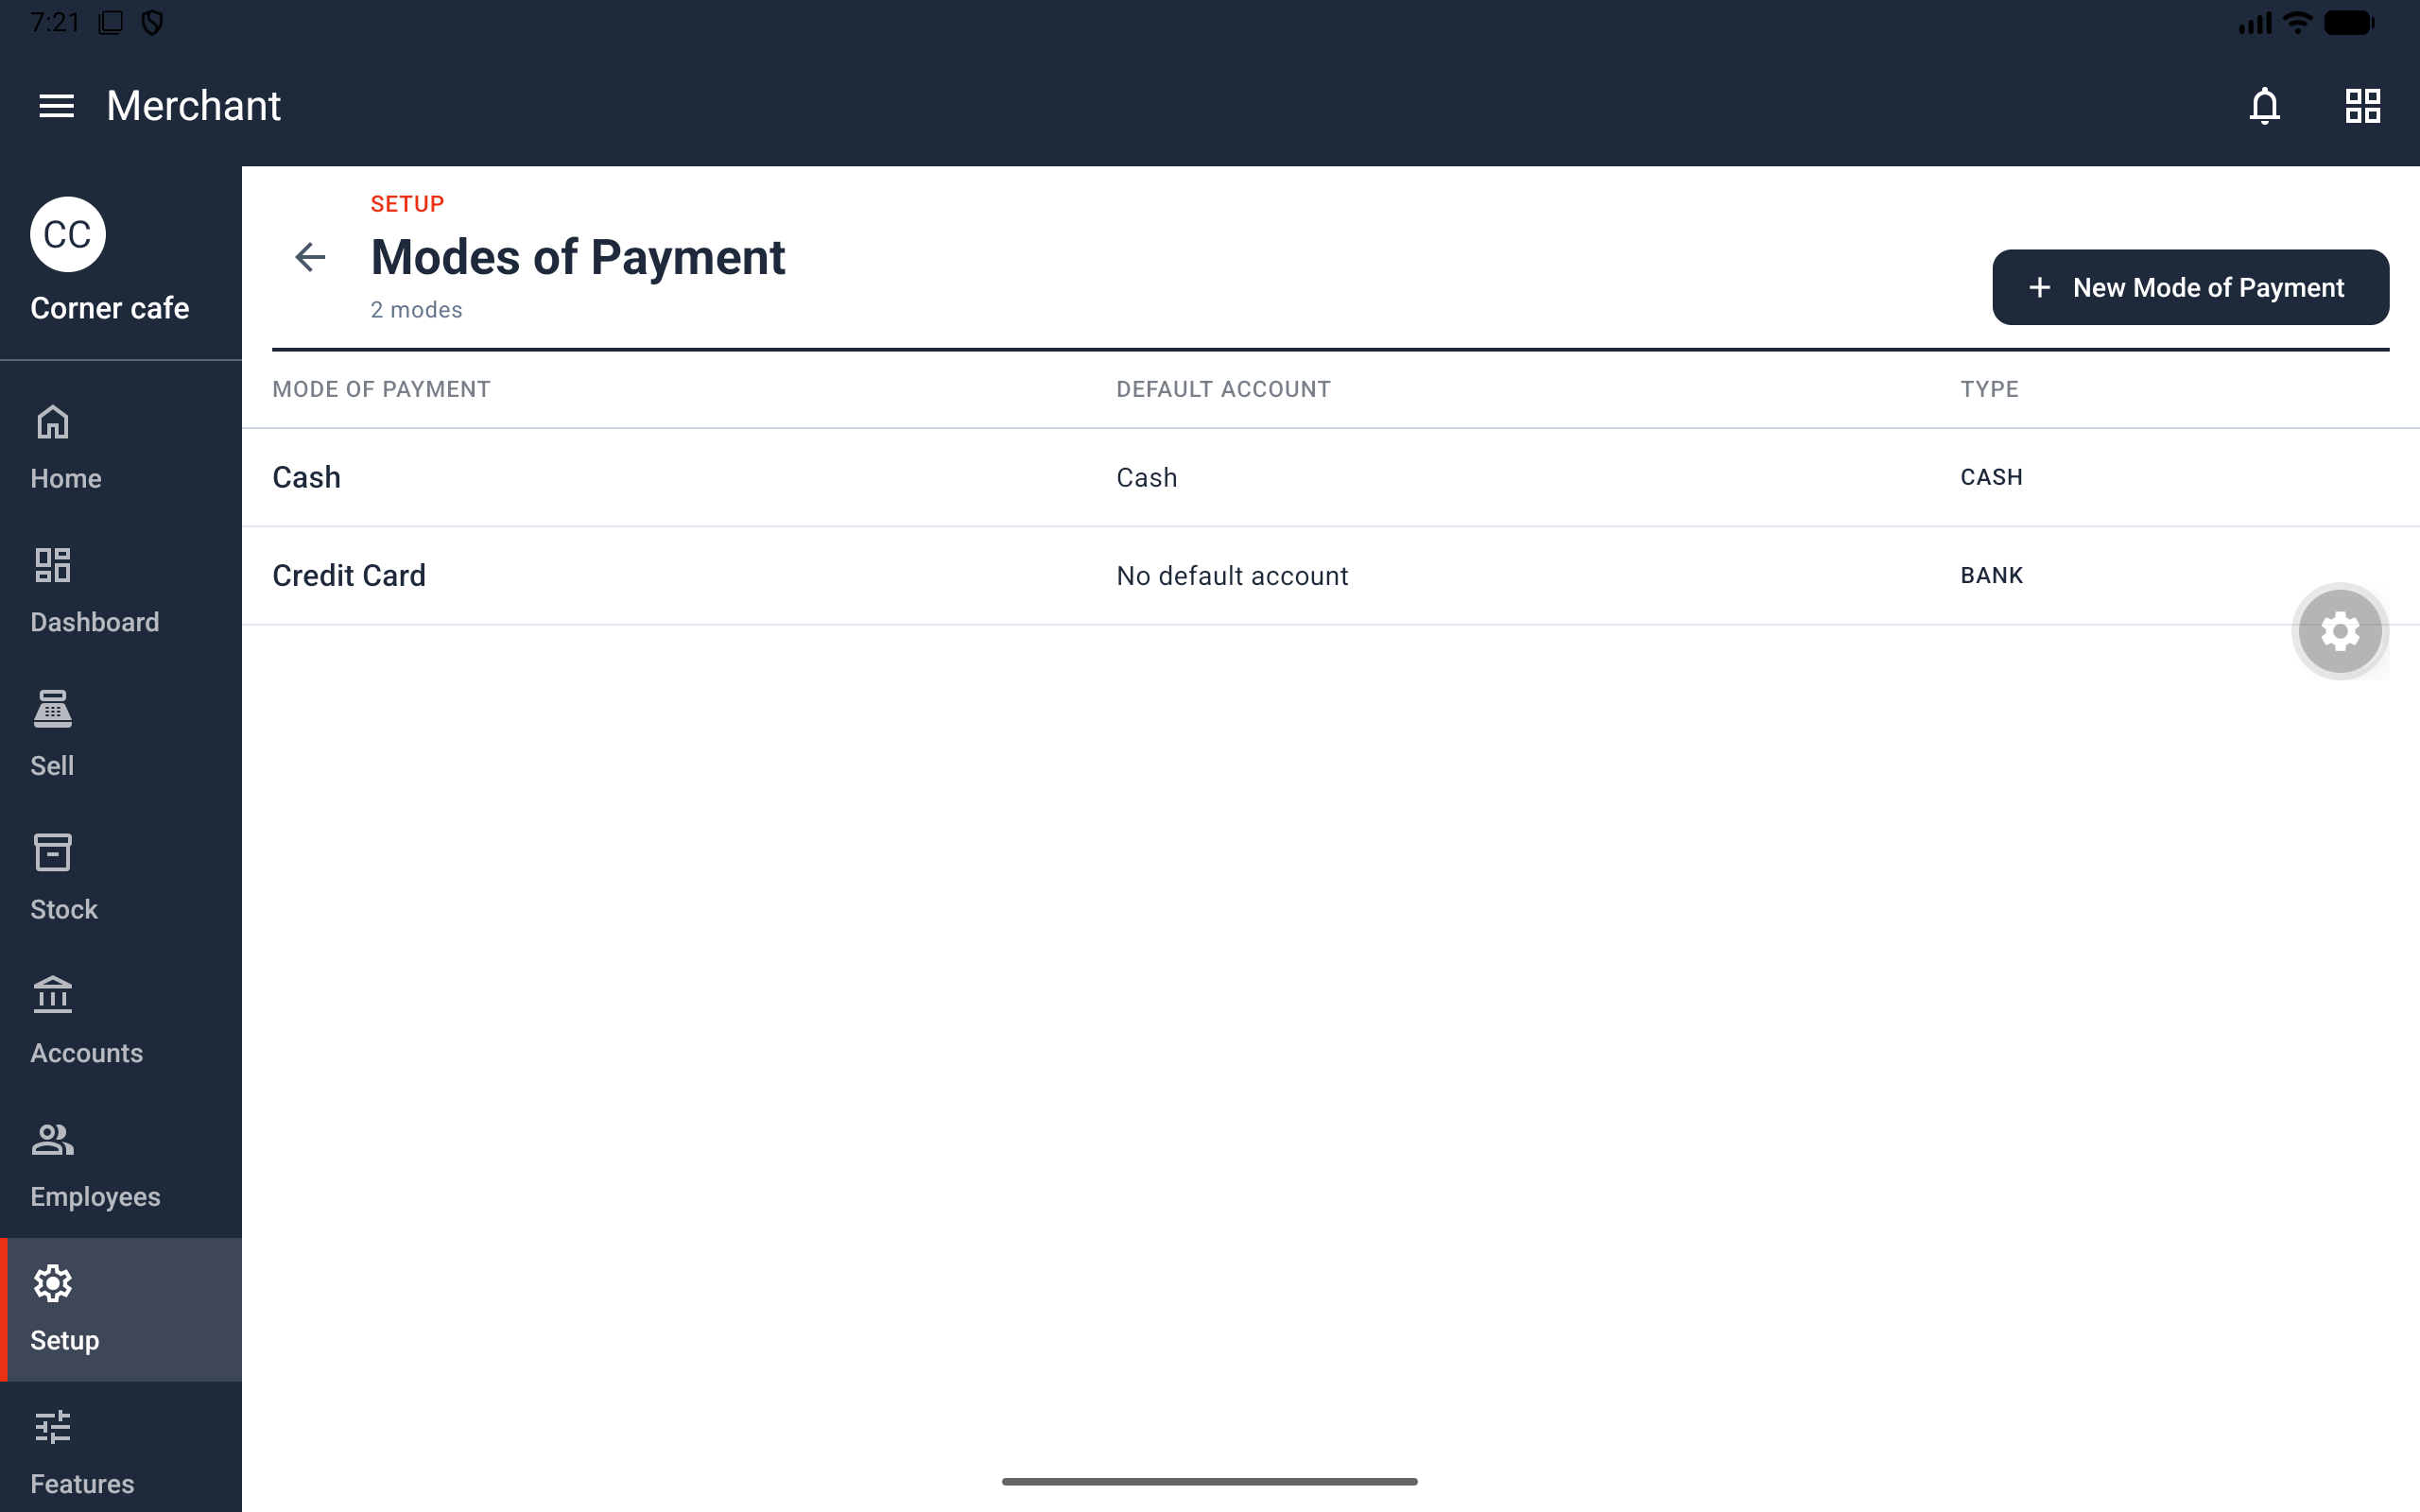
Figure 18. Modes of Payment list showing method, default account and type.
Defaults: A new store includes Cash linked to the Cash account, and Credit Card with type Bank but no account. Configure the missing account before using that mode in a POS Profile: profiles refuse payment methods with no account.

10.4 Create and check a sales tax template
Where: Setup > Taxes > Sales Taxes and Charges Templates. Who: Owner or Taxes.
1. Tap New Template and enter Title.
2. Select Tax Category as needed and review Default and Disabled.
3. Tap Add Row. Choose Type and Account Head, then enter the applicable Tax Rate and Description.
4. For a previous-row calculation, enter Reference Row #. Enable Is this Tax included in Basic Rate? when the price already includes the tax.
5. Tap Save.
6. From the list, tap Test Template. Choose the saved enabled template, enter Price and Quantity, and choose Item Tax Template if needed.
7. Review The sale gets: Net Rate, Net Total, tax rows, Total Taxes and Charges, Grand Total and Rounded Total.
Result: The template supplies sales tax rows and the ledger for each tax. Test Template is a separate calculator and saves nothing. On a phone it opens a page; on a tablet it opens a dialog. An invalid calculation shows an explanation instead of totals. There is no preview within the template editor; save before testing.
Row types: On Net Total, Actual, On Previous Row Amount, On Previous Row Total and On Item Quantity. Only one template is the default. A template referenced by a tax rule cannot be deleted.
Default records: The source describes a new store's Philippines Tax with a VAT @ 12 row, not selected as the default. These are documented app defaults, not advice about which tax treatment applies to a business.

10.5 Define item-specific tax rates
Where: Setup > Taxes > Item Tax Templates.
1. Tap New Item Tax Template and enter Title.
2. Add or edit rows using Tax and Tax Rate. Use Not Applicable when appropriate for that row.
3. Review Disabled and tap Save.
Result: Items or item groups can use the template to supply a different rate for a tax account, such as a zero rate. A tax account may appear only once in the template. The source describes an enabled initial Philippines Tax item template with VAT 12%. Select item templates in an item's or item group's Item Tax section.

10.6 Create tax categories
Where: Setup > Taxes > Tax Categories.
1. Tap New Tax Category.
2. Enter Title and set Disabled as needed.
3. Tap Save.
Result: The category names a tax treatment, such as Exempt or Zero Rated, for tax templates, Tax Rules and POS Profiles. A new store starts without categories. A category used by a template cannot be deleted.

10.7 Choose tax templates using rules
Where: Setup > Taxes > Tax Rules.
1. Tap New Tax Rule.
2. Choose Sales Taxes and Charges Template.
3. Set conditions with Tax Category, Item Group, From Date and To Date.
4. Enter Priority; 1 is highest. Tap Save.
5. Use Which Template? with a tax category, item group and sale date to inspect The sale takes, including the selected template and rule.
Result: A rule chooses a sale's template when the POS Profile does not name one. An empty condition matches every sale. More matching conditions take precedence, followed by priority and then the older rule. New stores start without tax rules.

11. Configure stock, selling and registers

11.1 Set up warehouses
Where: Setup > Stock > Warehouses. Who: Owner or Stock Setup for this and the other stock-setup pages in sections 11.2–11.7.
1. Open the parent group beneath All Warehouses. A new store has Stores under that root.
2. Tap New Warehouse.
3. Enter Warehouse Name, check Parent Warehouse, and select Account, or leave it at None to use the parent account.
4. Use Is Group for a folder and Disabled to control availability.
5. Tap Save.
Result: Items, POS Profiles and stock documents can select the warehouse. Rows show the stock account and its source. Without an applicable warehouse account, the store's DEFAULT INVENTORY ACCOUNT is the fallback. With Perpetual Inventory enabled, this account receives the stock value.
Restriction: A warehouse referenced by a brand, item group or Stock Settings cannot be deleted. Tablet navigation uses a tree table like the Chart of Accounts.

11.2 Define units of measure
Where: Setup > Stock > UOMs.
1. Tap New UOM.
2. Enter UOM Name.
3. Turn on Must Be Whole Number if fractional quantities must not be used. Set Enabled as needed.
4. Tap Save.
Result: The unit can be used as an item's stock or selling unit. The list identifies units as Whole numbers only or Fractions allowed. Initial units are Box, Centimeter, Gram, Hour, Kg, Litre, Meter, Millilitre, Nos, Pack, Pair, Set and Unit.

11.3 Convert between units
Where: Setup > Stock > UOM Conversion Factors.
1. Tap New Conversion.
2. Choose From UOM and To UOM.
3. Enter Value, then tap Save.
Result: Quantities can be converted between the units. The two units must differ and Value must be greater than zero. Initial examples are 1 Kg = 1000 Gram, 1 Litre = 1000 Millilitre and 1 Meter = 100 Centimeter. Use the displayed conversion sentence to check the direction before saving.

11.4 Create price lists
Where: Setup > Stock > Price Lists.
1. Tap New Price List.
2. Enter Price List Name and review Currency, Enabled and Price Not UOM Dependent.
3. Tap Save.
Result: The named list groups selling prices used by Item Prices, Selling Settings, brands and item groups. Create the actual item rates in Stock > Item Prices. The source's initial list is enabled Standard Selling in PHP. The source names Price Not UOM Dependent but does not give a detailed rule for its price calculations.

11.5 Create brands and their defaults
Where: Setup > Stock > Brands.
1. Tap New Brand.
2. Enter Brand Name and Description.
3. Select Default Warehouse, Default Price List and Default Income Account if needed.
4. Tap Save.
Result: Items can select the brand, and its defaults fill item defaults. New stores have no brands. Scan Product can recognize only brands already present in the store.

11.6 Organize item groups
Where: Setup > Stock > Item Groups.
1. Open the required parent under All Item Groups and tap New Item Group.
2. Enter Item Group Name, select Parent Item Group and set Is Group as appropriate.
3. Set Default Price List, Default Warehouse, Default Income Account and Default Expense Account as needed.
4. Tap Add Item Tax if the group needs item-tax rows.
5. Tap Save.
Result: Items can use the classification, defaults and tax rows. New stores include Products and Services beneath the root. A group referenced by Tax Rules or Stock Settings cannot be deleted. Tablets show each tree level in a table.

11.7 Set stock defaults and valuation
Where: Setup > Stock > Stock Settings.
1. Select ITEM NAMING BY, DEFAULT ITEM GROUP, DEFAULT STOCK UOM and DEFAULT WAREHOUSE.
2. Review DEFAULT VALUATION METHOD and the displayed FIFO/Moving Average example.
3. Set ALLOW NEGATIVE STOCK and AUTO INSERT PRICE LIST RATE IF MISSING as needed.
4. Tap Save.
Result: New items use the selected defaults, and the valuation method determines stock costing. The documented base defaults are Item Code, Products, Nos, Stores and FIFO, with both switches off. Store levels can change these defaults: Levels 1–2 use Naming Series; Level 1 enables negative stock.
Restriction: Once stock exists, the documented valuation-method change is only from FIFO to Moving Average. Review the in-app example before changing it. The source does not give a complete trigger rule for Auto Insert Price List Rate If Missing.

11.8 Configure selling prices
Where: Setup > Selling > Selling Settings. Who: Owner or Selling & Pricing, also used for Pricing Rules.
1. Choose DEFAULT PRICE LIST, initially Standard Selling.
2. Set USE PRICES FROM THE DEFAULT PRICE LIST AS FALLBACK.
3. Review ALLOW EDITING THE PRICE LIST RATE and VALIDATE SELLING PRICE.
4. Tap Save.
Result: These settings determine the sale's price source and permitted price editing. The three switches initially start off. Permission and profile restrictions still apply; enabling a setting does not grant Apply Discounts to a cashier.

11.9 Create automatic pricing rules
Where: Setup > Selling > Pricing Rules.
1. Tap New Pricing Rule and enter TITLE.
2. Set APPLY ON to Item Code, Item Group or Brand, and add the applicable Items.
3. Enter PRIORITY, where 1 is highest.
4. Set MIN QTY, MAX QTY, MIN AMT and MAX AMT as needed.
5. Tap Save.
Result: Matching rules provide automatic discounts to register lines. An item's own rule wins over an item-group rule, followed by a brand rule. New stores begin with no rules. The source does not enumerate discount-value fields for this form; use the actual form's supported controls without assuming an undocumented field or calculation.

11.10 Configure a POS Profile
Where: Setup > Point of Sale > POS Profiles. Who: Owner or POS Profiles.
1. Tap New POS Profile and enter POS PROFILE NAME.
2. Choose the required WAREHOUSE.
3. Review PRICE LIST, TAXES AND CHARGES, TAX CATEGORY, PRINT FORMAT and LETTER HEAD.
4. In Applicable for Users, add people if you want to restrict who may use the register. A profile listing one person permits only that person.
5. Tap Add Payment Method. Choose MODE OF PAYMENT, mark exactly one method as DEFAULT, and enable ALLOW IN RETURNS for methods usable for refunds.
6. Select Item Groups if the register should offer only those groups. Leaving the list empty offers every item, subject to other availability restrictions.
7. Review the accounting fields below and the profile's relevant receipt/discount settings where shown.
8. Tap Save.
Accounting field | Purpose in the profile
ACCOUNT FOR CHANGE AMOUNT | Account used for change
WRITE OFF ACCOUNT and WRITE OFF LIMIT | Account and limit for write-offs
INCOME ACCOUNT | Sales income account
EXPENSE ACCOUNT | Expense account
DISCOUNT ACCOUNT | Discount account

Result: The profile represents a register and is selected when opening a session. At least one payment row is required, exactly one must be default, and each method must have an account. Configure a missing account in Modes of Payment before saving.
Automatic versus manual setup: The source's basic POS Profiles section describes an empty list for a manually configured store. Its Store Levels section specifies Main Register creation at Levels 1–4 when none exists. For those levels, inspect or edit the existing profile rather than assuming every new store needs one created manually.

12. Set document numbers and receipt appearance

12.1 Configure document naming
Where: Setup > Naming & Printing > Document Naming Settings. Who: Owner or Naming & Printing, also used for the receipt pages below.
1. Open the row for the document you want to configure.
2. Edit its naming series, one per line, and tap Save.
3. To change a counter, tap Update Series, select the series and enter the value.
Result: The list displays each document's series and next name. Supported documents are Item, POS Closing Entry, POS Invoice, POS Opening Entry, Sales Invoice, Stock Entry and Stock Reconciliation. Naming series supply unique document numbers; the store time zone affects date parts, and .FY. uses today's fiscal year.
The source does not specify the full naming-series syntax or the final counter-update button label. Use the series controls shown in the app without assuming additional syntax.

12.2 Edit a receipt format
Where: Setup > Naming & Printing > Print Formats.
1. Open a format such as the default POS Receipt.
2. Review NAME, PAPER (58mm, 80mm or A4), PRINT HEADING, SHOW ITEM CODE and FOOTER NOTE.
3. Set DEFAULT and DISABLED as needed.
4. Review Sample receipt and tap Save.
Result: Receipts use the profile's format or the default. The initial POS Receipt uses 80mm paper. The sample is a made-up sale and is intended to help check the layout.
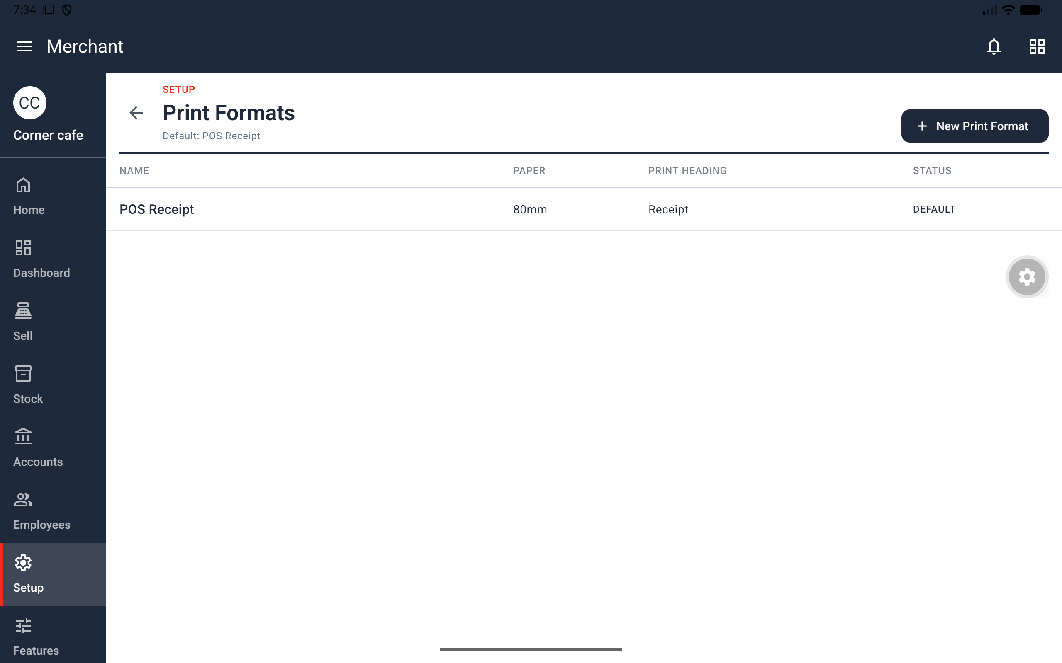
Figure 19. Print Formats list with POS Receipt selected as the default.

12.3 Create a letter head
Where: Setup > Naming & Printing > Letter Heads.
1. Tap New Letter Head.
2. Enter Name, a multiline Header and Footer.
3. Set Default Letter Head and Disabled as needed.
4. Tap Save.
Result: The letter head supplies the receipt's top and bottom text. The source describes an initial default named Sample Cafe; check that a real store's receipt wording is appropriate. Print Settings must have Print with Letterhead enabled for the default letter head to appear.

12.4 Choose receipt content
Where: Setup > Naming & Printing > Print Settings.
1. Set PRINT WITH LETTERHEAD, initially on.
2. Set COMPACT ITEM PRINT, initially on.
3. Set PRINT TAXES WITH ZERO AMOUNT, initially off.
4. Tap Save.
Result: The switches control receipt content. For rounded totals and the amount in words, use Global Defaults; for symbols and cash rounding, use Currency. POS Profiles can select the format and letter head used by their register.

13. Manage your account

13.1 Open Account and change appearance
Where: Account tab on a phone, or the account icon in the Home header on a tablet.
1. Open Account to see your photo, name and email.
2. Under Preferences, tap Dark Mode to switch the app between dark and light.
3. Under Security & Privacy, tap Privacy Policy or Terms of Service to read them. Back returns to Account.
Result: Dark Mode changes the whole app's appearance, and legal documents remain accessible after signing in. The Account section also lists Account Information and Your Businesses.
Current limitations: Themes is present but does nothing yet. The source lists Account Information and Your Businesses without describing their workflows. This manual does not invent editing controls for them.

13.2 Sign out or find account deletion
Account provides Sign Out and Delete account. Use Sign Out to leave the signed-in account and follow any prompts shown.
The source identifies Delete account but does not describe its confirmation steps or exact effects on owned stores and memberships. This manual therefore documents its location without presenting an unsupported deletion procedure. Store deletion is separately documented in section 2.3 and is explicitly irreversible.

14. Troubleshooting and reference

14.1 Common problems
Problem | What to check or do
A screen or page is missing | Confirm the open store, your permissions, its store level and your Features choices. Showing a page does not grant permission.
A newly admitted employee cannot work | The owner must assign a role in Employees. Admission through an access code does not assign one.
A permission changed unexpectedly with a role | Review individual exceptions and dependency switches. A new role preserves personal exceptions; Use the role's permissions restores role defaults.
There is no register to open | Inspect POS Profiles and Applicable for Users. Levels 1–4 add Main Register only when the store has no register.
POS Profile will not save | Add at least one payment method, select exactly one default, and ensure each method has an account. Credit Card initially has none.
Discount fields are absent | Check Apply Discounts and the profile's discount-editing allowance. The built-in Cashier lacks Apply Discounts.
A sale is refused for insufficient stock | Check Stock Balance and the actual Allow Negative Stock setting. Record a real delivery or count correction when appropriate. Level 1 enables negative stock.
An item is not found by the selling scanner | Verify its saved barcode or matching item code, the opened store and the Register's loaded items. The scanner uses loaded items when offline.
An item is not sold at this register | Check disabled status, profile item groups and out-of-stock hiding settings.
Repeated scanning adds the item only once | Remove the product from view for two seconds before scanning it again.
Camera access is blocked | Use Allow Camera or Open Settings and enable camera permission. Choose Photo remains available for label reading without camera permission.
No print found | Move the label closer, improve lighting or choose a clearer picture. Review filled fields before saving.
Another item already has this barcode | Search Items by barcode and use the correct existing item or correct the mistaken barcode. A store cannot have duplicate item barcodes.
An import fails | Correct every reported row, use CSV and keep the file within 500 items. Add barcodes separately; there is no Barcode column.
A posting date is refused | Check that an enabled fiscal year contains the date and that Accounts Frozen Till does not block it for the assigned role.
A return cannot proceed | Check Process Refunds, the required cashier's open session, returnable quantity and payment methods allowed for returns.
A sale cannot be voided | Check Void Transactions and whether the sale already has a return. A sale with a return cannot be voided.
A submitted stock entry cannot be edited or cancelled | Submitted entries cannot change. Receive Shipments permits submission, but cancellation requires Adjust Inventory.
A referenced setup record cannot be deleted | Review its references: defaults, payment modes, tax rules, templates, item groups or Stock Settings can prevent deletion. Account records can be disabled as documented.
A custom access-code date is refused | Choose a day that is not in the past. Expiry is midnight after the chosen day in the store time zone.
Access-code attempts are blocked | Ten wrong codes in 15 minutes cause a 15-minute block; wait for that block to end and check the owner's code.
Notifications or access changes are not immediate | The app checks while open every minute and again when opened. There are no lock-screen notifications yet.
A menu or level change has not saved offline | Features and level changes wait for a connection. Check the save state when connected.
A level change altered everyone's menu | This is documented behavior. Each person can customize their menu again in Features.
The receipt appearance differs | Check the POS Profile's print format and letter head, Print Settings, Global Defaults and Currency.
Themes does nothing | Themes is currently inactive. Use Dark Mode for the documented appearance switch.

14.2 What works offline
The source explicitly describes offline operation for Scan Product, Scan to Sell against items already loaded by the Register, and Store Guide. Features can open from its last saved copy offline, but saving menu choices or store-level changes waits for a connection.
These statements do not establish that every sale, stock transaction, sign-in or setup change works offline. The source does not provide a general offline transaction guarantee.

14.3 Glossary
Term | Meaning in this manual
Store | One business and its separate records, without branches
Store level | A preset menu and item-form complexity, with specified automatic setup
Feature visibility | A person's choice of which permitted screens/pages appear in a store menu
Role | A named set of permissions assigned to a person
Permission | Authorization to use a particular part of the application
Individual exception | A person's permission setting that differs from their role
POS / POS Profile | Point of sale / the configuration of a register
Session | One cashier's shift using a POS Profile
Item | A product or service sold by the store
UOM | Unit of measure, such as Nos, Kg or Box
Warehouse | A place where stock is held
Price list | A named collection of selling prices
Fiscal year | An enabled accounting period that contains posting dates
Ledger | A record of accounting entries or stock movements, depending on context
Voucher | The document referenced by a ledger entry
Valuation rate | The cost value per unit used in stock records
FIFO | First In, First Out, a stock valuation method
Moving Average | A stock valuation method using an average cost
Perpetual Inventory | The setting that posts stock movements to the books
Reconciliation | Setting book stock to an opening quantity or physical count
Naming series | A pattern and counter used to generate document identifiers
Letter head | Text placed at the top and bottom of receipts
Submitted | A saved transaction that has been formally posted; submitted stock documents cannot be edited

14.4 Source and coverage
This manual reorganizes all twenty-two sections of current-system-features.md into user workflows. Labels, defaults, restrictions and examples come from that source. Where a general statement has a more specific exception, the instructions include the exception—for example, Main Register creation and Level 1 negative stock.
Source section | Manual location
1. Store Creation Form | Chapter 2
2. Store & Calendar | Chapter 9
3. Defaults & Money | Chapter 9
4. Accounting | Chapter 10
5. Payments | Chapter 10
6. Taxes | Chapter 10
7. Stock setup | Chapter 11
8. Selling setup | Chapter 11
9. Point of Sale setup | Chapter 11
10. Employees and permissions | Chapter 7
11. Naming & Printing | Chapter 12
12. Stock operations and reports | Chapters 3 and 5
13. Sell | Chapter 4
14. Dashboard | Chapter 6
15. Accounts / General Ledger | Chapter 6
16. Side menu and Home | Chapters 1 and 8
17. Access Codes and Notifications | Chapter 7
18. Product Scan | Chapters 3 and 4
19. Features | Chapter 8
20. Store Levels | Chapters 2 and 3
21. Store Guide | Chapter 8
22. Home, Account and Sign-in | Chapters 1, 2 and 13

This is a source-based operating guide. The included tablet screenshots illustrate sample app screens and do not cover every permission, store level or transaction state. Procedures or behavior not established by the source are identified where relevant rather than filled in with assumptions.

