John Harold Arevalo
BSCS-4A
Activity 1:
input:
package erroranalysis;

public class Erroranalysis {
public static void main(String[] args) {
double sum = 0.1 + 0.2;
System.out.println("0.1 + 0.2 = " + sum);
}
}
Output:
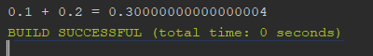
Discussion Questions
1. Why does the output differ from the expected value (0.3)?
- Because the decimal Computers store decimal numbers is binary (base2), not base 10.
2. How does the IEEE 754 standard contribute to this error?
- Because ieee 754 is the standard that define how computers store floating point numbers
3. What are some real-world consequences of floating-point errors?
- The consequence of floating points errors can lead to unexpected calculations like financials or Budget such as in company or store ex. You have budget allocated in that year that need an exact numbers but the money is already exact amount of all expenses because of decimals that budget can lead to errors and financial problems.

Activity 2:
Activity 2: Computing Absolute, Relative, and Percentage Errors
Input/Output:
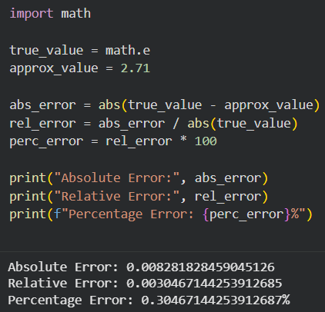
1. What happens to the relative error when the true value is very small?
As true values become super-duper small (like when it’s zero); the relative error blows up! Relative error is just a quotient: the absolute error divided by the true value. And small denominators do nothing but multiply any absolute error, even if it is tiny compared to your absolute error, into an enormous relative error. For instance, if your absolute error was .001, and your true value was .001, then your relative error would be (0.001 / 0.001) = 1.0 (or 100%) indicating complete inaccuracy. So for values approaching zero this type of error can be quite misleading.

2. How does error measurement help assess computational accuracy?
Error measurements will help you understand how good (accurate) your results actually are, and provide you with an objective (standardized) method to evaluate your errors. The absolute error tells you the actual amount of error in your result. This is helpful when the unit or tolerance you are working with is specific to the size of that unit or tolerance. The relative error and percentage error show you how the absolute error compares to other results — for example, when you are working with either value in excess of 1000, a difference of .008 might not matter; however, when you're working with either value in the range of 0 to 1, that same difference could be very significant. Collectively, the errors of absolute, relative and percentage errors can assist programmers/engineers in determining if their approximations are "good enough" for what they were designed, enabling them to limit the effects of floating point precision errors and contrasting the accuracy of different algorithms/numerical methods.
Activity 3:
Input:
import struct

def ieee754_conversion(number):
print(f"IEEE 754 Single-Precision Conversion of {number}")
print("=" * 55)

# Step 1: Sign Bit
sign = 0 if number >= 0 else 1
print(f"1. Sign: {'Positive' if sign == 0 else 'Negative'} → {sign}")

# Step 2: Convert to Binary
int_part = int(abs(number))
frac_part = abs(number) - int_part

# Integer part to binary
int_binary = bin(int_part)[2:]

# Fractional part to binary
frac_binary = ""
temp = frac_part
for _ in range(23):
temp *= 2
if temp >= 1:
frac_binary += "1"
temp -= 1
else:
frac_binary += "0"

full_binary = int_binary + "." + frac_binary
print(f"2. Binary: {number}₁₀ = {int_binary}.{frac_binary[:3]}₂")

# Step 3: Normalize
# Find position of first 1
dot_pos = len(int_binary) - 1 # exponent shift
normalized = int_binary[0] + "." + int_binary[1:] + frac_binary
print(f"3. Normalize: {int_binary}.{frac_binary[:3]} → "
f"1.{int_binary[1:]}{frac_binary[:3]} × 2^{dot_pos}")

# Step 4: Exponent
exponent = dot_pos + 127
exponent_binary = format(exponent, '08b')
print(f"4. Exponent: {dot_pos} + 127 = {exponent}₁₀ = {exponent_binary}₂")

# Step 5: Mantissa (23 bits)
mantissa_bits = (int_binary[1:] + frac_binary)[:23]
mantissa_bits = mantissa_bits.ljust(23, '0')
print(f"5. Mantissa: {int_binary[1:]}{frac_binary[:6]} (padded with zeros)")
print(f" → {mantissa_bits}")

# Step 6: Final IEEE 754 Result
print(f"\n6. Result:")
print(f" Sign | Exponent | Mantissa")
print(f" {sign} | {exponent_binary} | {mantissa_bits}")
print(f"\n Full: {sign} | {exponent_binary} | {mantissa_bits}")

# Verify using struct
packed = struct.pack('!f', number)
bits = ''.join(f'{byte:08b}' for byte in packed)
print(f"\n✅ Verified (struct): {bits[0]} | {bits[1:9]} | {bits[9:]}")

ieee754_conversion(172.625)
Output:
