John Harold B. Arevalo
BSCS 4A
Laboratory Activity 7:
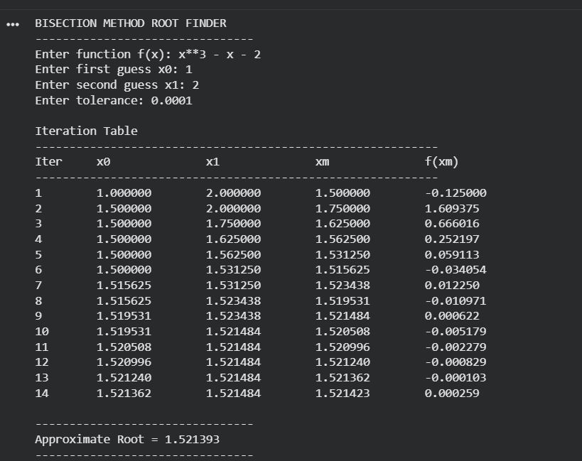
Guide Questions:
1. Compare the 4 methods of finding roots. Cite their differences.
- The Bisection method is a bracketing technique (bracketing method) that will repeatedly look to divide an interval in which a root occurs (i.e. repeatedly halve the interval). It has a high degree of reliability, but it has very slow convergence characteristics.
- The Regula Falsi method shares similar characteristics with the Bisection method, in addition to its use of a straight line joining two points rather than a halved interval. This aspect results in a slightly faster rate of convergence than the Bisection method.
- The Newton-Raphson method uses the derivative of the function to help predict where the root will be. If the initial estimate for the root was close to where the actual root is located, then this method converges very rapidly to this root. If the initial estimate is poor or has a zero derivative, then convergence may not occur.
- The Secant method operates in the same fashion as the Newton-Raphson method; however, it does not use the derivative of the function. Rather, it determines an approximate derivative using the two previously referenced estimate points. Consequently, when compared to the Bisection method, this method is faster than the Bisection method.
2. Why does the Secant Method converge faster than the Bisection Method in many cases?
Because it uses the slope to approximate the root using two points, the Secant Method converges more quickly than dividing an interval in half (Bisection method). This results in fewer iterations needed to achieve better estimates of the root.
3. What happens if the initial guesses are far from the root?
When the initial guesses are too far away from the root of the function, contributing factors are going to slow down the time it takes to come up with an approximation for a satisfactory solution. With certain methods, including Newton-Raphson or Secant methods, the initial guesses could also result in divergence and produce inaccurate roots.
4. Compare the number of iterations with the Newton–Raphson Method.
The Newton–Raphson Method usually requires fewer iterations compared to the Bisection Method because it uses derivative information to estimate the root more accurately. However, the Bisection Method is more stable and guaranteed to converge when the root is brack
5. Compare the result of manual computation and the result of your simulation.
Both the calculated values using the manual method and the simulation gave very similar outputs for the root calculated via the manual method, which was very close to 1.521, and the approximate value produced through the programmatic technique gave 1.521423. Due to its iterative nature, the simulation offers much more accurate approximations of the roots.

