@20

Intro
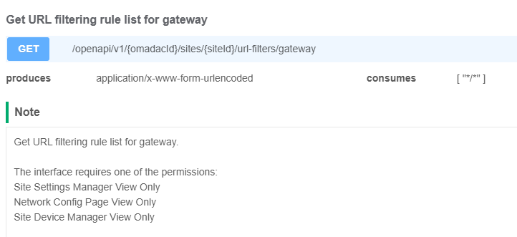
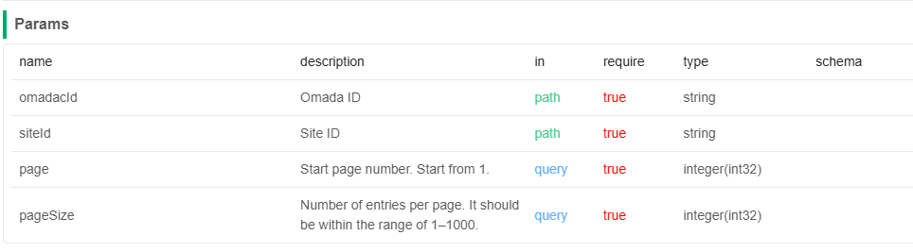
Response Params
name | Description | type | schema
errorCode |  | integer(int32) | integer(int32)
msg |  | string
result |  | UrlFilteringOpenApiGridVOQueryUrlFilteringOpenApiVO | UrlFilteringOpenApiGridVOQueryUrlFilteringOpenApiVO
totalRows | Total rows of all items. | integer(int64)
currentPage | Current page number. | integer(int32)
currentSize | Number of entries per page. | integer(int32)
data |  | array | QueryUrlFilteringOpenApiVO
id | ID of the URL filtering. | string
index | Index of the URL filtering. | integer(int32)
type | Type should be a value as follows: "gateway"; "ap". | string
name | Name should contain 1 to 64 characters. | string
status | Status of the URL filtering. | boolean
policy | Policy should be a value as follows: 0: drop; 1: allow. | integer(int32)
sourceType | Source type should be a value as follows: 0: network; 1: IP group; 2: SSID. | integer(int32)
sourceIds | Source IDs of the URL filtering. Network can be created using 'Create LAN network' interface, and network ID can be obtained from 'Get LAN network list' interface. IP group can be created using 'Create a new group profile' interface, and IP group ID can be obtained from 'Get group profile list' interface. SSID can be created using 'Create new SSID' interface, and SSID ID can be obtained from 'Get SSID list' interface. | array | string
mode | Mode should be a value as follows: 0: URL; 1: keyword. | integer(int32)
urls | URLs of the URL filtering, eg: www.google.com. | array | string
keywords | Keywords of the URL filtering. | array | string
filterMode | filterMode should be a value as follows: 0: URL; 1: category. | integer(int32)
scenarioMode | scenarioMode should be a value as follows:0: Custom 1: Family 2：Work 3：Education 4：Guest. | integer(int32)
categories | categories of the URL filtering, TreeMap> categories | object
timeRange | timeRange of the URL filtering, TimeSchedule | string
existKeyword | Whether this URL filtering is keyword mode. | boolean
existCategory | Whether this URL filtering is category mode. | boolean
existTimeSchedule | Whether this URL filtering contains time schedule setting. | boolean
supportKeyword | Whether keyword is supported of the URL filtering. | boolean
supportCategory | Whether category is supported of the URL filtering. | boolean
supportTimeSchedule | Whether time schedule is supported of the URL filtering. | boolean

Response Example

"scenarioMode": 0,
"categories": {},
"timeRange": "",
"existKeyword": true,
"existCategory": true,
"existTimeSchedule": true
}{
"errorCode": 0,
"msg": "",
"result": {
"totalRows": 0,
"currentPage": 0,
"currentSize": 0,
"data": [
{
"id": "",
"index": 0,
"type": "",
"name": "",
"status": true,
"policy": 0,
"sourceType": 0,
"sourceIds": [],
"mode": 0,
"urls": [],
"keywords": [],
"filterMode": 0,
],
"supportKeyword": true,
"supportCategory": true,
"supportTimeSchedule": true
}
}

