@22

Intro
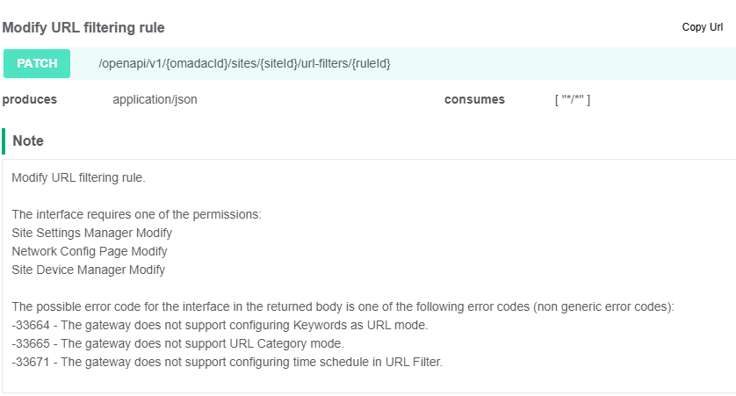

Example
{
"type": "",
"name": "",
"status": true,
"policy": 0,
"sourceType": 0,
"sourceIds": [],
"mode": 0,
"urls": [],
"keywords": [],
"filterMode": 0,
"scenarioMode": 0,
"categories": {},
"timeRange": ""
}

Parameter Recommendations
{
"type": "gateway",
"name": "", --REM User input
"status": true,
"policy": 0,
"sourceType": 2,
"sourceIds": [], --REM User input; SSID ID can be obtained from 'Get SSID list' interface.
"mode": 0,
"urls": [], --REM User Input
"keywords": [],
"filterMode": 0,
"scenarioMode": 0,
"categories": {},
"timeRange": ""
}
Params
Name | description | in | require | type | schema
omadacId | Omada ID | path | true | string
siteId | Site ID | path | true | string
ruleId | URL filtering rule ID | path | true | string
urlFilteringOpenApiVO | UrlFilteringOpenApiVO | body | true | UrlFilteringOpenApiVO | UrlFilteringOpenApiVO
Type | Type should be a value as follows: "gateway"; "ap". |  | true | string
Name | Name should contain 1 to 64 characters. |  | true | string
Status | Status of the URL filtering. |  | true | boolean
Policy | Policy should be a value as follows: 0: drop; 1: allow. |  | true | integer(int32)
sourceType | Source type should be a value as follows: 0: network; 1: IP group; 2: SSID. |  | true | integer(int32)
sourceIds | Source IDs of the URL filtering. Network can be created using 'Create LAN network' interface, and network ID can be obtained from 'Get LAN network list' interface. IP group can be created using 'Create a new group profile' interface, and IP group ID can be obtained from 'Get group profile list' interface. SSID can be created using 'Create new SSID' interface, and SSID ID can be obtained from 'Get SSID list' interface. |  | true | array | string
Mode | Mode should be a value as follows: 0: URL Path; 1: keywords(Only for gateway). |  | true | integer(int32)
Urls | URLs of the URL filtering, eg: www.google.com. |  | false | array | string
Keywords | Keywords of the URL filtering. |  | false | array | string
filterMode | filterMode should be a value as follows: 0: URL; 1: category. |  | true | integer(int32)
scenarioMode | scenarioMode should be a value as follows:0: Custom 1: Family 2：Work 3：Education 4：Guest. |  | false | integer(int32)
Categories | categories of the URL filtering, TreeMap> categories |  | false | object
timeRange | timeRange of the URL filtering, TimeSchedule |  | false | string

Response Params
Name | description | type | schema
errorCode |  | integer(int32) | integer(int32)
Msg |  | string

Response Example
{
"errorCode": 0,
"msg": ""
}

