# | Comment | Screenshot
1 | On the “Create WiFi Network” dialog, remove all the other parameters and just leave the “SSID Name” and the “Password”. The other parameters may be too technical for the targeted clients, so we just adopt the defaults in the background.  Also enable SSID Name validation to exclude anything related to UFO (containing substring “UFO”, “YOU”, “FOUR”, 4 , e.t.c. ) | 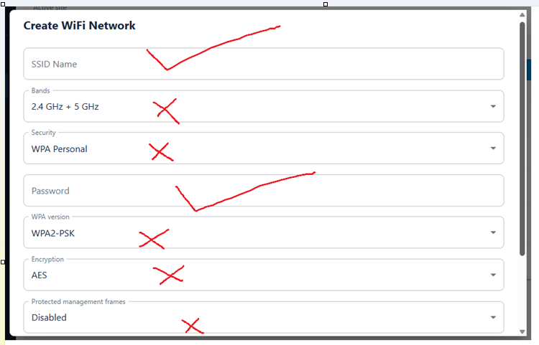  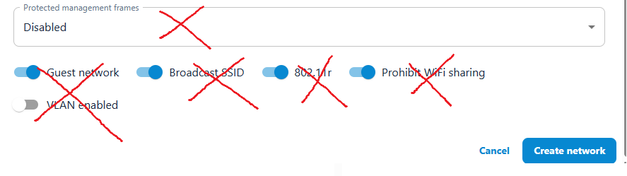
2 | On the Schedule Management screen, add a note stating that “Unassigned schedules will be automatically deleted after some time”. This will allow for external intervention on deleting schedules since we do not have an API call for that purpose.  Also enable Schedule Name validation to exclude anything related to UFO (containing substring “UFO”, “YOU”, “FOUR”, 4 , e.t.c. ) | 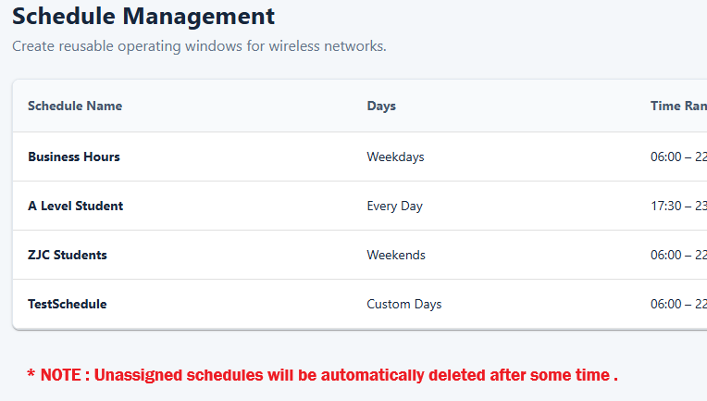
3 | On the “Create Voucher Portal” dialog, remove all the other parameters and just leave the “Portal Name” and the “Associated WiFi Networks”.  The other parameters may be too technical for the targeted clients, so we just adopt the defaults in the background.  Also enable Portal Name validation to exclude anything related to UFO (containing substring “UFO”, “YOU”, “FOUR”, 4 , e.t.c. ) | 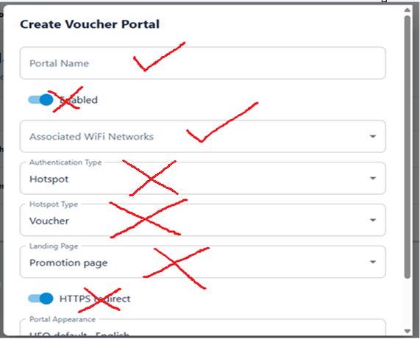  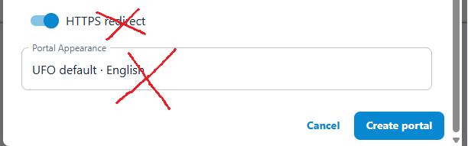
4 | On actions for Portal Management, the “Edit portal” option should invoke a dialogue box with:  - Edit Background  - Use default UFO background  - Upload a new background  - Edit Logo  - Do not use any Logo  - Use Default UFO Logo  - Upload a new Logo  Note: We may need a working session to test these Portal edits. | 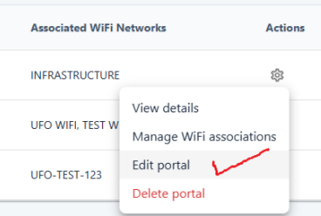
5 | On Voucher Management, we may need a working session to determine the appropriate information to display under the various columns. | 

