FPGA XADC Voltmeter: Basys 3
VHDL-based photoresistor voltage measurement, digital filtering, and real-time display
Project links: GitHub repository | Video demo
Overview
I designed and implemented a digital voltmeter on the Basys 3 FPGA board using the Artix-7 XADC to measure an analog voltage generated by a photoresistor voltage divider. The XADC produces a 12-bit sample that I process in VHDL, average over 16 samples to reduce small reading changes, convert into millivolts, and display in real time on the onboard four-digit seven-segment display. I also use the 16 onboard LEDs as a threshold-based visualization of the filtered ADC value. The filtered and unfiltered measurements were compared with a conventional digital multimeter to verify the design.
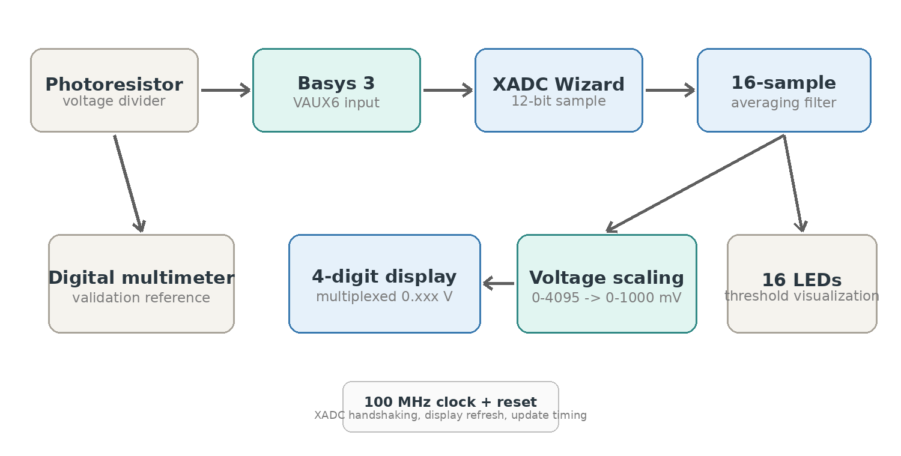
Architecture / Hardware
The analog input is built on a breadboard using a GL5528 photoresistor and resistors to form a voltage divider. The divider output is connected to the Basys 3 auxiliary analog input VAUX6. Inside the FPGA, the XADC Wizard provides the conversion interface, while the VHDL logic handles sample capture, filtering, scaling, LED thresholds, and display multiplexing.
Component | Details
FPGA board | Basys 3 with Xilinx Artix-7 XC7A35T and onboard XADC
Analog input | GL5528 photoresistor voltage divider connected to VAUX6
Passive parts | 10 kΩ and 1 kΩ resistors, breadboard, jumper wires
Reference instrument | Digital multimeter used to compare measured voltage
Development tools | VHDL, Vivado, XADC Wizard IP
Version control | Git / SourceTree with the project hosted on GitHub
Build Process
1. Analog Input Circuit
I built a photoresistor voltage divider on a breadboard so that changes in light level produce a changing analog voltage. This provided a simple real-world signal that could be measured by the Basys 3 XADC and independently checked with a digital multimeter.
2. XADC Configuration and Sample Capture
I instantiated the Vivado XADC Wizard and connected the auxiliary analog channel VAUX6. The design enables a read after end-of-conversion and waits for the data-ready signal before taking do_out(15 downto 4) as the 12-bit ADC sample. This keeps the VHDL logic synchronized with valid XADC conversions.
3. VHDL Structure and XADC Interface
The top-level entity defines the 100 MHz clock, reset, XADC differential input, 16 LEDs, seven-segment outputs, anodes, and decimal point. The component declaration and port map connect the generated XADC IP to the rest of the design.
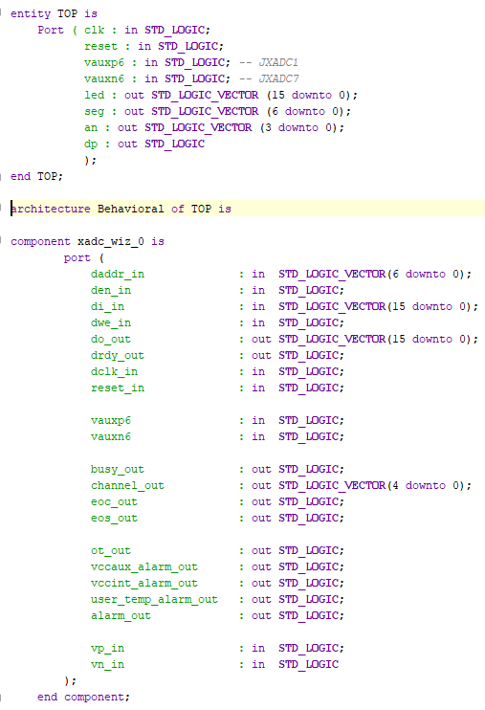  TOP entity and XADC component declaration | 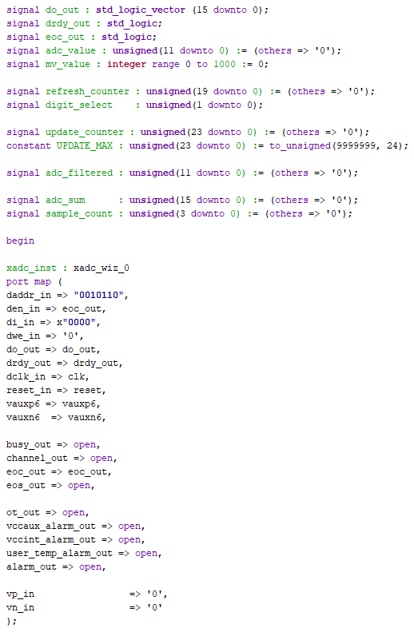  Internal signals and XADC Wizard port mapping
4. 16-Sample Averaging Filter
To make the displayed measurement more stable, I added a 16-sample averaging filter. Each new 12-bit sample is accumulated in a wider sum. After the sixteenth sample, the design divides the sum by 16 using a four-bit shift and stores the result in adc_filtered. The accumulator and sample counter are then reset for the next group of samples.
5. ADC Counts to Millivolts
The filtered ADC count is scaled from the XADC 0-4095 range into 0-1000 mV using mv_value <= ((to_integer(adc_filtered) * 1000) + 2047) / 4095. The +2047 term provides integer rounding before division so the displayed result is closer to the expected value.
6. LED Visualization and Seven-Segment Display
The 16 LEDs are driven by increasing thresholds based on adc_filtered, creating a quick visual indication of the measured level. A refresh counter multiplexes the four active-low display anodes, while digit-selection logic converts mv_value into decimal digits. The decimal point is placed so a value such as 340 mV is shown as 0.340 V.
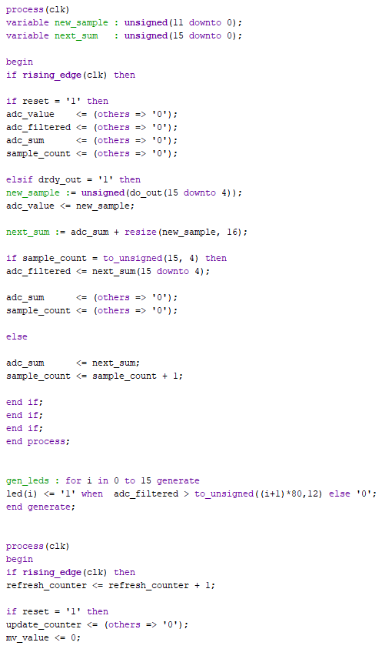  Sample accumulation, averaging filter, and LED generation | 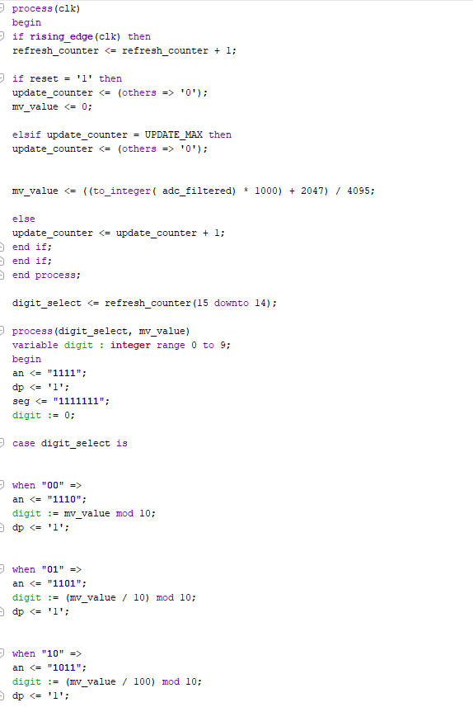  Millivolt update timing and seven-segment multiplexing
7. Constraints and Reproducible Project Setup
The XDC file assigns the Basys 3 pins for the clock, reset, analog input, LEDs, anodes, segments, and decimal point. The repository also includes a TCL project-creation script so the Vivado project can be recreated from the source files after cloning the repository.
Output Mapping / Constraints
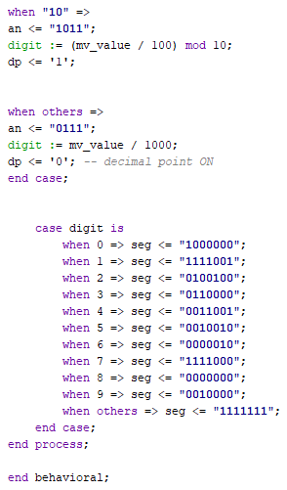  Digit-to-segment encoding and decimal-point placement | 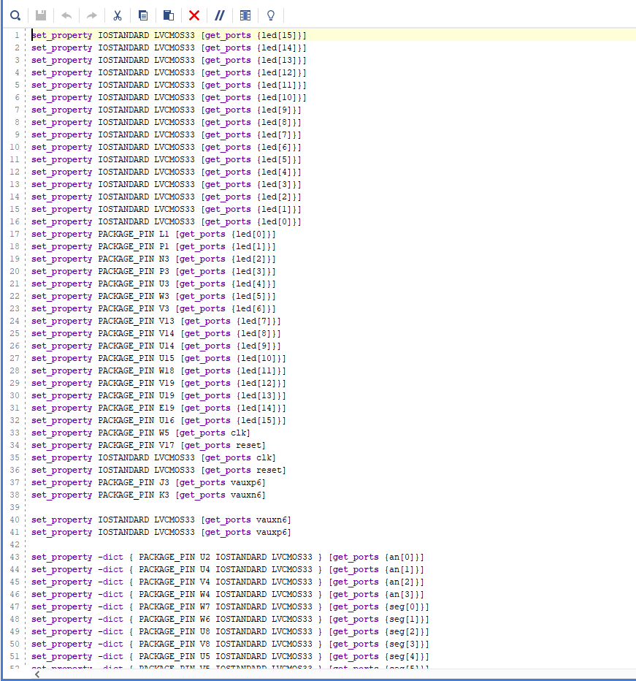  Vivado XDC pin assignments for LEDs, clock, reset, XADC, and display
8. Validation and Troubleshooting
The main challenge was turning a changing analog signal into a stable, readable measurement. The 16-sample average reduces visible jitter, while separate display-refresh and measurement-update timing keeps the four digits steady. I validated the FPGA reading against a digital multimeter and compared filtered versus unfiltered behavior in the project demo.
Key Skills Demonstrated
- VHDL RTL design and synchronous digital logic
- Xilinx Artix-7 XADC configuration and mixed-signal interfacing
- 12-bit ADC data handling, integer scaling, rounding, and digital filtering
- Multiplexed seven-segment display and LED output logic
- Vivado XDC constraints, pin mapping, and FPGA implementation
- Hardware validation using a breadboard circuit and digital multimeter
- Git / SourceTree project organization and reproducible Vivado setup
Lessons Learned
This project improved my understanding of how analog behavior appears inside digital hardware. I had to account for sensor noise, ADC resolution, numerical scaling, update rate, and display timing together. The averaging filter showed how simple digital signal processing can make a measurement system significantly easier to read.
Possible Next Steps
- Add gain/offset calibration using known voltages and the multimeter as a reference
- Make the averaging length selectable to trade filtering against response speed
- Stream raw and filtered samples over UART for plotting and data logging
- Add photoresistor light-level calibration and a VHDL testbench for the processing logic

