
REPUBLIC OF KENYA
MINISTRY OF ENVIRONMENT, CLIMATE CHANGE AND FORESTRY
STATE DEPARTMENT OF ENVIRONMENT AND CLIMATE CHANGE
KENYA METEOROLOGICAL DEPARTMENT
Dagoretti Corner, Ngong Road, P. O. Box 30259, 00100 GPO, Nairobi, Kenya
Telephone: 254 (0) 20 3867880-7, Fax: 254 (0) 20 3876955/3877373/3867888,
e-mail: director@meteo.go.ke, info@meteo.go.ke Website: http://www.meteo.go.ke

DAILY MARINE NEAR SHORE FORECAST FOR KENYAN COAST
Issued at: 1500 EAT on 02nd March, 2026
Valid: 0000 EAT on 03rd March, 2026 to 0000 EAT on 04th March, 2026.
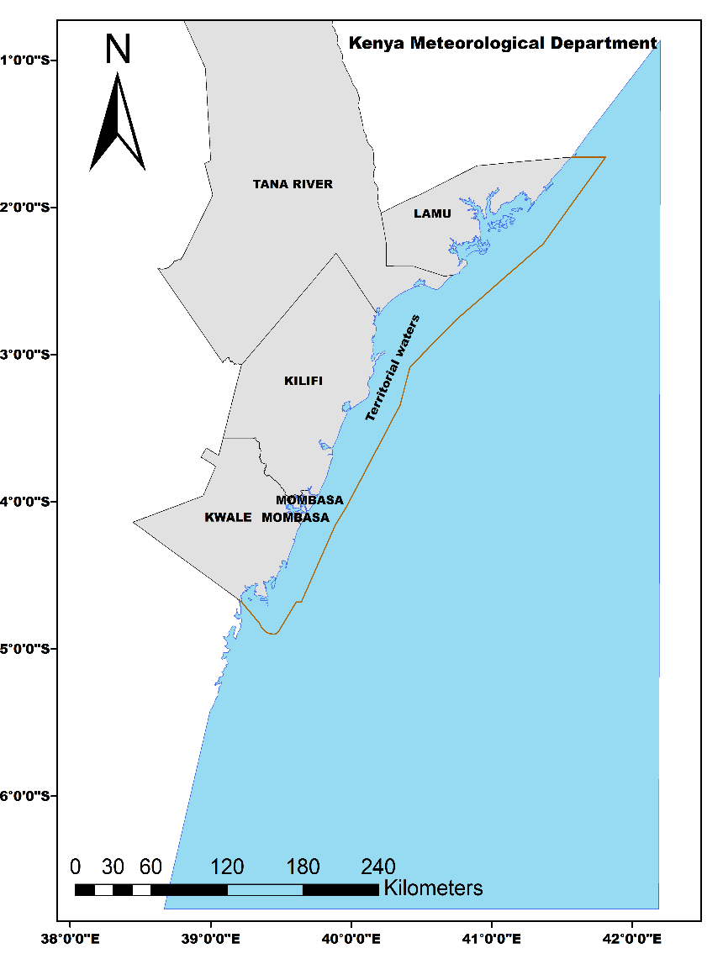 | GENERAL OUTLOOK  Morning sea state:  - Light and variable SSE to SSW winds (03-06knots) with smooth to slight chop seas. ENE to ESE waves of 1-2ft (0.3-0.6m) with very small short period waves of (6-9sec) are expected in Kwale, Mombasa, Kilifi and Lamu.  Afternoon sea state:  - Light to breezy E to SE winds (08-12knots) with slight chop to moderate choppy seas. ESE waves of 1-2ft (0.3-0.6m) with very small short period waves of (9 sec) are expected in Kwale, Mombasa, Kilifi and Lamu.  Visibility:  - Moderate visibility (9-10 km) expected in Kwale, Mombasa, Kilifi and Lamu.

COASTAL COUNTIES MARINE NEAR SHORE FORECAST

- KWALE
- Morning Winds: S 5 to 6 knots.
- Morning Waves: ENE 1 foot at 6 seconds.
- Morning sea state: Light S winds with a slight chop. Very small short period waves.
- Afternoon Winds: SE 8 to 10 knots.
- Afternoon Waves: ESE 1 foot at 9 seconds.
- Afternoon sea state: Light SE winds with a slight chop. Very small short period waves.
- Sunrise: 6:28AM and sunset: 6:40PM
- Visibility: Moderate (9-10 km)
- High Tide: 4:13AM;3.7m, 4:35PM;3.5m
- Low Tide: 10:28AM;0.2m, 10:37PM;0.2m

- MOMBASA
- Morning Winds: SSW 3 to 4 knots.
- Morning Waves: ESE 2 feet at 9 seconds.
- Morning sea state: Light and variable winds with smooth seas. Very small short period waves.
- Afternoon Winds: E 10 to 11 knots.
- Afternoon Waves: ESE 2 feet at 9 seconds.
- Afternoon sea state: Breezy SE winds with moderate choppy seas. Very small short period waves.
- Sunrise: 6:27AM and sunset: 6:38PM
- Visibility: Moderate (9-10 km)
- High Tide: 4:21AM;3.6m, 4:42PM;3.5m
- Low Tide: 10:32AM;0.3m, 10:42PM;0.3m

- KILIFI
- Morning Winds: SSW 5 to 6 knots.
- Morning Waves: ESE 2 feet at 9 seconds.
- Morning sea state: Light and variable winds with smooth seas. Very small short period waves.
- Afternoon Winds: SE 10 to 12 knots.
- Afternoon Waves: ESE 2 feet at 9 seconds.
- Afternoon sea state: Breezy SE winds with moderate choppy seas. Very small short period waves.
- Sunrise: 6:27AM and Sunset: 6:37PM
- Visibility: Moderate (9-10km)
- High Tide: 4:11AM;3.3m, 4:33PM;3.2m
- Low Tide: 10:23AM;0.1m, 10:34PM;0.1m

- LAMU
- Morning Winds: SSE 3 knots.
- Morning Waves: ESE 2 feet at 9 seconds.
- Morning sea state: Light and variable winds with smooth seas. Very small short period waves.
- Afternoon Winds: SE 9 to 11 knots
- Afternoon Waves: ESE 2 feet at 9 seconds.
- Afternoon sea state: Light SE winds with a slight chop. Very small short period waves
- Sunrise: 6:23AM and Sunset: 6:33PM
- Visibility: Moderate (9-10km)
- High Tide: 4:11AM;3.1m, 4:34PM;3m
- Low Tide: 10:25AM;0.1m, 10:35PM;0.1m

Advisory
- Slight sea conditions are expected with a significant wave height of 0.3-0.6m in Kwale, Mombasa, Kilifi and Lamu.
- Light to gentle breeze of 03-12knots expected in Kwale, Mombasa Kilifi and Lamu throughout the forecast period.

KEY ON SEA STATE
WAVE HEIGHT RANGE (Meters) | DESCRIPTION | IMPACT
0.6 – 1.0 m (≈ 1.8 – 3.0 ft) | Slight | Conditions suitable for Marine activities
1 – 1.9 m (≈ 3.0 – 5.7 ft) | Slight – Moderate
2.0 – 2.9 m (≈ 6.0 – 8.7 ft) | Moderate-Rough | Caution on operating marine activities
3.0 – 4.0 m (≈ 9.0 – 12.0 ft) | Rough | Warning in place!!!!  Warning in place and marine activities on hold
4.1 – 5.5 m (≈ 12.3 – 16.5 ft) | Very Rough

KEY ON SEA STATE
WIND | RANGE | DESCRIPTIONS | IMPACT
 | < 1 – 6 Knots | Calm to Light breeze | 1 – 6 knots, the Ocean is relatively calm with very little disturbance. Suitable for Marine operations
 | 7 – 21 Knots | Gentle breeze to Fresh breeze | 7 – 17 knots, small boats are likely to be filled with water sprays and become unstable. Caution in carrying out marine activities
 | 22 – ≥34 Knots | Strong breeze to Extremely Strong breeze | More than 21 knots, the ocean state is very much disturbed and the prevailing conditions are dangerous for marine operations. Warning in place!!!!!

In concurrence with outputs from relevant marine data platforms, acknowledgement is fully accorded to: ESSO- Indian National Centre for Ocean Information Services (INCOIS), mercator-ocean.fr, COPERNICUS Marine Environment Monitoring Service (CMEMS) and other related sources.

Mr. Kainga and Mr. Esibwe.
Duty Analysts
Marine Forecasting Services

For
DIRECTOR,
KENYA METEOROLOGICAL DEPARTMENT

