End Point | HTTP Method | Request Parameters | Return Object
signup | POST | - Username  - Email  - Password  - Repassword | {"error":false,"message":"Registered  successfully","userData":{"username":  "nisar_102","email":"nisarhussain007@gmail.com",  "password":"827ccb0eea8a706c4c34a16891f84e7b"}
login | POST | - Email  - Password | {"error":false,"user":{"username":"nisar_102",  "email":"nisarhussain@gmail.com",  "password":"827ccb0eea8a706c4c34a16891f84e7b"}}
profileupdate | POST | - user_id  - name  - about  - image | 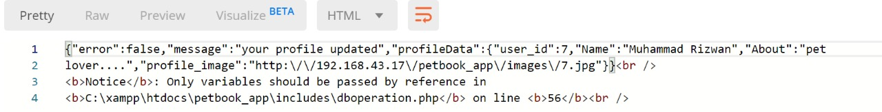
addnewpost | POST | - user_id  - description  - image | 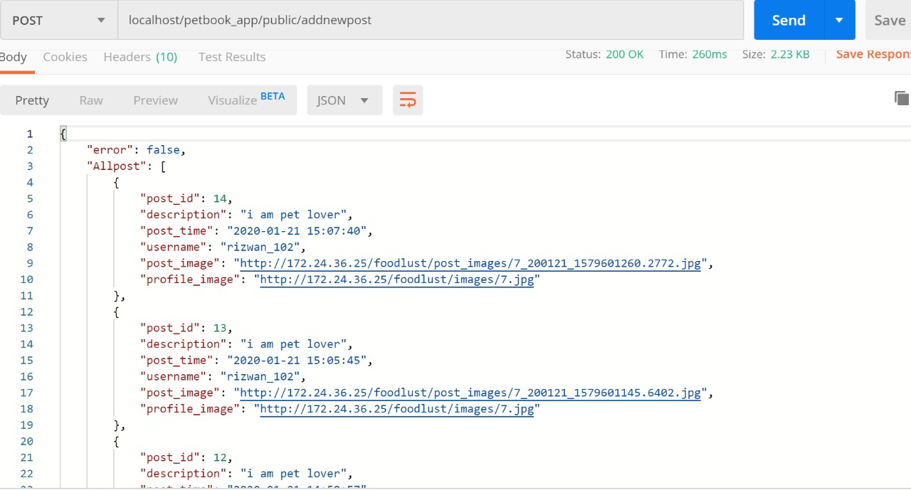
Base URL: https://localhost/petbook/public

PETBOOK
- Introduction
First of all, download files from GitHub and use following information for the web and android platform. You can clone API code from GitHub using below link. There is petbook.sql file in the folder that you download is our database file. Make a new database in xampp server and import this file in this database it will create required tables. login to GitHub with following credentials.
  - GitHub Login:
Username: codearmyteam
Password: codearmy@007
  - GitHub Link: https://github.com/teamcodearmy/petbook
  - BaseURL : https://localhost/petbook/public
--------------------------------------------------------------------------------------------------
- Endpoint: signup
  - HTTP Method: Post
  - Description: This end point is used to register user in our application by saving user data in our database by calling API
  - Request Parameters: There are four parameter required in the form of json object
    - Username
    - Email
    - Password
    - Repassword

  - Your json object look like:
{“username”:”value”,”email”:”value”,”password”:”value”,”repassword”:”value”}
  - Screen shorts of Jason object:
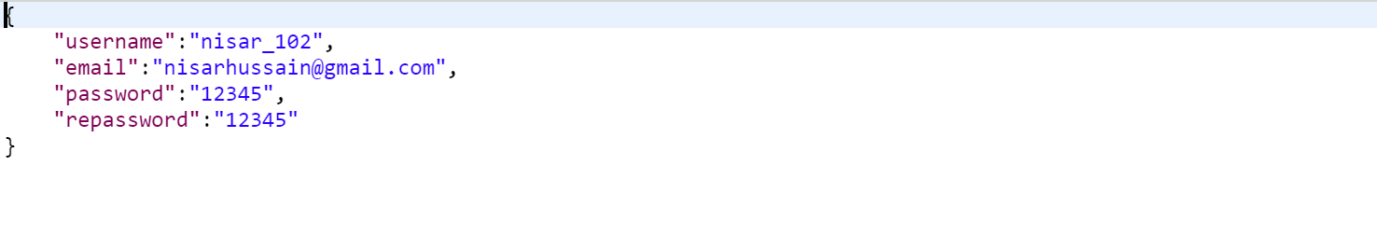
……………………………………………………………………………………….
- Endpoint: login
  - HTTP Method: Post
  - Description: This end point is used to login user in our application by authenticating user data from database.
  - Request Parameters: There are two parameter required in the form of json object
    - Email
    - Password
  - Your json object look like:
{”email”:”value”,”password”:”value” }
  - Screen shorts of Jason object:
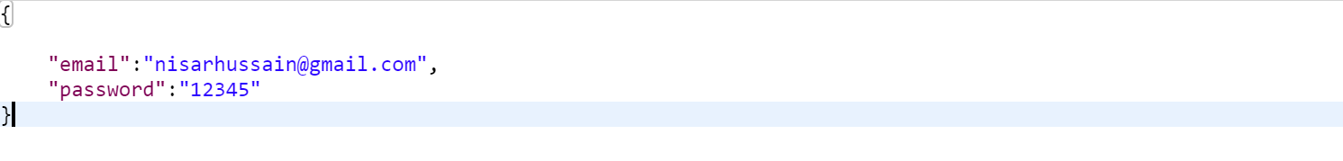
- Endpoint: profileupdate
  - HTTP Method: Post
  - Description: This end point is used to update profile.
  - Request Parameters: There are three parameter required in the form of json object.
    - user_id
    - name
    - about
    - image
  - Your json object look like:
  - Screen shorts of Jason object:
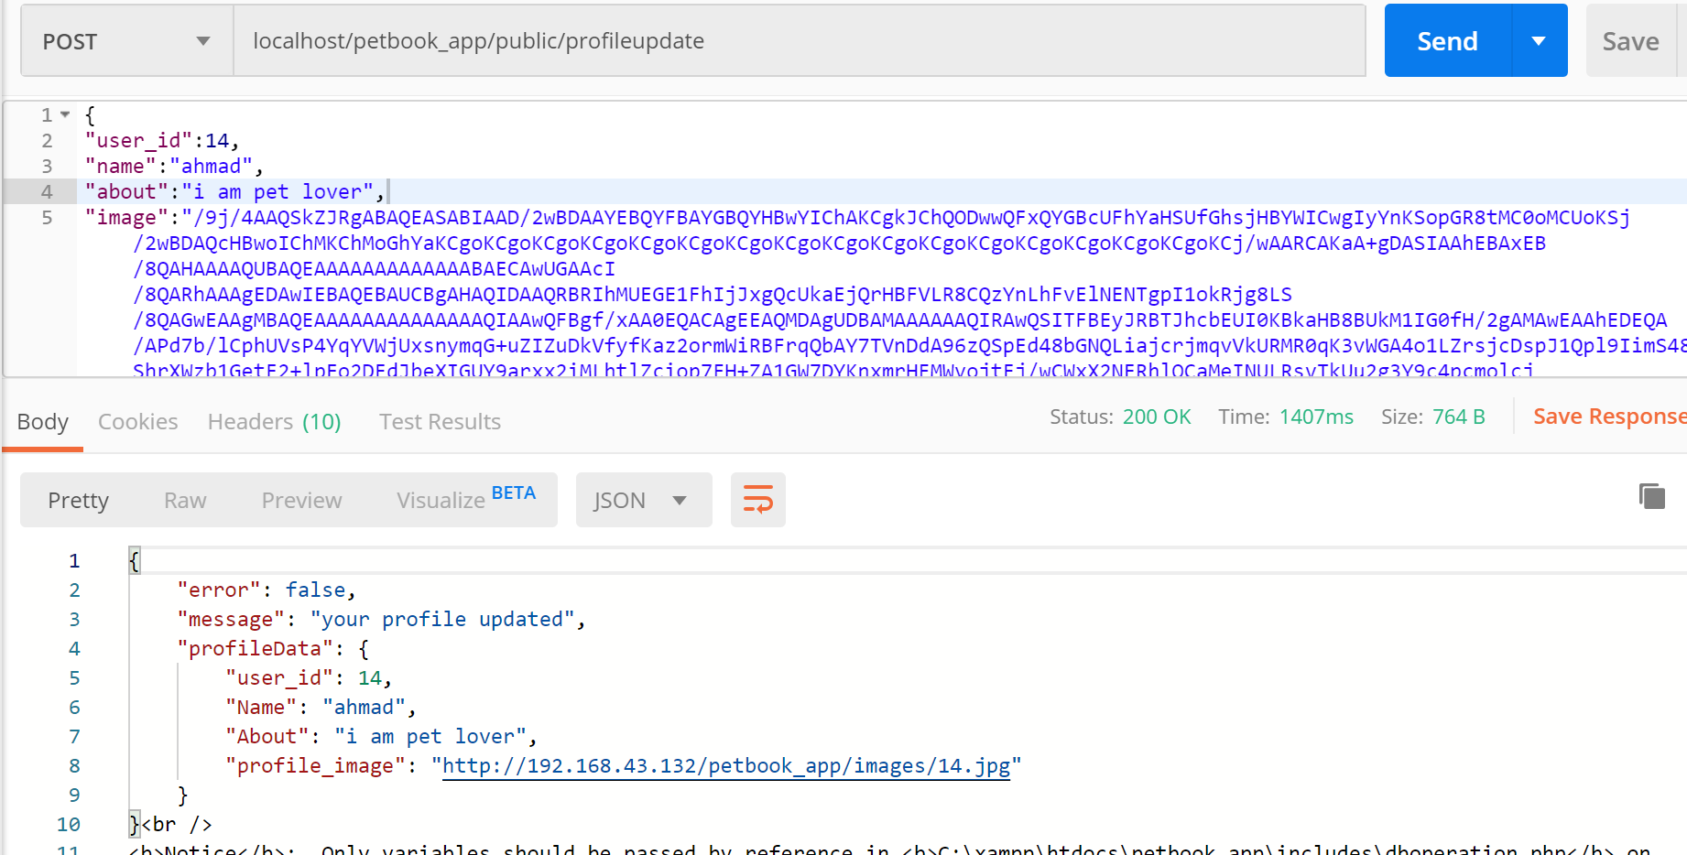
- Endpoint: addnewpost
  - HTTP Method: Post
  - Description: This end point is used for post.
  - Request Parameters: There are three parameter required in the form of json object.
    - user_id
    - description
    - image
  - Your json object look like:
  - Screen shorts of Jason object:
