DOCX Renderer Gap Checklist
Generated for Routa office-wasm DOCX preview comparison. Date: 2026-05-05. Reference sample: Microsoft Word rendering of the CAG Schedule 8 DOCX.
How to use: open this DOCX in Microsoft Word and in the Routa debug page. Compare the checklist first, then use the scenario pages as small visual smoke cases for page breaks, TOC-like leaders, footer text, heading rules, tables, bullets, and full-width imagery.

Current Status

Decoded protocol - stable
- Walnut-readable real-world DOCX JSON parity is green.
- Routa also handles several local files that Walnut rejects.
- Next action: add protocol fixtures only when a new corpus sample exposes concrete drift.

CAG reference layout - close, not pixel-perfect
- Covered: cover/full-width images, TOC entries, footer PAGE text, paragraph-mark color bug, and final contact page overlays.
- Remaining: late-page pagination is estimation-based; exact Word line/page layout is still not guaranteed.

Renderer tests - broad unit coverage
- Covered: section setup, headers/footers, columns, bullets/numbering, tables, image bboxes, chart references, and review markers.
- Remaining: focused e2e visual fixtures for page-flow and floating-object cases.

Prioritized Improvement Backlog

P0 - Word-like pagination estimator
- Why: most visible CAG drift comes from line height, paragraph spacing, heading rules, and orphan/widow behavior.
- Fixture: repeated Heading2 rules, short orphan paragraph, footer PAGE field.
- Implementation: keep heuristics bounded and fixture-backed; avoid document-specific hacks.

P0 - Floating object flow model
- Why: Word positions shapes/images with wrap, behind-doc, overlap, z-order, and distance-from-text rules.
- Fixture: inline, square wrap, top-bottom wrap, behind text, and full-width page anchor.
- Implementation: separate protocol extraction from visual flow decisions.

P1 - Table style visual inheritance
- Why: conditional table regions can change visible borders, fills, and merged-cell behavior.
- Fixture: first row, banded rows, merged cells, direct shading, and empty borders.

P1 - Chart fidelity
- Why: basic cached chart data renders, but Word-specific axes, legends, titles, and plot styling are shallow.
- Fixture: multi-series chart with legend, title, secondary axis, and data labels.

P1 - Header/footer variants
- Why: first-page, odd/even, inherited section footer, and overlay-hidden footer cases are easy to regress.
- Fixture: three-section DOCX with different first-page footer and inherited PAGE field.
Routa DOCX renderer gap checklist | page 1

Scenario Pages
These pages are intentionally small and synthetic. They are fast visual smoke inputs, not a replacement for the CAG reference document.

Scenario A - TOC-like Leaders
The following lines should resemble Word TOC entries: left title, dotted leader, right page number.
Thoughtworks approach to operations and maintenance ........................ 3
Service configuration ................................................... 16
Obsolescence management ................................................ 39

Scenario B - Heading Rules and Bullets
Heading2-like rules should not collapse into surrounding paragraphs. Bullets should stay indented and evenly spaced.
- Review and validate the service performance.
- Review service against current and future technology strategy.
- Identify service decommissioning requirements.

Scenario C - Compact Table
Section | Expected | Visual assertion
Obsolescence | Page 39 | Text remains dark, not paragraph-mark red.
Licence | Next page | Footer remains visible after section flow.
Contact | Final page | Contact block and full-width bottom image share one page.
Routa DOCX renderer gap checklist | page 2

Scenario D - Full-width Image Composition
This synthetic graphic approximates the CAG cover/final full-width airport image. It should span the content width cleanly and not introduce unexpected side margins.
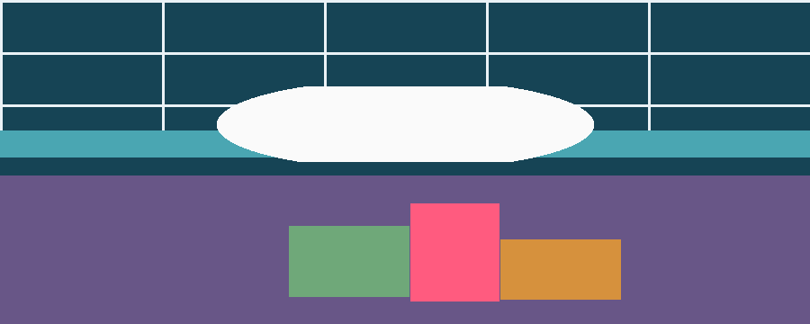

Scenario E - Orphan Paragraph
A short trailing paragraph should not become a blank-looking standalone page when there is enough practical room to keep it with the previous section flow.
Short trailing body paragraph for orphan-page checks.
Routa DOCX renderer gap checklist | page 3

