**Assignment 1**

**SEMISTER 3rd**

fall-2024

**SUBJECT**

Database Structures

**COURSE CODE**

CC210

**PROGRAMME**

BS (4 year)



**ABBOTTABAD UNIVERSITY OF SCIENCE AND TECHNOLGY ISLAMABAD**

**SUBMITTED TO**

**Mr. Jamal Abdul Ahad**

**SUBMITTED BY**

**Haroon Imran**

**STUDENT ROLL NO**

14723

**SUBMISSION DATE**

8 October 2024

**Exercise:1**

print("Hello, Python!")

**Exercise:2**

1. Declare variables of different data types:

age = 25 name = "Alice"

height = 5.9

is student = True

1. Write a program to convert Celsius to Fahrenheit:

celsius = 25

fahrenheit = (celsius * 9/5) + 32

print(f"{celsius}°C is {fahrenheit}°F")



1. Concatenate strings:

first name = "John

last_name = "Doe"

full_name = first_name + " " + last_name print(full_name)

**Exercise:3**

1. Write a program that takes a user's name and age as input and prints a greeting:

name = input("Enter your name: ")

age = input("Enter your age: ")

print(f"Hello {name}, you are {age} years old.")



1. Create a program to calculate the area of a rectangle:

length = float(input("Enter the length: "))

width = float(input("Enter the width: "))

area = length * width

print(f"The area of the rectangle is {area} square units.")



**Exercise:4**

1. Write a program that performs all basic arithmetic operations between two numbers.
2. num_1=23
3. num_2=2
4. operators=input("Choose basic operator  `+`, `-`, `*`, `/`, `//`, `%`, `**`  ")
5. if operators=="+":
6. print(num_1+num_2)
7. elif operators=="-":
8. print(num_1-num_2)
9. elif operators=="*":
10. print(num_1*num_2)
11. elif operators=="/":
12. print(num_1/num_2)
13. else:
14. print("choose correct operator")

**Output**

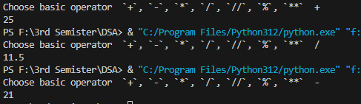

2.Write a program that checks if a number is even or odd

1. a = eval(input("Enter Any Number"))
2. if a % 2 == 0 :
3. print("The Numnber is Even")
4. else:
5. print("The Number is Odd")

**Output:**



3.Implement a simple calculator with addition, subtraction, multiplication, and division

num_1=input("Enter a first no ")

num_2=input("Enter a 2nd no ")

operators=input("Choose basic operator  `+`, `-`, `*`, `/`, `//`, `%`, `**`  ")

if operators=="+":

    print(num_1+num_2)

elif operators=="-":

    print(num_1-num_2)

elif operators=="*":

    print(num_1*num_2)

elif operators=="/":

    print(num_1/num_2)

else:

    print("choose correct operator")

**Output:**

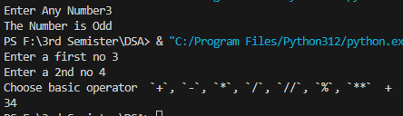

**Exercise:5**

1. Write a program that determines if a number is positive, negative, or zero.
2. a = int(input("Enter Any Integer"))
3. if a>=0:
4. print("The Number is Positive")
5. else:
6. print("The Number is Negative")

**Output:**



2. Create a program that checks if a year is a leap year.

year =int(input("Enter a year"))

if year%4==0 and (year%100!=0 or year%400==0):

    print(year,"it is a leap year")

else:

    print(year,"it is not a leap year")

**Output:**



3. Write a program to determine the largest of three numbers.

a=int(input("Enter Any Integer"))

b=int(input("Enter Any Integer"))

c=int(input("Enter Any Integer"))

if a>b and b>c:

    print("a is greater")

elif b>a and a>c:

    print("b is greater")

elif c>a and c>b:

    print("c is greater")

**Output:**

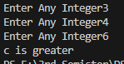

**Exercise:6**

1. Print the first 10 natural numbers using a `for` loop.
2. for i in range(1,11):
3. print(i)

**Output:**



2. Write a program to find the sum of numbers from 1 to `n` using a `while` loop.

i=1

sum=0

n=int(input("enter ending number"))

while(i<n):

    sum=i+sum

    print(sum)

    i+=1

**Output:**

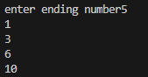

3. Print the multiplication table of a number given by the user.

n= int(input("Enter a number for table:"))

for i in range(1,11):

    print(n,"x",i,"=",i*10)

**Output:**

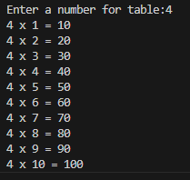

**Exercise:7**

1. Write a function to find the factorial of a number.
2. n=int(input("enter a num for fibonacci:"))
3. a=0
4. b=1
5. s=0
6. for x in range(n):
7. print(s,end=" ")
8. s=a+b
9. b=a
10. a=s

**Output:**



2. Create a function that checks if a number is prime.

n = 29 # Example number to check

if n < 2:

print(f"{n} is not a prime number")

else:

is_prime = True

for i in range(2, int(n ** 0.5) + 1):

if n % i == 0:

is_prime = False

break

if is_prime:

print(f"{n} is a prime number")

else:

print(f"{n} is not a prime number")

**Output:**



3. Write a function to calculate the sum of a list of numbers.

sum=0

numbers=[1,2,3,4,5,6]

for i in numbers:

    sum=sum+i

    print(sum)

**Output:**

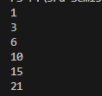

**Exercise:8**

1. Write a program to find the largest number in a list.

numbers = [10, 24, 36, 45, 12, 99, 54] # Example list

largest = numbers[0]

for num in numbers:

if num > largest:

largest = num

print(f"The largest number in the list is: {largest}")

**Output:**



**2. Convert a list to a set to remove duplicates.**

numbers = [10, 24, 36, 45, 12, 99, 54, 24, 36, 99]

unique_numbers = set(numbers)

print(unique_numbers)

**Output:**



**3. Write a program to count the frequency of each character in a string using a dictionary.**

text = "hello world"

char_count = {}

for char in text:

char_count[char] = char_count.get(char, 0) + 1

print(char_count)

**Output:**



**Exercise:9**

1. Write a program to read a text file and display its content.

filename = ' user_input.txt '

with open(filename, 'r') as file:

content = file.read()

print(content)

**Output:**



**2. Write a program that writes user input to a file.**

filename = 'user_input.txt'

with open(filename, 'w') as file:

user_input = input("Please enter some text: ")

file.write(user_input)

print(f"Your input has been written to {filename}.")

**Output:**



3. Create a program to count the number of lines, words, and characters in a file.

filename = 'user_input.txt'

with open(filename, 'r') as file:

    content = file.readlines()

line_count = len(content)

word_count = sum(len(line.split()) for line in content)

char_count = sum(len(line) for line in content)

print(f"Lines: {line_count}")

print(f"Words: {word_count}")

print(f"Characters: {char_count}")

**Output:**



**Exercise:10**

1. Define a class `Student` with attributes `name` and `age`, and a method `display` that prints the student's information.
2. class Student:
3. def __init__(self, name, age):
4. self.name = name
5. self.age = age
6. def display(self):
8. print(f"Name: {self.name}, Age: {self.age}")
9. student1 = Student("Alice", 20)
10. student1.display()

**Output:**



1. **Create a class `Circle` with methods to calculate area and circumference.**

class Circle:

def __init__(self, radius):

self.radius = radius

def area(self):

return 3.14 * self.radius ** 2

def circumference(self):

return 2 * 3.14 * self.radius

circle = Circle(5)

print("Area:", circle.area())

print("Circumference:", circle.circumference())

**Output:**



1. **Write a class `BankAccount` that supports deposit and withdrawal operations.**

class BankAccount:

def __init__(self, account_number, balance=0):

self.account_number = account_number

self.balance = balance

def deposit(self, amount):

if amount > 0:

self.balance += amount

print(f"Deposited: ${amount:.2f}")

else:

print("Deposit amount must be positive.")

def withdraw(self, amount):

if 0 < amount <= self.balance:

self.balance -= amount

print(f"Withdrew: ${amount:.2f}")

else:

print("Insufficient funds or invalid amount.")

def get_balance(self):

return self.balance

account = BankAccount("12345678")

account.deposit(100)

print("Current Balance:", account.get_balance())

account.withdraw(50)

print("Current Balance:", account.get_balance())

account.withdraw(100)

**Output:**

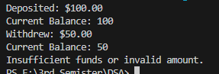

**Exercise:11**

1. Write a program that uses functions, loops, and conditionals to simulate a simple calculator with a user menu.
2. def calculator():
3. while True:
4. print("\nSimple Calculator")
5. print("1. Add")
6. print("2. Subtract")
7. print("3. Multiply")
8. print("4. Divide")
9. print("5. Exit")
11. choice = input("Select an operation (1-5): ")
12. if choice == '5':
13. print("Exiting the calculator. Goodbye!")
14. break
16. if choice in ['1', '2', '3', '4']:
17. num1 = float(input("Enter the first number: "))
18. num2 = float(input("Enter the second number: "))
20. if choice == '1':
21. print(num1, num2)
22. elif choice == '2':
23. print(num1, num2)
24. elif choice == '3':
25. print(num1, num2)
26. elif choice == '4':
27. print(num1, num2)
28. else:
29. print("Invalid input! Please select a valid option.")
30. calculator()

**Output:**

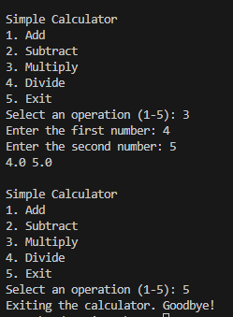

2. Write a program that reads data from a file, processes it, and writes the output to another file.

with open('user_input.txt', 'r') as infile, open('user_input.txt', 'w') as outfile:

    data = infile.read()

    outfile.write(data.upper())

print("Data processed and written to output.txt.")

**Output:**



3. Create a project to build a basic text-based game (e.g., number guessing game).

import random

def guess_number_game():

number = random.randint(1, 100)

attempts = 0

print("Welcome to the Number Guessing Game!")

print("Guess a number between 1 and 100.")

while True:

guess = int(input("Enter your guess: "))

attempts += 1

if guess < number:

print("Too low! Try again.")

elif guess > number:

print("Too high! Try again.")

else:

print(f"Congratulations! You guessed the number in {attempts} attempts.")

break

guess_number_game()

**Output:**

