Outline with figure assignments
OR Overtime paper (BMJ Quality & Safety)
Title: Where does operating-room overtime come from, and who pays for it? A 79,352-case analysis of one tertiary center

Structured abstract
- Objective. Characterize where operating-room overtime originates within a high-volume tertiary hospital and connect the operational pattern to published evidence on staff and patient harms.
- Design. Retrospective observational study of administrative Operating Room (OR) data.
- Setting. Campus Genk of the Ziekenhuis Oost-Limburg network, Belgium. A 24/7 tertiary hospital running 18 operating rooms across general, cardiac, and endoscopy blocks.
- Participants. 79,352 surgical and interventional procedures, January 2022 to May 2025.
- Main outcome measures. Case-level overtime flag and overtime minutes (time past the end of the case’s assigned shift), by room, weekday, shift, and urgency. Shift-transition displacement, start-time deviation, and duration-estimation accuracy as candidate mechanisms.
- Results. 7,729 cases (9.7%) ran past the end of their assigned shift, with a mean overtime of 60.3 min (among overtime cases) and P95 of 197 min. Overtime was concentrated in a small number of rooms: GO10 ran overtime in 32.9% of its cases (mean 154 min), while GO14 ran overtime in just 3.5% of its cases. 4,151 cases (5.2%) were displaced into a different shift than planned, with a mean start delay of 398.3 min and a mean duration 22.3 min shorter than planned, indicating upstream cascading rather than individual overruns. Urgent-elective overlap occurred on 68.8% of observation days, adding roughly 30 min to elective start times. First-case punctuality did not predict room-level overtime.
- Conclusion. Overtime at this center was concentrated, cascading, and driven by mid-day displacement. Room-level and cascading-focused metrics offer a more actionable target for quality improvement than utilization or first-case punctuality.

1. Introduction

1.1 Why overtime specifically
- Overtime is the binding economic cost in OR operations; overutilized time is approximately twice as expensive as underutilized time. [2].
- Staff harm. Overtime and long shifts are associated with poorer perceived quality of care and higher patient safety risk in a 12-country European nurse workforce study [3]. The companion study found that 12-hour shifts were associated with burnout and intent to leave [4]. The most recent direct evidence links mandatory overtime to intent to leave in a 2024 cross-sectional study of 264 South Korean nurses [5]. Both long shifts and overtime are associated with worse performance and well-being [23]; high workload and low decision latitude are established burnout predictors [24].
- Patient harm. After-hours surgery carries elevated mortality in a 2020 meta-analysis (adjusted OR 1.16, 95% CI 1.06–1.28, low-certainty evidence) [6], recently replicated in a 281,717-patient propensity-matched South Korean cohort, although the effect size (OR 3.58) has been challenged on residual-confounding grounds [7,26]. Each intraoperative anesthesia handover raises the odds of a major composite complication [8]. A 2025 UK national safety investigation (citing an MDU member survey of 481 doctors) named staff fatigue as a direct patient-safety problem [9]. Overtime hours above a breakpoint threshold were associated with a 2.09% increase in pressure ulcers across 70 US hospitals [10].
- Staff fatigue and handover transitions are the mechanisms that turn operational overtime into a clinical-safety problem.

1.2 The staffing-pyramid context
- At Campus Genk, 18 theatres run 08:00–16:30 (day shift). Staffing drops to 8 rooms during 16:30–17:30, then 4 rooms during 17:30–22:00, and a single overnight room with 3 on-call nurses.
- A case spilling past 16:30 is not merely late; it is competing for one of a sharply diminishing set of staffed rooms, covered by different staff than those who started the day.
- The staffing change at the shift boundary is what gives overtime its operational meaning at this site, rather than an arbitrary clock cut-off.

1.3 Research questions
- RQ1: How is overtime distributed across rooms and time within one tertiary center?
- RQ2: Which mechanism (late starts, individual case overruns, or mid-day cascading) accounts for most of the overtime minutes?
- RQ3: How do urgent cases interact with the elective program to produce spillover into staffed-down hours?

2. Methods

2.1 Setting
- Campus Genk, ZOL network, Belgium. Tertiary, >22,000 procedures/year.
- 18 surgical theatres, 7 interventional theatres, ambulatory anesthesia unit.
- 207 anaesthesiologists (including trainees, fellows). All surgeries except congenital cardiac and transplant.
- Staffing: 2–3 nurses per OR during the day shift, dropping per Figure 1. Weekends and bank holidays are covered by a back-up nurse rotation.

2.2 Data and inclusion
- Administrative OR data, 1 January 2022 – 31 May 2025. 79,352 cases at Genk.
- 60,895 unique patients, 195 surgeons, 207 anaesthesiologists, 18 distinct actual ORs, 1,276 distinct procedure names.
- Admission mix: 42.3% ambulatory (DAG), 57.7% inpatient (HOS).
- Time-stamp reliability disclosure: the hospital clinical team confirmed that room-in and room-out are the only reliable data points in the registration pipeline. All timing analyses use only room-in and room-out; induction, recovery, and ward-transfer marks are recorded but not used.

2.3 Variables
- Per Bauer et al. (2020) glossary [11]: planned duration, observed duration, planning deviation, scheduled start, actual start, start-time deviation, room-out time, overtime flag (room-out > assigned shift end), overtime minutes, planned room vs actual room (room-swap flag), urgency at planning (elective vs niet-electief), shift label (day 08:00–16:30; evening 16:30–22:00; night 22:00–08:00).
- The metric choice is justified by the heterogeneity of OR performance metrics documented in a recent systematic review [12] and the argument that aggregate utilization hides room-level reality [13].

2.4 Overtime definition
- Each case was assigned to one of three shift buckets based on its actual room-in time: day (08:00–16:30), evening (16:30–22:00), or night (22:00–08:00). A case was flagged as after-hours if its room-out time fell after the end of its assigned shift. Overtime minutes equal the difference between room-out and shift end, floored at zero. A day-shift case ending at 17:00 has 30 minutes of overtime; an evening-shift case ending at 23:00 has 60 minutes of overtime; a night-shift case ending at 09:00 has 60 minutes of overtime. Cases finishing within their assigned shift have zero overtime, irrespective of which shift that is.
- Chosen because the staffing change at each shift boundary is the operational event that gives overtime its meaning at this site. Aligns with Bauer 2020 [11].

2.5 Overlap definition
- An urgent case was deemed to overlap with an elective case when the urgent case’s actual room matched the elective case’s planned room and the urgent case’s actual time interval (room-in to room-out) overlapped with the elective case’s planned time interval (planned start to planned end). The day-level overlap metric counts the number of distinct calendar days on which at least one such overlap occurred. The case-level metric counts whether a given elective case’s planned slot was overlapped by an urgent case in the same room.

2.6 Analyses
- Case-level overtime rate, mean, median, P95. Distribution by room, weekday, year, shift. Room-level concentration is the primary analytic focus.
- Start-time deviation per case and per room. Duration deviation by planned-duration bucket via coefficient of variation [14,15]. Shift displacement: cases performed in a different shift than originally planned, with mean start delay and mean planning deviation.
- Urgency mix and timing. Urgent-elective overlap in the same OR (per day, per room, per month). Effect of overlap on elective start delay.
- Room swaps (0.7%) and idle time between cases (median 8 min) are reported as non-bottlenecks.

2.7 Ethics
- Institutional approval. Fully de-identified administrative data. No patient interaction.

3. Results

3.1 Sample and setting overview
- 79,352 cases, 60,895 unique patients, 195 surgeons, 207 anaesthesiologists, 18 ORs, 1276 procedure names.
- Weekday volume evenly distributed 17.9–20% Mon–Fri; weekends 1.8–2.1%.
- Year-on-year volume growth: 22,133 (2022) → 23,575 (2023) → 23,738 (2024) → 9,906 (2025 partial).
- Urgency mix: 85.4% elective, 14.6% non-elective.

3.2 Planning vs reality
- 45.7% of cases run longer than planned, 54.3% shorter. Mean overrun 22.6 min (median 14); mean underrun 21.2 min (median 12). The planning system is roughly unbiased on average; the dispersion is the problem.
- Coefficient of variation by planned-duration bucket: <30 min CV 0.61, 31–60 min CV 0.46, 61–90 min CV 0.36, 91–180 min CV 0.35, >180 min CV 0.42. Planning-deviation CV follows the same pattern but is more extreme: the>180 min bucket has a CV of 1.86.
- Mid-length cases (61–180 min) are most predictable. Very long cases carry the largest planning noise. This matters because the same complex cardiac and oncology procedures that drive planning variability are concentrated in the rooms with the most overtime.
- Weekend relative deviation is 23.1% (Saturday) and 23.7% (Sunday) vs 2.9–4.6% on weekdays. One sentence.
- Top deviation procedures: DEBULKING MET HIPEC (74.4 min), AVR (73.7), CABG OFF PUMP (60.4). These are the complex cardiac and oncology procedures concentrated in GO10.

3.3 Overtime: how often, where, when, how heavy
Headline numbers:
- 79,352 cases, 7,729 ran past the end of their assigned shift (9.7%). Mean overtime 60.3min (among overtime cases); median 39 min; P95 197 min.
Weekday pattern:
- Mon–Fri: 8.8–9.9% (Mon 9.8, Tue 9.6, Wed 9.5, Thu 8.8, Fri 9.9).
- Saturday 16.8%, Sunday 15.5%. Weekend rate roughly twice the weekday rate. Weekend volume is almost entirely non-elective.
Year trend:
- 2022 10% → 2023 10% → 2024 9.7% → 2025 (partial) 8.6%. Slow improvement, not a step change.
End-time distribution:
- Sharp peak immediately after 16:30 (~3,000 cases ending 16:30–17:30), rapid decay through 17:30–20:00, and a long, thin tail past 22:00. Most overtime cases land in the window when staffing has just dropped from 18 to 8 rooms.
Room-level concentration (the headline finding):
- GO10: 32.9% overtime, mean 154 min, P95 327 min. One in every three cases runs into after-hours. GO10 handles complex cardiac surgery (CABG, aortic valve replacement, mitral valve repair, MIDCAB, mini-maze ablation).
- Tier 2 (GO08–GO13): 11–16%.
- GO14 lowest at 3.5%. The within-campus spread (3.5–32.9%) exceeds the between-campus spread across the entire ZOL network (Lanaken: 0.5%, Maaseik: 2.8%, Cathlab: 5.8%, Genk: 9.7%).
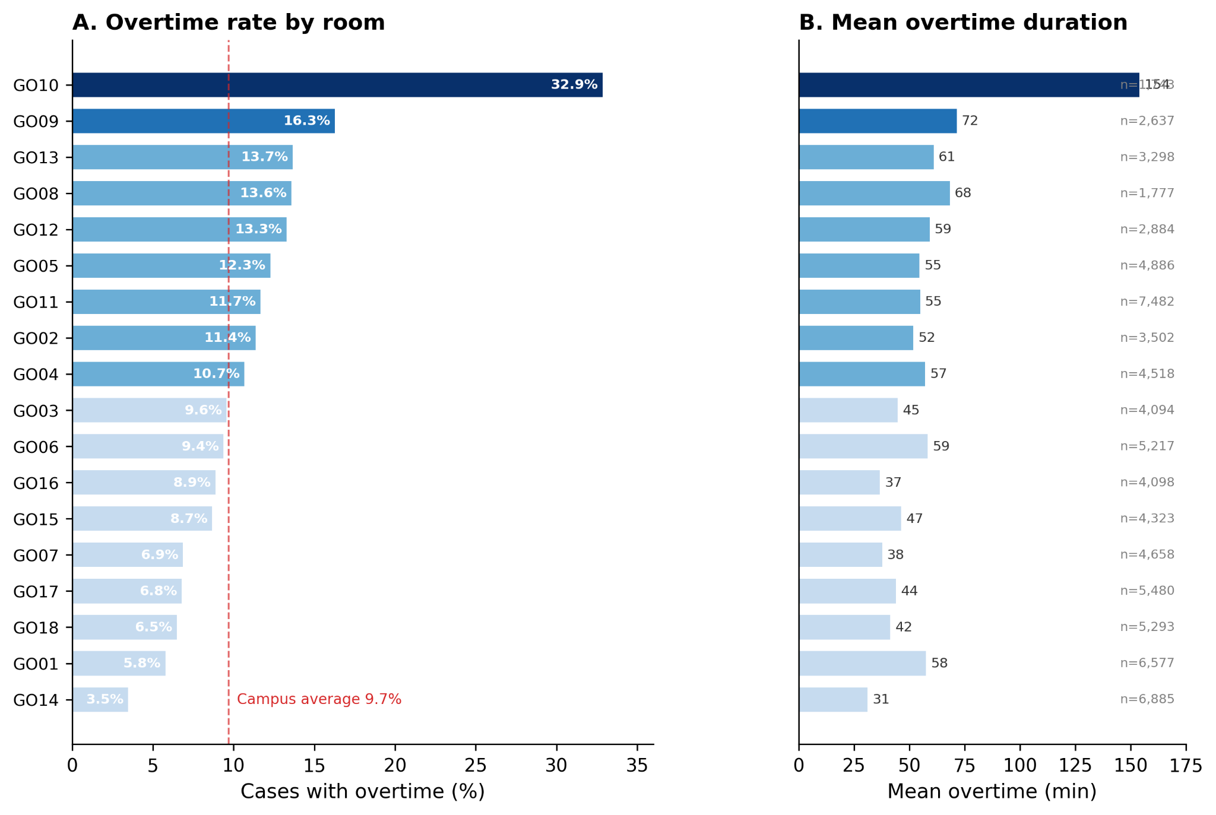
Figure 2
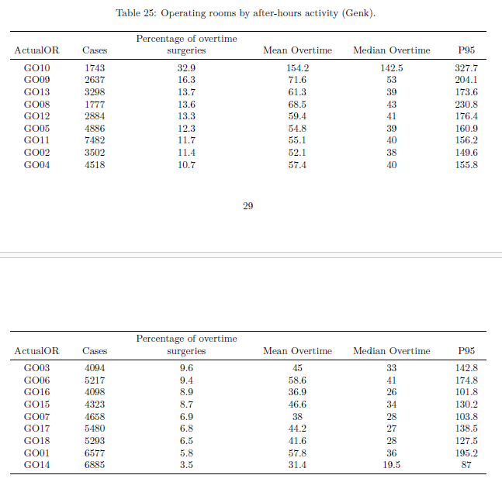

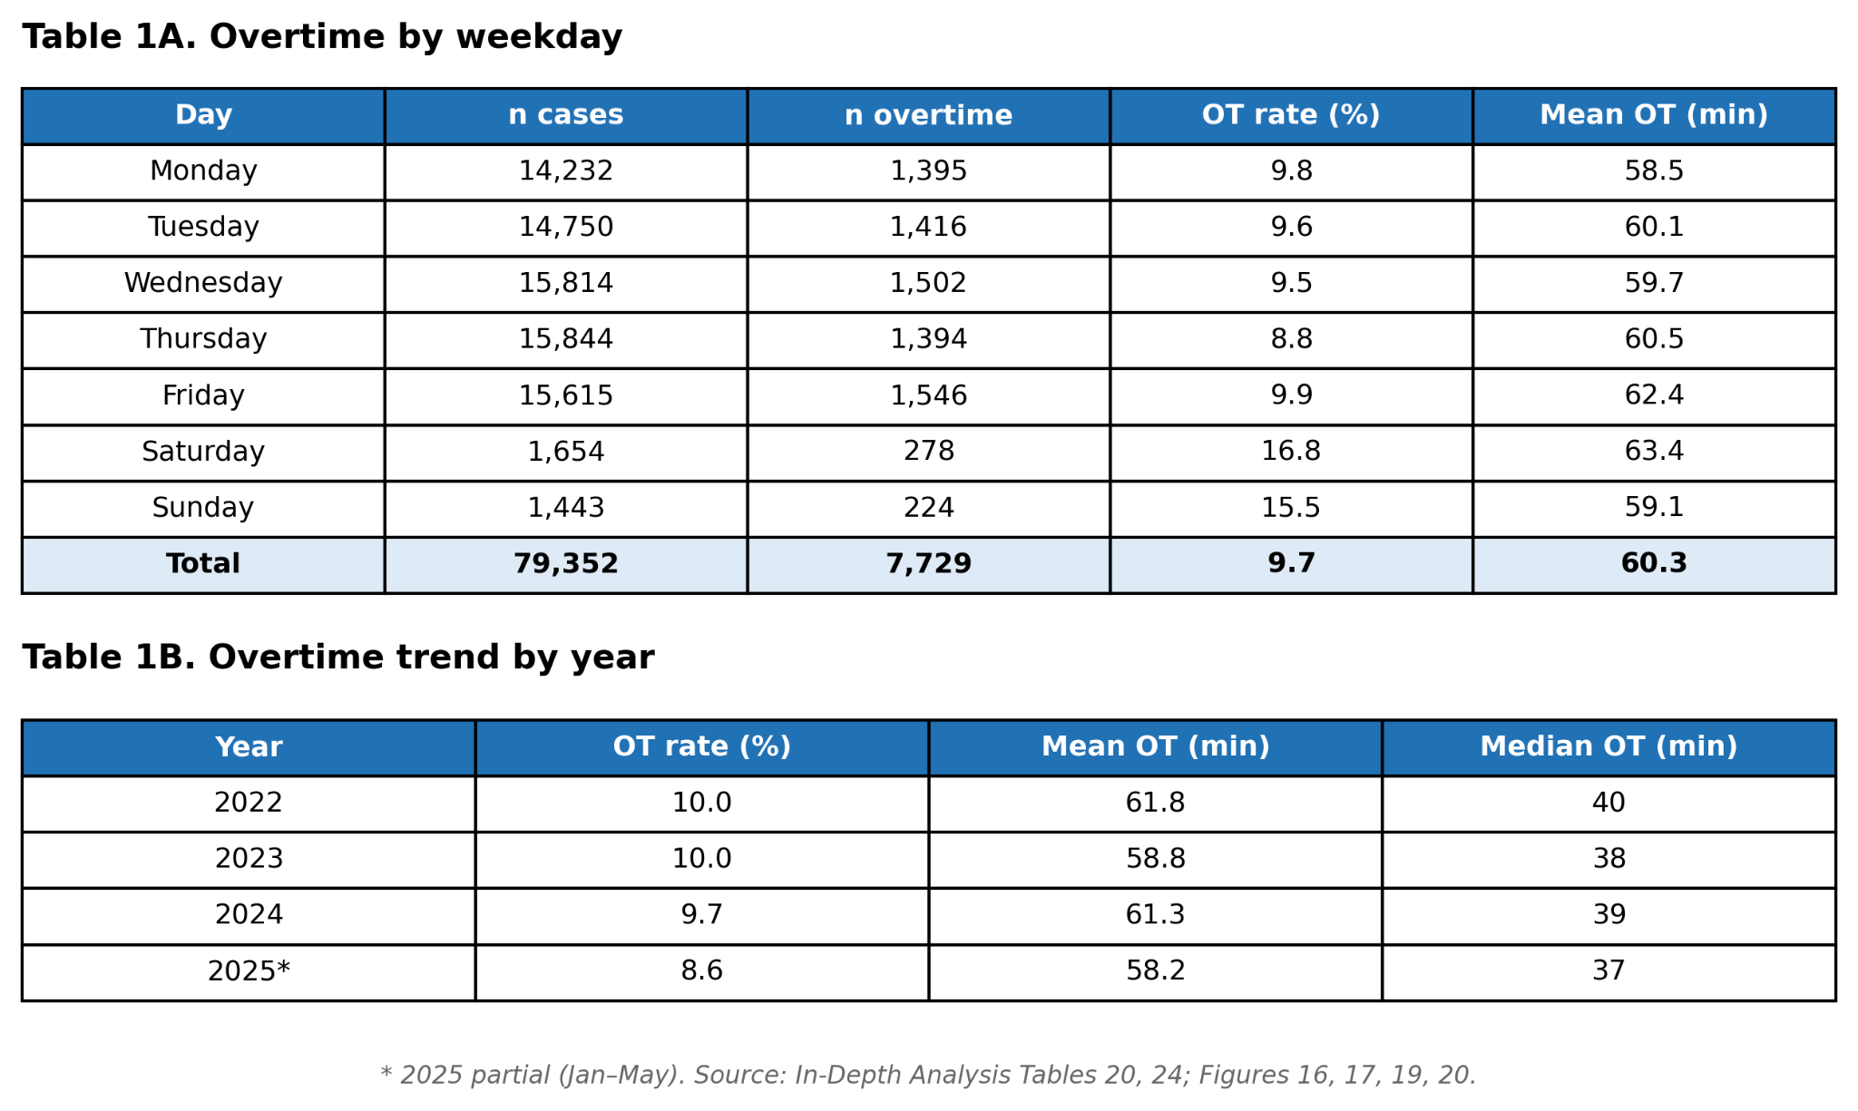
Table 1 & 2
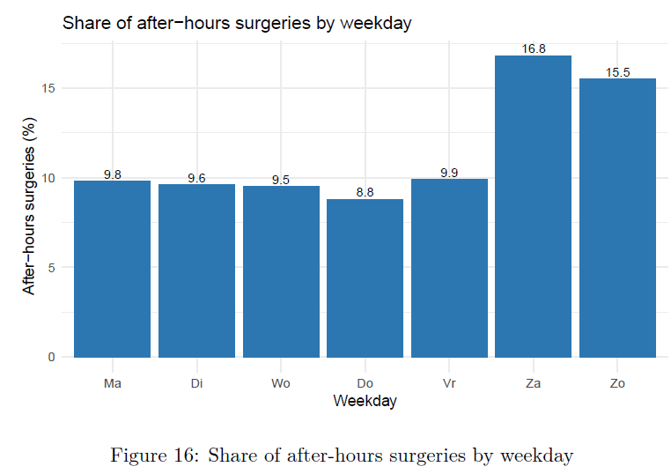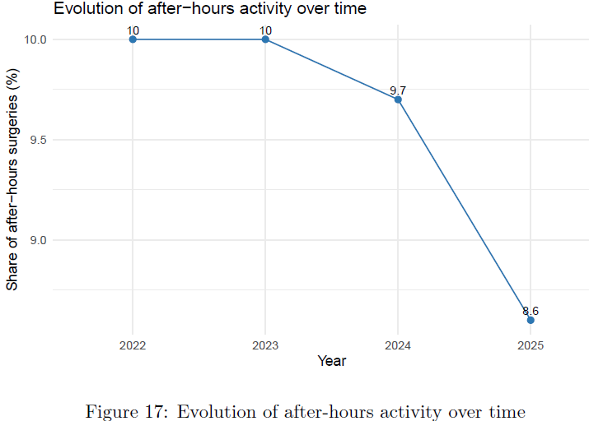

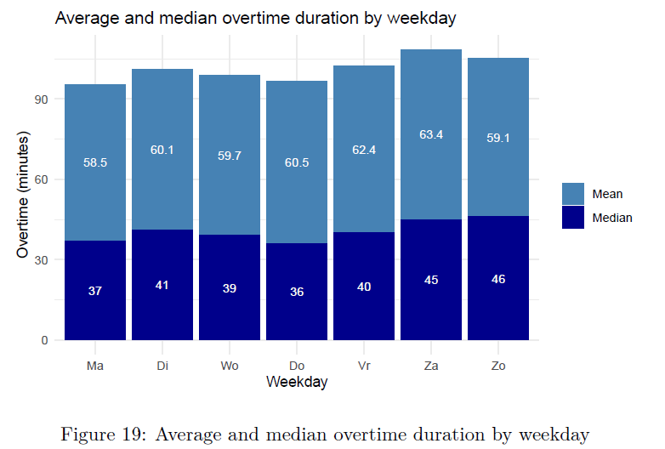
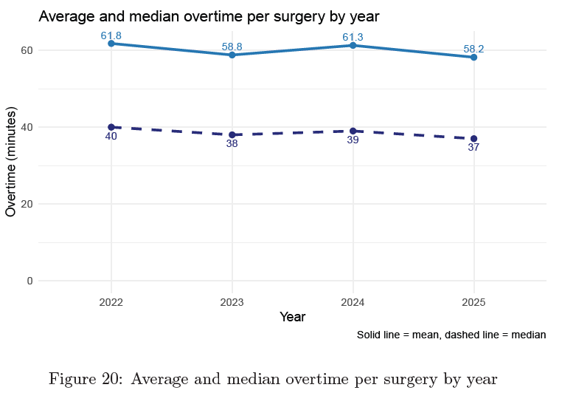

3.4 Cascading / shift displacement
- 4,151 cases (5.2% of total) were performed in a different shift than originally planned.
- Mean start delay for these cases: 398.3 min (6 hours & 38 mins).
- Mean duration deviation vs plan: -22.3 min (they finish shorter than planned).
- Mean overtime for these cases: 10.4 min.
- The displaced cases do not run long. They finish on time or early. They land in a later shift because upstream cases pushed them there. This reframes the intervention target: the problem is mid-day flow, not end-of-list management.
- Monthly trend: 7–8% of cases displaced in early 2022, declining to 4–5% by 2024. Modest improvement, parallel to the overall overtime trend.
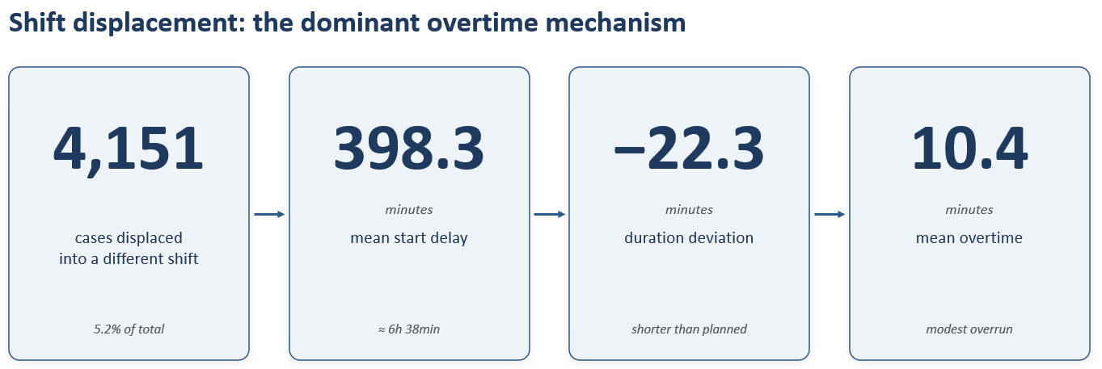
Figure 3
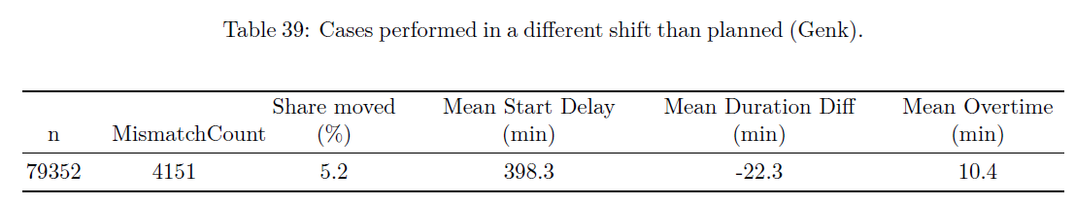

3.5 Urgent vs elective overtime
Per-case burden by urgency:
- Elective: 67,736 cases, 8.3% after-hours, mean OT 5 min (all cases, including zeros), P95 29 min.
- Non-elective: 11,616 cases, 18.2% after-hours, mean OT 10.7 min (all cases, including zeros), P95 69 min.
- Urgent cases are seen after hours at more than twice the rate. The 95th percentile of overtime minutes was longer for urgent cases (69 vs 29 min), indicating heavier tails. However, conditional on running over, the mean overrun length was similar in both groups (approximately 58–59 min). The difference in unconditional means (10.7 vs 5 min) reflects the higher overtime rate, not longer individual overruns. Elective cases are nearly six times more numerous, so the absolute pool of after-hours minutes is dominated by the elective program.
Daily overlap:
- Urgent-elective overlap in the same OR occurred on 858 of 1,247 observation days = 68.8%. Daily, not exceptional.
- Elective cases affected by an urgent overlap started ~30 min later on average (~60 min in early 2022).
- GO11 carries the highest overlap burden: 475 overlap events, 15.2% of its elective cases affected. GO11 is the designated urgent-intake room.
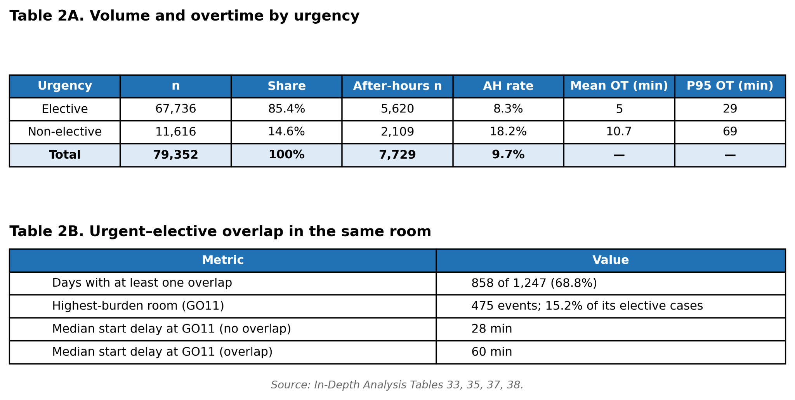
Tables 3 & 4

3.6 Stability and turnover
- Room swaps: 0.7% of cases. Overtime, 14.8% among swapped vs 9.7% among non-swapped. Swapped cases have higher OT, but at 0.7% of total volume, their absolute contribution is small.
- Idle time: mean 9.9 min, median 8 min, P95 25 min (gaps exceeding 60 min are excluded as planned downtime). Turnover is fast and consistent. Idle time between cases is not the bottleneck. [32]

3.7 Start-time delays
- GO14 has the second-worst punctuality (78.7% late) and the lowest overtime (3.5%). GO11 has the worst punctuality (82.4% late, mean delay 319 min) and mid-pack overtime (11.7%).
- GO10 (complex surgery): mid-pack on start punctuality (46.1% late), 32.9% overtime.
- This kills the FCOTS narrative: the room with the lowest overtime (GO14) is among the worst on punctuality (78.7% late), and the room with the worst overtime (GO10) is only mid-pack on punctuality (46.1% late). The room with the worst punctuality (GO11) is mid-pack on overtime. Consistent with Pandit et al. (2012), who found R-squared values of 0.04 to 0.08 between start and finish times across more than 7,000 theatre lists in two UK hospitals [17].

4. Discussion

4.1 Finding 1: Concentration, not prevalence
- The headline overtime rate of 9.7% is unremarkable. The finding is that nearly all of it sits in a handful of rooms. GO10 runs overtime in one of every three cases, with a mean overrun of 154 minutes. The within-campus spread (3.5–32.9%) exceeds the between-campus spread across the entire ZOL network (0.5–9.7%).
- Operational implication. Hospital-wide targets (e.g., “reduce overtime by 10%”) will miss the problem unless decomposed by room. The overtime is already concentrated; the intervention should be too. This aligns with Zhang, Dunstan & Pandit (2024), who argue that aggregate utilization metrics hide room-level operational reality [13].
- FCOTS contrast. The conventional view holds that first-cases-on-time starts drive end-of-day performance [16]. Our data contradict this: GO10 is mid-pack on punctuality and worst on overtime. Pandit et al. (2012) showed the same disconnect across more than 7,000 theatre lists in two UK hospitals (R-squared 0.04–0.08 between start and finish times) [17]. FCOTS is a useful discipline metric, but not a reliable lever for reducing overtime.

4.2 Finding 2: Cascading as the dominant mechanism
- The 4,151 shift-displaced cases finish on time or early (mean duration deviation -22.3 min), yet they land in the evening shift because of a mean start delay of 398.3 min. This is not an individual-case-overrun problem. It is mid-day delay accumulation pushing cases across the shift boundary.
- Literature parallel. Wachtel and Dexter (2009) showed that tardiness per case increased as the day progressed because the total duration of preceding cases increased; this is the classic cascade pattern [19]. Fugener et al. (2017) demonstrated systematic biases in surgeon duration estimates (planning fallacy, anchoring), which compound the cascade: each underestimated case pushes the next one later [20]. Our -22.3 min duration deviation is consistent with displaced cases being compressed or truncated to fit a shrinking window.
- Reframing the intervention. If the mechanism is cascading rather than long-running individual cases, the intervention point is earlier in the day: scheduling density, buffer placement, and urgent-case routing, rather than end-of-list management. Joseph et al. (2019) documented how minor flow disruptions cluster and escalate into major ones [21]. A systematic review of OR workflow disruptions estimated that roughly 20% of operating time involves disruptions, although the evidence for direct linkage to surgical outcomes is mixed [22].

4.3 Finding 3: Urgent-elective interaction
- Urgent cases run after-hours at more than twice the rate of elective cases (18.2% vs 8.3%), with heavier tails (P95 69 vs 29 min). When overtime does occur, however, the mean overrun length is similar in both groups (~58–59 min). Elective cases are nearly six times more numerous, so the absolute pool of after-hours minutes is dominated by the elective program. Overlap occurs on 68.8% of days, adding 30 min to elective start times.
- This is not an argument to restrict urgent access. It is an argument to protect the elective program from predictable disruption, either through dedicated urgent rooms or through scheduling buffers on historically high-urgency days. GO11 already absorbs much of the overlap and functions as a de facto urgent-intake room.
- The unpredictability of the overlap is the staff-harm dimension: both long shifts and overtime are associated with worse performance and wellbeing, and the unpredictable nature of urgent-driven overtime compounds the effect [23].

4.4 The double-ended harm argument
- The paper does not measure outcomes directly. It characterizes an exposure (cases and staff pushed into understaffed hours) and draws on published evidence for consequences at both ends.
- Staff harm. Overtime and long shifts are associated with burnout, reduced perceived quality of care, and intent to leave [3,4,5]. Both long shifts and overtime are risk factors for worse performance and wellbeing [23]; high workload and low decision latitude are established burnout predictors [24]. In two Belgian university hospitals, workload and unit-level nurse management were the strongest predictors of burnout and job outcomes [25]. The HSSIB 2025 investigation named staff fatigue as a patient-safety problem [9].
- Patient harm. After-hours surgery carries elevated mortality [6,7], though the effect size is debated [26]. Each intraoperative handover raises complication risk [8], though recent sub-specialty data are mixed [27]. Structured handover programs reduce adverse events (the I-PASS pediatric inpatient study showed a 30% reduction in preventable adverse events) [28]. Reducing intern shifts from extended (>24 h) to intervention schedules produced 36% fewer serious medical errors [30]; extended-duration shifts were associated with 3.5- to 7.5-fold higher odds of fatigue-related significant medical errors in a prospective intern cohort [29]. A systematic review of physician fatigue found associations with physician health outcomes, with mixed evidence for direct effects on surgical patient outcomes [31]. Overtime hours above a breakpoint threshold were associated with increased pressure ulcers across 70 US hospitals [10].
- Linking the two. In a hospital where 18 rooms drop to 8, then 4, then 1, each case pushed past the shift boundary lands in a setting with fewer staff, more handovers, and a fatigued workforce. The exposure we document is the upstream condition for both classes of harm.

4.5 Limitations
1. Single-site retrospective. Findings describe one Belgian tertiary center. Generalisability to different staffing models is unknown.
2. Administrative data. Room-in and room-out only; no induction or recovery timestamps. Cannot decompose what happens inside the case.
3. No direct outcome data. The harm argument rests on published literature, not on patient outcomes in this cohort.

5. Conclusion
- Operating-room overtime at this tertiary center is not a diffuse hospital-wide problem. It is concentrated in a small number of rooms, driven by mid-day cascading rather than individual case overruns, and amplified by urgent-elective overlap on most days.
- The staffing pyramid (18 rooms dropping to 8, then 4, then 1) means every case pushed past the shift boundary lands in a setting with fewer staff and more handovers. Published evidence links both the staff exposure (fatigue, burnout, intent to leave) and the patient exposure (after-hours surgery, handover transitions) to measurable harm.
- These findings argue for room-level rather than hospital-level overtime targets, for scheduling interventions that address mid-day flow rather than first-case punctuality alone.

Reference
2. Wachtel RE, Dexter F. Review of behavioral operations experimental studies of newsvendor problems for operating room management. Anesth Analg 2010;110(6):1698-1710.
3. Griffiths P, Dall’Ora C, Simon M, et al. Nurses’ shift length and overtime working in 12 European countries. Med Care 2014;52(11):975–81.
4. Dall’Ora C, Griffiths P, Ball J, et al. Association of 12 h shifts and nurses’ job satisfaction, burnout and intention to leave. BMJ Open 2015;5(9):e008331.
5. Bae S-H. Nurse staffing, work hours, mandatory overtime, and turnover in acute care hospitals affect nurse job satisfaction, intent to leave, and burnout. Int J Public Health 2024;69:1607068.
6. Cortegiani A, Ippolito M, Misseri G, et al. Association between night/after-hours surgery and mortality: a systematic review and meta-analysis. Br J Anaesth 2020;124(5):623–37.
7. Oh T-K, Song I-A. Outcomes of after-hours surgeries performed under general anaesthesia: a South Korean nationwide cohort study. Anaesthesia 2025. DOI: 10.1111/anae.16559.
8. Saager L, Hesler BD, You J, et al. Intraoperative transitions of anesthesia care and postoperative adverse outcomes. Anesthesiology 2014;121(4):695–706.
9. Health Services Safety Investigations Body (HSSIB). The impact of staff fatigue on patient safety. Investigation report, UK, 2025.
10. Pittman P, Tiunn H-L, et al. Increased utilization of overtime and agency nurses and patient safety. JAMA Netw Open 2025. PMID: 40172888.
11. Bauer M, Diemer M, Merkel M, et al. Glossary of perioperative process times and indicators. Anaesthesist 2020;69(Suppl 1):S5–17.
12. Schouten AEM, Flipse SM, van Nieuwenhuizen KE, et al. Operating room performance optimization metrics: a systematic review. J Med Syst 2023;47(1):19.
13. Zhang C, Dunstan C, Pandit JJ. A tutorial on “capped utilisation” as a metric in NHS England’s Model Hospital operating theatres database. Anesthesiol Perioper Sci 2024. DOI: 10.1007/s44254-024-00073-3.
14. Strum DP, May JH, Vargas LG. Modeling the uncertainty of surgical procedure times: comparison of log-normal and normal models. Anesthesiology 2000;92(4):1160–7.
15. Eijkemans MJ, van Houdenhoven M, Nguyen T, et al. Predicting the unpredictable: a new prediction model for operating room times. Anesthesiology 2010;112(1):41–9.
16. Dexter F, Epstein RH. Typical savings from each minute reduction in tardy first case of the day starts. Anesth Analg 2009;108(4):1262–7.
17. Pandit JJ, Abbott T, Pandit M, et al. Is “starting on time” useful (or useless) as a surrogate measure for “surgical theatre efficiency”? Anaesthesia 2012;67(8):823–32.
19. Wachtel RE, Dexter F. Influence of the operating room schedule on tardiness from scheduled start times. Anesth Analg 2009;108(6):1889–1901.
20. Fugener A, Schiffels S, Kolisch R. Overutilization and underutilization of operating rooms: insights from behavioral health care operations management. Health Care Manag Sci 2017;20(1):115–28.
21. Joseph A, Khoshkenar A, Taaffe KM, et al. Minor flow disruptions, traffic-related factors and their effect on major flow disruptions in the operating room. BMJ Qual Saf 2019;28(4):276–83.
22. Koch A, Burns J, Catchpole K, Weigl M. Associations of workflow disruptions in the operating room with surgical outcomes: a systematic review and narrative synthesis. BMJ Qual Saf 2020;29(12):1033–1045.
23. Dall’Ora C, Ball J, Recio-Saucedo A, Griffiths P. Characteristics of shift work and their impact on employee performance and wellbeing: a literature review. Int J Nurs Stud 2016;57:12–27.
24. Dall’Ora C, Ball J, Reinius M, Griffiths P. Burnout in nursing: a theoretical review. Hum Resour Health 2020;18:41.
25. Van Bogaert P, Peremans L, Van Heusden D, et al. Predictors of burnout, work engagement and nurse reported job outcomes and quality of care. BMC Nurs 2017;16:5.
26. Sakurai T. Assessing the influence of after-hours surgery: concerns with the confounders and conclusion. Anaesthesia 2025. DOI: 10.1111/anae.16591.
27. Guerra-Londono JJ, et al. The impact of intraoperative anesthesiology provider handovers on postoperative complications after hepatopancreatobiliary surgery. J Surg Oncol 2025. PMID: 39388390.
28. Starmer AJ, Spector ND, Srivastava R, et al. Changes in medical errors after implementation of a handoff program. N Engl J Med 2014;371(19):1803–12.
29. Barger LK, Ayas NT, Cade BE, et al. Impact of extended-duration shifts on medical errors, adverse events, and attentional failures. PLoS Med 2006;3(12):e487.
30. Landrigan CP, Rothschild JM, Cronin JW, et al. Effect of reducing interns’ work hours on serious medical errors in intensive care units. N Engl J Med 2004;351(18):1838–48.
31. Gates M, Wingert A, Featherstone R, et al. Impact of fatigue and insufficient sleep on physician and patient outcomes: a systematic review. BMJ Open 2018;8(9):e021967.

