Supplementary materials
For: Where does operating-room overtime come from? A retrospective single-center study.
Tharwat H, Riebus M, [Ben], [Dieter], Martin N.
Supplementary Table S1. Coefficient of variation by planned-duration bucket
Planned duration | n cases | CV (observed duration) | CV (planning deviation)
<30 min | 19,511 | 0.61 | 1.25
31–60 min | 28,674 | 0.46 | 1.07
61–90 min | 19,921 | 0.36 | 1.06
91–180 min | 20,592 | 0.35 | 0.91
>180 min | 7,343 | 0.42 | 1.86
Table S1. Coefficient of variation (CV) of observed duration and of planning deviation, stratified by planned-duration bucket. Mid-length cases (61–180 min) carry the lowest CV. Very long cases (>180 min) carry the largest planning-deviation CV.
Supplementary Table S2. Per-room start-time deviation vs overtime rate
Room | n cases | Late starts (%) | Mean delay (min) | Overtime (%)
OR11 | 7,482 | 82.4 | 319.1 | 11.7
OR14 | 6,885 | 78.7 | 37.3 | 3.5
OR01 | 6,577 | 75.1 | 38.0 | 5.8
OR08 | 1,777 | 71.9 | 44.9 | 13.6
OR02 | 3,502 | 70.3 | 42.2 | 11.4
OR07 | 4,658 | 70.0 | 43.5 | 6.9
OR05 | 4,886 | 68.3 | 54.3 | 12.3
OR03 | 4,094 | 65.9 | 44.6 | 9.6
OR09 | 2,637 | 64.5 | 48.9 | 16.3
OR04 | 4,518 | 63.5 | 49.4 | 10.7
OR15 | 4,323 | 63.1 | 40.5 | 8.7
OR16 | 4,098 | 62.6 | 35.0 | 8.9
OR18 | 5,293 | 62.3 | 36.9 | 6.5
OR17 | 5,480 | 61.8 | 38.4 | 6.8
OR06 | 5,217 | 61.7 | 42.1 | 9.4
OR12 | 2,884 | 54.5 | 48.3 | 13.3
OR13 | 3,298 | 53.7 | 48.6 | 13.7
OR10 | 1,743 | 46.1 | 63.2 | 32.9
Table S2. Per-room late-start rate and mean start delay (minutes) versus overtime rate. OR10 (lowest late-start rate, 46.1%) has the highest overtime (32.9%); OR14 (78.7% late, second-worst punctuality) has the lowest overtime (3.5%); OR11 (worst punctuality, 82.4% late, 319 min mean delay) sits at mid-pack overtime (11.7%).
Supplementary Figure S1. Idle time between consecutive cases
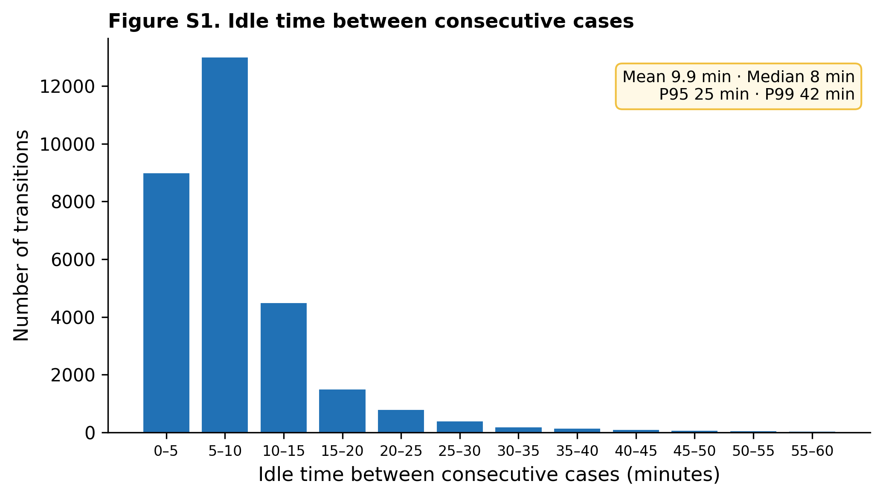
Figure S1. Distribution of inter-case idle time between consecutive cases in the same room. Mean 9.9 min, median 8 min, P95 25 min, P99 42 min. Turnover is fast and consistent.
Supplementary Figure S2. Timing of overtime case completions
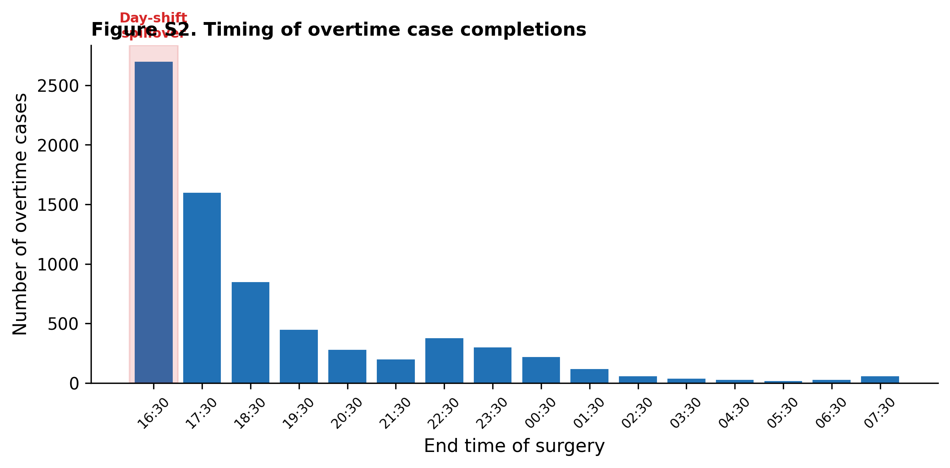
Figure S2. Number of overtime cases by end-time hour. The largest single block of completions falls in the 16:30–17:30 window, right after the day-shift handover. The distribution decays through the evening, with a thin tail past 22:00.

