VPC Endpoints | S3 Gateways, Bucket Policies
By Haroon Zaman | December 2025

Introduction
In this project, I connected my VPC directly to Amazon S3, allowing resources inside the VPC to interact with S3 securely and efficiently.
Instead of sending traffic through the public internet, this setup allows communication to stay within AWS’s internal network. This improves security, performance, and cost efficiency, since traffic takes a shorter and more controlled path to its destination.

What I Did in This Project
- Set up a VPC with an EC2 instance
- Configured IAM access keys to allow AWS CLI access from the instance
- Created an Amazon S3 bucket
- Uploaded and listed S3 objects using AWS CLI commands
- Verified that the EC2 instance inside the VPC could interact with S3 successfully

Why This Matters
By enabling direct access between a VPC and S3:
- Network traffic stays private and secure
- Requests reach their destination faster
- The setup is cheaper, as it avoids unnecessary internet routing
- Permissions are tightly controlled using IAM
This project tied together everything I learned throughout the AWS networking series — VPCs, EC2, IAM, and S3 — into a single, real-world use case.

Creating the VPC
- First, I created a new VPC and named it My_VPC_1.
- I chose one Availability Zone, since this project does not require multi-AZ availability.
- I created one public subnet and no private subnet.
  - This is because the EC2 instance in this project needs to be publicly reachable for testing S3 access, and a private subnet is not required at this stage.
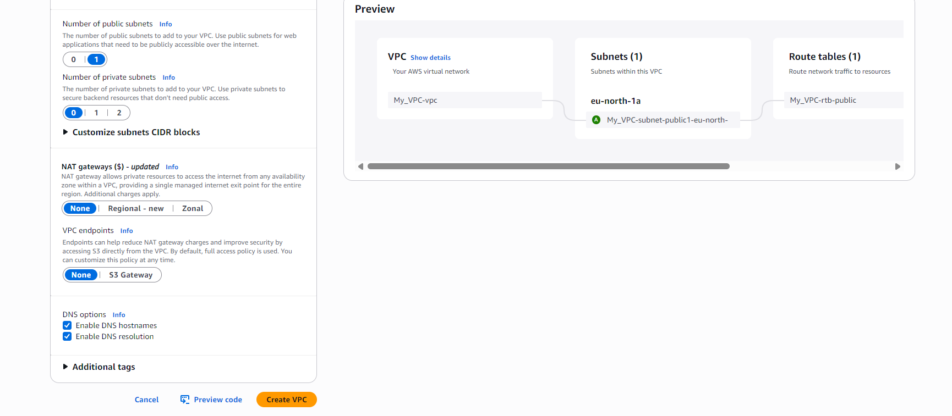
- I selected No NAT Gateway.
  - A NAT Gateway is only needed when private subnets require outbound internet access.
  - Since I did not create a private subnet, a NAT Gateway was not necessary.
- I selected No S3 Gateway Endpoint.
  - This is because I wanted to create and configure S3 access separately and in detail later in the project.
- After reviewing the configuration, I clicked Create VPC, and the VPC was created successfully.
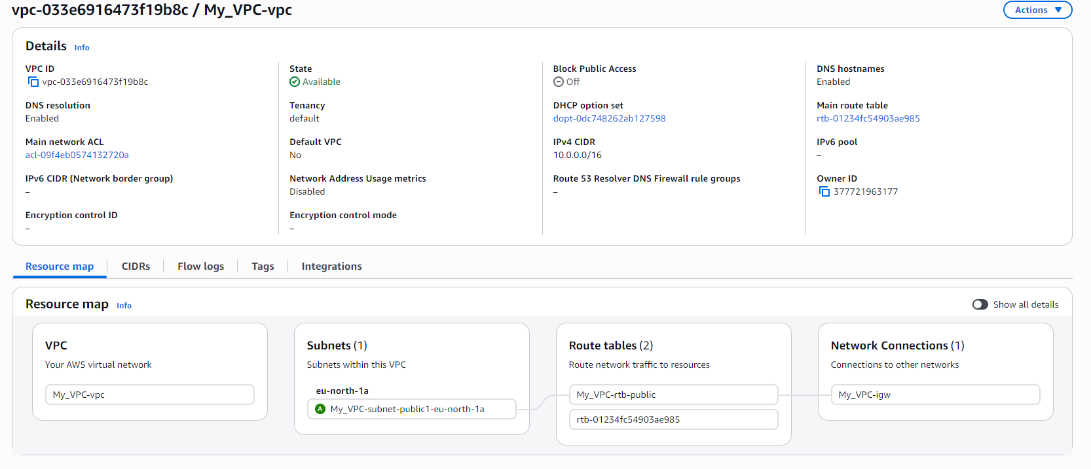

Creating the EC2 Instance
- Next, I created an EC2 instance and named it My_Instance_VPC_1.
- I selected Amazon Linux as the operating system.
- I chose the t3 instance type.
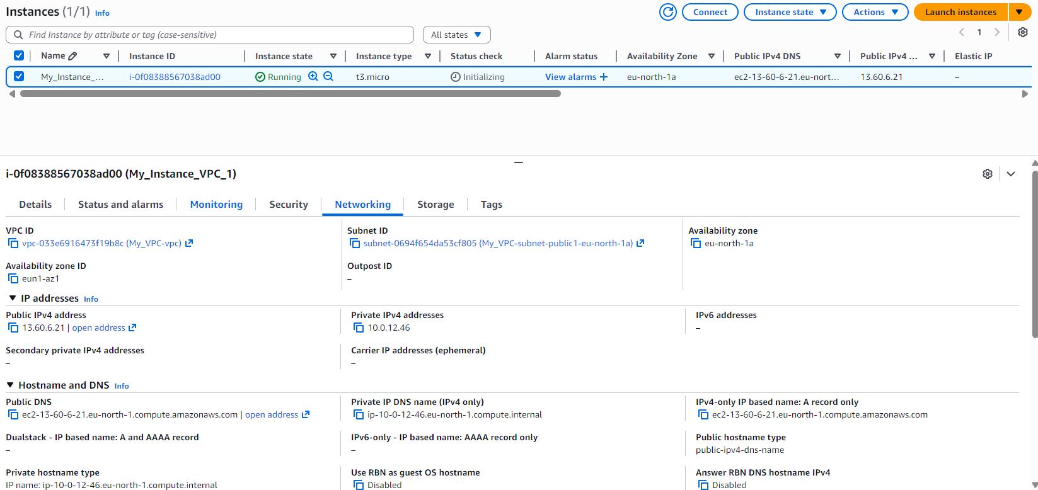

- In the Networking section, I selected My_VPC_1.
- I selected the public subnet of the VPC.
- I enabled Auto-assign Public IP.
- In the Firewall (Security Group) section, I created a new security group.
- After reviewing the settings, I clicked Create instance, and the instance was launched successfully.

Creating the S3 Bucket
- Next, I created an Amazon S3 bucket.
- I named the bucket haroon-vpc-bucket1.
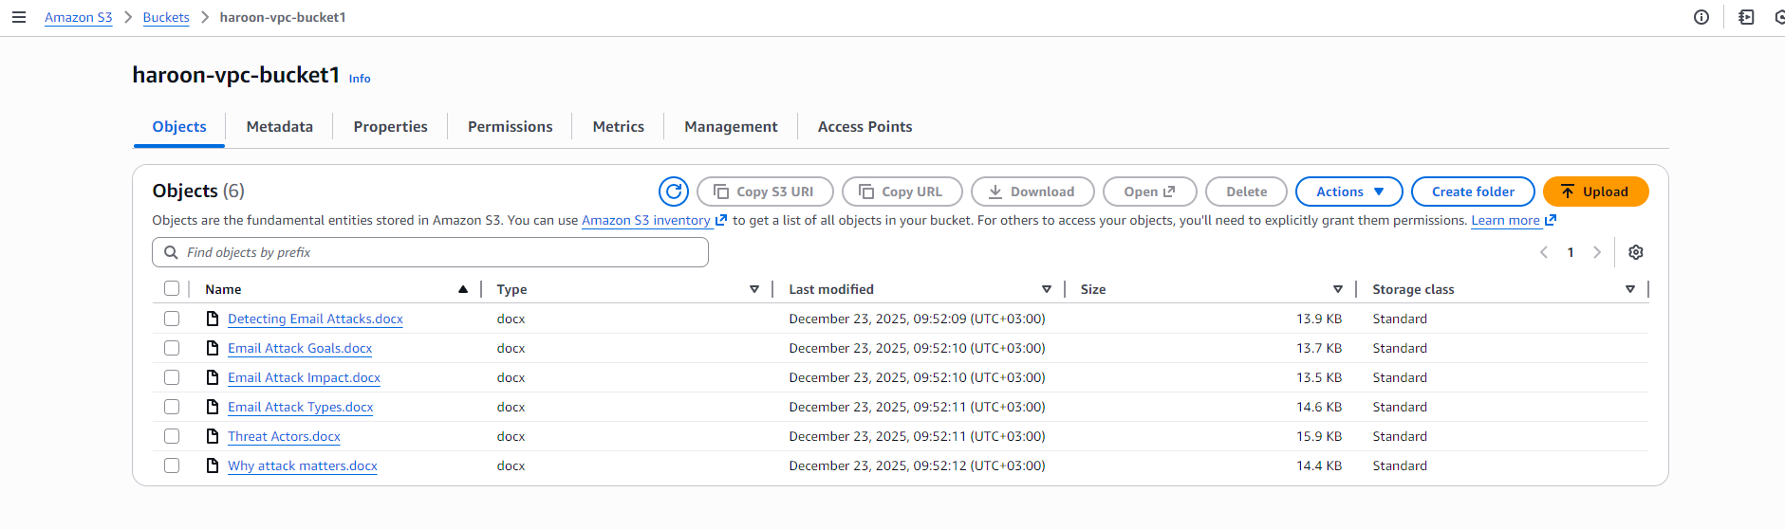
- I left all the settings on default.
- After reviewing the configuration, I clicked Create bucket, and the bucket was created successfully.
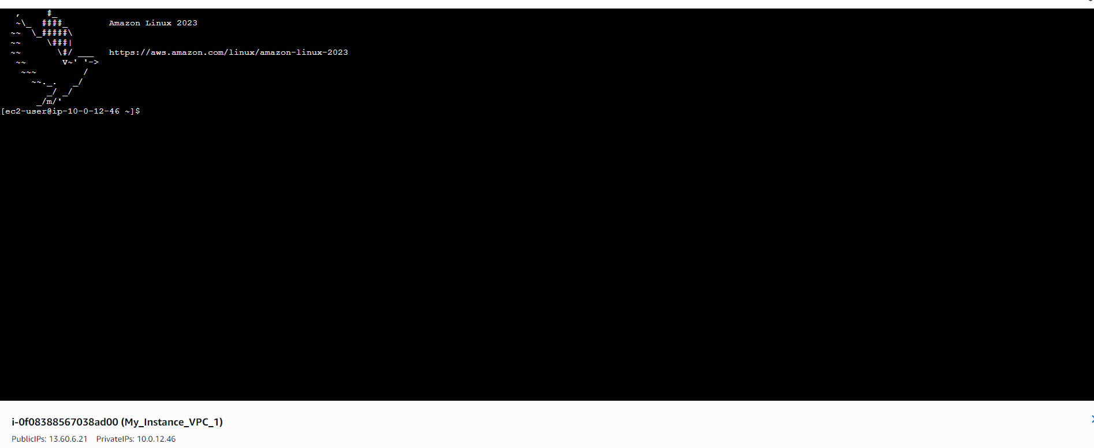

Connecting to the EC2 Instance
- After creating the instance, I connected to My_Instance_VPC_1 using the Connect option from the EC2 console.
- The connection was established successfully.
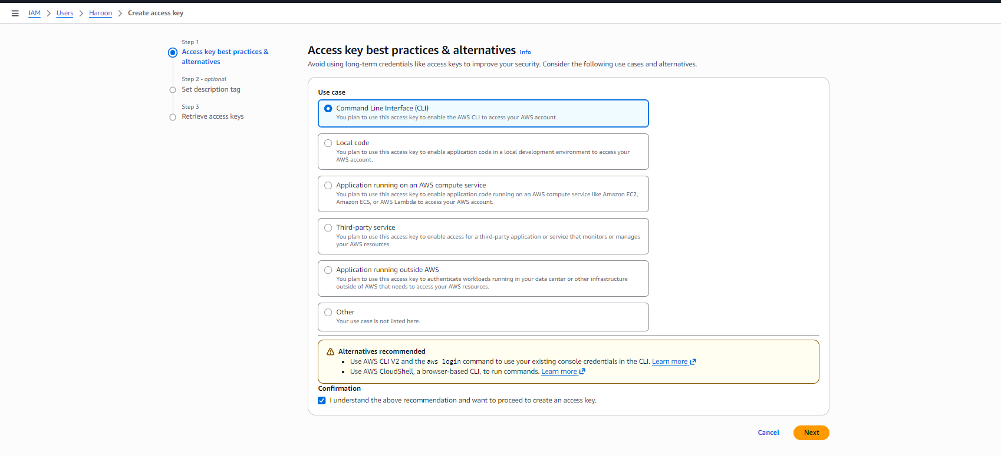

Creating the Access Key in IAM
- Next, I created an access key for my IAM user.
- In the access key setup, I selected the CLI option as the use case.
- I added a description to identify the key.
- After that, I clicked Create access key, and the access key was generated successfully.
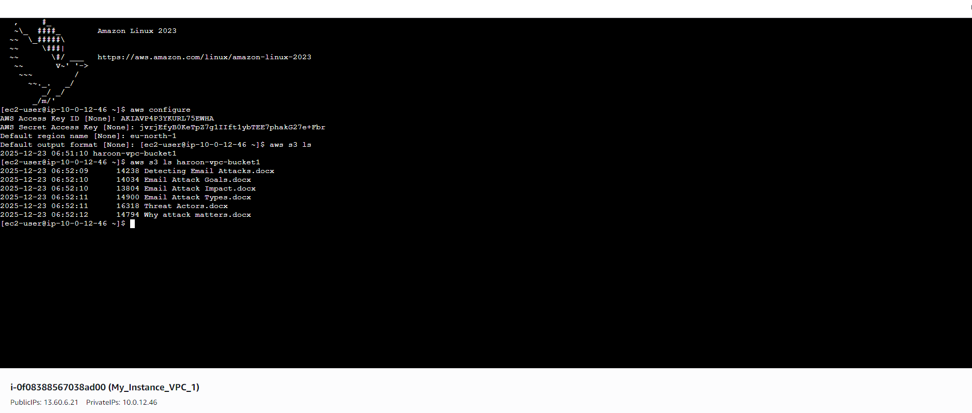

Configuring Credentials and AWS CLI Settings
- After creating the access key, I copied the credentials (Access Key ID and Secret Access Key).
- I went back to the connected EC2 instance and entered the Access Key ID and Secret Access Key when prompted.
- Next, I was asked for the Default region name.
  - I entered eu-north-1, which is the region where my resources are created.
- Then I was asked for the Default output format.
  - The default output format controls how AWS CLI command results are displayed in the terminal.
  - Available options include:
    - json – structured output (default)
    - text – plain text output
    - table – formatted table output
    - yaml – human-readable structured format
- I left this field empty.
  - When left empty, AWS CLI automatically uses JSON as the default output format.
- After completing these steps, the AWS CLI was fully configured.
- I then tested access to the S3 bucket by running:
aws s3 ls s3://haroon-vpc-bucket1
- The command returned the list of files already uploaded in the bucket, confirming successful access.

Creating an S3 VPC Endpoint
- An endpoint in AWS allows resources inside a VPC to connect to AWS services privately, without sending traffic over the public internet.
- This improves security, performance, and reduces exposure to external networks.
- A Gateway Endpoint is a special type of endpoint used specifically for Amazon S3 and DynamoDB.
- Instead of using the internet gateway, traffic to S3 is routed internally through the AWS network using the VPC route table.
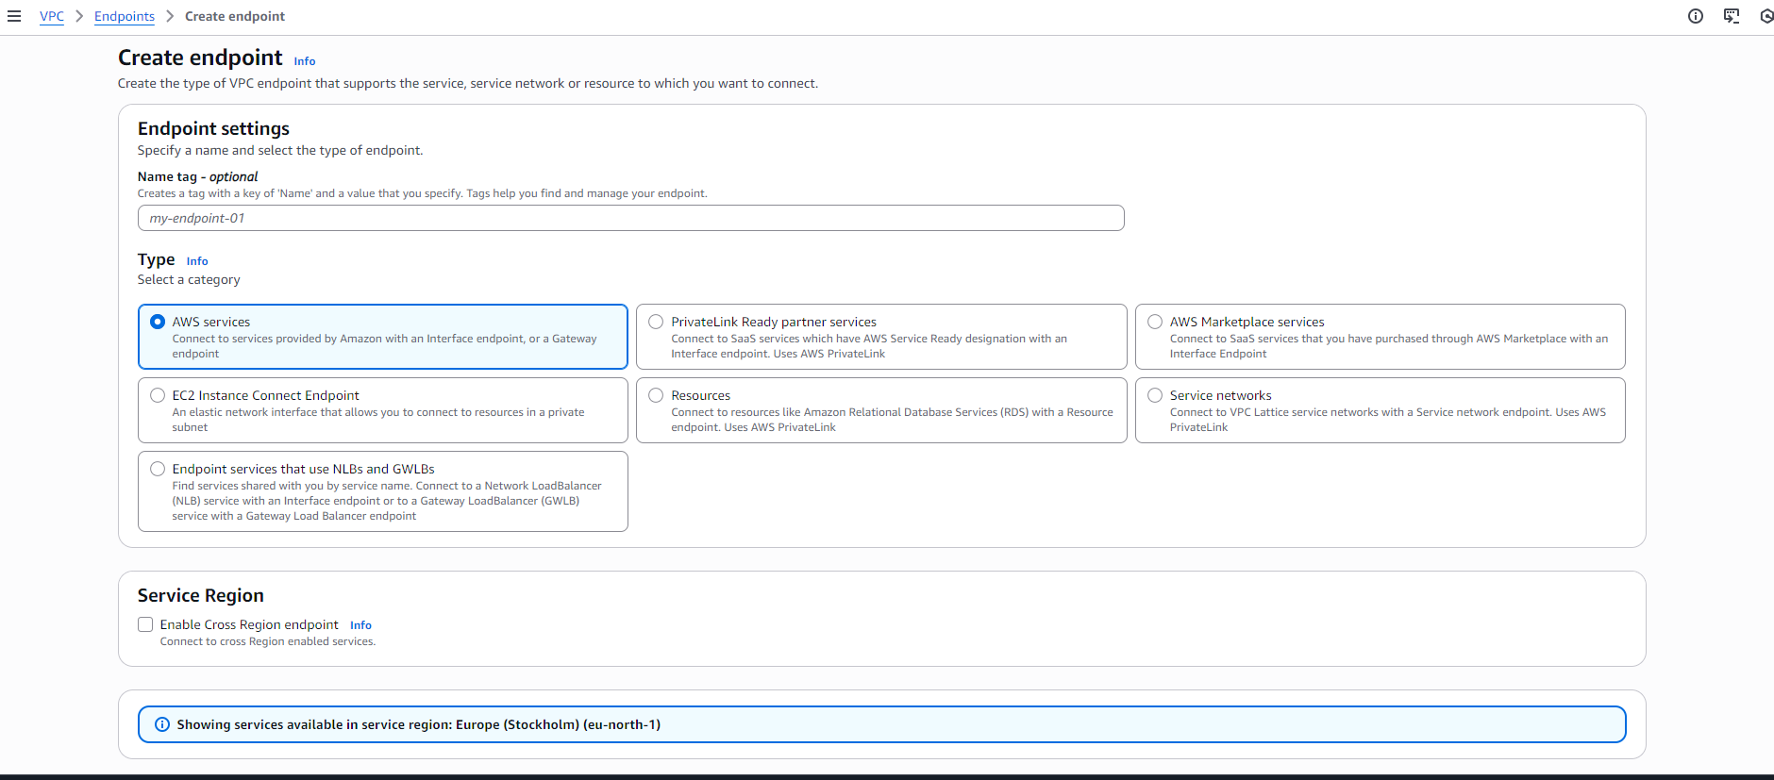

Creating the Endpoint
- I went to the VPC console.
- From the left-side panel, I selected Endpoints.
- I clicked on Create endpoint.
- I named the endpoint My_S3_EndPoint.

Endpoint Type Selection
- I selected AWS services as the endpoint type because:
  - I wanted to connect my VPC to an AWS-managed service (Amazon S3).
  - This option supports Gateway Endpoints for S3.
Other options available were:
- PrivateLink Ready partner services – used for third-party SaaS services.
- AWS Marketplace services – used for services purchased from AWS Marketplace.
- EC2 Instance Connect Endpoint – used for SSH access to private EC2 instances.
- Resources – used to connect to services like RDS using PrivateLink.
- Service networks – used with VPC Lattice for service-to-service communication.

Why This Matters
- My EC2 instance can now access S3 privately.
- Traffic stays inside the AWS network.
- This follows AWS best practices for secure VPC design.
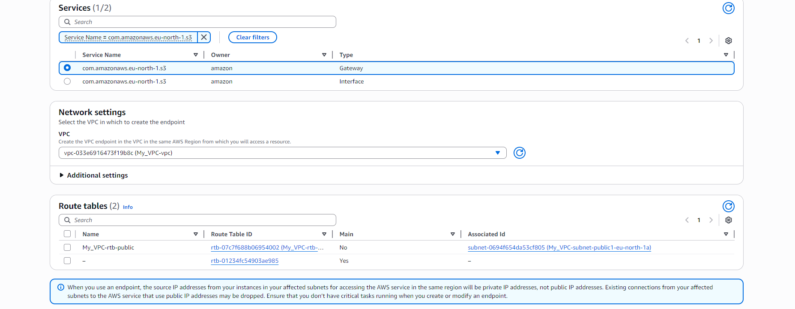

Selecting the S3 Service for the Endpoint
- In the Service section, I searched for S3.
- From the list, I selected the service name that ends with s3 and has the type Gateway.

What “Gateway” Means
- A Gateway Endpoint is a special endpoint type used for Amazon S3 (and DynamoDB).
- It allows traffic from the VPC to reach S3 without using the internet.
- Instead of creating network interfaces, it works by adding routes to the VPC route table.
- This means S3 traffic stays inside the AWS network, improving security and reliability.

Network Settings
- In the Network settings section, I selected the VPC I created earlier.
- I then selected the route table that was automatically created with the VPC.
- This ensures that traffic destined for S3 is routed through the Gateway Endpoint instead of the internet.

Endpoint Policy (Optional)
- While creating the endpoint, we can also attach an endpoint policy.
- An endpoint policy controls what actions are allowed or denied when accessing S3 through the endpoint.
- It works like an IAM policy but applies only to traffic using this endpoint.
- For this project, I left the policy as Full access, which allows all S3 actions from the VPC.
- In a real production setup, this can be restricted to specific buckets or actions for better security.

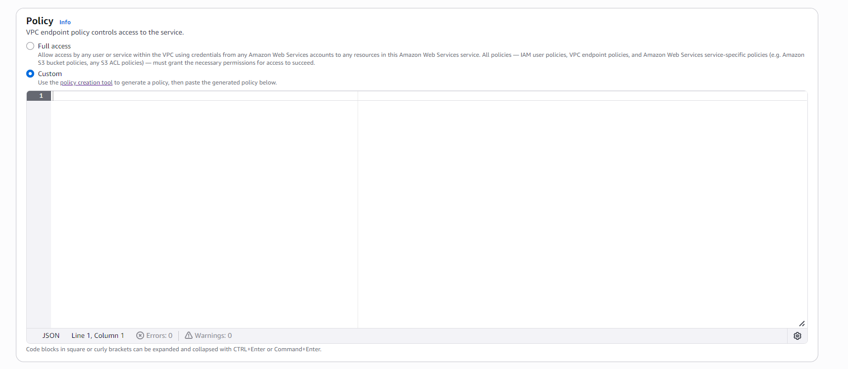
- We can also use the Policy Generator while creating the endpoint.
- The policy generator helps create endpoint policies without writing JSON manually.
- It lets us select allowed actions, services, and resources step by step.
- This reduces mistakes and makes policy creation easier, especially for beginners.
- The generated policy is automatically attached to the endpoint.
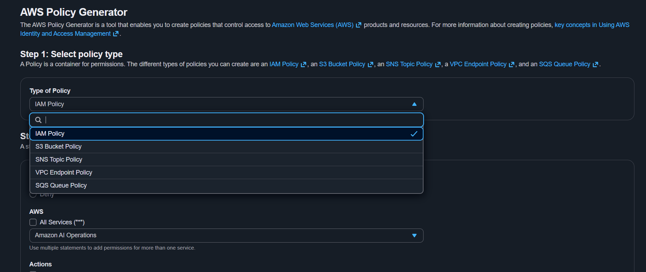
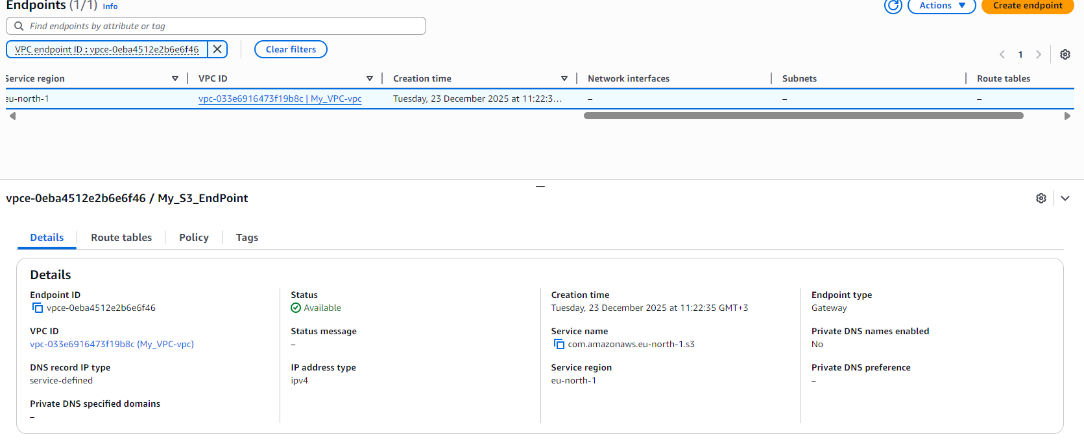
- After reviewing all the settings, I clicked Create endpoint.
- The endpoint was created successfully and linked to my VPC.
- This allowed resources inside the VPC to access Amazon S3 privately, without using the public internet.
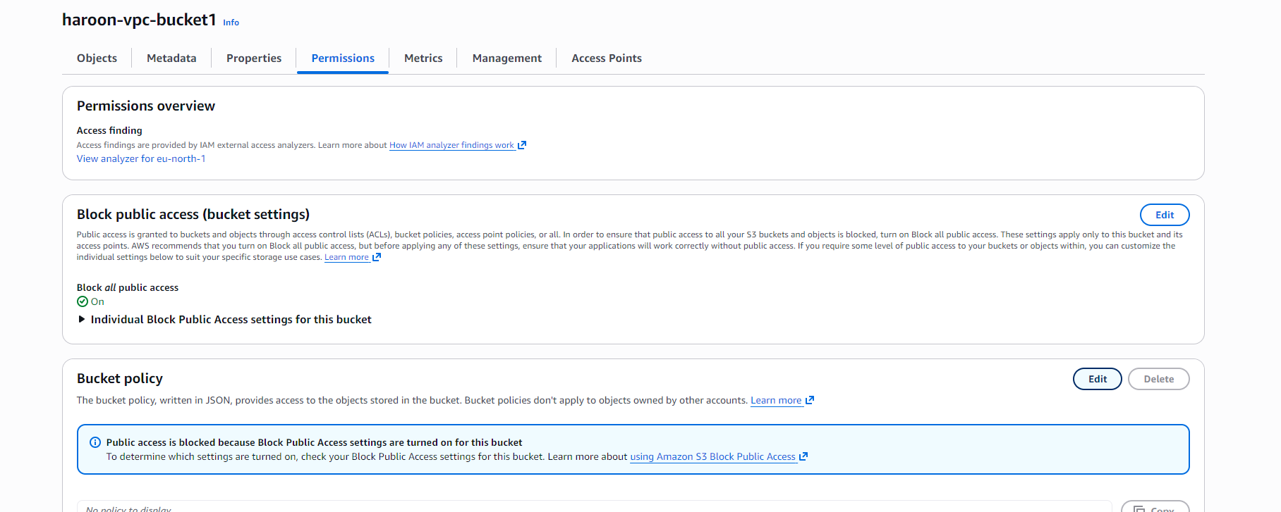

Creating a Super Secure S3 Bucket
- After creating the VPC endpoint, I wanted to make sure my S3 bucket could only be accessed through that endpoint and not from the public internet.
- A “super secure” S3 bucket means all access is blocked by default, except traffic coming from a trusted source—in this case, my VPC endpoint.
- To do this, I went to the S3 console and selected my bucket.
- I opened the Permissions tab.
- In the Bucket policy section, I clicked Edit.
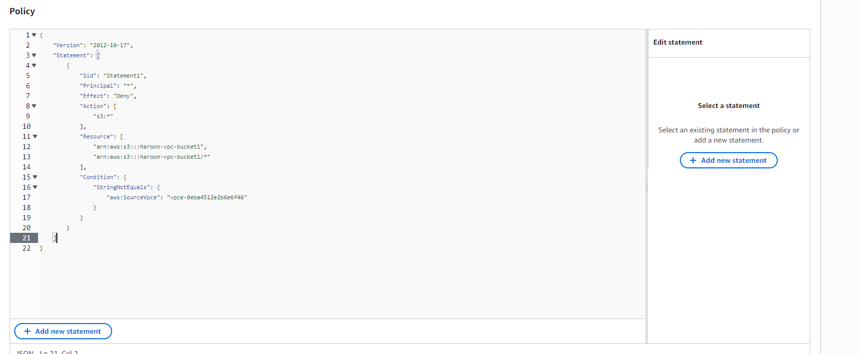
- In the next window, I added this bucket policy.
- This policy denies all S3 actions (s3:*) on the bucket and its objects for everyone by default.
- The Principal: "*" means the rule applies to any user or service.
- The condition StringNotEquals checks the source of the request.
- If the request does NOT come from my VPC endpoint (aws:SourceVpce), access is denied.
- Only traffic that originates from the specified S3 VPC endpoint is allowed.
- Any request coming from:
  - The public internet
  - Another VPC
  - A local machine
will be blocked.
- This confirms that:
  - My S3 bucket is not accessible publicly
  - My EC2 instance can access S3 only through the VPC endpoint
  - The data never travels over the public internet
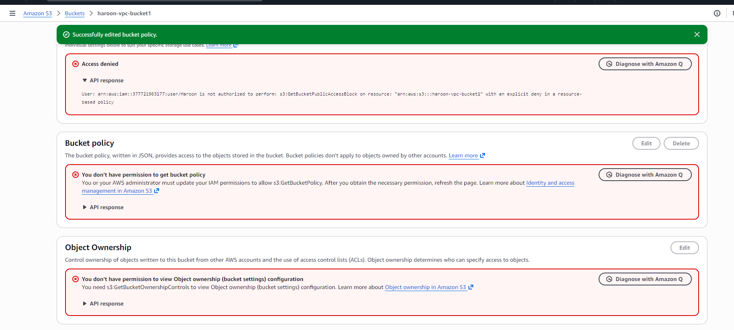
- After applying this bucket policy, all access from the AWS Console (GUI) was denied.
- This is expected behavior because the AWS Console accesses S3 over the public internet, not through the VPC endpoint.
- Since the policy allows access only when aws:SourceVpce matches my VPC endpoint, any GUI-based access is blocked.
- The EC2 instance inside the VPC can still access the bucket because its traffic goes through the S3 VPC endpoint.
- This confirms the policy is working exactly as intended:
- ❌ GUI / public access blocked
- ✅ VPC endpoint access allowed
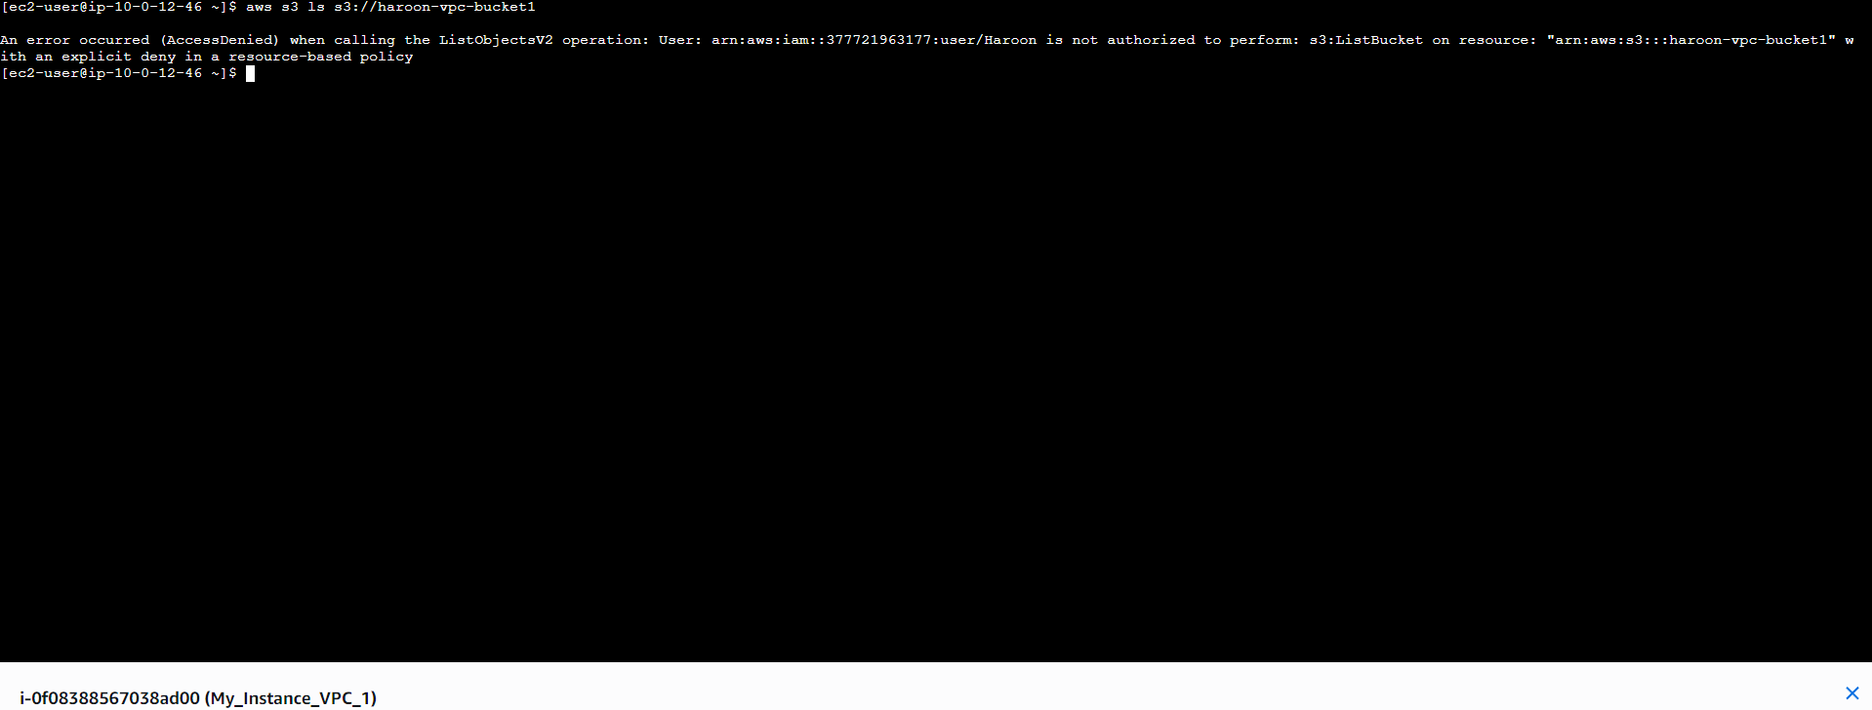
- Next, I tried to access the S3 bucket from the EC2 instance.
- Access was denied because the bucket policy allows requests only through the S3 VPC endpoint, and the request did not meet that condition at that time.
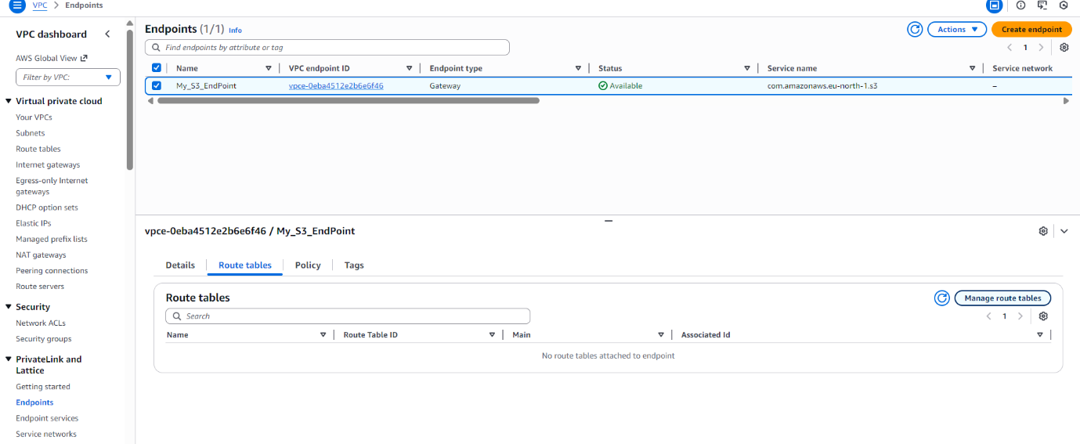
- The problem was that the subnet’s route table was not routing traffic to the S3 VPC endpoint.
- Because there was no route pointing S3 traffic to the endpoint, the EC2 instance was trying to reach S3 through the public internet instead.
- Since the bucket policy blocks all public internet access, those requests were denied.
- Once the route table was updated to send S3-bound traffic to the VPC endpoint, the EC2 instance was able to access the bucket successfully.
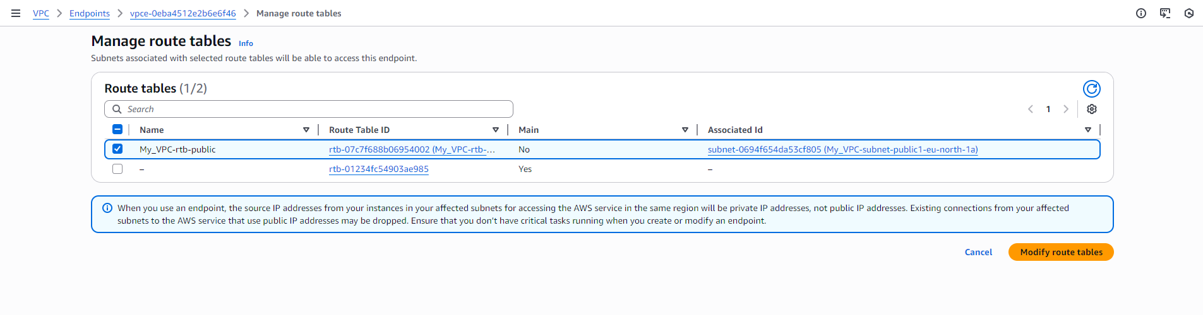
- Next, I selected the public route table of my VPC.
- From the VPC endpoint route tables section, I chose Modify route tables to associate the route table with the S3 endpoint.
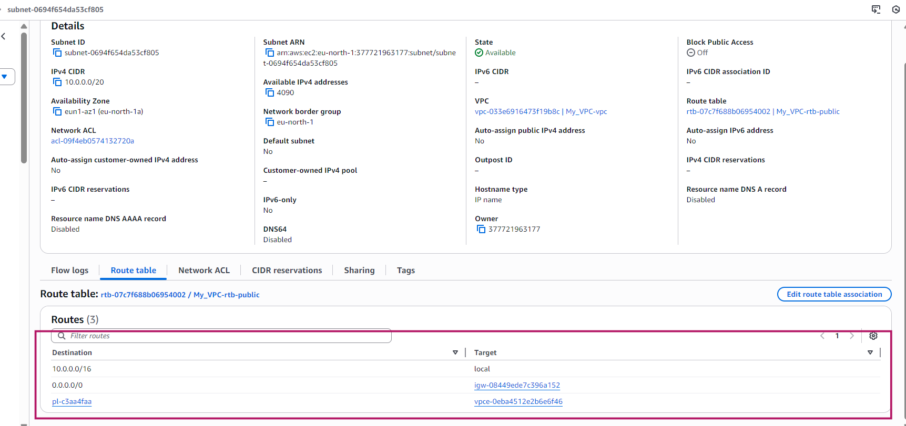
- After associating the route table, all required routes were added successfully.
- This included the route that directs traffic from the VPC endpoint to the S3 bucket, ensuring private connectivity to S3.
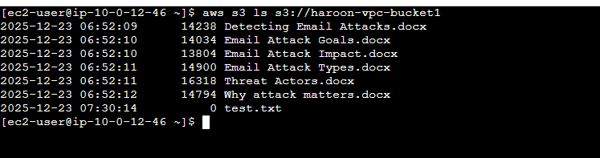
- After updating the routes, I could access the S3 bucket only from the EC2 instance inside the VPC.
- All other access paths were blocked, confirming that S3 access was restricted to the private VPC endpoint only.
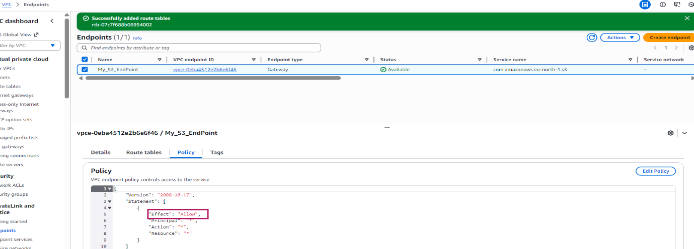
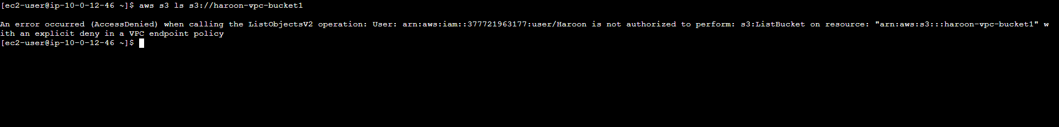
- In the endpoint policy, the effect is Allow by default, which permits access to the S3 bucket through the VPC endpoint.
- When I changed the effect to Deny in the edit policy, I could no longer access the S3 bucket.
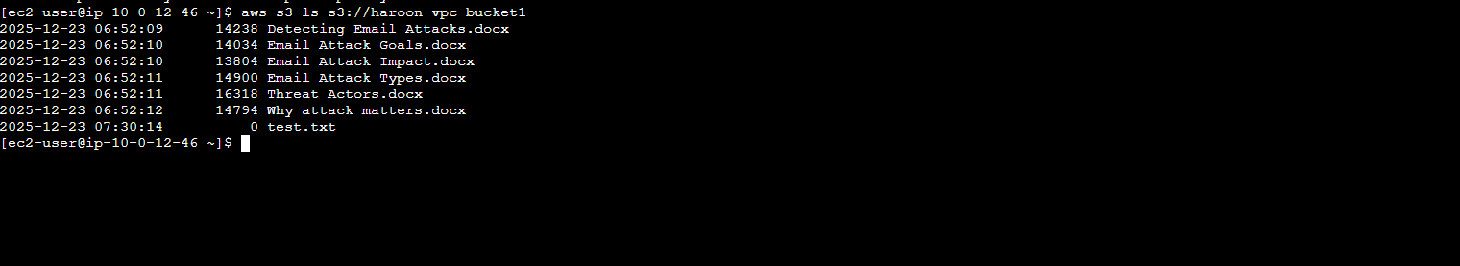
- Then I changed the endpoint policy back to Allow, and access to the S3 bucket started working again.

Conclusion
In this project, I learned how to securely access Amazon S3 from within a VPC using a VPC Gateway Endpoint. I created a VPC, launched an EC2 instance, configured IAM credentials, and verified S3 access using the AWS CLI. By introducing an S3 VPC endpoint and applying a restrictive bucket policy, I ensured that the S3 bucket could only be accessed through the private AWS network.
I also learned how route tables and endpoint policies directly affect access to AWS services. When the route table was not associated with the endpoint or when the endpoint policy was set to deny, access to S3 was blocked. Once corrected, access was restored, confirming that the security controls were working as intended.
This project helped me understand how AWS networking, IAM, and S3 work together to provide private, secure, and controlled access to cloud storage without relying on the public internet.

