Introduction
I worked on a project where I set up Microsoft Sentinel (Azure SIEM) and configured log ingestion from devices using Azure Arc. The purpose of this project was to get hands-on experience with setting up a SIEM in the cloud, connecting it with hybrid resources, and collecting security logs for monitoring.
The main reason I took on this project was to understand how modern organizations centralize their logs, detect threats, and manage both cloud and on-premises devices from a single platform. I wanted to practice the entire process—from creating the necessary Azure resources to connecting an external device and finally sending its security logs into Sentinel for analysis.

Steps I Took
- Created a Resource Group
- Set Up a Log Analytics Workspace
- Deployed Microsoft Sentinel
- Enabled Windows Security Events Data Connector
- Installed Azure Arc on a Device
- Created a Data Collection Rule (DCR)

Step 1: Azure Account & Resource Group Setup
- Created a new Azure account and selected the free subscription.
- Azure requires a credit card check for free subscription eligibility.
  - If the card was used before, the free subscription is not available.
- After signing in, I created a Resource Group (Sentinel will be deployed inside it).
- Made sure to use the same region for all resources and services, since the log timestamps in Sentinel follow the region selected.
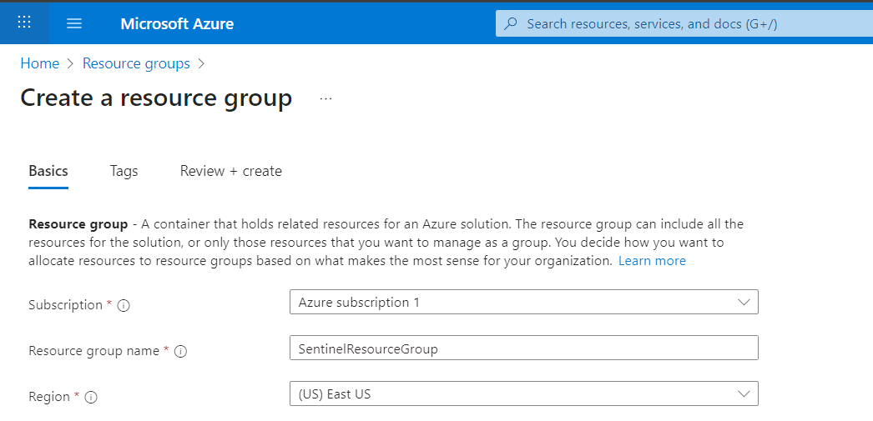

- A Log Analytics Workspace is like a storage + analysis space for all logs.
- Sentinel cannot work without it because Sentinel itself doesn’t store logs — it only analyzes what’s collected in the workspace.
- So the workspace is basically the backbone for Sentinel’s data.

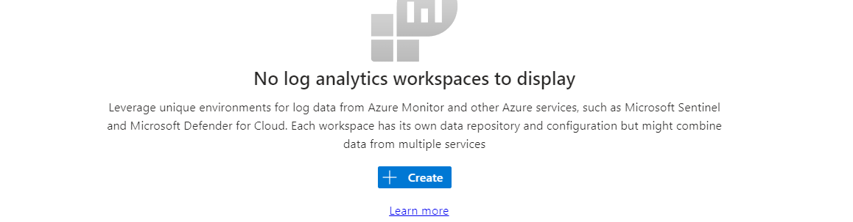Step 2: Create Log Analytics Workspace
- Created a Log Analytics Workspace (named SentinelLogSpace).
- This workspace is needed because it stores all logs that Sentinel will analyze.
- Chose the same region as the Resource Group for consistency and proper log timestamps.
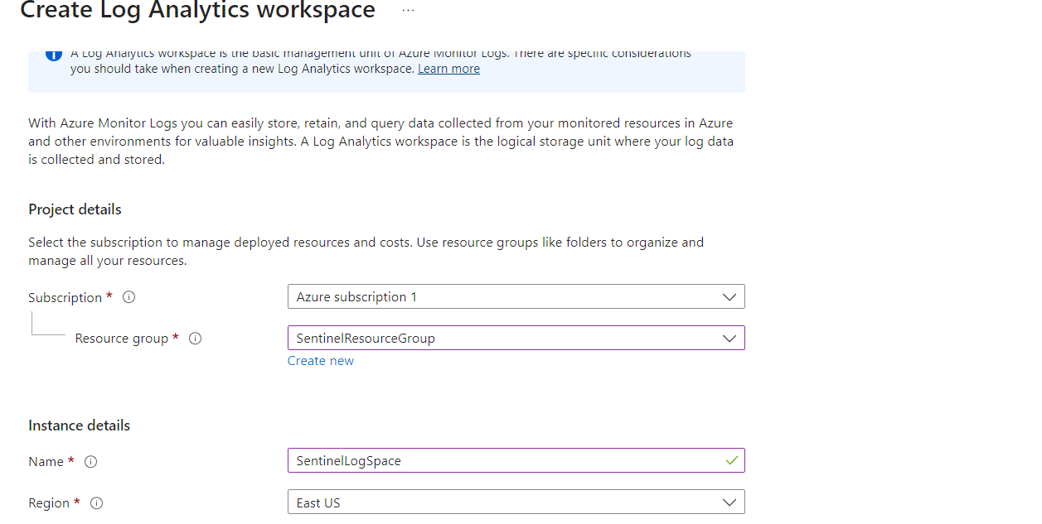

Step 3: Set Up Microsoft Sentinel
- Went back to Azure Services and selected Microsoft Sentinel.
- Added a new Sentinel instance.
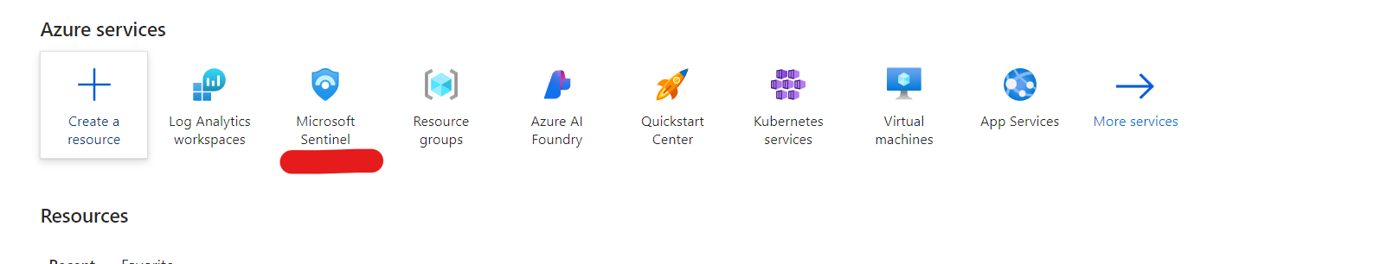
• Attached the Log Analytics Workspace (created earlier) to Sentinel.
• Optionally, Sentinel also allows creating a new workspace directly from its setup page, but I used the one I had already created.
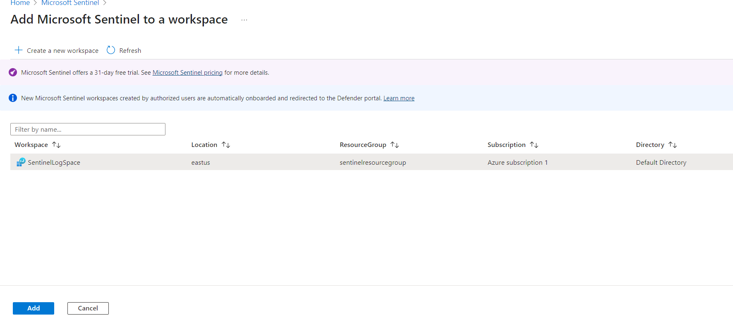

Step 4: Install Windows Security Events Data Collector
- Data Collectors in Sentinel are used to pull logs and events from different sources into the Log Analytics Workspace.
- These collectors provide the data that Sentinel analyzes, because Sentinel itself doesn’t generate logs.
- I installed the Windows Security Events connector on the host machine. These logs record important security activities like logins, failed logins, and privilege changes.
- Using Azure Arc, the Windows Security Events are brought from the host machine into Azure.
- The Data Collector then feeds these logs into Sentinel, allowing it to monitor and detect suspicious activities from that machine.

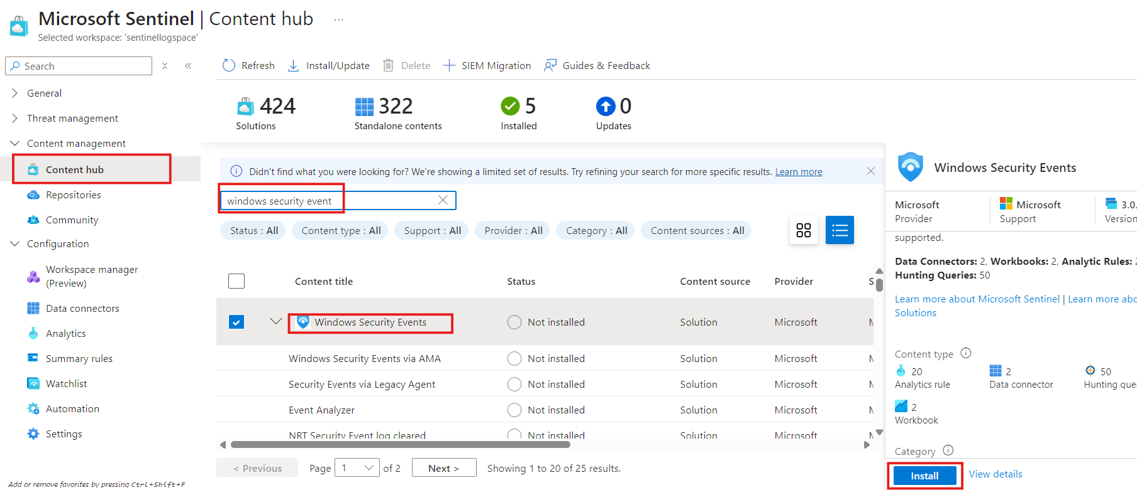

Step 5: Install Azure Arc on the Device
- Before setting up the data collector, I needed Azure Arc to bring data from my machine into Azure.
- After installing Windows Security Events, I started the Azure Arc service.
- Created the Azure Arc resource in the same Resource Group and same region as other resources.
- Selected Machine/Server as the resource type (suitable for my scenario).
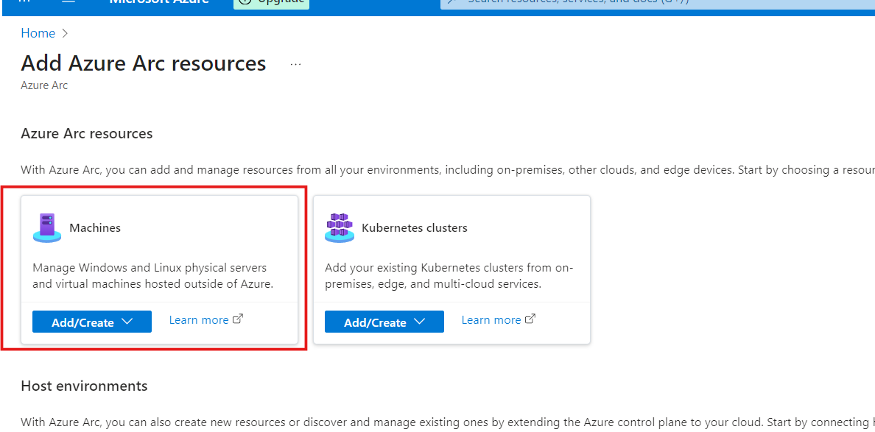
- Chose Single Server so I clicked on generate script for single server.

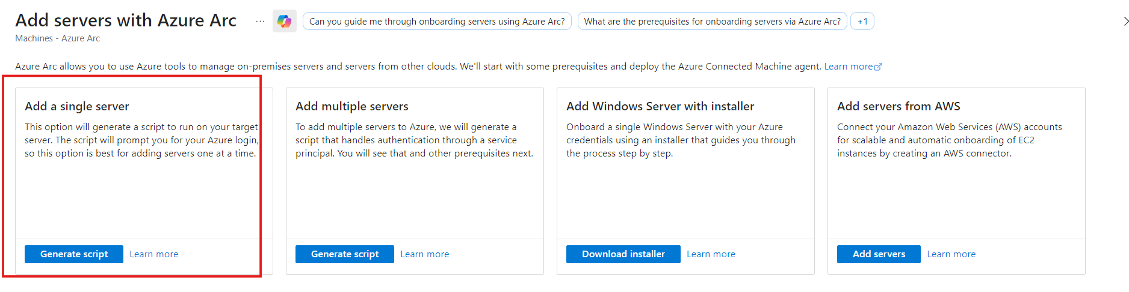
When I clicked Generate Script, I was prompted to Add a server to Azure Arc.
- Placed it in the same Resource Group and same region.
- Selected the correct operating system.
- Clicked Download and ran the script.
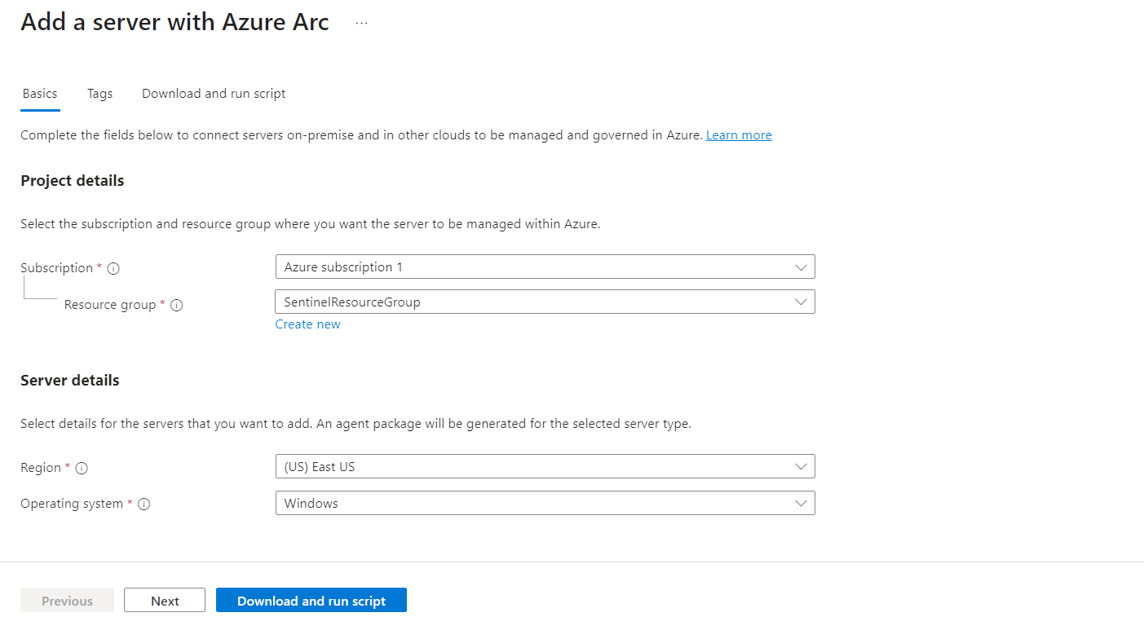
- Copied the script provided by Azure Arc and ran it in PowerShell as administrator.
- Ran into an Execution Policy error, because PowerShell restricts script execution by default.
- Fixed it by running the following command in the same PowerShell window:
Set-ExecutionPolicy -Scope Process -ExecutionPolicy Bypass
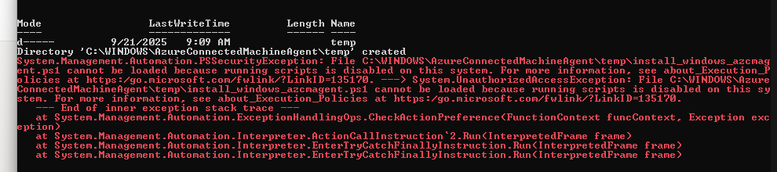
- After this, I ran the script again, entered my Microsoft credentials when prompted, and the script completed successfully.

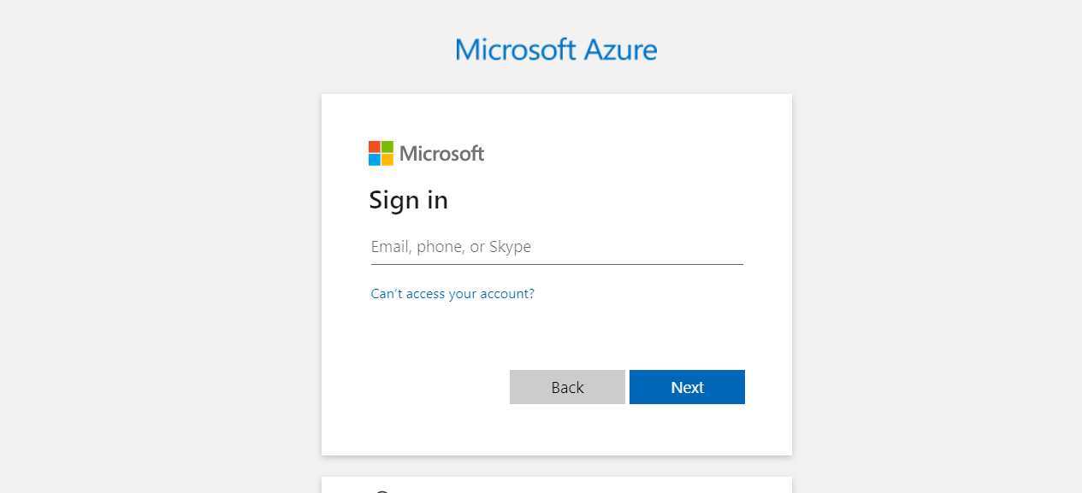

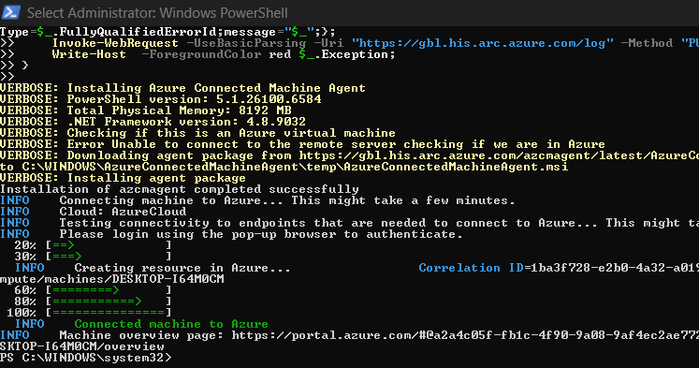
- Checked Azure Arc → Machines, and my machine was listed, confirming it was connected to Azure Arc.
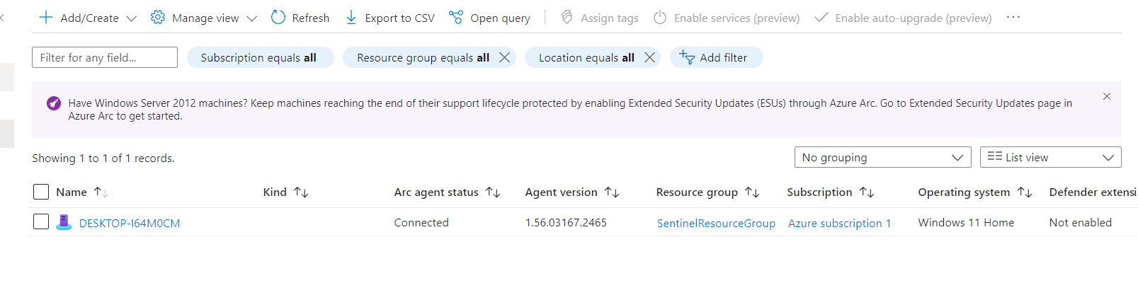

Step 6: Create a Data Collection Rule (DCR) in Windows Security Events
- Opened the Windows Security Events (WSE) connector in Sentinel.
- Noticed that no Data Collection Rules (DCRs) existed by default.
- Created a new rule to start collecting logs from my Arc-connected machine.
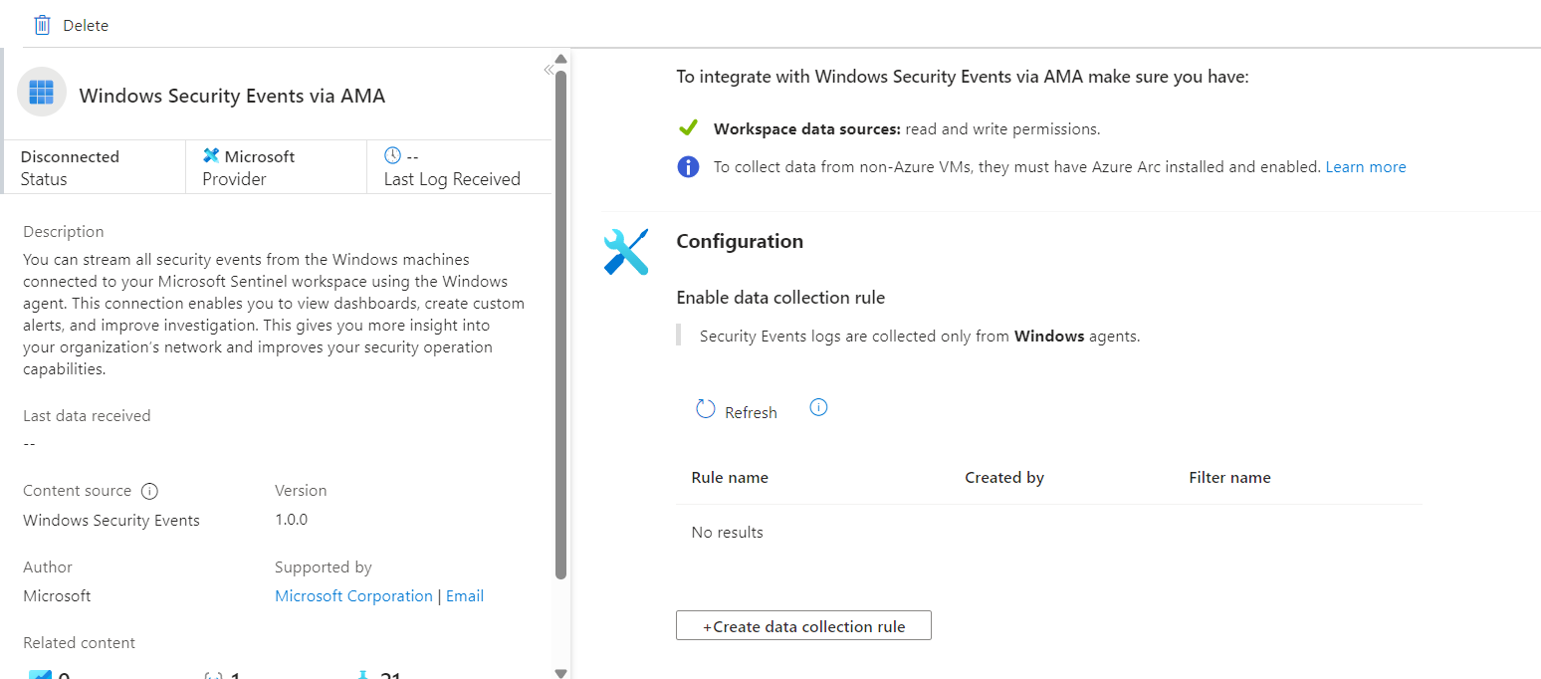
- Why: Without a DCR, Sentinel would not know which events to collect or from which machines, so creating this rule ensures that relevant Windows security events are ingested into the Log Analytics Workspace for monitoring and analysis.

Step 7: Configure Data Collection Rule (DCR) in Sentinel
- Step 1: Select Device
  - I have only one Arc-connected machine, so I selected it as the source for log collection.
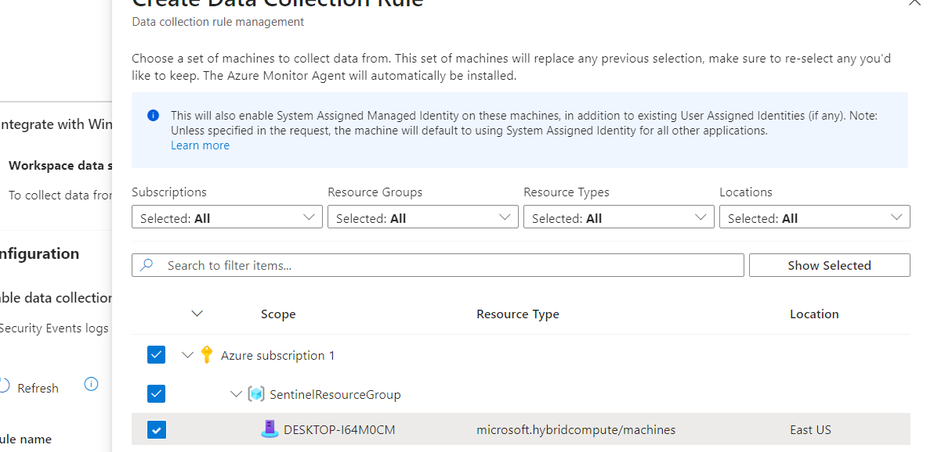
- Step 2: Select Data Type
  - Chose All Security Events to collect every security-related log from the device.
  - Examples of events collected: logins, failed logins, account lockouts, privilege changes, process creation, and policy changes.
- Other Options for Data Collection:
  - Common: Collects frequently used security logs (e.g., login attempts, account changes, and system events).
  - Minimal: Collects only essential security logs needed for basic monitoring.
  - Custom: Lets you select specific event types or IDs to fine-tune what logs Sentinel receives.
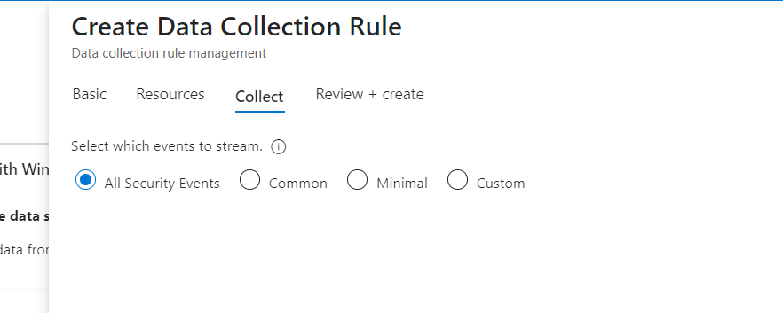

Step 8: Validate Log Ingestion in Sentinel
- Opened Microsoft Sentinel and went to the Logs section.
- Ran the query:
union *
- This query retrieves all logs from the connected sources in the Log Analytics Workspace.
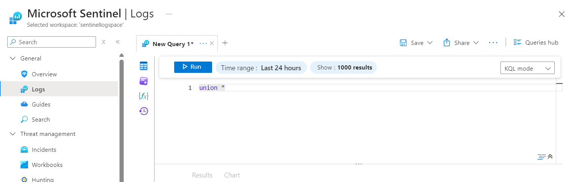
- Verified that logs from my Arc-connected machine and Windows Security Events were successfully ingested into Sentinel.
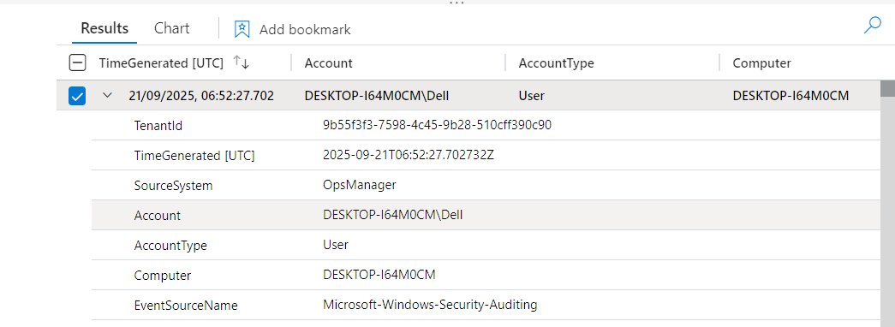
- After completing the project, I disconnected my Arc-connected machine from Azure using PowerShell.
- Ran the command:
- azagent disconnect
- This removed the machine from Azure Arc, stopping log ingestion to Sentinel.

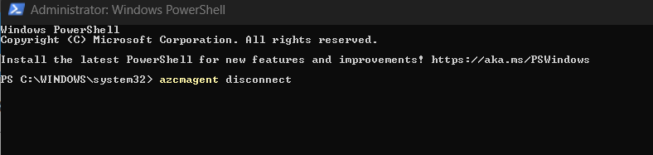

What I Learned
- Gained hands-on experience with Microsoft Sentinel and learned how to set up a SIEM in Azure.
- Learned the importance of a Log Analytics Workspace as the central repository for all collected logs.
- Understood how Azure Arc connects on-premises or hybrid devices to Azure for monitoring and management.
- Learned to install and configure the Windows Security Events connector to collect critical security logs.
- Gained experience creating Data Collection Rules (DCRs) and choosing which security events to collect (All, Common, Minimal, or Custom).
- Learned how to validate log ingestion in Sentinel using KQL queries (union *) to see all logs.
- Learned how to troubleshoot PowerShell Execution Policy errors when running scripts.
- Gained practical knowledge of disconnecting Arc-connected machines and controlling log flow from devices.
- Developed a clearer understanding of how SIEMs centralize, monitor, and analyze security events, which is essential for real-world cybersecurity operations.

