Access Amazon S3 from a VPC
By Haroon Zaman | December 2025

Introduction
In this project, I learned how to allow resources inside a Virtual Private Cloud (VPC) to securely interact with Amazon S3. By default, resources in a VPC cannot access AWS services unless proper permissions and network configurations are in place. This project focuses on enabling that access in a controlled and secure way.
The goal of this project was to understand how EC2 instances communicate with AWS services like S3, how access permissions are granted using AWS credentials, and how traffic flows from a VPC to external AWS services.
In this project, I performed the following tasks:
- Set up a VPC with an EC2 instance
- Used AWS access keys to give the EC2 instance permission to interact with AWS services
- Accessed and interacted with Amazon S3 directly from the EC2 instance
- Observed how network and security configurations allow private resources to reach AWS-managed services
This project helped me understand how AWS services work together, how identity and access management controls permissions, and how cloud resources securely communicate with services outside the VPC while staying within AWS’s infrastructure.
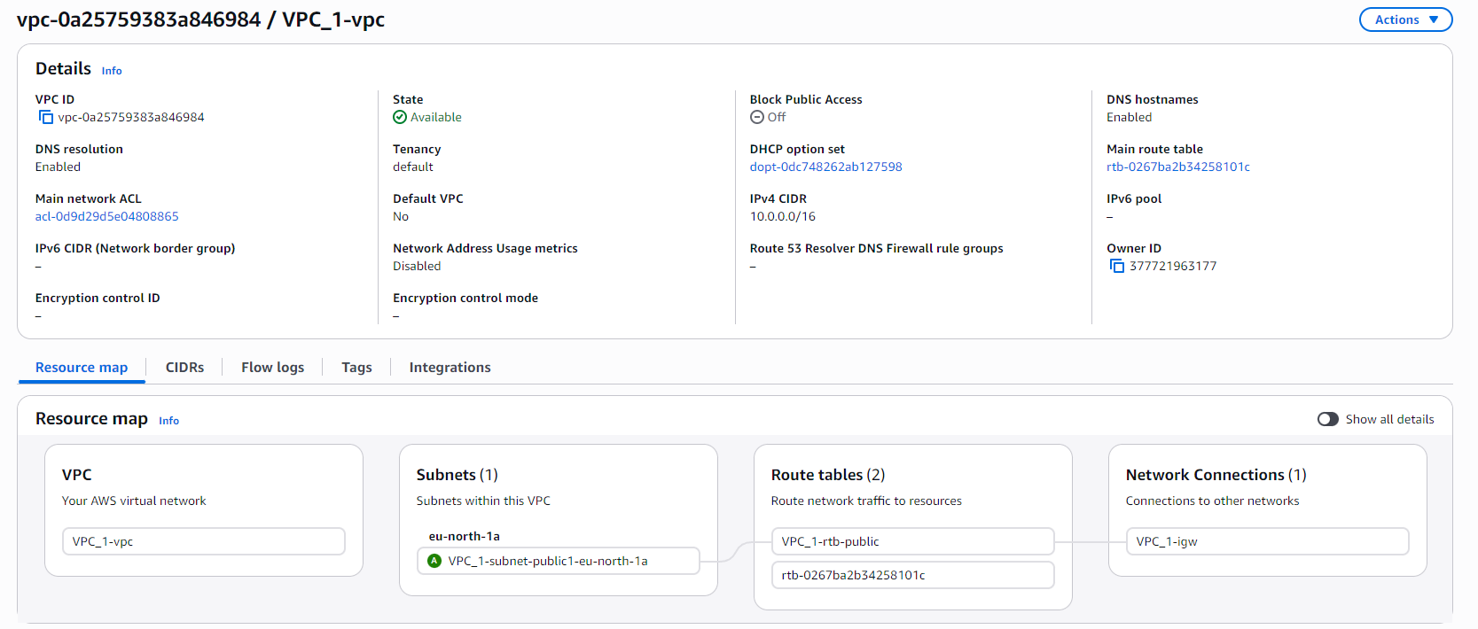

Create VPC and EC2 Instance
- I created a new VPC and named it VPC_1.
- I assigned the IPv4 CIDR block 10.0.0.0/16 to provide a large private IP range.
- I selected one Availability Zone for a simple setup.
- I created one public subnet and no private subnet, because this project only requires a public EC2 instance to access Amazon S3.
- I did not configure a NAT Gateway, since NAT is only needed when private subnets require outbound internet access.
- After reviewing the settings, I created the VPC.

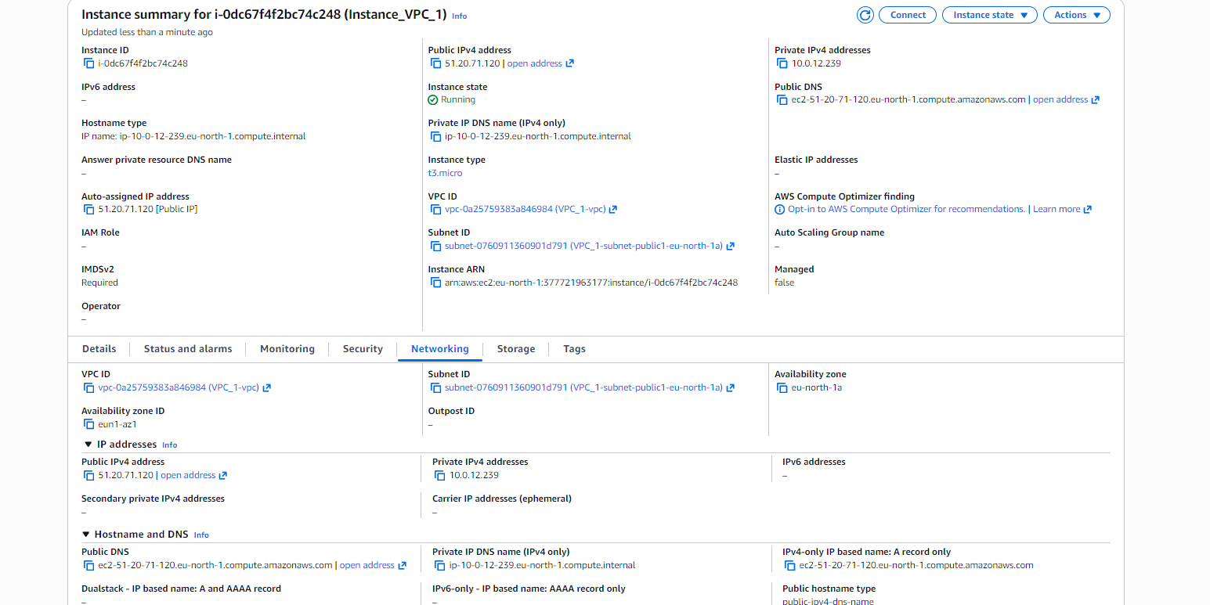
- Next, I created an EC2 instance and named it Instance_1.
- I selected Amazon Linux as the operating system.
- I chose the t3 instance type, which is suitable for lightweight testing and learning.
- I did not create a key pair, as SSH access was not required for this task.
- In the network settings, I selected VPC_1 and its public subnet.
- I enabled Auto-assign Public IP so the instance could reach AWS services.
- I created a new Security Group and allowed SSH.
- Finally, I launched the EC2 instance successfully.
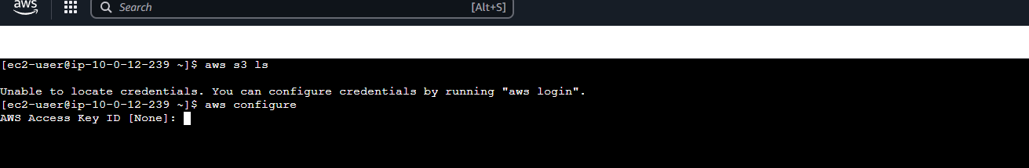

AWS Access Keys and Credentials
- After creating the instance, I connected to it and ran the command:
aws s3 ls
- This returned an error saying “Unable to locate credentials”, which means the instance did not yet have permission to access AWS services.
- To fix this, I ran aws configure, which requires an AWS Access Key ID.

What is an Access Key ID?
- An Access Key ID is part of an AWS credential.
- AWS credentials are similar to a username and password.
- The Access Key ID acts like the username, and the Secret Access Key acts like the password.
- You don’t get an access key automatically — it must be created through AWS IAM.

Difference Between Access Keys and Key Pairs
- Key Pairs are used for logging into EC2 instances via SSH.
- Access Keys are used by applications and services (like AWS CLI) to authenticate and interact with AWS resources such as S3.
- In simple terms:
  - Key Pair → Login to EC2
  - Access Key → Access AWS services
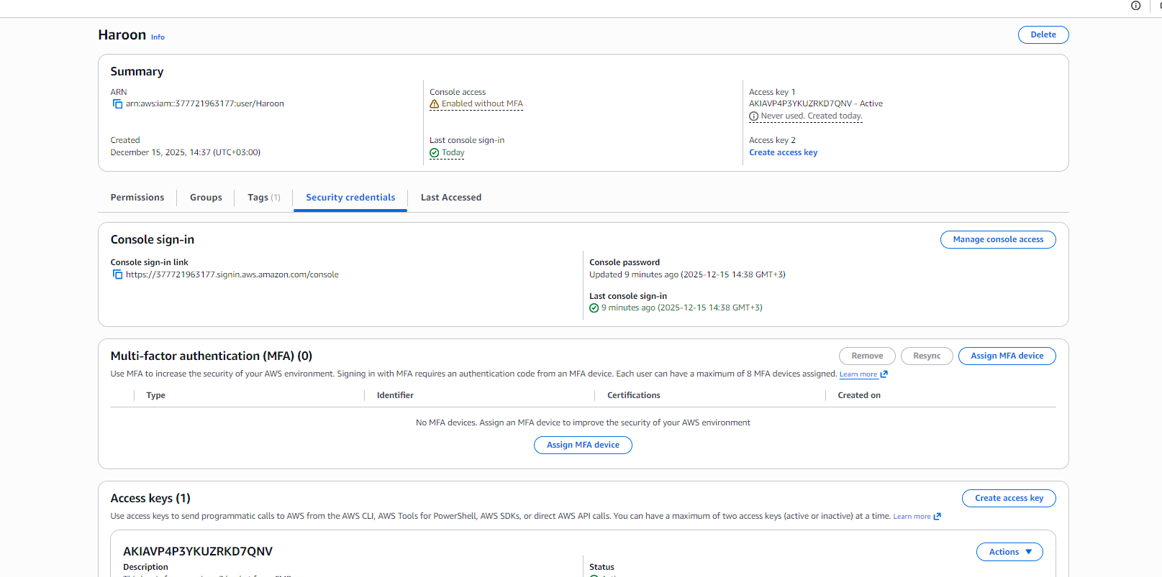

Creating an IAM User for Access Keys
- To create an Access Key, I first needed an IAM user, because access keys are managed at the user level.
- Since I did not have any IAM user already created, I created one myself.
- I created a new IAM user and named it Haroon.
- I granted this user Administrator permissions so it would have full access to AWS services for this project.
- After creating the user, I was able to manage and generate Access Keys for it.
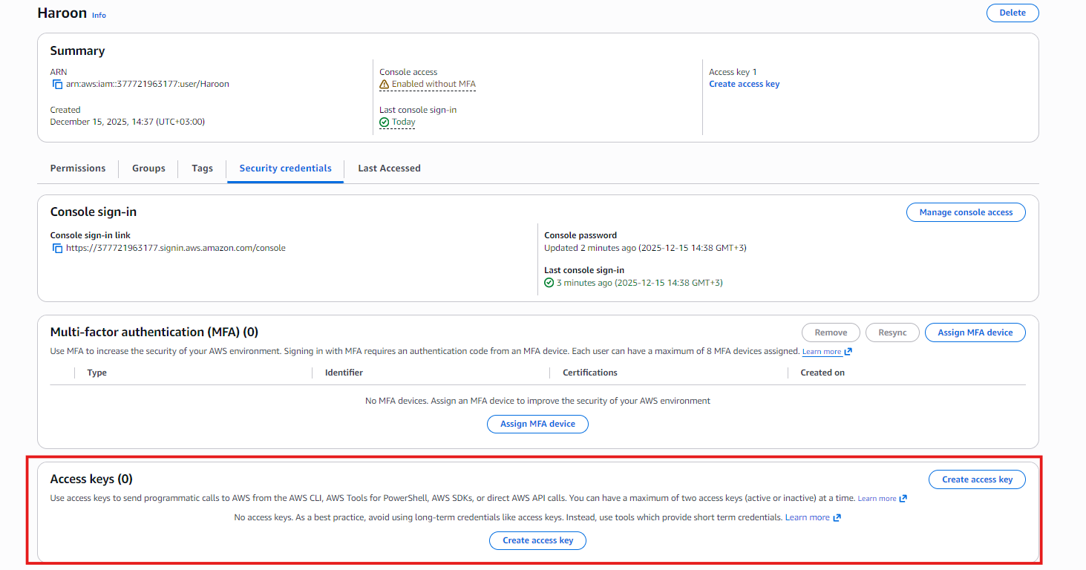
- After creating the IAM user, I opened the user Haroon in the IAM console.
- I scrolled down to the Access keys section.
- From there, I clicked on Create access key to generate new credentials for AWS CLI access.
- After clicking Create access key, a new window opened.
In Step 1, I had to choose the use case for the access key.
- The available use case options were:
- Command Line Interface (CLI)
Used when you want to access AWS services using the AWS CLI commands.
- Local code
Used when application code running on your local machine needs to access AWS resources.
- Application running on an AWS compute service
Used when applications running on EC2, ECS, or Lambda need AWS access.
- Third-party service
Used when an external tool or service needs permission to manage or monitor AWS resources.

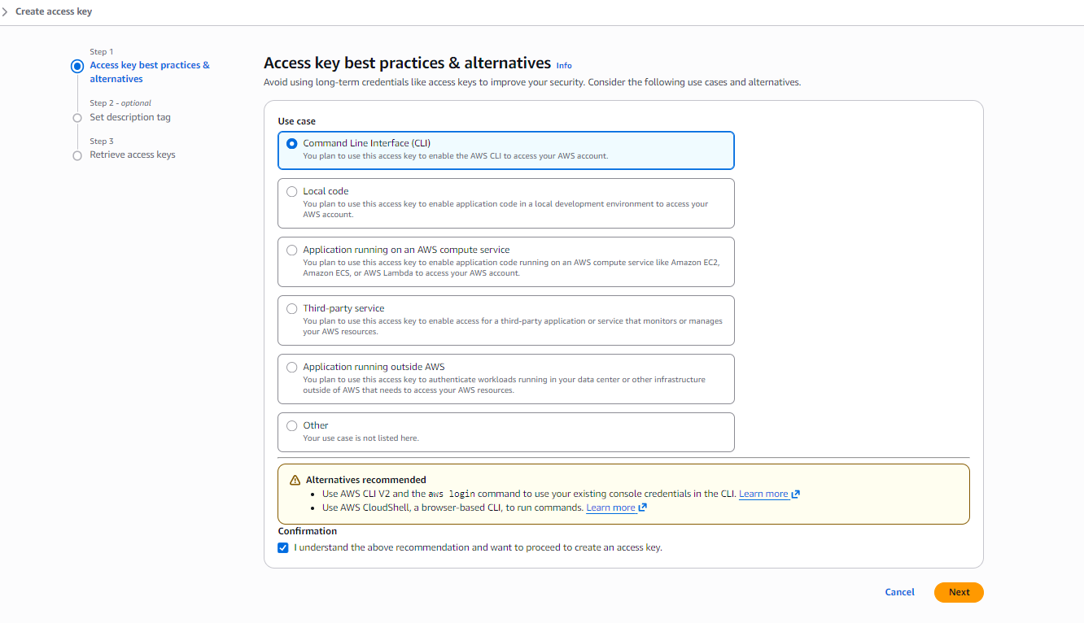
- Application running outside AWS
Used when workloads running outside AWS (on-prem or another cloud) need AWS access.
- Other
Used if your use case does not fit any of the listed options.
- I selected Command Line Interface (CLI) because I planned to use the AWS CLI from my EC2 instance.
- I checked the confirmation box and clicked Next.
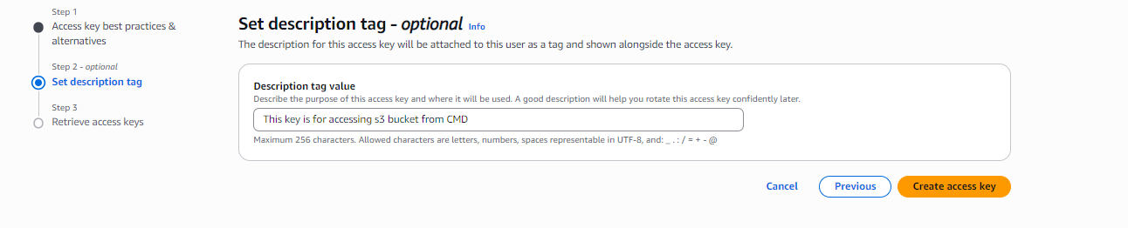
- In the next step, I added a description to help identify the access key later.
- After setting the description, I clicked Create access key to generate the credentials.

- After creating the access key, AWS generated an Access Key ID and a Secret Access Key.
- These credentials are used together to authenticate with AWS services.
- I was given the option to download the keys as a .csv file for safe storage.
- This is the only time the Secret Access Key is visible, so it must be saved securely.

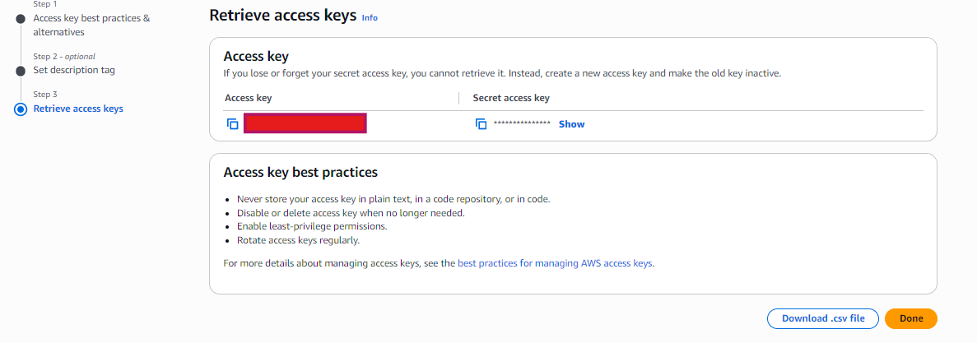
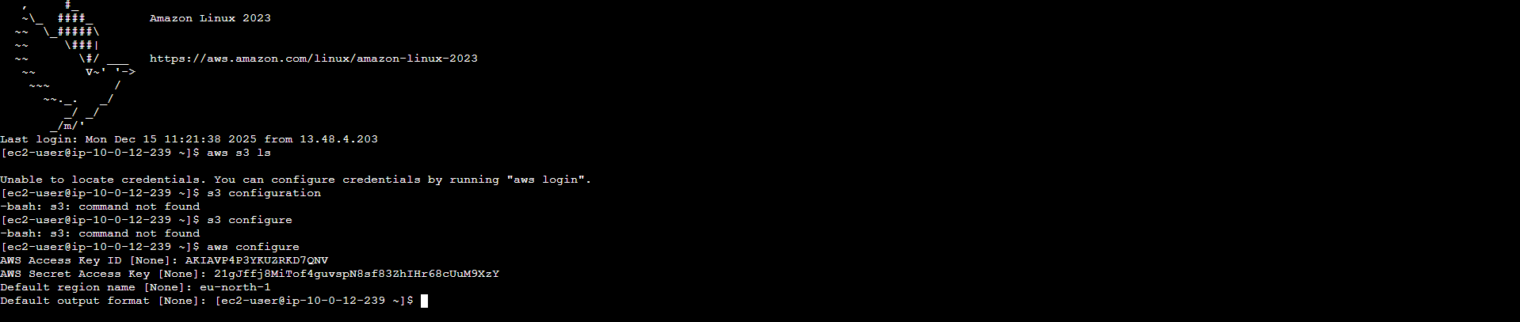
- After that, I went back to the EC2 instance I had connected to earlier.
- I entered the Access Key ID and then the Secret Access Key when prompted.
- After providing the credentials, the login and configuration were successful.
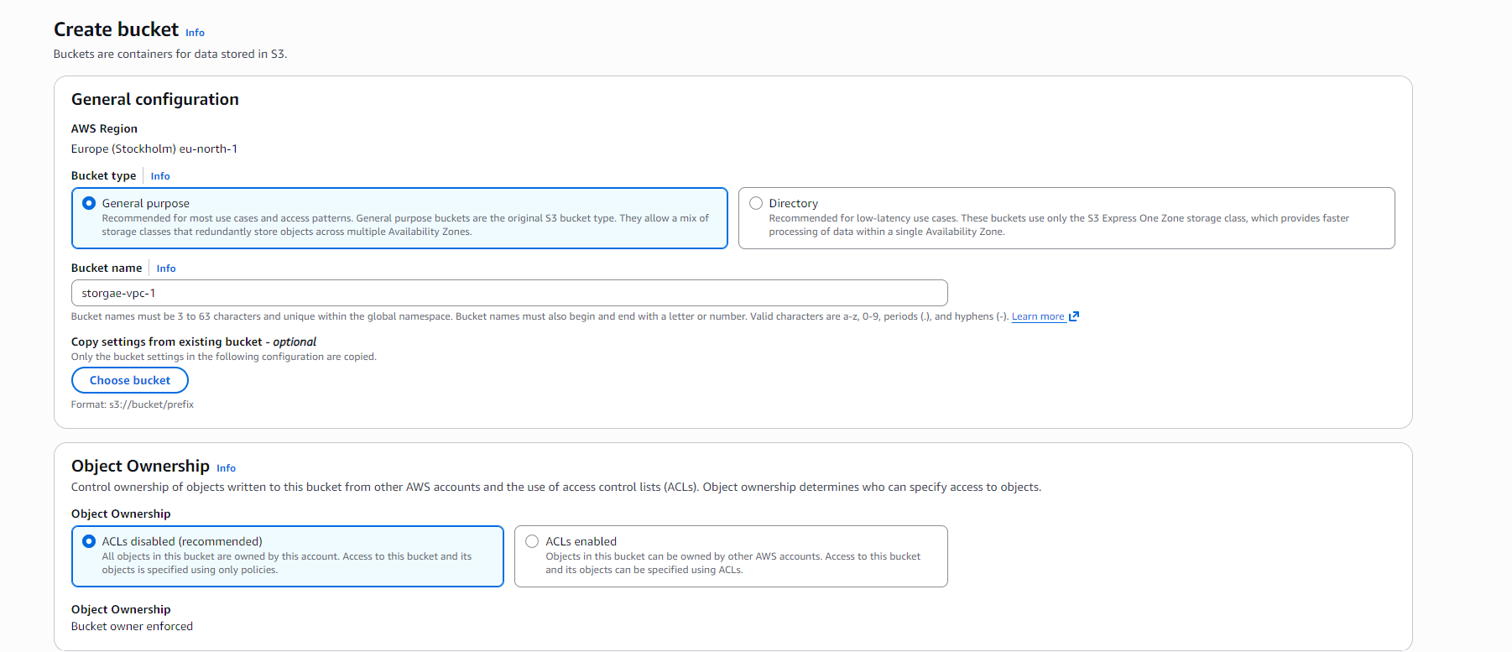

Creating the S3 Bucket
- Next, I created an Amazon S3 bucket.
- I searched for S3 in the AWS console and clicked Create bucket.
- I selected the General purpose bucket type, which is used for standard object storage like files, backups, and logs.
- I gave the bucket the name storage_vpc_1.
- For Object Ownership, I kept ACLs disabled.
  - This is recommended by AWS because access should be managed using IAM policies instead of ACLs.
  - Disabling ACLs improves security and simplifies permission management.
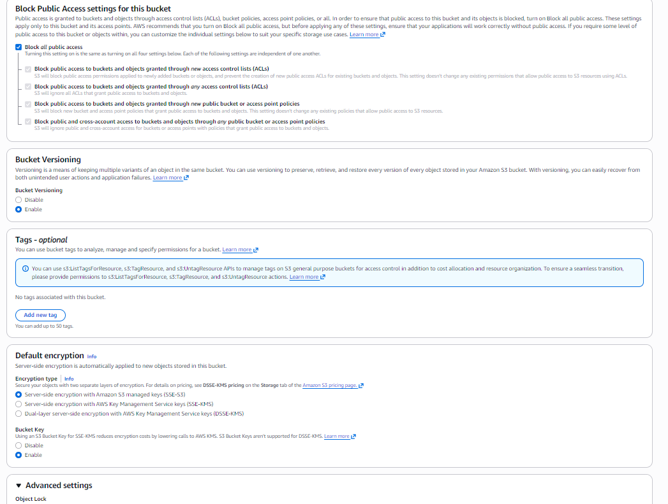
- I left all other settings on default.
- Finally, I clicked Create bucket, and the S3 bucket was created successfully.
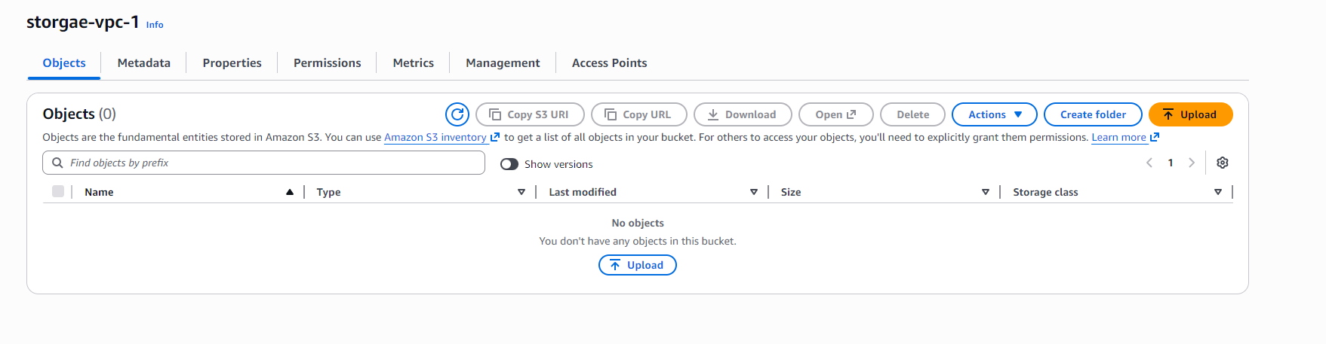
- After creating the S3 bucket, it was time to upload files.
- I opened the bucket storage_vpc_1.
- I clicked Upload and it opened a new window.

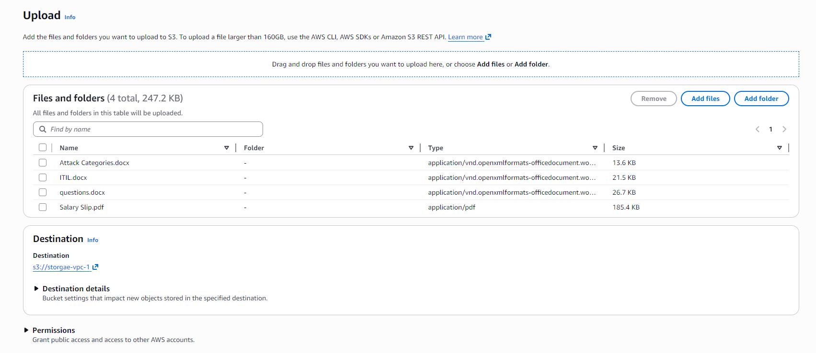
- In the upload window, I clicked Add files and selected some random files from my PC.
- I also had the option to create a folder inside the bucket.
- I could choose the destination location for the files and set permissions if needed.
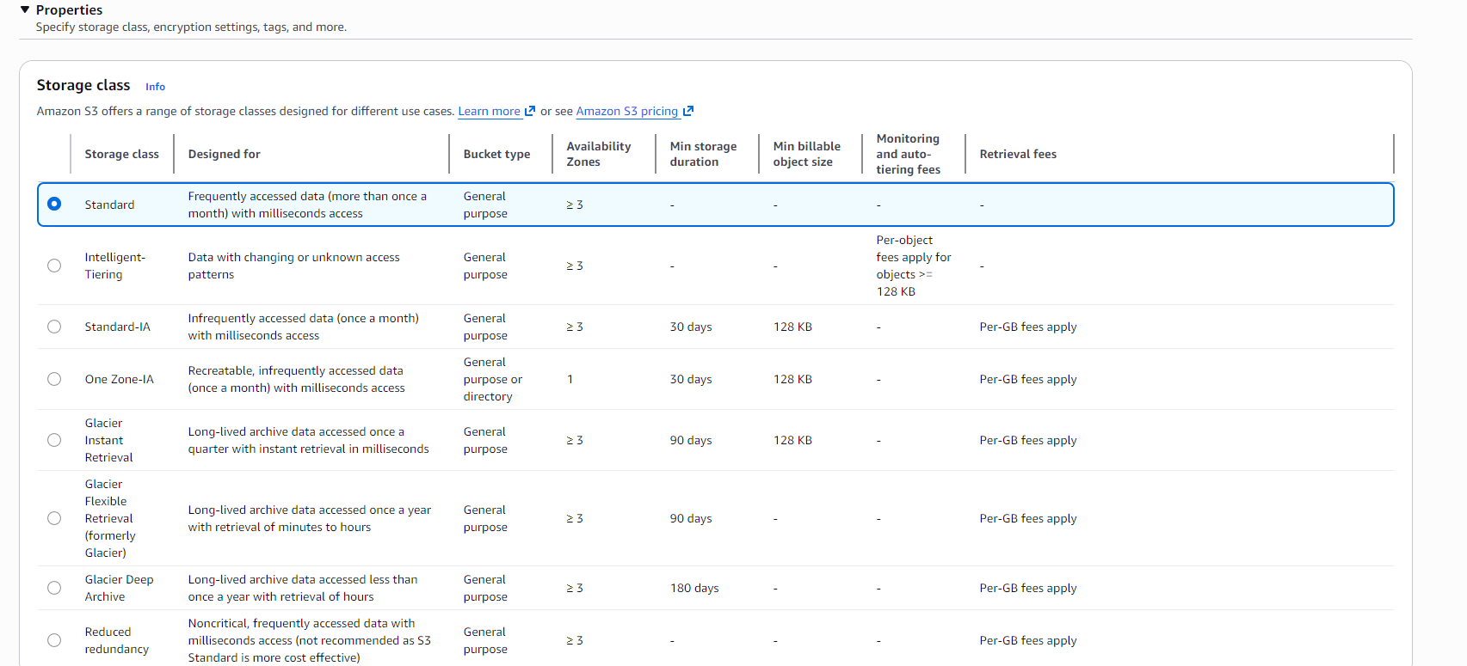

- After scrolling down, I reached the Storage class section.
- I selected Standard, which is used for frequently accessed data.
- Other storage class options available were:
- Intelligent-Tiering
- Standard-IA (Infrequent Access)
- One Zone-IA
- Glacier Instant Retrieval
- Glacier Flexible Retrieval
- Glacier Deep Archive
- After selecting the storage class, I clicked Upload.
- The files were uploaded successfully to the S3 bucket.
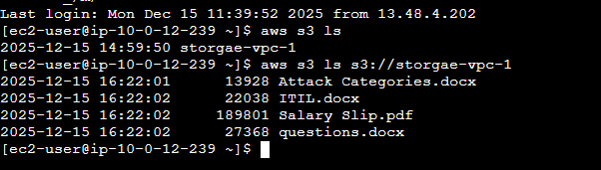
- From inside the EC2 instance in the VPC, after configuring the AWS credentials, I accessed the S3 bucket.
- I ran the command:
aws s3 ls s3://storage_vpc_1
- This command listed all files and folders stored inside the S3 bucket.
- The successful output confirmed that the EC2 instance inside the VPC could access Amazon S3 correctly.
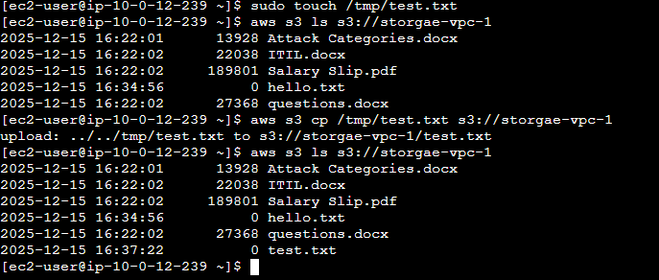

- I also created a file directly from the EC2 instance using the CLI.
- I ran the command:
sudo touch /tmp/test.txt
- This command created a file named test.txt inside the /tmp directory.
- After creating test.txt, I copied it to the S3 bucket.
- I ran the command:
aws s3 cp /tmp/test.txt s3://storage_vpc_1
- After copying the file, I checked the bucket contents again using:
aws s3 ls s3://storage_vpc_1
- The test.txt file was listed in the output, confirming that the file was successfully uploaded from the EC2 instance to the S3 bucket.

Conclusion
In this project, I successfully configured a VPC and EC2 instance to securely access Amazon S3. I learned how AWS credentials work, how access keys differ from key pairs, and how IAM users control permissions for AWS services.
By creating an S3 bucket, uploading files through the AWS Console, and interacting with the bucket directly from an EC2 instance using the AWS CLI, I verified that resources inside a VPC can communicate with AWS services when proper identity and access configurations are in place.
This project strengthened my understanding of IAM, S3, and AWS networking, and showed how permissions and credentials enable secure access to cloud services without exposing unnecessary public access.

