VPC Monitoring with Flow Logs & CloudWatch Logs
By Haroon Zaman | December 2025

Introduction
In this project, I explored how to monitor network traffic inside AWS using VPC Flow Logs and Amazon CloudWatch Logs. Network monitoring is essential for understanding how resources communicate within a VPC, how data moves in and out, and whether any security rules are blocking traffic.
Before enabling monitoring, I first set up the full networking environment:
- Created two separate VPCs, each with its own CIDR block
- Launched one EC2 instance in each VPC
- Created a VPC Peering connection so both VPCs could communicate privately
- Verified successful connectivity between both EC2 instances
Once the two VPCs were communicating, I added monitoring tools to track what kind of traffic was flowing between them.
Network monitoring helps engineers:
- Check the source and destination of traffic inside the VPC
- Analyse how much data is being transferred
- Identify traffic that is being blocked by security groups or NACLs
- Ensure resources are communicating securely
- Optimize network performance in advanced setups
In this project, I completed the following tasks:
- Set up two VPCs and validated their peering connection
- Enabled VPC Flow Logs to collect detailed network traffic information
- Sent logs to Amazon CloudWatch Logs
- Created the necessary IAM role and permissions policy
- Analysed flow log data using CloudWatch Log Insights
This setup allowed me to fully monitor the communication between my VPCs and understand how network traffic behaves at a low level inside AWS.

Creating Two VPCs for Monitoring

VPC 1 Setup
- I created the first VPC and named it VPC_1.
- I assigned it the IPv4 CIDR block 10.1.0.0/16, giving it a large private IP range.
- I created one public subnet inside this VPC.

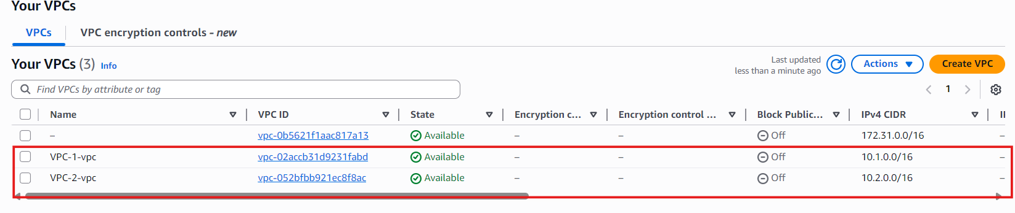
- I selected No NAT Gateway, since I wasn’t using private subnets that require outbound internet access.
- I also selected No S3 Gateway Endpoint, because this project focuses on VPC-to-VPC connectivity and monitoring, not private S3 access.

VPC 2 Setup
- Next, I created the second VPC named VPC_2.
- I assigned it a different IPv4 CIDR block: 10.2.0.0/16.
(Each VPC must have a unique CIDR range for peering and communication.)
- Just like the first VPC, I added one public subnet.
- Again, I chose No NAT Gateway, since the subnet didn't require private outbound traffic.
- I selected No S3 Gateway Endpoint for the same reasons as VPC_1.

Creating EC2 Instances in Both VPCs

Instance in VPC_1
- I created the first instance and named it Instance_VPC_1.
- I attached it to VPC_1 and selected the public subnet of that VPC.
- I enabled Auto-assign Public IPv4, so this instance could be reached from the internet for testing and monitoring.
- In the Security Group settings, I created a new SG specifically for this instance.
  - I allowed SSH (port 22) so I could connect to it.
  - I allowed ICMP – IPv4 so I could use ping for connectivity tests.
- After setting the rules, I launched the instance.
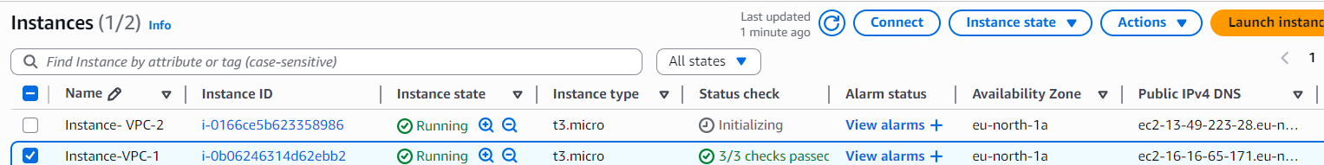

Instance in VPC_2
- I created the second instance and placed it inside VPC_2.
- I selected the public subnet of VPC_2 as well.
- This instance also uses private communication for peering tests, so the setup matched the first instance (except no need for a public IP if not connecting externally).
- I launched Instance_VPC_2 with similar settings to keep the testing environment consistent.

Setting Up CloudWatch for VPC Monitoring

What is Amazon CloudWatch?
- Amazon CloudWatch is a powerful monitoring service that observes everything happening in your AWS environment in real time.
- AWS services send their metrics and logs to CloudWatch, where you can view them as clear dashboards, graphs, and insights.
- CloudWatch helps track performance, detect unusual traffic, and understand the overall health of your AWS environment.
- It can even automate actions, such as blocking illegitimate traffic or alerting you when something suspicious happens.
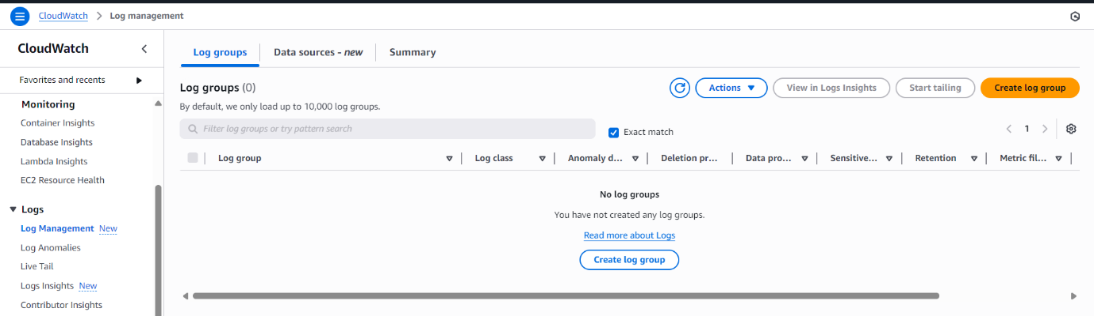

Creating a Log Group in CloudWatch
- I searched for CloudWatch in the AWS Console and opened the service.
- On the left panel, under Logs, I selected Log groups.
- I created a new log group, which is required to store all VPC Flow Log data.
- This log group will act as the destination where flow logs from both VPCs will be sent for monitoring and analysis.

Creating the Log Group in CloudWatch

What is a Log Group?
- A Log Group is a container inside CloudWatch where log data is stored and organized.
- All logs from a resource (like VPC Flow Logs, Lambda logs, EC2 logs, etc.) are sent into a log group.
- Think of it as a folder that stores and manages all related log streams for easier monitoring and analysis.

Cofiguring the Log Group
- I named my log group LG_VPC1n2, since it will store flow logs from both VPCs.
- The retention period defines how long the logs will be stored before CloudWatch automatically deletes them.
- Options range from 1 day up to 10 years.
- I selected Never Expire, which keeps all logs permanently unless deleted manually.
- This is useful for long-term troubleshooting or security analysis.
- CloudWatch offers two log classes:
Standard – Designed for logs that will be accessed or analyzed regularly.
Infrequent Access – Lower storage cost but higher cost per retrieval; suited for long-term archiving.
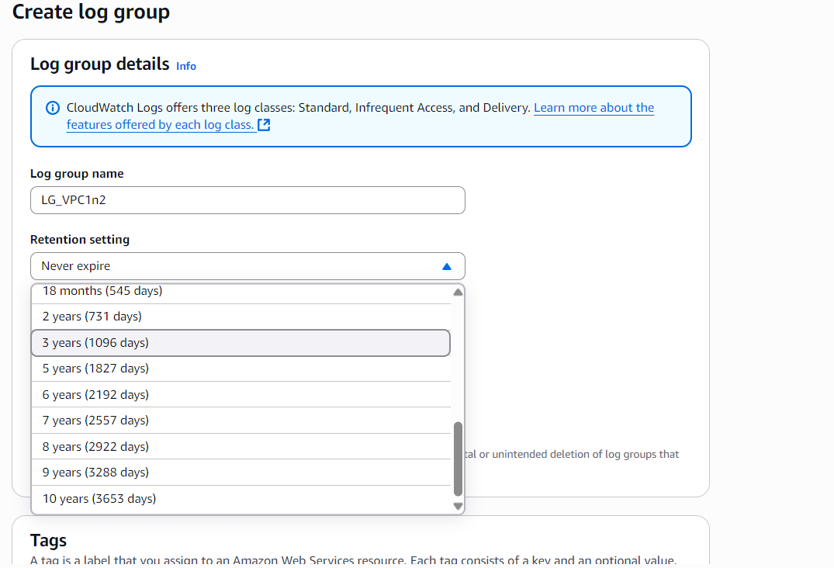
- I chose Standard, since I will be actively analyzing the VPC flow logs.
- A KMS Key ARN is an encryption key used to encrypt logs at rest.
- Since encrypting flow logs wasn’t required for this project, I left this setting empty.
- It remains optional unless strict compliance or encryption policies are needed.
- CloudWatch offers an option to protect the log group from accidental deletion.
- I left this unchecked, as I may modify or recreate the log group during practice.
- After reviewing all settings, I clicked Create Log Group, and LG_VPC1n2 was successfully created.
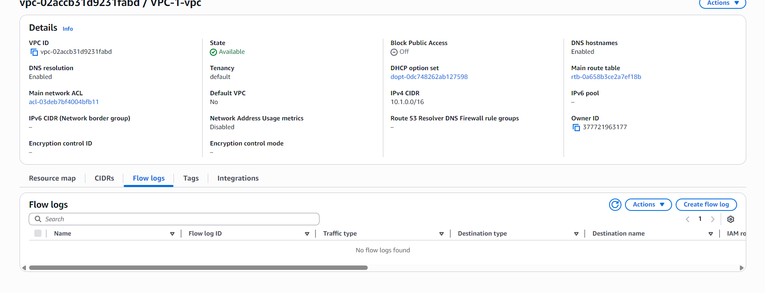

Creating VPC Flow Logs for VPC_1
- After creating the Log Group, I went back to the VPC Console and selected VPC_1.
- On the left-side menu, I opened Flow Logs and clicked Create Flow Log.
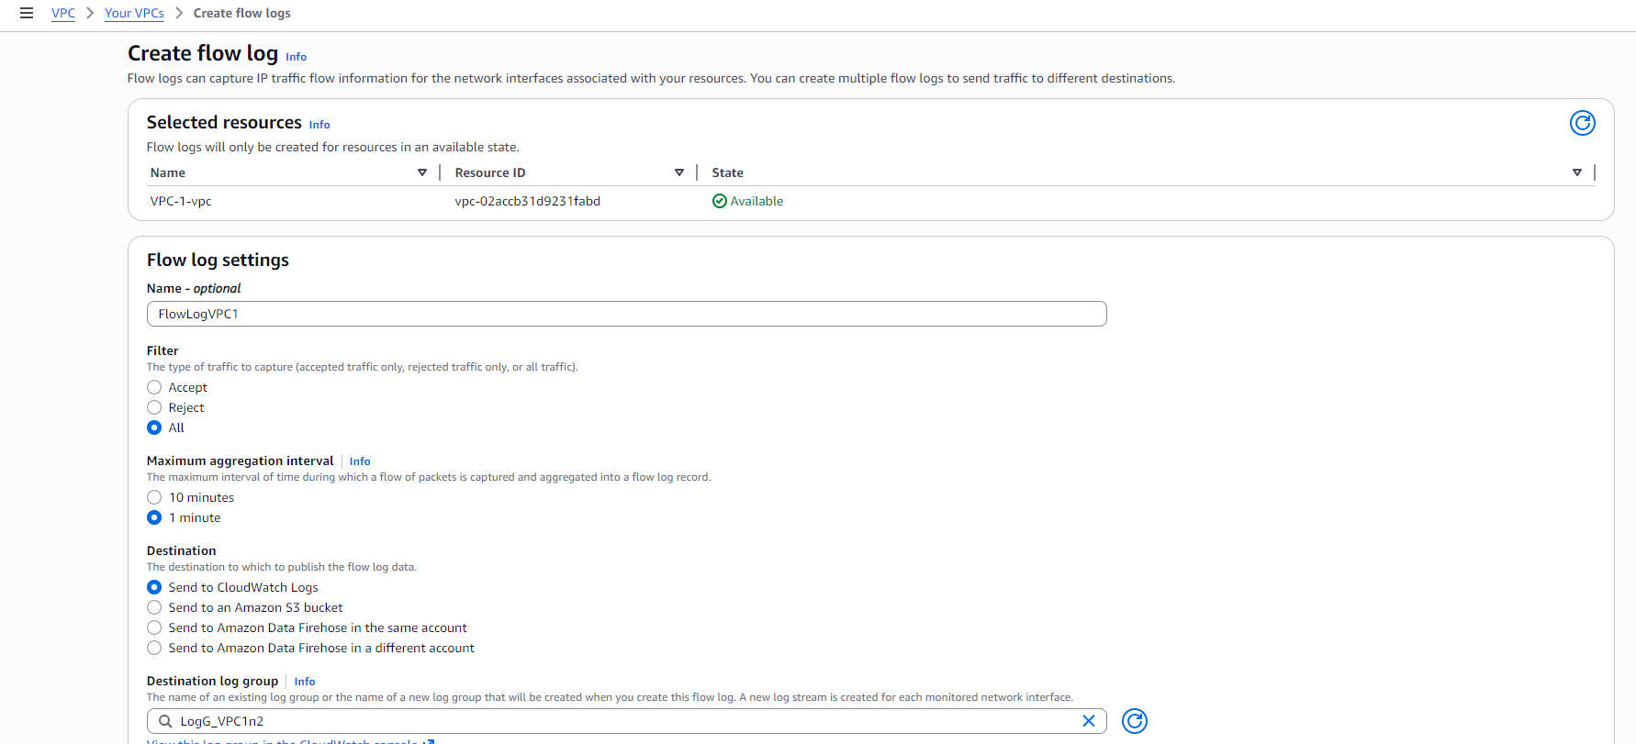

Configuring the Flow Log for VPC_1
- I named the flow log FlowLogVPC1 to clearly identify which VPC it belongs to.
- For the Filter, I selected All.
- This captures accepted, rejected, and all network traffic going in and out of the VPC.
- Choosing “All” provides complete visibility, which is ideal for learning and troubleshooting.
- I selected the 1-minute interval.
- What is Maximum Aggregation Interval?
  - It defines how often AWS delivers flow log records to the destination (CloudWatch).
  - Shorter intervals (like 1 min) give faster visibility into traffic.
  - Longer intervals (10 min) reduce cost but delay log delivery.
- For monitoring and testing, 1 minute is the best choice.
- For the destination, I selected CloudWatch Logs.
- Then I chose the log group I created earlier: LG_VPC1n2.
- This ensures all captured VPC traffic is stored and viewable inside CloudWatch.

Service Role Requirement
- Flow Logs require an IAM Service Role with permission to deliver logs into CloudWatch.
- Why is a service role needed?
  - Because VPC Flow Logs must write log data to CloudWatch Logs.
  - The VPC service itself doesn’t have permission by default.
  - The service role grants AWS permission to push logs into your CloudWatch log group on your behalf.
- Since I didn’t have a service role yet, I had to create one before completing the flow log setup.
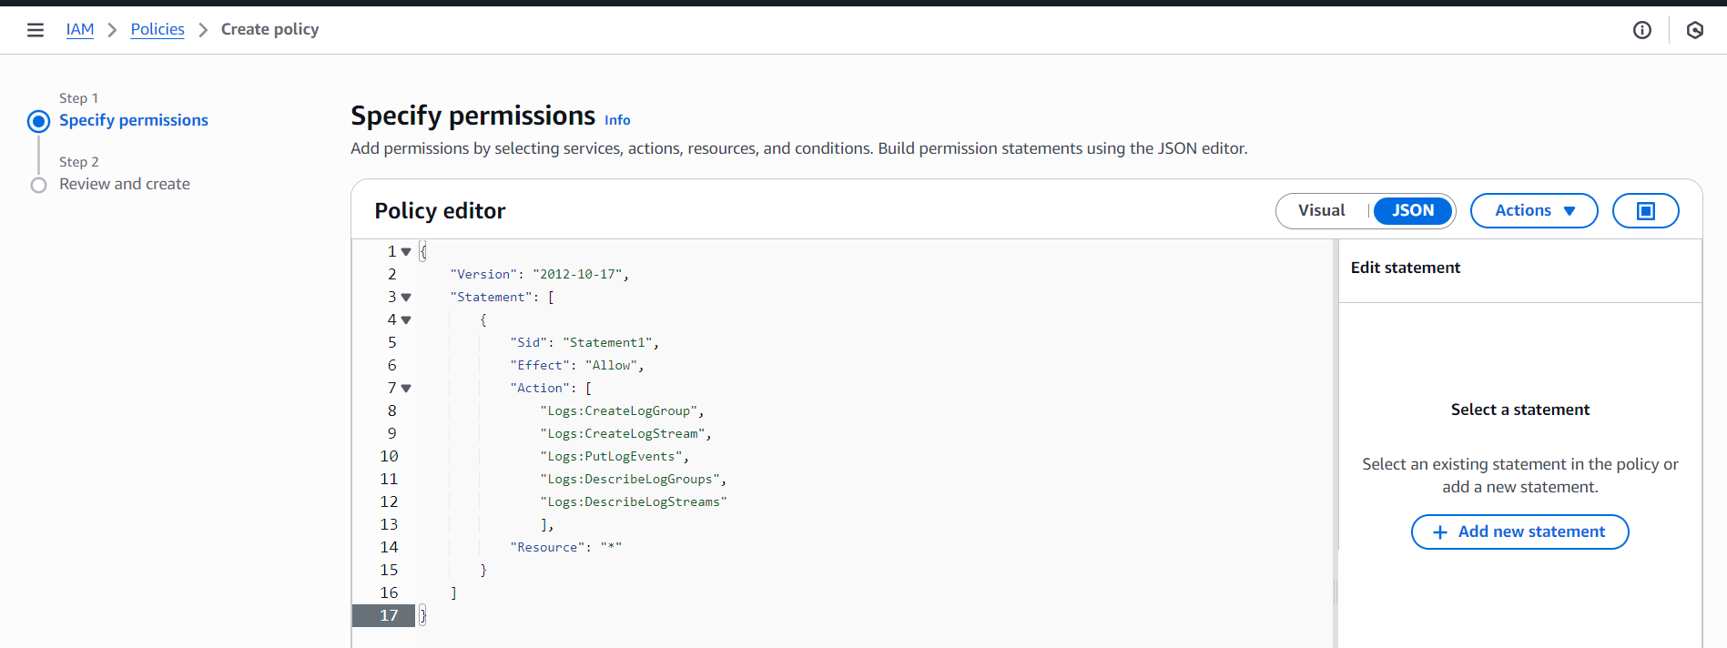

Creating the IAM Policy for Flow Logs
- I needed a service role, so I searched for IAM in the console.
- I first tried to create the role, but AWS required a policy to exist before the role could be created.
So I went to IAM → Policies → Create policy.
- I switched to the JSON editor because I wanted to create a custom policy.
  - A custom policy lets me define EXACTLY what permissions are allowed.
  - It works like a VIP list — only the services we choose can use this permission.
- In the JSON editor, I added the actions required for VPC Flow Logs to write logs to CloudWatch:
  - logs:CreateLogGroup – allows creating new log groups
  - logs:CreateLogStream – allows creating streams inside log groups
  - logs:PutLogEvents – allows sending log data into CloudWatch
  - logs:DescribeLogGroups – lets the role view log groups
  - logs:DescribeLogStreams – lets it view log streams
- For Resource, I used "*", meaning the policy applies to all log groups and streams.
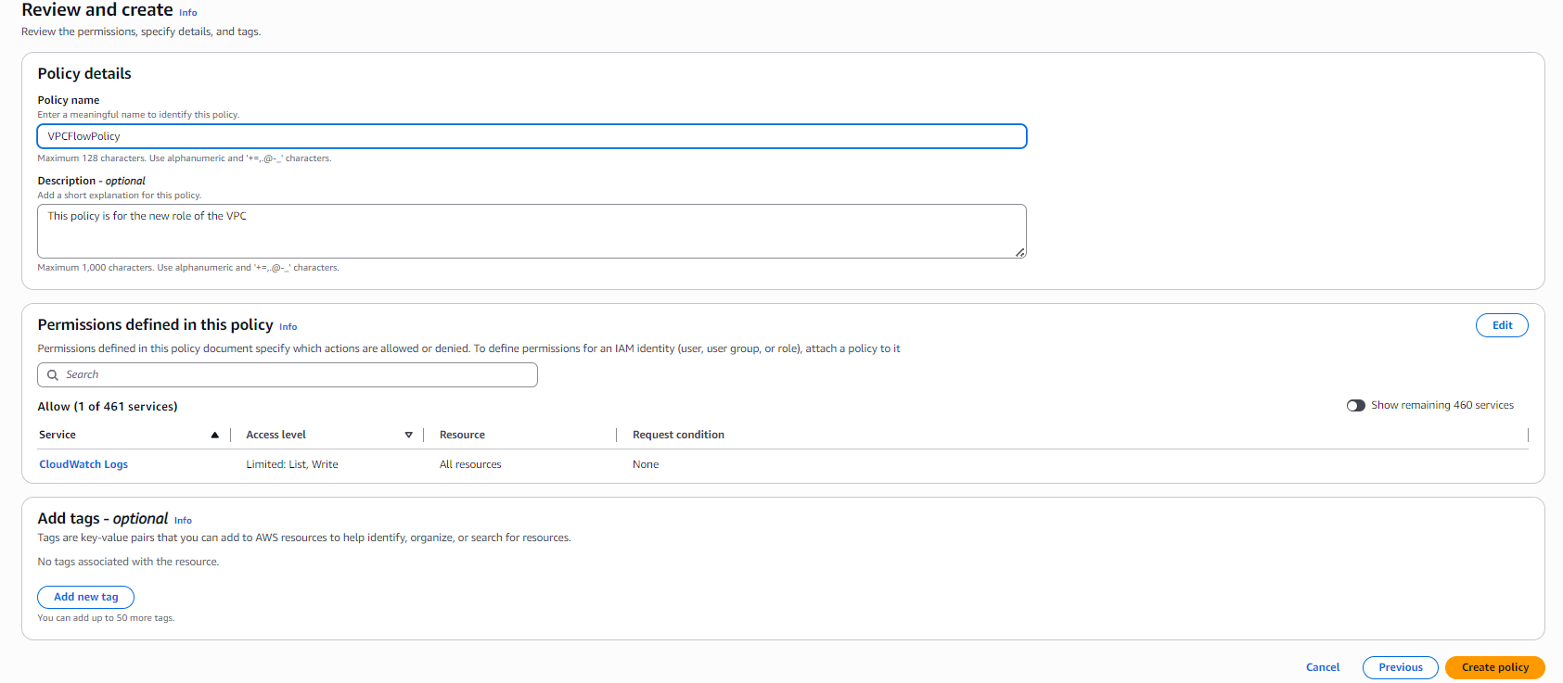
- After clicking Next, I reviewed the policy details to make sure everything was correct.
- I gave the policy the name VPCFlowPolicy so it clearly represents its purpose.
- Then I clicked Create policy, and the custom policy was successfully created.
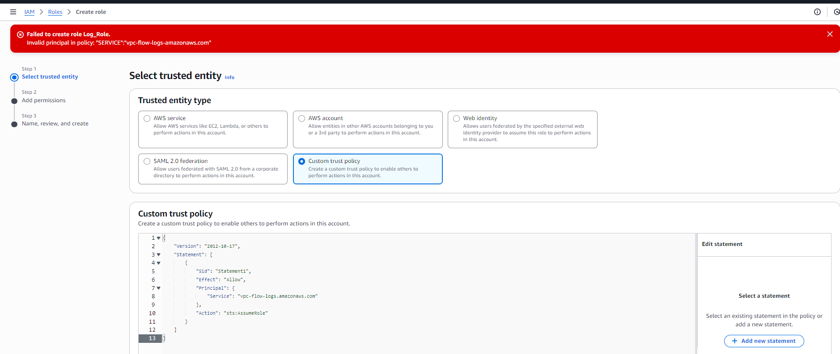

Creating the IAM Role for Flow Logs
- After creating the policy, I went to IAM → Roles and clicked Create role.
- For the trusted entity type, I selected Custom trust policy.
This option lets me specify exactly which AWS service is allowed to assume (use) this role.
- In the trust policy, I had to add the Principal, which identifies the AWS service that will use this role.
I added:
"Service": "vpc-flow-logs.amazonaws.com"
- What is this service?
  - This is the AWS service responsible for generating VPC Flow Logs.
  - By adding it as the principal, I am telling AWS that only VPC Flow Logs are allowed to assume this role and send logs to CloudWatch.
  - No other service or user can use this role.
- The red error I saw at first was simply a typo because earlier I wrote:
vpc-flow-logs"-"amazonaws.com
After correcting it to the proper format, the trust policy validated successfully.
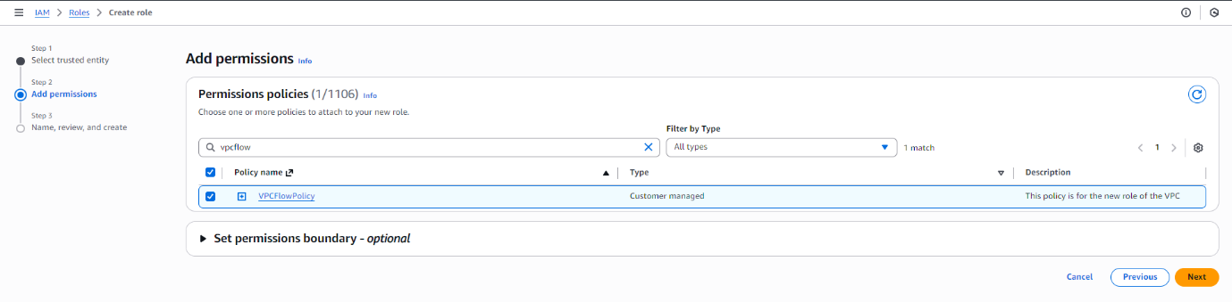
- After fixing the trust policy, I clicked Next to continue the role setup.
- On the Add permissions page, I selected the custom policy I created earlier: VPCFlowPolicy.
- This attaches the CloudWatch Logs permissions to the role so VPC Flow Logs can create log groups and push log data.
- After selecting the policy, I clicked Next to proceed.
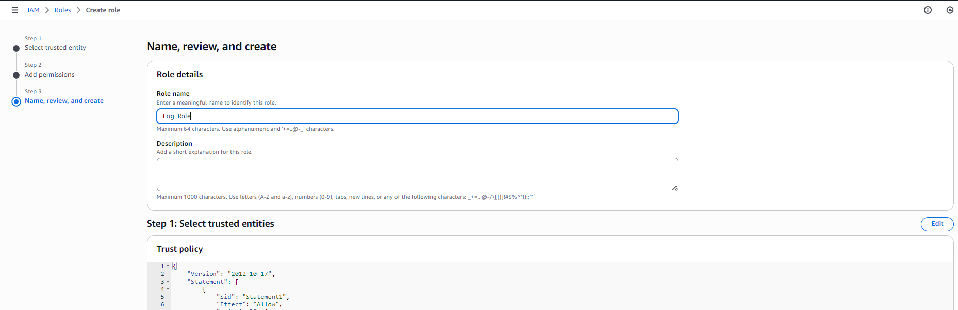
- On the final review page, I gave the role the name Log_Role so it’s clear that this role is used for VPC Flow Logs.
- After confirming everything looked correct, I clicked Create role.
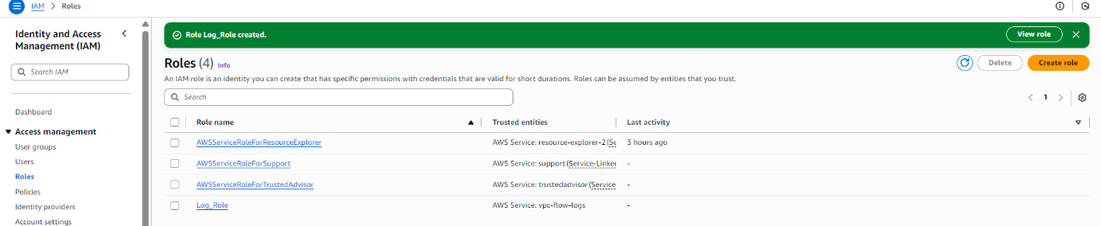
- The role was successfully created and is now ready to be used by the VPC Flow Logs service.
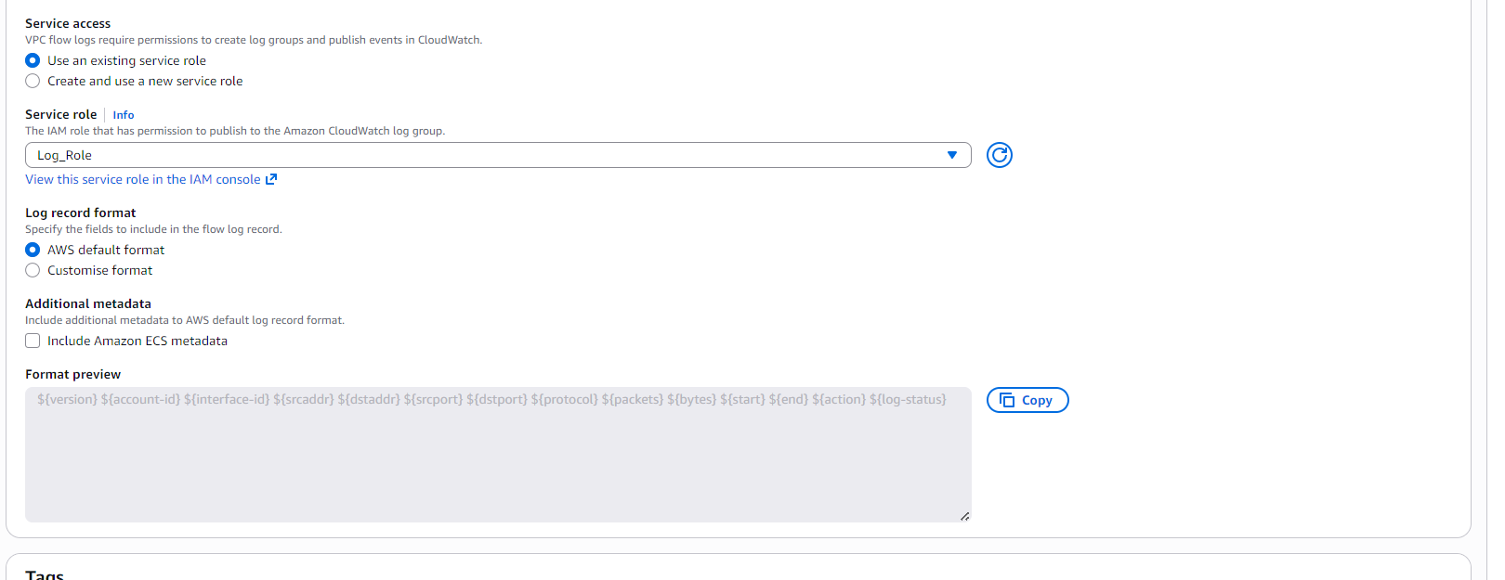
- After creating the IAM role, I went back to the Flow Log setup page for VPC_1.
- In the Service Role field, I selected the new role I created: Log_Role.
This gives VPC Flow Logs permission to write traffic logs into CloudWatch.
- There was also an option to choose a log format.
AWS offers custom formats where you can include additional fields like packet source, destination port, flow direction, etc.
- For this project, I kept the default log format, which already includes the essential details needed for monitoring.
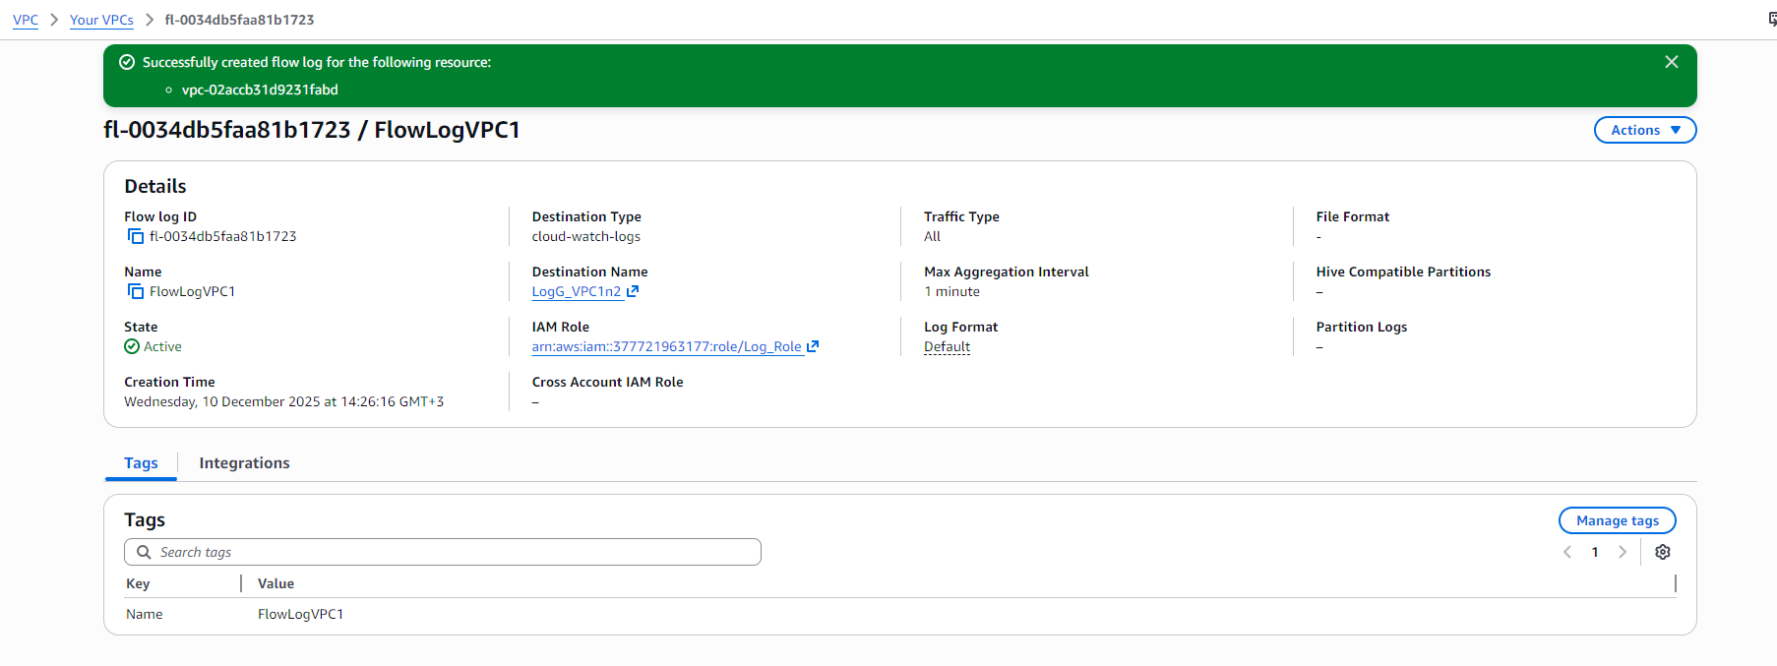
- After reviewing all settings, I clicked Create Flow Log, and the flow log for VPC_1 was successfully created.
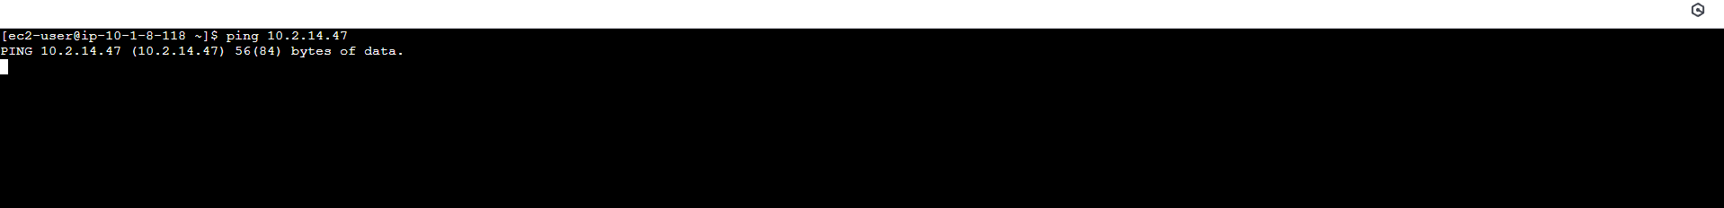
- Then I connected to Instance_VPC_1.
- I started pinging the private IP of Instance_VPC_2.
- Only one ping was sent, and that was it — no more replies came back.
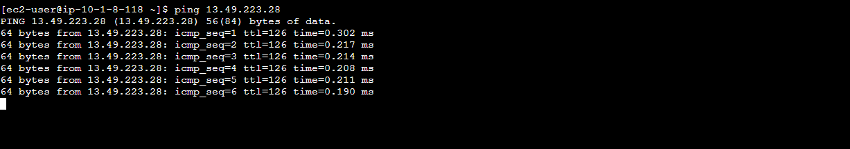
- Although the public IP of that instance was reachable from Instance_VPC_1.
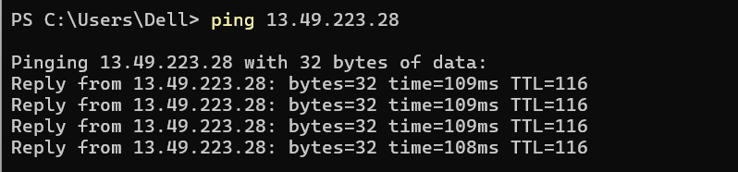
- I also tried from my own PC, and the public IP of that instance was responding.
- It did not respond to the private IP from Instance_VPC_1 because there was no peering connection created between the VPCs.
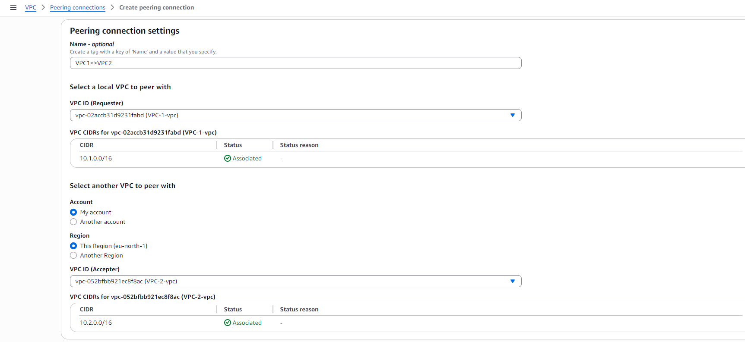
- So I went to Peering Connections and created a new one named VPC1 <> VPC2.
- I chose VPC_1 as the requestor and VPC_2 as the accepter, since both are in my account and in the same region.
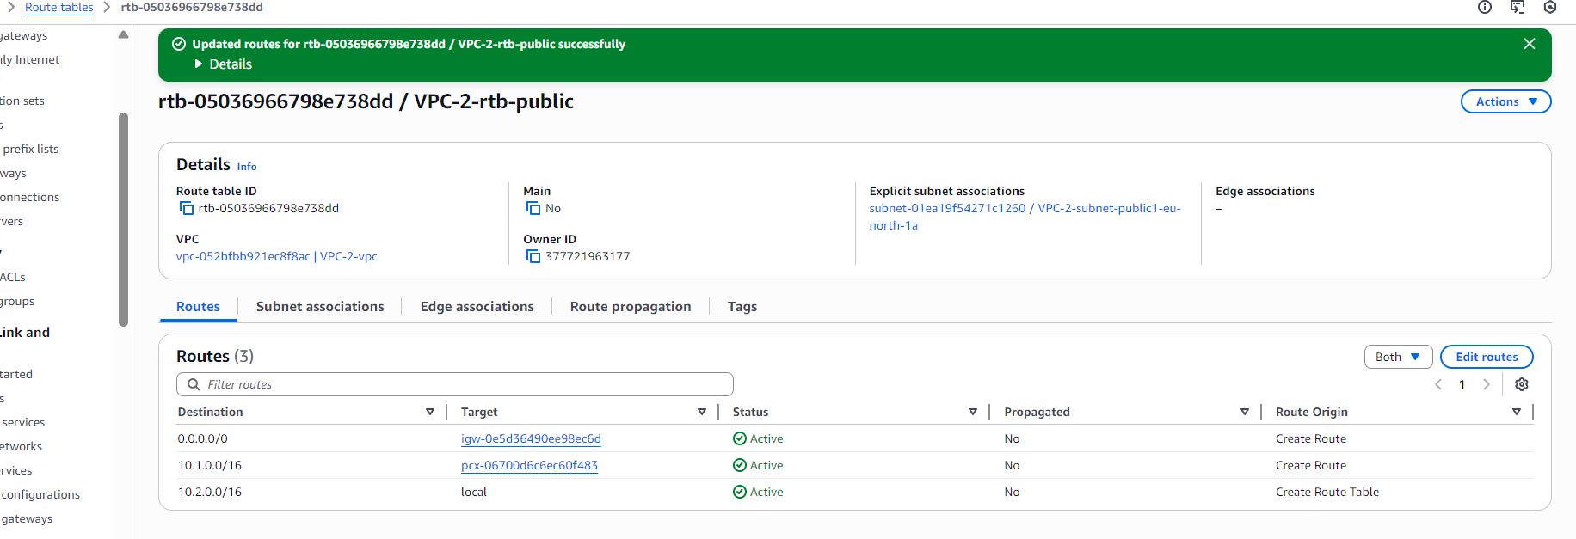
- Then I went on and added the routes.
- In the VPC_1 route table, I added the destination 10.2.0.0/16.
- In the VPC_2 route table, I added the destination 10.1.0.0/16.
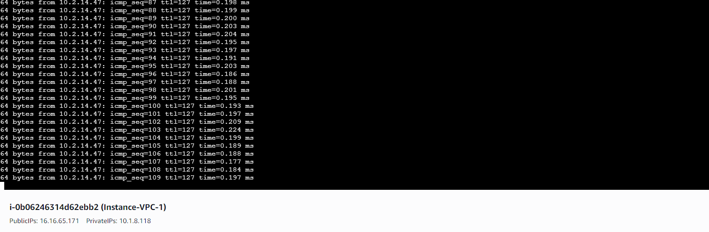
- After that, the traffic started.
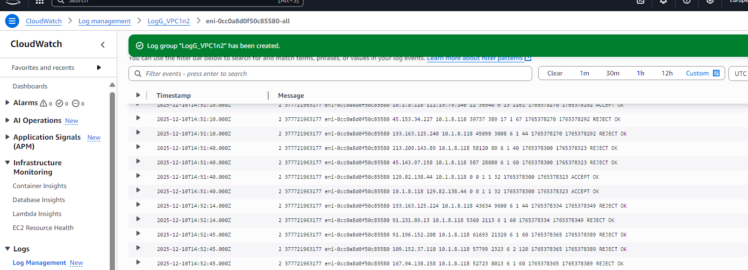
- After that, I went to CloudWatch and selected Log management, where the log group is located.
- When I selected the log group, the logs were shown to me.
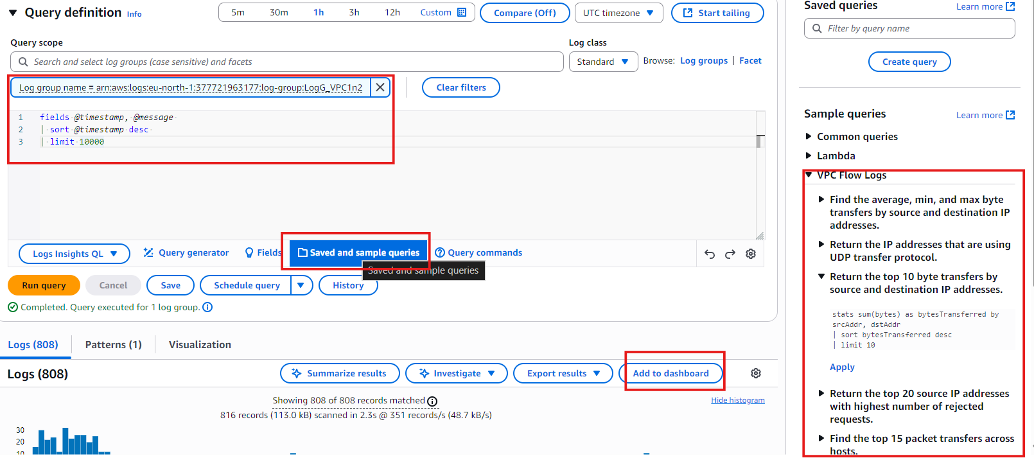
- Then I selected Log Insights from the side panel.
- In Log Insights, there are many options for how we want the logs to appear and how they can be filtered.
- First, I had to select the query scope, and when I selected my log group, it gave me a ready-made query.
- We also have the option to write our own query, or choose from saved and sample queries.
- On the right side, there are sample query templates that we can use.
- At the end, we can also add the query result to a CloudWatch dashboard.

Conclusion
In this project, I learned how to monitor network traffic inside AWS by setting up VPC Flow Logs and analyzing the data through CloudWatch Logs and Log Insights. I created two VPCs, deployed instances inside them, and established a peering connection to allow private communication. After enabling flow logs, I was able to capture and observe all network activity between the VPCs.
I also created a custom IAM policy and role to allow VPC Flow Logs to deliver data to CloudWatch. With Log Insights, I explored different ways to filter, view, and analyze traffic patterns. This project helped me understand how logs are generated, how they are stored, and how they can be used to troubleshoot or monitor VPC connectivity.
Overall, this hands-on experience strengthened my understanding of AWS monitoring tools and gave me practical exposure to analyzing network traffic inside a cloud environment.

