

**Assignment #2**

**Submitted to**

Muhammad Haroon(13269)

Muhammad Haris (12736)

**Submitted by**

Mam Ammarah Khalid

**Roll no**

BS-CS 3rd A

**Group**

D

**Subject**

Web Design and Application

**Riphah international University**

**Faisalabad Campus**

**Description**

* Tools/Software

Notepad ++.

I make this web page to use the Notepad ++ tool/Software.

* I made this web page through HTML & CSS.
* I Will design the page "Create the Google Account Page"
* First of all, I write some code in HTML and then apply the CSS.
* I use three pictures to make a web page
  + 1. Google
    2. eye hide icon
    3. side picture
* Two images are in the form tag or one image out of the form tag.

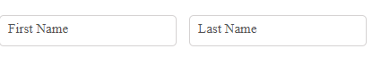

First/Last name is written in out of the box and then change the position of First/Last Name. compare the boxes of

**inline-block** CSS command.