|  |
| --- |
|  |
| BlogAll – The Public Blog |
| Project Proposal |
| By |
| Anukrit Gaur- (jc442707)**13391046** Harpal Singh- (jc333571)**13208618** Bhargavi Meduri- (jc444601)**13401322** Priya Mehta-(jc442658)**13390683** |
|  |

|  |
| --- |
| This document presents a proposal for a Blog. It describes the idea of developing a generic platform for people to share content. It explains how this idea can be converted to a revenue engine. |

Table of Contents

1. Introduction 2

2. Objectives of the project 2

3. Project Target Audience 3

4. Features of the platform 3

5. Technologies to be used 4

5.1 HTML 5

5.2 Javascript 5

5.3 CSS 5

5.4 PHP 5

5.5 MySQL Database 5

6. Task distribution 6

7. Project Planning and Schedule 6

Table of Figures

Figure 1: Typical Blog Admin Screen 3

Figure 2:Gantt Chart 9

# Introduction

A Blog is a platform which provides people with content in the form of articles. People can browse around category wise or tag wise. There are several platforms where more than one authors write blogs which allows the readers to browse author wise articles also. The backend of such a platform involves an interface to add new articles, manage the articles, create new author profiles etc. Our idea involves creating a similar platform and working towards making it a revenue generating automated algorithm.

Blog is today’s trend to share content or articles throughout the world. All the websites which earn high revenue involve some type of content sharing features in it. The internet giants Facebook and Twitter are a similar platform where people can do micro-blogging. Our concept here is about something very similar yet different from what is being done by others.

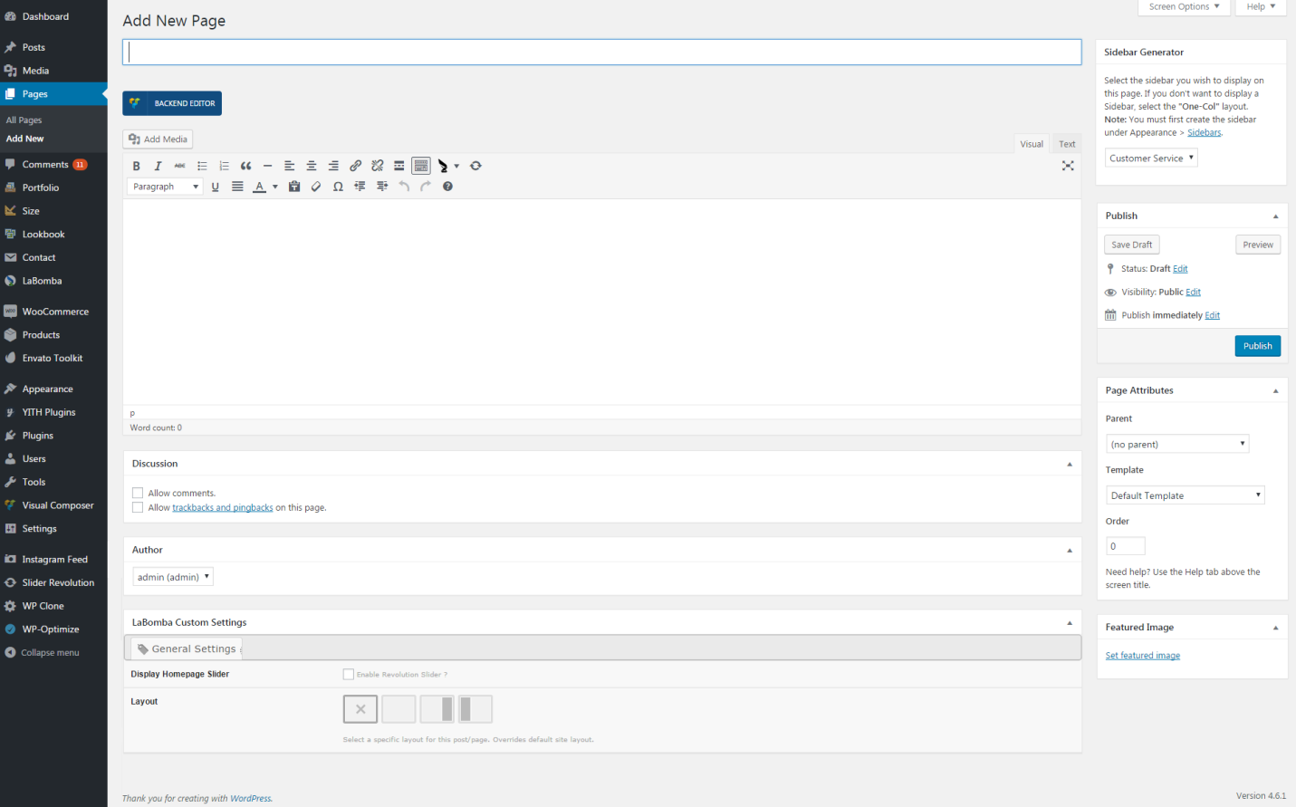

Figure : Typical Blog Admin Screen

Blog All – will be a platform for people to share their content. As the name indicates, it will allow everyone to blog. There will be approval flows involved in the same. This platform will allow users to register. The administrator of the website will approve the newly registered users after verifying sufficient details are available. The registered and approved users can then add articles which will be published on the website globally. This platform helps any creative writer to demonstrate his/her writing skills to the audience. Usually a blog requires considerable investment in terms of domain and hosting. Blog All eliminates this overhead and provides users with the right to publish their content for free. Thus, this project will help any content writer to earn by freelancing on this platform. The concept is expected to invite a huge crowd and turn into an autonomous revenue generator soon.

# Objectives of the project

The project focuses on creation of a Blogging platform using the latest backend and frontend technologies. The major objectives of the project are listed below:

* **Allow users to register and login**: Any visitor can register on this platform to become a writer
* **Allow any user to view blogs**: The blogs will be openly published initially. The content will be later secured to enable writers sell their content
* **Allow registered users to write a Blog post of their own choice**: In order to prevent spamming from users, only registered and approved users will be allowed to write articles on this platform
* **Provide privacy to each user to manage their content securely**:This will be a long term target where the authors can make their content private and thus sell it online
* **Generate advertisement revenue using Advertisements placed on the blog**: There will be certain columns which will show advertisements on the blog. This will be one of the source of revenue for the project
* **Generate commission revenue by selling the content of users online**: This is the long term goal which will be achieved once the website has gathered a large traffic of authors and content database.
* **Increase domain value by getting continuous inflow of traffic**: Any platform receiving a huge number of visitors daily has consequently a high valuation in the market. We will work towards achieving it

Since this will be a project targeting all domains of author, the platform will need to be as simple as possible. The platform will not involve any complex flows to create an article. It will be a simple self-explanatory interface which can be used by any user.

Initially the project will not generate any revenue. The main major of the project in the initial stage will be to generate content by getting others users to register and share their content via our blog. This will not only help in making the blog richer in content but also provide a good exposure as the links are shared further by the writers. The web traffic will thus be increased automatically once a minimum traffic exposure is gathered by the website.

A continuous web traffic generation will lead to increase in the value of domain. This will consequently lead to a higher valuation of the project in the long run.

# Project Target Audience

Visitors are the most important entity for any web project to be successful. The visitors are the major reason for increased value of the domain as well as website. This project is a platform which expects more number of user visits than any other normal business website. This is a platform where people will come to actually gain some knowledge or read some content. The main business here is to serve and fetch content. Hence, this idea works on the basis of readers and writers. The more readers and writers drop by the website, the more will the idea spread. Thus, we target the audience from the avid reader class to the talented and creative bloggers. Anyone, who has a good writing skills and wants to make a living out of it, is one of the groups we target for our project. The other group that we target is people who are interested in learning about how to write or how to be effective in content or just spend their time reading about certain topics. These are the readers who will constitute the major part of our audience. At a later stage in the project, we expect the people in need of content to be our audience. We plan to sell the content to the people in need of the content. This will not only generate revenue for the website but also attract more writers and consequently more audience to the website.

We target major blog enthusiasts and writers to join our website and publish their content to attract more people to leverage the platform. This will not only make it a hit but also make it a high revenue generating platform. Since there is no limit to the content being shared, the platform will gather a lot of content automatically and optimize the ranking in search engines automatically. Thus any user searching for blogs to read will soon be able to see our website.

# Features of the platform

This platform will use the simplest HTML technologies to develop website. This would make the website maintenance free. There will be several exceptional features for the blog. They are listed below:

* Rich text CK editor to allow users to publish rich text content
* Free content hosting by displaying the content on our website for free
* Free discussion forums for discussing about blog articles
* User registration and login to authenticate and save user preferences
* Filtered blog content using tag API
* Author based as well as tag based filtering
* Life-time free service to the audience
* We earn from the adverts and by selling content
* Allow user to earn revenue through us

This platform will be unique in the context that it will allow the bloggers to earn from their content by selling it securely online. The content selling will be made possible by showing abstract of the article to the audience and providing complete articles on receiving the payments.

The platform will be able to support online payments and content transfer to make the task completely automated. The automation will make it a constant revenue generating platform with hardly any effort to be put in after certain duration.

# Technologies to be used

As conveyed in the above section, the project will be target all the audience category – Technical as well as Non-technical. This necessitates that the website is simple in interface and easy to use. It should involve less amount of fancy stuff and focus more on delivery decent display of content. The interface should be self-explanatory and appealing to the audience to move around.

The functional requirements of the project can be summarized as below:

* A simple interface to register/login
* A web page displayed list of all articles that are written
* The web page displaying all articles should have pagination to prevent excessive data
* A web page able to display filtered articles like articles from specific category/author/tag
* A web page to display a single post with images
* A web page to introduce the blog and its facilities
* An interface for writers to add articles, uploaded images and other documents
* An interface for writers to manage the added articles
* An interface for administrator to create user as well as manage user approvals

In addition to these functional requirements, there will be data required to be stored in the database. The data to be stored will be related to articles, authors, readers as well as buyers. One needs the database which will be able to handle large amount of data easily. The sole task of the database will be to store and serve content as and when required.

Based on this analysis, the platform has been decided to be based on HTML (Hyper-text Markup language) for the frontend creation. HTML is the browser side language used to create web pages. In addition to HTML, one would need to handle button clicks, form submissions and content rendering also. Hence a detailed list of technologies, which will be used, is presented below:

* HTML – For basic web page design
* JavaScript – For handling events like button clicks, form submission etc. at user end
* CSS – For give a better visual appearance to the website
* PHP – For processing data at the backend, storing data in the backend and retrieving back the data when required
* MySQL database – Database to store the data of articles, users and other related project data

## 5.1 HTML

HTML is a web browser understandable way of putting down our content. It is used to create the basic web page layouts. It allows you to show text with different sizes, show various images, shapes, videos or any other graphics. Thus, we have chosen to use HTML to create our basic web page layout

## 5.2 JavaScript

JavaScript is a user side programming language which allows handling the clicks of button, submission of forms or any similar events programmatically. It also does the job of pre-processing any data before submitting it to the server. This makes sure that all the necessary data is available before actually passing it to the server. Thus, JavaScript will be used for registration and login forms as well as to manage blog article writing.

## 5.3 CSS

The most important component of any website which relies on user is to have a good CSS. CSS – Cascading style sheet is used to style up the web page. It is used to arrange different components in the page, to divide the page into parts so that the content remains organized, to display the content in an appealing manner. CSS does the job of changing the way web page looks. The default HTML content is in black color with other color in it. CSS helps in getting the web page to look colorful and appealing by changing fonts, colors, positions of content etc.

## 5.4 PHP

The task does not end by just creating good looking webpages. A dynamic website requires a backend technology to process the content being provided by the writers. PHP is a backend technology which is simplest among all the available languages today. PHP is straightforward in its syntax and can run on lightweight servers. Thus, we have chosen PHP to handle the backend of our Blogging platform as we expect a very high number of visitors and PHP is lightweight compared to any other technology.

## 5.5 MySQL Database

MySQL is the most used database around the world. The main reason for its vast use is that it is absolutely free to use. It covers almost all the basic database facilities any other database provides. MySQL support is easily available from various forums and blogs all around the world. Thus, it is the best choice to use most popular database for our project.

# Task distribution

The project is not a small one. This entire task of blog needs to be divided into bits and pieces to make sure the time is efficiently utilized and the deadline for project development is met. Being a team of 4 people – we have planned to distribute the tasks among us as shown below.

The responsibilities are divided in such a way that the team has independent tasks. Except the database design which needs to be handled by team collectively, all the other tasks are almost independent from each. This will help in maintaining more tasks in parallel.

# Budget Planning

The tentative cost factors to be considered for the project are:

* Hosting
* Domain
* Development
* Maintenance
* SEO + Marketing
* Paid Articles from famous bloggers

The below table shows an estimate of the costs involved in each.

|  |  |
| --- | --- |
| Feature/Task | Investment |
| Hosting and Domain | $200 per year |
| Development work hour billing | $5000 |
| SEO + Marketing | $300 per month |
| Website regular maintenance | $300 per month |
| Paid articles | $50 per article |

# Project Planning and Schedule

This section covers the milestones which need to be achieved at regular intervals. It also covers the work distribution over the period of time. Since the task distribution is done in such a way that most of the team members have independent tasks, the project has several parallel tasks running throughout the development cycle.

The project not only involves development but also unit testing at each stage. This makes sure that at the end of the allotted time, we have a well-tested project. The Gantt chart below outlines the tasks and their planned progress with time.

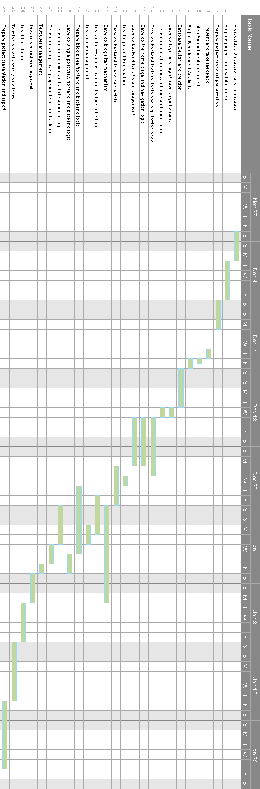

Figure : Gantt Chart

[**https://github.com/harpalsingh11/team04nov16.git**](https://github.com/harpalsingh11/team04nov16.git)

|  |  |  |
| --- | --- | --- |
| Uday Bhargavi Meduri | Index Page | Mystyle.css |
| Priya Mehta | Index Page |
| Anukrit Gaur | Login Page |
| Harpal singh | Register Page |