Assignment 2

Jeremy Harper
01.02.2011

STA4202

1.a. Stirring rate does not affect the grain size. The p-value for stirring rate is above 0.05 (p = 0.4995), so we can not reject the null hypothesis that stirring rate does not affect grain size. The overall model for grain size is significantly different though (p=0.042), indicating that another factor may be responsible for the difference.

22:17 Tuesday, February 1, 2011 1

The GLM Procedure

Class Level Information

Class Levels Values

Stirring_Rate 4 5 10 15 20

Furnace 4 1 2 3 4

Number of Observations Read 16
Number of Observations Used 16
22:17 Tuesday, February 1, 2011 2

The GLM Procedure

Dependent Variable: Grain_Size

Sum of
Source DF Squares Mean Square F Value Pr > F

Model 6 187.3750000 31.2291667 3.60 0.0420

Error 9 78.0625000 8.6736111

Corrected Total 15 265.4375000

R-Square Coeff Var Root MSE Grain_Size Mean

0.705910 38.31024 2.945100 7.687500

Source DF Type III SS Mean Square F Value Pr > F

Stirring_Rate 3 22.1875000 7.3958333 0.85 0.4995
Furnace 3 165.1875000 55.0625000 6.35 0.0133
22:17 Tuesday, February 1, 2011 3

The GLM Procedure

Tukey's Studentized Range (HSD) Test for Grain_Size

NOTE: This test controls the Type I experimentwise error rate, but it generally has a higher Type II
error rate than REGWQ.

Alpha 0.05
Error Degrees of Freedom 9
Error Mean Square 8.673611
Critical Value of Studentized Range 4.41489
Minimum Significant Difference 6.5011

Means with the same letter are not significantly different.

Stirring_
Tukey Grouping Mean N Rate

A 8.750 4 20
A
A 8.500 4 10
A
A 7.750 4 15
A
A 5.750 4 5

1.b. The plot has a sine-wave pattern to it, indicating that there is systematic deviation from the model. It shows a non-linear pattern, and I would say that the model used is not a good fit.
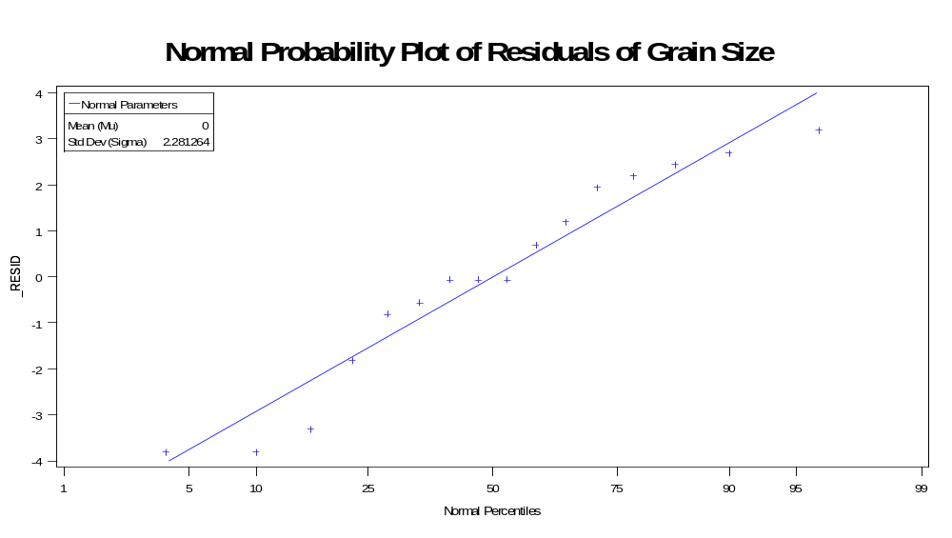
1.c. In this plot, the data looks distributed randomly, so we can assume independent error and constant variance assumptions among stirring rates.
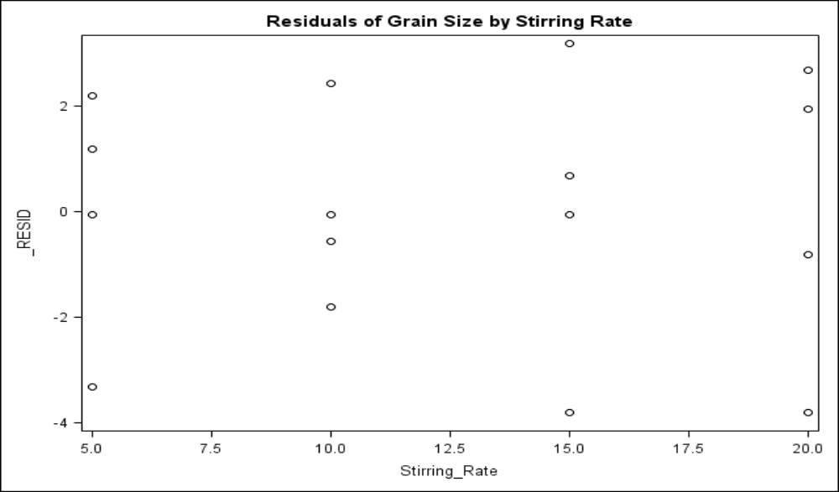
In this plot, the data looks distributed randomly, so we can assume independent error and constant variance assumptions among furnaces.
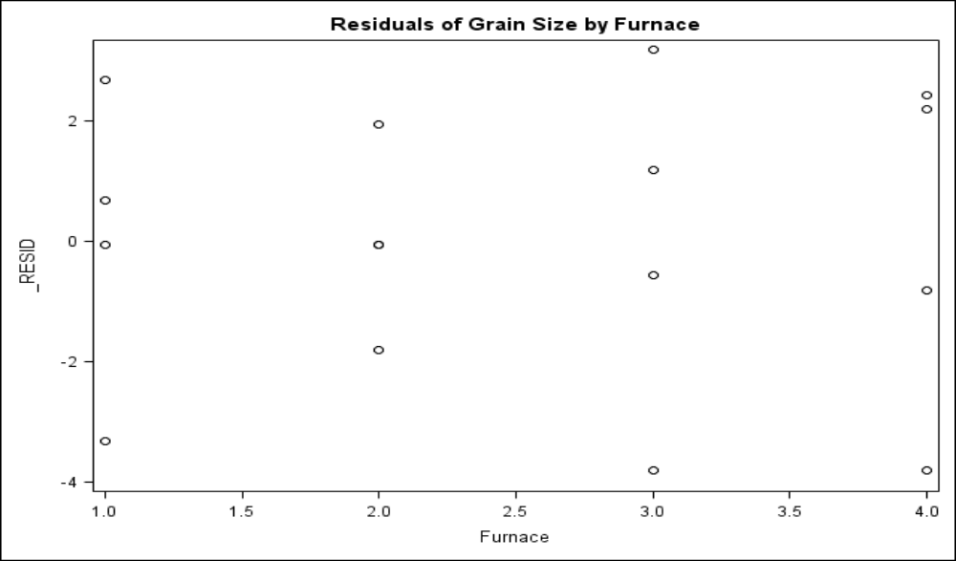

1.d. Stirring rate is not that important (since the ANOVA proved it to be non-significant) in producing grain size, but a rate of 5 produces smaller (albeit non-significantly) grain size. They should avoid using furnace 1 because the mean grain size for that furnace (evidenced by performing a Tukey test on the block means) is significantly larger (13.25) than any other furnaces. In the end, they should use a stirring rate of 5 and either furnace 3 or 4.

The GLM Procedure

Tukey's Studentized Range (HSD) Test for Grain_Size

NOTE: This test controls the Type I experimentwise error rate, but it generally has a higher Type II
error rate than REGWQ.

Alpha 0.05
Error Degrees of Freedom 9
Error Mean Square 8.673611
Critical Value of Studentized Range 4.41489
Minimum Significant Difference 6.5011

Means with the same letter are not significantly different.

Tukey Grouping Mean N Furnace

A 13.250 4 1

B 6.000 4 2
B
B 5.750 4 3
B
B 5.750 4 4

2. One can see that the blocking (day and batch) are not significant, but the type of catalyst used is significant (p = 0.0005). We can conclude that the difference in reactions times in this sample is due to the catalyst. From the Tukey test, we can conclude that catalyst B is not different from any other catalysts, but catalysts C and A are significantly different from D and E. If the researcher wants to reduce reaction time, she should use catalysts D or E, but if she wishes to increase it, she should use C or A.

Class Level Information

22:17 Tuesday, February 1, 2011 1

The GLM Procedure

Class Level Information

Class Levels Values

Batch 5 1 2 3 4 5

Day 5 1 2 3 4 5

Catalyst 5 A B C D E

Number of Observations Read 25
Number of Observations Used 25
22:17 Tuesday, February 1, 2011 2

The GLM Procedure

Dependent Variable: Time Time

Sum of
Source DF Squares Mean Square F Value Pr > F

Model 12 169.1200000 14.0933333 4.51 0.0072

Error 12 37.5200000 3.1266667

Corrected Total 24 206.6400000

R-Square Coeff Var Root MSE Time Mean

0.818428 30.07208 1.768238 5.880000

Source DF Type III SS Mean Square F Value Pr > F

Batch 4 15.4400000 3.8600000 1.23 0.3476
Day 4 12.2400000 3.0600000 0.98 0.4550
Catalyst 4 141.4400000 35.3600000 11.31 0.0005
22:17 Tuesday, February 1, 2011 3

The GLM Procedure

Tukey's Studentized Range (HSD) Test for Time

NOTE: This test controls the Type I experimentwise error rate, but it generally has a higher Type II
error rate than REGWQ.

Alpha 0.05
Error Degrees of Freedom 12
Error Mean Square 3.126667
Critical Value of Studentized Range 4.50771
Minimum Significant Difference 3.5646

Means with the same letter are not significantly different.

Tukey Grouping Mean N Catalyst

A 8.800 5 C
A
A 8.400 5 A

A
B A 5.600 5 B

B
B 3.400 5 D

B
B 3.200 5 E

3.a. The p-value for additive is well below alpha (p = 0.0012), so we can reject the null hypothesis that additive does not have an effect on mileage. The p-value for the blocks (i.e. car) is also significant, indicating that the type of car also affected mileage.

08:43 Thursday, February 3, 2011 1

The GLM Procedure

Class Level Information

Class Levels Values

Car 5 1 2 3 4 5

Additive 5 1 2 3 4 5

Number of Observations Read 20
Number of Observations Used 20
08:43 Thursday, February 3, 2011 2

The GLM Procedure

Dependent Variable: Mileage Mileage

Sum of
Source DF Squares Mean Square F Value Pr > F

Model 8 66.93333333 8.36666667 9.19 0.0007

Error 11 10.01666667 0.91060606

Corrected Total 19 76.95000000

R-Square Coeff Var Root MSE Mileage Mean

0.869829 7.919144 0.954257 12.05000

Source DF Type III SS Mean Square F Value Pr > F

Car 4 35.23333333 8.80833333 9.67 0.0013
Additive 4 35.73333333 8.93333333 9.81 0.0012

3.b. From the Tukey test, one can see that the only differences are between 1-3, 1-4, 1-5, and 2-5. The best mileage is attained by using additive 1 or 2 (although since 2 is not different from 3 or 4, one might choose additive 1 for the best results). When performing a Tukey test on the blocks, you discover that car 5 is significantly lower in mileage than the other cars, so the investigator may choose to omit this car in the next experiment to eliminate unnecessary variation between blocks.

08:43 Thursday, February 3, 2011 3

The GLM Procedure

Tukey's Studentized Range (HSD) Test for Mileage

NOTE: This test controls the Type I experimentwise error rate, but it generally has a higher Type II
error rate than REGWQ.

Alpha 0.05
Error Degrees of Freedom 11
Error Mean Square 0.910606
Critical Value of Studentized Range 4.57360
Minimum Significant Difference 2.1822

Means with the same letter are not significantly different.

Tukey Grouping Mean N Additive

A 14.0000 4 1
A

B A 12.7500 4 2
B
B C 11.7500 4 4
B C
B C 11.5000 4 3

C
C 10.2500 4 5

Tukey's Studentized Range (HSD) Test for Mileage

NOTE: This test controls the Type I experimentwise error rate, but it generally has a higher Type II
error rate than REGWQ.

Alpha 0.05
Error Degrees of Freedom 11
Error Mean Square 0.910606
Critical Value of Studentized Range 4.57360
Minimum Significant Difference 2.1822

Means with the same letter are not significantly different.

Tukey Grouping Mean N Car

A 13.5000 4 2
A
A 12.5000 4 1
A
A 12.5000 4 4
A
A 12.0000 4 3

B 9.7500 4 5

The plot of mileage residuals by car looks to satisfy the ANOVA assumptions (even though there might be a slight megaphone effect, since the blocks are categorical we could rearrange the plot with no penalty).

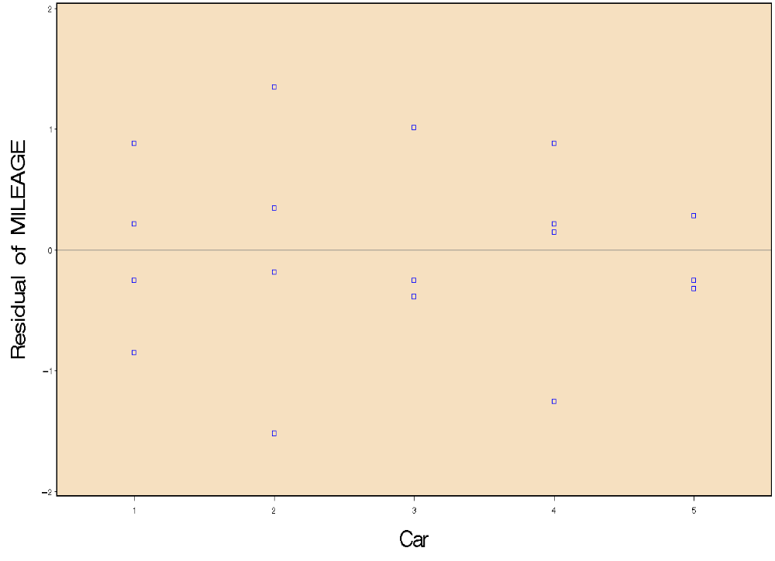

The plot of mileage residual by additive shows a slight megaphone effect, although again since the data is categorical we could rearrange it and eliminate this effect. Thus, the ANOVA assumptions are met.
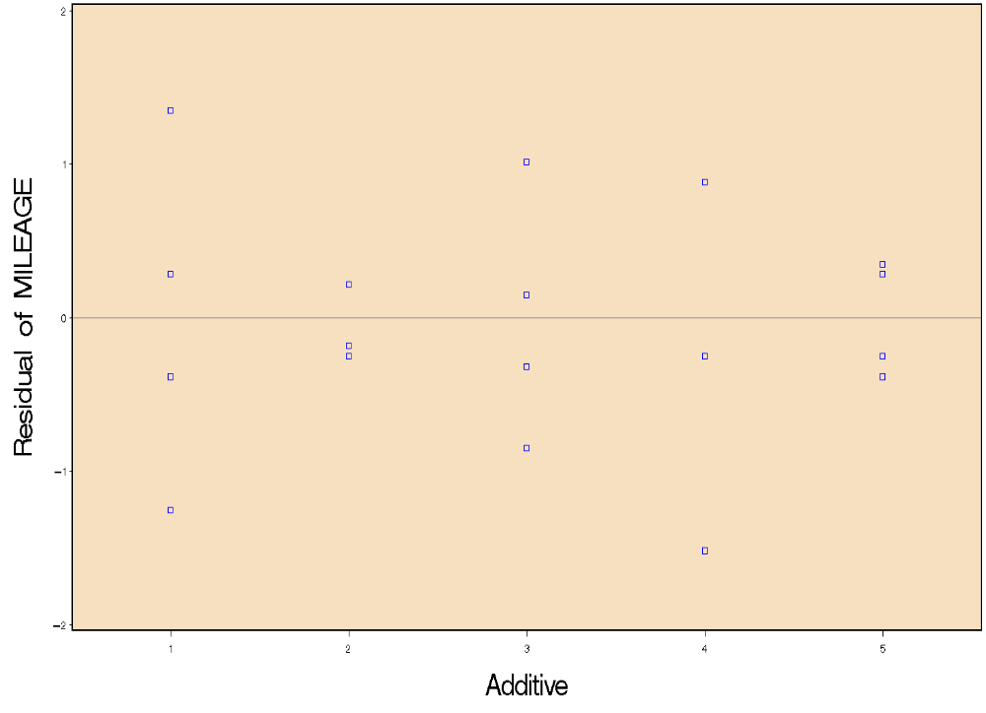
The plot of mileage residuals by predicted mileage has a slight megaphone effect, which may caution us that the ANOVA assumptions are not met. Since the two prior plots look OK, I think we can trust the model.
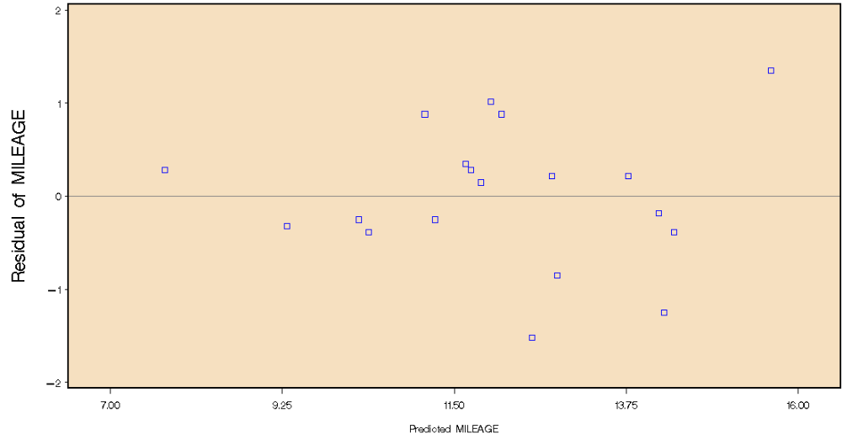
The normal probability plot looks like there is non-linearity in the data since the middle data points are horizontally aligned rather than diagonally. The model may not be a good fit.
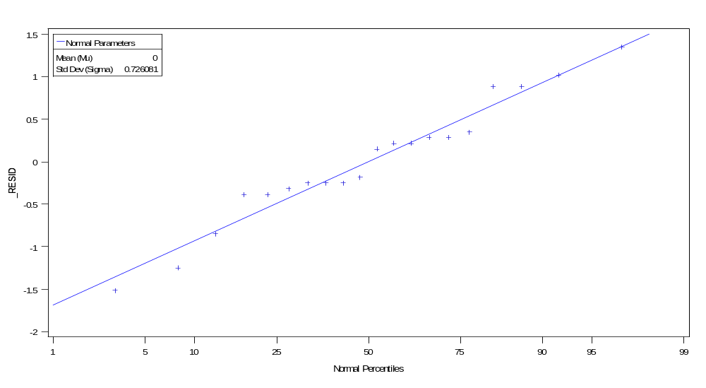

3.c. From the orthogonal contrasts, we can conclude that additive 3 is not different from the rest, but groups 1-2 and 4-5 are significantly different (p = 0.0001). The comparison of additives 1 and 2 almost meets significance criteria (p = 0.0591), but additives 4 and 5 do not (p = 0.2395). This confirms the findings from the Tukey test above.

Contrast DF Contrast SS Mean Square F Value Pr > F

Addivite 3 vs. Others 1 0.18750000 0.18750000 0.21 0.6588
Additives 1 and 2 vs. Additives 4 and 5 1 30.10416667 30.10416667 33.06 0.0001
Additives 1 vs. Additive 2 1 4.03333333 4.03333333 4.43 0.0591
Additives 4 vs. Additive 5 1 1.40833333 1.40833333 1.55 0.2395

proc glm data=Work.P_03;
class ADDITIVE CAR;
model MILEAGE = ADDITIVE CAR / SS3;
contrast 'Addivite 3 vs. Others' additive 1 1 -4 1 1;
contrast 'Additives 1 and 2 vs. Additives 4 and 5' additive 1 1 0 -1 -1;
contrast 'Additives 1 vs. Additive 2' additive -1 1 0 0 0;
contrast 'Additives 4 vs. Additive 5' additive 0 0 0 -1 1;
run; quit;

4.a. The overall model is significant (p<0.0001), and all three variables (cooking_time, pressure, and hardwood) are all significant, thus they affect the strength of paper. In terms of interactions, the only significant one is hardwood x pressure (cookingtime x pressure is trend level [p=0.07], but not significant). After removing the non-significant interactions, the results are basically the same, but the p-values for the interaction and hardwood got higher. From the Tukey test, one can see that the 4 hour cooking time produces stronger paper, hardwood concentration 2 produces stronger paper, and pressure of 650 also produces stronger paper (all of these are significantly different from the other conditions).

The GLM Procedure

Class Level Information

Class Levels Values

Hardwood 3 2 4 8

Cooking_Time 2 3 4

Pressure 3 400 500 650

Number of Observations Read 36
Number of Observations Used 36
16:25 Monday, February 7, 2011 2

The GLM Procedure

Dependent Variable: Strength Strength

Sum of
Source DF Squares Mean Square F Value Pr > F

Model 17 59.72888889 3.51346405 9.61 <.0001

Error 18 6.58000000 0.36555556

Corrected Total 35 66.30888889

R-Square Coeff Var Root MSE Strength Mean

0.900767 0.305274 0.604612 198.0556

Source DF Type III SS Mean Square F Value Pr > F

Cooking_Time 1 20.25000000 20.25000000 55.40 <.0001
Hardwood 2 7.76388889 3.88194444 10.62 0.0009
Pressure 2 19.37388889 9.68694444 26.50 <.0001
Hardwood*Cooking_Tim 2 2.08166667 1.04083333 2.85 0.0843
Cooking_Tim*Pressure 2 2.19500000 1.09750000 3.00 0.0750
Hardwood*Pressure 4 6.09111111 1.52277778 4.17 0.0146
Hardwo*Cookin*Pressu 4 1.97333333 0.49333333 1.35 0.2903

AFTER REMOVING NON-SIGNIFICANT INTERACTIONS
Sum of
Source DF Squares Mean Square F Value Pr > F

Model 9 53.47888889 5.94209877 12.04 <.0001

Error 26 12.83000000 0.49346154

Corrected Total 35 66.30888889

R-Square Coeff Var Root MSE Strength Mean

0.806512 0.354682 0.702468 198.0556

Source DF Type III SS Mean Square F Value Pr > F

Cooking_Time 1 20.25000000 20.25000000 41.04 <.0001
Hardwood 2 7.76388889 3.88194444 7.87 0.0021
Pressure 2 19.37388889 9.68694444 19.63 <.0001
Hardwood*Pressure 4 6.09111111 1.52277778 3.09 0.0332

Tukey's Studentized Range (HSD) Test for Strength

NOTE: This test controls the Type I experimentwise error rate, but it generally has a higher Type II
error rate than REGWQ.

Alpha 0.05
Error Degrees of Freedom 18
Error Mean Square 0.365556
Critical Value of Studentized Range 2.97115
Minimum Significant Difference 0.4234

Means with the same letter are not significantly different.

Cooking_
Tukey Grouping Mean N Time

A 198.8056 18 4

B 197.3056 18 3

Alpha 0.05
Error Degrees of Freedom 18
Error Mean Square 0.365556
Critical Value of Studentized Range 3.60930
Minimum Significant Difference 0.63

Means with the same letter are not significantly different.

Tukey Grouping Mean N Hardwood

A 198.6667 12 2
A
B A 197.9583 12 4
B
B 197.5417 12 8

Alpha 0.05
Error Degrees of Freedom 18
Error Mean Square 0.365556
Critical Value of Studentized Range 3.60930
Minimum Significant Difference 0.63

Means with the same letter are not significantly different.

Tukey Grouping Mean N Pressure

A 199.0917 12 650

B 197.5833 12 400
B
B 197.4917 12 500

In the interaction plot, you can see that the strongest paper is made by hardwood 2 and pressure 650, and that the pressure of 650 produces stronger paper than any other combination. The weakest paper is made by hardwood 2 and 400 pressure, but the other two hardwood concentrations with 400 pressure make stronger paper than 500 or 650 pressure, indicating some interaction between hardwood 2 and pressure 400.

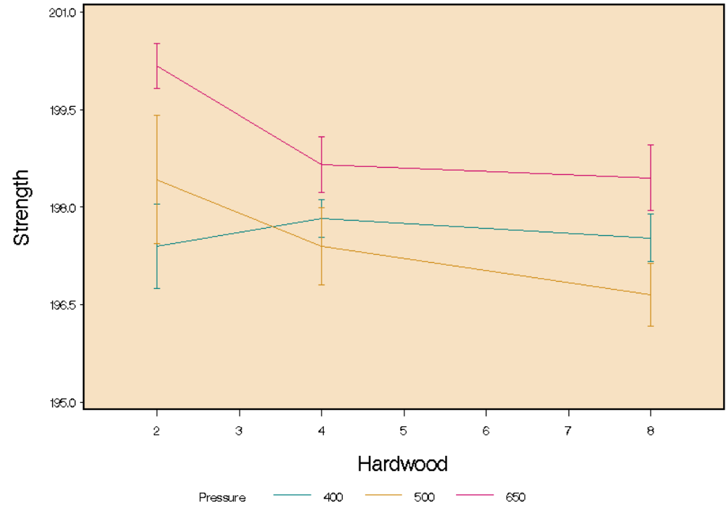

4.b. The residuals of strength by predicted strength are distributed randomly and appear to have independent and constant variance. There are a few outliers, but generally the plot looks to satisfy the ANOVA assumptions.
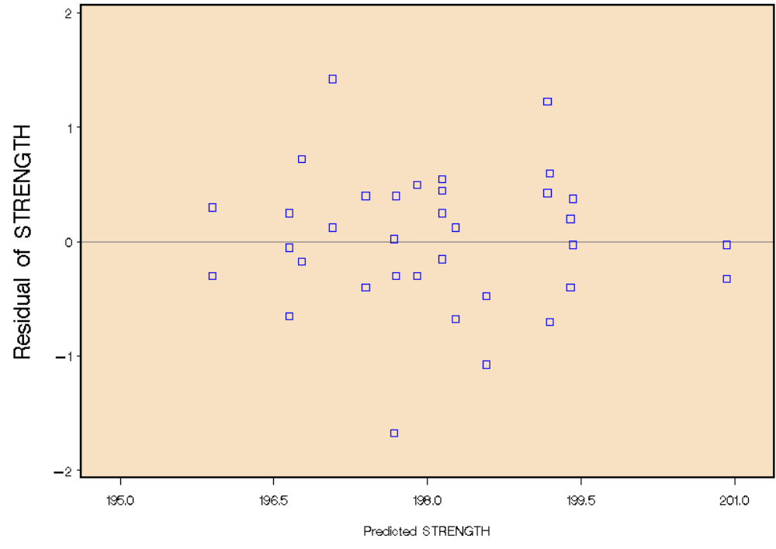
The plot of strength residuals by hardwood appears to have random distribution and constant and independent variance. There may be a slight megaphone effect, but overall the plot looks OK.
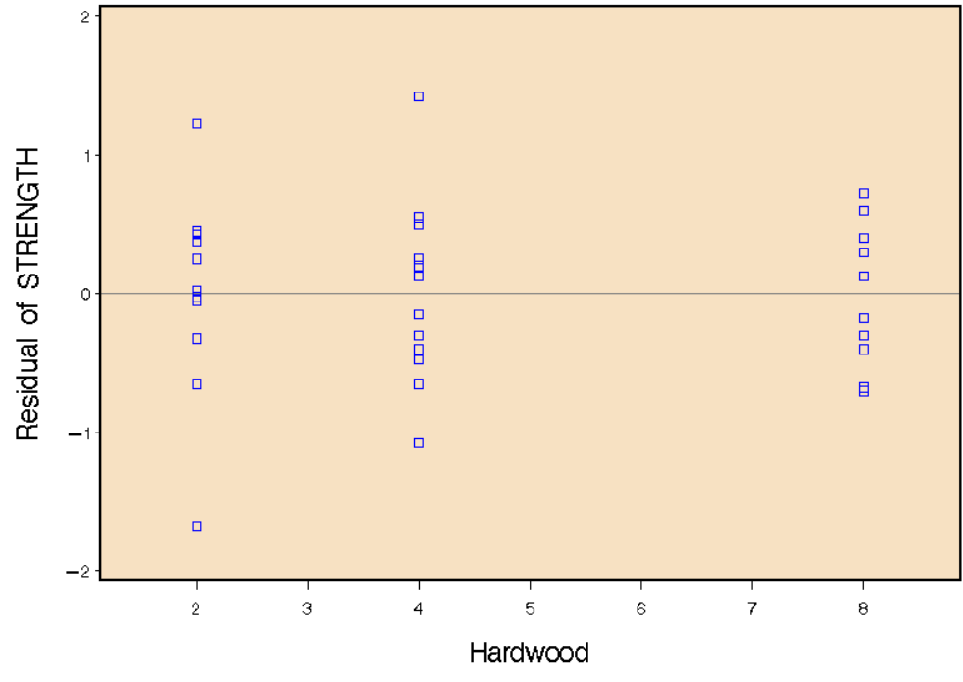
The plot of strength residuals by cooking time appears to have random distribution and constant and independent variance.

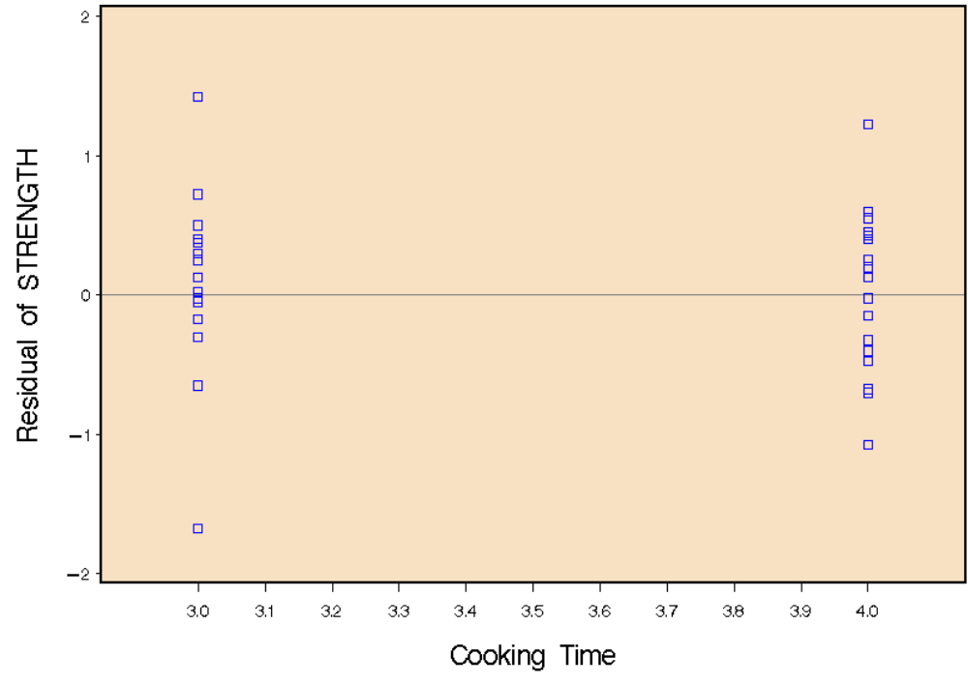
The plot of strength residuals by pressure appear to have a megaphone effect with less variation for 650.

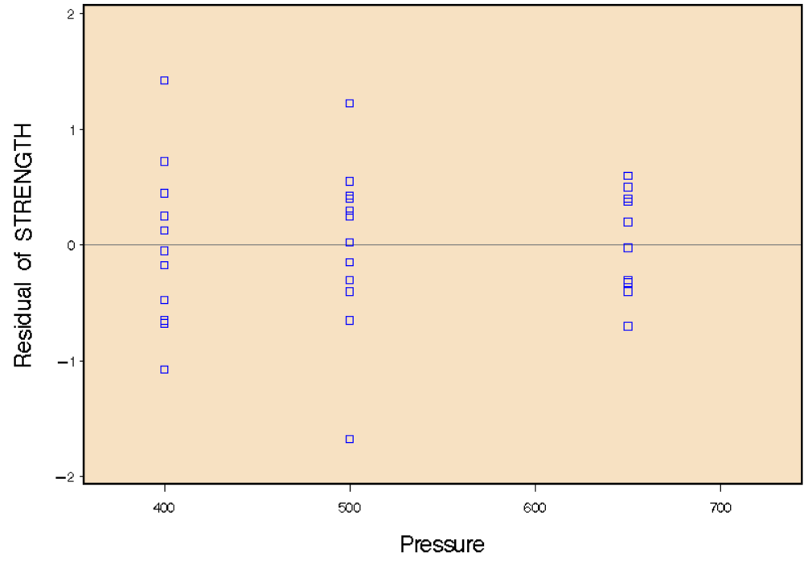
The normal probability plot of strength residuals does look to be OK; there are a few visible outliers, but it looks OK
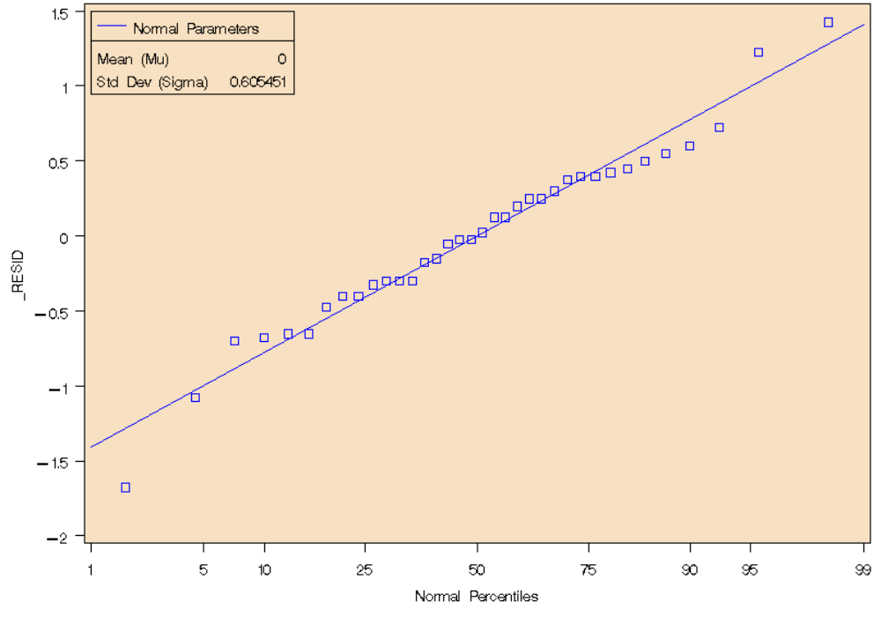
4.c. I would run the process with 4 hour cooking time, percentage hardwood concentration of 2, and pressure of 650 to get the strongest paper.

