STA4202 Project
Jeremy Harper
27.02.2011

- The current study was performed to measure risk-taking in a laboratory task. The psychology of risk is one that is important to many facets of human behavior and interaction, and is often cited as a possible factor in addiction. To better understand how humans evaluate and execute risky behaviors, we must figure out how different groups and ideologies play into this complex process. One can investigate if there are significant differences between groups, or do humans generally process risks in a similar fashion. It is possible that differing groups (e.g., gender or ethnic background) judge risks differently, and that one model may be inadequate for another group. I hypothesized that there will be significant differences between gender and ethnicity, but ‘worldview’ may not be a good measure of one’s overall ideology, so it may not show significance.
- The data was collected by administering a questionnaire that categorized the participants worldview, which was classified as individualistic, hierarchicalist, egalitarian, and unclassifiable. Basic demographics were also collected, including gender (0=Female, 1= Male), ethnicity (Caucasian [1], African-American [2], Mexican-American [3], and Taiwanese-American [4]), and age. Risk was measured on a 0-100 scale on a laboratory task which involved investing money in an ounce of silver. Gender, ethnicity, and worldview can be thought of as random effects, since we are attempting to generalize risk-taking behaviors to the greater population. The participants in this study are taken as representatives of the population, and we are assuming that we can make meaningful interpretations between groups that will apply to all people. The data is from http://www.stat.ucla.edu/projects/datasets/risk_proj.txt, and was previously analyzed by comparing subjective and objective measures of risk-taking, but was not analyzed in the way presented here. See “Evaluating the Simplified Conjoint Expected Risk Model: Comparing the Use of Objective and Subjective Information”, Carlstrom et al. (2000) for more information on their analyses.
- Presented below are the summary statistics for risk, and risk by gender, worldview, and ethnicity. The range of risk runs from 0 to 100, with the mean around 21. From the box-plot, we can identify six possible outliers, but I do not think they should be of concern since they reflect an individual’s risk score and not an artifactual anomaly.
Summary Statistics of Risk
Mean Std Dev N Minimum Maximum
-------------------------------------------------------------------
20.7906574 23.5830209 578 0 100.0000000
-------------------------------------------------------------------
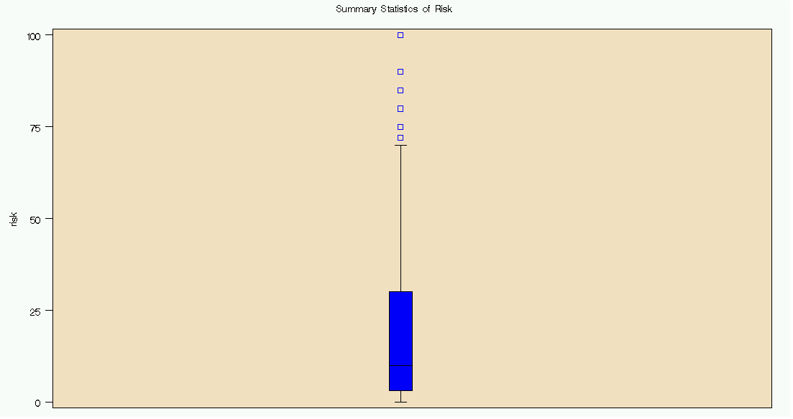
For risk by worldview, the means are generally centered around 20, the ranges are very similar across the groups, and the standard deviations for all world-views fall roughly between 20 and 25. There are many more unclassifiable observations than any other worldview, which may be of concern.

Summary Statistics of Risk by World-View
wvcat Obs Mean Std Dev N Minimum Maximum
----------------------------------------------------------------------------------------
0 384 22.0388889 24.8051715 360 0 100.0000000
1 51 22.3125000 25.8169961 48 0 100.0000000
2 98 18.0978261 19.7217233 92 0 90.0000000
3 78 17.2692308 20.0600871 78 0 90.0000000
-----------------------------------------------------------------------------------------
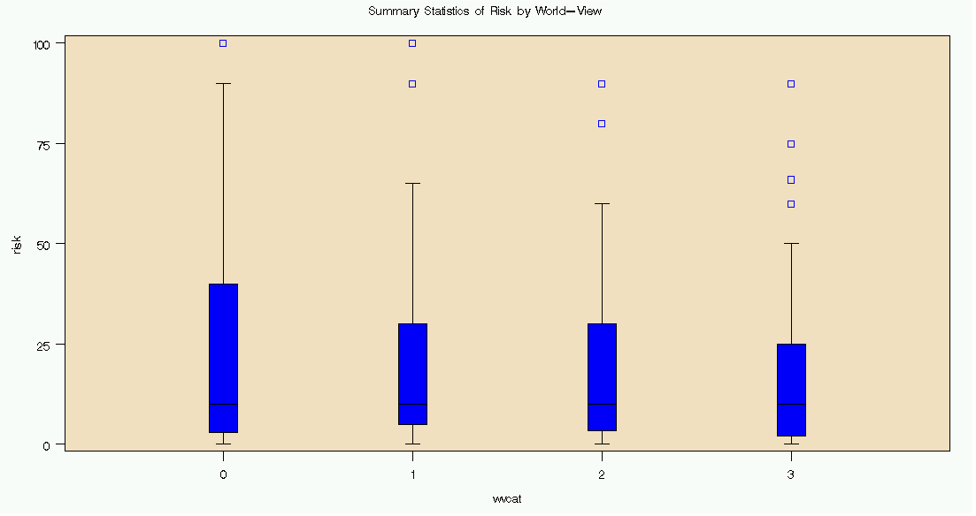
With gender by risk, again we don’t observe any strikingly noticeable differences.

Summary Statistics of Risk by Gender
gender Obs Mean Std Dev N Minimum Maximum
-----------------------------------------------------------------------------------------
0 385 19.0222222 22.3642810 360 0 100.0000000
1 226 23.7110092 25.2508880 218 0 100.0000000
-----------------------------------------------------------------------------------------
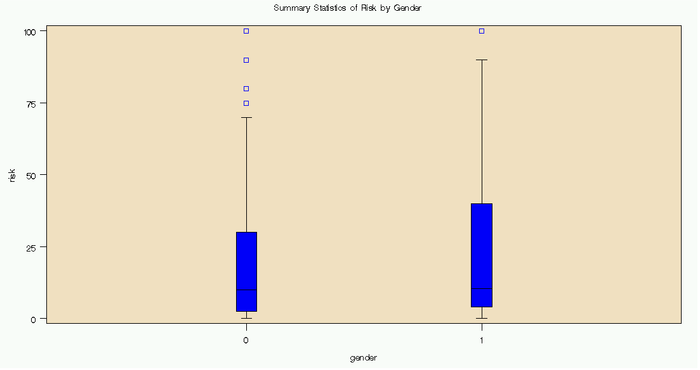
For ethnicity, it looks like group 2 may differ from the other groups, as the group mean and standard deviation are larger than the other three groups. Groups 1, 3, and 4 do not appear to differ much though. Also, there are no outliers in group 2, even up to the maximum risk (i.e, 100), while the other three groups have at least three outliers each.
Summary Statistics of Risk by Ethnicity
ethnic Obs Mean Std Dev N Minimum Maximum
-----------------------------------------------------------------------------------------
1 158 17.6092715 22.0958438 151 0 90.0000000
2 147 28.3046875 28.7819822 128 0 100.0000000
3 140 17.1037037 19.6207604 135 0 90.0000000
4 166 20.8902439 22.1932428 164 0 100.0000000
-----------------------------------------------------------------------------------------

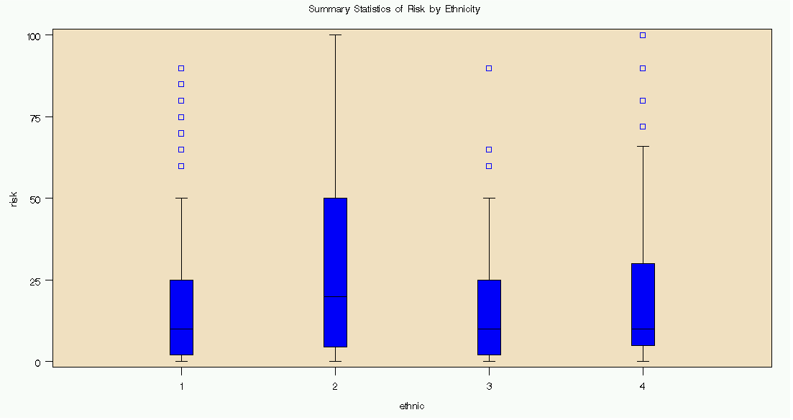
- I analyzed the data using a Factorial ANOVA. First, I entered all three variables (gender, worldview, ethnicity) into the model to examine any main effects or two- or three-way interactions. Sum of
Source DF Squares Mean Square F Value Pr > F
Model 31 33353.3872 1075.9157 2.04 0.0009
Error 546 287550.2824 526.6489
Corrected Total 577 320903.6696

ethnic 3 3875.37629 1291.79210 2.45 0.0625
gender 1 988.12340 988.12340 1.88 0.1713
wvcat 3 1337.06118 445.68706 0.85 0.4690
gender*ethnic 3 886.17240 295.39080 0.56 0.6410
wvcat*ethnic 9 5809.74062 645.52674 1.23 0.2763
gender*wvcat 3 899.56182 299.85394 0.57 0.6354
gender*wvcat*ethnic 9 12251.35049 1361.26117 2.58 0.0064
While the overall model and gender*worldview*ethnic interactions are significant, the rest of the main-effects and interactions are non-significant. From the resulting Tukey test, I discovered that there were no differences between world-views. Following this, I decided to remove worldview from the ANOVA to further tease out the differences between groups.

Difference Simultaneous
wvcat Between 95% Confidence
Comparison Means Limits

1 - 0 0.274 -8.814 9.361
1 - 2 4.215 -6.315 14.744
1 - 3 5.043 -5.806 15.892
0 - 1 -0.274 -9.361 8.814
0 - 2 3.941 -2.968 10.850
0 - 3 4.770 -2.616 12.156
2 - 1 -4.215 -14.744 6.315
2 - 0 -3.941 -10.850 2.968
2 - 3 0.829 -8.274 9.931
3 - 1 -5.043 -15.892 5.806
3 - 0 -4.770 -12.156 2.616
3 - 2 -0.829 -9.931 8.274

When gender and ethnicity are entered into the model, the interaction between them is non-significant, but the main effects and model are highly significant. The next step was to remove the interaction and hopefully produce a better model.
Sum of
Source DF Squares Mean Square F Value Pr > F
Model 7 14964.0146 2137.7164 3.98 0.0003
Error 570 305939.6550 536.7362
Corrected Total 577 320903.6696

Source DF Type III SS Mean Square F Value Pr > F

ethnic 3 10930.15043 3643.38348 6.79 0.0002
gender 1 3505.06953 3505.06953 6.53 0.0109
gender*ethnic 3 1089.60690 363.20230 0.68 0.5666

Once the gender*ethnic interaction was removed, the model reached maximum significance, and the main effect of both variables remained significant.
Sum of
Source DF Squares Mean Square F Value Pr > F
Model 4 13874.4077 3468.6019 6.47 <.0001
Error 573 307029.2619 535.8277
Corrected Total 577 320903.6696

Source DF Type III SS Mean Square F Value Pr > F

ethnic 3 10889.35391 3629.78464 6.77 0.0002
gender 1 3282.37486 3282.37486 6.13 0.0136

The Tukey test showed that there is a difference between genders, and that group 2 differed from all other groups, but there is no difference between the other groups.

ethnic Between Simultaneous 95%
Comparison Means Confidence Limits

2 - 4 7.414 0.440 14.389 ***
2 - 1 10.695 3.590 17.801 ***
2 - 3 11.201 3.905 18.497 ***
4 - 2 -7.414 -14.389 -0.440 ***
4 - 1 3.281 -3.389 9.951
4 - 3 3.787 -3.086 10.659
1 - 2 -10.695 -17.801 -3.590 ***
1 - 4 -3.281 -9.951 3.389
1 - 3 0.506 -6.499 7.510
3 - 2 -11.201 -18.497 -3.905 ***
3 - 4 -3.787 -10.659 3.086
3 - 1 -0.506 -7.510 6.499

Tukey Grouping Mean N gender

A 23.711 218 1

B 19.022 360 0
A residual analysis was then conducted. All analyses met the ANOVA assumptions of independent and constant variability, although the normal probability plot shows some outliers and non-normality at the extremes.

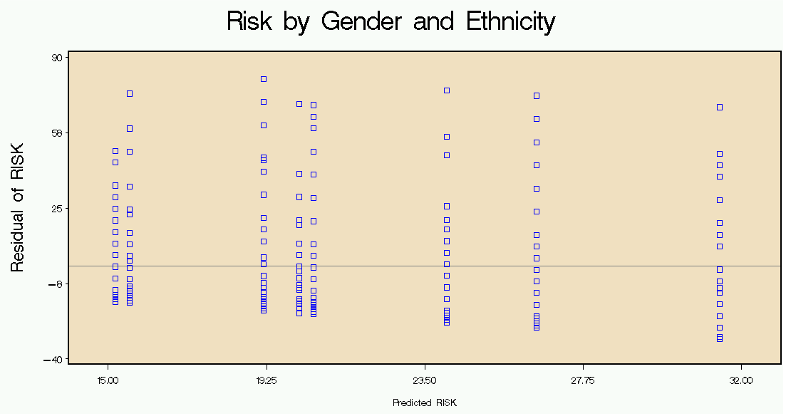
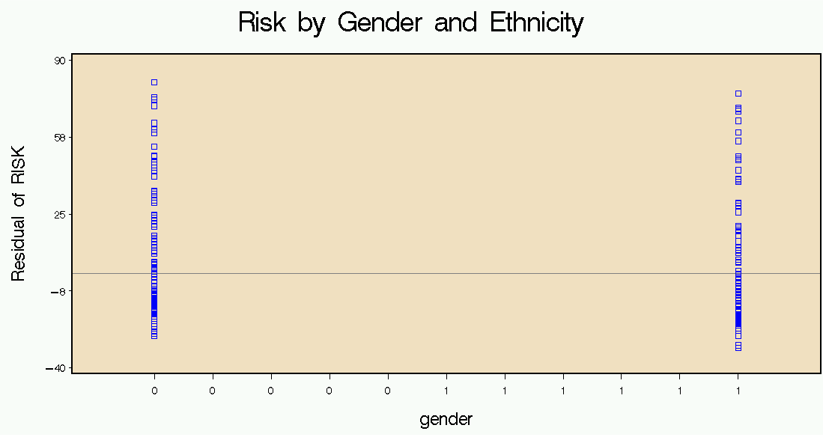
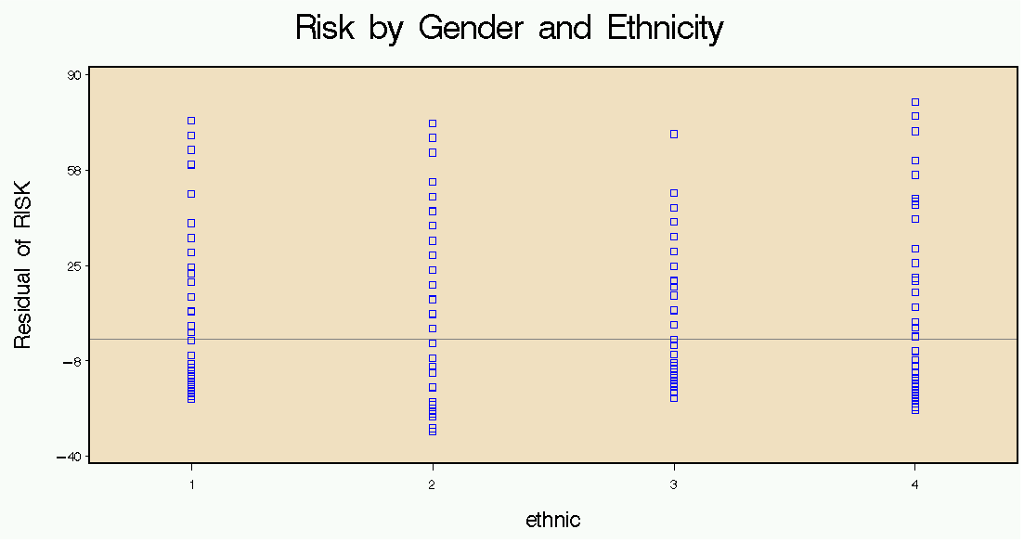
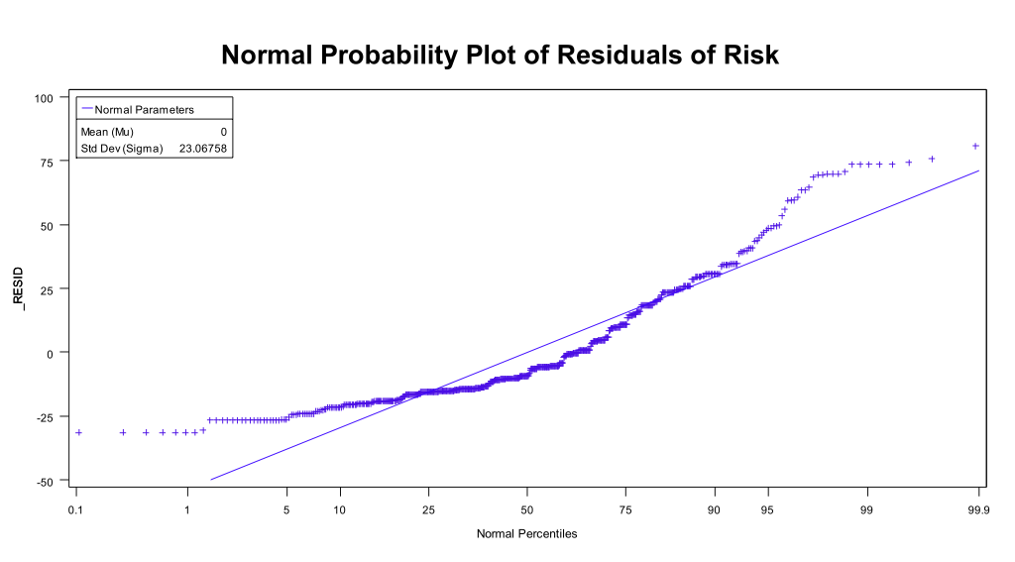
5. From the analysis, we can firmly conclude that there are differences in risk-taking behaviors between males and females and African-Americans and the other three ethnicities. Males scored higher on the risk task, as did African-Americans. Both of the hypotheses were confirmed: there was no significant difference between world-views, possibly indicating that the measures failed to capture the complete ideology of the participants, but there were meaningful differences between genders and ethnicities.

