CHAPTER 15: THE TERM STRUCTURE OF INTEREST RATES

PROBLEM SETS.

1. In general, the forward rate can be viewed as the sum of the market’s expectation of the future short rate plus a potential risk (or liquidity) premium. According to the expectations theory of the term structure of interest rates, the liquidity premium is zero so that the forward rate is equal to the market’s expectation of the future short rate. Therefore, the market’s expectation of future short rates (i.e., forward rates) can be derived from the yield curve, and there is no risk premium for longer maturities.
The liquidity preference theory, on the other hand, specifies that the liquidity premium is positive so that the forward rate is greater than the market’s expectation of the future short rate. This could result in an upward sloping term structure even if the market does not anticipate an increase in interest rates. The liquidity preference theory is based on the assumption that the financial markets are dominated by short-term investors who demand a premium in order to be induced to invest in long maturity securities.

2. True. Under the expectations hypothesis, there are no risk premia built into bond prices. The only reason for long-term yields to exceed short-term yields is an expectation of higher short-term rates in the future.

3. Uncertain. Expectations of lower inflation will usually lead to lower nominal interest rates. Nevertheless, if the liquidity premium is sufficiently great, long-term yields may exceed short-term yields despite expectations of falling short rates.

4. The liquidity theory holds that investors demand a premium to compensate them for interest rate exposure and the premium increases with maturity. Add this premium to a flat curve and the result is an upward sloping yield curve.

5. The pure expectations theory, also referred to as the unbiased expectations theory, purports that forward rates are solely a function of expected future spot rates. Under the pure expectations theory, a yield curve that is upward (downward) sloping, means that short-term rates are expected to rise (fall). A flat yield curve implies that the market expects short-term rates to remain constant.

6. The yield curve slopes upward because short-term rates are lower than long-term rates. Since market rates are determined by supply and demand, it follows that investors (demand side) expect rates to be higher in the future than in the near-term.

7. | Maturity | Price | YTM | Forward Rate
 | 1 | $943.40 | 6.00%
 | 2 | $898.47 | 5.50% | (1.055²/1.06) – 1 = 5.0%
 | 3 | $847.62 | 5.67% | (1.0567³/1.055²) – 1 = 6.0%
 | 4 | $792.16 | 6.00% | (1.06⁴/1.0567³) – 1 = 7.0%

8. The expected price path of the 4-year zero coupon bond is shown below. (Note that we discount the face value by the appropriate sequence of forward rates implied by this year’s yield curve.)
Beginning of Year | Expected Price | Expected Rate of Return
1 | $792.16 | ($839.69/$792.16) – 1 = 6.00%
2 | 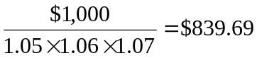 | ($881.68/$839.69) – 1 = 5.00%
3 | 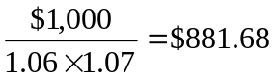 | ($934.58/$881.68) – 1 = 6.00%
4 | 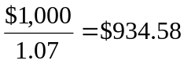 | ($1,000.00/$934.58) – 1 = 7.00%

9. If expectations theory holds, then the forward rate equals the short rate, and the one-year interest rate three years from now would be
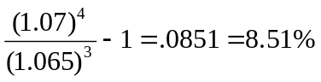

10. a. A 3-year zero coupon bond with face value $100 will sell today at a yield of 6% and a price of:
$100/1.06³ =$83.96
Next year, the bond will have a two-year maturity, and therefore a yield of 6% (from next year’s forecasted yield curve). The price will be $89, resulting in a holding period return of 6%.

b. The forward rates based on today’s yield curve are as follows:
Year | Forward Rate
2 | (1.05²/1.04) – 1 = 6.01%
3 | (1.06³/1.05²) – 1 = 8.03%
Using the forward rates, the forecast for the yield curve next year is:
Maturity | YTM
1 | 6.01%
2 | (1.0601 × 1.0803)^{1/2} – 1 = 7.02%
The market forecast is for a higher YTM on 2-year bonds than your forecast. Thus, the market predicts a lower price and higher rate of return.

11. a. 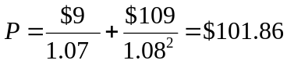

b. The yield to maturity is the solution for y in the following equation:
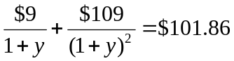
[Using a financial calculator, enter n = 2; FV = 100; PMT = 9; PV = –101.86; Compute i] YTM = 7.958%

c. The forward rate for next year, derived from the zero-coupon yield curve, is the solution for f ₂ in the following equation:
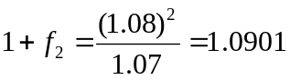 ⇒ f ₂ = 0.0901 = 9.01%.
Therefore, using an expected rate for next year of r₂ = 9.01%, we find that the forecast bond price is:
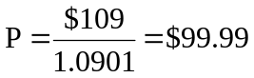

d. If the liquidity premium is 1% then the forecast interest rate is:
E(r₂) = f₂ – liquidity premium = 9.01% – 1.00% = 8.01%
The forecast of the bond price is:
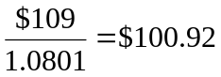

12. a. The current bond price is:
($85 × 0.94340) + ($85 × 0.87352) + ($1,085 × 0.81637) = $1,040.20
This price implies a yield to maturity of 6.97%, as shown by the following:
[$85 × Annuity factor (6.97%, 3)] + [$1,000 × PV factor (6.97%, 3)] = $1,040.17

b. If one year from now y = 8%, then the bond price will be:
[$85 × Annuity factor (8%, 2)] + [$1,000 × PV factor (8%, 2)] = $1,008.92
The holding period rate of return is:
[$85 + ($1,008.92 – $1,040.20)]/$1,040.20 = 0.0516 = 5.16%

13. | Year | Forward Rate | PV of $1 received at period end
 | 1 | 5% | $1/1.05 = $0.9524
 | 2 | 7 | 1/(1.05×1.07) = $0.8901
 | 3 | 8 | 1/(1.05×1.07×1.08) = $0.8241

a. Price = ($60 × 0.9524) + ($60 × 0.8901) + ($1,060 × 0.8241) = $984.14

b. To find the yield to maturity, solve for y in the following equation:
$984.10 = [$60 × Annuity factor (y, 3)] + [$1,000 × PV factor (y, 3)]
This can be solved using a financial calculator to show that y = 6.60%:
PV = -$984.10; N = 3; FV = $1,000; PMT = $60. Solve for I = 6.60%.

c.
Period | Payment Received at End of Period: | Will Grow by  a Factor of: | To a Future  Value of:
1 | $60.00 | 1.07 × 1.08 | $69.34
2 | 60.00 | 1.08 | 64.80
3 | 1,060.00 | 1.00 | 1,060.00
 |  |  | $1,194.14
$984.10 × (1 + y _{realized})³ = $1,194.14
1 + y _{realized} = 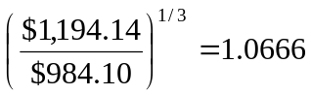 ⇒ y _{realized} = 6.66%

Alternatively, PV = -$984.10; N = 3; FV = $1,194.14; PMT = $0. Solve for I = 6.66%.

d. Next year, the price of the bond will be:
[$60 × Annuity factor (7%, 2)] + [$1,000 × PV factor (7%, 2)] = $981.92
Therefore, there will be a capital loss equal to: $984.10 – $981.92 = $2.18
The holding period return is: 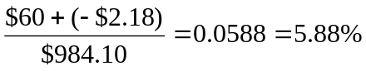

14. a. The return on the one-year zero-coupon bond will be 6.1%.
The price of the 4-year zero today is:
$1,000/1.064⁴ = $780.25
Next year, if the yield curve is unchanged, today’s 4-year zero coupon bond will have a 3-year maturity, a YTM of 6.3%, and therefore the price will be:
$1,000/1.063³ = $832.53
The resulting one-year rate of return will be: 6.70%
Therefore, in this case, the longer-term bond is expected to provide the higher return because its YTM is expected to decline during the holding period.

- If you believe in the expectations hypothesis, you would not expect that the yield curve next year will be the same as today’s curve. The upward slope in today's curve would be evidence that expected short rates are rising and that the yield curve will shift upward, reducing the holding period return on the four-year bond. Under the expectations hypothesis, all bonds have equal expected holding period returns. Therefore, you would predict that the HPR for the 4-year bond would be 6.1%, the same as for the 1-year bond.

15. The price of the coupon bond, based on its yield to maturity, is:
[$120 × Annuity factor (5.8%, 2)] + [$1,000 × PV factor (5.8%, 2)] = $1,113.99
If the coupons were stripped and sold separately as zeros, then, based on the yield to maturity of zeros with maturities of one and two years, respectively, the coupon payments could be sold separately for:
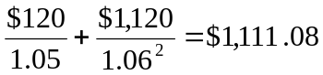
The arbitrage strategy is to buy zeros with face values of $120 and $1,120, and respective maturities of one year and two years, and simultaneously sell the coupon bond. The profit equals $2.91 on each bond.

16. a. The one-year zero-coupon bond has a yield to maturity of 6%, as shown below:
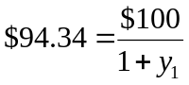  y1 = 0.06000 = 6.000%
The yield on the two-year zero is 8.472%, as shown below:
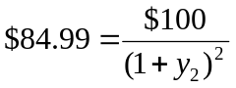  y2 = 0.08472 = 8.472%
The price of the coupon bond is: 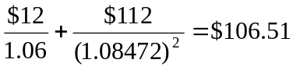
Therefore: yield to maturity for the coupon bond = 8.333%
[On a financial calculator, enter: n = 2; PV = –106.51; FV = 100; PMT = 12]

b. 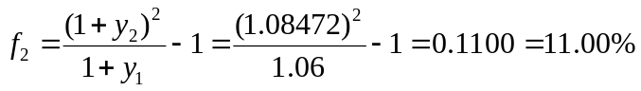
c. Expected price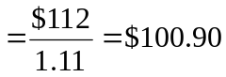
(Note that next year, the coupon bond will have one payment left.)
Expected holding period return =
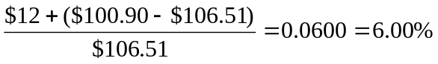
This holding period return is the same as the return on the one-year zero.

d. If there is a liquidity premium, then: E(r₂) < f ₂
E(Price) = 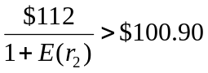
E(HPR) > 6%

17. a. We obtain forward rates from the following table:
Maturity | YTM | Forward Rate | Price (for parts c, d)
1 year | 10% |  | $1,000/1.10 = $909.09
2 years | 11% | (1.11²/1.10) – 1 = 12.01% | $1,000/1.11² = $811.62
3 years | 12% | (1.12³/1.11²) – 1 = 14.03% | $1,000/1.12³ = $711.78

b. We obtain next year’s prices and yields by discounting each zero’s face value at the forward rates for next year that we derived in part (a):
Maturity | Price | YTM
1 year | $1,000/1.1201 = $892.78 | 12.01%
2 years | $1,000/(1.1201 × 1.1403) = $782.93 | 13.02%
Note that this year’s upward sloping yield curve implies, according to the expectations hypothesis, a shift upward in next year’s curve.

- Next year, the 2-year zero will be a 1-year zero, and will therefore sell at a price of: $1,000/1.1201 = $892.78
Similarly, the current 3-year zero will be a 2-year zero and will sell for: $782.93
Expected total rate of return:
2-year bond: 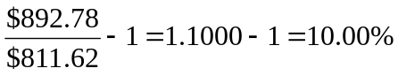
3-year bond: 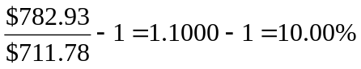

d. The current price of the bond should equal the value of each payment times the present value of $1 to be received at the “maturity” of that payment. The present value schedule can be taken directly from the prices of zero-coupon bonds calculated above.
Current price = ($120 × 0.90909) + ($120 × 0.81162) + ($1,120 × 0.71178)
= $109.0908 + $97.3944 + $797.1936 = $1,003.68
Similarly, the expected prices of zeros one year from now can be used to calculate the expected bond value at that time:
Expected price 1 year from now = ($120 × 0.89278) + ($1,120 × 0.78293)
= $107.1336 + $876.8816 = $984.02
Total expected rate of return =
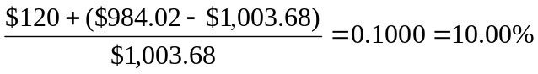

18. a.
Maturity (years) | Price | YTM | Forward Rate
1 | $925.93 | 8.00%
2 | 853.39 | 8.25 | 8.50%
3 | 782.92 | 8.50 | 9.00
4 | 15.00 | 8.75 | 9.50
5 | 650.00 | 9.00 | 10.00

- For each 3-year zero issued today, use the proceeds to buy:
$782.92/$715.00 = 1.095 four-year zeros
Your cash flows are thus as follows:
Time | Cash Flow
0 | $ 0
3 | -$1,000 | The 3-year zero issued at time 0 matures;  the issuer pays out $1,000 face value
4 | +$1,095 | The 4-year zeros purchased at time 0 mature;  receive face value
This is a synthetic one-year loan originating at time 3. The rate on the synthetic loan is 0.095 = 9.5%, precisely the forward rate for year 4.

c. For each 4-year zero issued today, use the proceeds to buy:
$715.00/$650.00 = 1.100 five-year zeros
Your cash flows are thus as follows:
Time | Cash Flow
0 | $ 0
4 | -$1,000 | The 4-year zero issued at time 0 matures;  the issuer pays out $1,000 face value
5 | +$1,100 | The 5-year zeros purchased at time 0 mature;  receive face value
This is a synthetic one-year loan originating at time 4. The rate on the synthetic loan is 0.100 = 10.0%, precisely the forward rate for year 5.

19. a. For each three-year zero you buy today, issue:
$782.92/$650.00 = 1.2045 five-year zeros
The time-0 cash flow equals zero.

b. Your cash flows are thus as follows:
Time | Cash Flow
0 | $ 0
3 | +$1,000.00 | The 3-year zero purchased at time 0 matures;  receive $1,000 face value
5 | -$1,204.50 | The 5-year zeros issued at time 0 mature;  issuer pays face value
This is a synthetic two-year loan originating at time 3.

- The effective two-year interest rate on the forward loan is:
$1,204.50/$1,000 − 1 = 0.2045 = 20.45%

- The one-year forward rates for years 4 and 5 are 9.5% and 10%, respectively. Notice that:
1.095 × 1.10 = 1.2045 =
1 + (two-year forward rate on the 3-year ahead forward loan)
The 5-year YTM is 9.0%. The 3-year YTM is 8.5%. Therefore, another way to derive the 2-year forward rate for a loan starting at time 3 is:
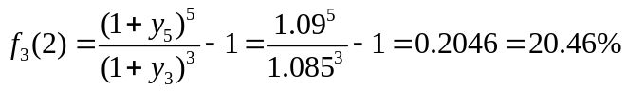
[Note: slight discrepancies here from rounding errors in YTM calculations]

CFA PROBLEMS

1. Expectations hypothesis: The yields on long-term bonds are geometric averages of present and expected future short rates. An upward sloping curve is explained by expected future short rates being higher than the current short rate. A downward-sloping yield curve implies expected future short rates are lower than the current short rate. Thus bonds of different maturities have different yields if expectations of future short rates are different from the current short rate.
Liquidity preference hypothesis: Yields on long-term bonds are greater than the expected return from rolling over short-term bonds in order to compensate investors in long-term bonds for bearing interest rate risk. Thus bonds of different maturities can have different yields even if expected future short rates are all equal to the current short rate. An upward-sloping yield curve can be consistent even with expectations of falling short rates if liquidity premiums are high enough. If, however, the yield curve is downward sloping and liquidity premiums are assumed to be positive, then we can conclude that future short rates are expected to be lower than the current short rate.

2. d. Investors bid up the price of short term securities and force yields to be relatively low, while doing just the opposite at the long end of the term structure. Therefore, they must be compensated more for giving up liquidity in the long term.

3. a. (1+y₄ )⁴ = (1+ y₃ )³ (1 + f ₄ )
(1.055)⁴ = (1.05)³ (1 + f ₄ )
1.2388 = 1.1576 (1 + f ₄ ) ⇒ f ₄ = 0.0701 = 7.01%

b. The conditions would be those that underlie the expectations theory of the term structure: risk neutral market participants who are willing to substitute among maturities solely on the basis of yield differentials. This behavior would rule out liquidity or term premia relating to risk.

c. Under the expectations hypothesis, lower implied forward rates would indicate lower expected future spot rates for the corresponding period. Since the lower expected future rates embodied in the term structure are nominal rates, either lower expected future real rates or lower expected future inflation rates would be consistent with the specified change in the observed (implied) forward rate.

4. The given rates are annual rates, but each period is a half-year. Therefore, the per period spot rates are 2.5% on one-year bonds and 2% on six-month bonds. The semiannual forward rate is obtained by solving for f in the following equation:
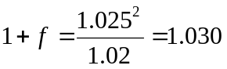
This means that the forward rate is 0.030 = 3.0% semiannually, or 6.0% annually.

5. The present value of each bond’s payments can be derived by discounting each cash flow by the appropriate rate from the spot interest rate (i.e., the pure yield) curve:
Bond A: 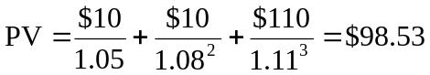
Bond B: 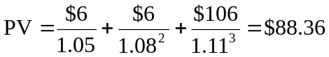
Bond A sells for $0.13 (i.e., 0.13% of par value) less than the present value of its stripped payments. Bond B sells for $0.02 less than the present value of its stripped payments. Bond A is more attractively priced.

6. a. Based on the pure expectations theory, VanHusen’s conclusion is incorrect. According to this theory, the expected return over any time horizon would be the same, regardless of the maturity strategy employed.

b. According to the liquidity preference theory, the shape of the yield curve implies that short-term interest rates are expected to rise in the future. This theory asserts that forward rates reflect expectations about future interest rates plus a liquidity premium that increases with maturity. Given the shape of the yield curve and the liquidity premium data provided, the yield curve would still be positively sloped (at least through maturity of eight years) after subtracting the respective liquidity premiums:
2.90% – 0.55% = 2.35%
3.50% – 0.55% = 2.95%
3.80% – 0.65% = 3.15%
4.00% – 0.75% = 3.25%
4.15% – 0.90% = 3.25%
4.30% – 1.10% = 3.20%
4.45% – 1.20% = 3.25%
4.60% – 1.50% = 3.10%
4.70% – 1.60% = 3.10%

7. The coupon bonds can be viewed as portfolios of stripped zeros: each coupon can stand alone as an independent zero-coupon bond. Therefore, yields on coupon bonds reflect yields on payments with dates corresponding to each coupon. When the yield curve is upward sloping, coupon bonds have lower yields than zeros with the same maturity because the yields to maturity on coupon bonds reflect the yields on the earlier interim coupon payments.

8. The following table shows the expected short-term interest rate based on the projections of Federal Reserve rate cuts, the term premium (which increases at a rate of 0.10% per 12 months), the forward rate (which is the sum of the expected rate and term premium), and the YTM, which is the geometric average of the forward rates.
Time | Expected Short Rate | Term Premium | Forward Rate (annual) | Forward Rate (semiannual) | YTM  (semiannual)
0 | 5.00% | 0.00% | 5.00% | 2.500% | 2.500%
6 months | 4.50 | 0.05 | 4.55 | 2.275 | 2.387
12 months | 4.00 | 0.10 | 4.10 | 2.050 | 2.275
18 months | 4.00 | 0.15 | 4.15 | 2.075 | 2.225
24 months | 4.00 | 0.20 | 4.20 | 2.100 | 2.200
30 months | 5.00 | 0.25 | 5.25 | 2.625 | 2.271
36 months | 5.00 | 0.30 | 5.30 | 2.650 | 2.334
This analysis is predicated on the liquidity preference theory of the term structure, which asserts that the forward rate in any period is the sum of the expected short rate plus the liquidity premium.

9. a. Five-year spot rate:
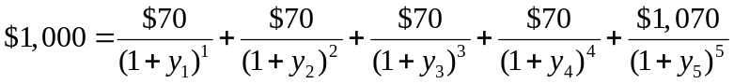
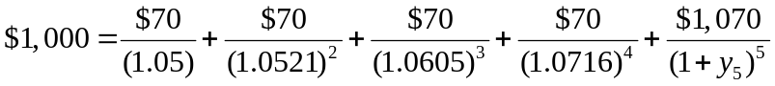
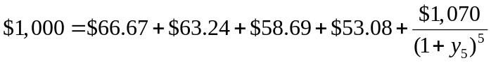
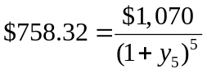
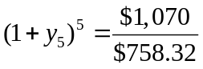⇒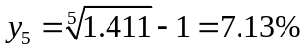
Five-year forward rate:
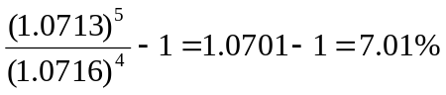

b. The yield to maturity is the single discount rate that equates the present value of a series of cash flows to a current price. It is the internal rate of return.
The short rate for a given interval is the interest rate for that interval available at different points in time.
The spot rate for a given period is the yield to maturity on a zero-coupon bond that matures at the end of the period. A spot rate is the discount rate for each period. Spot rates are used to discount each cash flow of a coupon bond in order to calculate a current price. Spot rates are the rates appropriate for discounting future cash flows of different maturities.
A forward rate is the implicit rate that links any two spot rates. Forward rates are directly related to spot rates, and therefore to yield to maturity. Some would argue (as in the expectations hypothesis) that forward rates are the market expectations of future interest rates. A forward rate represents a break-even rate that links two spot rates. It is important to note that forward rates link spot rates, not yields to maturity.
Yield to maturity is not unique for any particular maturity. In other words, two bonds with the same maturity but different coupon rates may have different yields to maturity. In contrast, spot rates and forward rates for each date are unique.

c. The four-year spot rate is 7.16%. Therefore, 7.16% is the theoretical yield to maturity for the zero-coupon U.S. Treasury note. The price of the zero-coupon note discounted at 7.16% is the present value of $1,000 to be received in four4 years. Using annual compounding:
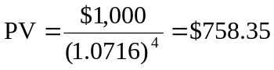

10. a. The two-year implied annually compounded forward rate for a deferred loan beginning in 3 years is calculated as follows:
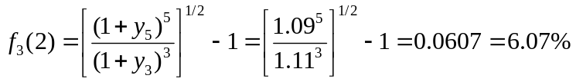

b. Assuming a par value of $1,000, the bond price is calculated as follows:
