CHAPTER 16: MANAGING BOND PORTFOLIOS

PROBLEM SETS

1. While it is true that short-term rates are more volatile than long-term rates, the longer duration of the longer-term bonds makes their prices and their rates of return more volatile. The higher duration magnifies the sensitivity to interest-rate changes.

2. Duration can be thought of as a weighted average of the maturities of the cash flows paid to holders of the perpetuity, where the weight for each cash flow is equal to the present value of that cash flow divided by the total present value of all cash flows. For cash flows in the distant future, present value approaches zero (i.e., the weight becomes very small) so that these distant cash flows have little impact and, eventually, virtually no impact on the weighted average.

3. The percentage change in the bond’s price is:
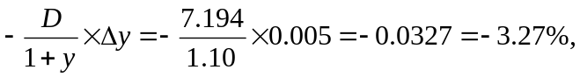 or a 3.27% decline

4. a. YTM = 6%
(1) | (2) | (3) | (4) | (5)
Time until Payment (Years) | Cash Flow | PV of CF (Discount Rate = 6%) | Weight | Column (1) × Column (4)
1 | $ 60.00 | $ 56.60 | 0.0566 | 0.0566
2 | 60.00 | 53.40 | 0.0534 | 0.1068
3 | 1,060.00 | 890.00 | 0.8900 | 2.6700
Column sums |  | $1,000.00 | 1.0000 | 2.8334
Duration = 2.833 years

b. YTM = 10%
(1) | (2) | (3) | (4) | (5)
Time until Payment (Years) | Cash Flow | PV of CF (Discount Rate = 10%) | Weight | Column (1) × Column (4)
1 | $ 60.00 | $ 54.55 | 0.0606 | 0.0606
2 | 60.00 | 49.59 | 0.0551 | 0.1102
3 | 1,060.00 | 796.39 | 0.8844 | 2.6532
Column sums |  | $900.53 | 1.0000 | 2.8240
Duration = 2.824 years, which is less than the duration at the YTM of 6%.

5. For a semiannual 6% coupon bond selling at par, we use the following parameters: coupon = 3% per half-year period, y = 3%, T = 6 semiannual periods.
(1) | (2) | (3) | (4) | (5)
Time until Payment (Years) | Cash Flow | PV of CF (Discount Rate = 3%) | Weight | Column (1) × Column (4)
1 | $ 3.00 | $ 2.913 | 0.02913 | 0.02913
2 | 3.00 | 2.828 | 0.02828 | 0.05656
3 | 3.00 | 2.745 | 0.02745 | 0.08236
4 | 3.00 | 2.665 | 0.02665 | 0.10662
5 | 3.00 | 2.588 | 0.02588 | 0.12939
6 | 103.00 | 86.261 | 0.86261 | 5.17565
Column sums |  | $100.000 | 1.00000 | 5.57971
D = 5.5797 half-year periods = 2.7899 years
If the bond’s yield is 10%, use a semiannual yield of 5% and semiannual coupon of 3%:
(1) | (2) | (3) | (4) | (5)
Time until Payment (Years) | Cash Flow | PV of CF (Discount Rate = 5%) | Weight | Column (1) × Column (4)
1 | $ 3.00 | $ 2.857 | 0.03180 | 0.03180
2 | 3.00 | 2.721 | 0.03029 | 0.06057
3 | 3.00 | 2.592 | 0.02884 | 0.08653
4 | 3.00 | 2.468 | 0.02747 | 0.10988
5 | 3.00 | 2.351 | 0.02616 | 0.13081
6 | 103.00 | 76.860 | 0.85544 | 5.13265
Column sums |  | $89.849 | 1.00000 | 5.55223
D = 5.5522 half-year periods = 2.7761 years
6. If the current yield spread between AAA bonds and Treasury bonds is too wide compared to historical yield spreads and is expected to narrow, you should shift from Treasury bonds into AAA bonds. As the spread narrows, the AAA bonds will outperform the Treasury bonds. This is an example of an intermarket spread swap.

7. D. Investors tend to purchase longer term bonds when they expect yields to fall so they can capture significant capital gains, and the lack of a coupon payment ensures the capital gain will be even greater.

8. a. Bond B has a higher yield to maturity than bond A since its coupon payments and maturity are equal to those of A, while its price is lower. (Perhaps the yield is higher because of differences in credit risk.) Therefore, the duration of Bond B must be shorter.

b. Bond A has a lower yield and a lower coupon, both of which cause Bond A to have a longer duration than Bond B. Moreover, A cannot be called, so that its maturity is at least as long as that of B, which generally increases duration.

9. a.
(1) | (2) | (3) |  |  | (4) | (5)
Time until Payment (Years) | Cash Flow | PV of CF (Discount Rate = 10%) |  |  | Weight | Column (1) × Column (4)
1 | $10 million | $ 9.09 million |  |  | 0.7857 | 0.7857
5 | 4 million | 2.48 million |  |  | 0.2143 | 1.0715
Column sums |  |  | $11.57 million | 1.0000 |  | 1.8572
D = 1.8572 years = required maturity of zero coupon bond.

- The market value of the zero must be $11.57 million, the same as the market value of the obligations. Therefore, the face value must be:
$11.57 million × (1.10)^{1.8572} = $13.81 million

10 In each case, choose the longer-duration bond in order to benefit from a rate decrease.
a. ii. The Aaa-rated bond has the lower yield to maturity and therefore the longer duration.

b. i. The lower-coupon bond has the longer duration and greater de facto call protection.

c. i. The lower coupon bond has the longer duration.

11. The table below shows the holding period returns for each of the three bonds:
Maturity | 1 Year | 2 Years | 3 Years
YTM at beginning of year | 7.00% | 8.00% | 9.00%
Beginning of year prices | $1,009.35 | $1,000.00 | $974.69
Prices at year-end (at 9% YTM) | $1,000.00 | $990.83 | $982.41
Capital gain | –$9.35 | –$9.17 | $7.72
Coupon | $80.00 | $80.00 | $80.00
1-year total $ return | $70.65 | $70.83 | $87.72
1-year total rate of return | 7.00% | 7.08% | 9.00%
You should buy the three-year bond because it provides a 9% holding-period return over the next year, which is greater than the return on either of the other bonds.

12. a. PV of the obligation = $10,000 × Annuity factor (8%, 2) = $17,832.65
(1) | (2) | (3) | (4) | (5)
Time until Payment (Years) | Cash Flow | PV of CF (Discount Rate = 8%) | Weight | Column (1) × Column (4)
1 | $10,000.00 | $ 9,259.259 | 0.51923 | 0.51923
2 | 10,000.00 | 8,573.388 | 0.48077 | 0.96154
Column sums |  | $17,832.647 | 1.00000 | 1.48077
D = 1.4808 years

- A zero-coupon bond maturing in 1.4808 years would immunize the obligation. Since the present value of the zero-coupon bond must be $17,832.65, the face value (i.e., the future redemption value) must be
$17,832.65 × 1.08^{1.4808} = $19,985.26

c. If the interest rate increases to 9%, the zero-coupon bond would decrease in value to
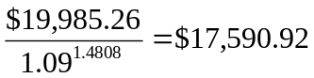
The present value of the tuition obligation would decrease to $17,591.11
The net position decreases in value by $0.19
If the interest rate decreases to 7%, the zero-coupon bond would increase in value to
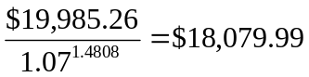
The present value of the tuition obligation would increase to $18,080.18
The net position decreases in value by $0.19
The reason the net position changes at all is that, as the interest rate changes, so does the duration of the stream of tuition payments.

13. a. PV of obligation = $2 million/0.16 = $12.5 million
Duration of obligation = 1.16/0.16 = 7.25 years
Call w the weight on the five-year maturity bond (which has duration of four years). Then
(w × 4) + [(1 – w) × 11] = 7.25 ⇒ w = 0.5357
Therefore: 0.5357 × $12.5 = $6.7 million in the 5-year bond and
0.4643 × $12.5 = $5.8 million in the 20-year bond.

b. The price of the 20-year bond is
[$60 × Annuity factor (16%, 20)] + [$1,000 × PV factor (16%, 20)] = $407.12
Alternatively, PMT = $60; N = 20; I = 16; FV = $1,000; solve for PV = $407.12.
Therefore, the bond sells for 0.4071 times its par value, and
Market value = Par value × 0.4071
$5.8 million = Par value × 0.4071 ⇒ Par value = $14.25 million
Another way to see this is to note that each bond with par value $1,000 sells for $407.12. If total market value is $5.8 million, then you need to buy approximately 14,250 bonds, resulting in total par value of $14.25 million.

14. a. The duration of the perpetuity is: 1.05/0.05 = 21 years
Call w the weight of the zero-coupon bond. Then
(w × 5) + [(1 – w) × 21] = 10 ⇒ w = 11/16 = 0.6875
Therefore, the portfolio weights would be as follows: 11/16 invested in the zero and 5/16 in the perpetuity.

b. Next year, the zero-coupon bond will have a duration of 4 years and the perpetuity will still have a 21-year duration. To obtain the target duration of nine years, which is now the duration of the obligation, we again solve for w:
(w × 4) + [(1 – w) × 21] = 9 ⇒ w = 12/17 = 0.7059
So, the proportion of the portfolio invested in the zero increases to 12/17 and the proportion invested in the perpetuity falls to 5/17.

15. a. The duration of the annuity if it were to start in one year would be
(1) | (2) | (3) | (4) | (5)
Time until Payment (Years) | Cash Flow | PV of CF (Discount Rate = 10%) | Weight | Column (1) × Column (4)
1 | $10,000 | $ 9,090.909 | 0.14795 | 0.14795
2 | 10,000 | 8,264.463 | 0.13450 | 0.26900
3 | 10,000 | 7,513.148 | 0.12227 | 0.36682
4 | 10,000 | 6,830.135 | 0.11116 | 0.44463
5 | 10,000 | 6,209.213 | 0.10105 | 0.50526
6 | 10,000 | 5,644.739 | 0.09187 | 0.55119
7 | 10,000 | 5,131.581 | 0.08351 | 0.58460
8 | 10,000 | 4,665.074 | 0.07592 | 0.60738
9 | 10,000 | 4,240.976 | 0.06902 | 0.62118
10 | 10,000 | 3,855.433 | 0.06275 | 0.62745
Column sums |  | $61,445.671 | 1.00000 | 4.72546
D = 4.7255 years
Because the payment stream starts in five years, instead of one year, we add four years to the duration, so the duration is 8.7255 years.

b. The present value of the deferred annuity is
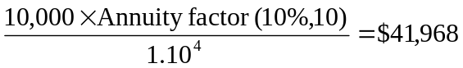
Alternatively, CF 0 = 0; CF 1 = 0; N = 4; CF 2 = $10,000; N = 10; I = 10; Solve for NPV = $41,968.
Call w the weight of the portfolio invested in the five-year zero. Then
(w × 5) + [(1 – w) × 20] = 8.7255 ⇒ w = 0.7516
The investment in the five-year zero is equal to
0.7516 × $41,968 = $31,543
The investment in the 20-year zeros is equal to
0.2484 × $41,968 = $10,423
These are the present or market values of each investment. The face values are equal to the respective future values of the investments. The face value of the five-year zeros is
$31,543 × (1.10)⁵ = $50,801
Therefore, between 50 and 51 zero-coupon bonds, each of par value $1,000, would be purchased. Similarly, the face value of the 20-year zeros is
$10,425 × (1.10)²⁰ = $70,123

16. Using a financial calculator, we find that the actual price of the bond as a function of yield to maturity is
Yield to Maturity Price
7% $1,620.45
8 1,450.31
9 1,308.21
(N = 30; PMT = $120; FV = $1,000, I = 7, 8, and 9; Solve for PV)
Using the duration rule, assuming yield to maturity falls to 7%
Predicted price change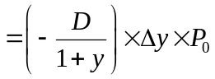
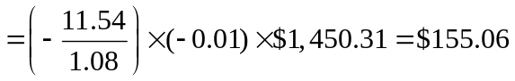
Therefore: predicted new price = $1,450.31 + $155.06 = $1,605.37
The actual price at a 7% yield to maturity is $1,620.45. Therefore
% error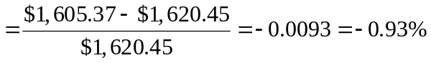(approximation is too low)
Using the duration rule, assuming yield to maturity increases to 9%
Predicted price change
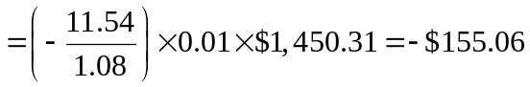
Therefore: predicted new price = $1,450.31 – $155.06= $1,295.25
The actual price at a 9% yield to maturity is $1,308.21. Therefore
% error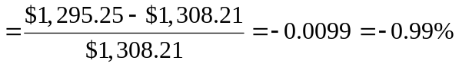(approximation is too low)
Using duration-with-convexity rule, assuming yield to maturity falls to 7%
Predicted price change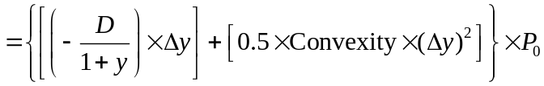
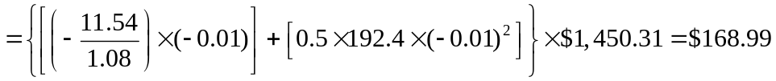
Therefore the predicted new price = $1,450.31 + $168.99 = $1,619.30.
The actual price at a 7% yield to maturity is $1,620.45. Therefore
% error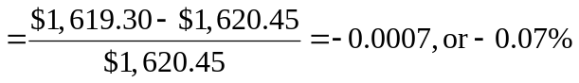(approximation is too low).
Using duration-with-convexity rule, assuming yield to maturity rises to 9%
Predicted price change
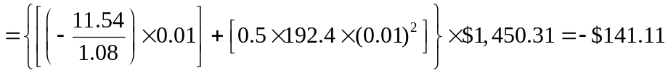
Therefore the predicted new price = $1,450.31 – $141.11 = $1,309.20.
The actual price at a 9% yield to maturity is $1,308.21. Therefore
% error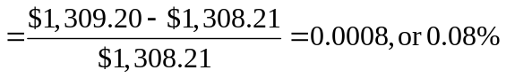(approximation is too high).
Conclusion: The duration-with-convexity rule provides more accurate approximations to the true change in price. In this example, the percentage error using convexity with duration is less than one-tenth the error using only duration to estimate the price change.

17. Shortening his portfolio duration makes the value of the portfolio less sensitive relative to interest rate changes. So if interest rates increase the value of the portfolio will decrease less.

18. Predicted price change:
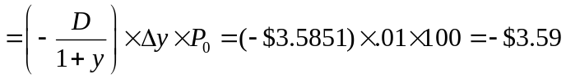decrease

19. The maturity of the 30-year bond will fall to 25 years, and its yield is forecast to be 8%. Therefore, the price forecast for the bond is $893.25
[Using a financial calculator, enter the following: n = 25; i = 8; FV = 1000; PMT = 70]
At a 6% interest rate, the five coupon payments will accumulate to $394.60 after five years. Therefore, total proceeds will be: $394.60 + $893.25 = $1,287.85
Therefore, the five-year return is ($1,287.85/$867.42) – 1 = 0.4847.
This is a 48.47% five-year return, or 8.22% annually.

The maturity of the 20-year bond will fall to 15 years, and its yield is forecast to be 7.5%. Therefore, the price forecast for the bond is $911.73.
[Using a financial calculator, enter the following: n = 15; i = 7.5; FV = 1000; PMT = 65]
At a 6% interest rate, the five coupon payments will accumulate to $366.41 after five years. Therefore, total proceeds will be $366.41 + $911.73 = $1,278.14.
Therefore, the five-year return is: ($1,278.14/$879.50) – 1 = 0.4533
This is a 45.33% five-year return, or 7.76% annually. The 30-year bond offers the higher expected return.

20.
a. | Period | Time until Payment (Years) | Cash Flow | PV of CF  Discount Rate = 6% per Period | Weight | Years × Weight
A. 8% coupon bond | 1 | 0.5 | $ 40 | $ 37.736 | 0.0405 | 0.0203
 | 2 | 1.0 | 40 | 35.600 | 0.0383 | 0.0383
 | 3 | 1.5 | 40 | 33.585 | 0.0361 | 0.0541
 | 4 | 2.0 | 1,040 | 823.777 | 0.8851 | 1.7702
Sum: |  |  |  | $930.698 | 1.0000 | 1.8829
B. Zero-coupon | 1 | 0.5 | $0 | $ 0.000 | 0.0000 | 0.0000
 | 2 | 1.0 | 0 | 0.000 | 0.0000 | 0.0000
 | 3 | 1.5 | 0 | 0.000 | 0.0000 | 0.0000
 | 4 | 2.0 | 1,000 | 792.094 | 1.0000 | 2.0000
Sum: |  |  |  | $792.094 | 1.0000 | 2.0000
For the coupon bond, the weight on the last payment in the table above is less than it is in Spreadsheet 16.1 because the discount rate is higher; the weights for the first three payments are larger than those in Spreadsheet 16.1. Consequently, the duration of the bond falls. The zero coupon bond, by contrast, has a fixed weight of 1.0 for the single payment at maturity.

b. | Period | Time until Payment (Years) | Cash Flow | PV of CF  Discount Rate = 5% per Period | Weight | Years × Weight
A. 8% coupon bond | 1 | 0.5 | $ 60 | $ 57.143 | 0.0552 | 0.0276
 | 2 | 1.0 | 60 | 54.422 | 0.0526 | 0.0526
 | 3 | 1.5 | 60 | 51.830 | 0.0501 | 0.0751
 | 4 | 2.0 | 1,060 | 872.065 | 0.8422 | 1.6844
Sum: |  |  |  | $1,035.460 | 1.0000 | 1.8396
Since the coupon payments are larger in the above table, the weights on the earlier payments are higher than in Spreadsheet 16.1, so duration decreases.

21.
a. |  | Time  (t) | Cash Flow | PV(CF) | t + t² | (t + t²) × PV(CF)
Coupon = | $80 | 1 | $ 80 | $ 72.727 | 2 | 145.455
YTM = | 0.10 | 2 | 80 | 66.116 | 6 | 396.694
Maturity = | 5 | 3 | 80 | 60.105 | 12 | 721.262
Price = | $924.184 | 4 | 80 | 54.641 | 20 | 1,092.822
 |  | 5 | 1,080 | 670.595 | 30 | 20,117.851
 |  | Price: |  | $924.184
 |  | Sum: |  |  |  | 22,474.083
 |  | Convexity = |  | Sum/[Price × (1+y)²] = 20.097

b. |  | Time  (t) | Cash Flow | PV(CF) | t² + t | (t² + t) × PV(CF)
Coupon = | $0 | 1 | $ 0 | $ 0.000 | 2 | 0.000
YTM = | 0.10 | 2 | 0 | 0.000 | 6 | 0.000
Maturity = | 5 | 3 | 0 | 0.000 | 12 | 0.000
Price = | $620.921 | 4 | 0 | 0.000 | 20 | 0.000
 |  | 5 | 1,000 | 620.921 | 30 | 18,627.640
 |  | Price: |  | $620.921
 |  | Sum: |  |  |  | 18,627.640
 |  | Convexity = |  | Sum/[Price × (1+y)²] = 24.793

22. a. The price of the zero-coupon bond ($1,000 face value) selling at a yield to maturity of 8% is $374.84 and the price of the coupon bond is $774.84.
At a YTM of 9%, the actual price of the zero-coupon bond is $333.28 and the actual price of the coupon bond is $691.79.
Zero-coupon bond:
Actual % loss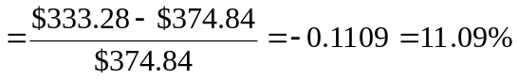loss
The percentage loss predicted by the duration-with-convexity rule is:
Predicted % lossloss
Coupon bond:
Actual % loss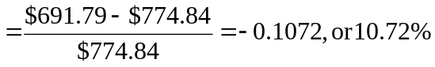loss
The percentage loss predicted by the duration-with-convexity rule is:
Predicted % lossloss
b. Now assume yield to maturity falls to 7%. The price of the zero increases to $422.04, and the price of the coupon bond increases to $875.91.
Zero-coupon bond:
Actual % gain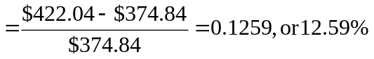 gain
The percentage gain predicted by the duration-with-convexity rule is:
Predicted % gain gain
Coupon bond:
Actual % gain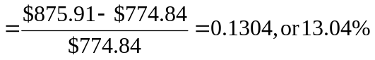gain
The percentage gain predicted by the duration-with-convexity rule is:
Predicted % gain gain

c. The 6% coupon bond, which has higher convexity, outperforms the zero regardless of whether rates rise or fall. This can be seen to be a general property using the duration-with-convexity formula: the duration effects on the two bonds due to any change in rates are equal (since the respective durations are virtually equal), but the convexity effect, which is always positive, always favors the higher convexity bond. Thus, if the yields on the bonds change by equal amounts, as we assumed in this example, the higher convexity bond outperforms a lower convexity bond with the same duration and initial yield to maturity.

d. This situation cannot persist. No one would be willing to buy the lower convexity bond if it always underperforms the other bond. The price of the lower convexity bond will fall and its yield to maturity will rise. Thus, the lower convexity bond will sell at a higher initial yield to maturity. That higher yield is compensation for lower convexity. If rates change only slightly, the higher yield–lower convexity bond will perform better; if rates change by a substantial amount, the lower yield–higher convexity bond will perform better.

23. a. The following spreadsheet shows that the convexity of the bond is 64.933. The present value of each cash flow is obtained by discounting at 7%. (Since the bond has a 7% coupon and sells at par, its YTM is 7%.)
Convexity equals: the sum of the last column (7,434.175) divided by:
[P × (1 + y)2] = 100 × (1.07)² = 114.49
Time  (t) | Cash Flow (CF) |  | PV(CF) |  | t² + t | (t² + t) × PV(CF)
1 | 7 |  | 6.542 |  | 2 | 13.084
2 | 7 |  | 6.114 |  | 6 | 36.684
3 | 7 |  | 5.714 |  | 12 | 68.569
4 | 7 |  | 5.340 |  | 20 | 106.805
5 | 7 |  | 4.991 |  | 30 | 149.727
6 | 7 |  | 4.664 |  | 42 | 195.905
7 | 7 |  | 4.359 |  | 56 | 244.118
8 | 7 |  | 4.074 |  | 72 | 293.333
9 | 7 |  | 3.808 |  | 90 | 342.678
10 | 107 |  | 54.393 |  | 110 | 5,983.271
Sum: |  |  | 100.000 |  |  | 7,434.175
 |  |  |  | Convexity: |  |  | 64.933
The duration of the bond is:
(1) | (2) | (3) | (4) | (5)
Time until Payment (Years) | Cash Flow | PV of CF (Discount Rate = 7%) | Weight | Column (1) × Column (4)
1 | $7 | $ 6.542 | 0.06542 | 0.06542
2 | 7 | 6.114 | 0.06114 | 0.12228
3 | 7 | 5.714 | 0.05714 | 0.17142
4 | 7 | 5.340 | 0.05340 | 0.21361
5 | $7 | 4.991 | 0.04991 | 0.24955
6 | 7 | 4.664 | 0.04664 | 0.27986
7 | 7 | 4.359 | 0.04359 | 0.30515
8 | 7 | 4.074 | 0.04074 | 0.32593
9 | 7 | 3.808 | 0.03808 | 0.34268
10 | 107 | 54.393 | 0.54393 | 5.43934
Column sums |  | $100.000 | 1.00000 | 7.51523
D = 7.515 years

b. If the yield to maturity increases to 8%, the bond price will fall to 93.29% of par value, a percentage decrease of 6.71%.
c. The duration rule predicts a percentage price change of
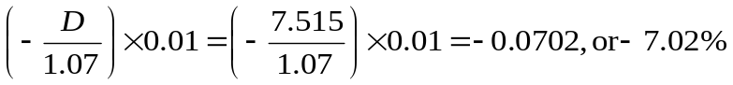
This overstates the actual percentage decrease in price by 0.31%.
The price predicted by the duration rule is 7.02% less than face value, or 92.98% of face value.

d. The duration-with-convexity rule predicts a percentage price change of
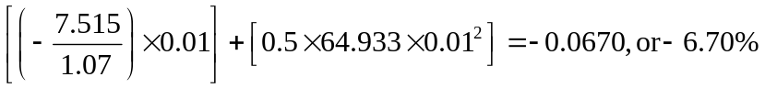
The percentage error is 0.01%, which is substantially less than the error using the duration rule.
The price predicted by the duration with convexity rule is 6.70% less than face value, or 93.30% of face value.

24.a. The following spreadsheet shows that the convexity of the “bullet” bond is 28. 2779. The present value of each cash flow is obtained by discounting at 3%. Convexity equals the sum of the last column (25,878.26) divided by
[P × (1 + y)2] = 862.61 × (1.03)² = 915.1416
Time  (t) | Cash flow (CF) |  | PV(CF) |  | t² + t | (t² + t) × PV(CF)
1 | 0 |  | 0 |  | 2 | 0
2 | 0 |  | 0 |  | 6 | 0
3 | 0 |  | 0 |  | 12 | 0
4 | 0 |  | 0 |  | 20 | 0
5 | 1000 |  | 862.61 |  | 30 | 25,878.26
Sum: |  |  | 862.61 |  |  | 25,878.26
 |  |  |  | Convexity: |  |  | 28.2779
The duration of the “bullet” is five years because of the single payment at maturity.
b. Time (t) | Cash Flow (CF) | PV(CF) | t + t² | (t + t²) x PV(CF) | t X PV(CF)/price
1 | 100 | $ 97.09 | 2 | $ 194.17 | 0.12
2 | 100 | 94.26 | 6 | 565.56 | 0.24
3 | 100 | 91.51 | 12 | 1,098.17 | 0.35
4 | 100 | 88.85 | 20 | 1,776.97 | 0.46
5 | 100 | 86.26 | 30 | 2,587.83 | 0.55
6 | 100 | 83.75 | 42 | 3,517.43 | 0.65
7 | 100 | 81.31 | 56 | 4,553.31 | 0.73
8 | 100 | 78.94 | 72 | 5,683.75 | 0.81
9 | 100 | 76.64 | 90 | 6,897.75 | 0.89
 | Sum | $778.61 |  | $26,874.95 | 4.80
 |  |  | Convexity | 32.53513991

The present value of each cash flow is obtained by discounting at 3%. Convexity equals: the sum of the last column (26,874.95) divided by
[P × (1 + y)2] = 778.61 × (1.03)² = 826.0283. The duration is the sum of the last column. Notice the duration is close to that of the bullet bond.
c. The barbell has the greater convexity.

CFA PROBLEMS

1. a. The call feature provides a valuable option to the issuer, since it can buy back the bond at a specified call price even if the present value of the scheduled remaining payments is greater than the call price. The investor will demand, and the issuer will be willing to pay, a higher yield on the issue as compensation for this feature.

b. The call feature reduces both the duration (interest rate sensitivity) and the convexity of the bond. If interest rates fall, the increase in the price of the callable bond will not be as large as it would be if the bond were noncallable. Moreover, the usual curvature that characterizes price changes for a straight bond is reduced by a call feature. The price-yield curve (see Figure 16.6) flattens out as the interest rate falls and the option to call the bond becomes more attractive. In fact, at very low interest rates, the bond exhibits negative convexity.

2. a. Bond price decreases by $80.00, calculated as follows:
10 × 0.01 × 800 = 80.00

b. ½ × 120 × (0.015)² = 0.0135 = 1.35%

c. 9/1.10 = 8.18

d. (i)

e. (i)

f. (iii)

3. a. Modified duration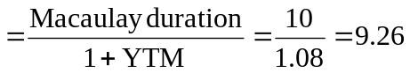years

b. For option-free coupon bonds, modified duration is a better measure of the bond’s sensitivity to changes in interest rates. Maturity considers only the final cash flow, while modified duration includes other factors, such as the size and timing of coupon payments, and the level of interest rates (yield to maturity). Modified duration indicates the approximate percentage change in the bond price for a given change in yield to maturity.

c. i. Modified duration increases as the coupon decreases.
ii. Modified duration decreases as maturity decreases.

d. Convexity measures the curvature of the bond’s price-yield curve. Such curvature means that the duration rule for bond price change (which is based only on the slope of the curve at the original yield) is only an approximation. Adding a term to account for the convexity of the bond increases the accuracy of the approximation. That convexity adjustment is the last term in the following equation:
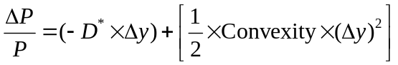

4. a. (i) Current yield = Coupon/Price = $70/$960 = 0.0729, or 7.29%
(ii) YTM = 3.993% semiannually or 7.986% annual bond equivalent yield.
[Financial calculator: n = 10; PV = –960; FV = 1000; PMT = 35 Compute the interest rate.]

(iii) Horizon yield or realized compound yield is 4.166% (semiannually), or 8.332% annual bond equivalent yield. To obtain this value, first find the future value (FV) of reinvested coupons and principal. There will be six payments of $35 each, reinvested semiannually at 3% per period. On a financial calculator, enter
PV = 0; PMT = $35; n = 6; i = 3%. Compute: FV = $226.39
Three years from now, the bond will be selling at the par value of $1,000 because the yield to maturity is forecast to equal the coupon rate. Therefore, total proceeds in three years will be $1,226.39.
Find the rate (y_{realized}) that makes the FV of the purchase price = $1,226.39:
$960 × (1 + y_{realized})⁶ = $1,226.39 ⇒ y_{realized} = 4.166% (semiannual)

Alternatively, PV = −$960; FV = $1,226.39; N = 6; PMT = $0; Solve for I = 4.16.

b. Shortcomings of each measure:
(i) Current yield does not account for capital gains or losses on bonds bought at prices other than par value. It also does not account for reinvestment income on coupon payments.
(ii) Yield to maturity assumes the bond is held until maturity and that all coupon income can be reinvested at a rate equal to the yield to maturity.
(iii) Horizon yield or realized compound yield is affected by the forecast of reinvestment rates, holding period, and yield of the bond at the end of the investor's holding period.
Note: This criticism of horizon yield is a bit unfair: while YTM can be calculated without explicit assumptions regarding future YTM and reinvestment rates, you implicitly assume that these values equal the current YTM if you use YTM as a measure of expected return.

5. a. (i) The effective duration of the 4.75% Treasury security is:
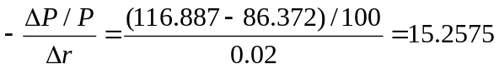

(ii) The duration of the portfolio is the weighted average of the durations of the individual bonds in the portfolio:
Portfolio duration = w₁D₁ + w₂D₂ + w₃D₃ + … + w_{k}D_{k}
where
w_{i} = Market value of bond i/Market value of the portfolio
D_{i} = Duration of bond i
k = Number of bonds in the portfolio
The effective duration of the bond portfolio is calculated as follows:
[($48,667,680/$98,667,680) × 2.15] + [($50,000,000/$98,667,680) × 15.26] = 8.79

b. VanHusen’s remarks would be correct if there were a small, parallel shift in yields. Duration is a first (linear) approximation only for small changes in yield. For larger changes in yield, the convexity measure is needed in order to approximate the change in price that is not explained by duration. Additionally, portfolio duration assumes that all yields change by the same number of basis points (parallel shift), so any nonparallel shift in yields would result in a difference in the price sensitivity of the portfolio compared to the price sensitivity of a single security having the same duration.

6. a. The Aa bond initially has a higher YTM (yield spread of 40 b.p. versus 31 b.p.), but it is expected to have a widening spread relative to Treasuries. This will reduce the rate of return. The Aaa spread is expected to be stable. Calculate comparative returns as follows:
Incremental return over Treasuries =
Incremental yield spread − (Change in spread × Duration)
Aaa bond: 31 bp − (0 × 3.1 years) = 31 bp
Aa bond: 40 bp − (10 bp × 3.1 years) = 9 bp
Therefore, choose the Aaa bond.

b. Other variables to be considered:
• Potential changes in issue-specific credit quality: If the credit quality of the bonds changes, spreads relative to Treasuries will also change.
• Changes in relative yield spreads for a given bond rating: If quality spreads in the general bond market change because of changes in required risk premiums, the yield spreads of the bonds will change even if there is no change in the assessment of the credit quality of these particular bonds.
• Maturity effect: As bonds near their maturity, the effect of credit quality on spreads can also change. This can affect bonds of different initial credit quality differently.

7. a. % price change = (−Effective duration) × Change in YTM (%)
CIC: (−7.35) × (−0.50%) = 3.675%
PTR: (−5.40) × (−0.50%) = 2.700%

b. Since we are asked to calculate horizon return over a period of only one coupon period, there is no reinvestment income.
Horizon return =
CIC: 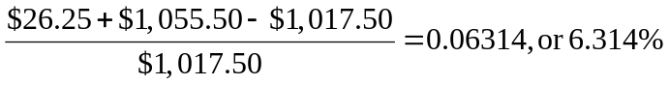
PTR: 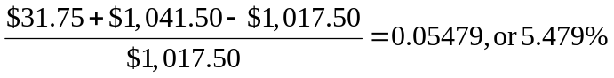

- Notice that CIC is noncallable but PTR is callable. Therefore, CIC has positive convexity, while PTR has negative convexity. Thus, the convexity correction to the duration approximation will be positive for CIC and negative for PTR.

8. The economic climate is one of impending interest rate increases. Hence, we will seek to shorten portfolio duration.
a. Choose the short maturity (2014) bond.

b. The Arizona bond likely has lower duration. The Arizona coupons are slightly lower, but the Arizona yield is higher.

c. Choose the 9 3/8 % coupon bond. The maturities are approximately equal, but the 9 3/8 % coupon is much higher, resulting in a lower duration.

d. The duration of the Shell bond is lower if the effect of the earlier start of sinking fund redemption dominates its slightly lower coupon rate.

e. The floating rate note has a duration that approximates the adjustment period, which is only six months, thus choose the floating rate note.

9. a. A manager who believes that the level of interest rates will change should engage in a rate anticipation swap, lengthening duration if rates are expected to fall, and shortening duration if rates are expected to rise.

b. A change in yield spreads across sectors would call for an intermarket spread swap, in which the manager buys bonds in the sector for which yields are expected to fall relative to other bonds and sells bonds in the sector for which yields are expected to rise relative to other bonds.

c. A belief that the yield spread on a particular instrument will change calls for a substitution swap in which that security is sold if its yield is expected to rise relative to the yield of other similar bonds, or is bought if its yield is expected to fall relative to the yield of other similar bonds.

10. a. The advantages of a bond indexing strategy are
- Historically, the majority of active managers underperform benchmark indexes in most periods; indexing reduces the possibility of underperformance at a given level of risk.
- Indexed portfolios do not depend on advisor expectations and so have less risk of underperforming the market.
- Management advisory fees for indexed portfolios are dramatically less than fees for actively managed portfolios. Fees charged by active managers generally range from 15 to 50 basis points, while fees for indexed portfolios range from 1 to 20 basis points (with the highest of those representing enhanced indexing). Other nonadvisory fees (i.e., custodial fees) are also less for indexed portfolios.
- Plan sponsors have greater control over indexed portfolios because individual managers do not have as much freedom to vary from the parameters of the benchmark index. Some plan sponsors even decide to manage index portfolios with in-house investment staff.
- Indexing is essentially “buying the market.” If markets are efficient, an indexing strategy should reduce unsystematic diversifiable risk and should generate maximum return for a given level of risk.
The disadvantages of a bond indexing strategy are
- Indexed portfolio returns may match the bond index, but do not necessarily reflect optimal performance. In some time periods, many active managers may outperform an indexing strategy at the same level of risk.
- The chosen bond index and portfolio returns may not meet the client objectives or the liability stream.
- Bond indexing may restrict the fund from participating in sectors or other opportunities that could increase returns.

b. The stratified sampling, or cellular, method divides the index into cells, with each cell representing a different characteristic of the index. Common cells used in the cellular method combine (but are not limited to) duration, coupon, maturity, market sectors, credit rating, and call and sinking fund features. The index manager then selects one or more bond issues to represent the entire cell. The total market weight of issues held for each cell is based on the target index’s composition of that characteristic.

c. Tracking error is defined as the discrepancy between the performance of an indexed portfolio and the benchmark index. When the amount invested is relatively small and the number of cells to be replicated is large, a significant source of tracking error with the cellular method occurs because of the need to buy odd lots of issues in order to accurately represent the required cells. Odd lots generally must be purchased at higher prices than round lots. On the other hand, reducing the number of cells to limit the required number of odd lots would potentially increase tracking error because of the mismatch with the target.

11. a. For an option-free bond, the effective duration and modified duration are approximately the same. Using the data provided, the duration is calculated as follows:
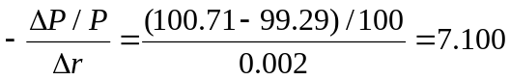

b. The total percentage price change for the bond is estimated as follows:
Percentage price change using duration = –7.90 × –0.02 × 100 = 15.80%
Convexity adjustment = 1.66%
Total estimated percentage price change = 15.80% + 1.66% = 17.46%

c. The assistant’s argument is incorrect. Because modified convexity does not recognize the fact that cash flows for bonds with an embedded option can change as yields change, modified convexity remains positive as yields move below the callable bond’s stated coupon rate, just as it would for an option-free bond. Effective convexity, however, takes into account the fact that cash flows for a security with an embedded option can change as interest rates change. When yields move significantly below the stated coupon rate, the likelihood that the bond will be called by the issuer increases and the effective convexity turns negative.

12. ∆P/P = −D* ∆y
For Strategy I:
5-year maturity: ∆P/P = −4.83 × (−0.75%) = 3.6225%
25-year maturity: ∆P/P = −23.81 × 0.50% = −11.9050%
Strategy I: ∆P/P = (0.5 × 3.6225%) + [0.5 × (−11.9050%)] = −4.1413%
For Strategy II:
15-year maturity: ∆P/P = −14.35 × 0.25% = −3.5875%

13. a. i. Strong economic recovery with rising inflation expectations. Interest rates and bond yields will most likely rise, and the prices of both bonds will fall. The probability that the callable bond will be called would decrease, and the callable bond will behave more like the noncallable bond. (Note that they have similar durations when priced to maturity). The slightly lower duration of the callable bond will result in somewhat better performance in the high interest rate scenario.
ii. Economic recession with reduced inflation expectations. Interest rates and bond yields will most likely fall. The callable bond is likely to be called. The relevant duration calculation for the callable bond is now modified duration to call. Price appreciation is limited as indicated by the lower duration. The noncallable bond, on the other hand, continues to have the same modified duration and hence has greater price appreciation.

b. Projected price change = (Modified duration) × (Change in YTM)
= (–6.80) × (–0.75%) = 5.1%
Therefore, the price will increase to approximately $105.10 from its current level of $100.

c. For Bond A, the callable bond, bond life, and therefore bond cash flows are uncertain. If one ignores the call feature and analyzes the bond on a “to maturity” basis, all calculations for yield and duration are distorted. Durations are too long and yields are too high. On the other hand, if one treats the premium bond selling above the call price on a “to call” basis, the duration is unrealistically short and yields too low. The most effective approach is to use an option valuation approach. The callable bond can be decomposed into two separate securities: a noncallable bond and an option:
Price of callable bond = Price of noncallable bond – Price of option
Since the call option always has some positive value, the price of the callable bond is always less than the price of the noncallable security.

