CHAPTER 18: EQUITY VALUATION MODELS

PROBLEM SETS

1. Theoretically, dividend discount models can be used to value the stock of rapidly growing companies that do not currently pay dividends; in this scenario, we would be valuing expected dividends in the relatively more distant future. However, as a practical matter, such estimates of payments to be made in the more distant future are notoriously inaccurate, rendering dividend discount models problematic for valuation of such companies; free cash flow models are more likely to be appropriate. At the other extreme, one would be more likely to choose a dividend discount model to value a mature firm paying a relatively stable dividend.

2. It is most important to use multistage dividend discount models when valuing companies with temporarily high growth rates. These companies tend to be companies in the early phases of their life cycles, when they have numerous opportunities for reinvestment, resulting in relatively rapid growth and relatively low dividends (or, in many cases, no dividends at all). As these firms mature, attractive investment opportunities are less numerous so that growth rates slow.

3. The intrinsic value of a share of stock is the individual investor’s assessment of the true worth of the stock. The market capitalization rate is the market consensus for the required rate of return for the stock. If the intrinsic value of the stock is equal to its price, then the market capitalization rate is equal to the expected rate of return. On the other hand, if the individual investor believes the stock is underpriced (i.e., intrinsic value > price), then that investor’s expected rate of return is greater than the market capitalization rate.

4. First estimate the amount of each of the next two dividends and the terminal value. The current value is the sum of the present value of these cash flows, discounted at 8.5%.

5. The required return is 9%. 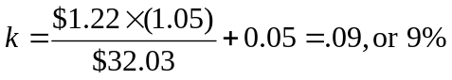

6. The Gordon DDM uses the dividend for period (t+1) which would be 1.05.

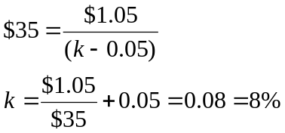
7. The PVGO is $0.56:
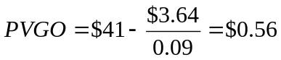
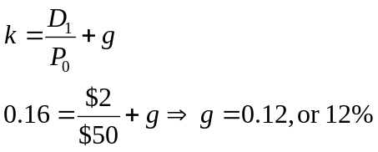
8. a.

b. 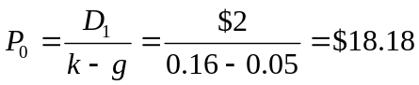
The price falls in response to the more pessimistic dividend forecast. The forecast for current year earnings, however, is unchanged. Therefore, the P/E ratio falls. The lower P/E ratio is evidence of the diminished optimism concerning the firm's growth prospects.

9. a. g = ROE × b = 16% × 0.5 = 8%
D₁ = $2 × (1 – b) = $2 × (1 – 0.5) = $1
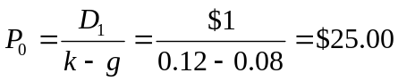

b. P₃ = P₀(1 + g)³ = $25(1.08)³ = $31.49

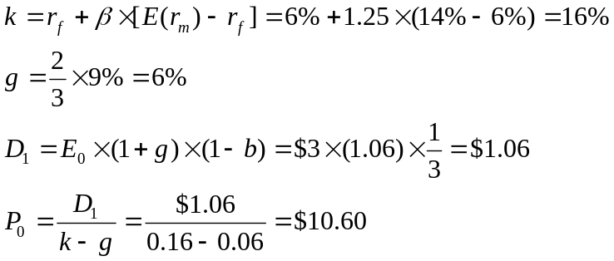10. a.

b. Leading P₀/E₁ = $10.60/$3.18 = 3.33
Trailing P₀/E₀ = $10.60/$3.00 = 3.53

c. 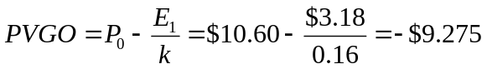
The low P/E ratios and negative PVGO are due to a poor ROE (9%) that is less than the market capitalization rate (16%).

- Now, you revise b to 1/3, g to 1/3 × 9% = 3%, and D₁ to:
E₀ × (1 + g) × (2/3)
$3 × 1.03 × (2/3) = $2.06
Thus:
V₀ = $2.06/(0.16 – 0.03) = $15.85
V₀ increases because the firm pays out more earnings instead of reinvesting a poor ROE. This information is not yet known to the rest of the market.

11. a. 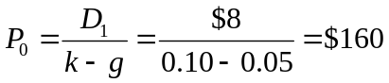

- The dividend payout ratio is 8/12 = 2/3, so the plowback ratio is b = 1/3. The implied value of ROE on future investments is found by solving:
g = b × ROE with g = 5% and b = 1/3 ⇒ ROE = 15%

- Assuming ROE = k, price is equal to:
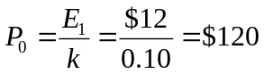
Therefore, the market is paying $40 per share ($160 – $120) for growth opportunities.

12. a. k = D₁/P₀ + g
D₁ = 0.5 × $2 = $1
g = b × ROE = 0.5 × 0.20 = 0.10
Therefore: k = ($1/$10) + 0.10 = 0.20, or 20%

b. Since k = ROE, the NPV of future investment opportunities is zero:
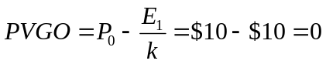
c. Since k = ROE, the stock price would be unaffected by cutting the dividend and investing the additional earnings.

13. a. k = r_{f} + β [E(r_{M} ) – r_{f} ] = 8% + 1.2(15% – 8%) = 16.4%
g = b × ROE = 0.6 × 20% = 12%
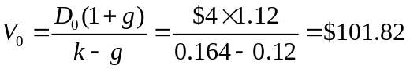

b. P₁ = V₁ = V₀(1 + g) = $101.82 × 1.12 = $114.04
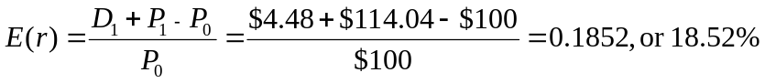

14.
Time: | 0 | 1 | 5 | 6
E _{t} | $10.000 | $12.000 | $24.883 | $27.123
D _{t} | $ 0.000 | $ 0.000 | $ 0.000 | $10.849
b | 1.00 | 1.00 | 1.00 | 0.60
g | 20.0% | 20.0% | 20.0% | 9.0%
The year-6 earnings estimate is based on growth rate of 0.15 × (1-.0.40) = 0.09.
a. 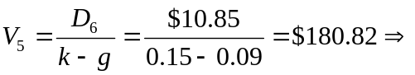
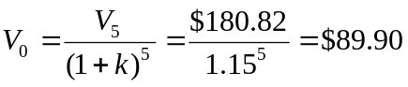
- The price should rise by 15% per year until year 6: because there is no dividend, the entire return must be in capital gains.

c. The payout ratio would have no effect on intrinsic value because ROE = k.

15. a. The solution is shown in the Excel spreadsheet below:
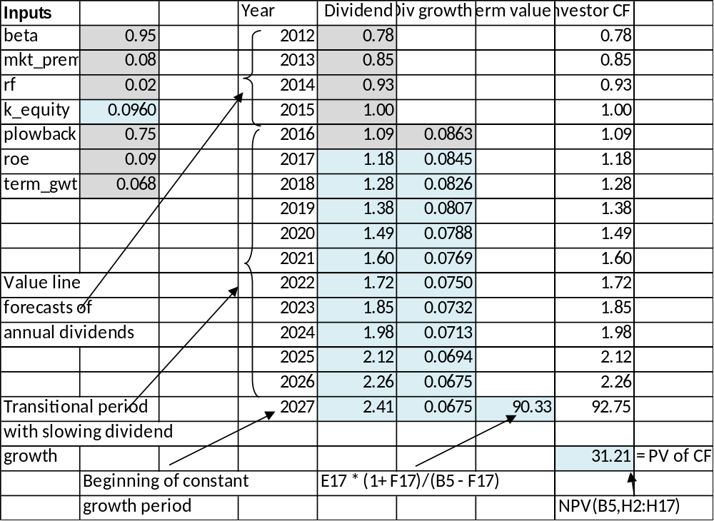
b., c. Using the Excel spreadsheet, we find that the intrinsic values are $33.80 and $32.80, respectively.

16. The solutions derived from Spreadsheet 18.2 are as follows:
 | Intrinsic Value:  FCFF | Intrinsic Value:  FCFE | Intrinsic Value per Share: FCFF | Intrinsic Value per Share: FCFE
a. | 100,000 | 75,128 | 38.89 | 41.74
b. | 109,422 | 81,795 | 44.12 | 45.44
c. | 89,693 | 66,014 | 33.16 | 36.67

17.
Time: | 0 | 1 | 2 | 3
D _{t} | $1.0000 | $1.2500 | $1.5625 | $1.953
g | 25.0% | 25.0% | 25.0% | 5.0%
a. The dividend to be paid at the end of year 3 is the first installment of a dividend stream that will increase indefinitely at the constant growth rate of 5%. Therefore, we can use the constant growth model as of the end of year 2 in order to calculate intrinsic value by adding the present value of the first two dividends plus the present value of the price of the stock at the end of year 2.
The expected price 2 years from now is:
P₂ = D₃/(k – g) = $1.953125/(0.20 – 0.05) = $13.02
The PV of this expected price is $13.02/1.20² = $9.04
The PV of expected dividends in years 1 and 2 is
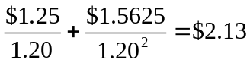
Thus the current price should be: $9.04 + $2.13 = $11.17

- Expected dividend yield = D₁/P₀ = $1.25/$11.17 = 0.112, or 11.2%

c. The expected price one year from now is the PV at that time of P₂ and D₂:
P₁ = (D₂ + P₂)/1.20 = ($1.5625 + $13.02)/1.20 = $12.15
The implied capital gain is
(P₁ – P₀)/P₀ = ($12.15 – $11.17)/$11.17 = 0.088 = 8.8%
The sum of the implied capital gains yield and the expected dividend yield is equal to the market capitalization rate. This is consistent with the DDM.

18.
Time: | 0 | 1 | 4 | 5
E _{t} | $5.000 | $6.000 | $10.368 | $10.368
D _{t} | $0.000 | $0.000 | $0.000 | $10.368
Dividends = 0 for the next four years, so b = 1.0 (100% plowback ratio).
a. 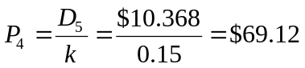
(Since k=ROE, knowing the plowback rate is unnecessary)
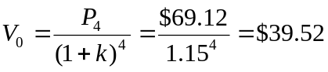

b. Price should increase at a rate of 15% over the next year, so that the HPR will equal k.

19. Before-tax cash flow from operations $2,100,000
Depreciation 210,000
Taxable Income 1,890,000
Taxes (@ 35%) 661,500
After-tax unleveraged income 1,228,500
After-tax cash flow from operations
(After-tax unleveraged income + depreciation) 1,438,500
New investment (20% of cash flow from operations) 420,000
Free cash flow
(After-tax cash flow from operations – new investment) $1,018,500
The value of the firm (i.e., debt plus equity) is:
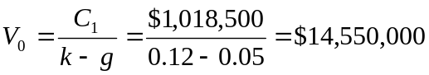
Since the value of the debt is $4 million, the value of the equity is $10,550,000.

20. a. g = ROE × b = 20% × 0.5 = 10%
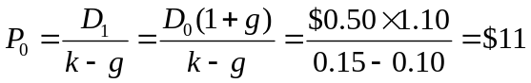

b. | Time | EPS | Dividend | Comment
 | 0 | $1.0000 | $0.5000
 | 1 | 1.1000 | 0.5500 | g = 10%, plowback = 0.50
 | 2 | 1.2100 | 0.7260 | EPS has grown by 10% based on last year’s earnings plowback and ROE; this year’s earnings plowback ratio now falls to 0.40 and payout ratio = 0.60
 | 3 | $1.2826 | $0.7696 | EPS grows by (0.4) (15%) = 6% and payout ratio = 0.60
At time 2: 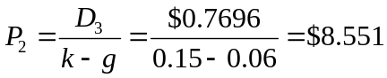
At time 0: 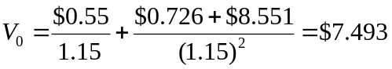

c. P₀ = $11 and P₁ = P₀(1 + g) = $12.10
(Because the market is unaware of the changed competitive situation, it believes the stock price should grow at 10% per year.)
P₂ = $8.551 after the market becomes aware of the changed competitive situation.
P3 = $8.551 × 1.06 = $9.064 (The new growth rate is 6%.)
Year | Return
1 | 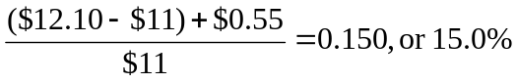
2 | 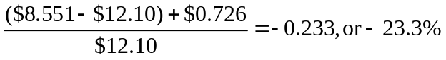
3 | 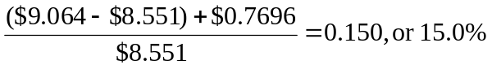
Moral: In normal periods when there is no special information, the stock return = k = 15%. When special information arrives, all the abnormal return accrues in that period, as one would expect in an efficient market.

CFA PROBLEMS

1. a. This director is confused. In the context of the constant growth model
[i.e., P0 = D1/ k – g)], it is true that price is higher when dividends are higher holding everything else including dividend growth constant. But everything else will not be constant. If the firm increases the dividend payout rate, the growth rate g will fall, and stock price will not necessarily rise. In fact, if ROE > k, price will fall.

- (i) An increase in dividend payout will reduce the sustainable growth rate as less funds are reinvested in the firm. The sustainable growth rate
(i.e. ROE × plowback) will fall as plowback ratio falls.
(ii) The increased dividend payout rate will reduce the growth rate of book value for the same reason -- less funds are reinvested in the firm.

2. Using a two-stage dividend discount model, the current value of a share of Sundanci is calculated as follows.
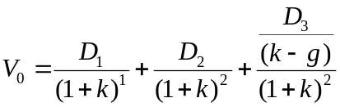
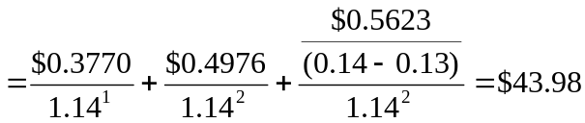
where:
E₀ = $0.952
D₀ = $0.286
E₁ = E₀ (1.32)¹ = $0.952 × 1.32 = $1.2566
D₁ = E₁ × 0.30 = $1.2566 × 0.30 = $0.3770
E₂ = E₀ (1.32)² = $0.952 × (1.32)² = $1.6588
D₂ = E₂ × 0.30 = $1.6588 × 0.30 = $0.4976
E₃ = E₀ × (1.32)² × 1.13 = $0.952 × (1.32)² × 1.13 = $1.8744
D₃ = E₃ × 0.30 = $1.8743 × 0.30 = $0.5623

3. a. Free cash flow to equity (FCFE) is defined as the cash flow remaining after meeting all financial obligations (including debt payment) and after covering capital expenditure and working capital needs. The FCFE is a measure of how much the firm can afford to pay out as dividends but, in a given year, may be more or less than the amount actually paid out.
Sundanci's FCFE for the year 2008 is computed as follows:
FCFE = Earnings + Depreciation − Capital expenditures − Increase in NWC
= $80 million + $23 million − $38 million − $41 million = $24 million
FCFE per share = 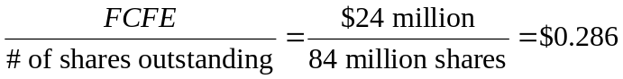
At this payout ratio, Sundanci's FCFE per share equals dividends per share.

b. The FCFE model requires forecasts of FCFE for the high growth years (2012 and 2013) plus a forecast for the first year of stable growth (2014) in order to allow for an estimate of the terminal value in 2013 based on perpetual growth. Because all of the components of FCFE are expected to grow at the same rate, the values can be obtained by projecting the FCFE at the common rate. (Alternatively, the components of FCFE can be projected and aggregated for each year.)
This table shows the process for estimating the current per share value:

FCFE Base Assumptions
Shares outstanding: 84 million, k = 14%
 |  |  | Actual  2011 | Projected  2012 |  | Projected  2013 |  | Projected  2014
Growth rate (g) |  |  |  | 27% |  | 27% |  | 13%
 | Total |  | Per Share
Earnings after tax | $80 |  | $0.952 | $1.2090 |  | $1.5355 |  | $1.7351
Plus: Depreciation expense | 23 |  | 0.274 | 0.3480 |  | 0.4419 |  | $0.4994
Less: Capital expenditures | 38 |  | 0.452 | 0.5740 |  | 0.7290 |  | $0.8238
Less: Increase in net working capital | 41 |  | 0.488 | 0.6198 |  | 0.7871 |  | $0.8894
Equals: FCFE | 24 |  | 0.286 | 0.3632 |  | 0.4613 |  | $0.5213
Terminal value |  |  |  |  |  | $52.1300*
Total cash flows to equity |  |  |  | $0.3632 |  | $52.5913†
Discounted value |  |  |  | $0.3186‡ |  | $40.4673‡
Current value per share |  |  |  |  |  |  | $40.7859§
*Projected 2013 terminal value = (Projected 2014 FCFE)/(r − g)
†Projected 2013 Total cash flows to equity =
Projected 2013 FCFE + Projected 2013 terminal value
‡Discounted values obtained using k= 14%
§Current value per share=Sum of discounted projected 2012 and 2013 total FCFE

c. i. The DDM uses a strict definition of cash flows to equity, i.e. the expected dividends on the common stock. In fact, taken to its extreme, the DDM cannot be used to estimate the value of a stock that pays no dividends. The FCFE model expands the definition of cash flows to include the balance of residual cash flows after all financial obligations and investment needs have been met. Thus the FCFE model explicitly recognizes the firm’s investment and financing policies as well as its dividend policy. In instances of a change of corporate control, and therefore the possibility of changing dividend policy, the FCFE model provides a better estimate of value. The DDM is biased toward finding low P/E ratio stocks with high dividend yields to be undervalued and conversely, high P/E ratio stocks with low dividend yields to be overvalued. It is considered a conservative model in that it tends to identify fewer undervalued firms as market prices rise relative to fundamentals. The DDM does not allow for the potential tax disadvantage of high dividends relative to the capital gains achievable from retention of earnings.

ii. Both two-stage valuation models allow for two distinct phases of growth, an initial finite period where the growth rate is abnormal, followed by a stable growth period that is expected to last indefinitely. These two-stage models share the same limitations with respect to the growth assumptions. First, there is the difficulty of defining the duration of the extraordinary growth period. For example, a longer period of high growth will lead to a higher valuation, and there is the temptation to assume an unrealistically long period of extraordinary growth. Second, the assumption of a sudden shift from high growth to lower, stable growth is unrealistic. The transformation is more likely to occur gradually, over a period of time. Given that the assumed total horizon does not shift (i.e., is infinite), the timing of the shift from high to stable growth is a critical determinant of the valuation estimate. Third, because the value is quite sensitive to the steady-state growth assumption, over- or underestimating this rate can lead to large errors in value. The two models share other limitations as well, notably difficulties in accurately forecasting required rates of return, in dealing with the distortions that result from substantial and/or volatile debt ratios, and in accurately valuing assets that do not generate any cash flows.

4. a. The formula for calculating a price earnings ratio (P/E) for a stable growth firm is the dividend payout ratio divided by the difference between the required rate of return and the growth rate of dividends. If the P/E is calculated based on trailing earnings (year 0), the payout ratio is increased by the growth rate. If the P/E is calculated based on next year’s earnings (year 1), the numerator is the payout ratio.
P/E on trailing earnings:
P/E = [payout ratio × (1 + g)]/(k − g) = [0.30 × 1.13]/(0.14 − 0.13) = 33.9
P/E on next year's earnings:
P/E = payout ratio/(k − g) = 0.30/(0.14 − 0.13) = 30.0
b. The P/E ratio is a decreasing function of riskiness; as risk increases, the P/E ratio decreases. Increases in the riskiness of Sundanci stock would be expected to lower the P/E ratio.
The P/E ratio is an increasing function of the growth rate of the firm; the higher the expected growth, the higher the P/E ratio. Sundanci would command a higher P/E if analysts increase the expected growth rate.
The P/E ratio is a decreasing function of the market risk premium. An increased market risk premium increases the required rate of return, lowering the price of a stock relative to its earnings. A higher market risk premium would be expected to lower Sundanci's P/E ratio.

5. a. The sustainable growth rate is equal to:
Plowback ratio × Return on equity = b × ROE
ROE = Net income/Beginning of year equity
In 2010:
b = [208 – (0.80 × 100)]/208 = 0.6154
ROE = 208/1380 = 0.1507
Sustainable growth rate = 0.6154 × 0.1507 = 9.3%
In 2013:
b = [275 – (0.80 × 100)]/275 = 0.7091
ROE = 275/1836 = 0.1498
Sustainable growth rate = 0.7091 × 0.1498 = 10.6%

b. i. The increased retention ratio increased the sustainable growth rate.
Retention ratio = 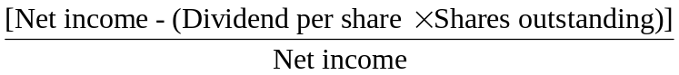
Retention ratio increased from 0.6154 in 2010 to 0.7091 in 2013.
This increase in the retention ratio directly increased the sustainable growth rate because the retention ratio is one of the two factors determining the sustainable growth rate.
ii. The decrease in leverage reduced the sustainable growth rate.
Financial leverage = (Total assets/Beginning of year equity)
Financial leverage decreased from 2.34 (3230/1380) at the beginning of 2010 to 2.10 at the beginning of 2013 (3856/1836)
This decrease in leverage directly decreased ROE (and thus the sustainable growth rate) because financial leverage is one of the factors determining ROE (and ROE is one of the two factors determining the sustainable growth rate).

6. a. The formula for the Gordon model is
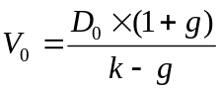
where:
D₀ = Dividend paid at time of valuation
g = Annual growth rate of dividends
k = Required rate of return for equity
In the above formula, P₀, the market price of the common stock, substitutes for V₀ and g becomes the dividend growth rate implied by the market:
P₀ = [D₀ × (1 + g)]/(k – g)
Substituting, we have:
58.49 = [0.80 × (1 + g)]/(0.08 – g) ⇒ g = 6.54%

b. Use of the Gordon growth model would be inappropriate to value Dynamic’s common stock, for the following reasons:
i. The Gordon growth model assumes a set of relationships about the growth rate for dividends, earnings, and stock values. Specifically, the model assumes that dividends, earnings, and stock values will grow at the same constant rate. In valuing Dynamic’s common stock, the Gordon growth model is inappropriate because management’s dividend policy has held dividends constant in dollar amount although earnings have grown, thus reducing the payout ratio. This policy is inconsistent with the Gordon model assumption that the payout ratio is constant.
ii. It could also be argued that use of the Gordon model, given Dynamic’s current dividend policy, violates one of the general conditions for suitability of the model, namely that the company’s dividend policy bears an understandable and consistent relationship with the company’s profitability.

7. a. The industry’s estimated P/E can be computed using the following model:
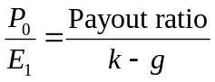
However, since k and g are not explicitly given, they must be computed using the following formulas:
g_{ind} = ROE × Retention rate = 0.25 × 0.40 = 0.10
k_{ind} = Government bond yield + ( Industry beta × Equity risk premium)
= 0.06 + (1.2 × 0.05) = 0.12
Therefore: 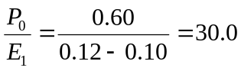

b. i. Forecast growth in real GDP would cause P/E ratios to be generally higher for Country A. Higher expected growth in GDP implies higher earnings growth and a higher P/E.
ii. Government bond yield would cause P/E ratios to be generally higher for Country B. A lower government bond yield implies a lower risk-free rate and therefore a higher P/E.
iii. Equity risk premium would cause P/E ratios to be generally higher for Country B. A lower equity risk premium implies a lower required return and a higher P/E.

8. a. k = rf + β (kM – rf) = 4.5% + 1.15(14.5% − 4.5%) = 16%

b. | Year | Dividend
 | 2009 |  | $1.72
 | 2010 | $1.72 × 1.12 = | $1.93
 | 2011 | $1.72 × 1.12² = | $2.16
 | 2012 | $1.72 × 1.12³ = | $2.42
 | 2013 | $1.72 × 1.12³ × 1.09 = | $2.63
Present value of dividends paid in 2010 – 2012:
 | Year | PV of Dividend
 | 2010 | $1.93/1.16¹ = | $1.66
 | 2011 | $2.16/1.16² = | $1.61
 | 2012 | $2.42/1.16³ = | $1.55
 |  | Total = | $4.82
Price at year-end 2012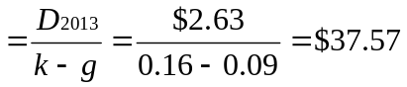
PV in 2009 of this stock price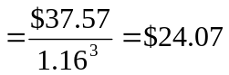
Intrinsic value of stock = $4.82 + $24.07 = $28.89

c. The data in the problem indicate that Quick Brush is selling at a price substantially below its intrinsic value, while the calculations above demonstrate that SmileWhite is selling at a price somewhat above the estimate of its intrinsic value. Based on this analysis, Quick Brush offers the potential for considerable abnormal returns, while SmileWhite offers slightly below-market risk-adjusted returns.
d. Strengths of two-stage versus constant growth DDM:
• Two-stage model allows for separate valuation of two distinct periods in a company’s future. This can accommodate life-cycle effects. It also can avoid the difficulties posed by initial growth that is higher than the discount rate.
• Two-stage model allows for initial period of above-sustainable growth. It allows the analyst to make use of her expectations regarding when growth might shift from off-trend to a more sustainable level.
A weakness of all DDMs is that they are very sensitive to input values. Small changes in k or g can imply large changes in estimated intrinsic value. These inputs are difficult to measure.

9. a. The value of a share of Rio National equity using the Gordon growth model and the capital asset pricing model is $22.40, as shown below.
Calculate the required rate of return using the capital asset pricing model:
k = rf + β × (kM – rf) = 4% + 1.8 × (9% – 4%) = 13%
Calculate the share value using the Gordon growth model:
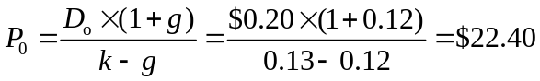

b. The sustainable growth rate of Rio National is 9.97%, calculated as follows:
g = b × ROE = Earnings retention rate × ROE = (1 – Payout ratio) × ROE =

10. a. To obtain free cash flow to equity (FCFE), the two adjustments that Shaar should make to cash flow from operations (CFO) are:
1. Subtract investment in fixed capital: CFO does not take into account the investing activities in long-term assets, particularly plant and equipment. The cash flows corresponding to those necessary expenditures are not available to equity holders and therefore should be subtracted from CFO to obtain FCFE.
2. Add net borrowing: CFO does not take into account the amount of capital supplied to the firm by lenders (e.g., bondholders). The new borrowings, net of debt repayment, are cash flows available to equity holders and should be added to CFO to obtain FCFE.

b. Note 1: Rio National had $75 million in capital expenditures during the year.
Adjustment: negative $75 million
The cash flows required for those capital expenditures (–$75 million) are no longer available to the equity holders and should be subtracted from net income to obtain FCFE.
Note 2: A piece of equipment that was originally purchased for $10 million was sold for $7 million at year-end, when it had a net book value of $3 million. Equipment sales are unusual for Rio National.
Adjustment: positive $3 million
In calculating FCFE, only cash flow investments in fixed capital should be considered. The $7 million sale price of equipment is a cash inflow now available to equity holders and should be added to net income. However, the gain over book value that was realized when selling the equipment ($4 million) is already included in net income. Because the total sale is cash, not just the gain, the $3 million net book value must be added to net income. Therefore, the adjustment calculation is:
$7 million in cash received – $4 million of gain recorded in net income =
$3 million additional cash received added to net income to obtain FCFE.
Note 3: The decrease in long-term debt represents an unscheduled principal repayment; there was no new borrowing during the year.
Adjustment: negative $5 million
The unscheduled debt repayment cash flow (–$5 million) is an amount no longer available to equity holders and should be subtracted from net income to determine FCFE.
Note 4: On January 1, 2013, the company received cash from issuing 400,000 shares of common equity at a price of $25 per share.
No adjustment
Transactions between the firm and its shareholders do not affect FCFE. To calculate FCFE, therefore, no adjustment to net income is required with respect to the issuance of new shares.
Note 5: A new appraisal during the year increased the estimated market value of land held for investment by $2 million, which was not recognized in 2013 income.
No adjustment
The increased market value of the land did not generate any cash flow and was not reflected in net income. To calculate FCFE, therefore, no adjustment to net income is required.

c. Free cash flow to equity (FCFE) is calculated as follows:
FCFE = NI + NCC – FCINV – WCINV + Net borrowing
where:
NCC = Noncash charges
FCINV = Investment in fixed capital
WCINV = Investment in working capital
 | Million $ | Explanation
NI = | $30.16 | From Table 18G
NCC = | +$67.17 | $71.17 (depreciation and amortization from Table 18G)  – $4.00* (gain on sale from Note 2)
FCINV = | –$68.00 | $75.00 (capital expenditures from Note 1)  – $7.00* (cash on sale from Note 2)
WCINV = | –$24.00 | –$3.00 (increase in accounts receivable from Table 18F) +  –$20.00 (increase in inventory from Table 18F) +  –$1.00 (decrease in accounts payable from Table 18F)
Net borrowing = | +(–$5.00) | –$5.00 (decrease in long-term debt from Table 18F)
FCFE = | $0.33
*Supplemental Note 2 in Table 18H affects both NCC and FCINV.

11. Rio National’s equity is relatively undervalued compared to the industry on a P/E-to-growth (PEG) basis. Rio National’s PEG ratio of 1.33 is below the industry PEG ratio of 1.66. The lower PEG ratio is attractive because it implies that the growth rate at Rio National is available at a relatively lower price than is the case for the industry. The PEG ratios for Rio National and the industry are calculated below:
Rio National
Current price = $25.00
Normalized earnings per share = $1.71
Price-to-earnings ratio = $25/$1.71 = 14.62
Growth rate (as a percentage) = 11
PEG ratio = 14.62/11 = 1.33
Industry
Price-to-earnings ratio = 19.90
Growth rate (as a percentage) = 12
PEG ratio = 19.90/12 = 1.66

