CHAPTER 19: FINANCIAL STATEMENT ANALYSIS

PROBLEM SETS

1. The major difference in approach of international financial reporting standards and U.S. GAAP accounting stems from the difference between principles and rules. U.S. GAAP accounting is rules-based, with extensive detailed rules to be followed in the preparation of financial statements; many international standards, European Union adapted IFRS, allow much greater flexibility, as long as conformity with general principles is demonstrated. Even though U.S. GAAP is generally more detailed and specific, issues of comparability still arise among U.S. companies. Comparability problems are still greater among companies in foreign countries.

2. Earnings management should not matter in a truly efficient market, where all publicly available information is reflected in the price of a share of stock. Investors can see through attempts to manage earnings so that they can determine a company’s true profitability and, hence, the intrinsic value of a share of stock. However, if firms do engage in earnings management, then the clear implication is that managers do not view financial markets as efficient.

3. Both credit rating agencies and stock market analysts are likely to be more or less interested in all of the ratios discussed in this chapter (as well as many other ratios and forms of analysis). Since the Moody’s and Standard and Poor’s ratings assess bond default risk, these agencies are most interested in leverage ratios. A stock market analyst would be most interested in profitability and market price ratios.

4. ROA = ROS × ATO
The only way that Crusty Pie can have an ROS higher than the industry average and an ROA equal to the industry average is for its ATO to be lower than the industry average.

5. ABC’s asset turnover must be above the industry average.

6. 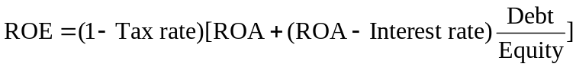
ROE_{A} > ROE_{B}
Firms A and B have the same ROA. Assuming the same tax rate and assuming that ROA > interest rate, then Firm A must have either a lower interest rate or a higher debt ratio.

7. 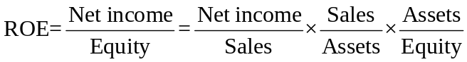
= Net profit margin × Asset turnover × Leverage ratio
= 5.5% × 2.0 × 2.2 = 24.2%

8. a. Lower bad debt expense will result in higher operating income.

b. Lower bad debt expense will have no effect on operating cash flow until Galaxy actually collects receivables.

9. A. Certain GAAP rules can be exploited by companies in order to achieve specific goals, while still remaining within the letter of the law. Aggressive assumptions, such as lengthening the depreciable life of an asset (which are utilized to boost earnings) result in a lower quality of earnings.

10. A. Off-balance-sheet financing through the use of operating leases is acceptable when used appropriately. However, companies can use them too aggressively in order to reduce their perceived leverage. A comparison among industry peers and their practices may indicate improper use of accounting methods.

11. A. A warning sign of accounting manipulation is abnormal inventory growth as compared to sales growth. By overstating inventory, the cost of goods sold is lower, leading to higher profitability.

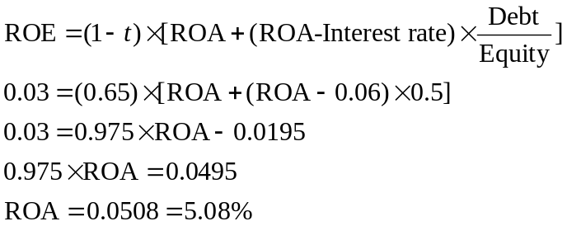12.

Alternatively,
0.03 = 0.65 × [ROA + (ROA - 0.06) × 0.5]
0.0462 = [ROA + (ROA - 0.06) × 0.5]
0.0462 = ROA + 0.5ROA - 0.03
0.0762 = ROA + 0.5ROA
0.0762 = 1.5ROA
0.0508 = ROA

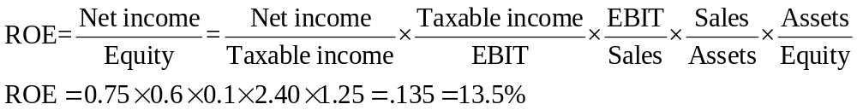
13.

14.
 |  | - Cash flows from investing activities
 |  |  | Sale of old equipment | $72,000
 |  |  | Purchase of bus | (33,000)
 |  |  | Net cash used in investing activities |  | 39,000
 |  | - Cash flows from financing activities
 |  |  | Repurchase of stock | $(55,000)
 |  |  | Cash dividend | (80,000)
 |  |  | Net cash used in financing activities |  | (135,000)
 |  |  | - Cash flows from operating activities
 |  |  | Cash collections from customers | $300,000
 |  |  | Cash payments to suppliers | (95,000)
 |  |  | Cash payments for interest | (25,000)
 |  |  | Net cash provided by operating activities |  | $180,000
 |  |  | Net increase in cash |  | $84,000

15. a. The total capital of the firms must first be calculated by adding their respective debt and equity together. The total capital for Acme is 100 + 50 = 150, and the total capital for Apex is 450 + 150 = 600. The economic value added will be the spread between the ROC and cost of capital multiplied by the total capital of the firm. Acme’s EVA thus equals (17% − 9%) × 150 = 12 (million). Apex’s EVA equals (15% − 10%) × 600 = 30 (mil). Notice that even though Apex’s spread is smaller, their larger capital stock allows them more economic value added.
b. However, since Apex has a larger capital stock, it’s EVA per dollar invested in capital is smaller at 30/600 = .05 compared to Acme’s 12/150 = .08

CFA PROBLEMS

1. SmileWhite has higher quality of earnings for the following reasons:
• SmileWhite amortizes its goodwill over a shorter period than does QuickBrush. SmileWhite therefore presents more conservative earnings because it has greater goodwill amortization expense.
• SmileWhite depreciates its property, plant and equipment using an accelerated depreciation method. This results in recognition of depreciation expense sooner and also implies that its income is more conservatively stated.
• SmileWhite’s bad debt allowance is greater as a percentage of receivables. SmileWhite is recognizing greater bad-debt expense than QuickBrush. If actual collection experience will be comparable, then SmileWhite has the more conservative recognition policy.

2. a. 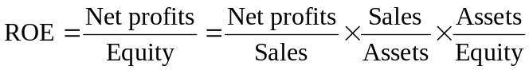
= Net profit margin × Total asset turnover × Assets/equity
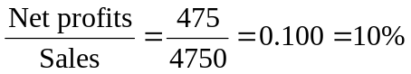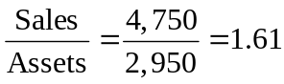

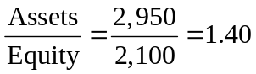

b.

c. g = ROE × Plowback 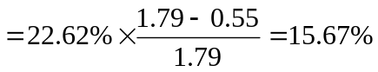

3. a. CF from operating activities = $260 – $85 – $12 – $35 = $128

- CF from investing activities = –$8 + $30 – $40 = –$18

c. CF from financing activities = –$32 – $37 = –$69

4. a. QuickBrush has had higher sales and earnings growth (per share) than SmileWhite. Margins are also higher. But this does not mean that QuickBrush is necessarily a better investment. SmileWhite has a higher ROE, which has been stable, while QuickBrush’s ROE has been declining. We can see the source of the difference in ROE using DuPont analysis:
Component | Definition | QuickBrush | SmileWhite
Tax burden (1 – t) | Net profits/pretax profits | 67.4% | 66.0%
Interest burden | Pretax profits/EBIT | 1.000 | 0.955
Profit margin | EBIT/Sales | 8.5% | 6.5%
Asset turnover | Sales/Assets | 1.42 | 3.55
Leverage | Assets/Equity | 1.47 | 1.48
ROE | Net profits/Equity | 12.0% | 21.4%
While tax burden, interest burden, and leverage are similar, profit margin and asset turnover differ. Although SmileWhite has a lower profit margin, it has a far higher asset turnover.

Sustainable growth = ROE × Plowback ratio
 | ROE | Plowback Ratio | Sustainable  Growth Rate | Ludlow’s Estimate of Growth Rate
QuickBrush | 12.0% | 1.00 | 12.0% | 30%
SmileWhite | 21.4 | 0.34 | 7.3 | 10
Ludlow has overestimated the sustainable growth rate for both companies. QuickBrush has little ability to increase its sustainable growth—plowback already equals 100%. SmileWhite could increase its sustainable growth by increasing its plowback ratio.

b. QuickBrush’s recent EPS growth has been achieved by increasing book value per share, not by achieving greater profits per dollar of equity. A firm can increase EPS even if ROE is declining as is true of QuickBrush. QuickBrush’s book value per share has more than doubled in the last two years.
Book value per share can increase either by retaining earnings or by issuing new stock at a market price greater than book value. QuickBrush has been retaining all earnings, but the increase in the number of outstanding shares indicates that it has also issued a substantial amount of stock.

5. a. ROE = Operating margin × Interest burden × Asset turnover × Leverage × Tax burden
ROE for Eastover (EO) and for Southampton (SHC) in 2013 is found as follows:
Profit margin = |  | SHC:  EO: | 145/1,793 =  795/7,406 = | 8.1%  10.7%
Interest burden = | 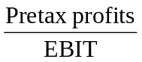 | SHC:  EO: | 137/145 =  600/795 = | 0.94  0.75
Asset turnover = |  | SHC:  EO: | 1,793/2,104 =  7,406/8,265 = | 0.85  0.90
Leverage = |  | SHC:  EO: | 2,104/1,167 =  8,265/3,864 = | 1.80  2.14
Tax burden = | 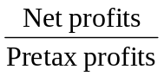 | SHC:  EO: | 91/137 =  394/600 = | 0.66  0.66
ROE |  | SHC:  EO: |  | 7.8%  10.2%

b. The differences in the components of ROE for Eastover and Southampton are:
Profit margin EO has a higher margin.
Interest burden EO has a higher interest burden because its pretax profits are a lower percentage of EBIT.
Asset turnover EO is more efficient at turning over its assets.
Leverage EO has higher financial leverage.
Tax burden No major difference here between the two companies ROE. EO has a higher ROE than SHC, but this is only in part due to higher margins and a better asset turnover. Greater financial leverage also plays a part.

- The sustainable growth rate can be calculated as ROE times plowback ratio. The sustainable growth rates for Eastover and Southampton are as follows:
 | ROE | Plowback Ratio* | Sustainable  Growth Rate
Eastover | 10.2% | 0.36 | 3.7%
Southampton | 7.8 | 0.58 | 4.5
*Plowback = (1 – Payout ratio)
EO: Plowback = (1 – 0.64) = 0.36
SHC: Plowback = (1 – 0.42) = 0.58
The sustainable growth rates derived in this manner are not likely to be representative of future growth because 2013 was probably not a “normal” year. For Eastover, earnings had not yet recovered to 2010–2011 levels; earnings retention of only 0.36 seems low for a company in a capital intensive industry. Southampton’s earnings fell by over 50 percent in 2013 and its earnings retention will probably be higher than 0.58 in the future. There is a danger, therefore, in basing a projection on one year’s results, especially for companies in a cyclical industry such as forest products.

6. a. The formula for the constant growth discounted dividend model is
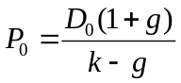
For Eastover:
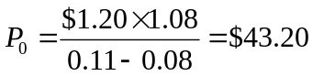
This compares with the current stock price of $28. On this basis, it appears that Eastover is undervalued.
b. The formula for the two-stage discounted dividend model is
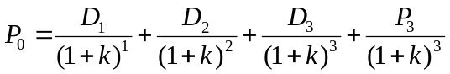
For Eastover: g₁ = 0.12 and g₂ = 0.08
D₀ = 1.20
D₁ = D₀ (1.12)¹ = $1.34
D₂ = D₀ (1.12)² = $1.51
D₃ = D₀ (1.12)³ = $1.69
D₄ = D₀ (1.12)³(1.08) = $1.82
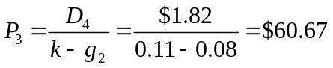
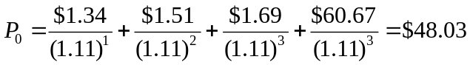
Alternatively, CF 0 = $0; CF 1 = $1.34; CF 2 = $1.51; CF 3 = $1.69 + $60.67; I = 11; Solve for NPV = $48.03.

This approach makes Eastover appear even more undervalued than was the case using the constant growth approach.

c. Advantages of the constant growth model include: (1) logical, theoretical basis; (2) simple to compute; (3) inputs can be estimated.
Disadvantages include: (1) very sensitive to estimates of growth; (2) g and k difficult to estimate accurately; (3) only valid for g < k; (4) constant growth is an unrealistic assumption; (5) assumes growth will never slow down; (6) dividend payout must remain constant; (7) not applicable for firms not paying dividends.
Improvements offered by the two-stage model include:
(1) The two-stage model is more realistic. It accounts for low, high, or zero growth in the first stage, followed by constant long-term growth in the second stage.
(2) The model can be used to determine stock value when the growth rate in the first stage exceeds the required rate of return.

7. a. In order to determine whether a stock is undervalued or overvalued, analysts often compute price-earnings ratios (P/Es) and price-book ratios (P/Bs); then, these ratios are compared to benchmarks for the market, such as the S&P 500 index. The formulas for these calculations are:
Relative P/E =
Relative P/B =
To evaluate EO and SHC using a relative P/E model, Mulroney can calculate the five-year average P/E for each stock and divide that number by the five-year average P/E for the S&P 500 (shown in the last column of Table 19E). This gives the historical average relative P/E. Mulroney can then compare the average historical relative P/E to the current relative P/E (i.e., the current P/E on each stock, using the estimate of this year’s earnings per share in Table 19F, divided by the current P/E of the market).
For the price/book model, Mulroney should make similar calculations, i.e., divide the five-year average price-book ratio for a stock by the five year average price/book for the S&P 500, and compare the result to the current relative price/book (using current book value). The results are as follows:
P/E model | EO | SHC | S&P500
5-year average P/E | 16.56 | 11.94 | 15.20
Relative 5-year P/E | 1.09 | 0.79
Current P/E | 17.50 | 16.00 | 20.20
Current relative P/E | 0.87 | 0.79
Price/Book model | EO | SHC | S&P500
5-year average price/book | 1.52 | 1.10 | 2.10
Relative 5-year price/book | 0.72 | 0.52
Current price/book | 1.62 | 1.49 | 2.60
Current relative price/book | 0.62 | 0.57
From this analysis, it is evident that EO is trading at a discount to its historical five-year relative P/E ratio, whereas Southampton is trading right at its historical five-year relative P/E. With respect to price/book, Eastover is trading at a discount to its historical relative price/book ratio, whereas SHC is trading modestly above its five-year relative price/book ratio. As noted in the preamble to the problem (see CFA Problem 5), Eastover’s book value is understated due to the very low historical cost basis for its timberlands. The fact that Eastover is trading below its five-year average relative price to book ratio, even though its book value is understated, makes Eastover seem especially attractive on a price/book basis.

b. Disadvantages of the relative P/E model include: (1) the relative P/E measures only relative, rather than absolute, value; (2) the accounting earnings estimate for the next year may not equal sustainable earnings; (3) accounting practices may not be standardized; (4) changing accounting standards may make historical comparisons difficult.
Disadvantages of the relative P/B model include: (1) book value may be understated or overstated, particularly for a company like Eastover, which has valuable assets on its books carried at low historical cost; (2) book value may not be representative of earning power or future growth potential; (3) changing accounting standards make historical comparisons difficult.

8. The following table summarizes the valuation and ROE for Eastover and Southampton:
 | Eastover | Southampton
Stock price | $28.00 | $48.00
Constant-growth model | $43.20 | $29.00
2-stage growth model | $48.03 | $35.50
Current P/E | 17.50 | 16.00

Current relative P/E | 0.87 | 0.79
5-year average P/E | 16.56 | 11.94
Relative 5 year P/E | 1.09 | 0.79
Current P/B | 1.62 | 1.49
Current relative P/B | 0.62 | 0.57
5-year average P/B | 1.52 | 1.10
Relative 5 year P/B | 0.72 | 0.52
Current ROE | 10.2% | 7.8%
Sustainable growth rate | 3.7% | 4.5%
Eastover seems to be undervalued according to each of the discounted dividend models. Eastover also appears to be cheap on both a relative P/E and a relative P/B basis. Southampton, on the other hand, looks overvalued according to each of the discounted dividend models and is slightly overvalued using the relative price/book model. On a relative P/E basis, SHC appears to be fairly valued. Southampton does have a slightly higher sustainable growth rate, but not appreciably so, and its ROE is less than Eastover’s.
The current P/E for Eastover is based on relatively depressed current earnings, yet the stock is still attractive on this basis. In addition, the price/book ratio for Eastover is overstated due to the low historical cost basis used for the timberland assets. This makes Eastover seem all the more attractive on a price/book basis. Based on this analysis, Mulroney should select Eastover over Southampton.

9. a. Net income can increase even while cash flow from operations decreases. This can occur if there is a buildup in net working capital—for example, increases in accounts receivable or inventories, or reductions in accounts payable. Lower depreciation expense will also increase net income but can reduce cash flow through the impact on taxes owed.

b. Cash flow from operations might be a good indicator of a firm's quality of earnings because it shows whether the firm is actually generating the cash necessary to pay bills and dividends without resorting to new financing. Cash flow is less susceptible to arbitrary accounting rules than net income is.

10. $1,200
Cash flow from operations = Sales – Cash expenses – Increase in A/R
Ignore depreciation because it is a noncash item and its impact on taxes is already accounted for.

11. Both current assets and current liabilities will decrease by equal amounts. But this is a larger percentage decrease for current liabilities because the initial current ratio is above 1.0. So the current ratio increases. Total assets are lower, so turnover increases.

12. Considering the components of after-tax ROE, there are several possible explanations for a stable after-tax ROE despite declining operating income:
1. Declining operating income could have been offset by an increase in nonoperating income (i.e., from discontinued operations, extraordinary gains, gains from changes in accounting policies) because both are components of profit margin (net income/sales).
2. Another offset to declining operating income could have been declining interest rates on any interest rate obligations, which would have decreased interest expense while allowing pretax margins to remain stable.
3. Leverage could have increased as a result of a decline in equity from: (a) writing down an equity investment; (b) stock repurchases, (c) losses; or (d) selling new debt. The effect of the increased leverage could have offset a decline in operating income.
4. An increase in asset turnover could also offset a decline in operating income. Asset turnover could increase as a result of a sales growth rate that exceeds the asset growth rate, or from the sale or write-off of assets.
5. If the effective tax rate declined, the resulting increase in earnings after tax could offset a decline in operating income. The decline in effective tax rates could result from increased tax credits, the use of tax loss carry-forwards, or a decline in the statutory tax rate.

13. a.
 |  | 2010 | 2014
(1) Operating margin = | 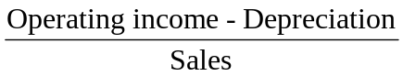 | 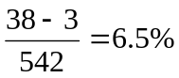 | 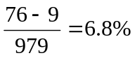
(2) Asset turnover = | 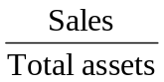 | 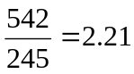 | 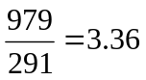
(3) Interest burden = |  | 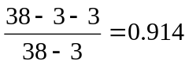 | 1.0
(4) Financial leverage = | 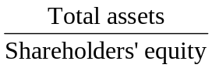 | 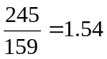 | 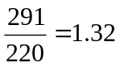
(5) Income tax rate = | 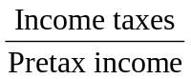 | 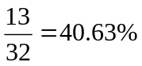 | 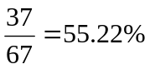
Using the Du Pont formula:
ROE = [1.0 – (5)] × (3) × (1) × (2) × (4)
ROE(2007) = 0.5937 × 0.914 × 0.065 × 2.21 × 1.54 = 0.120 = 12.0%
ROE(2011) = 0.4478 × 1.0 × 0.068 × 3.36 × 1.32 = 0.135 = 13.5%
Because of rounding error, these results differ slightly from those obtained by directly calculating ROE as net income/equity.)

b. Asset turnover measures the ability of a company to minimize the level of assets (current or fixed) to support its level of sales. The asset turnover increased substantially over the period, thus contributing to an increase in the ROE.
Financial leverage measures the amount of financing other than equity, including short- and long-term debt. Financial leverage declined over the period, thus adversely affecting the ROE. Since asset turnover rose substantially more than financial leverage declined, the net effect was an increase in ROE.

