CHAPTER 20: OPTIONS MARKETS: INTRODUCTION

PROBLEM SETS

1. Options provide numerous opportunities to modify the risk profile of a portfolio. The simplest example of an option strategy that increases risk is investing in an ‘all options’ portfolio of at the money options (as illustrated in the text). The leverage provided by options makes this strategy very risky, and potentially very profitable. An example of a risk-reducing options strategy is a protective put strategy. Here, the investor buys a put on an existing stock or portfolio, with exercise price of the put near or somewhat less than the market value of the underlying asset. This strategy protects the value of the portfolio because the minimum value of the stock-plus-put strategy is the exercise price of the put.

2. Buying a put option on an existing portfolio provides portfolio insurance, which is protection against a decline in the value of the portfolio. In the event of a decline in value, the minimum value of the put-plus-stock strategy is the exercise price of the put. As with any insurance purchased to protect the value of an asset, the trade-off an investor faces is the cost of the put versus the protection against a decline in value. The cost of the protection is the cost of acquiring the protective put, which reduces the profit that results should the portfolio increase in value.

3. An investor who writes a call on an existing portfolio takes a covered call position. If, at expiration, the value of the portfolio exceeds the exercise price of the call, the writer of the covered call can expect the call to be exercised, so that the writer of the call must sell the portfolio at the exercise price. Alternatively, if the value of the portfolio is less than the exercise price, the writer of the call keeps both the portfolio and the premium paid by the buyer of the call. The trade-off for the writer of the covered call is the premium income received versus forfeit of any possible capital appreciation above the exercise price of the call.

4. An option is out of the money when exercise of the option would be unprofitable. A call option is out of the money when the market price of the underlying stock is less than the exercise price of the option. If the stock price is substantially less than the exercise price, then the likelihood that the option will be exercised is low, and fluctuations in the market price of the stock have relatively little impact on the value of the option. This sensitivity of the option price to changes in the price of the stock is called the option’s delta, which is discussed in detail in Chapter 21. For options that are far out of the money, delta is close to zero. Consequently, there is generally little to be gained or lost by buying or writing a call that is far out of the money. (A similar result applies to a put option that is far out of the money, with stock price substantially greater than exercise price.)

A call is in the money when the market price of the stock is greater than the exercise price of the option. If stock price is substantially greater than exercise price, then the price of the option approaches the order of magnitude of the price of the stock. Also, since such an option is very likely to be exercised, the sensitivity of the option price to changes in stock price approaches one, indicating that a $1 increase in the price of the stock results in a $1 increase in the price of the option. Under these circumstances, the buyer of an option loses the benefit of the leverage provided by options that are near the money. Consequently, there is little interest in options that are far in the money.

5.
 |  | Cost | Payoff | Profit
a. | Call option, X = $190.00 $100.00¤$$100.00¤¤$$$100.00====$100.00==$100.00¤ ¤¤$100.000 ¤$$$1$$$100.00 | $6.75 | $5.00 | -$1.75
b. | Put option, X = $190.00 | 3.00 | 0.00 | -3.00
c. | Call option, X = $195.00 | 3.65 | 0.00 | -3.65
d. | Put option, X = $195.00 | 5.00 | 0.00 | -5.00
e. | Call option, X = $200.00 | 1.61 | 0.00 | -1.61
f. | Put option, X = $200.00 | 8.09 | 5.00 | -3.09

6. In terms of dollar returns, based on a $10,000 investment:
 | Price of Stock 6 Months from Now
Stock Price | $ 80 | $ 100 | $ 110 | $ 120
All stocks (100 shares) | 8,000 | 10,000 | 11,000 | 12,000
All options (1,000 options) | 0 | 0 | 10,000 | 20,000
Bills + 100 options | 9,360 | 9,360 | 10,360 | 11,360
In terms of rate of return, based on a $10,000 investment:
 | Price of Stock 6 Months from Now
Stock Price | $80 | $100 | $110 | $120
All stocks (100 shares) | -20% | 0% | 10% | 20%
All options (1,000 options) | -100 | -100 | 0 | 100
Bills + 100 options | -6.4 | -6.4 | 3.6 | 13.6

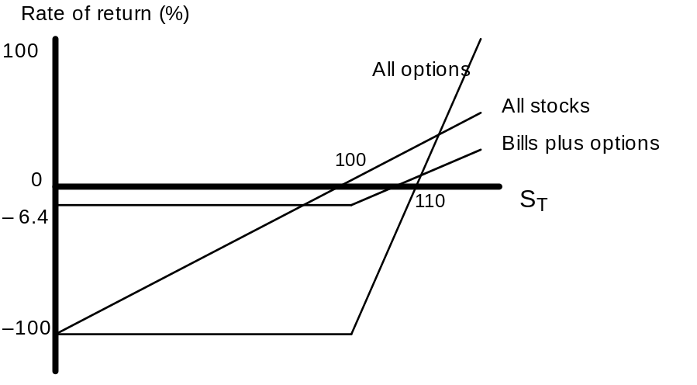

7. a. From put-call parity:
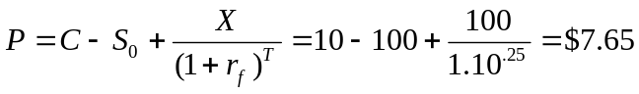

- Purchase a straddle, i.e., both a put and a call on the stock. The total cost of the straddle is $10 + $7.65 = $17.65

8. a. From put-call parity:
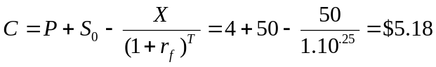
b. Sell a straddle, i.e., sell a call and a put, to realize premium income of
$5.18 + $4 = $9.18
If the stock ends up at $50, both of the options will be worthless and your profit will be $9.18. This is your maximum possible profit since, at any other stock price, you will have to pay off on either the call or the put. The stock price can move by $9.18 in either direction before your profits become negative.

c. Buy the call, sell (write) the put, lend $50/(1.10)^{1/4}
The payoff is as follows:
Position | Immediate CF | CF in 3 months
 |  | S _{T} ≤ X | S _{T} > X
Call (long) | C = 5.18 | 0 | S _{T} – 50
Put (short) | –P = 4.00 | – (50 – S _{T}) | 0
Lending position | 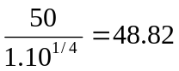 | 50 | 50
Total | C – P + 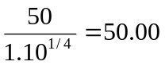 | S _{T} | S _{T}
By the put-call parity theorem, the initial outlay equals the stock price:
S₀ = $50
In either scenario, you end up with the same payoff as you would if you bought the stock itself.

9. a. i. A long straddle produces gains if prices move up or down and limited losses if prices do not move. A short straddle produces significant losses if prices move significantly up or down. A bullish spread produces limited gains if prices move up.

b. i. Long put positions gain when stock prices fall and produce very limited losses if prices instead rise. Short calls also gain when stock prices fall but create losses if prices instead rise. The other two positions will not protect the portfolio should prices fall.

10. Note that the price of the put equals the revenue from writing the call, net initial cash outlays = $38.00
Position | 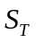 < 35 | 35   40 X₂X₂XX₂X₂X₂X₂X₂ | 40 <
Buy stock
Write call ($40) | 0 | 0 | 40 -
Buy put ($35) | 35- | 0 | 0
Total | $35 |  | $40

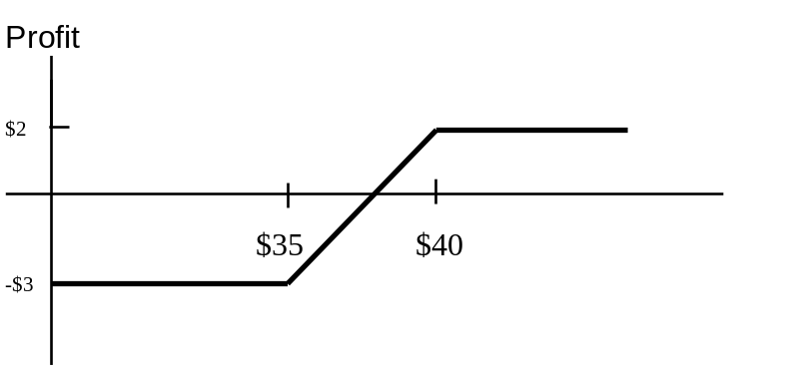

11. Answers may vary. For $5,000 initial outlay, buy 5,000 puts, write 5,000 calls:

Position | = $30 | = $40 X₂X₂XX₂X₂X₂X₂X₂ | =$50
Stock portfolio | $150,000 | $200,000 | $250,000
Write call(X=$45) | 0 | 0 | -$25,000
Buy put (X=$35) | $25,000 | 0 | 0
Initial outlay | -$5,000 | -$5,000 | -$5,000
Portfolio value | $170,000 | $195,000 | $220,000

Compare this to just holding the portfolio:
Position | = $30 | = $40 X₂X₂XX₂X₂X₂X₂X₂ | =$50
Stock portfolio | $150,000 | $200,000 | $250,000
Portfolio value | $150,000 | $200,000 | $250,000

12. a.
Outcome | S _{T} ≤ X | S _{T} > X
Stock | S _{T} + D | S _{T} + D
Put | X – S _{T} | 0
Total | X + D | S _{T} + D

b.
Outcome | S _{T} ≤ X | S _{T} > X
Call | 0 | S_{T} – X
Zeros | X + D | X + D
Total | X + D | S_{T} + D
The total payoffs for the two strategies are equal regardless of whether S _{T} exceeds X.

c. The cost of establishing the stock-plus-put portfolio is: S₀ + P
The cost of establishing the call-plus-zero portfolio is: C + PV(X + D)
Therefore:
S₀ + P = C + PV(X + D)
This result is identical to equation 20.2.

13. a.
Position | S _{T} < X₁ | X₁  S _{T}  X₂ | X₂ < S _{T}  X₃ | X₃ < S _{T}
Long call (X1) | 0 | S _{T} – X₁ | S _{T} – X₁ | S _{T} – X₁
Short 2 calls (X2) | 0 | 0 | –2(S _{T} – X₂) | –2(S _{T} – X₂)
Long call (X3) | 0 | 0 | 0 | S _{T} – X₃
Total | 0 | S _{T} – X₁ | 2X₂ – X₁ – S _{T} | (X₂ –X₁) – (X₃ –X₂) = 0

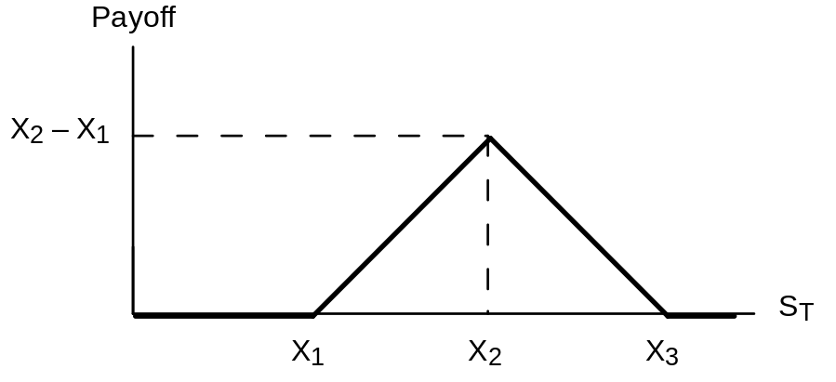

b.
Position | S _{T} < X₁ | X₁  S _{T}  X₂ X₂X₂XX₂X₂X₂X₂X₂ | X₂ < S _{T}
Buy call (X₂) | 0 | 0 | S _{T} – X₂
Buy put (X₁) | X₁ – S _{T} | 0 | 0
Total | X₁ – S _{T} | 0 | S _{T} – X₂

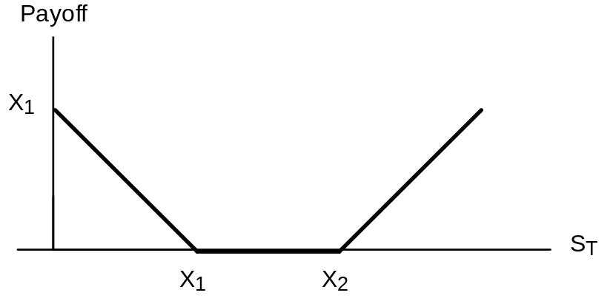

14.
Position | S _{T} < X₁ | X₁  S _{T}  X₂ XX₂ | X₂ < S _{T}
Buy call (X₂) | 0 | 0 | S _{T} – X₂
Sell call (X₁) | 0 | –(S _{T} – X₁) | –(S _{T} – X₁)
Total | 0 | X₁ – S _{T} | X₁ – X₂

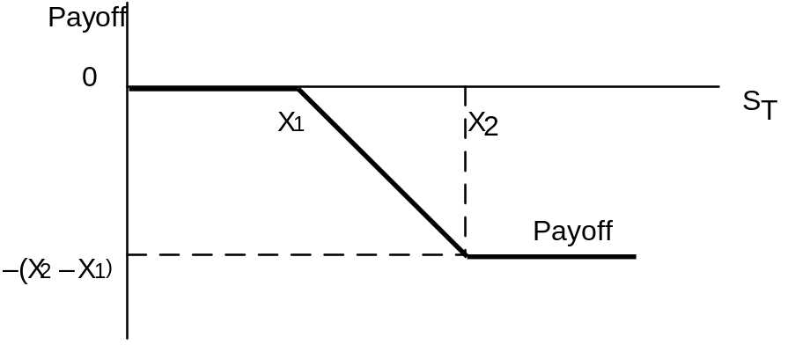

15. a. By writing covered call options, Jones receives premium income of $30,000. If, in January, the price of the stock is less than or equal to $45, then Jones will have his stock plus the premium income. But the most he can have at that time is ($450,000 + $30,000) because the stock will be called away from him if the stock price exceeds $45. (We are ignoring here any interest earned over this short period of time on the premium income received from writing the option.) The payoff structure is
Stock price Portfolio value
less than $45 10,000 times stock price + $30,000
greater than $45 $450,000 + $30,000 = $480,000
This strategy offers some extra premium income but leaves Jones subject to substantial downside risk. At an extreme, if the stock price fell to zero, Jones would be left with only $30,000. This strategy also puts a cap on the final value at $480,000, but this is more than sufficient to purchase the house.

b. By buying put options with a $35 strike price, Jones will be paying $30,000 in premiums in order to ensure a minimum level for the final value of his position. That minimum value is ($35 × 10,000) – $30,000 = $320,000.
This strategy allows for upside gain, but exposes Jones to the possibility of a moderate loss equal to the cost of the puts. The payoff structure is:
Stock price Portfolio value
less than $35 $350,000 – $30,000 = $320,000
greater than $35 10,000 times stock price – $30,000

c. The net cost of the collar is zero. The value of the portfolio will be as follows:
Stock price Portfolio value
less than $35 $350,000
between $35 and $45 10,000 times stock price
greater than $45 $450,000
If the stock price is less than or equal to $35, then the collar preserves the $350,000 principal. If the price exceeds $45, then Jones gains up to a cap of $450,000. In between $35 and $45, his proceeds equal 10,000 times the stock price.
The best strategy in this case would be (c) since it satisfies the two requirements of preserving the $350,000 in principal while offering a chance of getting $450,000. Strategy (a) should be ruled out since it leaves Jones exposed to the risk of substantial loss of principal.
Our ranking would be: (1) strategy c; (2) strategy b; (3) strategy a.

16. Using Excel, with Profit Diagram on next page.

Stock Prices
Beginning Market Price | 116.5 |  |  |  |  | Price | Profit
Ending Market Price | 130 |  |  |  |  | Ending | Straddle
Buying Options: |  |  |  |  |  | 50 | 42.80
Call Options Strike | Price | Payoff | Profit | Return % |  | 60 | 32.80
110 | 22.80 | 20.00 | -2.80 | -12.28% |  | 70 | 22.80
120 | 16.80 | 10.00 | -6.80 | -40.48% |  | 80 | 12.80
130 | 13.60 | 0.00 | -13.60 | -100.00% |  | 90 | 2.80
140 | 10.30 | 0.00 | -10.30 | -100.00% |  | 100 | -7.20
 |  |  |  |  |  | 110 | -17.20
Put Options Strike | Price | Payoff | Profit | Return % |  | 120 | -27.20
110 | 12.60 | 0.00 | -12.60 | -100.00% |  | 130 | -37.20
120 | 17.20 | 0.00 | -17.20 | -100.00% |  | 140 | -27.20
130 | 23.60 | 0.00 | -23.60 | -100.00% |  | 150 | -17.20
140 | 30.50 | 10.00 | -20.50 | -67.21% |  | 160 | -7.20
 |  |  |  |  |  | 170 | 2.80
Straddle | Price | Payoff | Profit | Return % |  | 180 | 12.80
110 | 35.40 | 20.00 | -15.40 | -43.50% |  | 190 | 22.80
120 | 34.00 | 10.00 | -24.00 | -70.59% |  | 200 | 32.80
130 | 37.20 | 0.00 | -37.20 | -100.00% |  | 210 | 42.80
140 | 40.80 | 10.00 | -30.80 | -75.49%
Selling Options: |  |  |  |  |  | Ending | Bullish
Call Options Strike | Price | Payoff | Profit | Return % |  | Stock Price | Spread
110 | 22.80 | -20 | 2.80 | 12.28% |  | 50 | -3.2
120 | 16.80 | -10 | 6.80 | 40.48% |  | 60 | -3.2
130 | 13.60 | 0 | 13.60 | 100.00% |  | 70 | -3.2
140 | 10.30 | 0 | 10.30 | 100.00% |  | 80 | -3.2
 |  |  |  |  |  | 90 | -3.2
Put Options Strike | Price | Payoff | Profit | Return % |  | 100 | -3.2
110 | 12.60 | 0 | 12.60 | 100.00% |  | 110 | -3.2
120 | 17.20 | 0 | 17.20 | 100.00% |  | 120 | -3.2
130 | 23.60 | 0 | 23.60 | 100.00% |  | 130 | 6.8

140 | 30.50 | 10 | 40.50 | 132.79% |  | 140 | 6.8
 |  |  |  |  |  | 150 | 6.8
Money Spread | Price | Payoff | Profit |  |  | 160 | 6.8
Bullish Spread |  |  |  |  |  | 170 | 6.8
Purchase 120 Call | 16.80 | 10.00 | -6.80 |  |  | 180 | 6.8
Sell 130 Call | 13.60 | 0 | 13.60 |  |  | 190 | 6.8
Combined Profit |  | 10.00 | 6.80 |  |  | 200 | 6.8
 |  |  |  |  |  | 210 | 6.8

Profit diagram for problem 16:

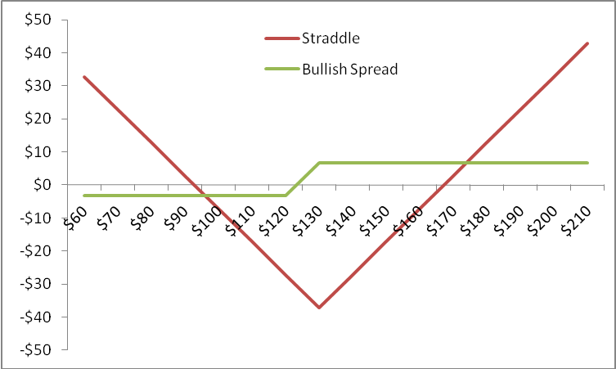

17. The farmer has the option to sell the crop to the government for a guaranteed minimum price if the market price is too low. If the support price is denoted PS and the market price Pm then the farmer has a put option to sell the crop (the asset) at an exercise price of P_{S} even if the price of the underlying asset (Pm) is less than P_{S}.

18. The bondholders have, in effect, made a loan that requires repayment of B dollars, where B is the face value of bonds. If, however, the value of the firm (V) is less than B, the loan is satisfied by the bondholders taking over the firm. In this way, the bondholders are forced to “pay” B (in the sense that the loan is cancelled) in return for an asset worth only V. It is as though the bondholders wrote a put on an asset worth V with exercise price B. Alternatively, one might view the bondholders as giving the right to the equity holders to reclaim the firm by paying off the B dollar debt. The bondholders have issued a call to the equity holders.

19. The manager receives a bonus if the stock price exceeds a certain value and receives nothing otherwise. This is the same as the payoff to a call option.

20. a.
Position | S _{T} < 190 | 190  S _{T}  195 | S _{T} > 195
Write call, X = $195 | 0 | 0 | –(S _{T} – 195)
Write put, X = $190 | –(190 – S _{T}) | 0 | 0
Total | S _{T} – 190 | 0 | 195 – S _{T}

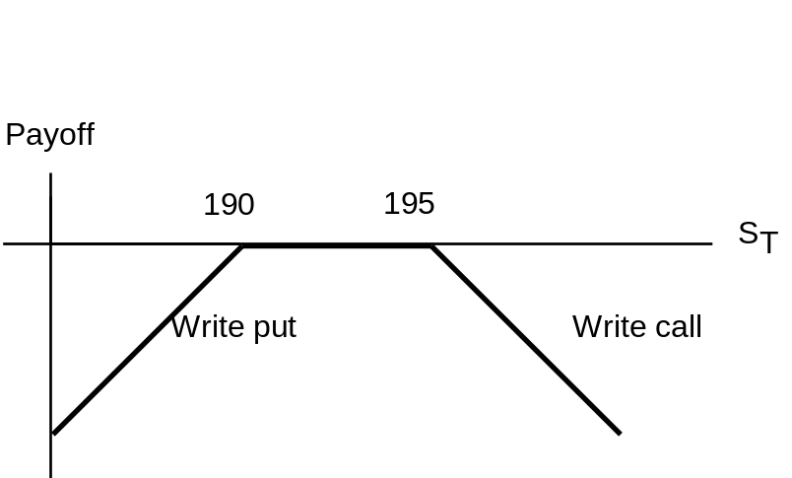

b. Proceeds from writing options:
Call: -$2.99
Put: $1.75
Total: -$1.24
If IBM sells at $198 on the option expiration date, the call option expires in the money—cash outflow of $3, resulting in a profit of -$1.24. If IBM sells at $208 on the option expiration date, the call written results in a cash outflow of $10 at expiration and an overall profit of: -$1.24 – $10.00 = -$11.24

c. You break even when either the put or the call results in a cash outflow of -$1.24. For the put, this requires that:
-$1.24 = $190.00 – S _{T} ⇒ S _{T} = $191.24
For the call, this requires that:
-$1.24 = S _{T} – $195.00 ⇒ S _{T} = $193.76

d. The investor is betting that IBM stock price will have low volatility. This position is similar to a straddle.

21. The put with the higher exercise price must cost more. Therefore, the net outlay to establish the portfolio is positive.
Position | S _{T} < 90 | 90  S _{T}  95 | S _{T} > 95
Write put, X = $90 | –(90 – S _{T}) | 0 | 0
Buy put, X = $95 | 95 – S _{T} | 95 – S _{T} | 0
Total | 5 | 95 – S _{T} | 0
The payoff and profit diagram is:
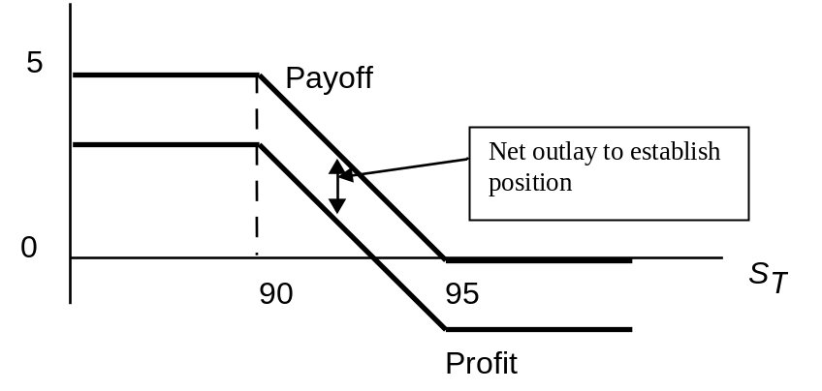

22. Buy the X = 62 put (which should cost more but does not) and write the X = 60 put. Since the options have the same price, your net outlay is zero. Your proceeds at expiration may be positive, but cannot be negative.
Position | S _{T} < 60 | 60  S _{T}  62 | S _{T} > 62
Buy put, X = $62 | 62 – S _{T} | 62 – S _{T} | 0
Write put, X = $60 | –(60 – S _{T}) | 0 | 0
Total | 2 | 62 – S _{T} | 0

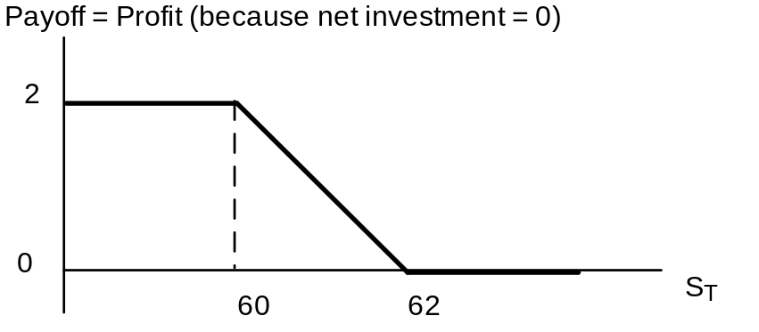

23. Put-call parity states that:
Solving for the price of the call option:
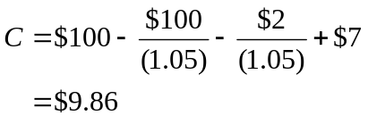

24. The following payoff table shows that the portfolio is riskless with time-T value equal to $10:
Position | S _{T} ≤ 10 | S _{T} > 10
Buy stock | S _{T} | S _{T}
Write call, X = $10 | 0 | –(S _{T} – 10)
Buy put, X = $10 | 10 – S _{T} | 0
Total | 10 | 10
Therefore, the risk-free rate is: ($10/$9.50) – 1 = 0.0526 = 5.26%

25. a., b.
Position | S _{T} < 100 | 100  S _{T}  110 | S _{T} > 110
Buy put, X = $110 | 110 – S _{T} | 110 – S _{T} | 0
Write put, X = $100 | –(100 – S _{T}) | 0 | 0
Total | 10 | 110 – S _{T} | 0
The net outlay to establish this position is positive. The put you buy has a higher exercise price than the put you write, and therefore must cost more than the put that you write. Therefore, net profits will be less than the payoff at time T.

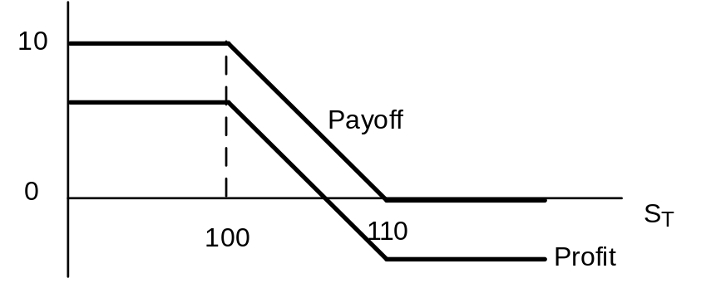

c. The value of this portfolio generally decreases with the stock price. Therefore, its beta is negative.

26. a. Joe’s strategy
Position | Cost | Payoff
 |  | S _{T}  1,200 | S _{T} > 1,200
Stock index | 1,200 | S _{T} | S _{T}
Put option, X = $1200 | 60 | 1,200 – S _{T} | 0
Total | -1,260 | 1,200 | S _{T}
Profit = payoff – $1260 |  | –60 | S _{T} – 1,260
Sally’s strategy
Position | Cost |  | Payoff
 |  |  | S _{T}  1,170 | S _{T} > 1,170
Stock index |  | 1,200 | S _{T} | S _{T}
Put option, X = $1,270 |  | 45 | 1,170 – S _{T} | 0
Total |  | 1,245 | 1,245 | S _{T}
Profit = Payoff – $1,245 |  |  | –76 | S _{T} – 1,245

b. Sally does better when the stock price is high, but worse when the stock price is low.

c. Sally’s strategy has greater systematic risk. Profits are more sensitive to the value of the stock index.

27. a., b. (See graph)
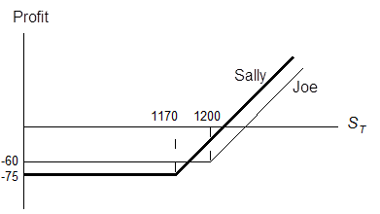
This strategy is a bear spread. Initial proceeds = $9 – $3 = $6
The payoff is either negative or zero:
Position | S _{T} < 50 | 50  S _{T}  60 | S _{T} > 60
Buy call, X = $60 | 0 | 0 | S _{T} – 60
Write call, X = $50 | 0 | –(S _{T} – 50) | –(S _{T} – 50)
Total | 0 | –(S _{T} – 50) | –10

c. Breakeven occurs when the payoff offsets the initial proceeds of $6, which occurs at stock price S _{T} = $56. The investor must be bearish: the position does worse when the stock price increases.

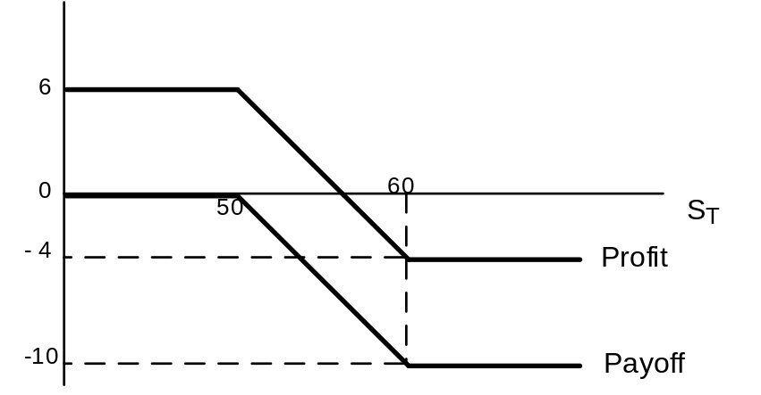

28. Buy a share of stock, write a call with X = $50, write a call with X = $60, and buy a call with X = $110.
Position | S _{T} < 50 | 50  S _{T}  60 | 60 < S _{T}  110 | S _{T} > 110
Buy stock | S _{T} | S _{T} | S _{T} | S _{T}
Write call, X = $50 | 0 | –(S _{T} – 50) | –(S _{T} – 50) | –(S _{T} – 50)
Write call, X = $60 | 0 | 0 | –(S _{T} – 60) | –(S _{T} – 60)
Buy call, X = $110 | 0 | 0 | 0 | S _{T} – 110
Total | S _{T} | 50 | 110 – S _{T} | 0
The investor is making a volatility bet. Profits will be highest when volatility is low and the stock price S _{T} is between $50 and $60.

29. a.
Position | S _{T} ≤ 1,179 | S _{T} > 1,170
Buy stock | S _{T} | S _{T}
Buy put | 1,170 – S _{T} | 0
Total | 1,170 | S _{T}

Position | S _{T} ≤ 1,260 | S _{T} > 1,260
Buy call | 0 | S _{T} – 1,260
Buy T-bills | 1,260 | 1,260
Total | 1,260 | S _{T}

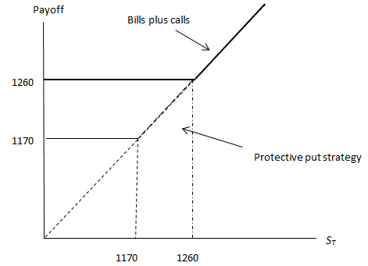

b. The bills plus call strategy has a greater payoff for some values of S _{T} and never a lower payoff. Since its payoffs are always at least as attractive and sometimes greater, it must be more costly to purchase.

c. The initial cost of the stock plus put position is $1,350 + $9 = $1,359
The initial cost of the bills plus call position is: $1,215 + $180 = $1,395
 | S _{T} = 1,000 | S _{T} = 1,260 | S _{T} = 1,350 | S _{T} = 1,440
Stock | 1,000 | 1,260 | 1,350 | 1,440
+ Put | 170 | 0 | 0 | 0
Payoff | 1,170 | 1,260 | 1,350 | 1,440
Profit | –189 | –99 | –9 | 81
Bill | 1,260 | 1,260 | 1,260 | 1,260
+ Call | 0 | 0 | 90 | 180
Payoff | 1,260 | 1,260 | 1,350 | 1,440
Profit | –135 | –135 | –45 | +45

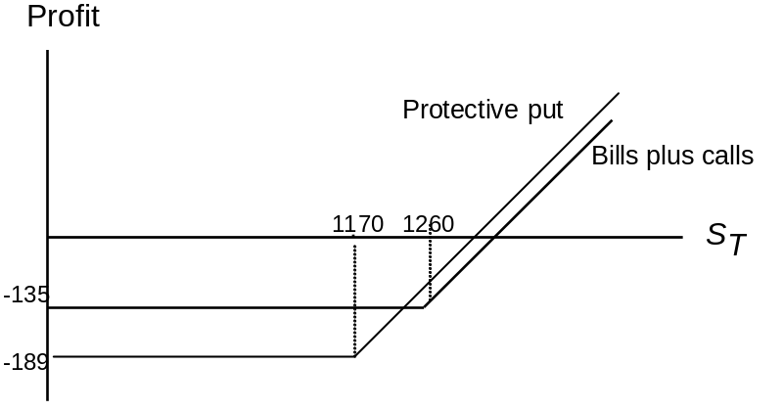

d. The stock and put strategy is riskier. This strategy performs worse when the market is down and better when the market is up. Therefore, its beta is higher.

e. Parity is not violated because these options have different exercise prices. Parity applies only to puts and calls with the same exercise price and expiration date.

30. According to put-call parity (assuming no dividends), the present value of a payment of $105 can be calculated using the options with January expiration and exercise price of $105.
PV(X) = S₀ + P – C
PV($105) = $100 + $6.94 – $2 =$104.93
Solving for C + X/(l + r_{f} )^{T} = S₀ + P, r_{f} will equal 0.06%

31. From put-call parity:
C – P = S₀ – X/(l + r_{f} )^{T}
If the options are at the money, then S₀ = X and
C – P = X – X/(l + rf )T
The right-hand side of the equation is positive, and we conclude that C > P.

CFA PROBLEMS

1. a. Donie should choose the long strangle strategy. A long strangle option strategy consists of buying a put and a call with the same expiration date and the same underlying asset, but different exercise prices. In a strangle strategy, the call has an exercise price above the stock price and the put has an exercise price below the stock price. An investor who buys (goes long) a strangle expects that the price of the underlying asset (TRT Materials in this case) will either move substantially below the exercise price on the put or above the exercise price on the call. With respect to TRT, the long strangle investor buys both the put option and the call option for a total cost of $9 and will experience a profit if the stock price moves more than $9 above the call exercise price or more than $9 below the put exercise price. This strategy would enable Donie's client to profit from a large move in the stock price, either up or down, in reaction to the expected court decision.

b. i. The maximum possible loss per share is $9, which is the total cost of the two options ($5 + $4).
ii. The maximum possible gain is unlimited if the stock price moves outside the breakeven range of prices.
iii. The breakeven prices are $46 and $69. The put will just cover costs if the stock price finishes $9 below the put exercise price
(i.e., $55 − $9 = $46), and the call will just cover costs if the stock price finishes $9 above the call exercise price (i.e., $60 + $9 = $69).

2. i. Equity index-linked note: Unlike traditional debt securities that pay a scheduled rate of coupon interest on a periodic basis and the par amount of principal at maturity, the equity index-linked note typically pays little or no coupon interest; at maturity, however, a unit holder receives the original issue price plus a supplemental redemption amount, the value of which depends on where the equity index settled relative to a predetermined initial level.
ii. Commodity-linked bear bond: Unlike traditional debt securities that pay a scheduled rate of coupon interest on a periodic basis and the par amount of principal at maturity, the commodity-linked bear bond allows an investor to participate in a decline in a commodity’s price. In exchange for a lower than market coupon, buyers of a bear tranche receive a redemption value that exceeds the purchase price if the commodity price has declined by the maturity date.

3. i. Conversion value of a convertible bond is the value of the security if it is converted immediately. That is:
Conversion value = Market price of the common stock × Conversion ratio
= $40 × 22
= $880

ii. Market conversion price is the price that an investor effectively pays for the common stock if the convertible bond is purchased:
Market conversion price = Market price of the convertible bond/Conversion ratio
= $1,050/22
= $47.73

4. a. i. The current market conversion price is computed as follows:
Market conversion price = Market price of the convertible bond/Conversion ratio = $980/25
= $39.20
ii. The expected one-year return for the Ytel convertible bond is
Expected return = [(End of year price + Coupon)/Current price] – 1
= [($1,125 + $40)/$980] – 1
= 0.1888, or 18.88%
iii. The expected one-year return for the Ytel common equity is:
Expected return = [(End of year price + Dividend)/Current price] – 1
= ($45/$35) – 1 = 0.2857, or 28.57%

- The two components of a convertible bond’s value are
- The straight bond value, which is the convertible bond’s value as a bond.
- The option value, which is the value from a potential conversion to equity.
(i.) In response to the increase in Ytel’s common equity price, the straight bond value should stay the same and the option value should increase.
The increase in equity price does not affect the straight bond value component of the Ytel convertible. The increase in equity price increases the option value component significantly, because the call option becomes deep “in the money” when the $51 per share equity price is compared to the convertible’s conversion price of: $1,000/25 = $40 per share.
(ii.) In response to the increase in interest rates, the straight bond value should decrease and the option value should increase.
The increase in interest rates decreases the straight bond value component (bond values decline as interest rates increase) of the convertible bond and increases the value of the equity call option component (call option values increase as interest rates increase). This increase may be small or even unnoticeable when compared to the change in the option value resulting from the increase in the equity price.
5. a. (ii) [Profit = $40 – $25 + $2.50 – $4.00]
b. (i) The most the put writer can lose occurs when the stock price drops completely to $0. This is a $40 loss less the $2 premium. The call writer will keep the premium of $3.50 if the option finishes out of the money.

