Bio-plastic: Pros
- Sustainable bio-plastics will help to remove our dependency on oil.
- Sustainable bio-plastics are made from renewable sources.
- Product costs are being lowered due to the increased oil prices.
- Many of the bio-plastics are biodegradable
- Sustainable bio-plastics are used and promoted for recycled products

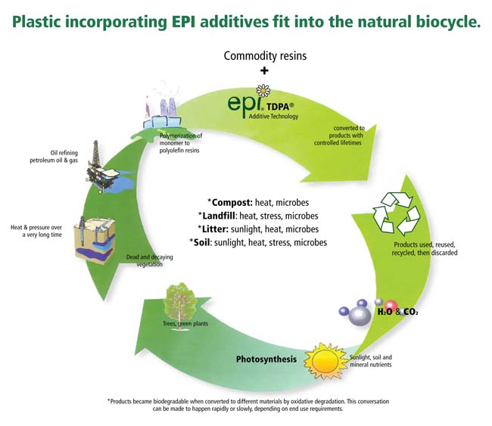

Joshua Markell Per. 3 02/28/12
Bio-plastic: Cons
- There is a limited shelf life for some of the sustainable bio-plastics.
- Some bio-plastics have a lesser performance factor when compared to petroleum
based plastics.
- Some bioplastics have been used for years and have a slow rate for biodegrading.
- The manufacturing process of bioplastics still relies on petroleum based energy.
- There are concerns that sustainable bioplastics will upset existing recycling
methods.
- Since the production of bioplastics as market is fairly new, the manufacturing
price tag is not as cost effective as the fossil fuel plastic production; this
is based on existing price of oil.

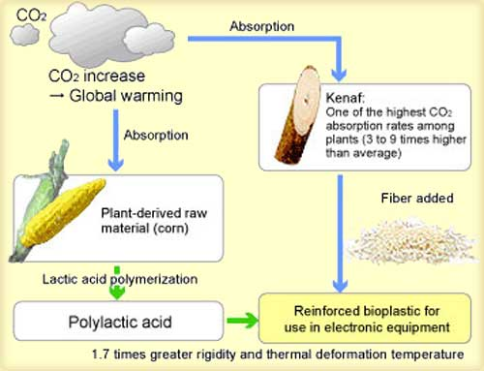

Joshua Markell Per. 3 02/28/12

Bio-plastic: Future and Present Uses
- Biodegradable bio-plastics are used for disposable items, such as packaging and catering items.
- Biodegradable bio-plastics are also often used for organic waste bags, where they can be composted together with the food or green waste.
- Genetic modification (GM) is also a challenge for the bio-plastics industry. None of the currently available bio-plastics (which can be considered first generation products) require the use of GM crops, although GM corn is the standard feedstock.
- Looking further ahead, some of the second generation bio-plastics manufacturing technologies under development employ the "plant factory" model, using genetically modified crops or genetically modified bacteria to optimise efficiency.
- Nondisposable applications include mobile phone casings, carpet fibres, and car interiors, fuel line and plastic pipe applications, and new electroactive bio-plastics are being developed that can be used to carry electrical current. In these areas, the goal is not biodegradability, but to create items from sustainable resources.

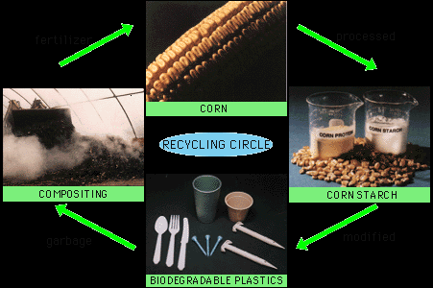

Joshua Markell Per. 3 02/28/12

C.E.R.C.L.A
- Superfund is the common name for the Comprehensive Environmental Response, Compensation, and Liability Act of 1980 (CERCLA), a United States federal law designed to clean up sites contaminated with hazardous substances.
- The law authorized the Environmental Protection Agency (EPA) to identify parties responsible for contamination of sites and compel the parties to clean up the sites.
- CERCLA authorizes two kinds of response actions: Removal actions. These are typically short-term response actions, where actions may be taken to address releases or threatened releases requiring prompt response. Remedial actions. These are usually long-term response actions. Remedial actions seek to permanently and significantly reduce the risks associated with releases or threats of releases of hazardous substances which are serious.
- The data in the Superfund Program is available to the public and on its web site provides free Geographic Information System (GIS) to locate Superfund and other contaminated sites in the United States that uses Google maps to help users visually explore data from the United States Environmental Protection Agency's (EPA) Toxics Release Inventory, RCRA, and Superfund programs.
- As of November 29, 2010, there are currently 1,280 sites listed on the National Priority List, an additional 347 have been delisted, and 62 new sites have been proposed.
- 70 percent of Superfund cleanup activities historically have been paid for by parties responsible (PRPs) for the cleanup of contamination.

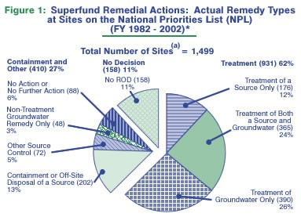

Joshua Markell Per. 3 02/28/12

Love Canal
- Love Canal was a neighborhood in Niagara Falls, New York, located in the white collar LaSalle section of the city.
- In the mid 1970s Love Canal became the subject of national and international attention after it was revealed in the press that the site had formerly been used to bury 21,000 tons of toxic waste by Hooker Chemical (now Occidental Petroleum Corporation) that caused health problems amoung its residents such as chromosomal damage.
- Hooker Chemical was found to be negligent in their disposal of waste, though not reckless in the sale of the land, in what became a test case for liability clauses.
- The dump site was discovered and investigated by the local newspaper, the Niagara Falls Gazette, from 1976 through the evacuation in 1978 and potential health problems were first raised by its reporters.
- Ten years after the incident, New York State Health Department Commissioner David Axelrod stated that Love Canal would long be remembered as a "national symbol of a failure to exercise a sense of concern for future generations."
- On August 7, 1978, United States President Jimmy Carter announced a federal health emergency, called for the allocation of federal funds and ordered the Federal Disaster Assistance Agency to assist the City of Niagara Falls to remedy the Love Canal site.
- This was the first time in American history that emergency funds were used other than for a natural disaster. Carter had trenches built that would transport the wastes to sewers and had home sump pumps sealed off.

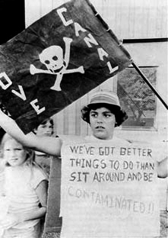

Joshua Markell Per. 3 02/28/12
Superfund Site in California
- Fresno Municipal Sanitary Landfill opened in 1935 in Fresno, California, was the first modern landfill in the U.S.
- In 1983, the California Department of Health Services was conducting tests and found that the site contained methane and vinyl chloride gases that were penetrating into the surrounding areas around the landfill.
- It became a model for other landfills around the country, and one of the longest-lived.
- The landfill was operated by the City of Fresno until it closed in 1989.
- It was declared a National Historic Landmark in 2001.
- In 1983, the California Department of Health Services was conducting tests and found that the site contained methane and vinyl chloride gases that were penetrating into the surrounding areas around the landfill.
- These tests also concluded that contaminants were being found in private ground-water wells around the landfill and on June 24, 1988, the site was proposed as a superfund site and was finalized on the NPL list on October 10, 1989.

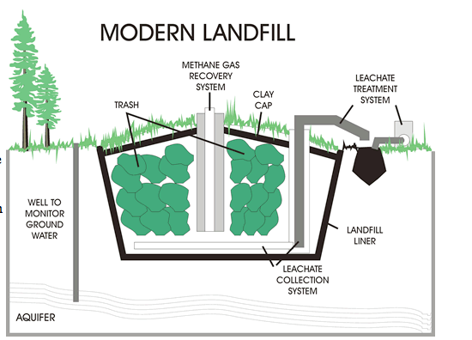

Joshua Markell Per. 3 02/28/12

