My work sample of wireframe:
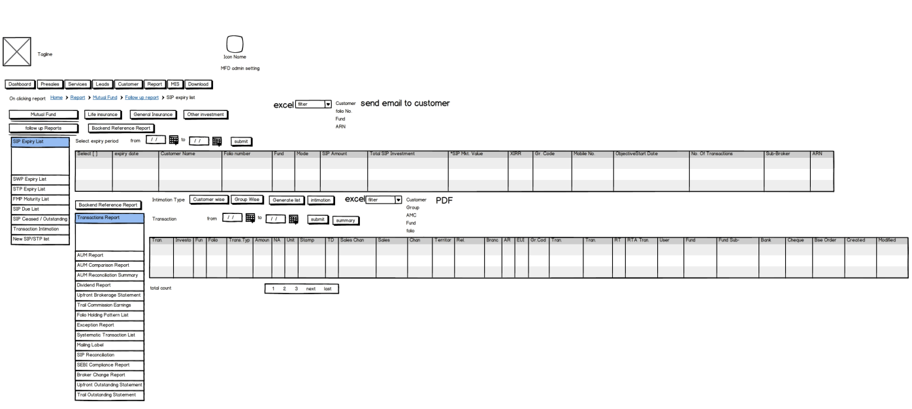

GENAI completion Badge



My work sample for Dataflow Diagram:

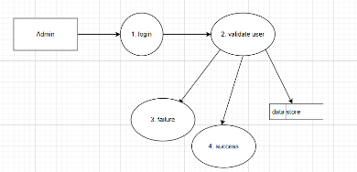
My work sample for Star Schema Database Diagram:
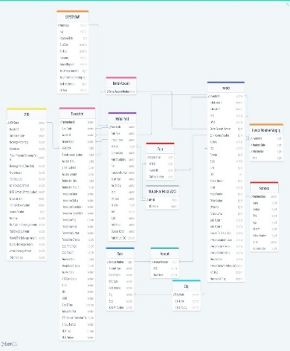
Sample of web sequence diagram for authentication:

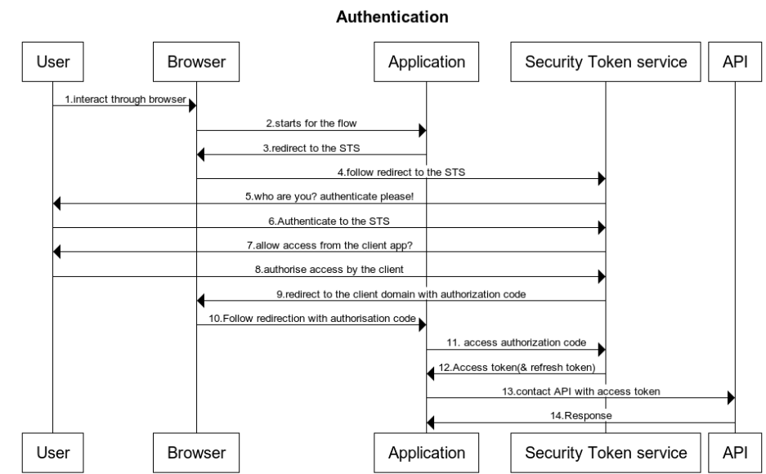

API Contract

{
OrgCode: “ODS-CODE”,//String
CreatedBy: “Role-Code”,//String
NameofAccessingUser: ”Name of the careprofessional”, //String
SummaryCareRecordViewSwitch: “ON-OFF”,//String

}

Use Case Diagram:

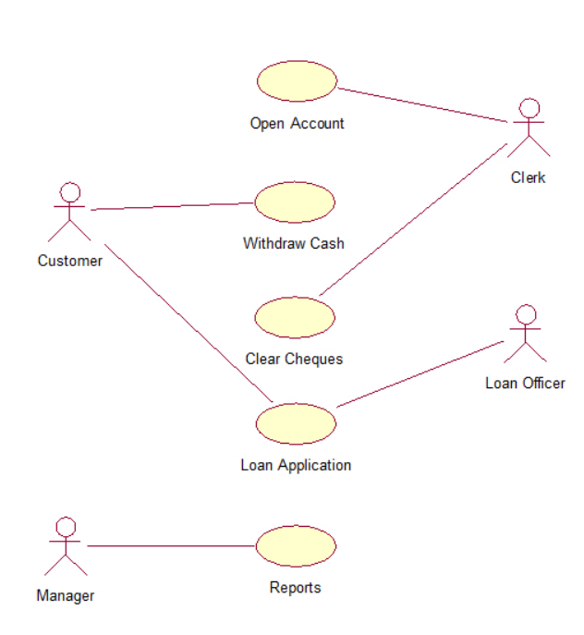

UML diagram:

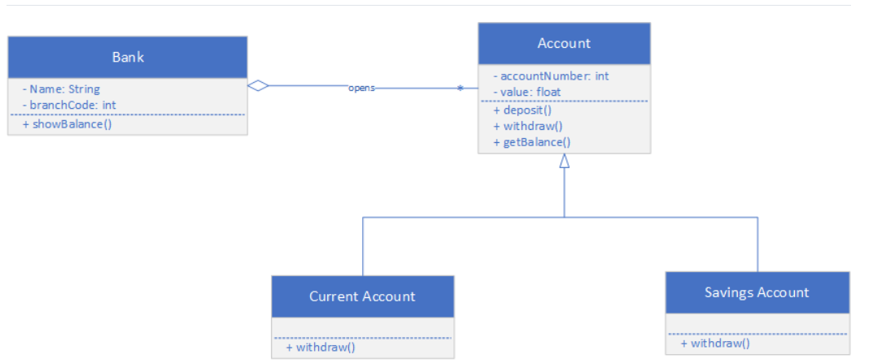

JMeter Summary Report Analysis

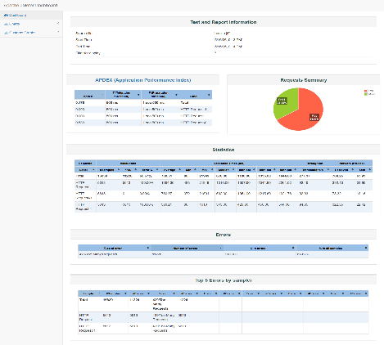

Data Analysis: Analyzed investment data created interactive dashboard using PowerBI
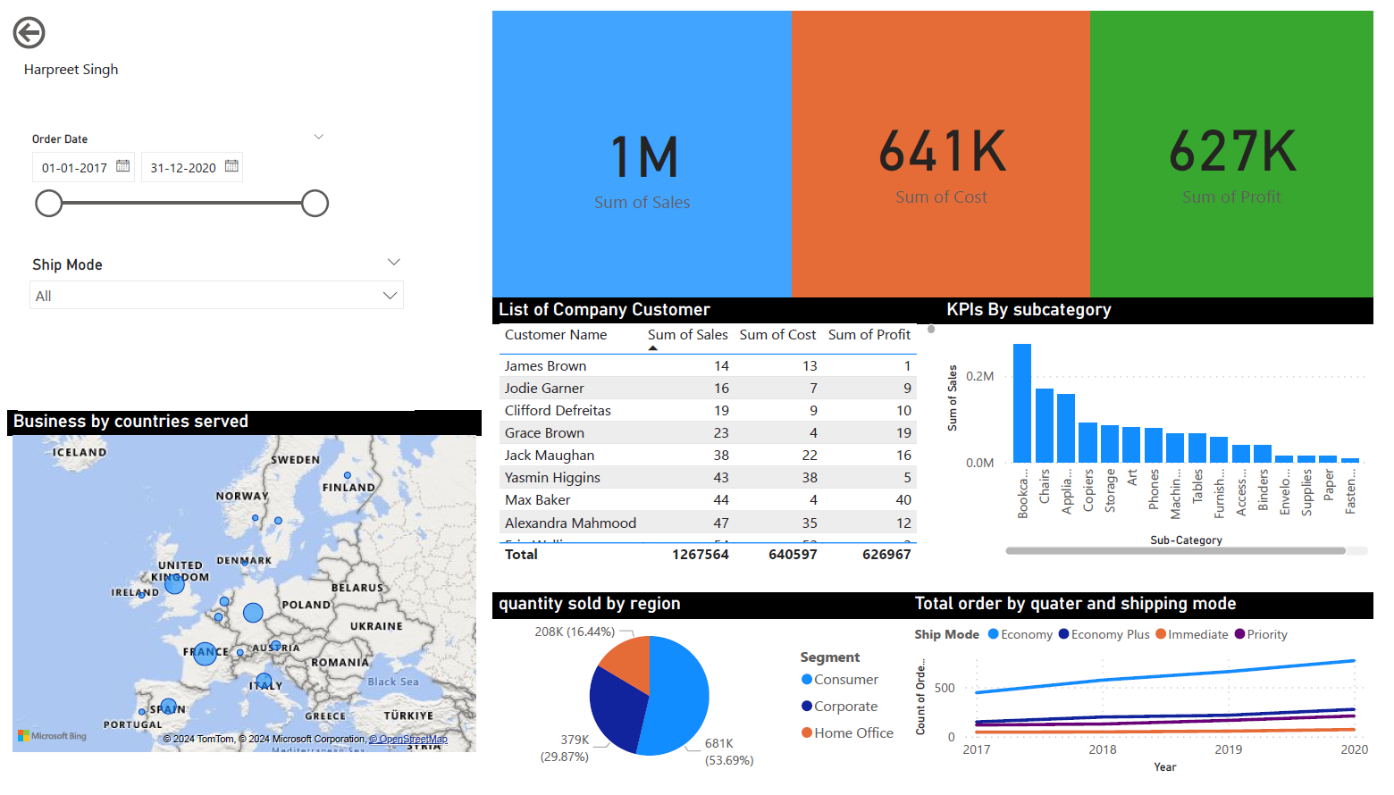

Data Platform architecture view

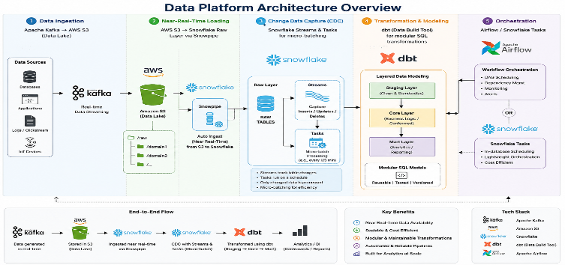

Cloud Data Pipeline for Risk Analytics (Snowflake Medallion Architecture)
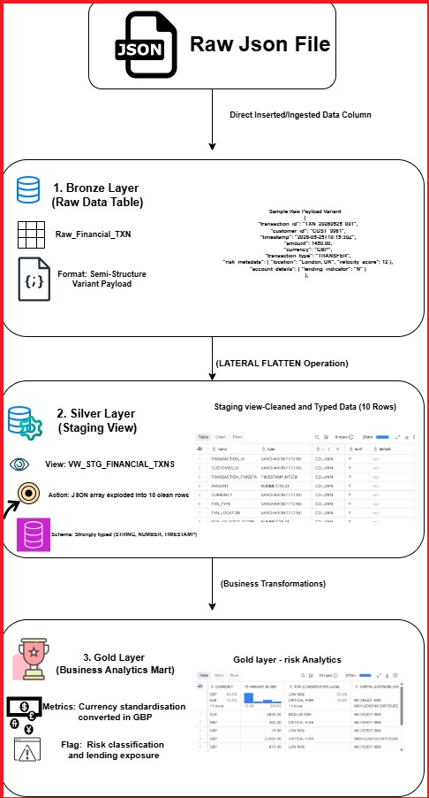

Analyzed the Data using wrangler (Python-Jupyter: Notebook):
Source: https://github.com/harpreet1987/Data_Analysis_Report

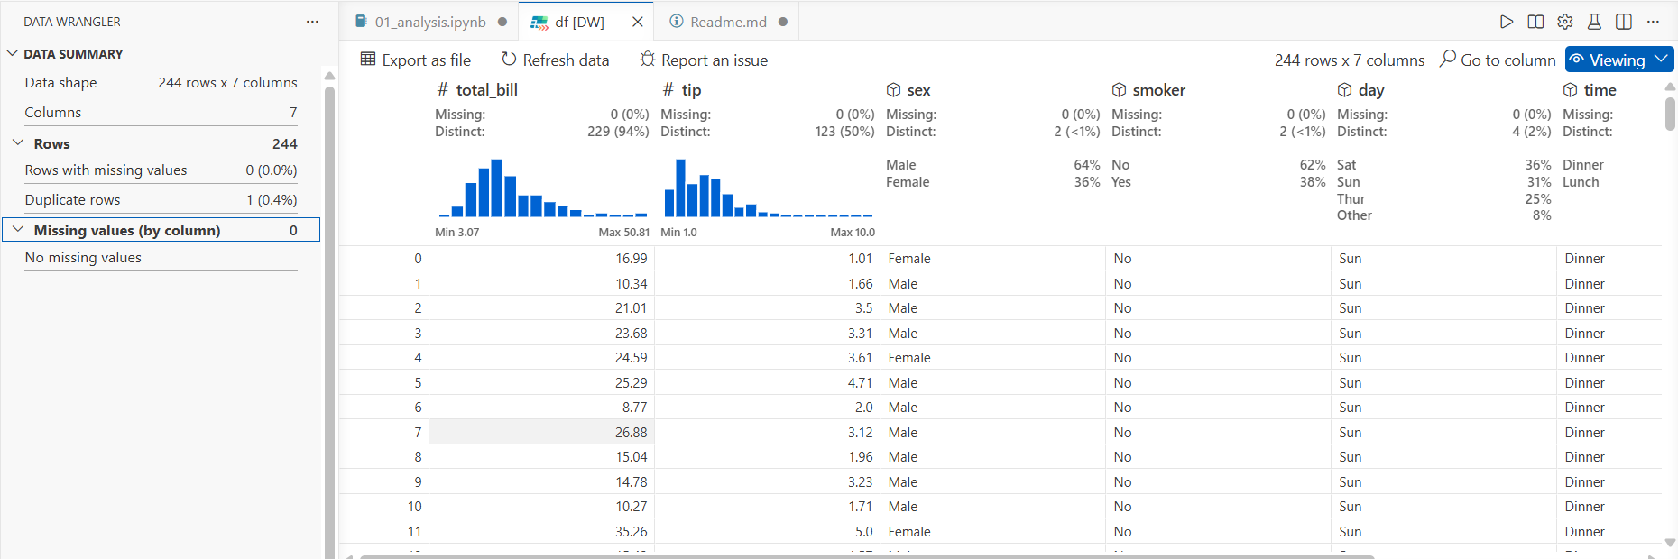

OCR – read Text from image using Tasseract: source: https://github.com/harpreet1987/Data_Analysis_Report

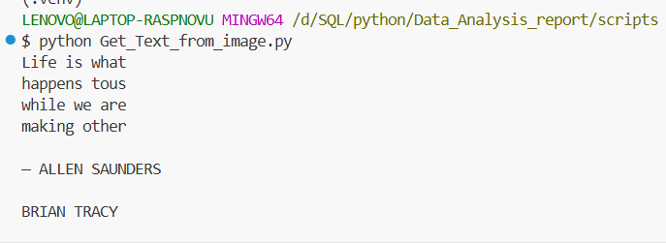
Architecture: Work sample for Solution architect for various project and module:

Financial product:
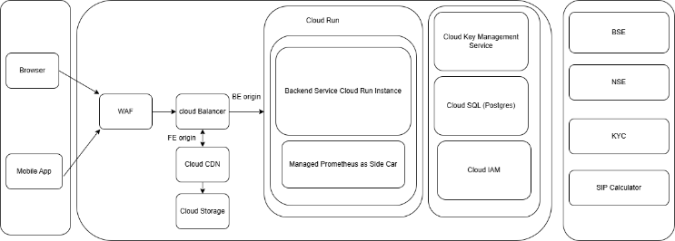

Dev-Secops pipeline
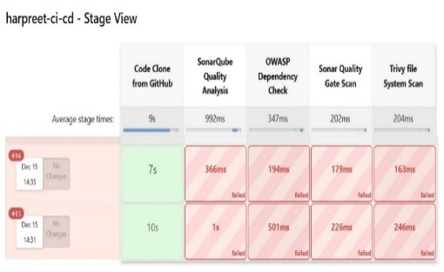

Health care Product architecture for Patient facing:
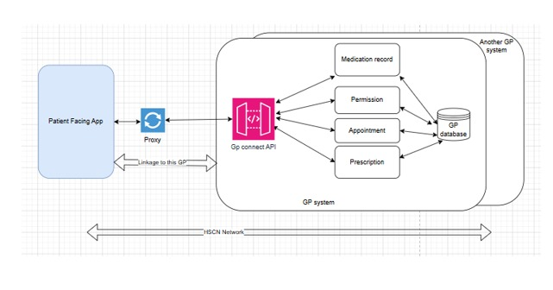
Kubernetes Architecture:
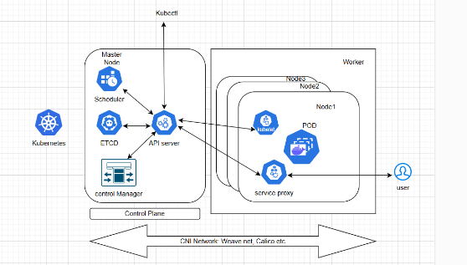
Kafka Architecture:
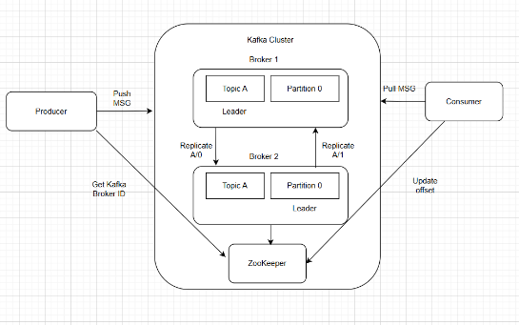
Docker Architecture
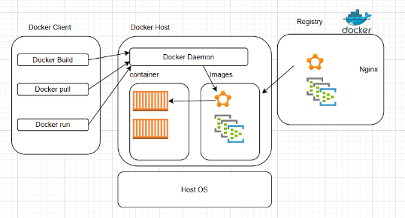

Demonstrating AWS IAM account i.e. roots and admin account:

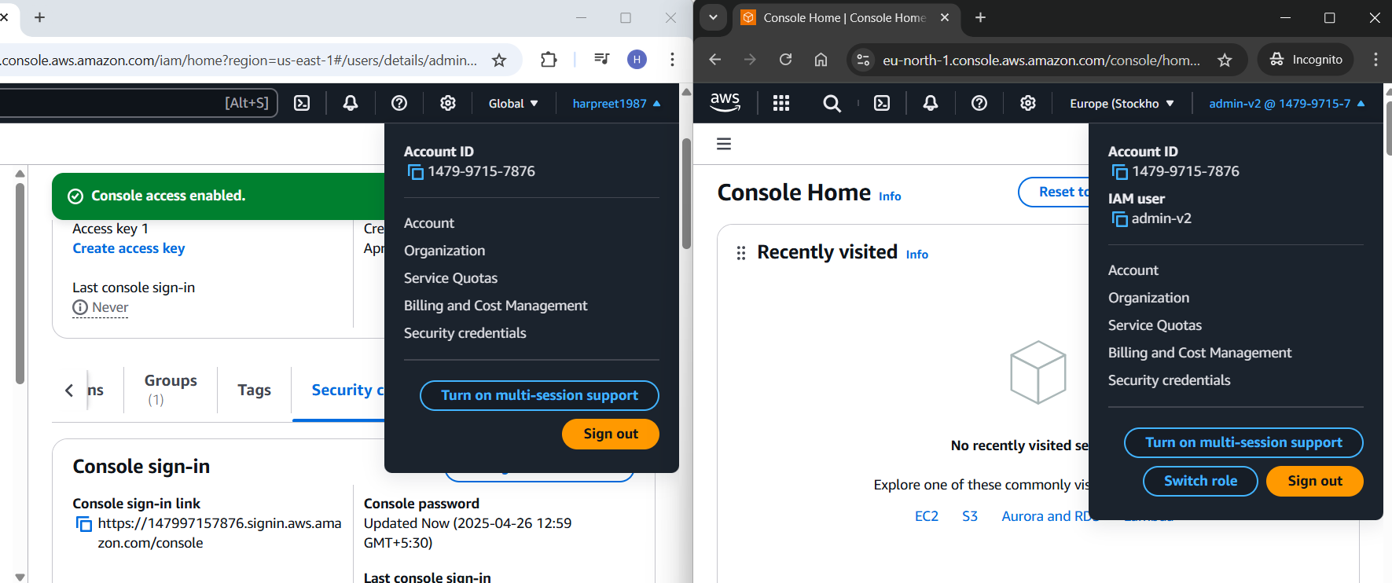

Ethereum Transaction Flow Infographic
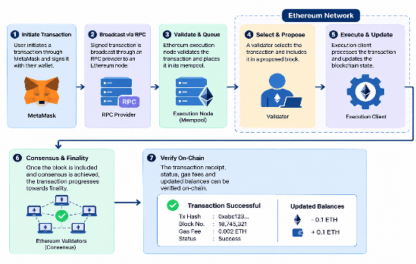
RAG Architecture and Query Flow


