**Lab Assignment #2 – Algorithm Analysis**

**Exercise 1**

1. Give a big-Oh characterization, in terms of n, of the running time of the example1 method from Exercises class in Lesson 4 examples.

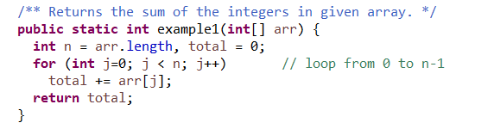

Ans: O(n)

Running time depends on the size of arr[] array, which is n. The loop is executed once for each element of arr until the end of arr is reached. Hence running time increases linearly to the number of elements in arr.

1. Give a big-Oh characterization, in terms of n, of the running time of the example2 method from Exercises class in Lesson 4 examples.

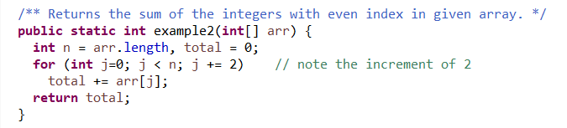

Ans: O(n)

Running time is linear and is dependent on the size of arr[]. There is an increment of 2 meaning running time would be n/2, which is still linear to the number of elements in arr. Hence linear running time.

1. Give a big-Oh characterization, in terms of n, of the running time of the example3 method from Exercises class in Lesson 4 examples.

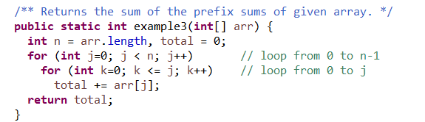

Ans: O(n^2)

For any given number of elements in arr[], 2 loops execute, hence running time is quadratic.

1. 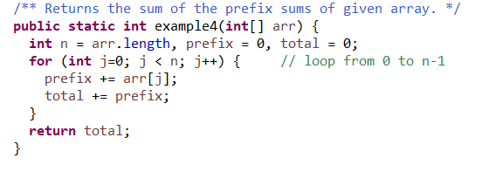Give a big-Oh characterization, in terms of n, of the running time of the example4 method from Exercises class in Lesson 4 examples.

Ans: O(n)

Running time is linear to the arr[] size as loop executes once for each array element.

1. Give a big-Oh characterization, in terms of n, of the running time of the example5 method from Exercises class in Lesson 4 examples.

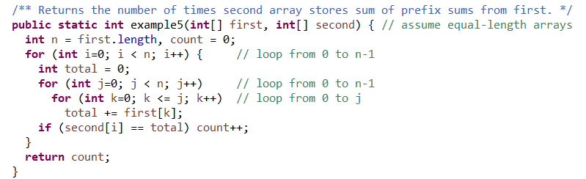

Ans: O(n^3)

For a given number of elements in first[] array, 3 loops execute, hence running time is cubic.