HTML - LIST ELEMENTS USER GUIDE

Table of Contents

**About the HTML** 2

**Intended Audience** 2

**Prerequisites** 2

**Copyrights©** 2

**1.** **HTML Overview** 3

1.1 Tags in HTML 3

1.2 Structure of a HTML Document 3

**2.** **HTML Elements** 4

2.1 Nested Elements 4

2.2 Attributes 4

**3.** **List Elements** 5

3.1 What is list? 5

3.2 Lists in HTML 5

3.3 Unordered List 5

**3.3.1** **Unordered List – Type Attribute** 8

3.4 Ordered List 9

**3.4.1** **Ordered List – Type Attribute** 11

**3.4.2** **Ordered List – Start Attribute** 12

3.5 Definition List 14

**4.** **To Work with Existing HTML Document** 17

References 18

# **About the HTML**

HTML stands for **Hypertext Markup Language**, which is the most widely used language on Web to develop web pages. HTML is a subset of SGML. HTML is the code that is used to structure a web page and its content. **Hypertext** refers to the hyperlinks that an HTML page may contain. **Markup Language** refers to the way tags are used to define the page layout and elements within the page. HTML elements are the building blocks of the HTML pages.

# **Intended Audience**

This document is designed for the users with a need to understand the **HTML – List Elements** in enough detail along with its simple overview, and practical examples. This document will give you enough information to start with HTML – List Elements from where you can take yourself at higher level of expertise in it.

# **Prerequisites**

Before proceeding with HTML – List Elements you should have a basic working knowledge with Windows or Linux operating system, additionally you must be familiar with:

* Experience with any text editor like notepad, notepad++, etc.
* Web browser(e.g. Chrome, Internet Explorer, etc.)
* How to create directories and files on your computer.
* How to navigate through different directories.
* How to type content in a file and save them on a computer.

# **Copyrights**

Copyright© 2021 by Precisely. All rights reserved worldwide. No parts of this publication may be reproduced, modified, transmitted, transcribed, stored in retrieval systems, or translated into any human or computer language, in any form or by any means, electronic, mechanical, magnetic, chemical, manual, or otherwise, without the express written permission of Precisely. Precisely may revise this document at any time without notice.

# **HTML Overview**

HTML provides a method to create structured documents by denoting structural semantics for text such as headings, paragraphs, lists, links, quotes, and other items. HTML elements are defined by tags, written using angle brackets.

Originally, HTML was developed with the intent of defining the structure of documents like headings, paragraphs, lists, and so forth to facilitate the sharing of scientific information between researchers.

Now, HTML is being widely used to format web pages with the help of different tags available in HTML language.

## Tags in HTML

Tags are one of the most important part in an HTML Document. HTML uses some predefined tags which tells the browser about content display property, that is how to display a particular given content. For Example, to create a paragraph, one must use the paragraph tags(<p> </p>) and to insert an image you must use the image tags(<img />).

There are generally two types of tags in HTML:

**Paired Tags:** These tags come in pairs. That is, they have both opening(< >) and closing(</ >) tags. A paired tag is called an element.

**Singular Tags:** These tags do not require to be closed (e.g. <br> and <hr>).

***Note****: HTML tags are not case sensitive.*

## Structure of a HTML Document

An HTML document mainly divides into two parts:

**HEAD**: This contains the information about the HTML document. For Example, Title of the page, version of HTML, Meta Data etc.

**BODY**: This contains all the visible contents, such as headings, paragraphs, images, hyperlinks, tables, lists, etc.

<!DOCTYPE HTML>

<HTML lang=”en”>

<head>

<meta charset=”UTF-8”>

<title> HTML List Elements </title>

</head>

<body>

<h1>List Elements</h1>

<p>This section provides procedure to use the List elements in the HTML document.</p>

</body>

</HTML>

**<!DOCTYPE HTML>:** This tag is used to tells the HTML version.

**<HTML>:** This is called HTML root element and used to wrap all the code. The “lang” attribute defines the document language.

**<head>:** This tag is used to represent the document’s header and contains tags like metadata, title, page CSS etc.

**<meta>**: This tag defines metadata about an HTML document. Metadata is used by browsers (how to display content or reload page), search engines (keywords), and other web services.

**<title>:** This tag is used to mention the document title.

**<body>:** Body tag is used to enclose all the data which a web page has from texts to links. All the content that you see rendered in the browser is contained within this element.

**<h1>:** This tag is used to represent headings in a Web Page.

**Heading Tags:** There are six levels of headings defined by HTML. These six heading elements are h1, h2, h3, h4, h5, and h6; with h1 being the highest level and h6 the least.

**<p>:** This tag is used to write paragraph statements in a webpage.

**<br>:** This is an empty tag and used to break the lines in a paragraph.

**<hr>:** This is an empty tag used to create a horizontal line and breaks the page into various sections.

# **HTML Elements**

A HTML element indicates by a pair of tags a “**<tag name>**” and “**</tag name>**” (e.g. <p>Content</p>). The HTML element is everything from a “**<start tag>**” to the “**<end tag>**”. An element is a building block of HTML page.

Some HTML elements have no content (e.g. <br> and <hr>). These elements are called empty elements. Empty elements do not have an end tag.

## Nested Elements

Nested elements in HTML are tags inside the tag. An HTML document permits child elements and parent elements in a document. Nested elements are children of their parent container tag.

A HTML document is an example for nested elements.

## Attributes

An attribute is used to provide additional information about an element. All HTML elements can have attributes.

An attribute has two parameters : a **name** and a **value**. These define the properties of the element and is placed inside the **opening tag** of the element. Every name has some value that must be written within quotes.

Example: <p style=”color:red;”> This is HTML document </p>.

Result: 

# **List Elements**

## What is list?

A list is a record of short pieces of information, such as names, usually written or printed with a single thing on each line and ordered in a way that makes a particular thing easy to find.

## Lists in HTML

HTML offers three ways for specifying lists of information. All lists must contain one or more list elements.

The lists used in HTML are :

1. **ul** : An unordered list. This will list items using plain bullets.
2. **ol** : An ordered list. This will use different schemes of numbers to list your items.
3. **dl** : A definition list. A definition list is a list of terms, with a description of each term.

***Note****: List elements cannot be children of paragraph <p> element*

## Unordered List

An **Unordered List** or **Bulleted List** in HTML displays elements in bulleted format. We can use unordered list where we do not need to display items in any particular order. The HTML **<ul>** tag is used for the unordered list.

An unordered list starts with <ul> tag and each list item start with <li> tag.

To use the unordered list element in a HTML document, do the below steps:

1. Create a Project folder (name as required) in your computer.
2. Open the text-editor (Notepad or Notepad++).
3. Create a HTML document structure. Refer to Structure of a HTML **Document**.
4. Enter your contents inside the elements. Use the appropriate elements.
5. Insert the unordered list (<ul></ul>) element below the paragraph or wherever required.

***Note****: List elements cannot be children of paragraph <p> element.*

1. Insert the list (<li> </li>) element inside the <ul> element.
2. Enter the list item inside the list element.
3. You can add more list items by inserting list elements. Refer to the below image.

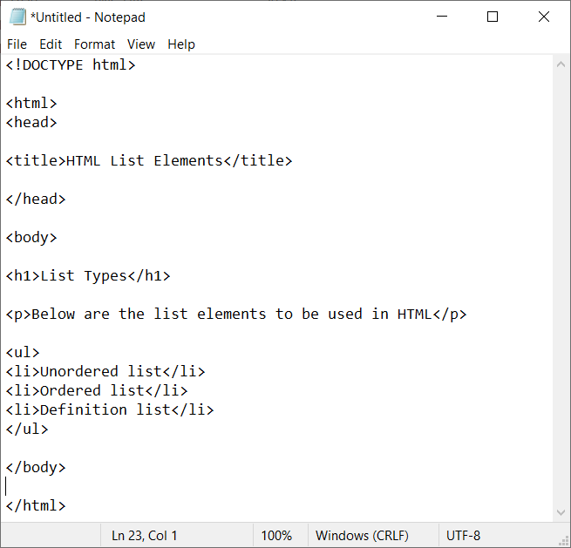

1. Click the **File** from Notepadmenu and then select **Save As**.

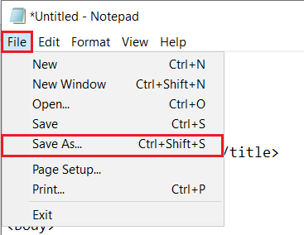

1. Navigate to the Project folder and enter the file name with **.htm** or **.html** extension.
2. Select the **Encoding** as **UTF-8** and click **Save** to add the file in the Project folder.

1. You can see the created HTML document inside the Project folder.
2. Open the HTML document with a browser. Refer to the below image.

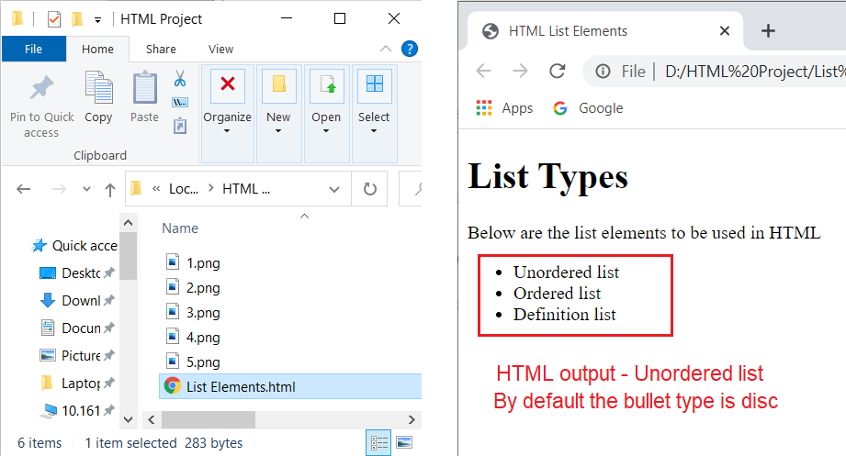

### **Unordered List – Type Attribute**

You can use type attribute for <ul> tag to specify the type of bullet you like. By default, it is a disc type.

The following type attributes are used in the unordered list <ul> tag:

* <ul type = "circle">
* <ul type = "square">

To insert or modify the bullet type, do the below steps:

1. Open the HTML document in Notepad.
2. Enter the required attribute name (type) and enter the name value (“square”) Inside the <ul> element start tag.
3. Enter the list items and save the document.
4. Open the HTML document with browser.
5. You can see the bullet type changed. Refer to the below image.

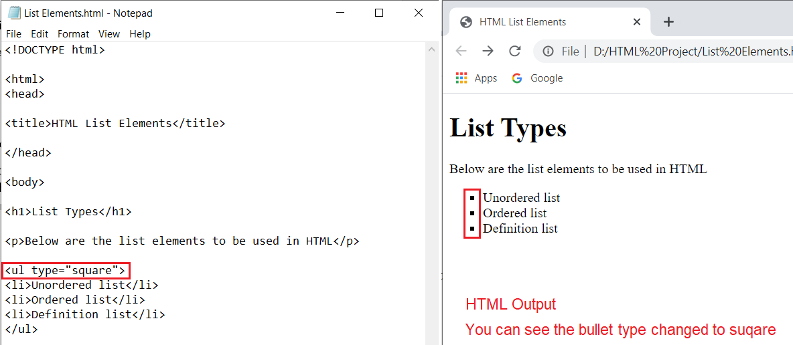

1. Do the above steps from 1 to 4 for type=”circle” attribute.

## Ordered List

An ordered list is a numbered list of items. HTML gives you the ability to control the sequence number to continue where the previous list left off, or to start at a particular number. If you are required to put your items in a numbered list instead of bulleted, then HTML ordered list will be used. This list is created by using <ol> tag. The numbering starts at one and is incremented by one for each successive ordered list element tagged with <li>.

To use the ordered list element in a HTML document, do the below steps:

1. Create a Project folder (name as required) in your computer.
2. Open the text-editor (Notepad).
3. Create a HTML document structure. Refer to Structure of a HTML **Document**.
4. Enter your contents inside the tags. Use the appropriate tags.
5. Insert the ordered list (<ol></ol>) element below the paragraph or wherever required.

***Note****: List elements cannot be children of paragraph <p> element.*

1. Insert the list (<li> </li>) element inside the <ul> element.
2. Enter the list item inside the list element.
3. You can add more list items by inserting list elements. Refer to the below image.

1. Click the **File** from Notepadmenu and then select **Save As**.



1. Navigate to the Project folder and enter the file name with **.htm** or **.html** extension.
2. Select the **Encoding** as **UTF-8** and click **Save** to add the file in the Project folder.

1. You can see the created HTML document inside the Project folder.
2. Open the HTML document with a browser. Refer to the below image.

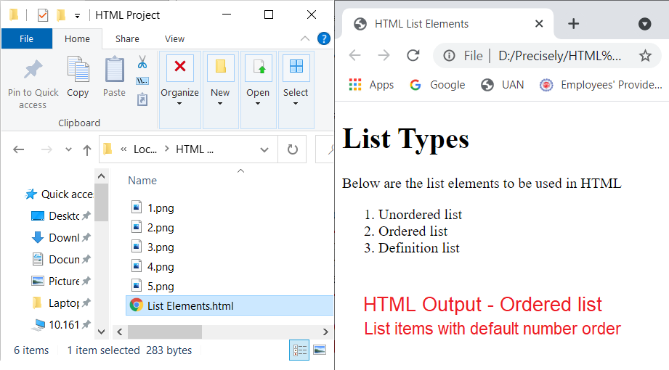

### **Ordered List – Type Attribute**

You can use type attribute for ordered list <ol> tag to specify the type of numbering you like. By default, it is a number order.

The below are the type attributes used in the ordered list <ol> tag:

* <ol type = "1"> - Default-Case Numerals
* <ol type = "I"> - Upper-Case Numerals
* <ol type = "i"> - Lower-Case Numerals
* <ol type = "A"> - Upper-Case Letters
* <ol type = "a"> - Lower-Case Letters

To insert or modify the number type, do the below steps:

1. Open the HTML document in Notepad.
2. Enter the required attribute name (type) and enter the name value ( “I”) Inside the <ol> element start tag.
3. Enter the list items and save the document.
4. Open the HTML document with browser.
5. You can see the number type changed. Refer to the below image.

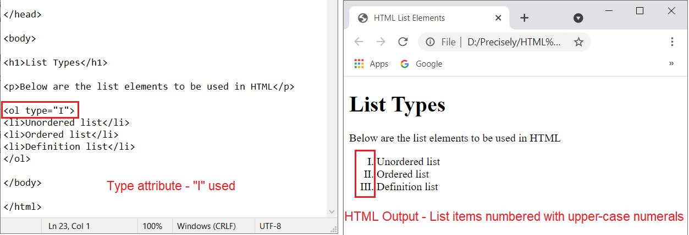

*<ol type = I"> - Upper-Case Numerals*

1. Do the above procedure from step 1 to step 4 for type attributes lower-case numerals, upper-case letters, and lower case-letters.
2. The below images are showing the HTML list output for the ordered list type attributes.

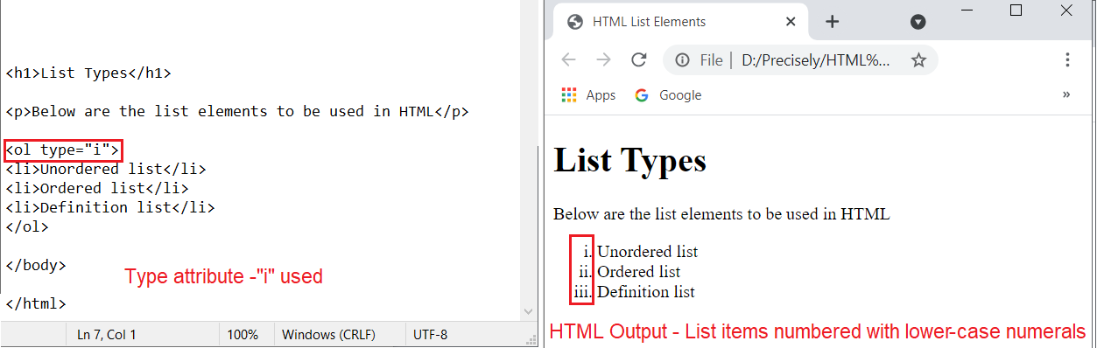

*<ol type = "i"> - lower-Case Numerals*

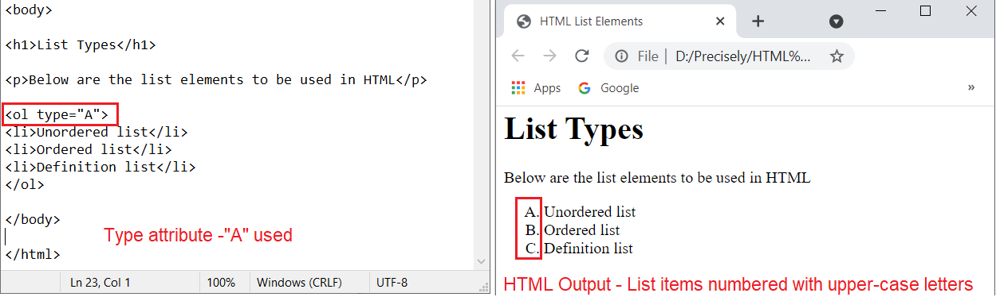

*<ol type = A"> - Upper-Case Letters*

*<ol type = “a"> - Lower-Case Letters*

### **Ordered List – Start Attribute**

You can use start attribute for ordered list <ol> tag to specify the starting point of numbering you need. The start attribute specifies the start value of the first list item in an ordered list.

The below are the start attributes used in the ordered list <ol> tag:

* <ol type = "1" start = "7"> - Numerals starts with 7
* <ol type = "I" start = "8"> - Upper-case Numerals starts with VIII
* <ol type = "i" start = "9"> - Lower-Case Numerals starts with ix
* <ol type = "A" start = "10”> - Upper-Case Letters starts with J
* <ol type = "a" start = "11"> - Lower-Case Letters starts with k

To insert the start attributes, do the below steps:

1. Open the HTML document in Notepad.
2. Enter the start attribute next to the type-attribute and enter the start value ( “7”) Inside the <ol> element start tag.
3. Enter the list items and save the document.
4. Open the HTML document with a browser.
5. You can see the number type changed. Refer to the below image.

*<ol type = "1" start = "7"> - Numerals starts with 7*

1. Do the above procedure from step 1 to step 4 for the other start attributes.
2. The below images are showing the HTML list output for the ordered list start attributes.

*<ol type = "I" start = "8"> - Upper-Case Numerals starts with VIII*

*<ol type = "i" start = "9"> - Lower-Case Numerals starts with ix*

*<ol type = "A" start = "10"> - Upper-Case Letters starts with J*

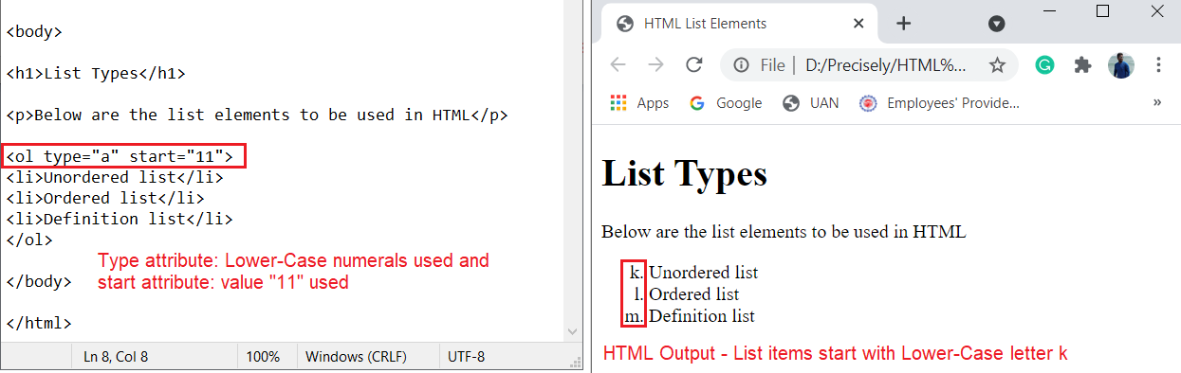

*<ol type = "a" start = "11"> - Lower-Case Letter starts with k*

## Definition List

HTML definition list represents a term and a relevant description in the form of the list. HTML definition list uses the <dl> element (i.e. <dl> and </dl>). The terms are enclosed with <dt> element (i.e. <dt> and </dt>). The description is enclosed with the <dd> element (i.e. <dd> and </dd>). No attribute is specific to the definition list <dl>. The definition list is the standard way to present a glossary, list of terms, or other name/value list.

To use the definition list element in a HTML document, do the below steps:

1. Create a Project folder (name as required) in your computer.
2. Open the text-editor (Notepad or Notepad++).
3. Create a HTML document structure. Refer to Structure of a HTML **Document**.
4. Enter your contents inside the elements. Use the appropriate elements.
5. Insert the ordered list (<dl></dl>) element below the paragraph or wherever required.

***Note****: List elements cannot be children of paragraph <p> element.*

1. Insert the term (<dt> </dt>) element inside the <dl> element.
2. Enter the term value inside the term element.
3. Insert the description term (<dd></dd>) element below the term <dt> element.
4. Enter the term definition inside the description term element.
5. You can add more definition terms and description by inserting <dt> and <dd> elements. Refer to the below image.

1. Click the **File** from Notepadmenu and then select **Save As**.



1. Navigate to the Project folder and enter the file name with **.htm** or **.html** extension.
2. Select the **Encoding** as **UTF-8** and click **Save** to add the file in the Project folder.

1. You can see the created HTML document inside the Project folder.
2. Open the HTML document with browser. Refer to the below image.

# **To Work with Existing HTML Document**

You can add or modify the existing HTML document list elements using the text editor.

Do the below steps to add or modify the list elements:

1. Navigate to the project folder/HTML document location.
2. Select and right-click the HTML document.
3. Select the **Open with** option and click the **Notepad** option (or any installed text editor). Refer to the below image.

1. You can see the HTML code opened in Notepad editor.
2. Insert the list element (refer to Unordered **List**, Ordered **List**, and Definition **List**) wherever required.
3. Add the list items and save the document.
4. Open the modified HTML document with browser.
5. You can the added list element(s) in the document. Refer to below images.

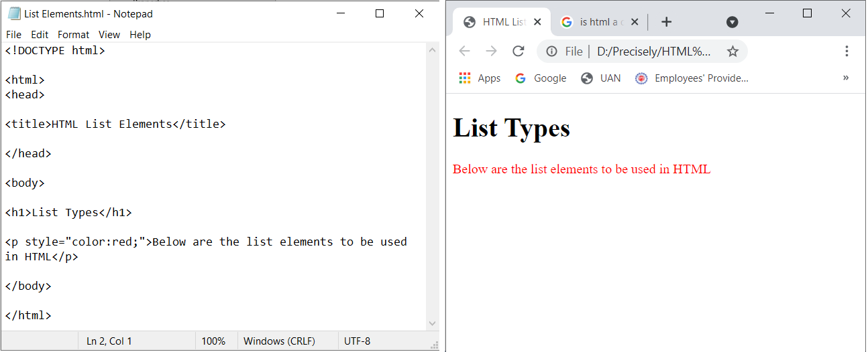

*Before adding the list element*

*After adding the list element*

1. You can change the list items from unordered list to ordered list using the <ol> element.
2. You can change the list item numbering’s by inserting/modifying the type/start attributes.

## References

To know more about HTML, tags, formatting, and styling of HTML elements refer to <https://html.spec.whatwg.org/multipage/>.